Lesson 6
Objective: Use the associative property to subtract from three-digit numbers and verify solutions with addition.

Suggested Lesson Structure
 Application Problem (5 minutes)
 Fluency Practice (9 minutes)
 Concept Development (36 minutes)
 Student Debrief (10 minutes)
Total Time (60 minutes)
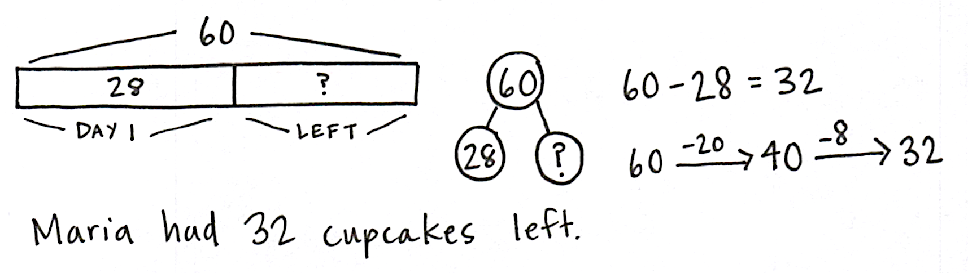
Application Problem (5 minutes)
Maria made 60 cupcakes for the school bake sale. She sold 28 cupcakes on the first day. How many cupcakes did she have left?
Note: This Application Problem prepares students for subtracting multiples of 10. They may use whichever subtraction strategy they prefer. Lead students through the RDW process, or have students work independently and then share their work.
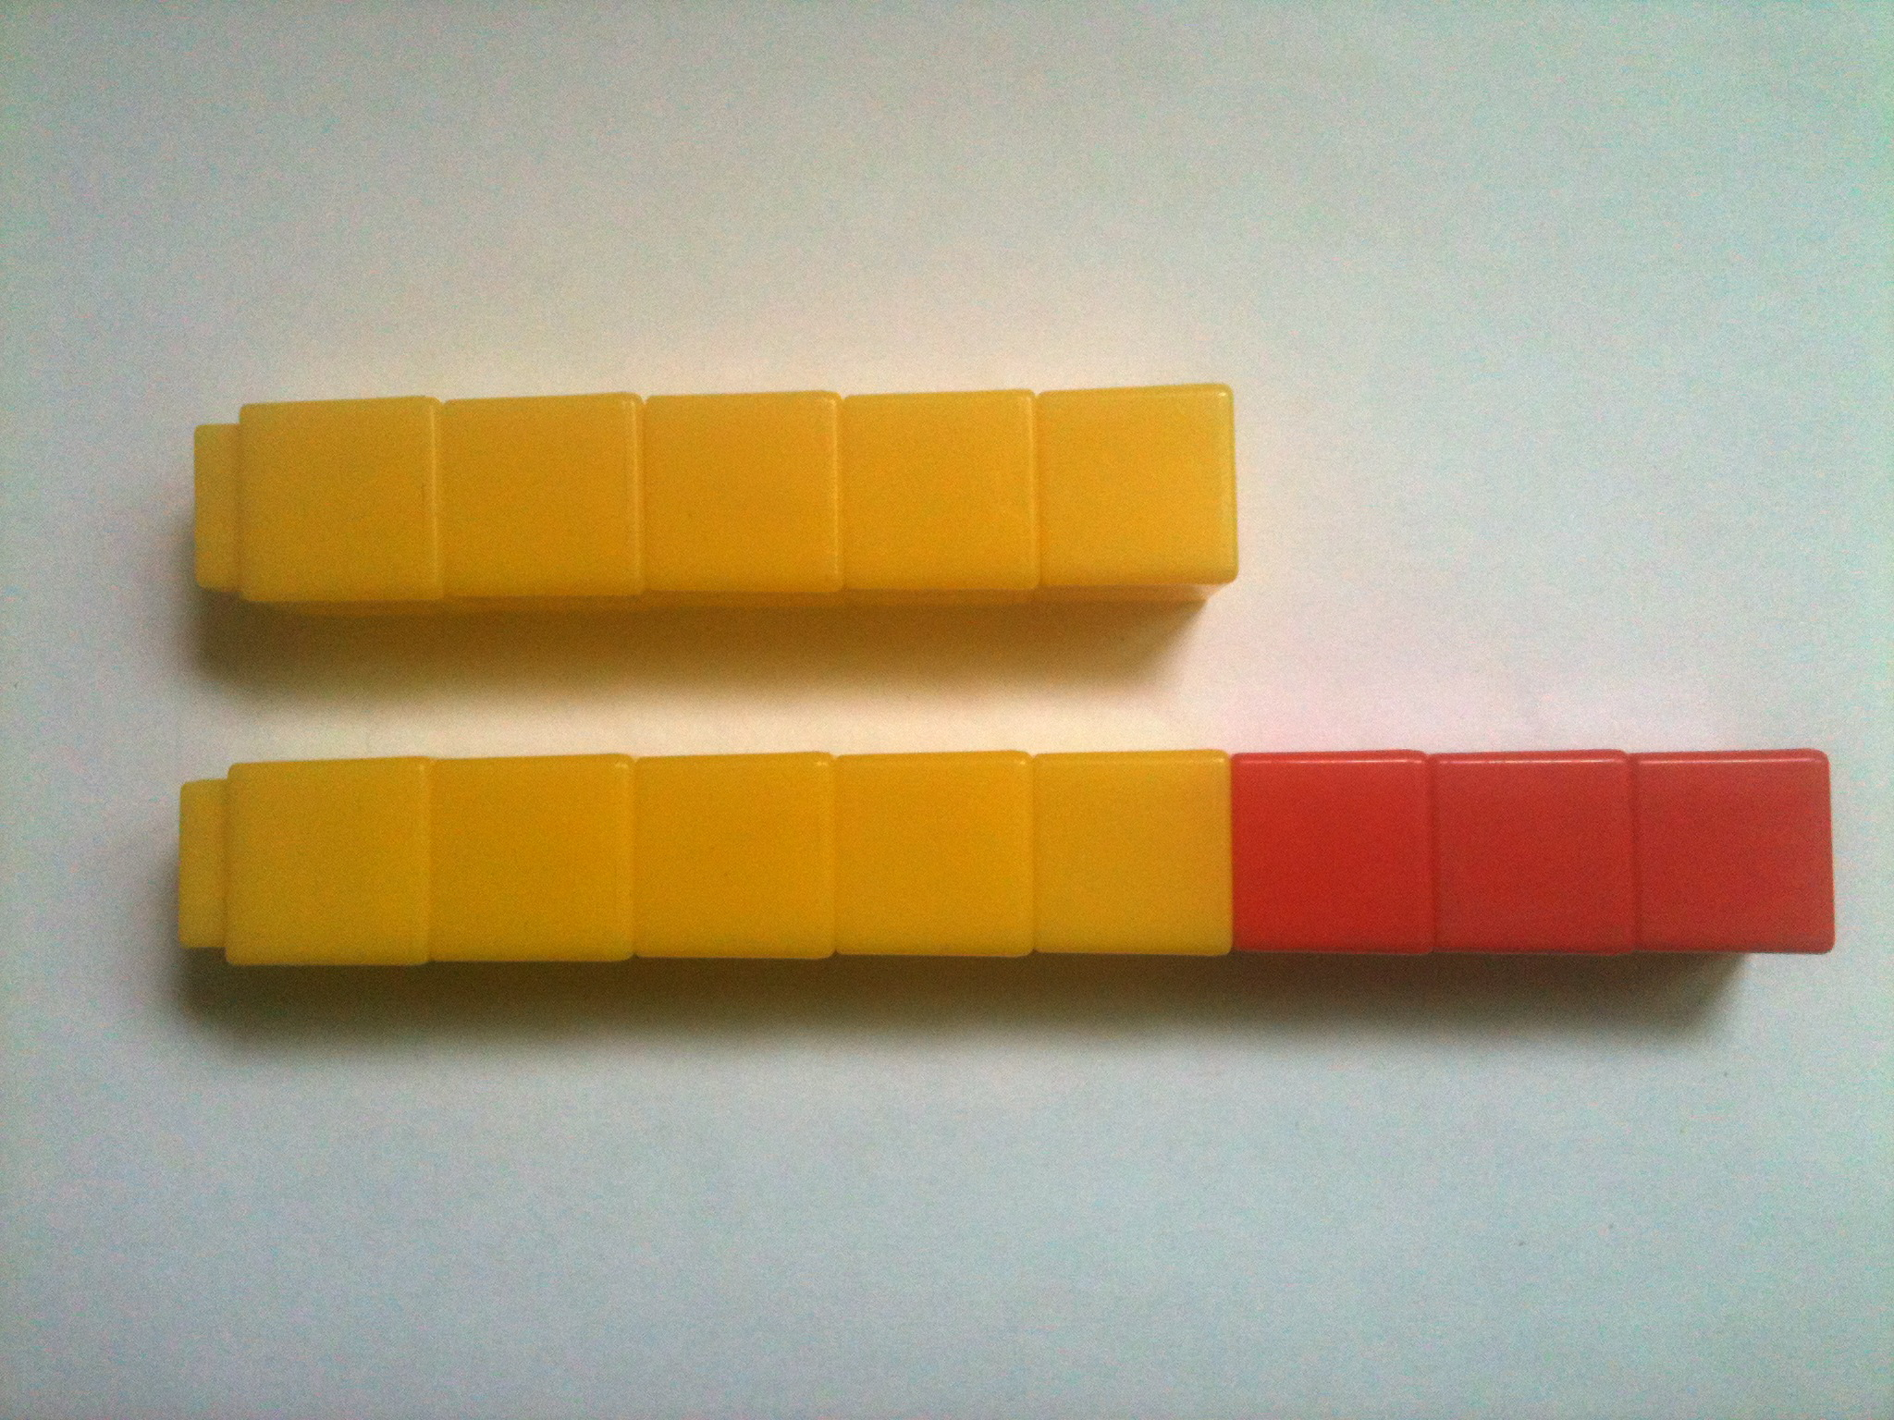
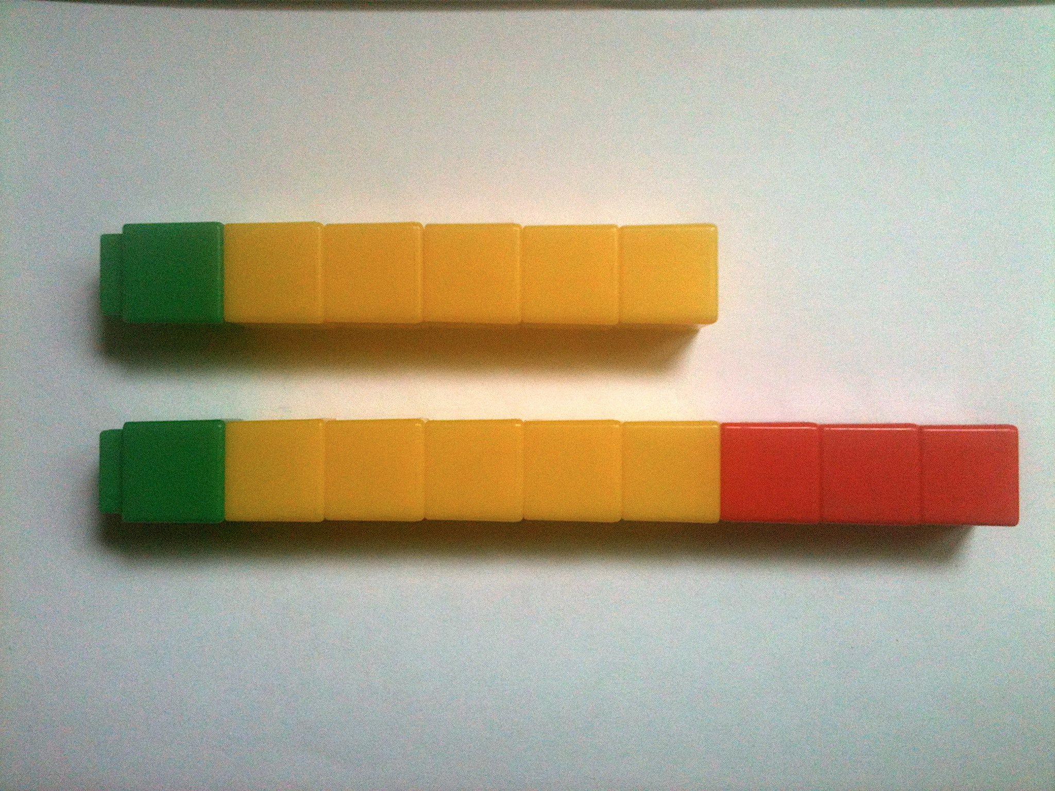
Fluency Practice (9 minutes)
8 – 5 = 9 – 6
- Compensation with Linking Cubes 2.NBT.5 (5 minutes)
- Compensation with Subtraction 2.NBT.5 (4 minutes)
Compensation with Linking Cubes (5 minutes)
Materials: (S) Linking cubes in three colors
Note: This is a teacher-directed, whole-class activity. With continued practice, students gain automaticity compensating when subtracting.
T: (Show a row of 8 cubes with 5 in yellow and 3 in red and a row of 5 yellow cubes.) What is the difference between 8 and 5?
S: 3.
T: What is a number sentence to represent the difference?
S: 8 – 5 = 3.
T: Now, add 1 green cube to the end of each stick.
Has the difference changed?
NOTES ON
MULTIPLE MEANS
OF ENGAGEMENT:
Cultivate confidence, particularly for students who shy away from participating. Invite a student forward to add 1 green cube to the end of each stick. Guide the student to give the new number sentence, pointing to cubes as he speaks. Then, during pair-share, have a private conversation: “What does this mean?” Listen intently to see if the student understands that the difference does not change. Celebrate risk taking and problem solving!

S: No.
T: What is the new number sentence?
S: 9 – 6 = 3.
T: True or false? (Write 8 – 5 = 9 – 6 on the board.)
S: True.
Continue with the following possible sequence: 7 – 3 = 8 – 4 and 9 – 4 = 10 – 5.
Compensation with Subtraction (4 minutes)
Note: This fluency activity prepares students for the lesson by reviewing compensation when subtracting. Students add the same amount to the minuend and subtrahend to make a multiple of 10 to make the problem easier to solve. Post a tape diagram on the board for visual representation.
T: (Write 34 – 19 = _____.) Let’s use the same mental math strategy to subtract larger numbers. How much more does 19 need to make the next ten?
S: 1 more.
+ 1
+ 1
34
19
T: Add 1 to each number, and give me the number sentence.
S: 35 – 20 = 15.
T: 34 – 19 is...?
S: 15.
T: True or false? (Write 34 – 19 = 35 – 20 on board.)
S: True.
T: What are both expressions equal to?
S: 15.
T: 43 – 28. Give me the new number sentence.
S: 45 – 30 = 15.
Continue with the following possible sequence: 52 – 29, 64 – 38, 83 – 27, 74 – 49, 93 – 47, and 95 – 58.
Concept Development (36 minutes)
Materials: (T) Linking cubes in three colors (S) Personal white board
Note: Compensation for subtraction is always shown on the left-hand side, whether manipulating linking cubes or drawing a tape diagram, to make it clear that the difference remains the same. If compensation is shown on the right, the difference shifts, so students may wonder if it has changed.
Problem 1: Compensation with Two-Digit Numbers and Checking with Addition
T: Let’s imagine each of the cubes is worth 10. (Show the 8 and 5 sticks used in the Fluency activity.) Let’s count them by tens. (Count together: 10, 20, 30, etc.)
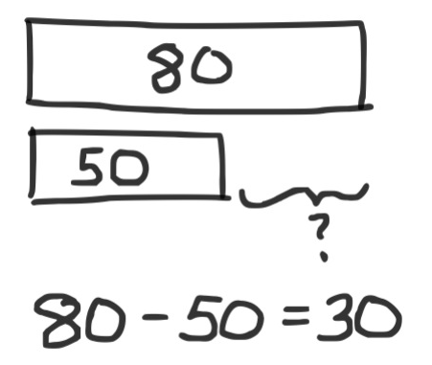
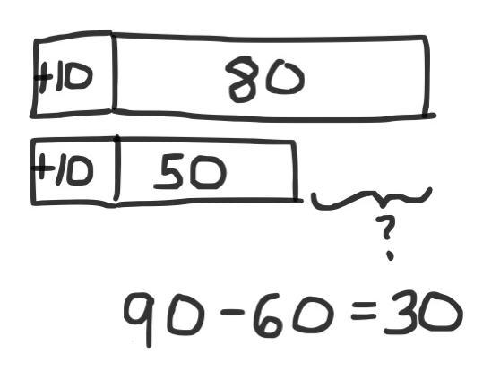
T: What is the difference now? Say the number sentence.
S: 80 – 50 = 30.
T: (Add 1 cube to the end of each stick.) How about now? Say the number sentence.
S: 90 – 60 = 30.
T: (Draw a two-bar diagram to represent these two problems.)
T: Let’s check to see if that worked for both of these problems. (Point to 80 – 50.) In this problem, since 80 is the whole, and 50 is one part, what is the other part? (Point to the 30.)
S: 30.
T: We know if we add both parts, we should get the whole again. Does it work? If we add 30 to 50, what do we get?
S: 80.
T: It works! (Write 30 + 50 = 80 on the board.)
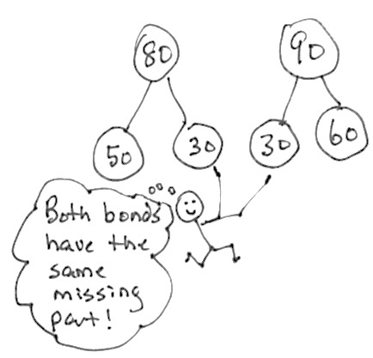
Repeat this sequence with 90 – 60 = 30.
T: (Quickly draw the bonds as exemplified to the right.) Both bonds have the same missing part!
Problem 2: Compensation with Multiples of 10 and Three-Digit Numbers and Checking with Addition
T: Let’s try a new problem. (Write 230 – 180 on the board.)
T: This problem is a bit challenging, isn’t it?
T: What is 250 – 200?
S: 50.
T: How did you know that so fast?
MP.7
S: Because the hundreds were the same, so 50 is left. It’s easy! Just take away 200. I started at 200, and 50 more is 250, so the answer is 50.
MP.7
T: It’s easier to take away the hundreds, isn’t it?
T: (Draw a tape diagram on the board to represent 230 – 180. Direct students to do the same. Call a student volunteer forward to label the tape diagram.)
T: Can you tell me how 230 – 180 and my other problem, 250 – 200, are related? Turn and talk.
S: 230 – 180 is the same as 250 – 200, but you added 20 more to each number. The difference is the same, 50. Even though the number sentence is different, they are equal to each other.
T: Exactly! We call this compensation. We can add the same amount to both numbers to make an equivalent, but easier, problem!
T: (Call on a volunteer to add 20 to each bar on the board to change the model to 250 – 200.)
S: (Do the same at their seats.)
NOTES ON
MULTIPLE MEANS
OF ACTION AND EXPRESSION:
Some students may struggle to see the compensation. Allow them to continue using the linking cubes to represent the larger numbers. Again, instruct them to show the compensation with an alternate color.
For students struggling with fine motor skills, provide square tiles to help them draw the tape diagrams. Do not, however, become overly concerned with precision because their conceptual understanding is paramount. The tape diagram is a vehicle for understanding the compensation.

MP.7
T: Now, how much is each bar worth?
S: The top bar is 250, and the bottom bar is 200.
T: We added 20 to each bar to make the problem easy!
T: Now, let’s check it with addition the way we did before. (Point and talk.) What is 50 + 200?
S: 250.
T: What is 50 + 180? (Give students a moment to think.)
S: 230.
T: How do you know? Talk with a partner.
S: The parts go together to make the same whole.
I counted by tens just to make sure. It’s like a number bond, so the subtraction and addition problems are related.
T: (Write on the board: 330 – 280, 500 – 370, and
570 – 380.) Now, it’s your turn. On your personal white board, solve these problems by using this strategy.
Problem 3: Compensation with Three-Digit Numbers and Checking with Addition
T: So far, we have only been working with numbers with zero ones. Now, let’s try subtracting numbers with some ones.
T: (Write 321 – 199 on the board.) In this problem, I see that the number I am taking away is very close to 200. How much more do I need to add to make 200?
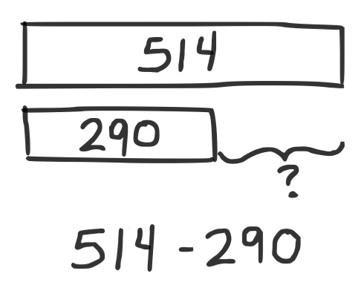
S: 1.
T: Let’s draw a tape diagram for that. (Draw a tape diagram representing 321 – 199, and add 1 to the left of each bar.)
Draw this on your personal white board, too.
T: What is our new problem?
S: 322 – 200.
T: That’s easier, don’t you think? Turn your board over when you have the answer.
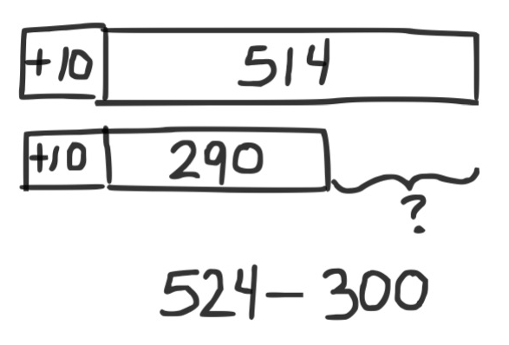
T: What is 322 – 200?
S: 122.
T: Let’s check that with addition. (Write 122 + 200 on the board.) What is the sum?
S: 322.
T: It works! Let’s try another problem. (Write 514 – 290 on the board below a tape diagram.)
T: How much should we add to each number to make this problem easier?
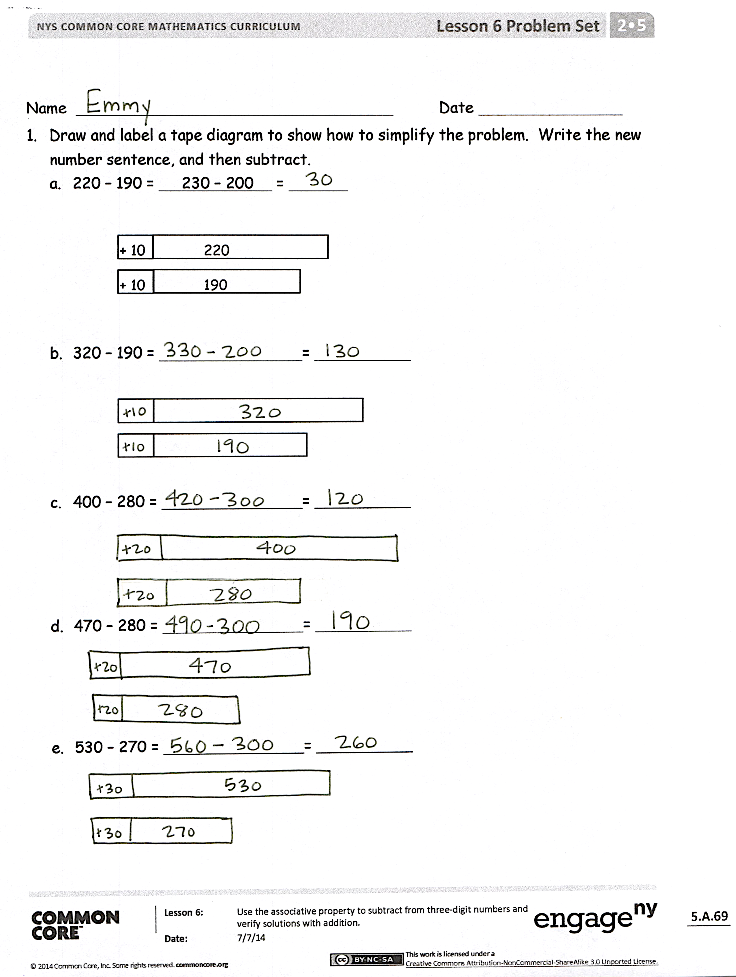
S: 10.
T: What is our new problem? (Draw 10 more onto the left of each bar.)
S: 524 – 300.
T: Draw a tape diagram and solve. Check your answer using addition.
Repeat with the following possible sequence: 547 – 498 and 720 – 575.
Problem Set (10 minutes)
Students should do their personal best to complete the Problem Set within the allotted 10 minutes. For some classes, it may be appropriate to modify the assignment by specifying which problems they work on first. Some problems do not specify a method for solving. Students should solve these problems using the RDW approach used for Application Problems.
Student Debrief (10 minutes)
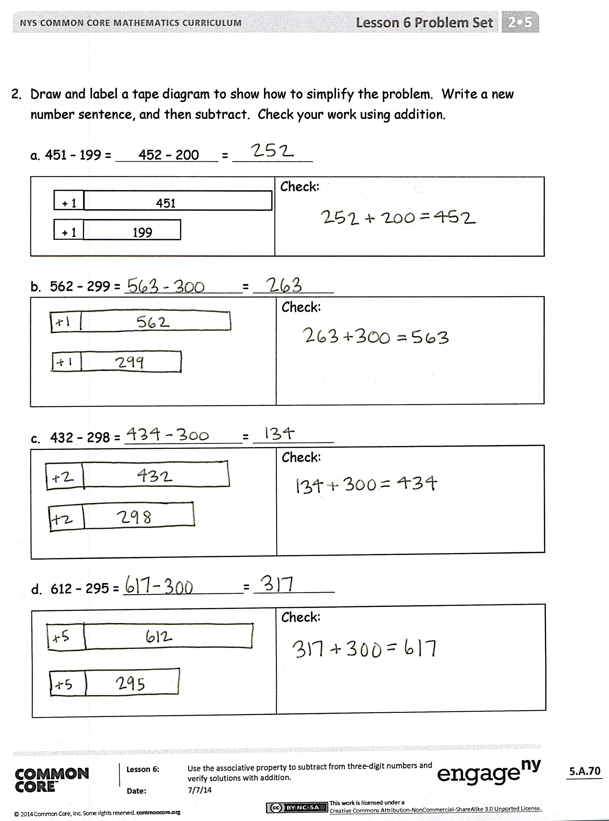
Lesson Objective: Use the associative property to subtract from three-digit numbers and verify solutions with addition.
The Student Debrief is intended to invite reflection and active processing of the total lesson experience.
Invite students to review their solutions for the Problem Set. They should check work by comparing answers with a partner before going over answers as a class. Look for misconceptions or misunderstandings that can be addressed in the Debrief. Guide students in a conversation to debrief the Problem Set and process the lesson.
Any combination of the questions below may be used to lead the discussion.
- In Problem 1(b), what number did you add to both numbers in the equation to make an easier problem? Why? How did you check your work?
- For Problem 1(c), 400 – 280, explain to your partner your strategy to solve. Then, compare how you checked your work. Make a prediction: Why will this be easier than using vertical form to solve?
- Share with a partner: What was your new number sentence for Problem 1(e)? What is the solution? What other simplifying strategies could you use to check your work?
- What main difference do you notice between the problems on pages 1 and 2 of the Problem Set? How are they different? How is your goal the same?
- For Problems 1(b) and (c), convince me that compensation is a smart strategy to select.
- Explain what the compensation and number bond strategies have in common. What actions do you take to make solving easier?
Exit Ticket (3 minutes)
After the Student Debrief, instruct students to complete the Exit Ticket. A review of their work will help with assessing students’ understanding of the concepts that were presented in today’s lesson and planning more effectively for future lessons. The questions may be read aloud to the students.

Name Date
- Draw and label a tape diagram to show how to simplify the problem. Write the new
number sentence, and then subtract.
  - 220 − 190 = 230 – 200 =

+ 10
+ 10
220

190

  - 320 − 190 = =

  - 400 − 280 = =

  - 470 − 280 = =

  - 530 − 270 = =

- Draw and label a tape diagram to show how to simplify the problem. Write a new number sentence, and then subtract. Check your work using addition.
  - 451 − 199 = 452 − 200 =
+ 1  + 1  199  451 | Check:

  - 562 − 299 = =
Check:

  - 432 − 298 = =
Check:

  - 612 − 295 = =
Check:

Name Date
Draw and label a tape diagram to show how to simplify the problem. Write the new number sentence, and then subtract.

- 363 − 198 = =
- 671 − 399 = =
- 862 − 490 = =

Name Date
- Draw and label a tape diagram to show how to simplify the problem. Write the new number sentence, and then subtract.
  - 340 − 190 = 350 − 200 =

+ 10
+ 10
340

190

  - 420 − 190 = =

  - 500 − 280 = =

  - 650 − 280 = =

  - 740 − 270 = =

- Draw and label a tape diagram to show how to simplify the problem. Write a new
number sentence, and then subtract. Check your work using addition.

  - 236 − 99 = 237 − 100 =
+ 1  + 1  99  236 | Check:

  - 372 − 199 = =
Check:

  - 442 − 298 = =
Check:

  - 718 − 390 = =
Check:

