Lesson 5
Objective: Use the associative property to make a hundred in one addend.

Suggested Lesson Structure
 Application Problem (6 minutes)
 Fluency Practice (10 minutes)
 Concept Development (34 minutes)
 Student Debrief (10 minutes)
Total Time (60 minutes)
Application Problem (6 minutes)
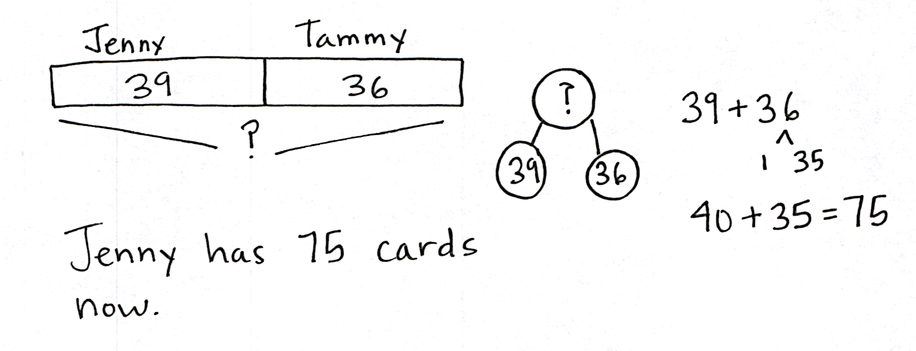
Jenny had 39 collectible cards in her collection. Tammy gave her 36 more. How many collectible cards does Jenny have now?
Note: This problem is designed to provide a real life context for the skills the students have learned in previous lessons. Invite students to solve this problem using number bonds or any other simplifying strategy they have learned. After solving the problem, have students share their strategies with a partner.
Fluency Practice (10 minutes)
- Making the Next Hundred 2.NBT.5, 2.NBT.7 (4 minutes)
- Making the Next Hundred to Add 2.NBT.5, 2.NBT.7 (6 minutes)
Making the Next Hundred (4 minutes)
Note: This fluency activity reviews foundations that lead into today’s lesson.
T: (Post 170 + ___ = 200 on the board.) Let’s find missing parts to make the next hundred. I say 170, you say 30. Ready? 170.
S: 30.
T: Give the number sentence.
S: 170 + 30 = 200.
Continue with the following possible sequence: 190, 160, 260, 270, 370, 380, 580, 620, 720, 740, 940, 194, 196, 216, 214, and 224.
Making the Next Hundred to Add (6 minutes)
Note: This fluency activity reviews foundations that lead into today’s lesson.
Post on board:

90 + 40 = _____
/\
10 30

90 + 10 = 100
100 + 30 = 130
T: When I say 9 tens + 4 tens, you say 10 tens + 3 tens. Ready?
9 tens + 4 tens.
S: 10 tens + 3 tens.
T: Answer in standard form?
S: 130.
T: 90 + 40.
S: 130.
Continue with the following possible sequence: 19 tens + 4 tens, 29 tens + 4 tens, 29 tens + 14 tens,
9 tens + 6 tens, 19 tens + 6 tens, 19 tens + 16 tens, 29 tens + 16 tens, 8 tens + 3 tens, 18 tens + 3 tens,
18 tens + 13 tens, 28 tens + 13 tens, 8 tens + 5 tens, 18 tens + 15 tens, and 28 tens + 15 tens.
Concept Development (34 minutes)
Materials: (S) Personal white board
Part 1: 17 + 13, 17 tens + 13 tens, 170 + 130, 170 + 40
T: What is 17 + 12?
S: 29.
T: What is 17 + 13?
S: 30.
T: That was fast! How did you know?
S: I added 1 more to 17 + 12. 13 is 1 more than 12, so the answer had to be 1 more than 29.
T: How many tens equal 17 tens plus 13 tens?
S: 30 tens.
T: What is the value of 30 tens?
S: 300.
T: What is 170 + 130?
S: 300.
T: What happened when we added those numbers? Turn and talk.
S: We made a new hundred, just like when we added 17 to 13 and made a new ten. We composed a new hundred. Instead of 30 ones, we have 30 tens. It’s just like 17 + 13 except that the place value is different.
T: What is 17 + 14? Write it on your personal white board, and turn it over, so I know when you’re ready.
T: (Wait until students are ready.) Show me!
S: (Show 31.)
NOTES ON
MULTIPLE MEANS
OF ACTION AND EXPRESSION:
For students working above grade level, ask for alternative addition and subtraction number sentences that would have the same total (e.g., 32 tens or 320). Include number sentences with three addends.
- ____ + ____ = 32 tens
- 32 tens - ____ = ____
- ____ + ____ + ____ = 320

T: How many tens equal 17 tens plus 14 tens?
S: 31 tens!
T: 170 + 140?
S: 310.
T: Talk with your partner. How did you know?
S: 17 tens plus 14 tens is just like 17 + 14, only in tens, so the answer is similar but in tens. 170 + 140 is 10 more than 170 + 130, so the answer has to be 10 more. Since 170 + 130 was 30 tens, I knew that 170 + 140 had to be 31 tens. It’s 1 more ten.
Extend to 17 tens + 15 tens, and continue until students are comfortable with the concept.
Part 2: Add multiples of 10 by making a hundred.
T: In the past, we’ve used number bonds to make the next ten. Let’s do it here, too, to make our adding easier when we have hundreds.
T: (Write 190 + 120 on the board.) Is one of these numbers close to the next hundred?
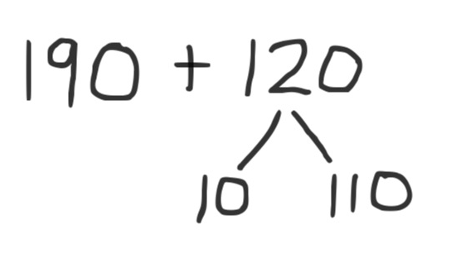
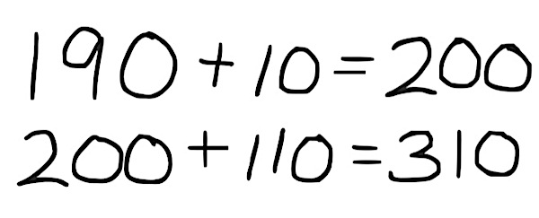
S: Yes!
T: Which one?
S: 190.
T: What is it close to?
S: 200.
T: How many more do we need to make 200?
S: 10 more!
T: Where can we get 10 more?
NOTES ON
MULTIPLE MEANS
OF REPRESENTATION:
For students who have trouble seeing that the two expressions, 190 + 120 and 200 + 110, are equivalent, show compensation using manipulatives, such as place value disks.

S: From the 120.
T: Great idea! Let’s break apart 120 into 110 and 10. Now, we can add the 10 from 120 to the 190. And we know that 190 plus 10 equals 200. (Show number bond on the board.)
T: What is our new addition problem? (Point to corresponding parts of the number bond.)
S: 200 + 110.
T: Talk with a partner. What does this equal?
S: 310. I did 200 + 100 and added 10, so 310. I remembered what we did with tens, so I thought of 20 + 11, which is 31, and 31 tens equals 310.
T: I heard someone say she remembered what she did with the tens. Great! When we have a zero in the ones place, we can think of it as tens.
T: How can we prove that 200 + 110 is the same as 190 + 120? Turn and talk.
S: I can add 100 to 190 and get 290, and then count 20 more by tens. So, that’s 300, 310. I can show both the arrow way, first adding hundreds, then tens. I just know that since 190 is 10 less than 200, the other part has to be 10 more than 110. Then, the total will be equal. I did it by using vertical form, and I got the same answer.
Have students solve the following problems on their personal white boards with a partner using number bonds: 190 + 160, 430 + 180, and 370 + 240.
Part 3: Add three-digit numbers by making a hundred.
T: So far, we’ve only been working with numbers that have zero in the ones place. Let’s try something different now. (Write 199 + 25 on the board.)
T: What hundred is close to 199?
S: 200.
T: How far away is it?
S: 1 away!
T: Let’s try decomposing 25 into 24 and 1. We can add the 1 from 25 to the 199. We know that 199 plus 1 equals 200. (Draw number bond.) What is our new addition problem?
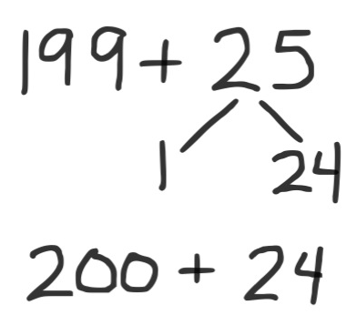
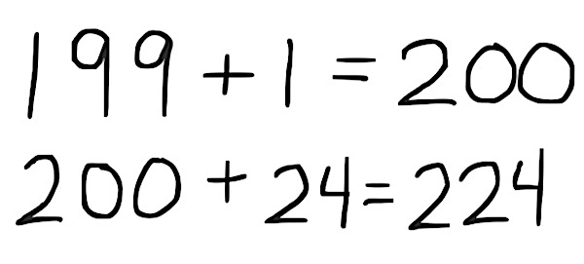
S: 200 + 24.
T: And, what is the total?
S: 224.
T: Let’s try another example. (Write 295 + 78 on the board.)
T: I see one number that is close to some hundreds. Which number is that?
S: 295.
T: How far away is it?
MP.7
S: 5 away!
T: Talk with a partner. How would you use a number bond to make a new, simpler number sentence?
S: I could make 295 into 300 and have 73 left over. I break 78 into 5 and 73, and then I give the 5 to 295, so 300 + 73. I get 300 and 73.
T: (After student conversation, choose a volunteer to show the number bond and new number sentence on the board.) What is 300 + 73?
S: 373.
T: Now, let’s try one that has hundreds in both addends. (Write 535 + 397 on the board.)
T: Which number is closer to the next hundred?
S: 397.
T: With a partner, write the number bond and new addition problem. Then, solve it.
S: I made 532 + 400, so 932. 397 is 3 away from 400, so I need to move 3 from the 535 to the 397. 400 + 532 = 932. Since I added 3 to 397, I had to take away 3 from 535. Now, it’s easy to add 4 hundreds onto 532.
Have students solve these problems on their personal white boards with a partner using number bonds:
299 + 22, 495 + 30, and 527 + 296. As they complete the problems, they may begin work on the Problem Set.
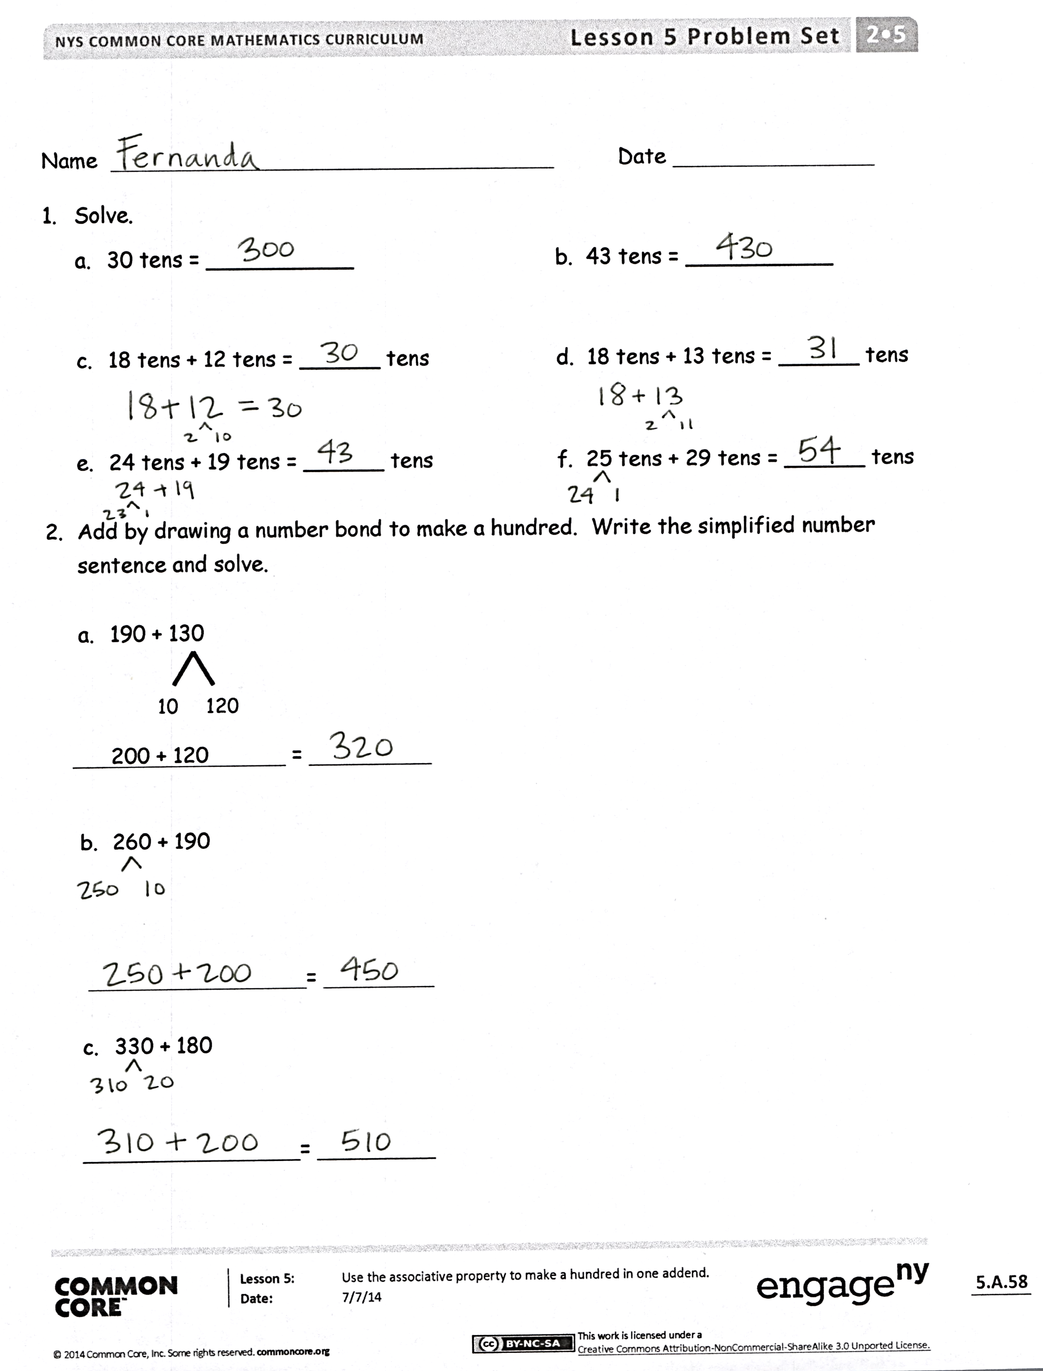
Problem Set (10 minutes)
Students should do their personal best to complete the Problem Set within the allotted 10 minutes. For some classes, it may be appropriate to modify the assignment by specifying which problems they work on first. Some problems do not specify a method for solving. Students should solve these problems using the RDW approach used for Application Problems.
Student Debrief (10 minutes)
Lesson Objective: Use the associative property to make a hundred in one addend.
The Student Debrief is intended to invite reflection and active processing of the total lesson experience.
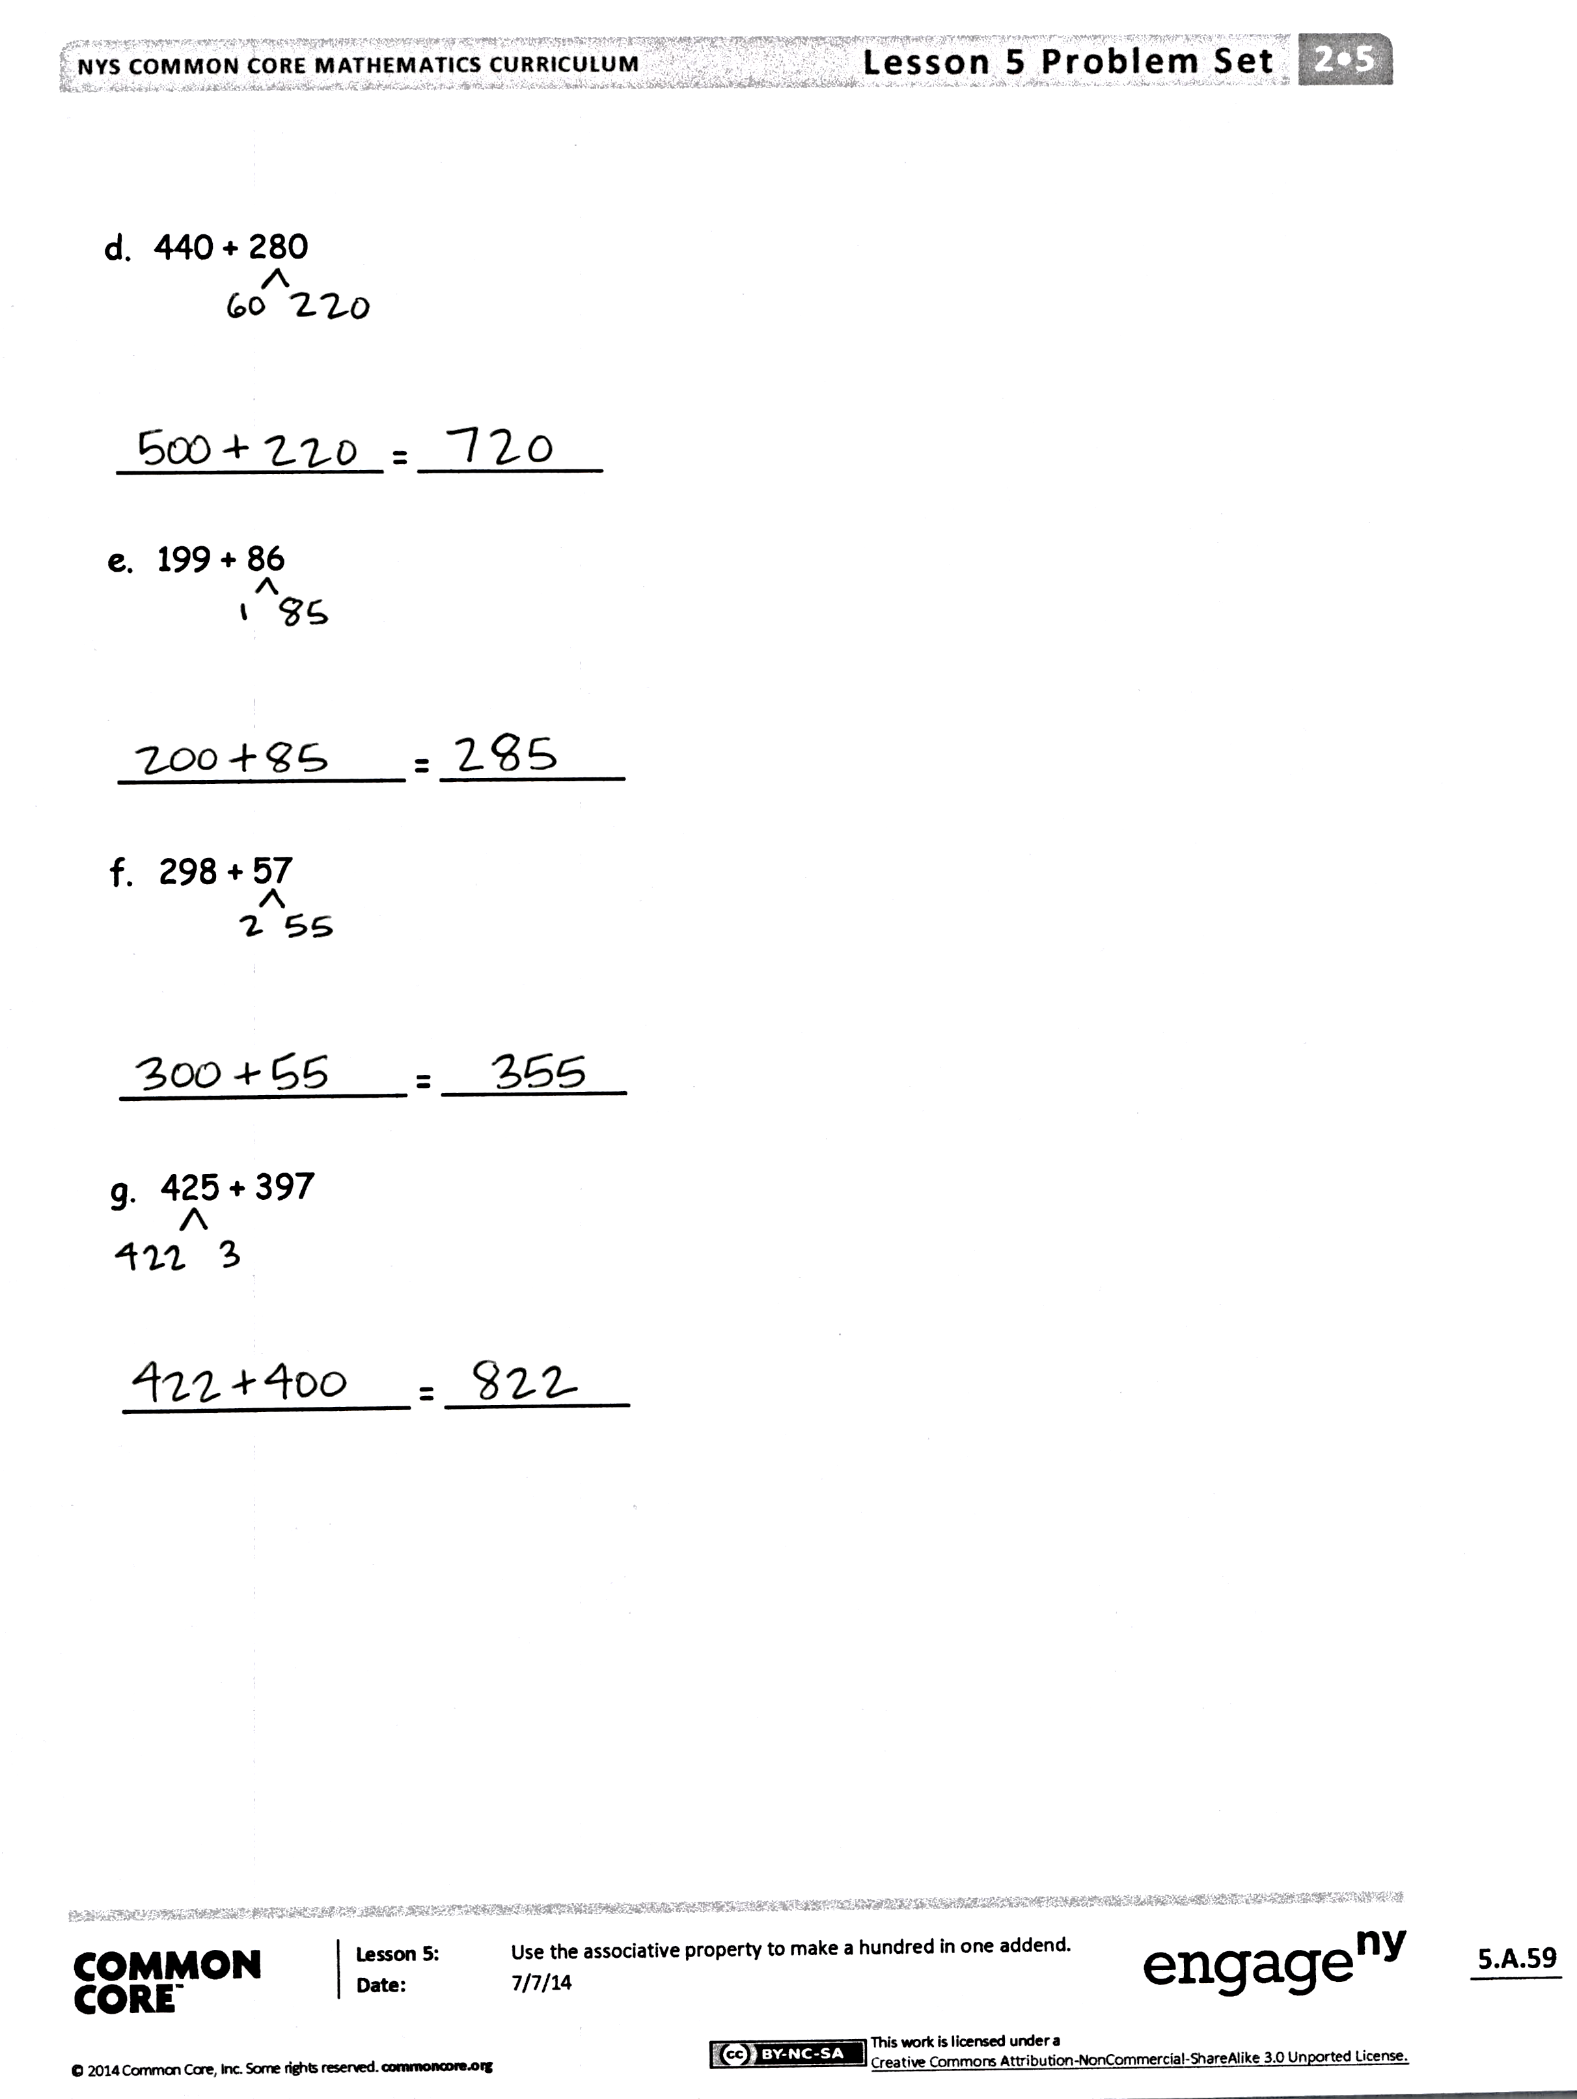
Invite students to review their solutions for the Problem Set. They should check work by comparing answers with a partner before going over answers as a class. Look for misconceptions or misunderstandings that can be addressed in the Debrief. Guide students in a conversation to debrief the Problem Set and process the lesson.
Any combination of the questions below may be used to lead the discussion.
- For Problem 1(c), 18 tens + 12 tens is the same as adding what two numbers? What is the value of 30 tens? How does (c) help you solve (d)?
- Share with a partner: How did you solve Problem 1(e)? How could you have used 1(e) to help you solve 1(f)? What would it look like to solve with a number bond? In Problem 2(b), 260 + 190, how did you use a number bond to make a new, simpler addition problem? Which number did you break apart, or decompose? Why?
- In Problem 2(c), 330 + 180, how did you extend your understanding of the make ten strategy? What do these strategies have in common? What is 330 + 180 the Say Ten Way?
- For Problem 2(e), 199 + 86, can you think of alternate strategies to solve? Do you think you could use disks and a place value chart? Why should we choose a number bond? Explain to your partner the steps you took to solve.
- What connections can you make between the number bond strategy and the arrow way? What is the goal of these strategies?
Exit Ticket (3 minutes)
After the Student Debrief, instruct students to complete the Exit Ticket. A review of their work will help with assessing students’ understanding of the concepts that were presented in today’s lesson and planning more effectively for future lessons. The questions may be read aloud to the students.

Name Date
- Solve.
  - 30 tens = ___________ b. 43 tens = ___________

- 18 tens + 12 tens = ______ tens d. 18 tens + 13 tens = ______ tens

e. 24 tens + 19 tens = ______ tens f. 25 tens + 29 tens = ______ tens

- Add by drawing a number bond to make a hundred. Write the simplified number sentence and solve.

  - 190 + 130
10
120

200 + 120 =

  - 260 + 190

=

  - 330 + 180

=

  - 440 + 280

_____________ = _________

  - 199 + 86

______________ = _________

  - 298 + 57

______________ = _________

  - 425 + 397

______________ = _________

Name Date
- Add by drawing a number bond to make a hundred. Write the simplified number sentence and solve.
  - 390 + 210

=

  - 798 + 57

=

- Solve.
53 tens + 38 tens = _______________

Name Date
- Solve.
  - 32 tens = _________ b. 52 tens = ________

- 19 tens + 11 tens = ______ tens d. 19 tens + 13 tens = ______ tens

- 28 tens + 23 tens = ______ tens f. 28 tens + 24 tens = ______ tens

- Add by drawing a number bond to make a hundred. Write the simplified number sentence and solve.

- 90 + 180
10
170

100 + 170 =

- 190 + 460

=

- 540 + 280

=

- 380 + 430

=

- 99 + 141

=

- 75 + 299

=

- 795 + 156

=

