Lesson 4
Objective: Subtract multiples of 100 and some tens within 1,000.

Suggested Lesson Structure
 Application Problem (5 minutes)
 Fluency Practice (11 minutes)
 Concept Development (34 minutes)
 Student Debrief (10 minutes)
Total Time (60 minutes)
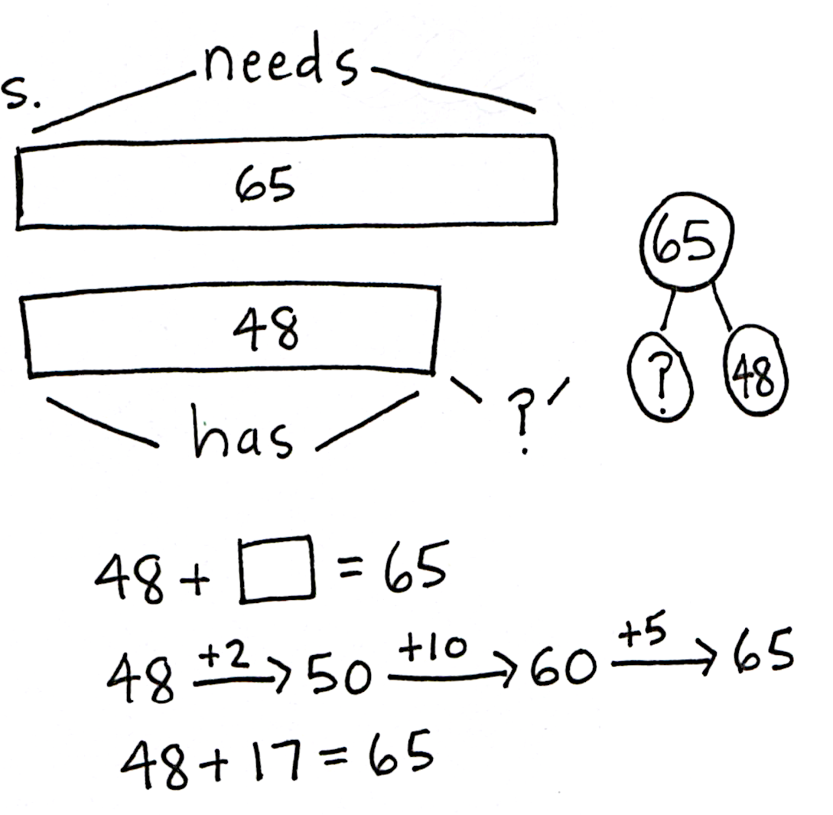
Application Problem (5 minutes)
Diane needs 65 craft sticks to make a gift box. She only has 48. How many more craft sticks does she need?
Note: Instruct students to approach this addend unknown problem using any simplifying strategy or even the vertical form. When students are finished, invite them to share their tape diagrams and solution strategies.
Fluency Practice (11 minutes)
- Subtracting Multiples of Hundreds and Tens 2.NBT.7 (2 minutes)
- Sprint: Subtracting Multiples of Ten and Some Ones 2.NBT.7 (9 minutes)
Subtracting Multiples of Hundreds and Tens (2 minutes)
Note: Students review fluently subtracting multiples of tens and hundreds in preparation for today’s lesson.
T: What is 2 tens less than 130?
S: 110.
T: Give the subtraction sentence.
S: 130 – 20 = 110.
T: What is 2 hundreds less than 350?
S: 150.
T: Give the subtraction sentence.
S: 350 – 200 = 150.
Continue with the following sequence: 6 tens less than 150, 3 hundreds less than 550, and 7 tens less than 250.
Sprint: Subtracting Multiples of Ten and Some Ones (9 minutes)
Materials: (S) Subtracting Multiples of Ten and Some Ones Sprint
Note: Students fluently subtract multiples of ten and some ones in preparation for today’s lesson.
Concept Development (34 minutes)
Materials: (S) Personal white board, unlabeled hundreds place value chart (Lesson 1 Template 2), place value disks (7 hundreds, 8 tens)
Problem 1: 570 – 100, 570 – 110
T: (While speaking, record using the arrow way.) 570 – 100 is...?
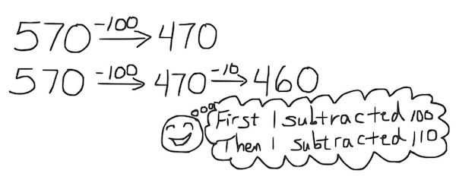
S: 470.
T: 570 – 100 (pause) – 10 is…?
S: 460.
T: How much did we take away in all?
S: 110.
T: Say the complete number sentence for our last problem.
S: 570 – 110 = 460.
T: Turn and talk to your partner about the steps in subtracting 110 from 570.
S: We first took away 1 hundred and then 1 ten. We made it into two steps: first taking away the hundred and then the ten, to make it easier.
Problem 2: 450 – 200, 450 – 210, 450 – 250, 450 – 260
T: Let’s try another. (Record as before.) 450 – 200 is...?
S: 250.
T: 450 – 200 (pause) – 10 is...?
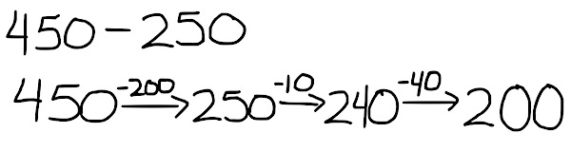
S: 240.
T: Subtract another 40. Now, we have…?
S: 200.
T: Talk with your partner. What just happened?
S: We started with 450. We took away 200 and then 10 to make 240. Then, we took away 40 more to get 200. We took away 250 in all, one chunk at a time.
T: What if I needed to solve 450 – 260? Could I use 450 – 250 to help me?
S: Yes. They are 10 apart, so it’s easy. Just subtract 10 more.
T: 450 – 250 – 10 is...?
S: 190
Problem 3: 780 – 300, 780 – 380, 780 – 390
NOTES ON
MULTIPLE MEANS
OF ENGAGEMENT:
As students show 780 – 390, scaffold questioning to guide connections between the place value disks and arrow notation:
- How many hundreds can you subtract first? Which digit changes? Which digits stay the same?
- How many tens do you want to subtract now from 480? Why 80 and not 90?
- Which hundred is closest to 390?
- How much have you subtracted so far? How much is left to subtract from 400?
- What happened to the digits when you subtracted from 400? Why?
- How did you break 390 into smaller parts?

T: Now, with your place value disks, show me 780 – 300.
S: (Remove 3 hundreds, showing 480 on their place value charts.)
T: (Draw 780 on the board. Cross out 3 hundreds to show 480.)
T: Yes! Now we have 480. How much do we need to take away from 780 to get 400? Turn and talk.
S: 80 more. 380 altogether. Take away 300, then take away 80 more, so 380.
T: I heard some people say we have to take 380 away. Start with 780, and take away 380 with your place value disks. Do you get 400?
S: Yes!
T: (Cross out 8 tens on the board.) I started by taking away 3 hundreds and then 8 tens. I got 400, too.
T: Now, I want to solve 780 – 390. What do I need to do to solve this? Turn and talk.
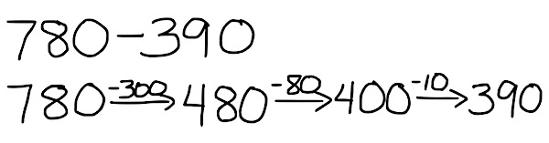
S: Start with 780 – 380, which is 400. Then, take away 10 more. Rename a hundred to make 10 tens, and take a ten away. Do one more step to get 10 less than 400, so 390.
T: I’m going to show this on the board while you do it with your place value disks. (Unbundle a hundred as shown at the right.)
NOTES ON
MULTIPLE MEANS
OF ACTION AND EXPRESSION:
Some students may struggle with understanding the sequence from
400 – 200 to 440 – 260:
- Express each number as tens
(e.g., 40 – 20, 44 – 20, 44 – 24,
44 – 26).
- Then, calculate using tens without including 44 tens – 26 tens
(e.g., “What is 44 tens – 24 tens?”).
- Restate the first three problems in standard form.
- Include an easier final question,
440 – 250, emphasizing its relationship to 440 – 240.

T: What is 780 – 390?
S: 390.
T: Now, let’s show this problem using the arrow way. (Draw on the board as shown above to the right.)
Problem 4: 400 – 200, 440 – 200, 440 – 240, 440 – 260
In this part, students record their answers on their personal white boards and then turn them over. When most students are ready, say, “Show me.” Students hold up their boards for a visual check. Then, they erase their boards and get ready for the next problem.
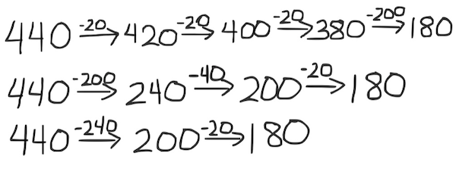
T: 400 – 200. Show me.
MP.7
S: (Show 200.)
T: 440 – 200. Show me.
S: (Show 240.)
T: 440 – 240. Show me.
S: (Show 200.)
T: 440 – 260? Talk with a partner.
MP.7
S: I used 440 – 240 and took away 20 more to get 180. I did 440 minus 200. Then, I took away 40 more to make 200, and then 20 more. I took 200 away, then 20 and 20 and 20.
T: Let’s see how we might draw that the arrow way. (Draw as shown at the top right.)
T: Now, try 620 – 430. Draw it the arrow way.
Check students’ work on their personal white boards, and invite several students to share their work on the board.
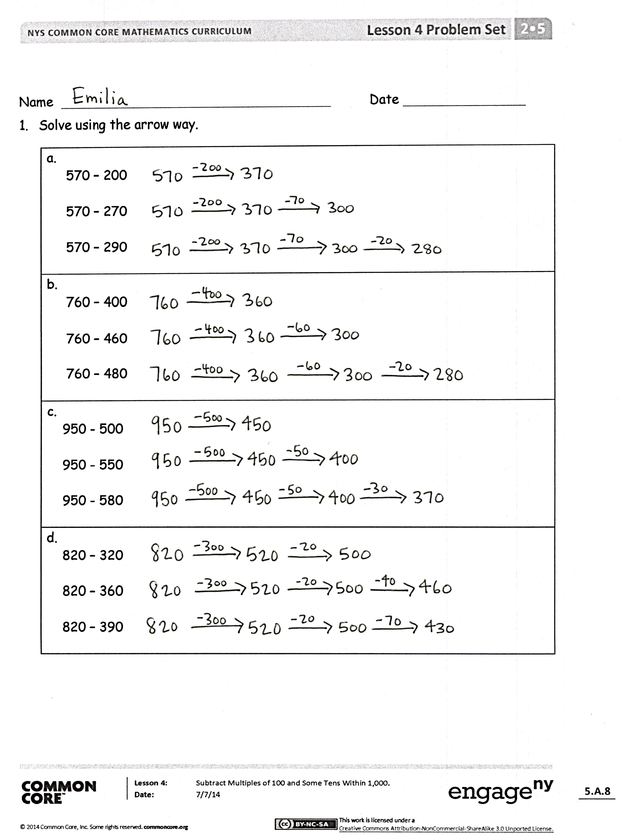
Problem Set (10 minutes)
Students should do their personal best to complete the Problem Set within the allotted 10 minutes. For some classes, it may be appropriate to modify the assignment by specifying which problems they work on first. Some problems do not specify a method for solving. Students should solve these problems using the RDW approach used for Application Problems.
Student Debrief (10 minutes)
Lesson Objective: Subtract multiples of 100 and some tens within 1,000.
The Student Debrief is intended to invite reflection and active processing of the total lesson experience.
Invite students to review their solutions for the Problem Set. They should check work by comparing answers with a partner before going over answers as a class. Look for misconceptions or misunderstandings that can be addressed in the Debrief. Guide students in a conversation to debrief the Problem Set and process the lesson.
Any combination of the questions below may be used to lead the discussion.
- For Problem 1(a), how does knowing 570 – 200 help you solve the other problems in that set?
- For Problem 1(b), what makes solving 760 – 480 more challenging? How did you use what you know about place value to subtract?
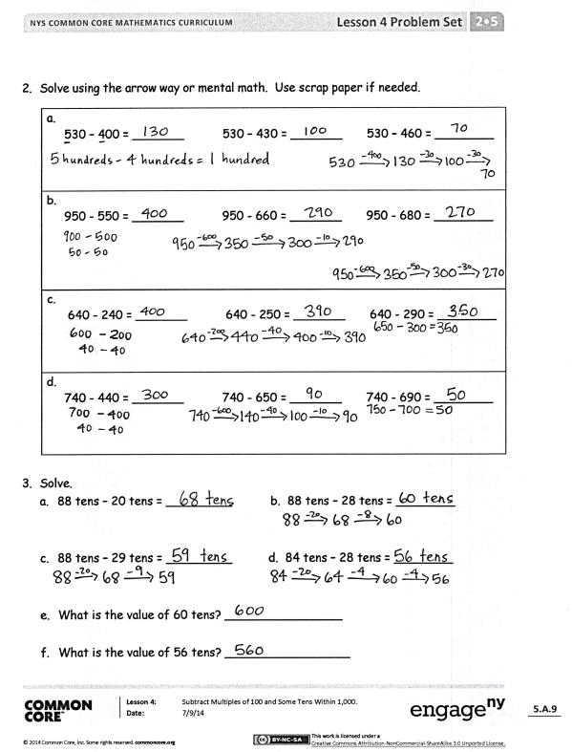
- Share with a partner: How did using the arrow way help you solve Problem 1(c), 950 – 580? What careful observations can you make about the numbers you subtracted? Why did you choose to subtract 50, then 30? Why didn’t you just subtract 80?
- Look carefully at the numbers in Problem 1(d). What pattern do you notice within the numbers you subtracted from 820? How did this affect the arrow way? Could you have solved these mentally?
- For Problem 2(d), 740 – 690, Terri solved the problem using an equal sign instead of arrows: 740 – 600 = 140 – 40 = 100 – 50 = 50. Is her answer correct? Is her equation correct? Why can’t she use an equal sign to show the change?
- How does using the arrow way help us when there are not enough tens from which to subtract (e.g., 740 – 650)? How did you decompose one part to subtract more easily?
Exit Ticket (3 minutes)
After the Student Debrief, instruct students to complete the Exit Ticket. A review of their work will help with assessing students’ understanding of the concepts that were presented in today’s lesson and planning more effectively for future lessons. The questions may be read aloud to the students.

Subtracting Multiples of Ten and Some Ones
Number Correct: _______
A
 | 33 – 22 = |  |  |  | 99 – 32 =
 | 44 – 33 = |  |  |  | 86 – 32 =
 | 55 – 44 = |  |  |  | 79 – 32 =
 | 99 – 88 = |  |  |  | 79 – 23 =
 | 33 – 11 = |  |  |  | 68 – 13 =
 | 44 – 22 = |  |  |  | 69 – 23 =
 | 55 – 33 = |  |  |  | 89 – 14 =
 | 88 – 22 = |  |  |  | 77 – 12 =
 | 66 – 22 = |  |  |  | 57 – 12 =
 | 43 – 11 = |  |  |  | 77 – 32 =
 | 34 – 11 = |  |  |  | 99 – 36 =
 | 45 – 11 = |  |  |  | 88 – 25 =
 | 46 – 12 = |  |  |  | 89 – 36 =
 | 55 – 12 = |  |  |  | 98 – 16 =
 | 54 – 12 = |  |  |  | 78 – 26 =
 | 55 – 21 = |  |  |  | 99 – 37 =
 | 64 – 21 = |  |  |  | 89 – 38 =
 | 63 – 21 = |  |  |  | 59 – 28 =
 | 45 – 21 = |  |  |  | 99 – 58 =
 | 34 – 12 = |  |  |  | 99 – 45 =
 | 43 – 21 = |  |  |  | 78 – 43 =
 | 54 – 32 = |  |  |  | 98 – 73 =

Subtracting Multiples of Ten and Some Ones
Number Correct: _______
Improvement: _______
B
[KEY]

 | 33 – 11 = |  |  |  | 99 – 42 =
 | 44 – 11 = |  |  |  | 79 – 32 =
 | 55 – 11 = |  |  |  | 89 – 52 =
 | 88 – 11 = |  |  |  | 99 – 23 =
 | 33 – 22 = |  |  |  | 79 – 13 =
 | 44 – 22 = |  |  |  | 79 – 23 =
 | 55 – 22 = |  |  |  | 99 – 14 =
 | 99 – 22 = |  |  |  | 87 – 12 =
 | 77 – 22 = |  |  |  | 77 – 12 =
 | 34 – 11 = |  |  |  | 87 – 32 =
 | 43 – 11 = |  |  |  | 99 – 36 =
 | 54 – 11 = |  |  |  | 78 – 25 =
 | 55 – 12 = |  |  |  | 79 – 36 =
 | 46 – 12 = |  |  |  | 88 – 16 =
 | 44 – 12 = |  |  |  | 88 – 26 =
 | 64 – 21 = |  |  |  | 89 – 37 =
 | 55 – 21 = |  |  |  | 99 – 38 =
 | 53 – 21 = |  |  |  | 69 – 28 =
 | 44 – 21 = |  |  |  | 89 – 58 =
 | 34 – 22 = |  |  |  | 99 – 45 =
 | 43 – 22 = |  |  |  | 68 – 43 =
 | 54 – 22 = |  |  |  | 98 – 72 =

Name Date
- Solve using the arrow way.
a.
570 − 200

570 − 270

570 − 290

b.
760 − 400

760 − 460

760 − 480

c.
950 − 500

950 − 550

950 − 580

d.
820 − 320

820 − 360

820 − 390

- Solve using the arrow way or mental math. Use scrap paper if needed.
a.
530 − 400 = _______ 530 − 430 = _______ 530 − 460 = ________

b.
950 − 550 = _______ 950 − 660 = _______ 950 − 680 = ________

c.
640 − 240 = _______ 640 − 250 = _______ 640 − 290 = ________

d.
740 − 440 = _______ 740 − 650 = _______ 740 − 690 = ________

- Solve.
  - 88 tens − 20 tens = _________ b. 88 tens − 28 tens = ________

- 88 tens − 29 tens = _________ d. 84 tens − 28 tens = ________

- What is the value of 60 tens? ________________

- What is the value of 56 tens? _________________

Name Date
- Solve using a simplifying strategy. Show your work if needed.
830 − 530 = _______ 830 − 750 = _______ 830 − 780 = ________

2. Solve.
  - 67 tens − 30 tens = _____ tens. The value is ______.
  - 67 tens − 37 tens = _____ tens. The value is ______.
  - 67 tens − 39 tens = _____ tens. The value is ______.

Name Date
- Solve using the arrow way.
a.
430 − 200

430 − 230

430 − 240

b.
570 − 300

570 − 370

570 − 390

c.
750 − 400

750 − 450

750 − 480

d.
940 − 330

940 − 360

940 − 480

- Solve using the arrow way or mental math. Use scrap paper if needed.
a.
330 − 200 = _______ 330 − 230 = _______ 330 − 260 = ________

b.
440 − 240 = _______ 440 − 260 = _______ 440 − 290 = ________

c.
860 − 560 = _______ 860 − 570 = _______ 860 − 590 = ________

d.
970 − 470 = _______ 970 − 480 = _______ 970 − 490 = ________

- Solve.
  - 66 tens − 30 tens = _________ b. 66 tens − 36 tens = ________

- 66 tens − 38 tens = _________ d. 67 tens − 39 tens = ________

- What is the value of 28 tens? _________________

- What is the value of 36 tens? _________________

