Lesson 3
Objective: Add multiples of 100 and some tens within 1,000.

Suggested Lesson Structure
 Application Problem (5 minutes)
 Fluency Practice (11 minutes)
 Concept Development (34 minutes)
 Student Debrief (10 minutes)
Total Time (60 minutes)
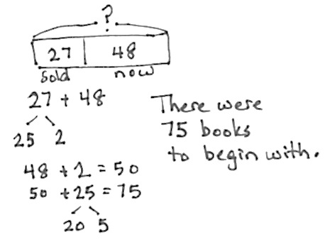
Application Problem (5 minutes)
A children’s library sold 27 donated books. Now, they have 48. How many books were there to begin with?
Note: This problem is a take from with start unknown. Because selling invites subtraction, the problem may prove to be a challenge for some students. The calculation itself involves using their place value strategies from Module 4, allowing them to choose between using the vertical form, a number bond, or the arrow way.
Fluency Practice (11 minutes)
- How Many More to Make 100? 2.NBT.7 (2 minutes)
- Sprint: Adding Multiples of Ten and Some Ones 2.NBT.7 (9 minutes)
How Many More to Make 100? (2 minutes)
Note: Students practice mentally making 100.
T: How many more ones does 8 need to make 10?
S: 2 ones.
T: Say the addition number sentence.
S: 8 + 2 = 10.
T: How many more tens does 8 tens need to make 10 tens?
S: 2 tens.
T: Say the addition number sentence starting with 8 tens.
S: 8 tens + 2 tens = 10 tens.
T: How much more does 80 need to make 100?
S: Twenty.
T: Say the addition sentence.
S: 80 + 20 = 100.
Continue with the following sequence: 16 + 4, 16 tens + 4 tens, 160 + 40, and 28 + 2, 28 tens + 2 tens,
280 + 20.)
Sprint: Adding Multiples of Ten and Some Ones (9 minutes)
Materials: (S) Adding Multiples of Ten and Some Ones Sprint
Note: Students review adding multiples of ten and some ones in preparation for today’s lesson.
Concept Development (34 minutes)
Materials: (S) Personal white board
Problem 1: 420 + 100, 420 + 110
T: (While speaking, record using the arrow way.) 420 + 100 is...?
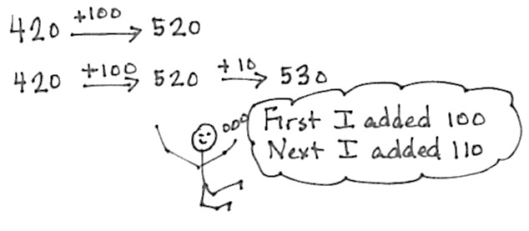
S: 520.
T: 420 + 100 (pause) + 10 is...?
S: 530.
T: How much did we add in all?
S: 110.
T: Say the complete number sentence for our last problem.
S: 420 + 110 = 530.
T: Turn and talk to your partner about the steps in adding 110 to 420.
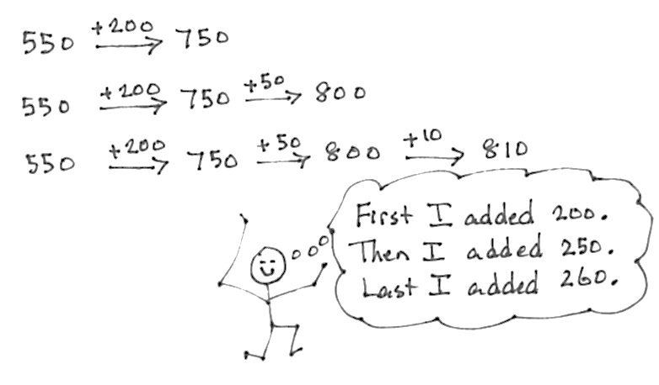
S: We first added 1 hundred, then 1 ten. We chopped 110 into two parts—a hundred and a ten. We added each one to make it easier.
Problem 2: 550 + 200, 550 + 250, 550 + 260
T: Let’s try another. (Record as before.)
550 + 200 is...?
S: 750.
T: 550 + 200 (pause) + 50 is...?
S: 800.
T: Add another 10. Now, we have…?
S: 810.
T: Talk with your partner. What just happened?
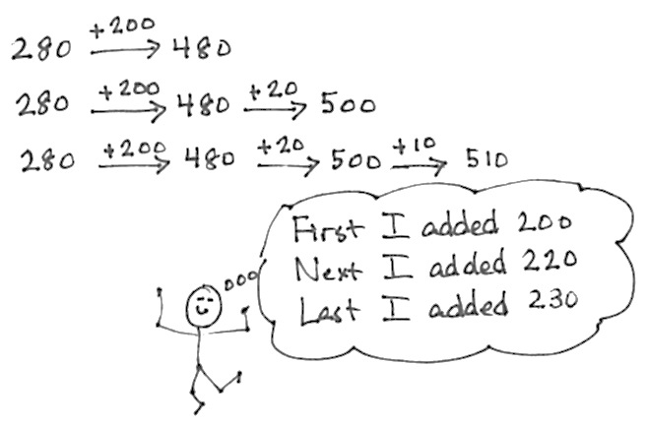
S: We started with 550. We added 200 and then added 50 to make 8 hundred. Then, we added 10 more to get 810. We added 260 in all, one chunk at a time.
Problem 3: 280 + 200, 280 + 220, 280 + 230
T: (Write 280 on the board.)
T: Add 200. Now, we have…?
S: 480.
T: How much more to get to the next hundred? Talk with a partner.
S: Two tens. Twenty.
T: Now, we have 500. Let’s show this the arrow way. Do what I do on your personal white board. (Draw as shown at the right.)

NOTES ON
MULTIPLE MEANS
OF REPRESENTATION:
For students who struggle to see the change in numbers using the arrow way, use smaller numbers (e.g., 180 + 130 = 310) and couple number sentences with models. Return to a concrete manipulative such as bundled straws to show that 18 tens + 10 tens = 28 tens, or 280. Then ask, “How can I compose a new hundred?” Have students model adding 2 more tens and showing the +20 change using the arrow way. Once they have crossed the hundred, adding the remaining ten is simple.

S: (Write.)
T: (Show the same on the board.) We just added 280 + 220. Let’s write this using the arrow way.
(Write on the board as shown at the right.)
T: First, we added 200 to 280, and then we added another 20 to compose the new hundred.
T: Now, let’s add another 10. Show me on your personal white board.
S: (Add another 10 on personal white board.)
T: What do we have?
S: 510.
T: This is the same as 280 + 230. First, we added 200, then composed a new hundred, and then we added 10 to get 510.
Problem 4: 470 + 200, 470 + 210, 470 + 230
Note: In this part, students record their answers on their personal white board and then turn them over. When most students are ready, say, “Show me.” Students hold up their board for a visual check. Then, they erase their board and get ready for the next problem.
T: 400 + 200. Show me.
S: (Show 600.)
T: 470 + 200. Show me.
S: (Show 670.)

T: 470 + 210? Talk with a partner first.
MP.6
NOTES ON
MULTIPLE MEANS
OF ACTION AND EXPRESSION:
Have students talk through their simplifying strategy (i.e., the arrow way) step-by-step to demonstrate their thinking. Before they solve and discuss, post questions such as those below:
- Which addend did you write first?
- Which did you add first, hundreds or tens? Why?
- How did you show making a new hundred: 3 tens plus 7 tens (e.g., 530 + 70) or 6 tens plus 4 tens (e.g., 860 + 40)?
- When you must cross a hundred, what is it helpful to do first?

S: I added 7 tens and 1 ten to make 8 tens, and then 4 hundreds and 2 hundreds to make 6 hundreds. That’s 680. I added 400 + 200 and then 70 + 10. 600 plus 80 equals 680. I used the arrow way and added 200 to 470, which is 670, and then added on 10 more, to make 680.
T: Show me.
S: (Show 680.)
T: 470 + 230?
S: That’s like the problem we did before!
T: Yes! We can find 470 + 230 using 470 + 210 to help us.
T: How much more do we need to get from 210 to 230?
S: 20 more.
T: What was 470 + 210?
S: 680.
T: 20 more? (Demonstrate as shown at the right.)
S: 700.
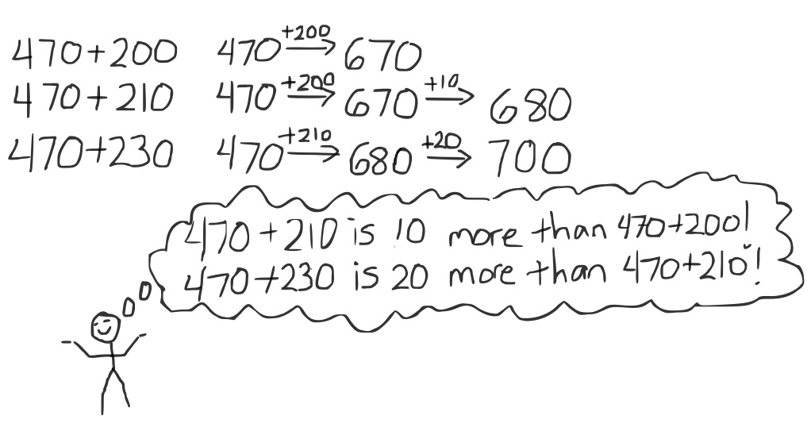
T: Now, try 470 + 250. Talk with your partner about how you solved it.
S: I did 400 + 200 and then did 70 + 30 to get another hundred, and then added the 20 more to get 720.
I added 470 and 200, then 30 more to get 700, and then added the leftover 20 to get 720. I added
470 + 230 like we did before, and then I just added the last 20.
Problem 5: 590 + 240
T: I notice something interesting about the first number. (Point to 590 on the board.) I wonder if anyone else notices the same thing.
S: It’s close to 600. It’s just 10 away from 600. I can make the next 100 to help me solve the problem.
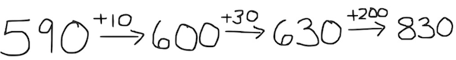
T: Let’s try it. You write what I write. (Record as shown below.)

T: How much do we have left in 240 after using 10?
S: 230.
Guide students through adding the hundreds and tens the arrow way, asking for their input as you go. When they have worked through this problem, invite them to complete the Problem Set.
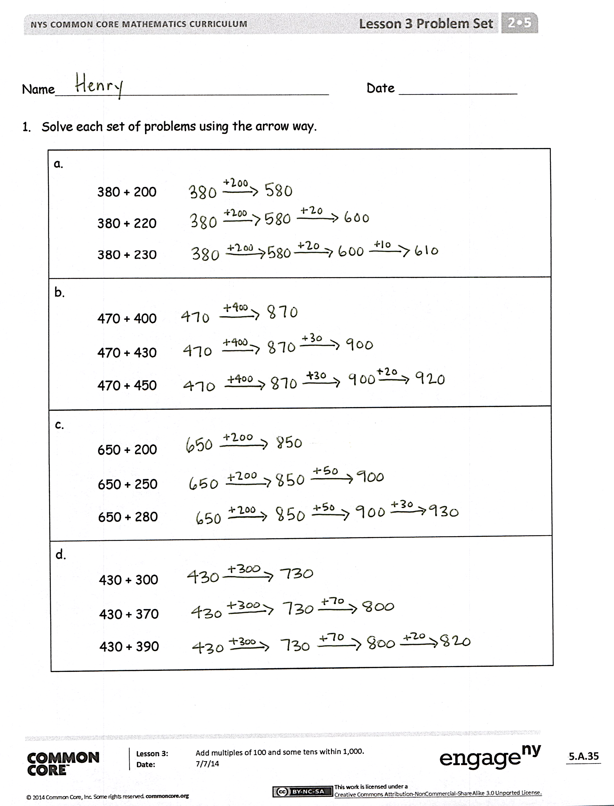
Problem Set (10 minutes)
Students should do their personal best to complete the Problem Set within the allotted 10 minutes. For some classes, it may be appropriate to modify the assignment by specifying which problems they work on first. Some problems do not specify a method for solving. Students should solve these problems using the RDW approach used for Application Problems.
Student Debrief (10 minutes)
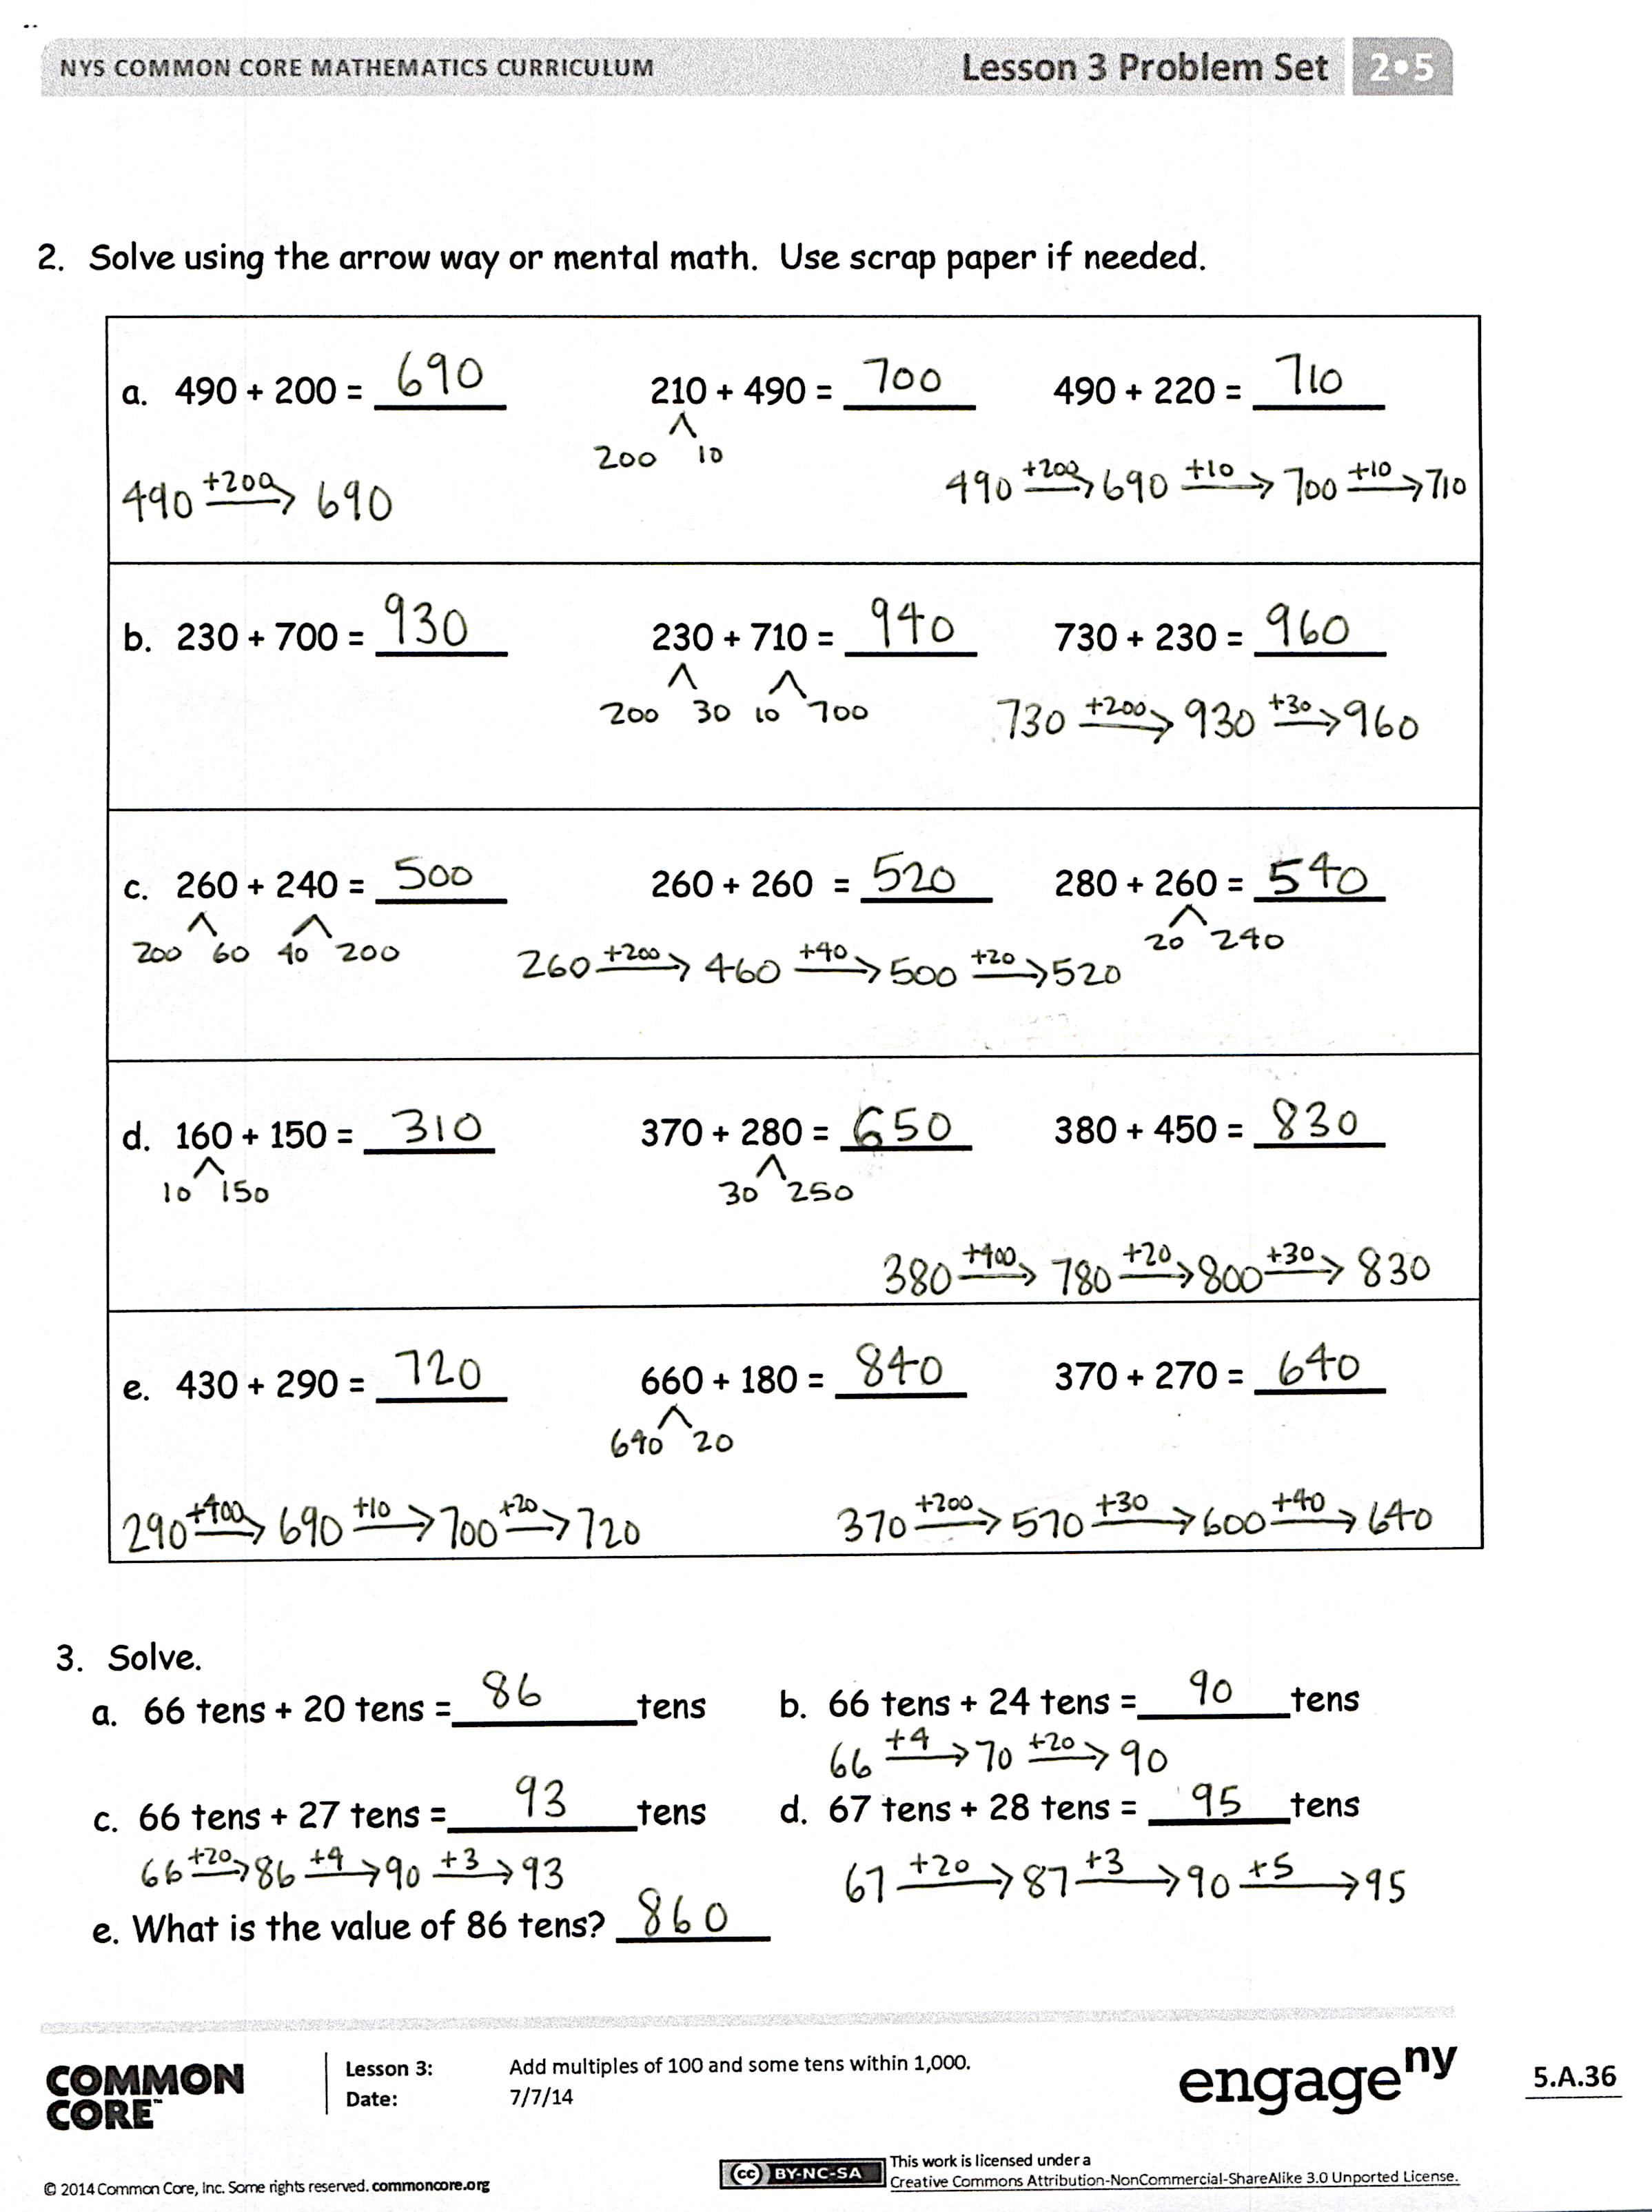
Lesson Objective: Add multiples of 100 and some tens within 1,000.
The Student Debrief is intended to invite reflection and active processing of the total lesson experience.
Invite students to review their solutions for the Problem Set. They should check work by comparing answers with a partner before going over answers as a class. Look for misconceptions or misunderstandings that can be addressed in the Debrief. Guide students in a conversation to debrief the Problem Set and process the lesson.
Any combination of the questions below may be used to lead the discussion.
- For Problem 1(b), how does knowing 470 + 400 help you solve the other problems in that set?
- In Problem 1, what do you notice about the second problem in each set?
- Share with a partner: How did you use the arrow way to solve Problem 1(c), 650 + 280? How did you decompose 280 to add?
- For Problems 2(a) and (b), how did the first problem in each set help you solve the next two?
- Share with a partner: For Problem 2(c), what was the most efficient way to add 280 + 260? Did you agree or disagree with your partner? Is there more than one way to solve?
- How is thinking about the make ten strategy helpful when composing a new hundred?
Exit Ticket (3 minutes)
After the Student Debrief, instruct students to complete the Exit Ticket. A review of their work will help with assessing students’ understanding of the concepts that were presented in today’s lesson and planning more effectively for future lessons. The questions may be read aloud to the students.

A
Number Correct: _______
Adding Multiples of Ten and Some Ones
 | 40 + 3 = |  |  |  | 45 + 44 =
 | 40 + 8 = |  |  |  | 44 + 45 =
 | 40 + 9 = |  |  |  | 30 + 20 =
 | 40 + 10 = |  |  |  | 34 + 20 =
 | 41 + 10 = |  |  |  | 34 + 21 =
 | 42 + 10 = |  |  |  | 34 + 25 =
 | 45 + 10 = |  |  |  | 34 + 52 =
 | 45 + 11 = |  |  |  | 50 + 30 =
 | 45 + 12 = |  |  |  | 56 + 30 =
 | 44 + 12 = |  |  |  | 56 + 31 =
 | 43 + 12 = |  |  |  | 56 + 32 =
 | 43 + 13 = |  |  |  | 32 + 56 =
 | 13 + 43 = |  |  |  | 23 + 56 =
 | 40 + 20 = |  |  |  | 24 + 75 =
 | 41 + 20 = |  |  |  | 16 + 73 =
 | 42 + 20 = |  |  |  | 34 + 54 =
 | 47 + 20 = |  |  |  | 62 + 37 =
 | 47 + 30 = |  |  |  | 45 + 34 =
 | 47 + 40 = |  |  |  | 27 + 61 =
 | 47 + 41 = |  |  |  | 16 + 72 =
 | 47 + 42 = |  |  |  | 36 + 42 =
 | 45 + 42 = |  |  |  | 32 + 54 =

Adding Multiples of Ten and Some Ones
B
[KEY]

Number Correct: _______
Improvement: _______
 | 50 + 3 = |  |  |  | 55 + 44 =
 | 50 + 8 = |  |  |  | 44 + 55 =
 | 50 + 9 = |  |  |  | 40 + 20 =
 | 50 + 10 = |  |  |  | 44 + 20 =
 | 51 + 10 = |  |  |  | 44 + 21 =
 | 52 + 10 = |  |  |  | 44 + 25 =
 | 55 + 10 = |  |  |  | 44 + 52 =
 | 55 + 11 = |  |  |  | 60 + 30 =
 | 55 + 12 = |  |  |  | 66 + 30 =
 | 54 + 12 = |  |  |  | 66 + 31 =
 | 53 + 12 = |  |  |  | 66 + 32 =
 | 53 + 13 = |  |  |  | 32 + 66 =
 | 13 + 43 = |  |  |  | 23 + 66 =
 | 50 + 20 = |  |  |  | 25 + 74 =
 | 51 + 20 = |  |  |  | 13 + 76 =
 | 52 + 20 = |  |  |  | 43 + 45 =
 | 57 + 20 = |  |  |  | 26 + 73 =
 | 57 + 30 = |  |  |  | 54 + 43 =
 | 57 + 40 = |  |  |  | 72 + 16 =
 | 57 + 41 = |  |  |  | 61 + 27 =
 | 57 + 42 = |  |  |  | 63 + 24 =
 | 55 + 42 = |  |  |  | 32 + 45 =

Name Date
- Solve each set of problems using the arrow way.

a.
380 + 200
380 + 220
380 + 230
b.
470 + 400
470 + 430
470 + 450
c.
650 + 200
650 + 250
650 + 280
d.
430 + 300
430 + 370
430 + 390

- Solve using the arrow way or mental math. Use scrap paper if needed.

a. | 490 + 200 = | 210 + 490 = _______ | 490 + 220 =
b. | 230 + 700 = | 230 + 710 = _______ | 730 + 230 =
c. | 260 + 240 = | 260 + 260 = _______ | 280 + 260 =
d. | 160 + 150 = | 370 + 280 = _______ | 380 + 450 =
e. | 430 + 290 = | 660 + 180 = _______ | 370 + 270 =

- Solve.
  - 66 tens + 20 tens = tens b. 66 tens + 24 tens = _tens

c. 66 tens + 27 tens = tens d. 67 tens + 28 tens = _tens
e. What is the value of 86 tens?
Name Date
Solve each set of problems using the arrow way.
1.
440 + 300
360 + 440

440 + 380

2.
670 + 230

680 + 240
250 + 660

Name Date
- Solve each set of problems using the arrow way.

a.
260 + 200
260 + 240
260 + 250
b.
320 + 400
320 + 480
320 + 490
c.
550 + 200
550 + 250
550 + 270
d.
230 + 400
230 + 470
230 + 490

- Solve using the arrow way or mental math. Use scrap paper if needed.

a. | 320 + 200 = _______ | 280 + 320 = ______ | 290 + 320 = _______
b. | 130 + 500 = ______ | 130 + 560 = ______ | 130 + 580 = _______
c. | 360 + 240 = ______ | 350 + 270 = ______ | 380 + 230 = ______
d. | 260 + 250 = ______ | 270 + 280 = _______ | 280 + 250 = ______
e. | 440 + 280 = ______ | 660 + 160 = ______ | 770 + 150 = _______

- Solve.
  - 34 tens + 20 tens = _______tens b. 34 tens + 26 tens = _______tens

c. 34 tens + 27 tens = _______tens d. 34 tens + 28 tens = _______tens
e. What is the value of 62 tens?

