Lesson 2

Objective: Add and subtract multiples of 100, including counting on to subtract.

Suggested Lesson Structure

 Application Problem (6 minutes)

 Fluency Practice (10 minutes)

 Concept Development (34 minutes)

 Student Debrief (10 minutes)

**Total Time (60 minutes)**

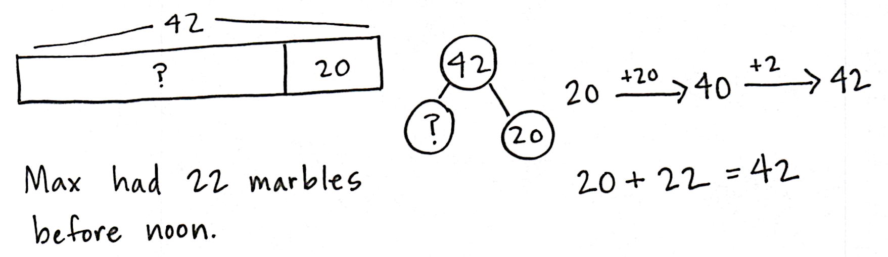Application Problem (6 minutes)

Max has 42 marbles in his marble bag after he added 20 marbles at noon. How many marbles did he have before noon?

Note: This problem gives students a chance to apply their new learning and to practice an *add to with start unknown* problem—as in Module 4. Many students will incorrectly say 62 marbles. Encourage them to represent the problem using a number bond if they are struggling. This way, they will see the part–whole relationship modeled differently.

Fluency Practice (10 minutes)

* Place Value **2.NBT.1, 2.NBT.7** (7 minutes)
* How Many More Hundreds?  **2.NBT.7** (3 minutes)

Place Value (7 minutes)

Materials: (T) Hundreds place value chart (Lesson 1 Template 1) (S) Personal white board, hundreds place value chart (Lesson 1 Template 1)

Note: Practicing place value skills prepares students for adding and subtracting multiples of 100 in today’s lesson.

T: (Project hundreds place value chart.) Show 1 hundred 5 tens 2 ones in chips on a place value chart. Write the number below it.

S: (Draw 1 hundred 5 tens 2 ones in chips on a place value chart.)

T: Say the number in unit form.

S: 1 hundred 5 tens 2 ones.

T: Say the number in unit form using only tens and ones.

S: 15 tens 2 ones.

T: Say the number in unit form using only hundreds and ones.

S: 1 hundred 52 ones.

T: Say the number in standard form.

S: 152.

T: Add 2 hundreds to your chart. How many hundreds do you have now?

S: 3 hundreds.

T: What is 200 more than 152?

S: 352.

T: Add 3 hundreds to 352. How many hundreds do you have now?

S: 6 hundreds.

T: What is 300 more than 352?

S: 652.

T: Now, subtract 4 hundreds from 652. What is 400 less than 652?

S: 252.

Continue with the following possible sequence: + 500, – 100, + 300, and – 900.

How Many More Hundreds? (3 minutes)

Note: Practice with subtracting multiples of 100 prepares students for today’s lesson.

T: If I say 300 – 200, you say 100. To say it in a sentence, you say, “100 more than 200 is 300.” Ready?

T: 300 – 200.

S: 100.

T: Say it in a sentence.

S: 100 more than 200 is 300.

Continue with the following possible sequence: 405 – 305, 801 – 601, 650 – 350, 825 – 125, and 999 – 299.

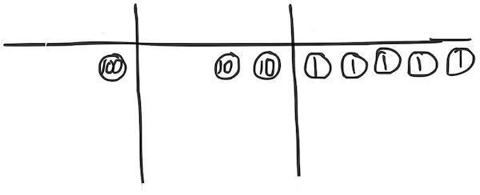Concept Development (34 minutes)

Materials: (T) Hide zero cards (Template) (S) Personal white board, 9 each of ones, tens, and hundreds disks

Draw a place value chart on the board. Show 125 using Hide Zero cards.

**1 0 0**

**2 0**

**5**

T: In Lesson 1 we added and subtracted 1 hundred. Today, let’s add 2 hundreds, then 3 hundreds, and more!

T: How many do you see?

S: 125.

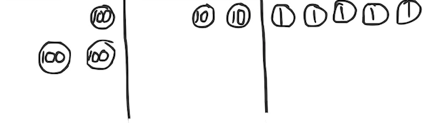T: (Separate the cards.) Say the number in unit form.

S: 1 hundred 2 tens 5 ones.

T: Show me this number with your place value disks.

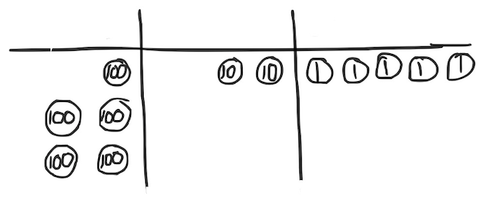S: (Show 1 hundred, 2 tens, and 5 ones on their charts.)

T: (Draw the labeled disks on the board. Change hundreds card to 300, and put cards together.) How much do you see?

S: 325.

T: How can you show this change using your place value disks?

|  |  |
| --- | --- |
|  | NOTES ON  MULTIPLE MEANS  OF ENGAGEMENT: |
| During the lesson, encourage a student who struggled with adding tens in Module 4 to explain the process of adding hundreds to the class. This will help the students solidify their understanding and build their confidence. Praise their use of place value language to explain their thinking. | |

S: Add 2 more hundreds.

T: Now, I am going to add 2 more hundreds. (Draw 2 more hundreds.) You do it, too. Turn and talk: What will happen to the number when I add 2 hundreds?

S: The number in the hundreds place will get bigger by 2. 🡪 The number will get bigger by 200. The ones and tens digits will stay the same. 🡪 It will be 525.

T: What is 325 + 200?

S: 525.

T: Say it in unit form.

S: 5 hundreds 2 tens 5 ones!

T: If I asked you to add 3 hundreds to 450, how could you solve that?

S: Count on by a hundred 3 times. 🡪 Change the 4 to 7 because 4 hundreds plus 3 hundreds is 7 hundreds. 🡪 Add 3 hundreds disks on the place value chart.

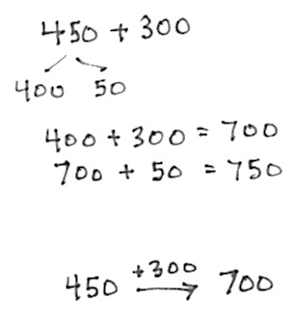

T: Let’s show that on the board using both simplifying strategies, the arrow way, and number bonds. I know many of you can just do mental math!

T: I can add 3 hundreds using the arrow way, as we did in the last lesson. (Demonstrate and involve the students as you write.) I can also break apart the hundreds and tens with a number bond, add the hundreds, and then add the tens. (Demonstrate and involve the students as you write.)

T: No matter which way I write it, when I add hundreds to a number, the tens and ones stay the same!

T: Now, it’s your turn. On your personal white board, solve 147 + 200. Show me your board when you have an answer.

Repeat this process, as needed, with the following possible sequence: 276 + 300, 382 + 400, and 400 + 516.

(Show 725 using Hide Zero cards, and draw disks on the place value chart on the board.)

T: Now, let’s subtract 2 hundreds, then 3 hundreds, and more!

T: How many do you see?

|  |  |
| --- | --- |
|  | NOTES ON  MULTIPLE MEANS  OF ACTION AND EXPRESSION: |
| Invite a student to be in charge of the place value chart while you work with the Hide Zero cards, or vice versa.  The number bond’s decomposition is one choice for solving the problem that may not work for some students as a solution strategy, but is beneficial for all to understand. Students should be encouraged to make connections between different solution strategies and to choose what works best for a given problem or for their way of thinking. | |

S: 725.

T: Say it in unit form.

S: 7 hundreds 2 tens 5 ones!

T: (Replace the 700 card with 500 and erase 2 hundreds from the chart.) How many do you see?

S: 5 hundreds 2 tens 5 ones.

T: I am going to subtract 2 more hundreds. Turn and talk: What will happen to the number when I subtract 2 hundreds?

S: The number in the hundreds place will get smaller by 2. 🡪 The number will get smaller by 200. 🡪 It will be 325 because 5 hundreds minus 2 hundreds equals 3 hundreds. The other digits stay the same.

**MP.8**

T: (Subtract 2 hundreds.) What is 525 ─ 200?

S: 325.

T: Say it in unit form.

S: 3 hundreds 2 tens 5 ones!

T: Okay, now let’s subtract 3 hundreds from 582. Take a moment and work on your personal white board to solve 582 – 300. (Show the work on the board as students work out this first problem using number bonds and the arrow way.)

T: (Model both the number bond and arrow method from their work.) We have an extra simplifying strategy when we are subtracting. We can count up from the part we know.

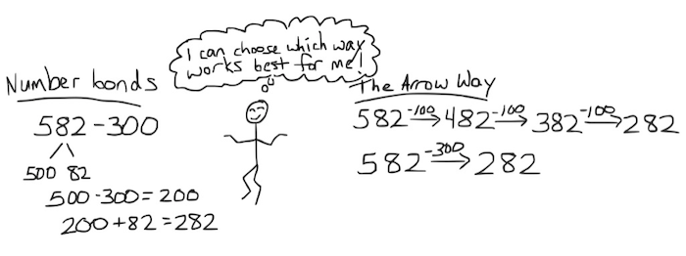T: What is the whole?

S: 582.

T: What is the part we know?

S: 300.

T: How can we show the missing part with an addition problem?

S: 300 + ___ = 582. 🡪 ___ + 300 = 582.

T: We can use the arrow way, counting first by either tens or ones. Try it with a partner.

Guide students through this, or let them work independently. Starting at 300, they might add 2 hundreds first, and then 82, or add 82 first, and then add 2 hundreds.

Repeat with 620 – 400, 541 – 200, and 797 – 300.

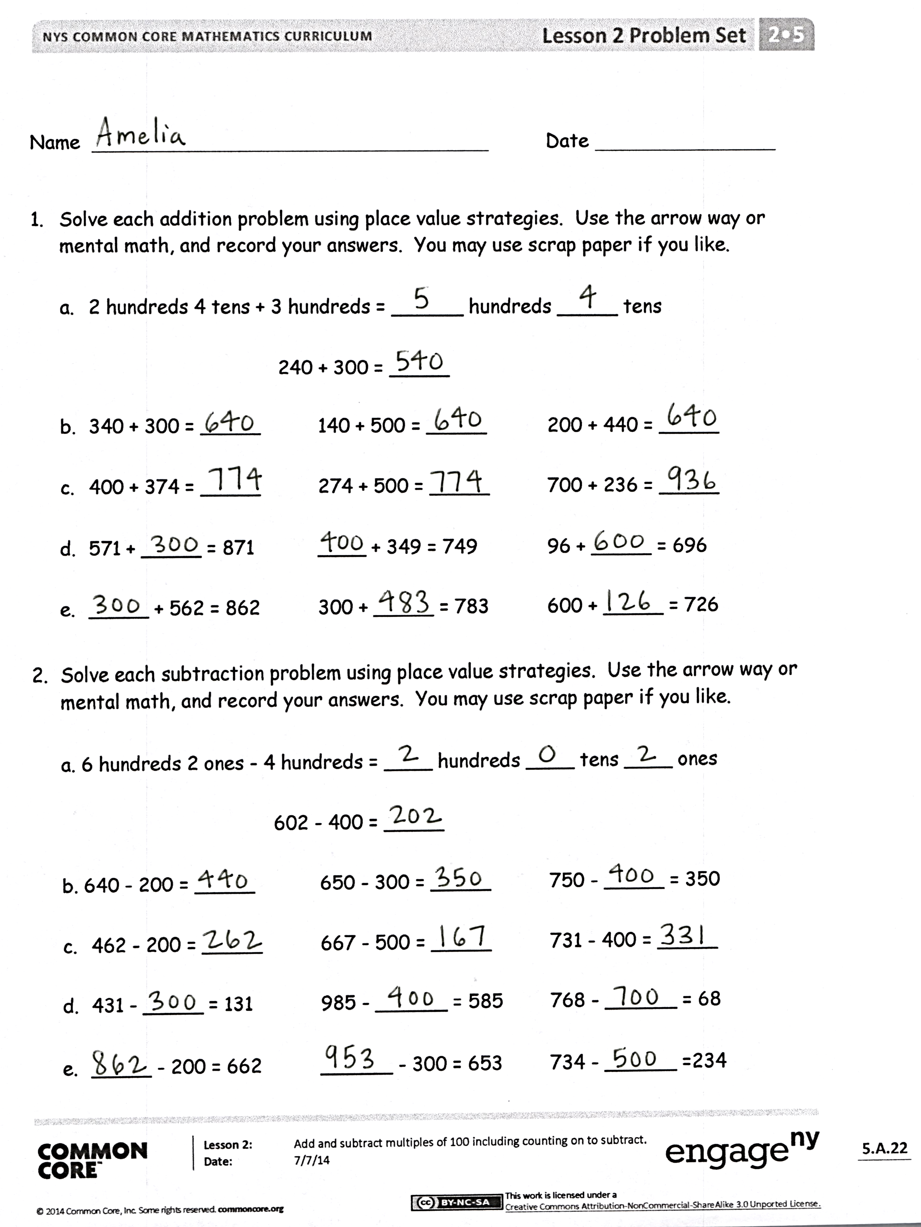Problem Set (10 minutes)

Students should do their personal best to complete the Problem Set within the allotted 10 minutes. For some classes, it may be appropriate to modify the assignment by specifying which problems they work on first. Some problems do not specify a method for solving. Students should solve these problems using the RDW approach used for Application Problems.

Student Debrief (10 minutes)

**Lesson Objective:** Add and subtract multiples of 100, including counting on to subtract.

The Student Debrief is intended to invite reflection and active processing of the total lesson experience.

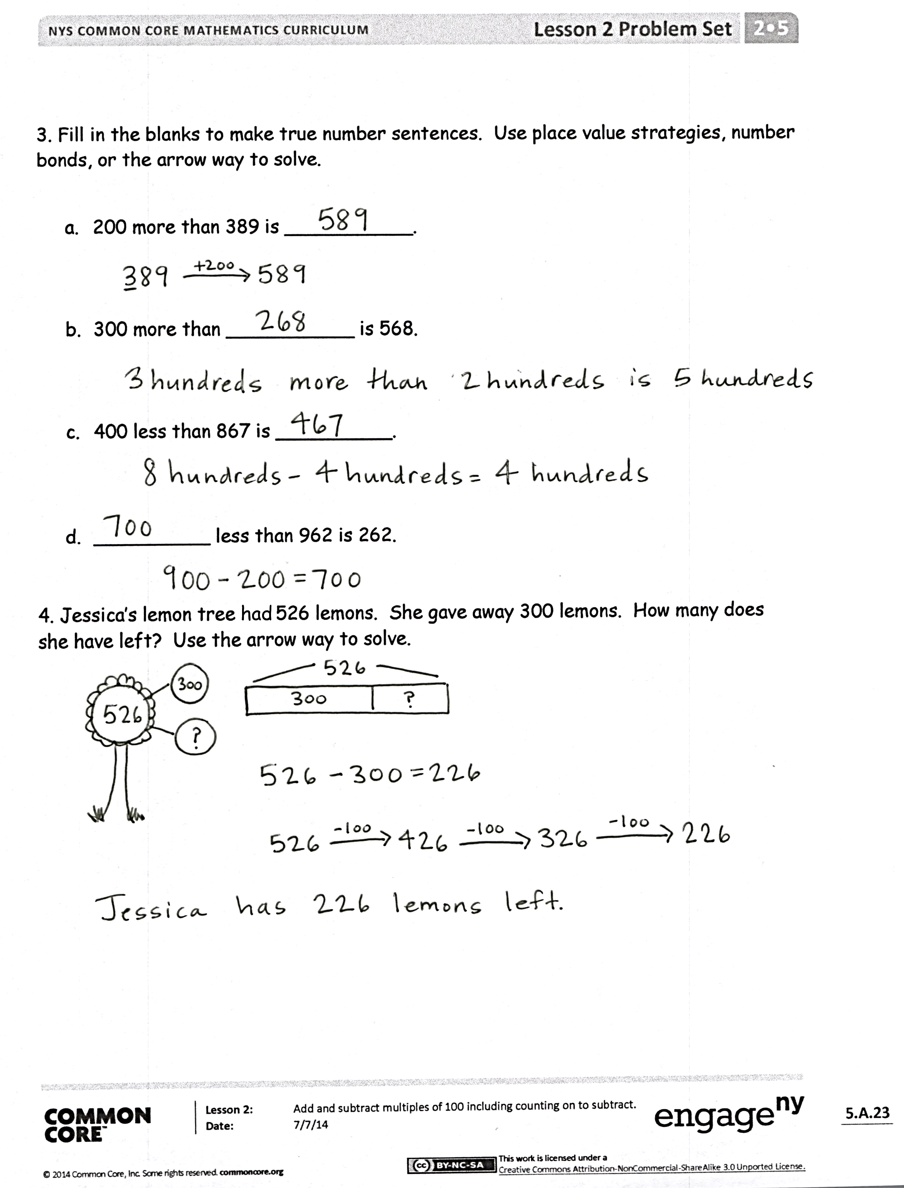Invite students to review their solutions for the Problem Set. They should check work by comparing answers with a partner before going over answers as a class. Look for misconceptions or misunderstandings that can be addressed in the Debrief. Guide students in a conversation to debrief the Problem Set and process the lesson.

Any combination of the questions below may be used to lead the discussion.

* In Problem 1(c), 400 + 374, what happened to 374 when you added 4 hundreds? What happened to the other digits?
* Which strategy did you use to solve the sequence in Problem 1(e)? Why is the arrow way a good choice when you have a missing part or addend?
* If you were using place value disks to show Problem 2(c), 667 – 500, what change would you make on your place value chart? What would stay the same?
* Explain to your partner how you solved the sequence in Problem 2(c). How could you show the missing part with an addition problem? How could you count on from the part you know?
* How was solving Problem 3(b) different from solving Problem 3(c)? Did you add hundreds in both situations? For each problem, did you find the part or whole?
* Explain to your partner which strategies you used to solve Problems 3(c) and (d). Did you use the same strategy for both problems? Can you think of another way to solve these problems?

Exit Ticket (3 minutes)

After the Student Debrief, instruct students to complete the Exit Ticket. A review of their work will help with assessing students’ understanding of the concepts that were presented in today’s lesson and planning more effectively for future lessons. The questions may be read aloud to the students.

Name Date

1. Solve each addition problem using place value strategies. Use the arrow way or mental math, and record your answers. You may use scrap paper if you like.
   1. 2 hundreds 4 tens + 3 hundreds = _____ hundreds _____ tens

240 + 300 = _____

* 1. 340 + 300 = _____ 140 + 500 = _____ 200 + 440 = _____
  2. 400 + 374 = _____ 274 + 500 = _____ 700 + 236 = _____
  3. 571 + _____ = 871 _____ + 349 = 749 96 + _____ = 696
  4. _____ + 562 = 862 300 + _____ = 783 600 + _____ = 726

1. Solve each subtraction problem using place value strategies. Use the arrow way or mental math, and record your answers. You may use scrap paper if you like.

a. 6 hundreds 2 ones − 4 hundreds = ____ hundreds ____ tens ____ ones

602 − 400 = _____

b. 640 − 200 = _____ 650 − 300 = _____ 750 − _____ = 350

1. 462 − 200 = _____ 667 − 500 = _____ 731 − 400 = _____
2. 431 − _____ = 131 985 − _____ = 585 768 − _____ = 68
3. _____ − 200 = 662 _____ − 300 = 653 734 − _____ =234

3. Fill in the blanks to make true number sentences. Use place value strategies, number bonds, or the arrow way to solve.

1. 200 more than 389 is ___________.
2. 300 more than ___________ is 568.
3. 400 less than 867 is __________.
4. __________ less than 962 is 262.

4. Jessica’s lemon tree had 526 lemons. She gave away 300 lemons. How many does she have left? Use the arrow way to solve.

Name Date

Solve using place value strategies. Use the arrow way or mental math, and record your answers. You may use scrap paper if you like.

* 1. 760 − 500 = _____ 880 − 600 = _____ 990 − _____ = 590
  2. 534 − 334 = _____ _____ − 500 = 356 736 − _____ = 136

Name Date

1. Solve each addition problem using place value strategies. Use the arrow way or mental math, and record your answers. You may use scrap paper if you like.
2. 4 hundreds 5 tens + 2 hundreds = ______ hundreds _____ tens

450 + 200 = _____

1. 220 + 300 = _____ 230 + 500 = _____ 200 + 440 = _____
2. 400 + 368 = _____ 386 + 500 = _____ 700 + 239 = _____
3. 119 + _____ = 519 _____ + 272 = 872 62 + _____ = 562
4. Solve each subtraction problem using place value strategies. Use the arrow way or mental math, and record your answers. You may use scrap paper if you like.
5. 5 hundreds 8 ones − 3 hundreds = ____ hundreds ____ tens ____ ones

508 − 300 = ____

1. 430 − 200 = _____ 550 − 300 = _____ 860 − _____ = 360
2. 628 − 200 = _____ 718 − 500 = _____ 836 − 400 = _____
3. 553 − _____ = 153 981 − _____ = 381 827 − _____ = 27
4. Fill in the blanks to make true number sentences. Use place value strategies, number bonds, or the arrow way to solve.
5. 300 more than 215 is ___________.
6. 300 more than ___________ is 668.
7. 500 less than 980 is __________.
8. __________ less than 987 is 487.
9. 600 ___________ than 871 is 271.
10. 400 ___________ than 444 is 844.

[1]

[2]

1. hide zero cards
2. hide zero cards