Lesson 1
Objective: Relate 10 more, 10 less, 100 more, and 100 less to addition and subtraction of 10 and 100.

Suggested Lesson Structure
 Fluency Practice (10 minutes)
 Application Problem (8 minutes)
 Concept Development (32 minutes)
 Student Debrief (10 minutes)
Total Time (60 minutes)
Fluency Practice (10 minutes)
- Place Value 2.NBT.1, 2.NBT.5 (6 minutes)
- More/Less 2.NBT.5 (4 minutes)
Place Value (6 minutes)
Materials: (T) Hundreds place value chart (Template 1) (S) Personal white board, hundreds place value chart (Template 1)
Note: Practicing place value skills prepares students for adding and subtracting 10 and 100 in today’s lesson.
T: (Project place value chart to the hundreds.) Show 6 ones in chips. Write the number below it.
S: (Draw 6 chips in the ones column, and write 6 below it.)
T: Show 1 chip in the tens column, and write the number below it.
S: (Draw 1 chip in the tens column, and write 1 at the bottom of the tens column.)
T: The Say Ten Way?
S: 1 ten 6.
T: Say the number in standard form.
S: 16.
T: Add 1 chip to your tens column. What is 10 more than 16?
S: 26.
T: The Say Ten Way?
S: 2 tens 6.
T: Now, add 1 chip to your hundreds column. What is 100 more than 26?
S: 126.
T: The Say Ten Way?
S: 1 hundred 2 tens 6.
T: Cross out a chip in the tens column. What is 10 less than 126?
S: 116.
T: The Say Ten Way?
S: 1 hundred 1 ten 6.
T: Cross out a chip in the hundreds column. What is 100 less than 116?
S: 16.
Continue with the following possible sequence: 254, 310, and 505.
More/Less (4 minutes)
Note: Giving 10 or 100 more or less prepares students to add and subtract 10 and 100 fluently.
T: For every number I say, you say a number that is 10 more. When I say 5, you say 15. Ready?
T: 5.
S: 15.
T: 10.
S: 20.
Continue with the following possible sequence: 19, 67, 90, 95, 110, 111, 139, 156, 256, 299, 305, and 319.
T: Now, for every number I say, you say a number that is 10 less. When I say 20, you say 10. Ready?
T: 20.
S: 10.
T: 22.
S: 12.
Continue with the following possible sequence: 19, 78, 100, 107, 182, 201, 299, 312, and 321.
T: For every number I say, you say a number that is 100 more. When I say 56, you say 156. Ready?
T: 56.
S: 156.
T: 37.
S: 137.
Continue with the following possible sequence: 80, 8, 88, 288, 300, 333, 566, and 900.
T: Now, for every number I say, you say a number that is 100 less. When I say 150, you say 50. Ready?
T: 150.
S: 50.
T: 159.
S: 59.
Continue with the following possible sequence: 168, 170, 270, 277, 400, 404, and 434.
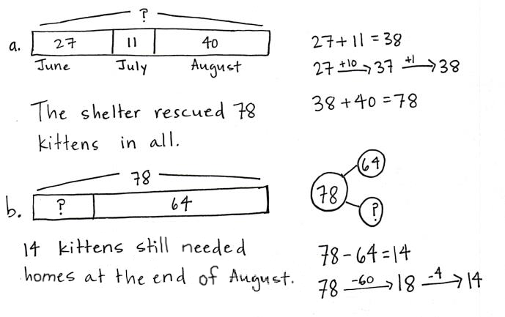
Application Problem (8 minutes)
The shelter rescued 27 kittens in June. In July, 11 kittens were rescued. In August, 40 more were rescued.
- How many kittens did the shelter rescue during those 3 months?
- If 64 of those kittens found homes by the end of August, how many still needed homes?
Note: This problem is designed to lead into the Concept Development for today’s lesson, relating 10 more and 10 less to addition and subtraction. Students complete this problem independently to provide insight into the kinds of mental strategies they currently use.
Review the RDW procedure for problem solving: Read the problem, draw and label, write a number sentence, and write a word sentence. The more students participate in reasoning through problems with a systematic approach, the more they internalize those behaviors and thought processes.
(Excerpted from “How to Implement A Story of Units.”)
Concept Development (32 minutes)
10 more than ___ is ___. 10 less than ___ is ___.
___ is 10 more than ___. ___ is 10 less than ___.
100 more than ___ is ___. 100 less than ___ is ___.
___ is 100 more than ___. ___ is 100 less than ___.
Materials: (T) Set of sentence frames as shown to the right (S) 7 hundreds disks, 9 tens disks, 9 ones disks, personal white board, unlabeled hundreds place value chart (Template 2)
Post more sentence frames on one side of the board and less frames on the other side. Pass out charts and place value disks.
NOTES ON
MULTIPLE MEANS
OF REPRESENTATION:
Use different models to demonstrate the change in 10 more, 10 less, 100 more, and 100 less.
- Use Hide Zero cards to show the changes in place value.
- Use concrete objects other than place value disks, such as bundled straws or base ten blocks, to show new groups of hundreds and new groups of tens.

T: Use your place value disks to show me 157 on your place value chart.
S: (Show 1 hundred 5 tens 7 ones.)
T: Show me 10 more.
S: (Add a tens disk to show 1 hundred 6 tens 7 ones.)
MP.8
MP.3
T: Use a sentence frame to describe adding 10 to 157.
S: 10 more than 157 is 167. 167 is 10 more than 157.
T: What did you do to change 157?
S: We added 10 to the tens place. We added 1 ten to 5 tens.
T: Give me an addition sentence starting with 157.
S: 157 + 10 = 167.
T: Start with 167.
S: 167 = 10 + 157. 167 = 157 + 10.
(Repeat the process for 10 less than 157.)
T: Show me 157 again. (Pause as students reset their place value charts.)
T: Show me 100 more than 157.
S: (Add a hundreds disk to show 2 hundreds 5 tens 7 ones.)
T: Use a sentence frame to describe adding 100 to 157.
NOTES ON
MULTIPLE MEANS
OF ACTION AND EXPRESSION:
Listen intently as students use place value language to talk with their partners. Use place value disks and place value charts to help students navigate the following vocabulary: place value, hundreds, tens, ones, digit, value, and unit. Add new vocabulary to the wall and point to words accompanied by a visual.

S: 257 is 100 more than 157. 100 more than 157 is 257.
MP.8
T: What did you do to change 157?
S: We added another hundred. We added 1 hundred to 1 hundred.
T: Be specific. Where did you add the hundred?
S: To the hundreds place.
T: Yes!
T: Give me an addition sentence starting with 157.
S: 157 + 100 = 257.
T: Start with 257.
S: 257 = 100 + 157. 257 = 157 + 100.
Repeat the process for 100 less than 157.
T: Talk with your partner. Use place value language to explain what you understand about 10 more, 10 less, 100 more, and 100 less. (Allow about one minute for discussion.)
S: We already knew about 10 more and 10 less, and now 100 acts the same. 10 less or 100 less is the same as taking away 10 or 100. We have to subtract and add the same units, so the tens place changes when we add or subtract 10. The same for the hundreds place.
T: (Collect the place value disks and place value charts.) Listen as I say a number pattern. Raise your hand when you know the more or less rule for my pattern.
T: For example, if I say, “121, 131, 141, 151, 161,” you say, “10 more.” Wait for my signal. Ready?
T: 135, 145, 155, 165, 175.
S: 10 more!
T: 282, 272, 262, 252, 242.
S: 10 less!
Continue until students can readily identify the rule.
T: Take out your personal white board. Now, I’ll write a series of numbers on the board. You write the rule and the next three numbers. The rules are + 10, ─ 10, + 100, and ─ 100.
T: Turn your personal white board over after you have written your answer. Wait until I say, “Show me.” Ready?
T: (Write 67, 57, 47, ___, ___, ___. Pause.) Show me.
S: (Show ─ 10 and 37, 27, 17.)
Continue to give students practice with each rule.
In this next activity, model arrow notation by recording the following sequence on the board step-by-step as students write each answer.
+100
-10
-10
-100
-100
542 $⟶$ ___ $⟶$ ___ $⟶$ ___ $⟶$ ___ $⟶$ ___.
+ 100
T: Let’s try something different. (Write 542 $⟶$ ___ on the board.) What is 542 + 100? Show me.
S: (Write 642.)
-10
T: Minus 10? (Continue to record the sequence by filling in 642 and writing $⟶$ ___.)
S: (Write 632.)
-10
T: Minus 10? (Fill in 632 and write $⟶$ ___.)
S: (Write 622.)
-100
T: Minus 100? (Fill in 622 and write $⟶$ ___.)
S: (Write 522.)
-100
T: Minus 100? (Fill in 522 and write $⟶$ ___.)
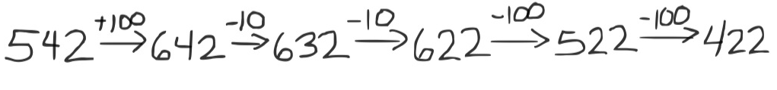
S: (Write 422.)
T: (Point to the completed sequence on the board.) In the last module, we used this simplifying strategy. We called it the arrow way. Talk to your partner about how this example is the same as and different from the ones we’ve done before.
S: Instead of ones and tens, this is tens and hundreds. It’s just different place values. Everything else is the same. It shows that you’re changing the ones or the tens place and whether it’s more or less.
If necessary or if time permits, model another example with the following problems:
367 – 220.
-10
-10
-100
-100
224 $⟶$ ___ $⟶$ ___ $⟶$ ___ $⟶$ ___.
Problem Set (10 minutes)
Students should do their personal best to complete the Problem Set within the allotted 10 minutes. Some problems do not specify a method for solving. This is an intentional reduction of scaffolding that invokes MP.5, Use Appropriate Tools Strategically. Students should solve these problems using the RDW approach used for Application Problems.
For some classes, it may be appropriate to modify the assignment by specifying which problems students should work on first. With this option, let the purposeful sequencing of the Problem Set guide the selections so that problems continue to be scaffolded. Balance word problems with other problem types to ensure a range of practice. Consider assigning incomplete problems for homework or at another time during the day.
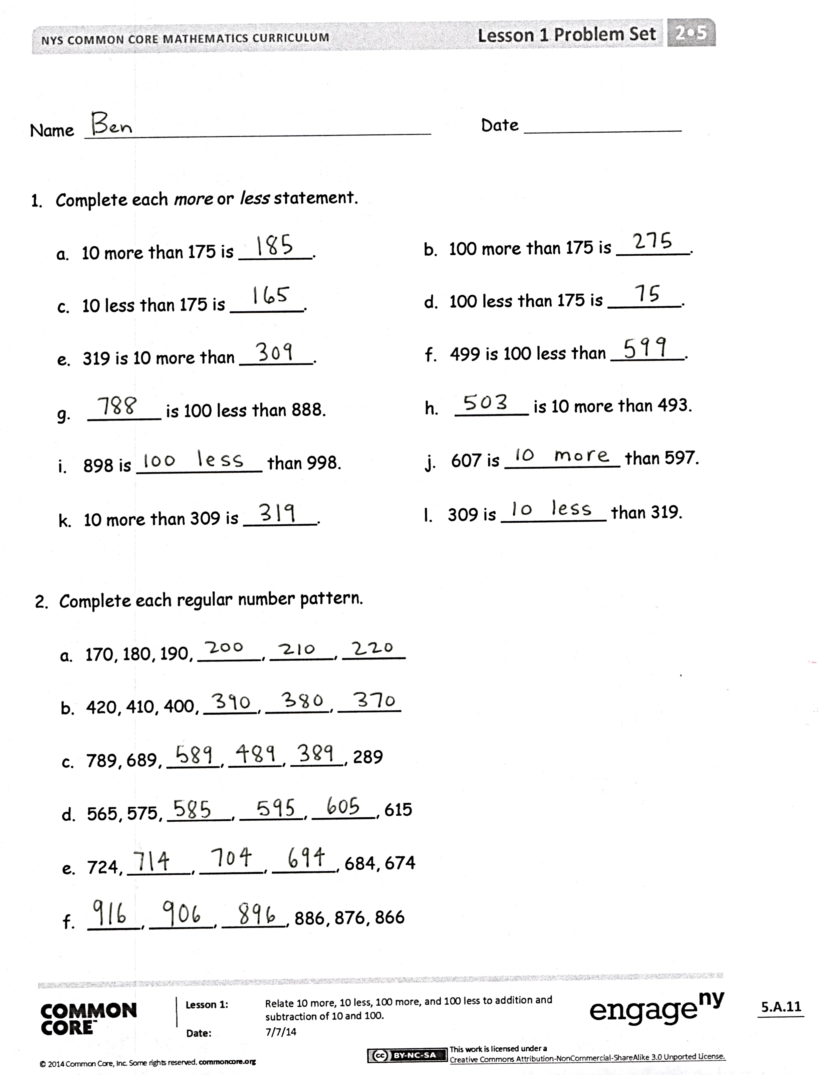
Student Debrief (10 minutes)
Lesson Objective: Relate 10 more, 10 less, 100 more, and 100 less to addition and subtraction of 10 and 100.
The Student Debrief is intended to invite reflection and active processing of the total lesson experience.
Invite students to review their solutions for the Problem Set. They should check work by comparing answers with a partner before going over answers as a class. Look for misconceptions or misunderstandings that can be addressed in the Debrief. Guide students in a conversation to debrief the Problem Set and process the lesson.
Any combination of the questions below may be used to lead the discussion.
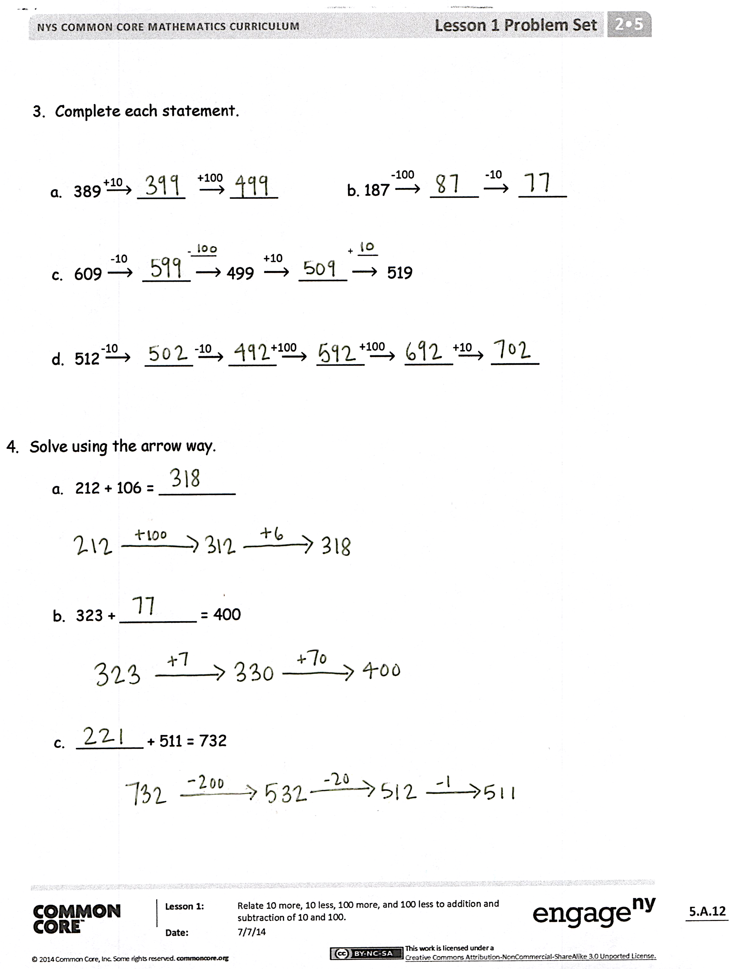
- What makes Problems 1(e) and (f) more challenging? In Problem 1(e), does 10 more mean we should add 10 to 319? Why not? In Problem 1(f), why did you add 100 to 499 when it says 100 less?
- What do you need to know to complete each pattern in Problem 2?
- In Problem 3(b), what total quantity did you subtract from 187? How can you write it as an equation?
- In Problem 4(b), what total quantity did you add to 323 to arrive at 400? How did you show the missing addend using the arrow way? How can we show it as an equation?
- Which simplifying strategy did we use today to record a sequence of numbers? How is it helpful?
- What important connection did we make today? What are we actually doing when we talk about 10 more, 10 less, 100 more, or 100 less than a number?

Exit Ticket (3 minutes)
After the Student Debrief, instruct students to complete the Exit Ticket. A review of their work will help with assessing students’ understanding of the concepts that were presented in today’s lesson and planning more effectively for future lessons. The questions may be read aloud to the students.

Name Date
- Complete each more or less statement.

- 10 more than 175 is _______. | - 100 more than 175 is _______.
- 10 less than 175 is _______. | - 100 less than 175 is _______.
- 319 is 10 more than _______. | - 499 is 100 less than _______.
- _______ is 100 less than 888. | - _______ is 10 more than 493.
- 898 is ____________ than 998. | - 607 is ___________ than 597.
- 10 more than 309 is _______. | - 309 is __________ than 319.
- Complete each regular number pattern.

- 170, 180, 190, ______, ______, ______
- 420, 410, 400, ______, ______, ______

- 789, 689, ______, ______, ______, 289

- 565, 575, ______, ______, ______, 615

- 724, ______, ______, ______, 684, 674

- ______, ______, ______, 886, 876, 866

- Complete each statement.

-10
-100
+100
+10
- 389 $⟶$ _____ $⟶$ _____ b. 187 $⟶$ _____ $⟶$ _____

+10
-10
+ ____
-_____

- 609 $⟶$ _____ $⟶$ 499 $⟶$ _____ $⟶$ 519

+10
+100
+100
-10
-10
- 512 $⟶$ _____ $⟶$ _____ $⟶$ _____ $⟶$ _____$⟶$ _____

- Solve using the arrow way.
- 212 + 106 = ________

- 323 + ________ = 400

- _______ + 511 = 732

Name Date
Solve using the arrow way.
- 448 + 206 = ___________
- 679 + __________ = 890
- _________ + 765 = 945

Name Date
- Complete each more or less statement.
- 10 more than 222 is _______. | - 100 more than 222 is _______.
- 10 less than 222 is _______. | - 100 less than 222 is _______.
- 515 is 10 more than _______. | - 299 is 100 less than _______.
- _______ is 100 less than 345. | - _______ is 10 more than 397.
- 898 is ____________ than 998. | - 607 is ___________ than 597.
- 10 more than 309 is _______. | - 309 is __________ than 319.
- Complete each regular number pattern.

- 280, 290, ______, ______, ______, 330
- 530, 520, 510, ______, ______, ______
- 643, 543, ______, ______, ______, 143

- 681, 691, ______, ______, ______, 731

- 427, ______, ______, ______, 387, 377

- ______, ______, ______, 788, 778, 768

- Complete each statement.

-100
-10
+100
+10
- 235 $⟶$ _____ $⟶$ _____ b. 391 $⟶$ _____ $⟶$ _____

-100
-10
-_____
417 $⟶$ _____ $⟶$ _____ $⟶$ 297

+10
+100
+100
-10
-10
- 311 $⟶$ _____ $⟶$ _____ $⟶$ _____ $⟶$ _____ $⟶$ _____

- Solve using the arrow way.
  - 376 + 103 = _________

  - 290 + ________ = 400

  - _______ + 712 = 852

hundreds
tens
ones

hundreds place value chart
unlabeled hundreds place value chart

