Lesson 33
Objective: Create story contexts for numerical expressions and tape diagrams, and solve word problems.

Suggested Lesson Structure
 Fluency Practice (12 minutes)
 Concept Development (38 minutes)
 Student Debrief (10 minutes)
Total Time (60 minutes)
Fluency Practice (12 minutes)
- Sprint: Divide Decimals 5.NBT.7 (8 minutes)
- Write Equivalent Expressions 5.OA.1 (4 minutes)
Sprint: Divide Decimals (8 minutes)
Materials: (S) Divide Decimals Sprint
Note: This fluency activity reviews Lessons 29–32.
Write Equivalent Expressions (4 minutes)
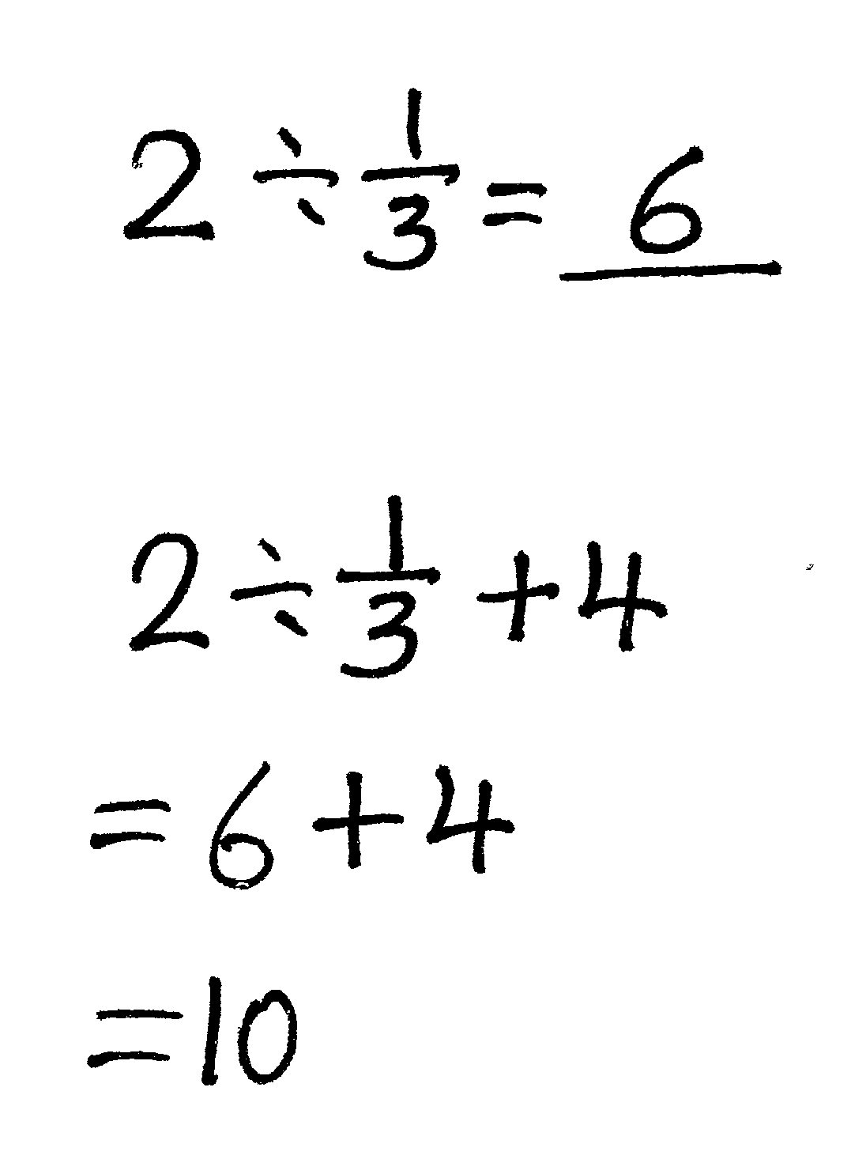
Materials: (S) Personal white board
Note: This fluency activity reviews Lesson 32.
T: (Write 2 ÷ $\frac{1}{3}$ = ____.) What is 2 ÷ $\frac{1}{3}$?
S: 6.
T: (Write 2 ÷ $\frac{1}{3}$ + 4.) On your personal white board, write the complete number sentence.
S: (Write 2 ÷ $\frac{1}{3}$ + 4. Beneath it, write = 6 + 4. Beneath it, write = 10.)
Continue with the following possible sequence: $\frac{5 \text{+} 3}{5}$, $\frac{1}{3}$ ÷ (2 + 2), (4 + 3) ÷ $\frac{1}{4}$, and ($\frac{2}{5}$ – $\frac{3}{10}$) ÷ 5.

Concept Development (38 minutes)
Materials: (S) Problem Set
Note: The time normally allotted for the Application Problem has been included in the Concept Development portion of today’s lesson to give students the time necessary to write story problems.
Suggested Delivery of Instruction for Solving Lesson 33 Word Problems
- Model the problem.
Have two pairs of student work at the board while the others work independently or in pairs at their seats. Review the following questions before beginning the first problem:

NOTES ON
MULTIPLE MEANS
OF ENGAGEMENT:
Consider selecting students who may have difficulty grasping the Problem Set to work at the board. Support them as they work, and praise their effort and perseverance. This approach can help improve classroom climate, where top students are usually selected to work at the board, and reinforce the notion that determination and persistence are key to learning math skills.

struggle to work at the board, being sure to support them as necessary but also praising their effort and perseverance as they work. This approach can help improve the classroom climate and reinforce the notion that math work is often more about determination and persistence than it is sheer math skill.
- Can you draw something?
- What can you draw?
- What conclusions can you make from your drawing?
As students work, circulate. Reiterate the questions above. After two minutes, have the two pairs of students share only their labeled diagrams. For about one minute, have the demonstrating students receive and respond to feedback and questions from their peers.
- Calculate to solve and write a statement.
Give everyone two minutes to finish work on that question, sharing their work and thinking with a peer. All should write their equations and statements of the answer.
- Assess the solution for reasonableness.
Give students one to two minutes to assess and explain the reasonableness of their solution.
Problem 1
Ms. Hayes has $\frac{1}{2}$ liter of juice. She distributes it equally to 6 students in her tutoring group.
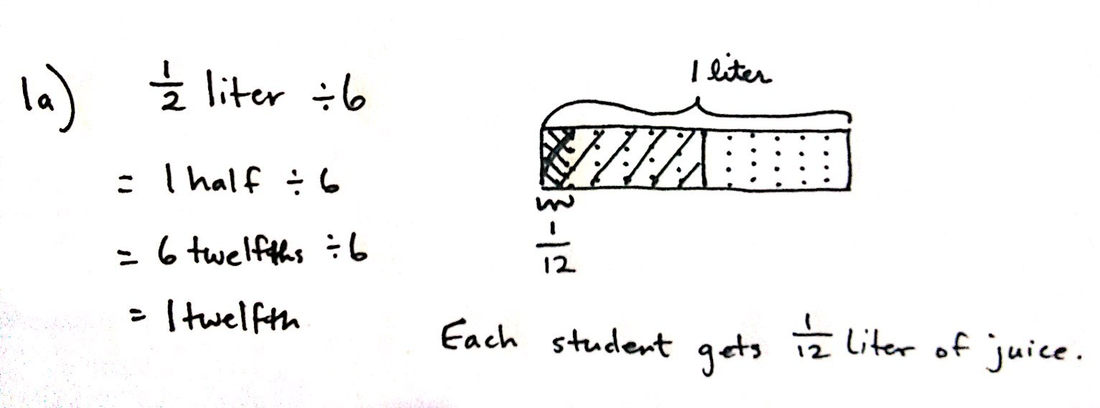
  - How many liters of juice does each student get?

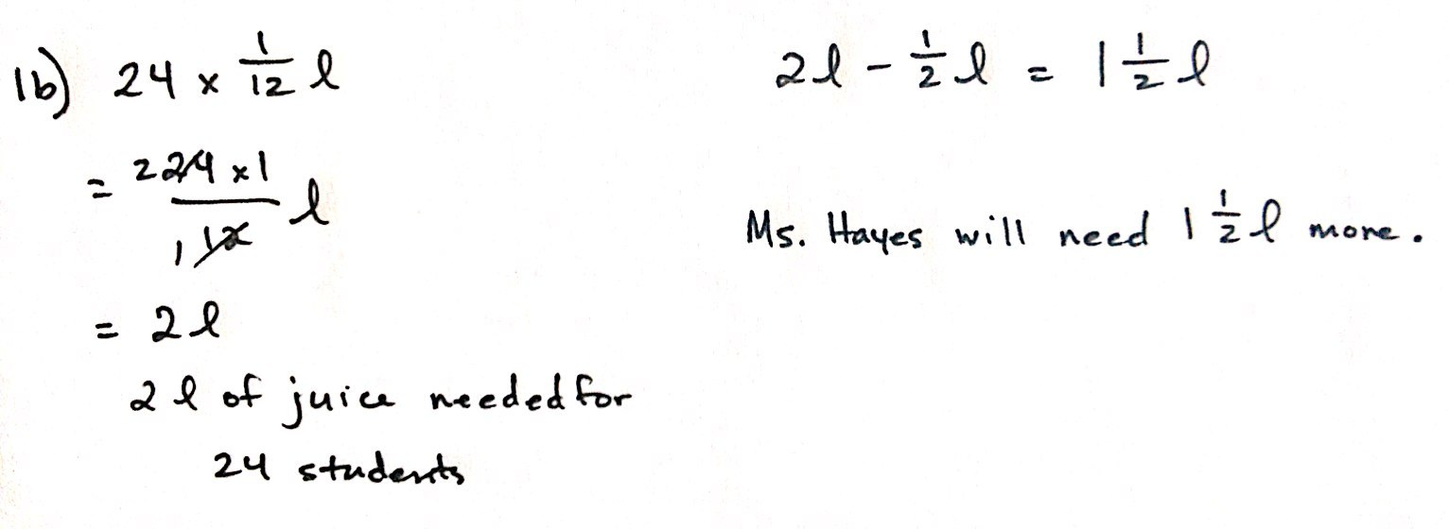
  - How many more liters of juice will Ms. Hayes need if she wants to give each of the 24 students in her class the same amount of juice found in Part (a)?

In this problem, Ms. Hayes is sharing equally, or dividing, one-half liter of juice among 6 students. Students should recognize this problem as $\frac{1}{2}\text{÷}$ 6. A tape diagram shows that when halves are partitioned into 6 equal parts, twelfths are created. Likewise, the diagram shows that 1 half is equal to 6 twelfths, and when written in unit form, 6 twelfths divided by 6 is a simple problem. Each student receives one-twelfth liter of juice. In Part (b), students must find how much more juice is necessary to give a total of 24 students $\frac{1}{12}$ liter of juice. Some students may choose to solve by multiplying 24 by one-twelfth to find that a total of 2 liters of juice is necessary. Encourage interpretation as a scaling problem. Help students see that, since 24 students is 4 times more students than 6 students, Ms. Hayes will need 4 times more juice as well. 4 times one-half is, again, equal to 2 liters of juice. Either way, Ms. Hayes will need $\text{1}\frac{1}{2}$ more liters of juice.
Problem 2
Lucia has 3.5 hours left in her workday as a car mechanic. Lucia needs $\frac{1}{2}$ of an hour to complete one oil change.
- How many oil changes can Lucia complete during the rest of her workday?
- Lucia can complete two car inspections in the same amount of time it takes her to complete one oil change. How long does it take her to complete one car inspection?
- How many inspections can she complete in the rest of her workday?
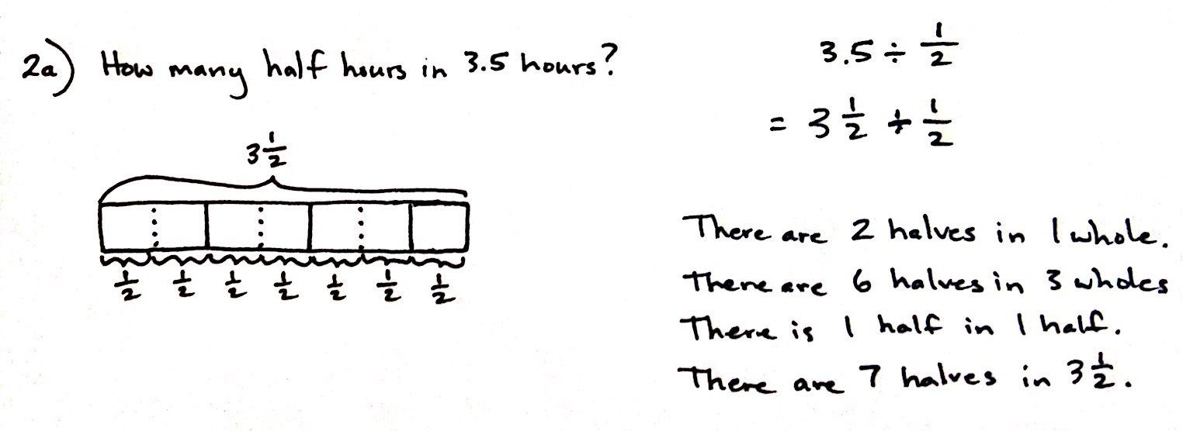
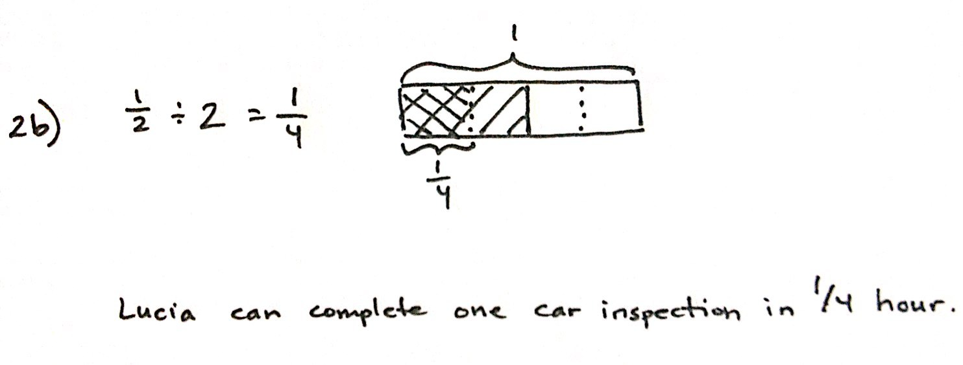
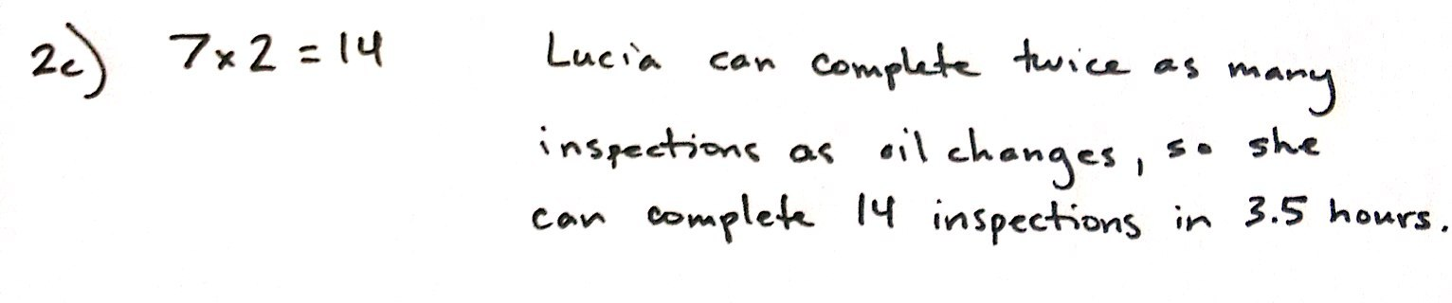
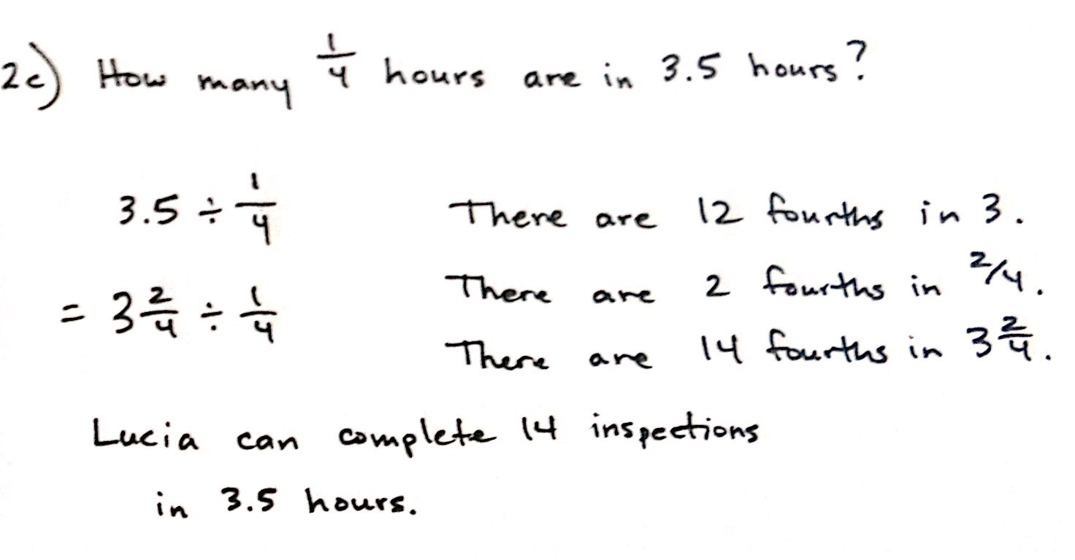
In Part (a), students are asked to find how many half-hours are in a 3.5-hour period. The presence of both decimal and fraction notation in these problems adds a layer of complexity. Students should be comfortable choosing which form of fractional number is most efficient for solving. This will vary by problem and, in many cases, by student. In this problem, many students may prefer to deal with 3.5 as a mixed number ($\text{3}\frac{1}{2}$). Then, a tape diagram clearly shows that $\text{3}\frac{1}{2}$ can be partitioned into 7 units of $\frac{1}{2}$. Others may prefer to express the half hour as 0.5. Still, others may begin their thinking with, “How many halves are in 1 whole?” and continue with similar prompts to find how many halves are in 3 wholes and 1 half.
In Part (b), students reason that since Lucia can complete 2 inspections in the time it takes her to complete just one oil change, $\frac{1}{2}$ may be divided by 2 to find the fraction of an hour that an inspection requires. Students may also reason that there are two 15-minute units in one half-hour period, and therefore, Lucia can complete an inspection in $\frac{1}{4}$ hour.

NOTES ON
MULTIPLE MEANS
OF ENGAGEMENT:
Challenge high-achieving students (who may also be early finishers) to solve the problems more than one way. After looking at their work, challenge them by specifying the operation they must use to begin, or change the path of their approach by requiring a certain operation within their solution.
Challenge them further by asking them to use the same general context, but to write a different question that results in the same answer as that obtained for the original problem.
In Part (c), a variety of approaches are also possible. Some may argue that, since Lucia can work twice as fast completing inspections, they need only to double the number of oil changes she could complete in 3.5 hours to find the number of inspections done. This type of thinking is evidence of a deeper understanding of a scaling principle. Other students may solve Part (c), just as they did Part (a), but using a divisor of $\frac{1}{4}.$ In either case, Lucia can complete 14 inspections in 3.5 hours.
MP.7

Problem 3
Carlo buys $14.40 worth of grapefruit. Each grapefruit costs $0.80.
- How many grapefruits does Carlo buy?
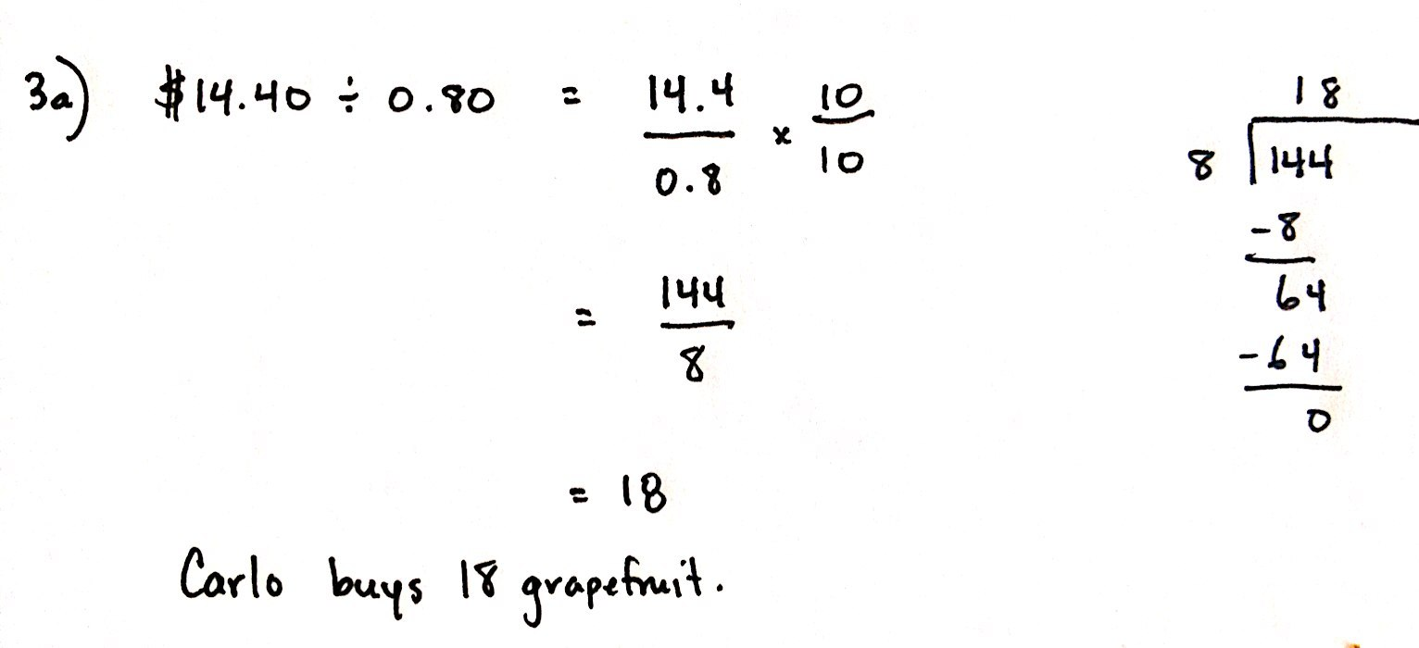
- At the same store, Kahri spends one-third as much money on grapefruit as Carlo. How many grapefruits does she buy?
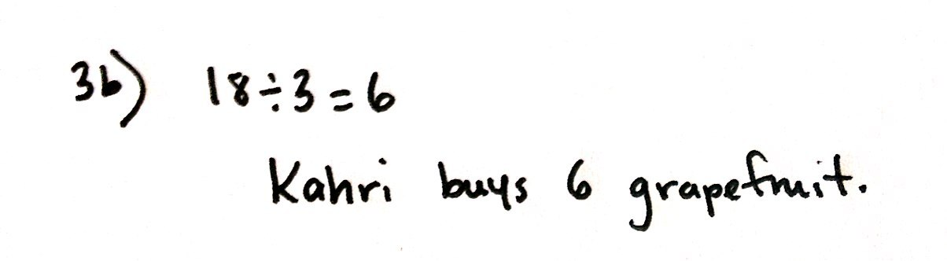

Students divide a decimal dividend by a decimal divisor to solve Problem 3. This problem is made simpler by showing the division expression as a fraction. Then, multiplication by a fraction equal to 1 ($\frac{10}{10}$ or $\frac{100}{100}$, depending on whether 80 cents is expressed as 0.8 or 0.80) results in both a whole number divisor and dividend. From here, students must divide 144 by 8 to find a quotient of 18. Carlo buys 18 grapefruits with his money.
In Part (b), since Kahri spends one-third of her money on equally priced grapefruit, students should reason that she would be buying one-third the number of fruit. Therefore, 18 $\text{÷}$ 3 shows that Kahri buys 6 grapefruit. Students may also choose the far less-direct method of solving a third of $14.40 and dividing that number ($4.80) by $0.80 to find the number of grapefruits purchased by Kahri.
Problem 4
Studies show that a typical giant hummingbird can flap its wings once in 0.08 of a second.
- While flying for 7.2 seconds, how many times will a typical giant hummingbird flap its wings?
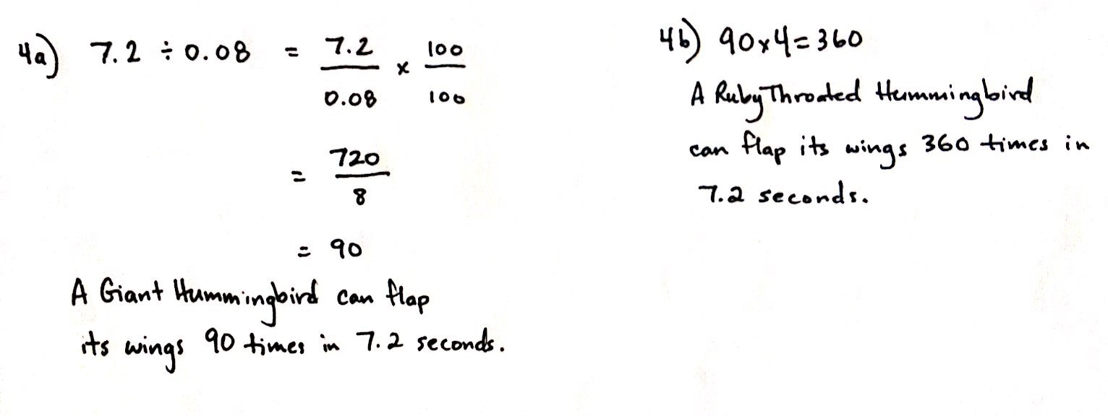
- A ruby-throated hummingbird can flap its wings 4 times faster than a giant hummingbird. How many times will a ruby-throated hummingbird flap its wings in the same amount of time?

Problem 4 is another decimal divisor/dividend problem. Similarly, students should express this division as a fraction, and then multiply to rename the divisor as a whole number. Ultimately, students should find that the giant hummingbird can flap its wings 90 times in 7.2 seconds. Part (b) is another example of the usefulness of the scaling principle. Since a ruby-throated hummingbird can flap its wings 4 times faster than the giant hummingbird, students need only multiply 90 by 4 to find that a ruby-throated hummingbird can flap its wings a remarkable 360 times in 7.2 seconds. Though not very efficient, students could also divide 0.08 by 4 to find that it takes a ruby-throated hummingbird just 0.02 seconds to flap its wings once. Then, division of 7.2 by 0.02 (or 720 by 2, after renaming the divisor as a whole number) yields a quotient of 360.
Problem 5
Create a story context for the following expression.
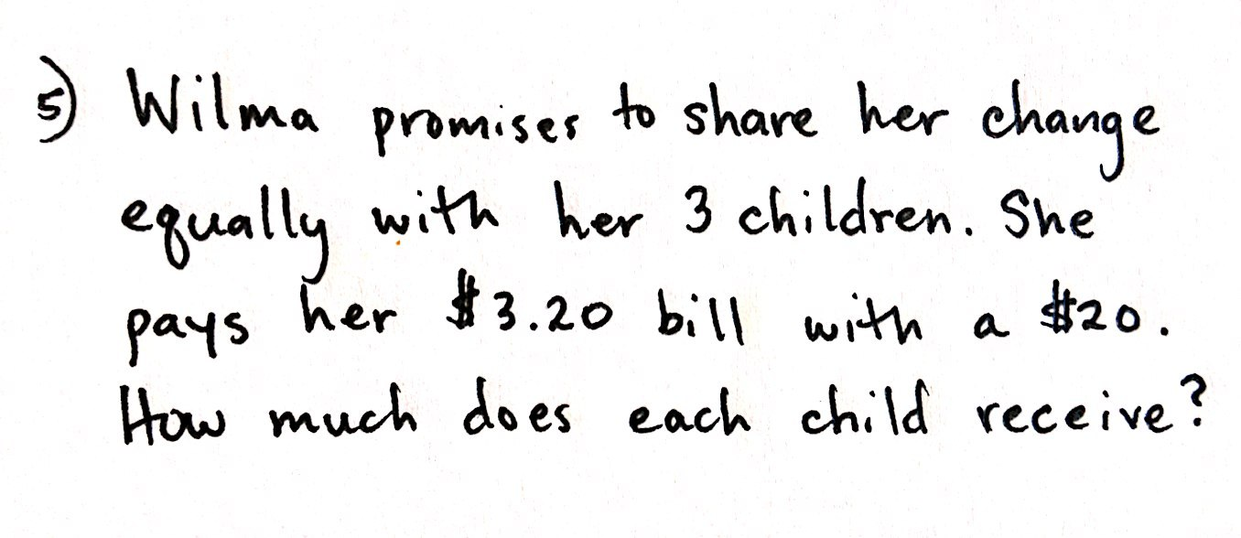
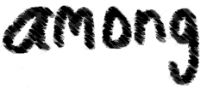
$\frac{1}{3} \text{×}$($20 – $3.20)
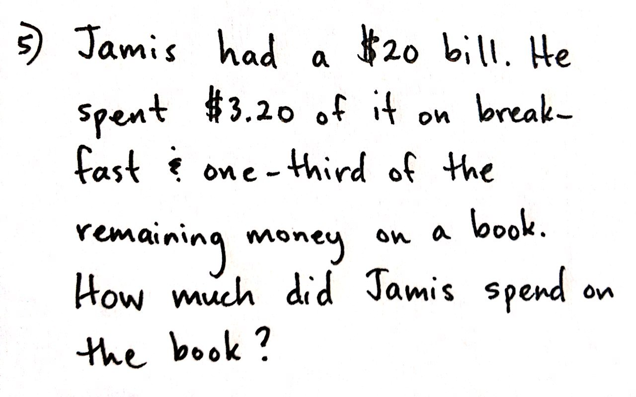

Working backwards from expression to story may be challenging for some students. Since the expression given contains parentheses, the story created must first involve the subtraction of $3.20 from $20. For students in need of assistance, drawing a tape diagram first may be of help. Note that the story of Jamis interprets the multiplication of $\frac{1}{3}$ directly, whereas the story of Wilma interprets the expression as division by 3.

NOTES ON
MULTIPLE MEANS
OF ENGAGEMENT:
Challenge early finishers in this lesson by encouraging them to go back to each problem and provide an alternate means for solution or an additional model to represent the problem. Students could discuss how their interpretation of each problem led them to solve it the way they did, and how and why alternate interpretations could lead to a different solution strategy.

Problem 6
Create a story context about painting a wall for the following tape diagram.

1
?

Again, students are asked to create a story problem, this time using a given tape diagram and the context of painting a wall. The challenge here is that this tape diagram implies a two-step word problem. The whole, 1, is first partitioned into half, and then one of those halves is divided into thirds. The story students create should reflect this two-part drawing. Students should be encouraged to share aloud and discuss their stories and thought process for solving.
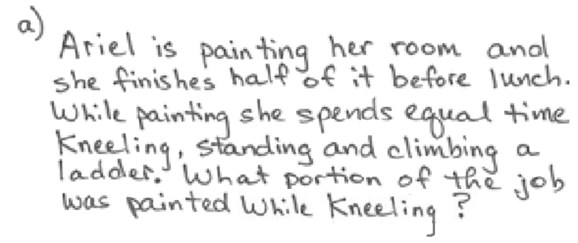
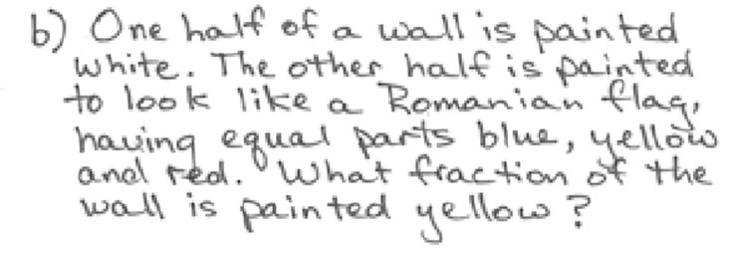
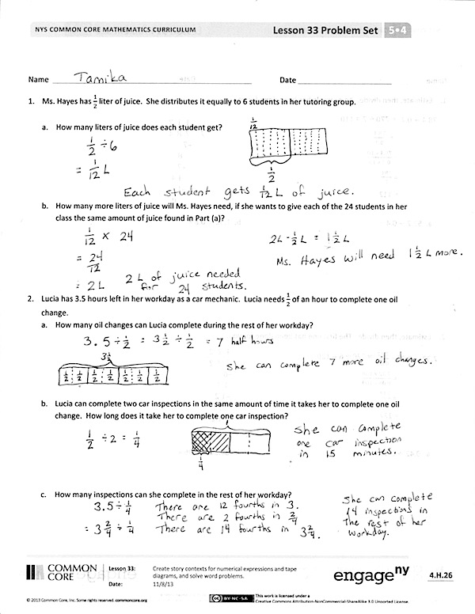
Student Debrief (10 minutes)
Lesson Objective: Create story contexts for numerical expressions and tape diagrams, and solve word problems.
The Student Debrief is intended to invite reflection and active processing of the total lesson experience.
Invite students to review their solutions for the Problem Set. They should check work by comparing answers with a partner before going over answers as a class. Look for misconceptions or misunderstandings that can be addressed in the Debrief. Guide students in a conversation to debrief the Problem Set and process the lesson.
You may choose to use any combination of the questions below to lead the discussion.
- For Problems 1–5, did you draw a tape diagram to help solve the problems? If so, share your drawings and explain them to a partner.
- For Problems 1–4, there are different ways to solve the problems. Share and compare your strategy with a partner.
- For Problems 5 and 6, share your story problem with a partner. Explain how you interpreted the expression in Problem 5 and the tape diagram in Problem 6.

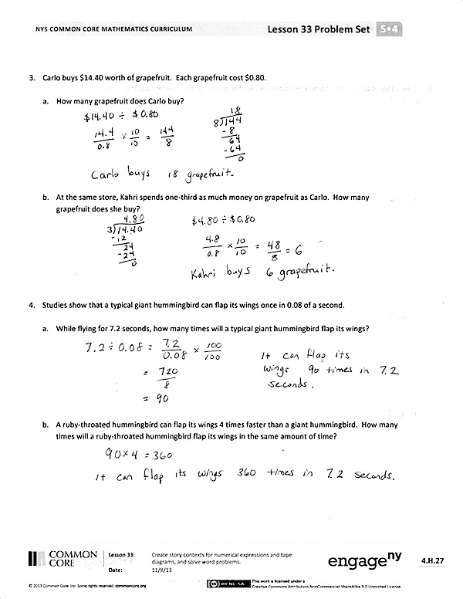
Exit Ticket (3 minutes)
After the Student Debrief, instruct students to complete the Exit Ticket. A review of their work will help you assess the students’ understanding of the concepts that were presented in the lesson today and plan more effectively for future lessons. You may read the questions aloud to the students.
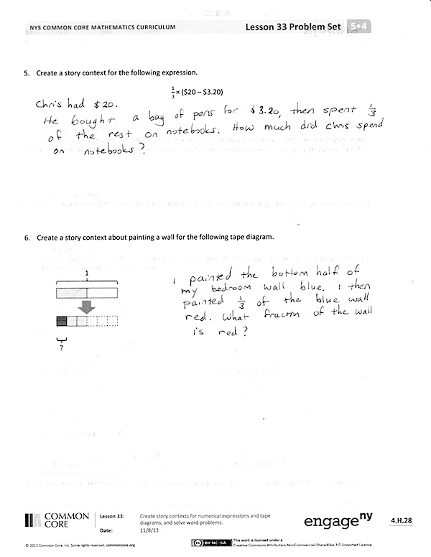

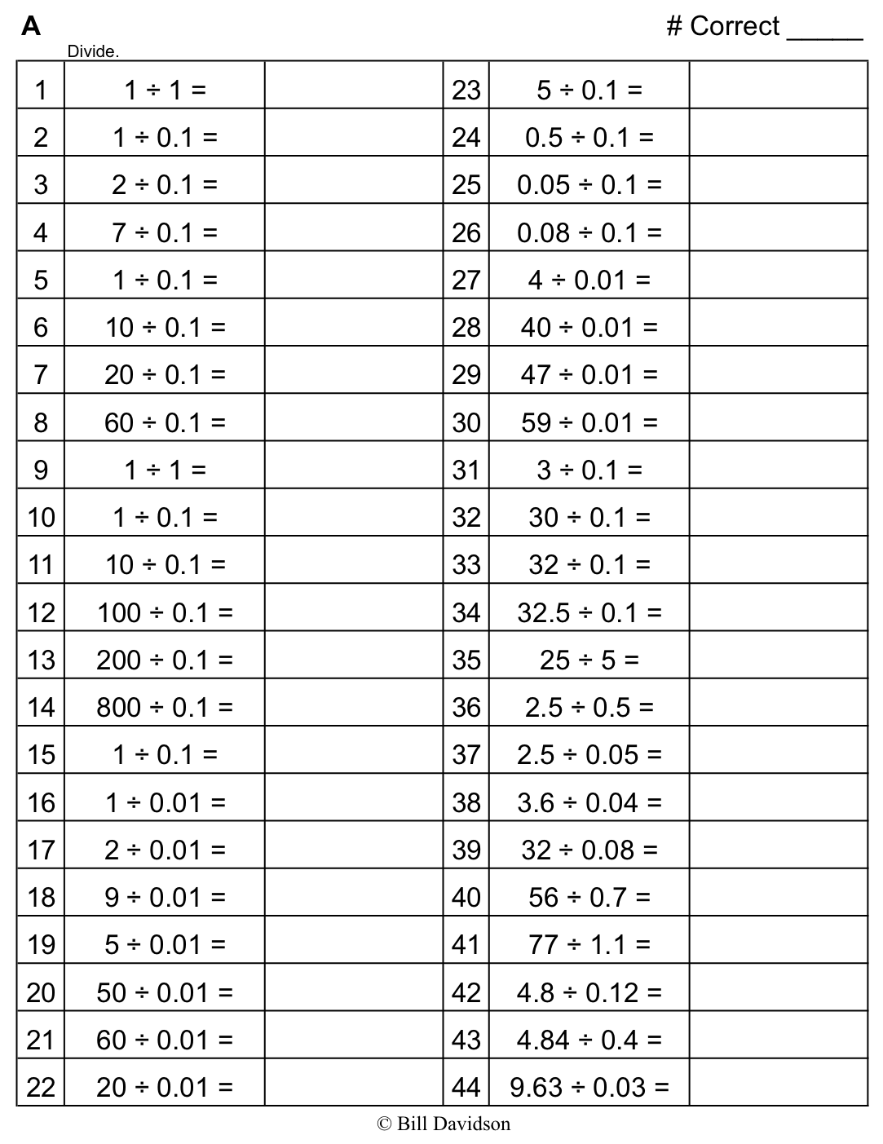
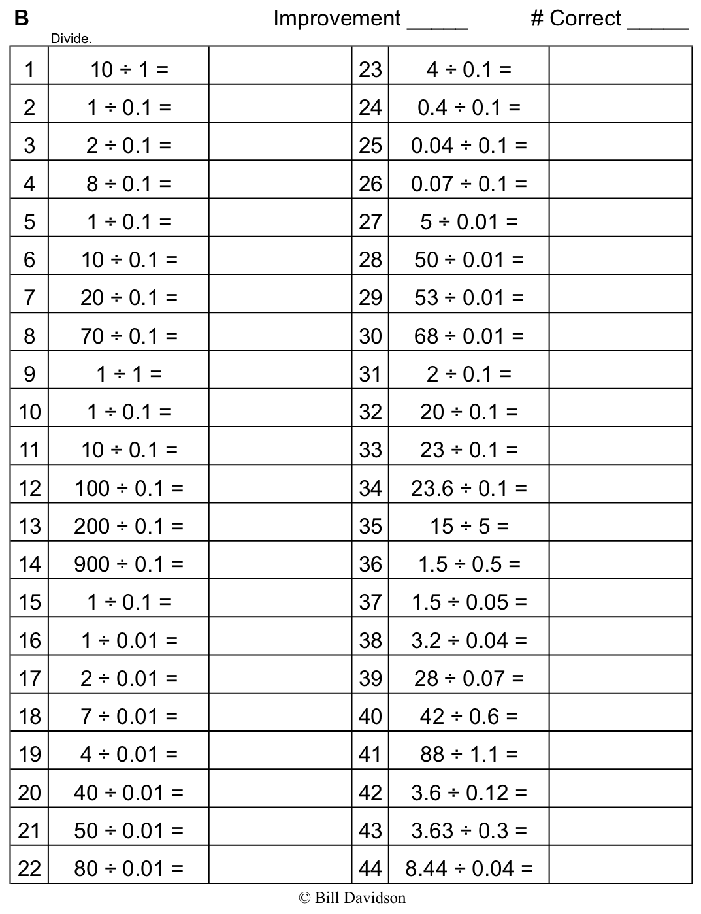
Name Date
- Ms. Hayes has $\frac{1}{2}$ liter of juice. She distributes it equally to 6 students in her tutoring group.
  - How many liters of juice does each student get?

  - How many more liters of juice will Ms. Hayes need if she wants to give each of the 24 students in her class the same amount of juice found in Part (a)?

- Lucia has 3.5 hours left in her workday as a car mechanic. Lucia needs $\frac{1}{2}$ of an hour to complete one oil change.
  - How many oil changes can Lucia complete during the rest of her workday?

  - Lucia can complete two car inspections in the same amount of time it takes her to complete one oil change. How long does it take her to complete one car inspection?

  - How many inspections can she complete in the rest of her workday?

- Carlo buys $14.40 worth of grapefruit. Each grapefruit costs $0.80.

  - How many grapefruist does Carlo buy?

  - At the same store, Kahri spends one-third as much money on grapefruits as Carlo. How many grapefruits does she buy?

- Studies show that a typical giant hummingbird can flap its wings once in 0.08 of a second.

  - While flying for 7.2 seconds, how many times will a typical giant hummingbird flap its wings?

  - A ruby-throated hummingbird can flap its wings 4 times faster than a giant hummingbird. How many times will a ruby-throated hummingbird flap its wings in the same amount of time?

- Create a story context for the following expression.
$\frac{1}{3}\text{×}$($20 – $3.20)

- Create a story context about painting a wall for the following tape diagram.

1
?

Name Date
- An entire commercial break is 3.6 minutes.
  - If each commercial takes 0.6 minutes, how many commercials will be played?

  - A different commercial break of the same length plays commercials half as long. How many commercials will play during this break?

Name Date
- Chase volunteers at an animal shelter after school, feeding and playing with the cats.
  - If he can make 5 servings of cat food from a third of a kilogram of food, how much does one serving weigh?

  - If Chase wants to give this same serving size to each of 20 cats, how many kilograms of food will he need?

- Anouk has 4.75 pounds of meat. She uses a quarter pound of meat to make one hamburger.
  - How many hamburgers can Anouk make with the meat she has?

  - Sometimes Anouk makes sliders. Each slider is half as much meat as is used for a regular hamburger. How many sliders could Anouk make with the 4.75 pounds?

- Ms. Geronimo has a $10 gift certificate to her local bakery.
  - If she buys a slice of pie for $2.20 and uses the rest of the gift certificate to buy chocolate macaroons that cost $0.60 each, how many macaroons can Ms. Geronimo buy?

  - If she changes her mind and instead buys a loaf of bread for $4.60 and uses the rest to buy cookies that cost $\text{1}\frac{1}{2}$ times as much as the macaroons, how many cookies can she buy?

- Create a story context for the following expressions.
  - ($\text{5}\frac{1}{4}$ – 2$\frac{1}{8}$) ÷ 4 b. 4 $\text{×}$ ($\frac{4.8}{0.8}$)

- Create a story context for the following tape diagram.

6
?

