Lesson 32
Objective: Interpret and evaluate numerical expressions including the language of scaling and fraction division.

Suggested Lesson Structure
 Fluency Practice (12 minutes)
 Application Problem (6 minutes)
 Concept Development (32 minutes)
 Student Debrief (10 minutes)
Total Time (60 minutes)
Fluency Practice (12 minutes)
- Order of Operations 5.OA.1 (3 minutes)
- Divide Decimals by 1 Tenth and 1 Hundredth 5.NBT.7 (3 minutes)
- Divide Decimals 5.NBT.7 (6 minutes)
Order of Operations (3 minutes)
Materials: (S) Personal white board
Note: This fluency activity prepares students for today’s lesson.
T: (Write 12 ÷ 3 + 1.) On your personal white board, write the complete number sentence.
S: (Write 12 ÷ 3 + 1 = 5.)
T: (Write 12 ÷ (3 + 1).) Copy the expression on your personal white board.
S: (Write 12 ÷ (3 + 1).)
T: Write the complete number sentence, performing the operation inside the parentheses.
S: (Beneath 12 ÷ (3 + 1) = ____, write 12 ÷ 4 = 3.)
Continue with the following possible sequence: 20 – 4 ÷ 2, (20 – 4) ÷ 2, 24 ÷ 6 – 2, and 24 ÷ (6 – 2).

Divide Decimals by 1 Tenth and 1 Hundredth (3 minutes)
Materials: (S) Personal white board
Note: This fluency activity reviews Lesson 29.
T: (Write 1 ÷ 0.1.) How many tenths are in 1?
S: 10 tenths.
T: 2?
S: 20 tenths.
T: 3?
S: 30 tenths.
T: 6?
S: 60 tenths.
T: (Write 10 ÷ 0.1.) On your personal white board, write the complete number sentence answering how many tenths are in 10.
S: (Write 10 ÷ 0.1 = 100.)
T: (Write 20 ÷ 0.1 = ____.) If there are 100 tenths in 10, how many tenths are in 20?
S: 200 tenths.
T: 30?
S: 300 tenths.
T: 80?
S: 800 tenths.
T: (Write 43 ÷ 0.1.) On your personal white board, write the complete number sentence.
S: (Write 43 ÷ 0.1 = 430.)
T: (Write 43.5 ÷ 0.1 = ____.) Write the complete number sentence.
S: (Write 43.5 ÷ 0.1 = 435.)
T: (Write 0.04 ÷ 0.1 = $\frac{}{100}$ ÷ $\frac{}{10}$.) Complete the division sentence.
S: (Write 0.04 ÷ 0.1 = $\frac{4}{100}$ ÷ $\frac{1}{10}$.)
Continue with the following possible sequence: 0.97 ÷ 0.1, 9.7 ÷ 0.01, 97 ÷ 0.1, and 970 ÷ 0.01.

Divide Decimals (6 minutes)
Materials: (S) Personal white board
Note: This fluency activity reviews Lessons 29–30.
T: (Write $\frac{8}{2}$ = ____.) Say the division sentence with the answer.
S: 8 ÷ 2 = 4.
T: (Write $\frac{8}{2}$= 4. Beneath it, write $\frac{0.8}{0.2}$= ____.) What is 8 tenths ÷ 2 tenths?
S: 4 tenths.
T: (Write $\frac{0.8}{0.02}$ = ____.) On your personal white boards, complete the division sentence.
S: (Write 0.8 ÷ 0.02 = 40.)
Continue this process with the following possible sequence: 12 ÷ 3, 1.2 ÷ 0.3, 1.2 ÷ 0.03, and 12 ÷ 0.3.
T: (Write 23.84 ÷ 0.2 = ____.) On your personal white board, write the division sentence as a fraction.
S: (Write $\frac{23.84}{0.2}.\text{)}$
T: (Write = $\frac{23.84}{0.2}$.) What do we need to multiply the divisor by to make it a whole number?
S: 10.
T: Multiply your numerator and denominator by 10.
S: (Write $\frac{23.84 \text{×} 10}{ 0.2 \text{×} 10}$.)
T: (Beneath 23.84 ÷ 0.2 = ____, write $\frac{23.84 \text{×} 10}{ 0.2 \text{×} 10}$.) Use the standard algorithm to solve, and then write your answer.
S: (Write 23.84 ÷ 0.2 = 119.2 after solving.)
Continue this process with these possible problems: 5.76 ÷ 0.4, 9.54 ÷ 0.03, and 98.4 ÷ 0.12.
Application Problem (6 minutes)
Four baby socks can be made from $\frac{1}{3}$ skein of yarn. How many baby socks can be made from a whole skein? Draw a number line to show your thinking.
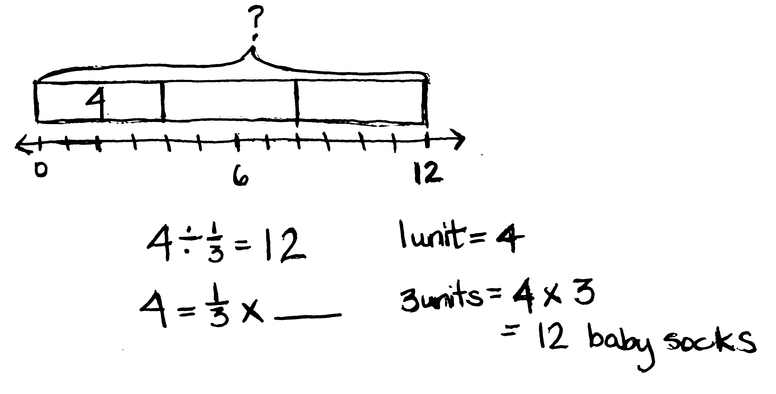
Note: This Application Problem is a partitive fraction division problem intended to give students more experience with this interpretation of division.

Concept Development (32 minutes)
Materials: (S) Personal white board
Problem 1: Write word form expressions numerically.
- Twice the sum of $\frac{3}{5}$ and $\text{1}\frac{1}{2}$
- Half the sum of $\frac{3}{5}$ and $\text{1}\frac{1}{2}$
- The difference between $\frac{3}{4}$ and $\frac{1}{2}$ divided by 3
T: (Post Problem 1(a) on the board.) Read the expression aloud with me.
S: (Read.)
T: What do you notice about this expression that would help us translate these words into symbols? Turn and talk.

NOTES ON
MULTIPLE MEANS
OF REPRESENTATION:
The complexity of language in the word form expressions may pose challenges for English language learners. Consider drawing tape diagrams for each expression. Then, have students match each expression to its tape diagram before writing the numerical expression.
S: It says twice; that means we have to make two copies of something or multiply by 2. It says the sum of, so something is being added. The part that says sum of needs to be added before multiplying, so we’ll need parentheses.
T: Let’s take a look at the first part of the expression. On your personal white board, show me how can we write twice numerically.
S: (Write $\text{2 }\text{×}\text{.)}$
T: (Write 2 $\text{×}$ _____ on the board.) Great, what is being multiplied by 2?

NOTES ON
MULTIPLE MEANS
OF REPRESENTATION:
Because of the commutativity of addition and multiplication, there are multiple ways of writing expressions involving these operations. Have students be creative and experiment with their expressions. Be cautious, though, that students do not overgeneralize this property and try to apply it to subtraction and division.
S: The sum of 3 fifths and 1 and one-half.
T: Show me the sum of 3 fifths and 1 and one-half numerically.
S: (Write$\frac{3}{5} \text{+} 1\frac{1}{2}$.)
T: (Write $\frac{3}{5} \text{+} 1\frac{1}{2}$ in the blank.) Are we finished? Turn and talk.
S: (Share.)
T: What else is needed?
S: Parentheses.
T: Why? Turn and talk.
S: You must have parentheses around the addition expression so that the addition is done before the multiplication. If you don’t, the answer will be $\frac{6}{5} \text{+} 1\frac{1}{2}$.
Because otherwise, you just go left to right and multiply first.
T: (Draw parentheses around the addition expression.) Work with a partner to find another way to write this expression numerically.
S: (Work and show ($\frac{3}{5} \text{+} \text{1}\frac{1}{2}$) $\text{×}$ 2.)
T: (Post Problem 1(b), half the sum of $\frac{3}{5}$ and 1 $\frac{1}{2},$ on the board.) Read this expression out loud with me.
S: (Read.)
T: Compare this expression to the previous one. Turn and talk.
S: (Share.)
T: Without evaluating this expression, will the value of this expression be more than or less than the previous one? Turn and talk.
S: It’s less. The other one multiplied the sum by 2, and this one is one-half of the same sum. Taking half of a number is less than doubling it.
T: This expression again includes the sum of 3 fifths and 1 and one-half. (Write $\frac{3}{5}\text{+} \text{1}\frac{1}{2}$ on the board.) We need to show one-half of it. Tell a neighbor how we can show one-half of this expression.
S: We can multiply it by $\frac{1}{2}$. We can show $\frac{1}{2}$ times the addition expression, or we can show the addition expression times $\frac{1}{2}.$ Taking a half of something is the same as dividing it by 2, so we could divide the addition expression by 2. We could divide the addition expression by 2, but write it like a fraction with 2 as the denominator.
T: Work with a partner to write this expression numerically in at least two different ways.
S: (Work and share.)
T: (Select students to share their work and explain their thought process.)
T: (Post Problem 1(c), the difference between $\frac{3}{4}$ and $\frac{1}{2}$ divided by 3, on the board.) Read this expression aloud with me.
S: (Read.)
T: Talk with a neighbor about what is happening in this expression.
S: Difference means subtract, so one half is being subtracted from three fourths. The last part says divided by 3, so we can put parentheses around the subtraction expression and then write $\text{÷}$ 3. Since it says divided by 3, we can write that like a fraction with 3 as the denominator. Dividing by 3 is the same as taking a third of something, so we can multiply the subtraction expression by $\frac{1}{3}$.
T: Work independently to write this expression numerically. Share your work with a neighbor when you’re finished.
S: (Work and share.)
T: Look at your numerical expression. Let’s evaluate it. Let’s put this expression in its simplest form. What is the first step?
S: Subtract one-half from 3 fourths.
T: Why must we do that first?
S: Because it is in parentheses. Because we need to evaluate the numerator before dividing by 3.
T: Work with a partner, then show me the difference between 3 fourths and one-half.
S: (Work and show $\frac{1}{4}$.)
T: Since we wrote our numerical expressions in different ways, tell your partner what your next step will be in evaluating your expression.
S: I need to multiply one-fourth times one-third. I need to divide one-fourth by 3.
T: Complete the next step and then share your work with a partner.
S: (Work and share.)
T: What is this expression equal to in simplest form?
S: 1 twelfth.
T: Everyone got 1 twelfth?
S: Yes!
T: What does that show us about the different ways to write these expressions? Turn and talk.
S: (Share.)
Problem 2: Write numerical expressions in word form.
a. $\frac{2}{5}\text{×}$($\frac{1}{2}-$ 0.4) b. ($\frac{3}{4}$ + 1.25) $\text{÷}$ $\frac{1}{3}$ c. (2 $\text{÷}\frac{1}{5}$) $\text{×}$ 0.3

T: (Post Problem 2(a) on the board.) Now, we’ll rewrite a numerical expression in word form. What is happening in this expression? Turn and talk.
S: In parentheses, there’s the difference between one-half and 4 tenths.
The subtraction expression is being multiplied by 2 fifths.
T: Show me a word form expression for the operation outside the parentheses.
S: (Show $\frac{2}{5}$times.)
T: (Write $\frac{2}{5}$ times______ on the board.) We have 2 fifths times what?
S: The difference between one-half and 4 tenths.

T: Exactly! (Write the difference between $\frac{1}{2}$ and 0.4 in the blank, and then post Problem 2(b) on the board.) Work with a partner to write this expression using words.
S: (Work and show the sum of $\frac{3}{4}$ and 1.25 divided by $\frac{1}{3}$.)
T: Let’s evaluate the numerical expression. What must we do first?
S: Add $\frac{3}{4}$ and 1.25.
T: Work with a partner to find the sum in its simplest form.
S: (Work and show 2.)
T: What’s the next step?
S: Divide 2 by one-third.
T: How many thirds are in 1 whole?
S: 3.
T: How many are in 2 wholes?
S: 6.
T: (Post Problem 2(c) on the board.) Work independently to rewrite this expression using words. If you finish early, evaluate the expression. Check your work with a partner when you’re both ready.
S: (Work and share.)
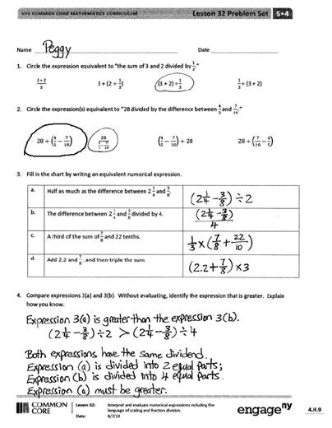
Problem Set (10 minutes)
Students should do their personal best to complete the Problem Set within the allotted 10 minutes. For some classes, it may be appropriate to modify the assignment by specifying which problems they work on first. Some problems do not specify a method for solving. Students should solve these problems using the RDW approach used for Application Problems.
Student Debrief (10 minutes)
Lesson Objective: Interpret and evaluate numerical expressions including the language of scaling and fraction division.
The Student Debrief is intended to invite reflection and active processing of the total lesson experience.
Invite students to review their solutions for the Problem Set. They should check work by comparing answers with a partner before going over answers as a class. Look for misconceptions or misunderstandings that can be addressed in the Debrief. Guide students in a conversation to debrief the Problem Set and process the lesson.
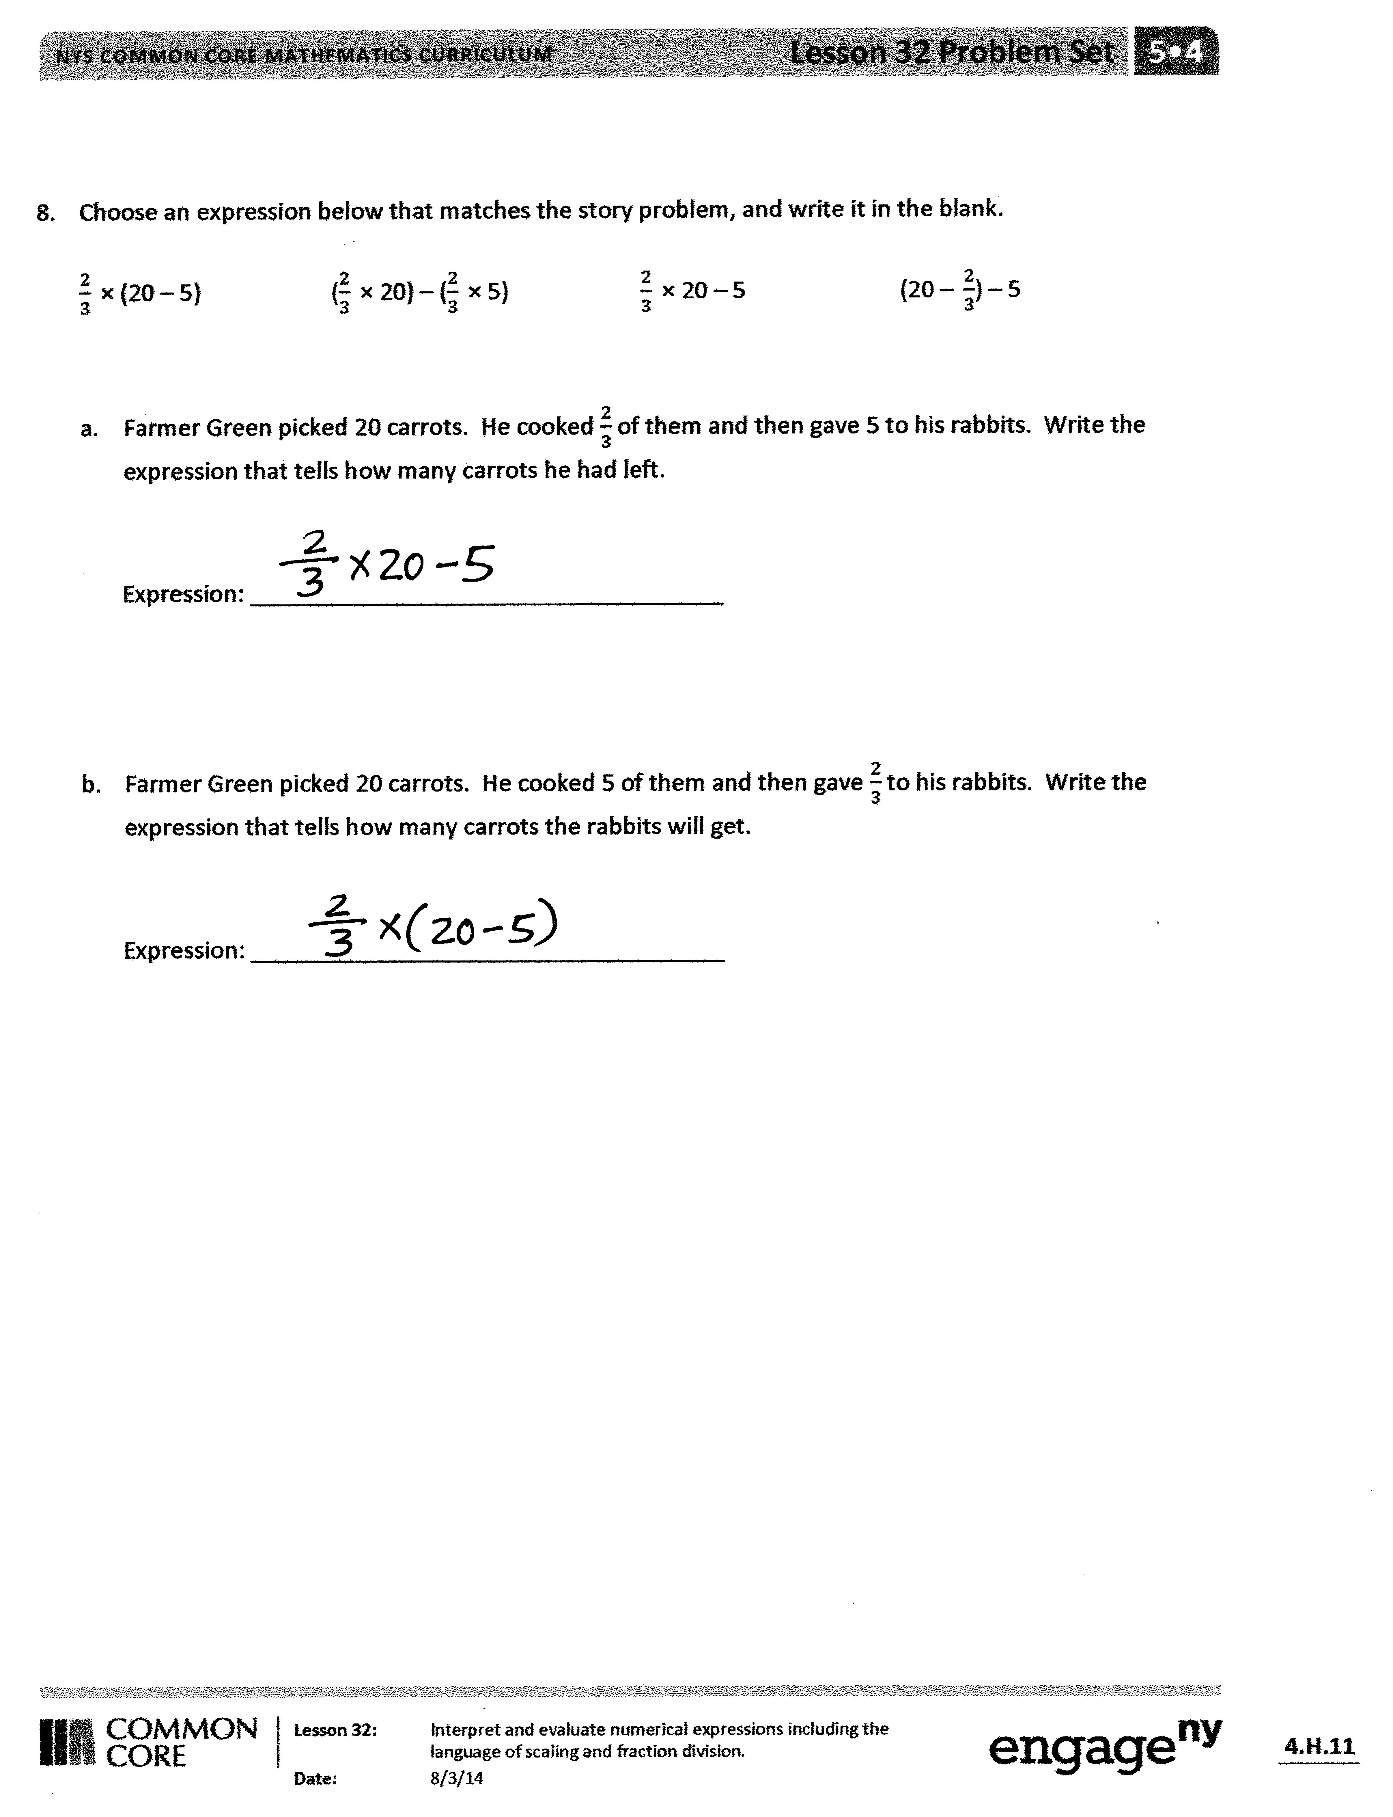
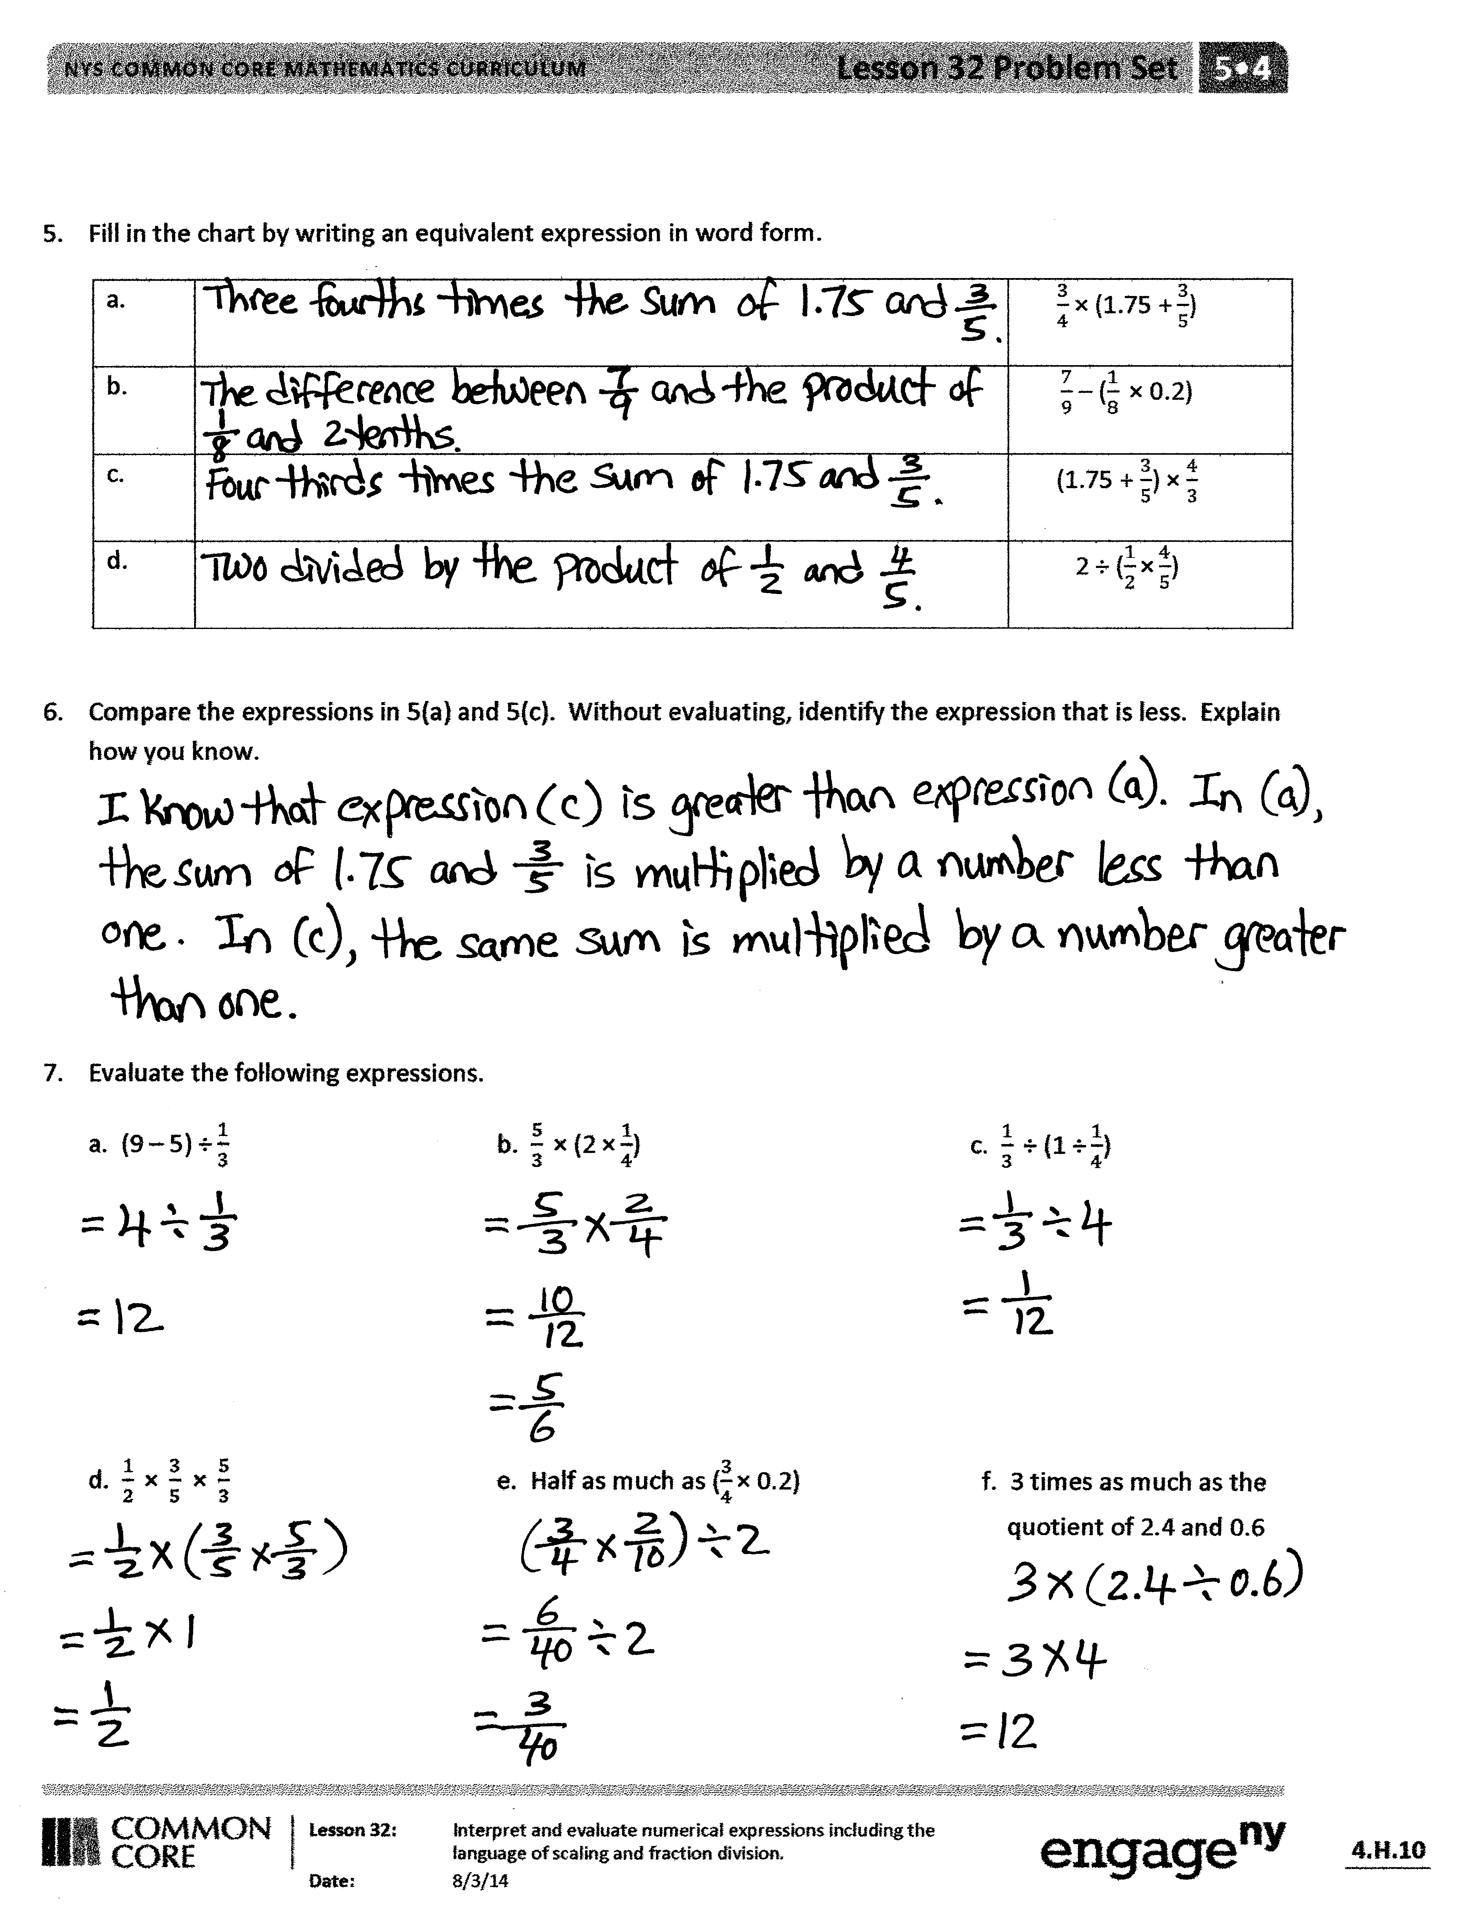
You may choose to use any combination of the questions below to lead the discussion.
- For Problems 1 and 2, explain to a partner how you chose the correct equivalent expression(s).
- Compare your answer for Problem 3 with a partner. Is there more than one correct answer?
- What’s the relationship between Problems 5(a) and 5(c)?
- Share and compare your solutions for Problem 7 with a partner. Be careful with the order of operations; calculate the parenthesis first.
- Share and compare your answers for Problem 8 with a partner. For the two expressions that did not match the story problems, can you think of a story problem for them? Share your ideas with a partner.
Exit Ticket (3 minutes)
After the Student Debrief, instruct students to complete the Exit Ticket. A review of their work will help you assess the students’ understanding of the concepts that were presented in the lesson today and plan more effectively for future lessons. You may read the questions aloud to the students.
Name Date
- Circle the expression equivalent to the sum of 3 and 2 divided by $\frac{1}{3}$.
$\frac{3 \text{+} 2}{3}$ 3 $\text{+}$ (2 $÷$ $\frac{1}{3}$) (3 + 2) $\text{÷}\frac{1}{3}$ $\frac{1}{3}\text{÷}$ (3 + 2)

- Circle the expression(s) equivalent to 28 divided by the difference between$\frac{4}{5}$ and $\frac{7}{10}$.

$28÷\left(\frac{4}{5}-\frac{7}{10}\right)$ $\frac{28}{\frac{4}{5} \text{–} \frac{7}{10}}$ $\left(\frac{4}{5}-\frac{7}{10}\right)÷28$ $28÷\left(\frac{7}{10}-\frac{4}{5}\right)$

- Fill in the chart by writing an equivalent numerical expression.

a. | Half as much as the difference between $2\frac{1}{4}$ and $\frac{3}{8}$.
b. | The difference between $2\frac{1}{4}$ and $\frac{3}{8}$ divided by 4.
c. | A third of the sum of $\frac{7}{8}$ and 22 tenths.
d. | Add 2.2 and $\frac{7}{8}$ , and then triple the sum.

- Compare expressions 3(a) and 3(b). Without evaluating, identify the expression that is greater. Explain how you know.

- Fill in the chart by writing an equivalent expression in word form.
a. |  | $\frac{3}{4}$ $\text{×}$(1.75 $\text{+}\frac{3}{5}$)
b. |  | $\frac{7}{9}$ $\text{–}$ ($\frac{1}{8} \text{×}$ 0.2)
c. |  | (1.75 $\text{+}$ $\frac{3}{5}$) $\text{×}$ $\frac{4}{3}$
d. |  | 2 $\text{÷}$ ($\frac{1}{2}\text{×}\frac{4}{5}$)

- Compare the expressions in 5(a) and 5(c). Without evaluating, identify the expression that is less. Explain how you know.

- Evaluate the following expressions.
a. (9 $\text{–}$ 5) $\text{÷}\frac{1}{3}$ b. $\frac{5}{3} \text{×}$(2 $\text{×}\frac{1}{4}$) c. $\frac{1}{3} \text{÷}$ (1 $\text{÷}\frac{1}{4}$)

d. $\frac{1}{2} \text{×} \frac{3}{5}$ $\text{×} \frac{5}{3}$ e. Half as much as ($\frac{3}{4}\text{×}$0.2) f. 3 times as much as the quotient of 2.4 and 0.6

- Choose an expression below that matches the story problem, and write it in the blank.

$\frac{2}{3} \text{×}$ (20 $\text{–}$ 5) ($\frac{2}{3} \text{×}$ 20) $\text{–}$ ($\frac{2}{3} \text{×}$ 5) $\frac{2}{3} \text{×}$ 20 $\text{–}$ 5 (20 $\text{–} \frac{2}{3}$) $\text{–}$ 5

- Farmer Green picked 20 carrots. He cooked $\frac{2}{3}$ of them, and then gave 5 to his rabbits. Write the expression that tells how many carrots he had left.

Expression: ____________________________________

- Farmer Green picked 20 carrots. He cooked 5 of them, and then gave $\frac{2}{3}$ to his rabbits. Write the expression that tells how many carrots the rabbits will get.

Expression: ____________________________________

Name Date
- Write an equivalent expression in numerical form.
A fourth as much as the product of two-thirds and 0.8

- Write an equivalent expression in word form.
a. $\frac{3}{8} \text{×}$(1 $\text{–}\frac{1}{3}$) b. (1 $\text{–}\frac{1}{3}$) ÷ 2

- Compare the expressions in 2(a) and 2(b). Without evaluating, determine which expression is greater, and explain how you know.

Name Date
- Circle the expression equivalent to the difference between 7 and 4, divided by a fifth.
7 + (4 $\text{÷}$ $\frac{1}{5})$ $\frac{7 - 4}{5}$ (7 $-$ 4) $\text{÷}\frac{1}{5}$ $\frac{1}{5}\text{÷}$ (7 $-$ 4)
- Circle the expression(s) equivalent to 42 divided by the sum of$\frac{2}{3}$ and $\frac{3}{4}$.
($\frac{2}{3}\text{+}\frac{3}{4}) \text{÷}$ 42 (42 $\text{÷}$ $\frac{2}{3}$) + $\frac{3}{4}$ 42 $\text{÷}$ ($\frac{2}{3}\text{+}\frac{3}{4}$) $\frac{42}{\frac{2}{3} \text{+} \frac{3}{4}}$

- Fill in the chart by writing the equivalent numerical expression or expression in word form.

 | Expression in word form | Numerical expression
a. | A fourth as much as the sum of 3$\frac{1}{8}$ and 4.5
b. |  | (3$\frac{1}{8}$ + 4.5) $\text{÷}$ 5
c. | Multiply $\frac{3}{5}$ by 5.8, then halve the product
d. |  | $\frac{1}{6}$ $\text{×}$(4.8 $\text{–}\frac{1}{2}$)
e. |  | 8 $\text{–}$ ($\frac{1}{2}\text{÷} 9$)

- Compare the expressions in 3(a) and 3(b). Without evaluating, identify the expression that is greater. Explain how you know.

- Evaluate the following expressions.

- (11 $\text{–}$ 6) $\text{÷}\frac{1}{6}$ b. $\frac{9}{5} \text{×}$(4 $\text{×}$ $\frac{1}{6}$) c. $\frac{1}{10} \text{÷}$ (5 $\text{÷}\frac{1}{2}$)

d. $\frac{3}{4} \text{×} \frac{2}{5}$ $\text{×} \frac{4}{3}$ e. 50 divided by the difference between $\frac{3}{4}$ and $\frac{5}{8}$

- Lee is sending out 32 birthday party invitations. She gives 5 invitations to her mom to give to family members. Lee mails a third of the rest, and then she takes a break to walk her dog.
a. Write a numerical expression to describe how many invitations Lee has already mailed.

- Which expression matches how many invitations still need to be sent out?

32 $\text{–}$ 5 $\text{–}$ $\frac{1}{3}$ (32 – 5) $\frac{2}{3} \text{×}$ 32 $\text{–}$ 5 (32 $\text{–}$ 5)$\text{÷}$ $\frac{1}{3}$ $\frac{1}{3} \text{×}$ (32 $\text{–}$ 5)

