Lesson 31
Objective: Divide decimal dividends by non‐unit decimal divisors.

Suggested Lesson Structure
 Fluency Practice (12 minutes)
 Application Problem (6 minutes)
 Concept Development (32 minutes)
 Student Debrief (10 minutes)
Total Time (60 minutes)
Fluency Practice (12 minutes)
- Multiply Decimals by 10 and 100 5.NBT.1 (4 minutes)
- Divide Decimals by 1 Tenth and 1 Hundredth 5.NBT.7 (3 minutes)
- Divide Decimals 5.NBT.7 (5 minutes)
Multiply Decimals by 10 and 100 (4 minutes)
Materials: (S) Personal white board
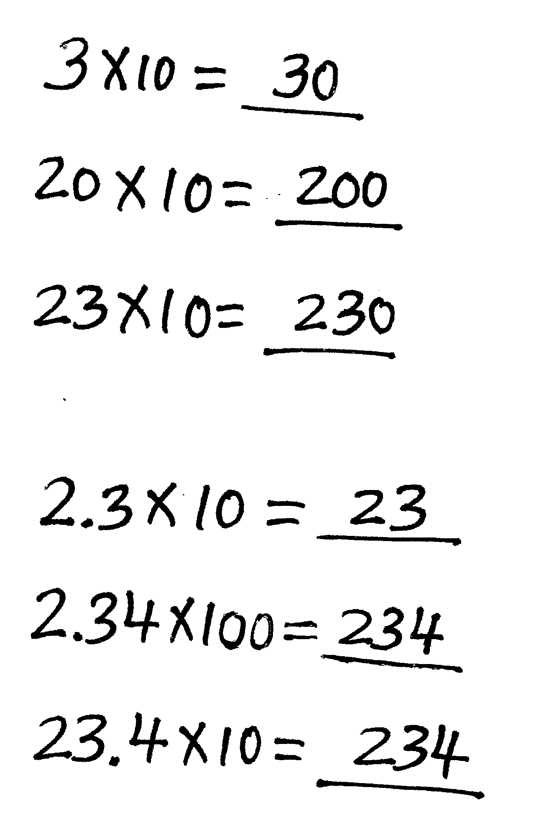
Note: This fluency activity prepares students for Lesson 31.
T: (Write 3 × 10 = ____.) Say the multiplication sentence with the answer.
S: 3 × 10 = 30.
T: (Write 3 × 10 = 30. Beneath it, write 20 × 10 = ____.) Say the multiplication sentence with the answer.
S: 20 × 10 = 200.
T: (Write 20 × 10 = 200. Beneath it, write 23 × 10 = ____.) Say the multiplication sentence with the answer.
S: 23 × 10 = 230.
T: (Write 2.3 × 10 = ____. Point to 2.3.) How many tenths is 2 and 3 tenths?
S: 23 tenths.
T: On your personal white boards, write the multiplication sentence with the answer.
S: (Write 2.3 × 10 = 23.)
T: (Write 2.34 × 100 = ____. Point to 2.34.) How many hundredths is 2 and 34 hundredths?
S: 234 hundredths.
T: Write the multiplication sentence with the answer.
S: (Write 2.34 × 100 = 234.)
T: (Write 23.4 × 10 = ____. Point to 23.4.) How many tenths is 23 and 4 tenths?
S: 234 tenths.
T: Write the multiplication sentence with the answer.
S: (Write 23.4 × 10 = 234.)
Continue with the following possible sequence: 47.3 × 10, 4.73 × 100, 8.2 × 10, 38.2 × 10, and 6.17 × 100.
Divide Decimals by 1 Tenth and 1 Hundredth (3 minutes)
Materials: (S) Personal white board
Note: This fluency activity reviews Lesson 29.
T: (Write 1 ÷ 0.1 = ____.) How many tenths are in 1?
S: 10 tenths.
T: 2?
S: 20 tenths.
T: 3?
S: 30 tenths.
T: 7?
S: 70 tenths.
T: (Write 10 ÷ 0.1.) On your personal white board, write the complete number sentence, answering how many tenths are in 10.
S: (Write 10 ÷ 0.1 = 100.)
T: (Write 20 ÷ 0.1.) If there are 100 tenths in 10, how many tenths are in 20?
S: 200 tenths.
T: 30?
S: 300 tenths.
T: 90?
S: 900 tenths.
T: (Write 65 ÷ 0.1.) On your personal white board, write the complete number sentence.
S: (Write 65 ÷ 0.1 = 650.)
T: (Write 65.2 ÷ 0.1.) Write the complete number sentence.
S: (Write 65.2 ÷ 0.1 = 652.)
T: (Write 0.08 ÷ 0.1 = $\frac{}{100}$ ÷ $\frac{}{10}$.) Complete the division sentence.
S: (Write 0.08 ÷ 0.1 = $\frac{8}{100}$ ÷ $\frac{1}{10}$.)
Continue with the following possible sequence: 0.36 ÷ 0.1, 3.6 ÷ 0.01, 36 ÷ 0.1, and 360 ÷ 0.01.

Divide Decimals (5 minutes)
Materials: (S) Personal white board
Note: This fluency activity reviews Lessons 29–30.
T: (Write 15 ÷ 5 = ____.) Say the division sentence with the answer.
S: 15 ÷ 5 = 3.
T: (Write 15 ÷ 5 = 3. Beneath it, write 1.5 ÷ 0.5 = ____.) Say the division sentence in tenths.
S: 15 tenths ÷ 5 tenths.
T: Write 15 tenths ÷ 5 tenths as a fraction.
S: (Write$\frac{1.5}{0.5}$.)
T: (Beneath 1.5 ÷ 0.5, write $\frac{1.5 \text{×} 10}{0.5 \text{× }10}$.) On your personal white board, rewrite the fraction using whole numbers.
S: (Write $\frac{1.5 \text{×} 10}{0.5 \text{×} 10}$. Beneath it, write $\frac{15}{5}$.)
T: (Beneath $\frac{1.5 \text{×} 10}{0.5 \text{×} 10}$, write $\frac{15}{5}$. Beneath it, write = ____.) Fill in your answer.
S: (Write = 3.)
Continue with the following possible sequence: 1.5 ÷ 0.05, 0.12 ÷ 0.3, 1.04 ÷ 4, 4.8 ÷ 1.2, and 0.48 ÷ 1.2.
Application Problem (6 minutes)
A café makes ten 8-ounce fruit smoothies. Each smoothie is made with 4 ounces of soy milk and 1.3 ounces of banana flavoring. The rest is blueberry juice. How much of each ingredient will be necessary to make the smoothies?
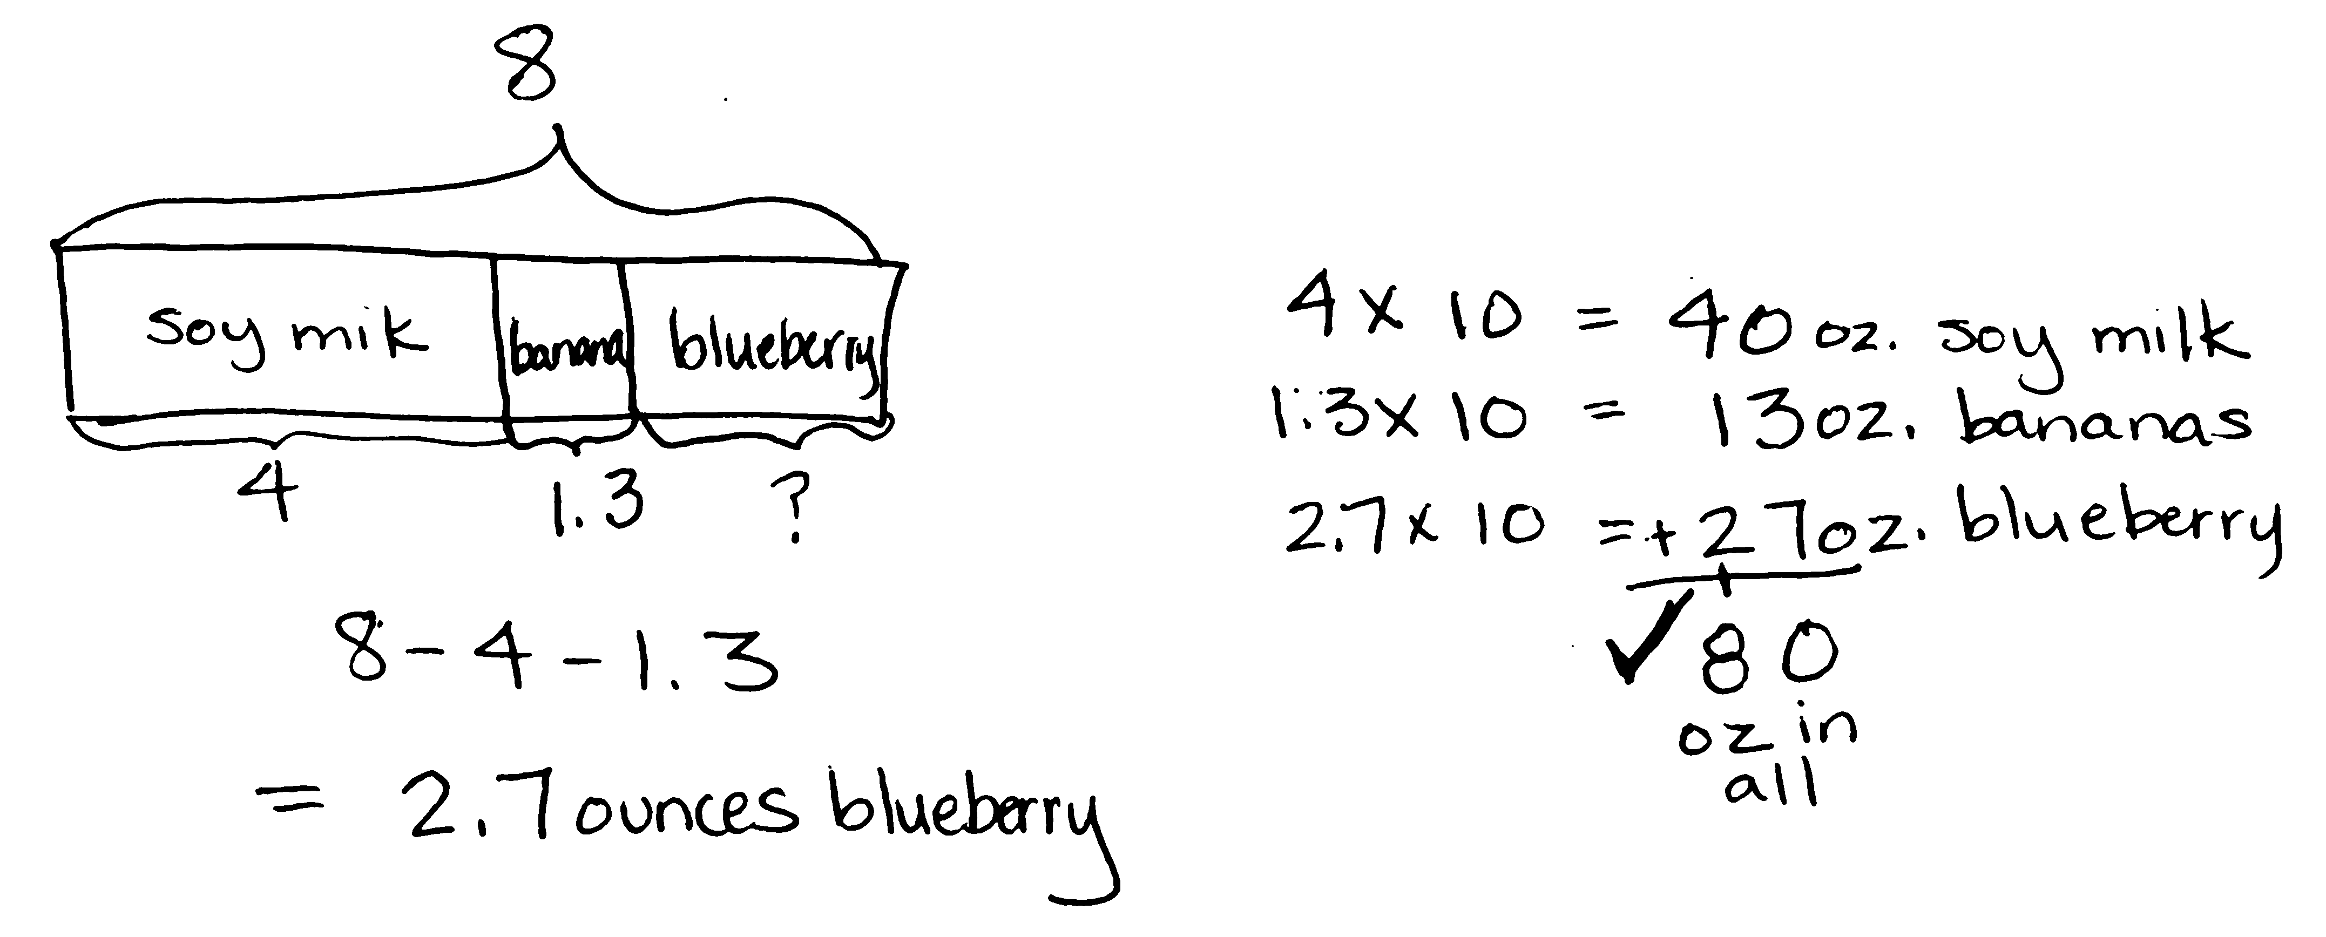
Note: This two-step problem requires decimal subtraction and multiplication, reviewing concepts from Module 1. Some students will be comfortable performing these calculations mentally, while others may need to sketch a quick visual model. Developing versatility with decimals by reviewing strategies for multiplying decimals serves as a quick warm-up for today’s lesson.

Concept Development (32 minutes)
Materials: (S) Personal white board
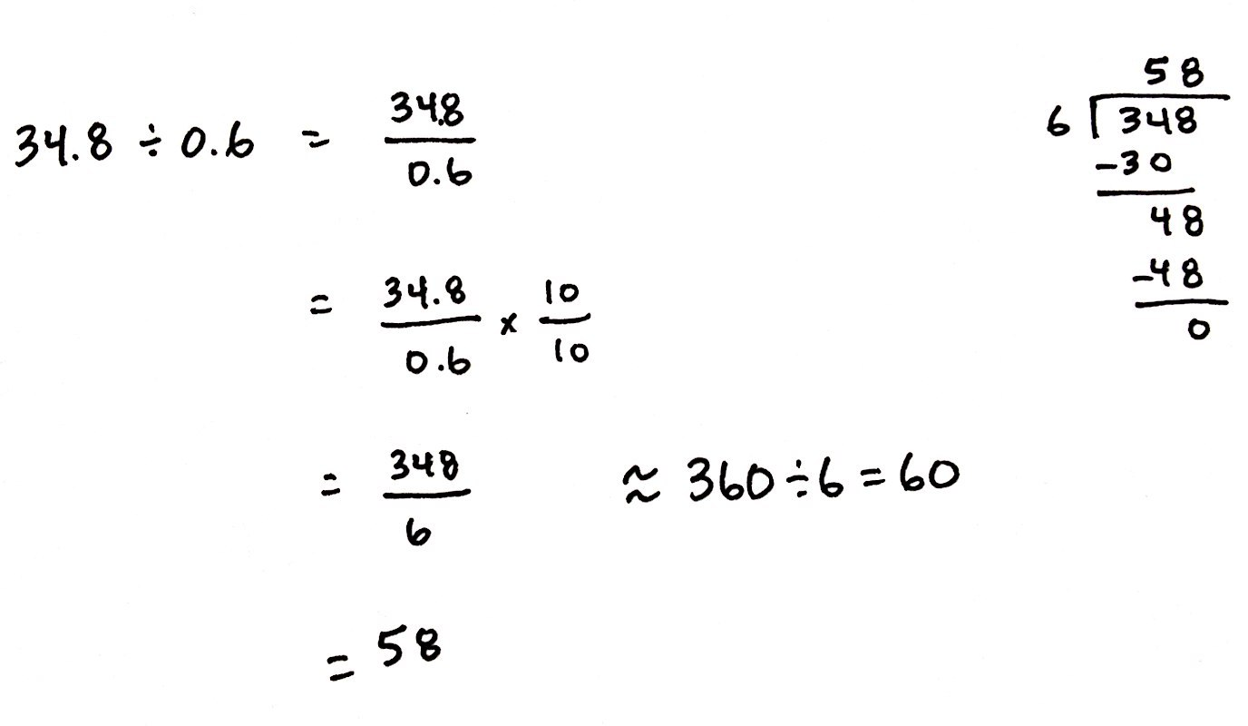
Problem 1: a. 34.8 $\text{÷}$ 0.6 b. 7.36 $\text{÷}$ 0.08
T: (Post Problem 1(a), 34.8 $\text{÷}$ 0.6, on the board.) Rewrite this division expression as a fraction.
S: (Work and show $\frac{34.8}{0.6}$.)
T: (Write = $\frac{34.8}{0.6}$.) How can we express the divisor as a whole number?
S: Multiply by a fraction equal to 1.
T: Tell a neighbor which fraction equal to 1 you’ll use.
S: I could multiply by 5 fifths, which would make the divisor 3, but I’m not sure I want to multiply 34.8 by 5. That’s not as easy. If we multiply by 10 tenths, that would make both the numerator and the denominator whole numbers. There are a lot of choices. If I use 10 tenths, the digits will all stay the same—they will just move to a larger place value.

NOTES ON
MULTIPLE MEANS
OF ENGAGEMENT:
Some students may require a refresher on the process of long division. This example dialogue might help:
T: Can we divide 3 hundreds by 6, or must we decompose?
S: We need to decompose.
T: Let’s work with 34 tens then. What is 34 tens divided by 6?
S: 5 tens.
T: What is 5 tens times 6?
S: 30 tens.
T: How many tens remain?
S: 4 tens.
T: Can we divide 4 tens by 6?
S: Not without decomposing.
T: 4 tens is equal to 40 ones, plus the 8 ones in our whole makes 48 ones. What is 48 ones divided by 6?
S: 8 ones.
T: As always, we have many fractions equal to 1 that would create a whole number divisor. Which fraction would be most efficient?
S: 10 tenths.
T: (Write $\text{×} \frac{10}{10}$.) Multiply, and then show me the equivalent fraction.
S: (Work and show $\frac{348}{6}$.)
T: (Write = $\frac{348}{6}$.) This isn’t mental math like the basic facts we saw yesterday, so before we divide, let’s estimate to give us an idea of a reasonable quotient. Think of a multiple of 6 that is close to 348 and divide.
(Write $\text{≈}$ _____ $\text{÷}$ 6.) Turn and share your ideas with a partner.
S: I can round 348 to 360. I can use mental math to divide 360 by 6 = 60.
T: (Fill in the blank to obtain $\text{≈}$ 360 $\text{÷}$ 6 = 60.) Now, use the division algorithm to find the actual quotient.
S: (Work.)
T: What is 34.8 $\text{÷}$ 0.6? How many 6 tenths are in 34.8?
S: 58.
T: Is our quotient reasonable?
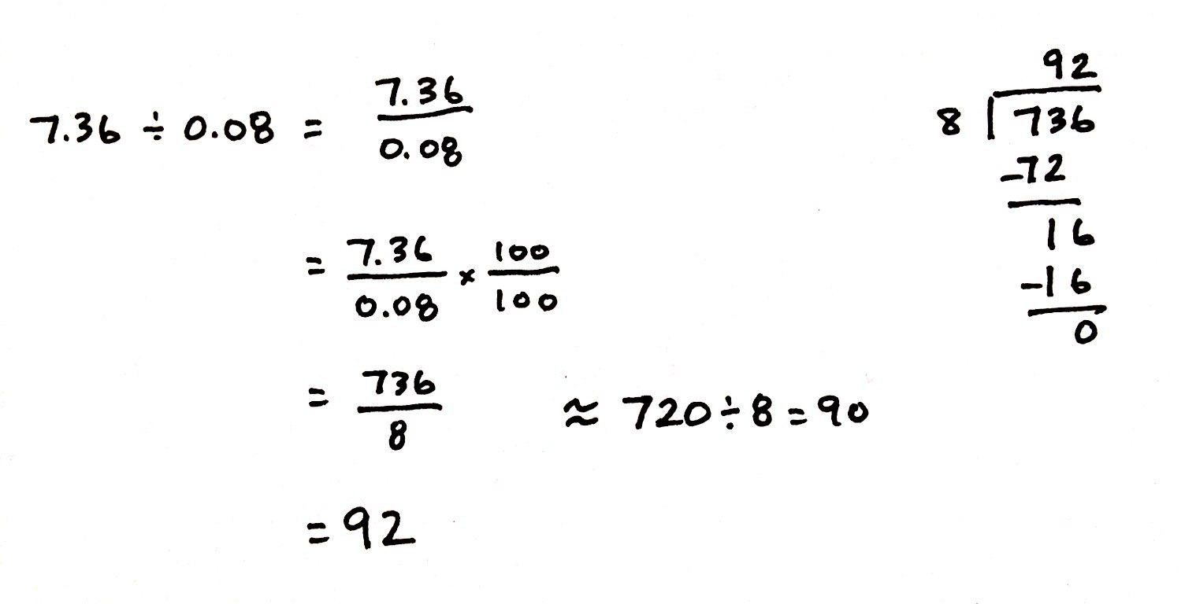
S: Yes, our estimate was 60.
T: (Post Problem 1(b), 7.36 $\text{÷}$ 0.08, on the board.) Work with a partner to find the quotient. Remember to rename your fraction so that the denominator is a whole number.
S: (Work and share.)
T: What is 7.36 $\text{÷}$ 0.08? How many 8 hundredths are in 7.36?
S: 92.
T: Is the quotient reasonable considering your estimate?
S: Yes, our estimate was 100. We got an estimate of 90, so 92 is reasonable.
Problem 2: a. 21.56 $\text{÷}$ 0.98 b. 45.5 $\text{÷}$ 0.7 c. 4.55 $\text{÷}$ 0.7
T: (Post Problem 2(a) on the board.) Rewrite this division expression as a fraction.
S: (Work and show $\frac{21.56}{0.98}.$)
T: We know that, before we divide, we’ll want to rename the divisor as a whole number. Remind me how we’ll do that.
S: Multiply the fraction by $\frac{100}{100}$.
T: Then, what would the fraction be after multiplying?
S: $\frac{2,156}{98}$.
T: In this case, both the divisor and whole become 100 times greater. When we write the number that is 100 times as much, we must shift the digits two places to the…?
MP.7
S: Left.
T: Rather than writing the multiplication sentence to show this, I’m going to record that thinking using arrows. (Draw a thought bubble around the fraction and use arrows to show the change in value of the divisor and whole.)
T: Is this fraction equivalent to the one we started with? Turn and talk.
S: It looks a little different, but it shows the fraction we got when we multiplied by 100 hundredths. It’s equal. Both the divisor and whole were multiplied by the same amount, so the two fractions are still equal.
T: Because it is an equal fraction, the division will give us the same quotient as dividing 21.56 by 0.98. Estimate 98.
S: 100.
T: (Write $\text{≈}$ _____ $\text{÷}$ 100.) Now, estimate the whole, 2,156, as a number that we can easily divide by 100. Turn and talk.

NOTES ON
MULTIPLE MEANS
OF ACTION AND EXPRESSION:
Unit form is a powerful means of representing these dividends so that students can more easily see the multiples of the rounded divisor. Expressing 2,156 as 21 hundreds + 56 ones may allow students to estimate more accurately.
Similarly, students should be using easily identifiable multiples to find an estimated quotient. Remind students about the relationship between multiplication and division so they can think of the following division sentences as multiplication equations:

- 2,200 ÷ 100 =
Think: 100 × = 2,200

- 490 ÷ 7 =
Think: 7 × = 490

S: 100 times 22 is 2,200. 2,156 is between 21 hundreds and 22 hundreds. It’s closer to 22 hundreds. I’ll round to 2,200.
T: Record your estimated quotient, and then work with a partner to divide.
S: (Work and share.)
T: Say the quotient.
S: 22.
T: Is that reasonable?
S: Yes.
T: (Post Problem 2(b), 45.5 $\text{÷}$ 0.7, on the board.) Rewrite this expression as a fraction and show a thought bubble as you rename the divisor as a whole number.
S: (Work and show $\frac{455}{7}$.)
T: Work independently to estimate, and then find the quotient. Check your work with a neighbor as you go.
S: (Work and share.)
T: (Check student work and discuss reasonableness of the quotient. Post Problem 2(c), 4.55 $\text{÷}$ 0.7, on the board.) Use a thought bubble to show this expression as a fraction with a whole number divisor.
S: (Work and show $\frac{45.5}{7}.$)
T: How is this problem similar to and different from the previous one? Turn and talk.
S: The digits are all the same, but the whole is smaller this time. The whole still has a decimal point in it. The whole is 1 tenth the size of the previous whole.
T: We still have a divisor of 7, but this time, our whole is 45 and 5 tenths. Is the whole more than or less than it was in the previous problem?
S: Less than.
T: So, will the quotient be more than 65 or less than 65? Turn and talk.
S: Our whole is smaller, so we can make fewer groups of 7 from it. The quotient will be less than 65. The whole is 1 tenth as large, so the quotient will be, too.
T: Divide.
S: (Work.)
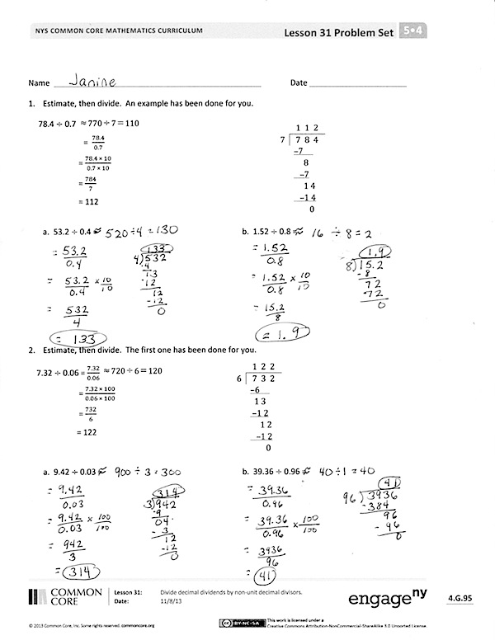
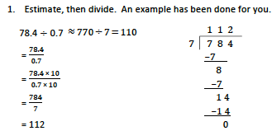
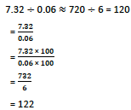
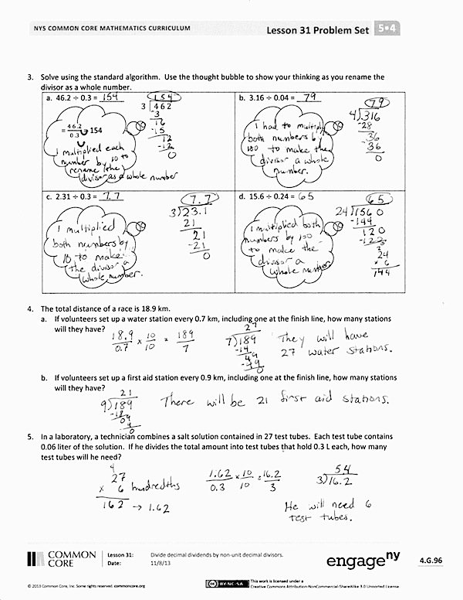
T: What is the quotient?

S: 6 and 5 tenths.
T: Does that make sense?
S: Yes.
Problem Set (10 minutes)
Students should do their personal best to complete the Problem Set within the allotted 10 minutes. For some classes, it may be appropriate to modify the assignment by specifying which problems they work on first. Some problems do not specify a method for solving. Students should solve these problems using the RDW approach used for Application Problems.
Student Debrief (10 minutes)
Lesson Objective: Divide decimal dividends by non‐unit decimal divisors.
The Student Debrief is intended to invite reflection and active processing of the total lesson experience.
Invite students to review their solutions for the Problem Set. They should check work by comparing answers with a partner before going over answers as a class. Look for misconceptions or misunderstandings that can be addressed in the Debrief. Guide students in a conversation to debrief the Problem Set and process the lesson.
You may choose to use any combination of the questions below to lead the discussion.
- Look at the example in Problem 1. What is another way to estimate the quotient? (Students could say 78 divided by 1 is equal to 78.) Compare the two estimated sentences,
770 ÷ 7 = 110 and 78 ÷ 1 = 78. Why is the actual quotient equal to 112? Does it make sense?
- In Problems 1(a) and 1(b), is your actual quotient close to your estimated quotients?
- In Problems 2(a) and 2(b), is your actual quotient close to your estimated quotients?
- How did you solve Problem 4? Share and explain your strategy to a partner.
- How did you solve Problem 5? Did you draw a tape diagram to help you solve? Share and compare your strategy with a partner.
Exit Ticket (3 minutes)
After the Student Debrief, instruct students to complete the Exit Ticket. A review of their work will help you assess the students’ understanding of the concepts that were presented in the lesson today and plan more effectively for future lessons. You may read the questions aloud to the students.

Name Date

 | 1 1 2
7 | 7 8 4
 | –7
 | 8
 | –7
 | 1 4
 | –1 4
 | 0

- Estimate, and then divide. An example has been done for you.
$≈$ ₇₇₀ $÷$ ₇ $=$ ₁₁₀
78.4 $÷$ 0.7
= $\frac{78.4}{0.7}$
=$\frac{78.4 \text{×} 10}{0.7 \text{×} 10}$
= $\frac{784}{7}$
= 112
- 53.2 $÷$ 0.4 $≈$ | b. 1.52 $÷$ 0.8 $≈$

 | 1 2 2
6 | 7 3 2
 | –6
 | 1 3
 | –1 2
 | 1 2
 | –1 2
 | 0

- Estimate, and then divide. The first one has been done for you.
7.32 $÷$ 0.06 $≈$720 $÷$ 6 = 120
= $\frac{7.32}{0.06}$
= $\frac{7.32 \text{×} 100}{0.06 \text{×} 100}$
= $\frac{732}{6}$
= 122
a. 9.42 $÷$ 0.03 $≈$ | b. 39.36 $÷$ 0.96 $≈$

- Solve using the standard algorithm. Use the thought bubble to show your thinking as you rename the divisor as a whole number.

3 | 4 6 2

a. 46.2 $÷$ 0.3 = ______  = $\frac{4 6 . 2}{0 . 3}$ = 154 | b. 3.16 $÷$ 0.04 = ______
c. 2.31 $÷$ 0.3 = ______ | d. 15.6 $\text{÷}$ 0.24 = ______

- The total distance of a race is 18.9 km.
- If volunteers set up a water station every 0.7 km, including one at the finish line, how many stations will they have?

- If volunteers set up a first aid station every 0.9 km, including one at the finish line, how many stations will they have?

- In a laboratory, a technician combines a salt solution contained in 27 test tubes. Each test tube contains 0.06 liter of the solution. If he divides the total amount into test tubes that hold 0.3 liter each, how many test tubes will he need?

Name Date
Estimate first, and then solve using the standard algorithm. Show how you rename the divisor as a whole number.
- 6.39 ÷ 0.09

- 82.14 ÷ 0.6

Name Date

 | 1 1 2
7 | 7 8 4
 | –7
 | 8
 | –7
 | 1 4
 | –1 4
 | 0

- Estimate, and then divide. An example has been done for you.
$≈$ ₇₇₀ $÷$ ₇ $=$ ₁₁₀
78.4 $÷$ 0.7
= $\frac{78.4}{0.7}$
= $\frac{78.4 \text{×} 10}{0.7 \text{×} 10}$
= $\frac{784}{7}$
= 112
 | a. 61.6 $÷$ 0.8 $≈$ |  | b. 5.74 $÷$ 0.7 $≈$

 | 1 2 2
6 | 7 3 2
 | –6
 | 1 3
 | –1 2
 | 1 2
 | –1 2
 | 0

- Estimate, and then divide. An example has been done for you.
$≈$ ₇₂₀ $÷$ ₆ $=$ ₁₂₀
7.32 $÷$ 0.06
= $\frac{7.32}{0.06}$
= $\frac{7.32 \text{×} 100}{0.06 \text{×} 100}$
= $\frac{732}{6}$
= 122
a. 4.74 $÷$ 0.06 $≈$ | b. 19.44 $÷$ 0.54 $≈$

- Solve using the standard algorithm. Use the thought bubble to show your thinking as you rename the divisor as a whole number.

6 | 3 8 4

a. 38.4 $÷$ 0.6 = ______  = $\frac{38.4}{0. 6}$ = | b. 7.52 $÷$ 0.08 = ______
c. 12.45 $÷$ 0.5 = ______ | d. 5.6 $÷$ 0.16 = ______

- Lucia is making a 21.6 centimeter beaded string to hang in the window. She decides to put a green bead every 0.4 centimeters and a purple bead every 0.6 centimeters. How many green beads and how many purple beads will she need?

- A group of 14 friends collects 0.7 pound of blueberries and decides to make blueberry muffins. They put 0.05 pound of berries in each muffin. How many muffins can they make if they use all the blueberries they collected?

