Lesson 30
Objective: Divide decimal dividends by non‐unit decimal divisors.

Suggested Lesson Structure
 Fluency Practice (12 minutes)
 Application Problem (6 minutes)
 Concept Development (32 minutes)
 Student Debrief (10 minutes)
Total Time (60 minutes)
Fluency Practice (12 minutes)
- Sprint: Divide Whole Numbers by Fractions and Fractions by Whole Numbers 5.NBT.7 (9 minutes)
- Divide Decimals 5.NBT.7 (3 minutes)
Sprint: Divide Whole Numbers by Fractions and Fractions by Whole Numbers (9 minutes)
Materials: (S) Divide Whole Numbers by Fractions and Fractions by Whole Numbers Sprint
Note: This fluency activity reviews Lessons 26─28.
Divide Decimals (3 minutes)
Materials: (S) Personal white board
Note: This fluency activity reviews Lesson 29.
T: (Write 1 ÷ 0.1 = ____.) How many tenths are in 1?
S: 10 tenths.
T: 2?
S: 20 tenths.
T: 3?
S: 30 tenths.
T: 9?
S: 90 tenths.
T: (Write 10 ÷ 0.1 = ____.) On your personal white board, complete the equation, answering how many tenths are in 10.
S: (Write 10 ÷ 0.1 = 100.)
T: (Write 20 ÷ 0.1 = ____.) If there are 100 tenths in 10, how many tenths are in 20?
S: 200 tenths.
T: 30?
S: 300 tenths.
T: 70?
S: 700 tenths.
T: (Write 75 ÷ 0.1 = ____.) On your personal white board, complete the equation.
S: (Write 75 ÷ 0.1 = 750.)
T: (Write 75.3 ÷ 0.1 = ____.) Complete the equation.
S: (Write 75.3 ÷ 0.1 = 753.)
Continue this process with the following possible sequence: 0.63 ÷ 0.1, 6.3 ÷ 0.01, 63 ÷ 0.1, and 630 ÷ 0.01.
Application Problem (6 minutes)
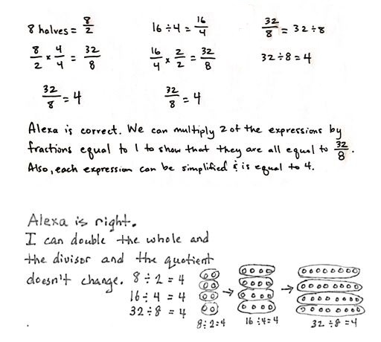
Alexa claims that 16 $\text{÷}$ 4, $\frac{32}{8}$, and 8 halves are all equivalent expressions. Is Alexa correct? Explain how you know.
Method 1
Method 2

Note: This Application Problem reminds students that, when you multiply (or divide) both the divisor and the dividend by the same factor, the quotient stays the same or, alternatively, that when multiplying (or dividing), it can be thought of as the fraction having the same value. This concept is critical to the Concept Development in this lesson.
Concept Development (32 minutes)
Materials: (S) Personal white board
Problem 1: a. 2 $\text{÷}$ 0.1 b. 2 $\text{÷}$ 0.2 c. 2.4 $\text{÷}$ 0.2 d. 2.4 $\text{÷}$ 0.4
T: (Post Problem 1(a), 2 ÷ 0.1, on the board.) We did this yesterday. How many tenths are in 2?
S: 20.
T: (Write = 20.) Tell a partner how you know.
S: I can count by tenths. 1 tenth, 2 tenths, 3 tenths,… all the way up to 20 tenths, which is 2 wholes. There are 10 tenths in 1, so there are 20 tenths in 2. Dividing by 1 tenth is the same as multiplying by 10, and 2 times 10 is 20.
T: We also know that any division expression can be rewritten as a fraction. Rewrite this expression as a fraction.

NOTES ON
MULTIPLE MEANS
OF REPRESENTATION:
The presence of decimals in the denominators in this lesson may pique the interest of students working above grade level. These students can be encouraged to investigate and operate with complex fractions (fractions whose numerator, denominator, or both contain a fraction).
S: (Show $\frac{2}{0.1}$.)
T: That fraction looks different from most we’ve seen before. What’s different about it?
S: The denominator has a decimal point; that’s weird.
T: It is different, but it’s a perfectly acceptable fraction. We can rename this fraction so that the denominator is a whole number. What have we learned that allows us to rename fractions without changing their value?
S: We can multiply by a fraction equal to 1.
T: What fraction equal to 1 will rename the denominator as a whole number? Turn and talk.
S: Multiplying by $\frac{2}{2}$ is easy, but that would just make the denominator 0.2. That’s not a whole number. I think it is fun to multiply by $\frac{13}{13} ,$ but then we’ll still have 1.3 as the denominator. I’ll multiply by $\frac{10}{10}$. That way, I’ll be able to keep the digits the same. If we just want a whole number, $\frac{20}{20}$ would work. Any fraction with a numerator and denominator that are multiples of 10 would work, really.
T: I overheard a lot of suggestions for ways to rename this denominator as a whole number. I’d like you to try some of your suggestions. Be prepared to share your results about what worked and what didn’t. (Allow students time to work and experiment.)
S: (Work and experiment.)
T: Let’s share some of the equivalent fractions we’ve created.
S: (Share while teacher records on the board. Possible examples include $\frac{20}{1},\frac{40}{2},\frac{100}{5}, \text{and} \frac{200}{10}$.)
T: Show me these fractions written as division expressions with the quotient.
S: (Work and show 20$\text{÷}$ 1 = 20, 40 $\text{÷}$2 = 20,
100 $\text{÷}$ 5 = 20, etc.)
T: What do you notice about all of these division sentences?
S: The quotients are all 20.
T: Since all of the quotients are equal to each other, can we say then that these expressions are equivalent as well? (Write 2 $\text{÷}$ 0.1 = 20 $\text{÷}$ 1 = 40 $\text{÷}$ 2, etc.)
S: The answers for all of the expressions are the same, so they are equivalent expressions. Since they are equal but don’t look alike, they remind me of equal fractions.
T: These are all equivalent expressions. When we multiply by a fraction equal to 1, we create equal fractions and an equivalent division expression.
T: (Post Problem 1(b), 2 $\text{÷}$ 0.2, on the board.) Let’s use this thinking as we find the value of this expression. Turn and talk about what you think the quotient will be.
S: I can count by 2 tenths. 2 tenths, 4 tenths, 6 tenths,… 20 tenths. That was 10. The quotient must be 10. Two is like 2.0 or 20 tenths. 20 tenths divided by 2 tenths is going to be 10. The divisor in this problem is twice as large as the one we just did, so the quotient will be half as big. Half of 20 is 10.
T: Let’s see if our thinking is correct. Rewrite this division expression as a fraction.
S: (Work and show $\frac{2}{0.2}$.)
T: What do you notice about the denominator?

NOTES ON
MULTIPLE MEANS
OF ACTION AND EXPRESSION:
Place value mats can be used here to support struggling learners. The same concepts that students studied in Module 1 apply here. By writing the divisor and dividend on a place value mat, students can see that 2 ones divided by 2 tenths is equal to 10 since the digit 2 in the ones place is 10 times greater than a 2 in the tenths place.
S: It’s not a whole number. It’s a decimal.
T: How will you find an equal fraction with a whole number divisor? Share your ideas.
S: We have to multiply it by a fraction equal to 1. I think multiplying by $\frac{5}{5}$ would work. That will make the divisor exactly 1. $\frac{10}{10}$ would work again. That would make $\frac{20}{2}$. This time, any numerator and denominator that is a multiple of 5 would work.
T: I heard the fraction 10 tenths being mentioned during both discussions. What if our divisor were 0.3? If we multiplied by $\frac{10}{10 }$, what would the new denominator be?
S: 3.
T: What if the divisor were 0.8?
S: 8.
T: What about 1.2?
S: 12.
T: What do you notice about the decimal point and digits when we use tenths to rename?
S: The digits stay the same, but they shift to the right. The digits shift so that the numerator and the denominator are 10 times as much.
T: Multiply the fraction by 10 tenths.
S: (Show $\frac{2}{0.2} \text{×} \frac{10}{10} \text{=} \frac{20}{2}$.)
T: What division expression does our renamed fraction represent?
S: 20 divided by 2.
T: What’s the quotient?
S: 10.
T: Let’s be sure. To check our answer (write $\frac{2}{0.2}$ = 10), we multiply the quotient by the…?
S: Divisor.
T: Show me.
S: (Show 10 $\text{×}$0.2 = 2 or 10 $\text{×}$ 2 tenths = 20 tenths.)
T: (Post Problem 1(c), 2.4 $÷$ 0.2, on the board.) Share your thoughts about what the quotient might be for this expression.
S: I think it is 12. I counted by 2 tenths again and got 12. 2.4 is only 4 tenths more than the last problem, and there are two groups of 2 tenths in 4 tenths, so that makes 12 altogether.
I’m thinking 24 tenths divided by 2 tenths is going to be 12. I’m starting to think of it like whole number division. It almost looks like 24 divided by 2, which is 12.
T: Rewrite this division expression as a fraction.
S: (Write and show $\frac{2.4}{0.2}$.)
T: This time, we have a decimal in both the divisor and whole. Remind me. What will you do to rename the divisor as a whole number?
S: Multiply by $\frac{10}{10}$.
T: What will happen to the numerator when you multiply by $\frac{10}{10}$?
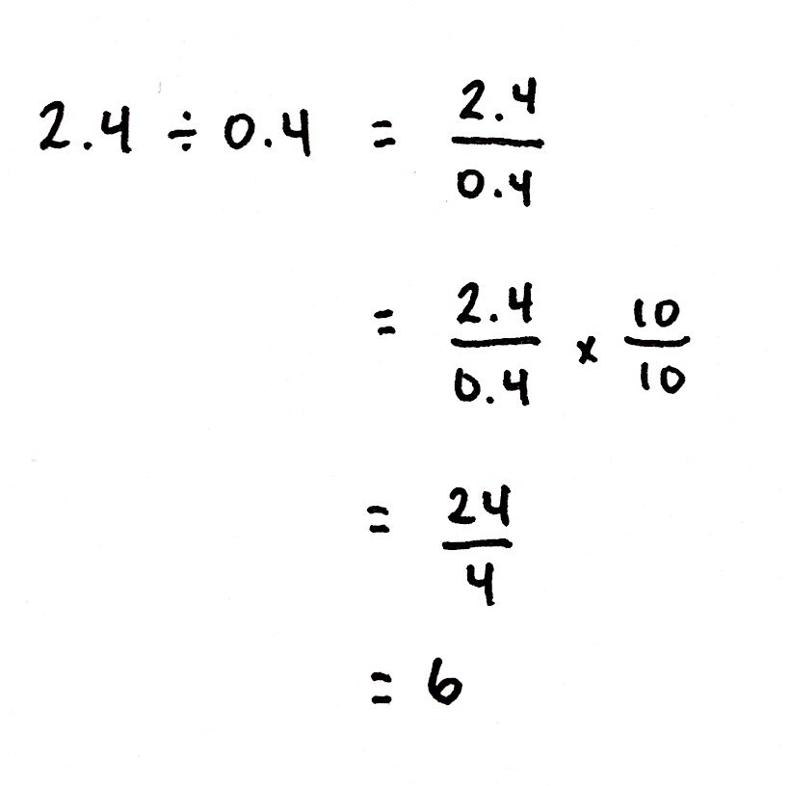
S: It will be renamed as a whole number, too.
T: Show me.
S: (Work and show $\frac{2.4}{0.2} \text{×} \frac{10}{10} \text{=} \frac{24}{2}$.)
T: Say the fraction as a division expression with the quotient.
S: 24 divided by 2 equals 12.
T: Check your work.
S: (Check work.)
T: (Post Problem 1(d), 2.4 ÷ 0.4, on the board.) Work this one independently.
S: (Work and share.)
Problem 2: a. 1.6 $÷$ 0.04 b. 1.68 $÷$ 0.04 c. 1.68 $÷$ 0.12
T: (Post Problem 2(a), 1.6 ÷ 0.04, on the board.) Rewrite this expression as a fraction.
S: (Write $\frac{1.6}{0.04}$.)
T: How is this expression different from the ones we just evaluated?
S: This one is dividing by hundredths. Our divisor is 4 hundredths rather than 4 tenths.
T: Our divisor is still not a whole number, and now it’s a hundredth. Will multiplying by 10 tenths create a whole number divisor?
S: No, 4 hundredths times 10 is just 4 tenths. That’s still not a whole number.
T: Since our divisor is now a hundredth, the most efficient way to rename it as a whole number is to multiply by 100 hundredths. Multiply and show me the equivalent fraction.
S: (Show $\frac{1.6}{0.04} \text{×} \frac{100}{100} \text{=} \frac{160}{4}$.)
T: Say the division expression.
S: 160 divided by 4.
T: This expression is equivalent to 1.6 divided by 0.04. What is the quotient?
S: 40.
T: So, 1.6 divided by 0.04 is also equal to what number?
S: 40.
T: Show me the multiplication sentence you can use to check.
S: (Show 40 $\text{×}$ 0.04 = 1.6 or 40 $\text{×}$ 4 hundredths = 160 hundredths.)
T: (Post Problem 2(b), 1.68 ÷ 0.04, on the board.) Work with your partner to solve and check.
S: (Work.)
T: (Post Problem 2(c), 1.68 ÷ 0.12, on the board.) Work independently to find the quotient. Check your work with a partner after each step.
S: (Work and share.)

Problem Set (10 minutes)
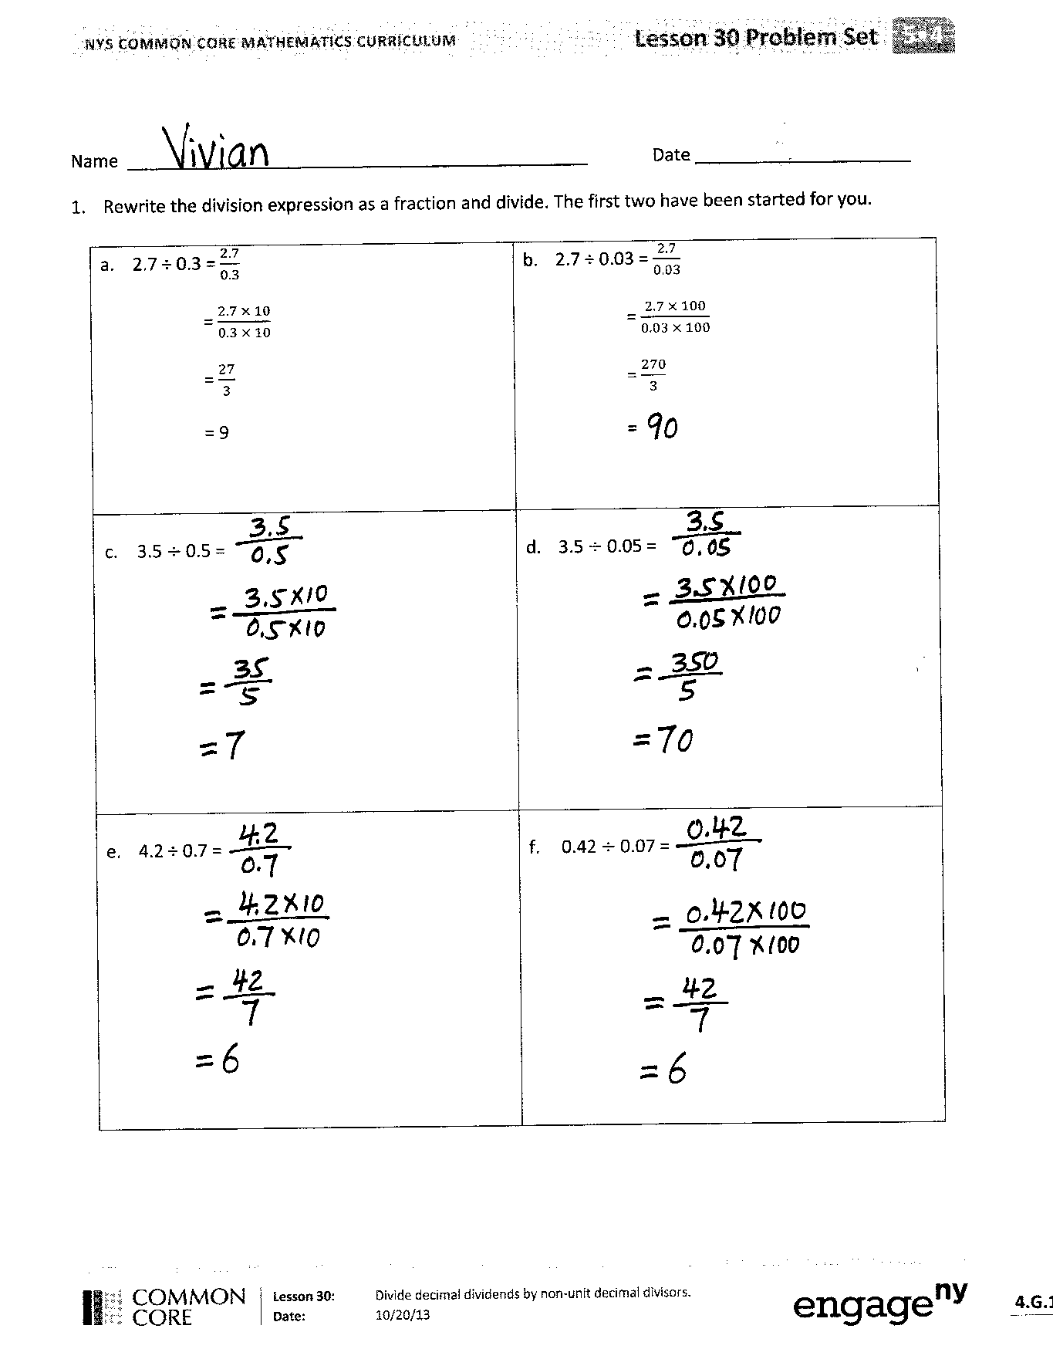
Students should do their personal best to complete the Problem Set within the allotted 10 minutes. For some classes, it may be appropriate to modify the assignment by specifying which problems they work on first. Some problems do not specify a method for solving. Students should solve these problems using the RDW approach used for Application Problems.
Student Debrief (10 minutes)
Lesson Objective: Divide decimal dividends by non‐unit decimal divisors.
The Student Debrief is intended to invite reflection and active processing of the total lesson experience.
Invite students to review their solutions for the Problem Set. They should check work by comparing answers with a partner before going over answers as a class. Look for misconceptions or misunderstandings that can be addressed in the Debrief. Guide students in a conversation to debrief the Problem Set and process the lesson.
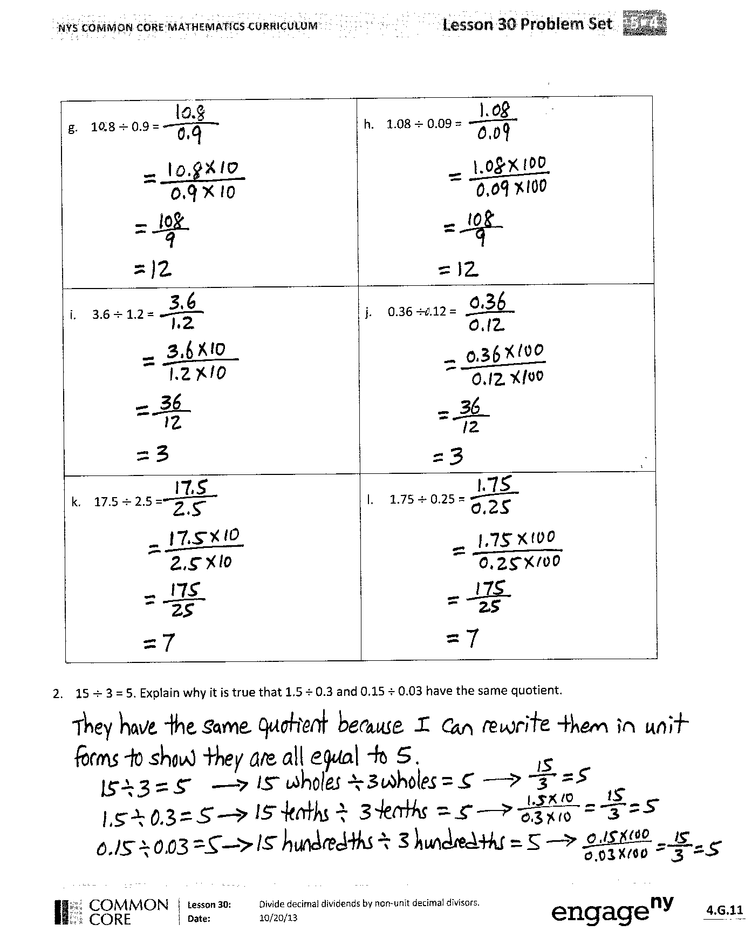
You may choose to use any combination of the questions below to lead the discussion.
- In Problem 1, what did you notice about the relationship between (a) and (b), (c) and (d), (e) and (f), (g) and (h), (i) and (j), and (k) and (l)?
- Share your explanation for Problem 2 with a partner.
- In Problem 3, what is the connection between (a) and (b)? How did you solve (b)? Did you solve it mentally or by recalculating everything?
- Share and compare your solution for Problem 4 with a partner.
- How did you solve Problem 5? Did you use drawings to help you solve the problem? Share and compare your strategy with a partner.
- Use the work you completed today to help you find the quotient of 0.08 $\text{÷}$0.4.

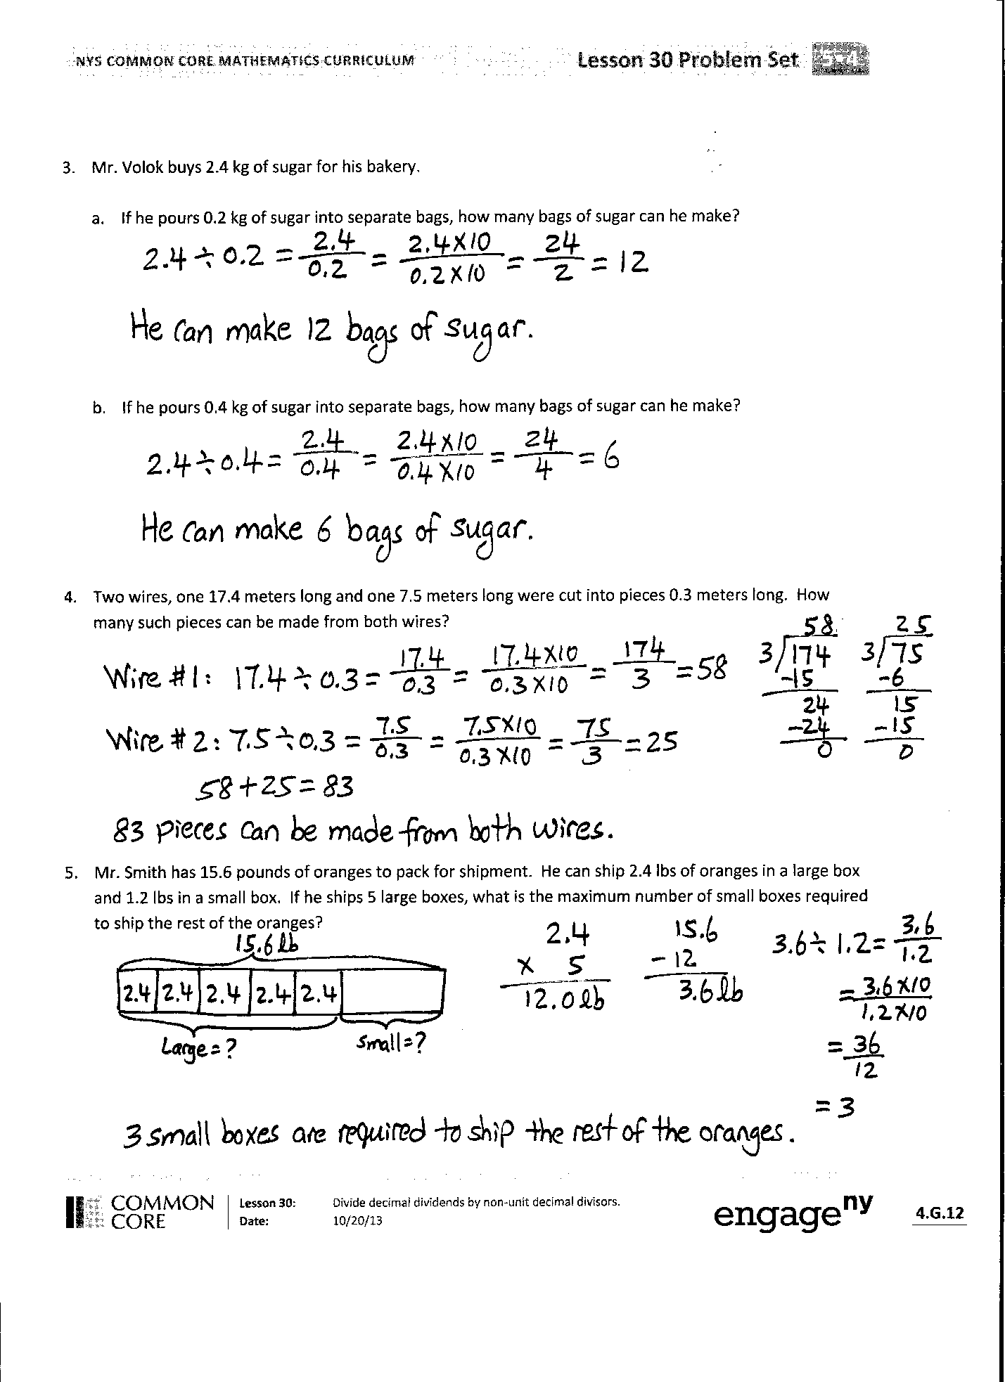
Exit Ticket (3 minutes)
After the Student Debrief, instruct students to complete the Exit Ticket. A review of their work will help you assess the students’ understanding of the concepts that were presented in the lesson today and plan more effectively for future lessons. You may read the questions aloud to the students.

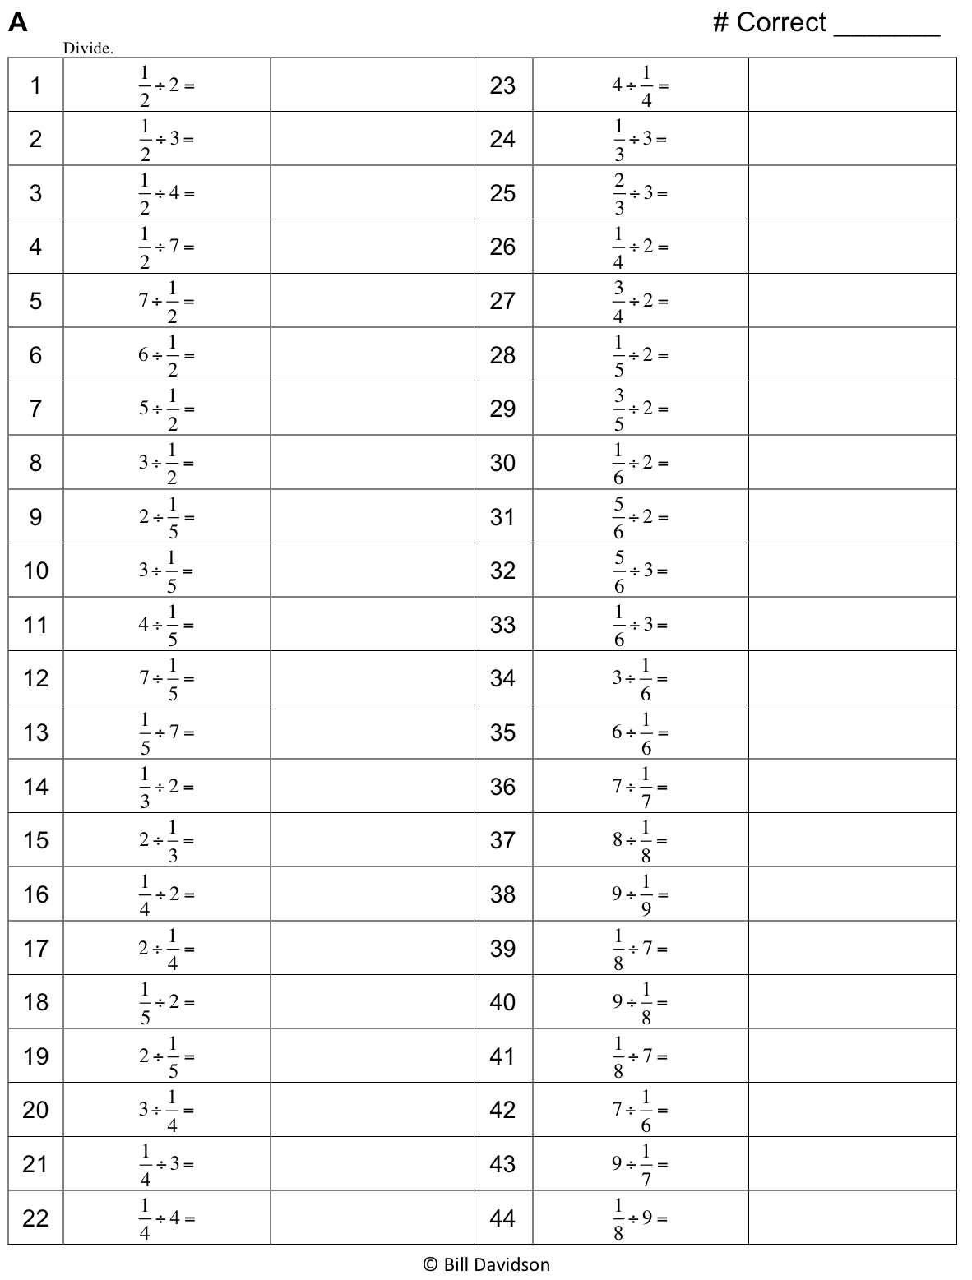
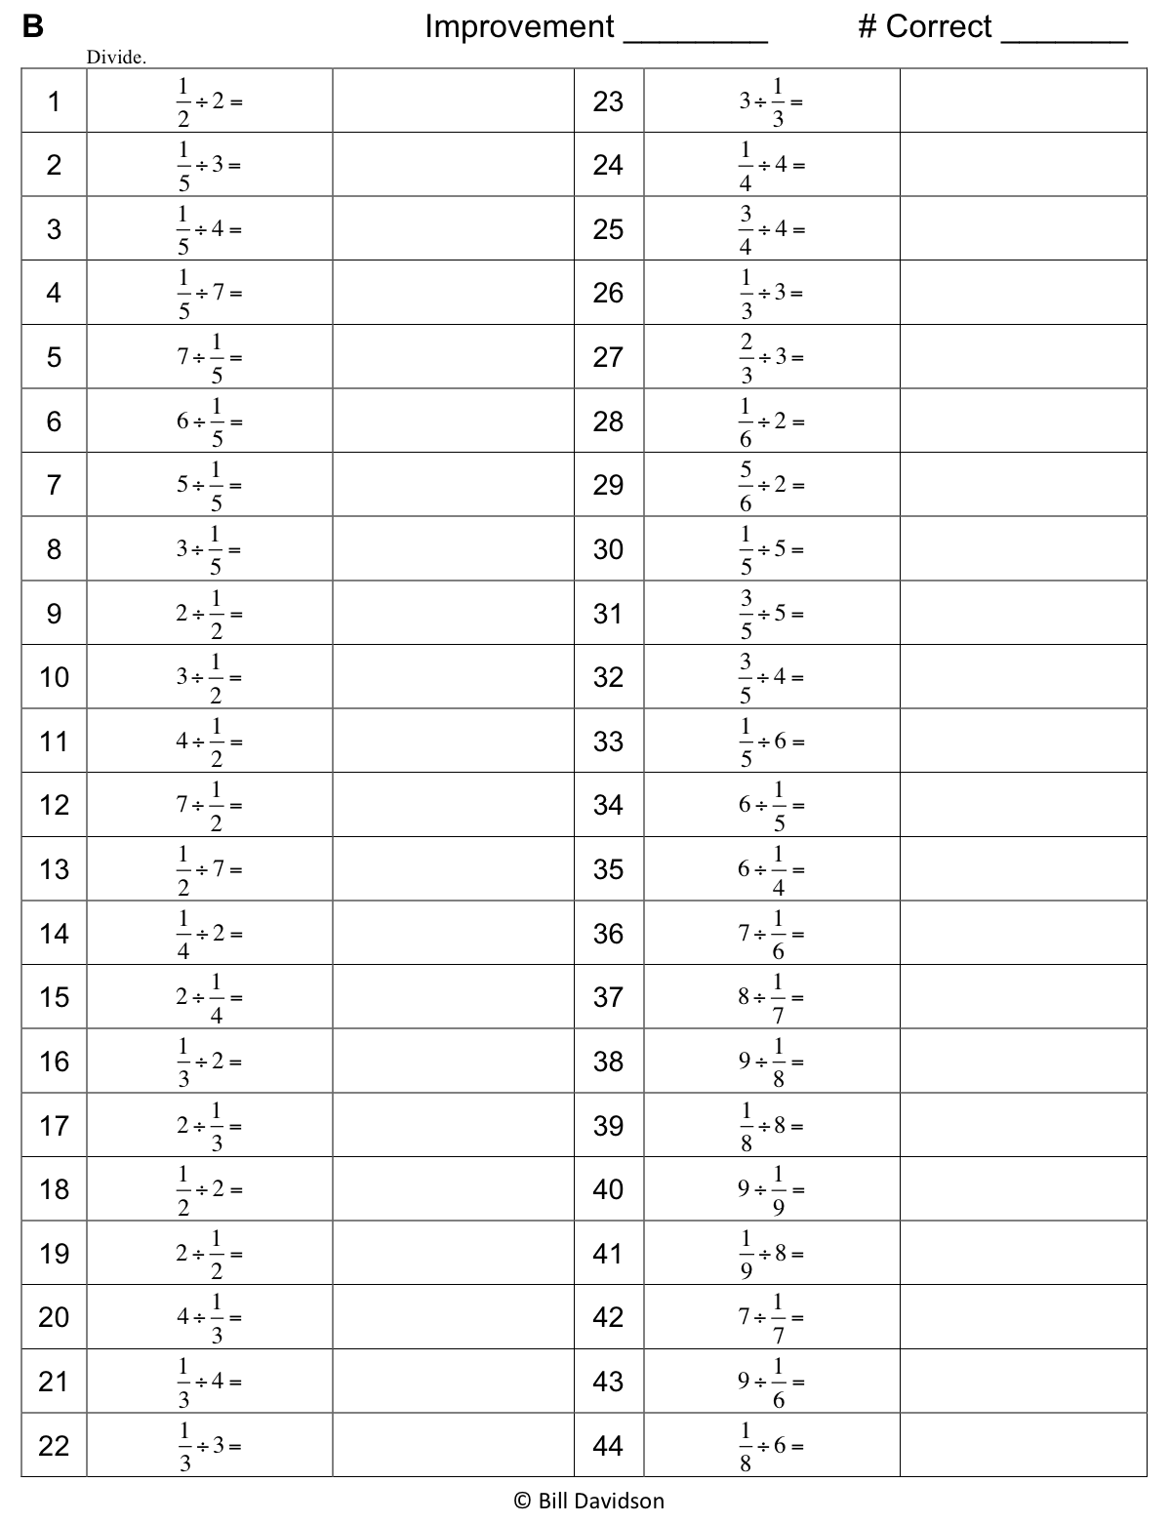
Name Date
- Rewrite the division expression as a fraction and divide. The first two have been started for you.

- 2.7 ÷ 0.3 = $\frac{2.7}{0.3}$  = $\frac{2.7 \text{× }10}{0.3 \text{×} 10}$  = $\frac{27}{3}$  = 9 | - 2.7 ÷ 0.03 = $\frac{2.7}{0.03}$  = $\frac{2.7 \text{×} 100}{0.03 \text{× }100}$  = $\frac{270}{3}$  =
- 3.5 $÷$ 0.5 = | - 3.5 $÷$ 0.05 =
- 4.2 ÷ 0.7 = | - 0.42 $÷$ 0.07 =
- 10.8 $÷$ 0.9 = | - 1.08 $÷$ 0.09 =
- 3.6 $÷$ 1.2 = | - 0.36 $÷$ 0.12 =
- 17.5 $÷$2.5 = | - 1.75 $÷$ 0.25 =

- 15 $÷$ 3 = 5. Explain why it is true that 1.5 ÷ 0.3 and 0.15 ÷ 0.03 have the same quotient.

- Mr. Volok buys 2.4 kg of sugar for his bakery.
- If he pours 0.2 kg of sugar into separate bags, how many bags of sugar can he make?

- If he pours 0.4 kg of sugar into separate bags, how many bags of sugar can he make?

- Two wires, one 17.4 meters long and one 7.5 meters long, were cut into pieces 0.3 meters long. How many such pieces can be made from both wires?

- Mr. Smith has 15.6 pounds of oranges to pack for shipment. He can ship 2.4 pounds of oranges in a large box and 1.2 pounds in a small box. If he ships 5 large boxes, what is the minimum number of small boxes required to ship the rest of the oranges?
Name Date
Rewrite the division expression as a fraction and divide.

- 3.2 ÷ 0.8 = | - 3.2 ÷ 0.08 =
- 7.2 $÷$ 0.9 = | - 0.72 $÷$ 0.09 =

Name Date
- Rewrite the division expression as a fraction and divide. The first two have been started for you.

- 2.4 ÷ 0.8 = $\frac{2.4}{0.8}$  = $\frac{2.4 \text{×} 10}{0.8 \text{×} 10}$  = $\frac{24}{8}$  = | - 2.4 ÷ 0.08 = $\frac{2.4}{0.08}$  = $\frac{2.4 \text{×} 100}{0.08 \text{×} 100}$  = $\frac{240}{8}$  =
- 4.8 ÷ 0.6 = | - 0.48 $÷$ 0.06 =
- 8.4 $÷$ 0.7 = | - 0.84 $÷$ 0.07 =
- 4.5 $÷$ 1.5 = | - 0.45 $÷$ 0.15 =
- 14.4 $÷$1.2 = | - 1.44 $÷$ 0.12 =

- Leann says 18 $\text{÷}$ 6 = 3, so 1.8 ÷ 0.6 = 0.3 and 0.18 ÷ 0.06 = 0.03. Is Leann correct? Explain how to solve these division problems.

- Denise is making bean bags. She has 6.4 pounds of beans.
- If she makes each bean bag 0.8 pounds, how many bean bags will she be able to make?

- If she decides instead to make mini bean bags that are half as heavy, how many can she make?

- A restaurant’s small salt shakers contain 0.6 ounces of salt. Its large shakers hold twice as much. The shakers are filled from a container that has 18.6 ounces of salt. If 8 large shakers are filled, how many small shakers can be filled with the remaining salt?

