Lesson 29
Objective: Connect division by a unit fraction to division by 1 tenth and 1 hundredth.

Suggested Lesson Structure
 Fluency Practice (9 minutes)
 Application Problem (10 minutes)
 Concept Development (31 minutes)
 Student Debrief (10 minutes)
Total Time (60 minutes)
Fluency Practice (9 minutes)
- Count by Fractions 5.NF.7 (5 minutes)
- Divide Whole Numbers by Unit Fractions and Fractions by Whole Numbers 5.NF.7 (4 minutes)
Count by Fractions (5 minutes)
Materials: (S) Personal white board
Note: This fluency activity prepares students for today’s lesson.
T: Count by tenths to 20 tenths. When you reach a whole number, say the whole number.
(Write as students count.)
S: 1 tenth, 2 tenths, 3 tenths, 4 tenths, 5 tenths, 6 tenths, 7 tenths, 8 tenths, 9 tenths, 1 whole, 11 tenths, 12 tenths, 13 tenths, 14 tenths, 15 tenths, 16 tenths, 17 tenths, 18 tenths, 19 tenths, 2 wholes.
T: How many tenths are in 1 whole?
S: 10 tenths.
T: 2 wholes?
S: 20 tenths.
T: 3 wholes?
S: 30 tenths.
T: 9 wholes.
S: 90 tenths.
T: 10 wholes?
S: 100 tenths.
T: (Write 10 = 100 tenths. Beneath it, write 20 = ____ tenths.) On your personal white board, fill in the unknown.
S: (Write 20 = 200 tenths.)
Continue the process with 30, 50, 70, and 90.
T: (Write 90 = 900 tenths. Beneath it, write 91 = ____ tenths.) On your personal white board, fill in the unknown.
S: (Write 91 = 910 tenths.)
Continue the process with 92, 82, 42, 47, 64, 64.1, 64.2, and 83.5.
Divide Whole Numbers by Unit Fractions and Fractions by Whole Numbers (4 minutes)
Materials: (S) Personal white board
Note: This fluency activity reviews Lessons 25─27 and prepares students for today’s lesson.
T: (Write 2 ÷ $\frac{\text{1}}{\text{2}}$ .) Say the division sentence with the answer.
S: 2 ÷ $\frac{\text{1}}{\text{2}}$ = 4.
T: (Write 2 ÷ $\frac{\text{1}}{\text{2}}$ = 4. Beneath it, write 3 ÷ $\frac{\text{1}}{\text{2}}$ .) Say the division sentence with the answer.
S: 3 ÷ $\frac{\text{1}}{\text{2}}$ = 6.
T: (Write 3 ÷ $\frac{\text{1}}{\text{2}}$ = 6. Beneath it, write 8 ÷ $\frac{\text{1}}{\text{2}}$ .) On your personal white board, complete the division sentence.
S: (Write 8 ÷ $\frac{\text{1}}{\text{2}}$ = 16.)
Continue the process with 5 ÷ $\frac{\text{1}}{\text{4}}$ , 7 ÷ $\frac{\text{1}}{\text{3}}$ , 1 ÷ $\frac{\text{1}}{\text{10}}$, 2 ÷ $\frac{\text{1}}{\text{10}}$, 7 ÷ $\frac{\text{1}}{\text{10}}$ , and 10 ÷ $\frac{\text{1}}{\text{10}}$.
T: (Write $\frac{\text{1}}{\text{2}}$ ÷ 3.) Say the division sentence with the answer.
S: $\frac{\text{1}}{\text{2}}$ ÷ 3 = $\frac{\text{1}}{\text{6}}$.
T: (Write $\frac{\text{1}}{\text{2}}$ ÷ 3 = $\frac{\text{1}}{\text{6}}$. Beneath it, write $\frac{\text{1}}{\text{3}}$ ÷ 4.) Say the division sentence with the answer.
S: $\frac{\text{1}}{\text{3}}$ ÷ 4 = $\frac{\text{1}}{\text{12}}$.
T: (Write $\frac{\text{1}}{\text{3}}$ ÷ 4 = $\frac{\text{1}}{\text{12}}$. Beneath it, write $\frac{\text{1}}{\text{8}}$ ÷ 5.) On your personal white board, complete the division sentence.
S: (Write $\frac{\text{1}}{\text{8}}$ ÷ 5 = $\frac{\text{1}}{\text{40}}$.)
T: (Write $\frac{\text{1}}{\text{4}}$ ÷ 5.) Say the division sentence with the answer.
S: $\frac{\text{1}}{\text{4}}$ ÷ 5 = $\frac{1}{20}$.
Continue the process with 7 ÷ $\frac{\text{1}}{\text{4}}$, $\frac{\text{1}}{\text{4}}$ ÷ 7, 5 ÷ $\frac{\text{1}}{\text{6}}$ , $\frac{\text{1}}{\text{6}}$ ÷ 5, $\frac{\text{1}}{\text{8}}$ ÷ 7, and 9 ÷ $\frac{\text{1}}{\text{8}}$.
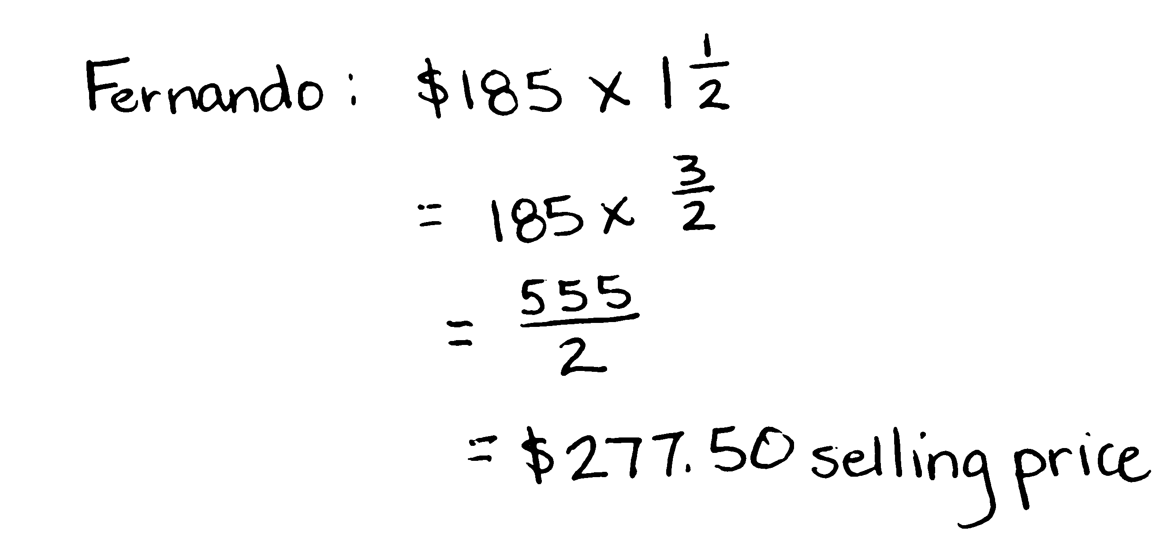
Application Problem (10 minutes)
Fernando bought a jacket for $185 and sold it for $\text{1}\frac{\text{1}}{\text{2}}$ times what he paid. Marisol spent $\frac{\text{1}}{\text{5}}$ as much as Fernando on the same jacket but sold it for $\frac{\text{1}}{\text{2}}$ as much as Fernando did. How much money did Marisol make? Explain your thinking using a diagram.
Note: This problem is a multi-step problem requiring a high level of organization. Scaling language and fraction multiplication from Topic G, coupled with fraction of a set and subtraction, warrant the extra time given to today’s Application Problem.
Concept Development (31 minutes)
Materials: (S) Personal white board
Problem 1: 7 $\text{÷}$ 0.1
T: (Post Problem 1 on the board.) Read the division expression using unit form.
S: 7 ones divided by 1 tenth.

NOTES ON
MULTIPLE MEANS
OF ACTION AND EXPRESSION:
The same place value mats that were used in previous modules can be used in this lesson to support students who are struggling. Students can start Problem 1 by drawing or placing 7 disks in the ones column. Teachers can follow the same dialogue that is written in the lesson. Have the students physically decompose the 7 wholes into 70 tenths, which can then be divided by one-tenth.
T: Rewrite this expression using a fraction.
S: (Write 7 $\text{÷}$ $\frac{\text{1}}{\text{10}}$.)
T: (Write 7 $\text{÷}\frac{\text{1}}{\text{10}}$.) What question does this division expression ask us?
S: How many tenths are in 7? 7 is one tenth of what number?
T: (Write There are ____ tenths in 1 whole.) Let’s start with just 1 whole. How many tenths are in 1 whole?
S: 10 tenths.

T: (Write 10 in the blank, and then below it write, There are _____ tenths in 7 wholes.) So, if there are 10 tenths in 1 whole, how many are in 7 wholes?
S: 70 tenths.
T: (Write 70 in the blank.) Explain how you know. Turn and talk.
S: There are 10 tenths in 1, 20 tenths in 2, and 30 tenths in 3, so there are 70 tenths in 7. 7 is 7 times greater than 1, and 70 tenths is 7 times more than 10 tenths. Seven times 10 is 70 so there are 70 tenths in 7.
MP.2
T: Let’s think about it another way. 7 is one-tenth of what number? Explain to your partner how you know.
S: It’s 70 because I think of a tape diagram with 10 parts, and 1 part is 7. 7 × 10 is 70. I think of place value. Just move each digit one place to the left. It’s ten times as much.
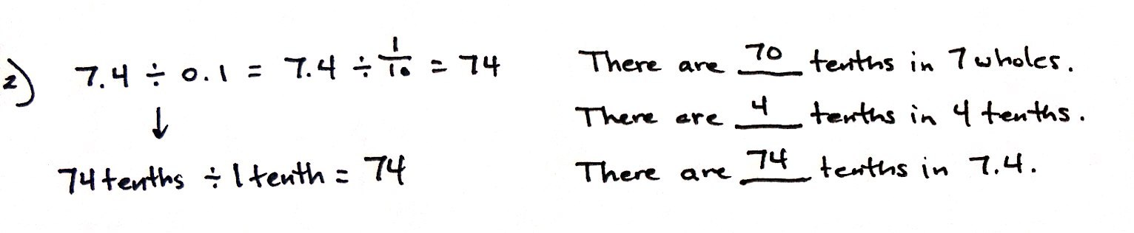
Problem 2: 7.4 $\text{÷}$ 0.1
T: (Post Problem 2 on the board.) Rewrite this division expression using a fraction for the divisor.
S: (Write 7.4 $\text{÷}\frac{\text{1}}{\text{10}}$.)
T: Compare this problem to the one we just solved. What do you notice? Turn and talk.
S: There still are 7 wholes, but now there are also 4 more tenths. The whole in this problem is just 4 tenths more than in problem 1. There are 74 tenths instead of 70 tenths. We can ask ourselves, 7.4 is 1 tenth of what number?
T: We already know part of this problem. (Write There are _____ tenths in 7 wholes.) How many tenths are in 7 wholes?
S: 70.
T: (Write 70 in the blank, and below it, write There are _____ tenths in 4 tenths.) How many tenths are in 4 tenths?
S: 4.
T: (Point to 7 ones.) So, if there are 70 tenths in 7 wholes, and (point to 4 tenths) 4 tenths in 4 tenths, how many tenths are in 7 and 4 tenths?
S: 74.
T: Work with your partner to rewrite this expression using only tenths to name the whole and divisor.
S: (Write 74 tenths $\text{÷}$ 1 tenth.)
T: Look at our new expression. How many tenths are in 74 tenths?
S: 74 tenths.
T: (Write 6$\text{÷}$0.1.) Read this expression.
S: 6 divided by 1 tenth.
T: How many tenths are in 6? Show me on your personal white board.
S: (Write and show 60 tenths.)
T: 6 is 1 tenth of what number?
S: 60.
T: (Erase 6 and replace with 6.2.) How many tenths in 6.2?
S: (Write 62 tenths.)
T: 6.2 is 1 tenth of what number?
S: 62.
Continue the process with 9 ÷ 0.1, 9.8 ÷ 0.1, 12 ÷ 0.1, and 12.6 ÷ 0.1.
Problem 3: a. 7 $\text{÷}$ 0.01 b. 7.4 $\text{÷}$ 0.01 c. 7.49 $\text{÷}$ 0.01
T: (Post Problem 3 (a) on the board.) Read this expression.
S: 7 divided by 1 hundredth.
T: Rewrite this division expression using a fraction for the divisor.
S: (Write 7 $\text{÷}\frac{\text{1}}{\text{100}}$.)
T: We can think of this as finding how many hundredths are in 7. Will your thinking need to change to solve this? Turn and talk.
S: No, because the question is really the same. How many smaller units are in the whole? The units we are counting are different, but that doesn’t really change how we find the answer.

NOTES ON
MULTIPLE MEANS
OF REPRESENTATION:
Generally speaking, it is better for teachers to use unit form when they read decimal numbers. For example, seven and four-tenths is generally preferable to seven point four. Seven point four is appropriate when teachers or students are trying to express what they need to write. Similarly, it is preferable to read fractions in unit form, too. For example, it’s better to say two-thirds, rather than two over three unless referring to how the fraction is written.
T: Will our quotient be greater or less than our last problem? Again, talk with your partner.
S: The quotient will be greater because we are counting units that are much smaller, so there’ll be more of them in the wholes. It’s the same basic idea, but since our divisor has gotten smaller, the quotient should be larger than before.
T: Before we think about how many hundredths are in 7 wholes, let’s find how many hundredths are in 1 whole. (Write on the board: There are _____ hundredths in 1 whole.) Fill in the blank.
S: 100.
T: (Write 100 in the blank. Write, There are _____ hundredths in 7 wholes.) Knowing this, how many hundredths are in 7 wholes?
S: 700.

T: (Write 700 in the blank. Then, post Problem 3 (b) on the board.) What is the whole in this division expression?
S: 7 and 4 tenths.
T: How will you solve this problem? Turn and talk.
S: It’s only 4 more tenths than the one we just solved. We need to figure out how many hundredths are in 4 tenths.
We know there are 700 hundredths in 7 wholes, and this is 4 tenths more than that. There are 10 hundredths in 1 tenth so there must be 40 hundredths in 4 tenths.
T: How many hundredths are in 7 wholes?
S: 700.
T: How many hundredths in 4 tenths?
S: 40.
T: How many hundredths in 7.4?
S: 740.
T: Asked another way, if 7.4 is 1 hundredth, what is the whole?
S: 740.
T: (Post Problem 3 (c) on the board.) Work with a partner to solve this problem. Be prepared to explain your thinking.
S: (Work and show 7.49 $\text{÷}$ 0.01 = 749.)
T: Explain your thinking as you solved.
S: 7.49 is just 9 hundredths more in the dividend than 7.4 $\text{÷}$ 0.01, so the answer must be 749. There are 700 hundredths in 7, and 49 hundredths in 49 hundredths. That’s 749 hundredths all together.
T: Let’s try some more. Think first... how many hundredths are in 6? Show me.
S: (Show 600.)
T: Show me how many hundredths are in 6.2?
S: (Show 620.)
T: 6.02?
S: (Show 602.)
T: 12.6?
S: (Show 1,260.)
T: 12.69?
S: (Show 1,269.)
T: What patterns are you noticing as we find the number of hundredths in each of these quantities?
MP.2
S: The digits stay the same, but they are in a larger place value in the quotient. I’m beginning to notice that, when we divide by a hundredth, each digit shifts two places to the left. It’s like multiplying by 100.
T: That helps us think of our division expression differently. When we divide by a hundredth, we can think, “This number is 1 hundredth of what whole?” or “What number is this 1 hundredth of?”
MP.2
T: (Write 7 ÷ $\frac{\text{1}}{\text{100}}$ on the board.) What number is 7 one hundredths of?
S: 700.
T: Explain to your partner how you know.
S: It’s like thinking 7 times 100 because 7 is one of a hundred parts. It’s place value again, but this time, the digits shifted two places to the right.
T: You can use that way of thinking about these expressions, too.
Problem Set (10 minutes)
Students should do their personal best to complete the Problem Set within the allotted 10 minutes. For some classes, it may be appropriate to modify the assignment by specifying which problems they work on first. Some problems do not specify a method for solving. Students should solve these problems using the RDW approach used for Application Problems.
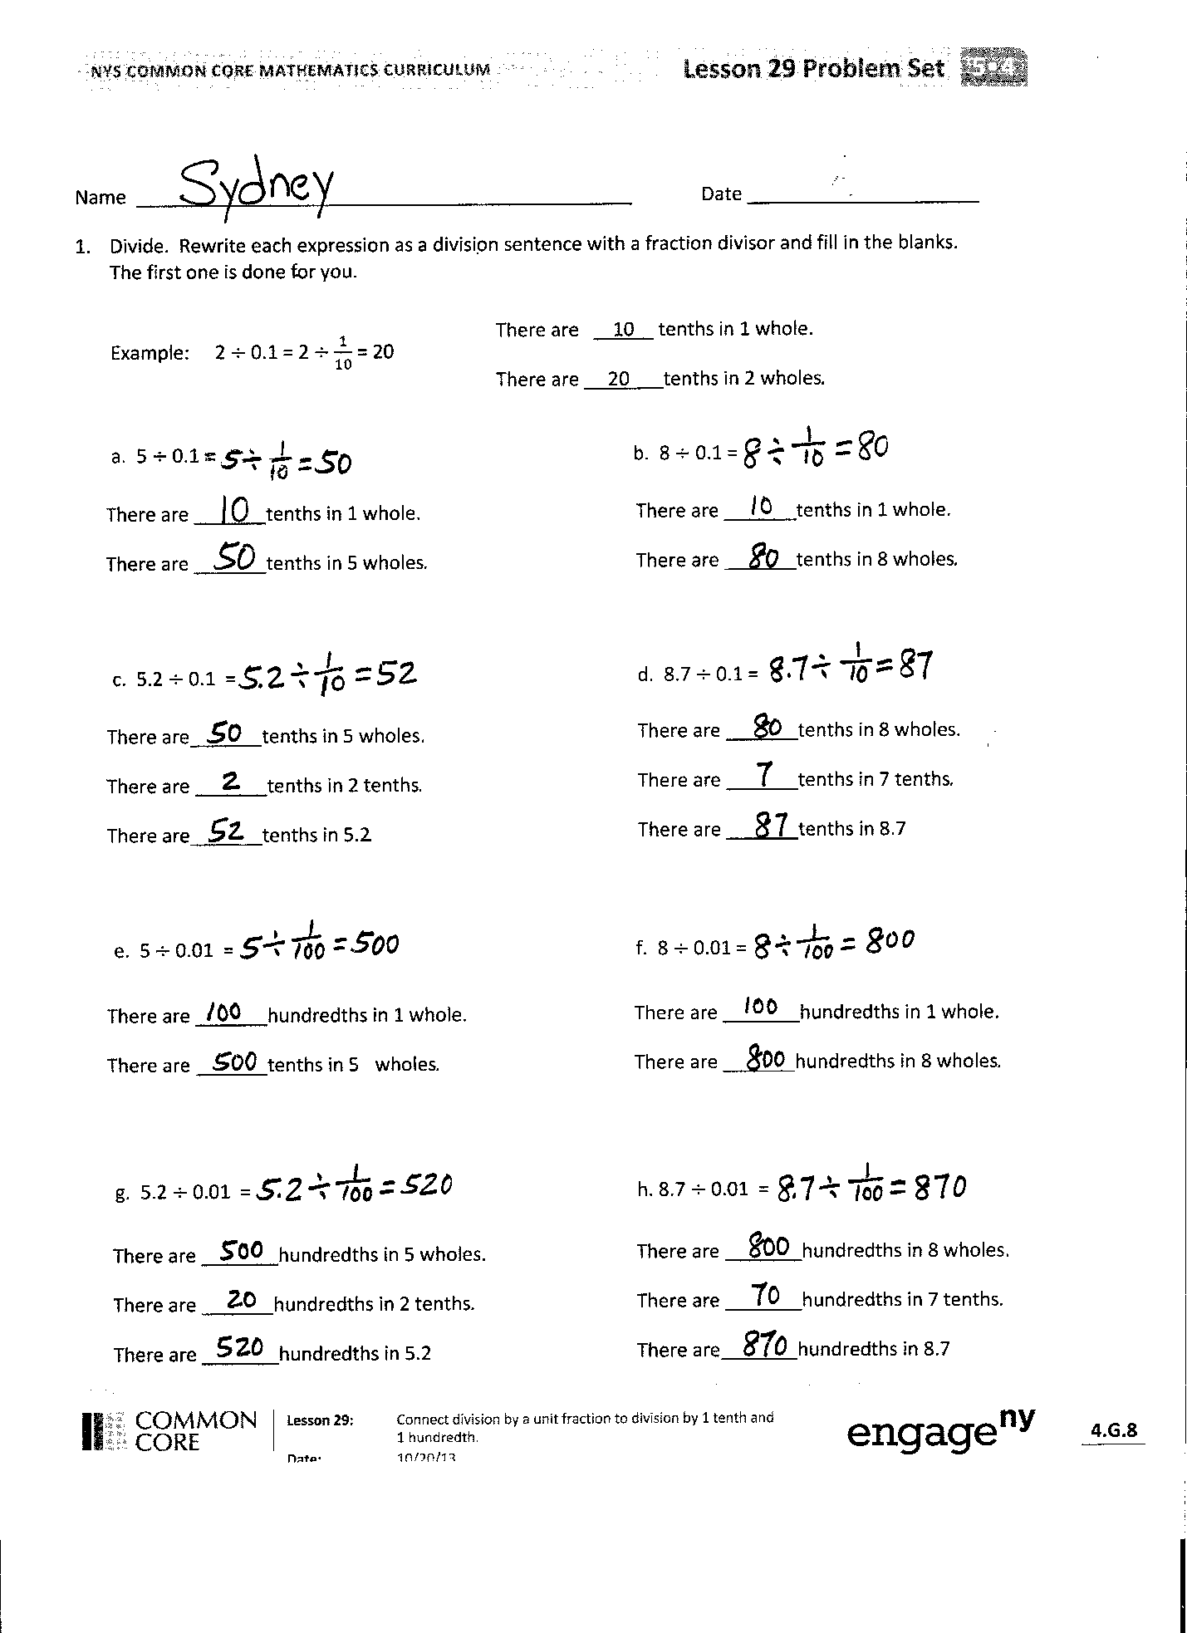
Student Debrief (10 minutes)
Lesson Objective: Connect division by a unit fraction to division by 1 tenth and 1 hundredth.
The Student Debrief is intended to invite reflection and active processing of the total lesson experience.
Invite students to review their solutions for the Problem Set. They should check work by comparing answers with a partner before going over answers as a class. Look for misconceptions or misunderstandings that can be addressed in the Debrief. Guide students in a conversation to debrief the Problem Set and process the lesson.
You may choose to use any combination of the questions below to lead the discussion.
- In Problem 1, did you notice the relationship between (a) and (c), (b) and (d), (e) and (g), (f) and (h)?
- What is the relationship between Problems 2(a) and 2(b)? (The quotient of (b) is triple that of (a).)
- What strategy did you use to solve Problem 3? Share your strategy and explain to a partner.
- How did you answer Problem 4? Share your thinking with a partner.
- Compare your answer for Problem 5 to your partner’s.
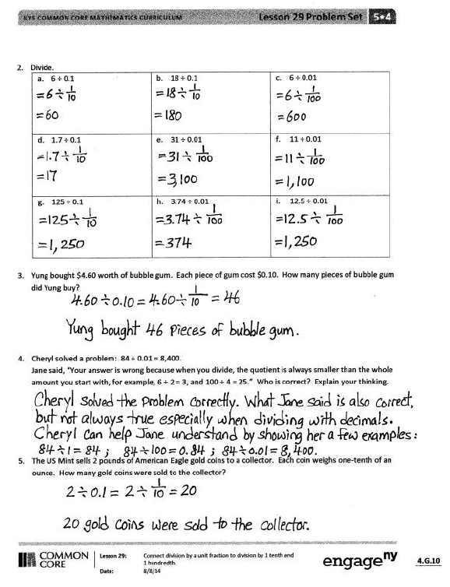
- Connect the work of Module 1, the movement on the place value chart, to the division work of this lesson. (Back then, the focus was on conversion between units. However, it’s important to note that place value work asks the same questions, “How many tenths are in 1 whole?” “How many hundredths are in a tenth?” Further, the partitive division interpretation leads naturally to a discussion of multiplication by powers of 10. That is, if 6 is 1 hundredth, what is the whole? (6 $\text{×}$ 100 = 600.) This echoes the work students have done on the place value chart.)
Exit Ticket (3 minutes)
After the Student Debrief, instruct students to complete the Exit Ticket. A review of their work will help you assess the students’ understanding of the concepts that were presented in the lesson today and plan more effectively for future lessons. You may read the questions aloud to the students.

Name Date
- Divide. Rewrite each expression as a division sentence with a fraction divisor, and fill in the blanks.
The first one is done for you.
There are 10 tenths in 1 whole.
There are 20 tenths in 2 wholes.

Example: 2 $÷$ 0.1 = 2 $÷$ $\frac{\text{1}}{\text{10}}$ = 20

a. 5 $÷$0.1 = b. 8$÷$ 0.1 =
There are tenths in 1 whole.
There are tenths in 8 wholes.

There are tenths in 1 whole.
There are tenths in 5 wholes.

d. 8.7 $÷$ 0.1 =
c. 5.2 $÷$ 0.1 =
There are tenths in 8 wholes.
There are tenths in 7 tenths.
There are tenths in 8.7

There are tenths in 5 wholes.
There are tenths in 2 tenths.
There are tenths in 5.2

e. 5 $÷$ 0.01 = f. 8 $÷$ 0.01 =
There are hundredths in 1 whole.
There are hundredths in 8 wholes.

There are hundredths in 1 whole.
There are hundredths in 5 wholes.

g. 5.2 $÷$ 0.01 = h. 8.7 $÷$ 0.01 =
There are hundredths in 8 wholes.
There are hundredths in 7 tenths.
There are hundredths in 8.7

There are hundredths in 5 wholes.
There are hundredths in 2 tenths.
There are hundredths in 5.2

- Divide.
- 6 ÷ 0.1 | - 18 ÷ 0.1 | - 6 ÷ 0.01
- 1.7 ÷ 0.1 | - 31 ÷ 0.01 | - 11 ÷ 0.01
- 125 ÷ 0.1 | - 3.74 ÷ 0.01 | - 12.5 ÷ 0.01

- Yung bought $4.60 worth of bubble gum. Each piece of gum cost $0.10. How many pieces of bubble gum did Yung buy?

- Cheryl solved a problem: 84 ÷ 0.01 = 8,400.
Jane said, “Your answer is wrong because when you divide, the quotient is always smaller than the whole amount you start with, for example, 6 ÷ 2 = 3 and 100 ÷ 4 = 25.” Who is correct? Explain your thinking.

- The U.S. Mint sells 2 ounces of American Eagle gold coins to a collector. Each coin weighs one-tenth of an ounce. How many gold coins were sold to the collector?

Name Date
- 8.3 is equal to 2. 28 is equal to

_______ tenths _______ hundredths

_______ hundredths _______ tenths

3. 15.09 ÷ 0.01 = _______ 4. 267.4 ÷ $\frac{\text{1}}{\text{10}}$ = _______

- 632.98 ÷ $\frac{\text{1}}{\text{100}}$ = _______

Name Date
- Divide. Rewrite each expression as a division sentence with a fraction divisor, and fill in the blanks. The first one is done for you.

Example: 4 $\text{÷}$ 0.1 = 4 $\text{÷}\frac{\text{1}}{\text{10}}$ = 40
There are 10 tenths in 1 whole.
There are 40 tenths in 4 wholes.

There are 40 tenths in 4 wholes.

- 9 $\text{÷}$0.1 = b. 6 $\text{÷}$0.1 =
There are ______ tenths in 1 whole.
There are ______ tenths in 6 wholes.

There are ______ tenths in 1 whole.
There are ______ tenths in 9 wholes.

- 3.6 $\text{÷}$0.1 = d. 12.8 $\text{÷}$0.1 =
There are ______ tenths in 3 wholes.
There are ______ tenths in 6 tenths.
There are ______ tenths in 3.6.

There are ______ tenths in 12 wholes.
There are ______ tenths in 8 tenths.
There are ______ tenths in 12.8.

- 3 $\text{÷}$0.01 = f. 7 $\text{÷}$0.01 =
There are ______ hundredths in 1 whole.
There are ______ hundredths in 3 wholes.

There are ______ hundredths in 1 whole.
There are ______ hundredths in 7 wholes.

- 4.7 $\text{÷}$0.01 = h. 11.3 $\text{÷}$0.01 =
There are ______ hundredths in 11 wholes.
There are ______ hundredths in 3 tenths.
There are ______ hundredths in 11.3.

There are ______ hundredths in 4 wholes.
There are ______ hundredths in 7 tenths.
There are ______ hundredths in 4.7.

- Divide.
- 2 ÷ 0.1 | - 23 ÷ 0.1 | - 5 ÷ 0.01
- 7.2 ÷ 0.1 | - 51 ÷ 0.01 | - 31 ÷ 0.1
- 231 ÷ 0.1 | - 4.37 ÷ 0.01 | - 24.5 ÷ 0.01

- Giovanna is charged $0.01 for each text message she sends. Last month, her cell phone bill included a $12.60 charge for text messages. How many text messages did Giovanna send?

- Geraldine solved a problem: 68.5 ÷ 0.01 = 6,850.
Ralph said, “This is wrong because a quotient can’t be greater than the whole you start with. For example, 8 ÷ 2 = 4 and 250 ÷ 5 = 50.” Who is correct? Explain your thinking.

- The price for an ounce of gold on September 23, 2013, was $1,326.40. A group of 10 friends decide to equally share the cost of 1 ounce of gold. How much money will each friend pay?

