Lesson 28
Objective: Write equations and word problems corresponding to tape and number line diagrams.

Suggested Lesson Structure
 Fluency Practice (10 minutes)
 Concept Development (40 minutes)
 Student Debrief (10 minutes)
Total Time (60 minutes)
Fluency Practice (10 minutes)
- Count by Fractions 5.NF.7 (5 minutes)
- Divide Whole Numbers by Unit Fractions and Unit Fractions by Whole Numbers 5.NF.7 (5 minutes)
Count by Fractions (5 minutes)
Materials: (S) Personal white board
Note: This fluency activity prepares students for Lesson 29.
T: Count by tenths to 20 tenths. (Write as students count.)
S: 1 tenth, 2 tenths,… 20 tenths.
T: Let’s count by tenths again. This time, when we arrive at a whole number, say the whole number. (Write as students count.)
S: 1 tenth, 2 tenths,… 1, 11 tenths, 12 tenths,… 2.
T: Let’s count by tenths again. This time, say the tenths in decimal form. (Write as students count.)
S: Zero point 1, zero point 2,….
T: How many tenths are in 1 whole?
S: 10 tenths.
T: (Write 1 = 10 tenths. Beneath it, write 2 = ____ tenths.) How many tenths are in 2 wholes?
S: 20 tenths.
T: 3 wholes?
S: 30 tenths.
T: (Write 9 = ____ tenths.) On your personal white board, fill in the unknown number.
S: (Write 9 = 90 tenths.)
T: (Write 10 = ____ tenths.) Fill in the unknown number.
S: (Write 10 = 100 tenths.)
Divide Whole Numbers by Unit Fractions and Unit Fractions by Whole Numbers (5 minutes)
Materials: (S) Personal white board
Note: This fluency activity reviews Lessons 25─26 and prepares students for today’s lesson.
T: (Write 2 ÷ $\frac{1}{3}.$) Say the division sentence with the answer.
S: 2 ÷ $\frac{1}{3}$ = 6.
T: (Write 2 ÷ $\frac{1}{3}$ = 6. Beneath it, write 3 ÷ $\frac{1}{3}$.) Say the division sentence with the answer.
S: 3 ÷ $\frac{1}{3}$ = 9.
T: (Write 3 ÷ $\frac{1}{3}$ = 9. Beneath it, write 8 ÷ $\frac{1}{3}$ = ____.) On your personal white board, write the division sentence with the answer.
S: (Write 8 ÷ $\frac{1}{3}$ = 24.)
Continue with the following suggested problems: 2 ÷ $\frac{1}{4}$ , 5 ÷ $\frac{1}{6}$ , and 9 ÷ $\frac{1}{6}$.
T: (Write $\frac{1}{2}$ ÷ 2.) Say the division sentence with the answer.
S: $\frac{1}{2}$ ÷ 2 = $\frac{1}{4}$.
T: (Write $\frac{1}{2}$ ÷ 2 = $\frac{1}{4}$. Beneath it, write $\frac{1}{4}$ ÷ 2.) Say the division sentence with the answer.
S: $\frac{1}{4}$ ÷ 2 = $\frac{1}{8}$.
T: (Write $\frac{1}{4}$ ÷ 2 = $\frac{1}{8}$. Erase the board and write $\frac{1}{3}$ ÷ 2.) On your personal white board, write the sentence with the answer.
S: (Write $\frac{1}{3}$ ÷ 2 = $\frac{1}{6}$.)
Continue the process with the following possible suggested problems: $\frac{1}{6}$ ÷ 2 and $\frac{1}{3}$ ÷ 3.
Concept Development (40 minutes)
Materials: (S) Problem Set, personal white board
Note: Today’s lesson involves creating word problems, which can be time intensive. The time for the Application Problem has been included in the Concept Development.
Note: Students create word problems from expressions and visual models in the form of tape diagrams. In Problem 1, guide students to identify what the whole and the divisor are in the expressions before they start writing the word problems. After about 10 minutes of working time, guide students to analyze the tape diagrams in Problems 2, 3, and 4. After the discussion, allow students to work for another 10 minutes. Finally, review the answers and have students share their answers with the class.

Problems 1─2
- Create and solve a division story problem about 5 meters of rope that is modeled by the tape diagram below.
$$\frac{1}{4}$$
$$\frac{1}{4}$$
. . .
$$\frac{1}{4}$$
5 meters
? fourths

T: Let’s take a look at Problem 1 on our Problem Set and read it out loud together. What’s the whole in the tape diagram?
S: 5.
T: 5 what?
S: 5 meters of rope.
T: What else can you tell me about this tape diagram? Turn and share with a partner.
S: The 5 meters of rope is being cut into fourths. The 5 meters of rope is being cut into pieces that are 1 fourth meter long. How many pieces can be cut? This is a division drawing because a whole is being partitioned into equal parts. We’re trying to find out how many fourths are in 5.
T: Since we seem to agree that this is a picture of division, what would the division expression look like? Turn and talk.
S: Since 5 is the whole, it is the dividend. The one-fourths are the equal parts, so that is the divisor.
5 ÷ $\frac{1}{4}$.
T: Work with your partner to write a story about this diagram, then solve for the answer. (A possible response appears on the student work example of the Problem Set.)
T: (Allow students time to work.) How can we be sure that 20 fourths is correct? How do we check a division problem?
S: Multiply the quotient and the divisor.
T: What would our checking equation look like? Write it with your partner and solve.
S: 20 $\text{×}\frac{1}{4}\text{=} \frac{20}{4}\text{=} \text{5}$.
T: Were we correct? How do you know?
S: Yes. Our product matches the dividend with which we started.

- Create and solve a story problem about $\frac{1}{4}$ pound of almonds that is modeled by the tape diagram below.
$$\frac{1}{4}$$
?

T: Let’s now look at Problem 2 on the Problem Set and read it together.
MP.4
S: (Read aloud.)
T: Look at the tape diagram. What’s the whole, or dividend, in this problem?
S: $\frac{1}{4}$ pound of almonds.
T: What else can you tell me about this tape diagram? Turn and share with a partner.
S: The 1 fourth is being cut into 5 parts. I counted 5 boxes. It means the one-fourth is cut into 5 equal units, and we have to find how much 1 unit is. When you find the value of 1 equal part, that is division. I see that we could find $\frac{1}{5}$ of $\frac{1}{4}$. That would be $\frac{1}{4}\text{×}\frac{1}{5}$. That’s the same as dividing by 5 and finding 1 part.
T: We must find how much of a whole pound of almonds is in each of the units. Say the division expression.
S: $\frac{1}{4}\text{÷} \text{5}$.
T: I noticed some of you were thinking about multiplication here. What multiplication expression would also give us the part that has the question mark?
S: $\frac{1}{4}\text{×}\frac{1}{5}$.
T: Write the expression down on your paper, then work with a partner to write a division story and solve. (A possible response appears on the student work example of the Problem Set).
T: How can we check our division work?
S: Multiply the answer and the divisor.
T: Check it now.
S: (Write $\frac{1}{20}\text{× 5} \text{=} \frac{5}{20}\text{=} \frac{1}{4}.\text{)}$

Problem 3 a. 2 ÷ $\frac{1}{3}$ b. $\frac{1}{3}$ ÷ 4 c. $\frac{1}{4}$ ÷ 3 d. 3 ÷ $\frac{1}{5}$
T: (Write the four expressions on the board.) What do all of these expressions have in common?
S: They are division expressions. They all have unit fractions and whole numbers. Problems (b) and (c) have dividends that are unit fractions. Problems (a) and (d) have divisors that are unit fractions.
T: What does each number in the expression represent? Turn and discuss with a partner.
S: The first number is the whole, and the second number is the divisor. The first number tells how much there is in the beginning. It’s the dividend. The second number tells how many in each group or how many equal groups we need to make. In Problem (a), 2 is the whole, and $\frac{1}{3}$ is the divisor. In Problems (b) and (c), both expressions have a fraction divided by a whole number.
T: Compare these expressions to the word problems we just wrote. Turn and talk.
S: Problems (a) and (d) are like Problem 1, and the other two are like Problem 2. Problems (a) and (d) have a whole number dividend just like Problem 1. The others have fraction dividends like Problem 2. Our tape diagram for (a) should look like the one for Problem 1. The first one is asking how many fractional units in the wholes like Problems (a) and (d). The others are asking what kind of unit you get when you split a fraction into equal parts. Problems (b) and (c) will look like Problem 2.
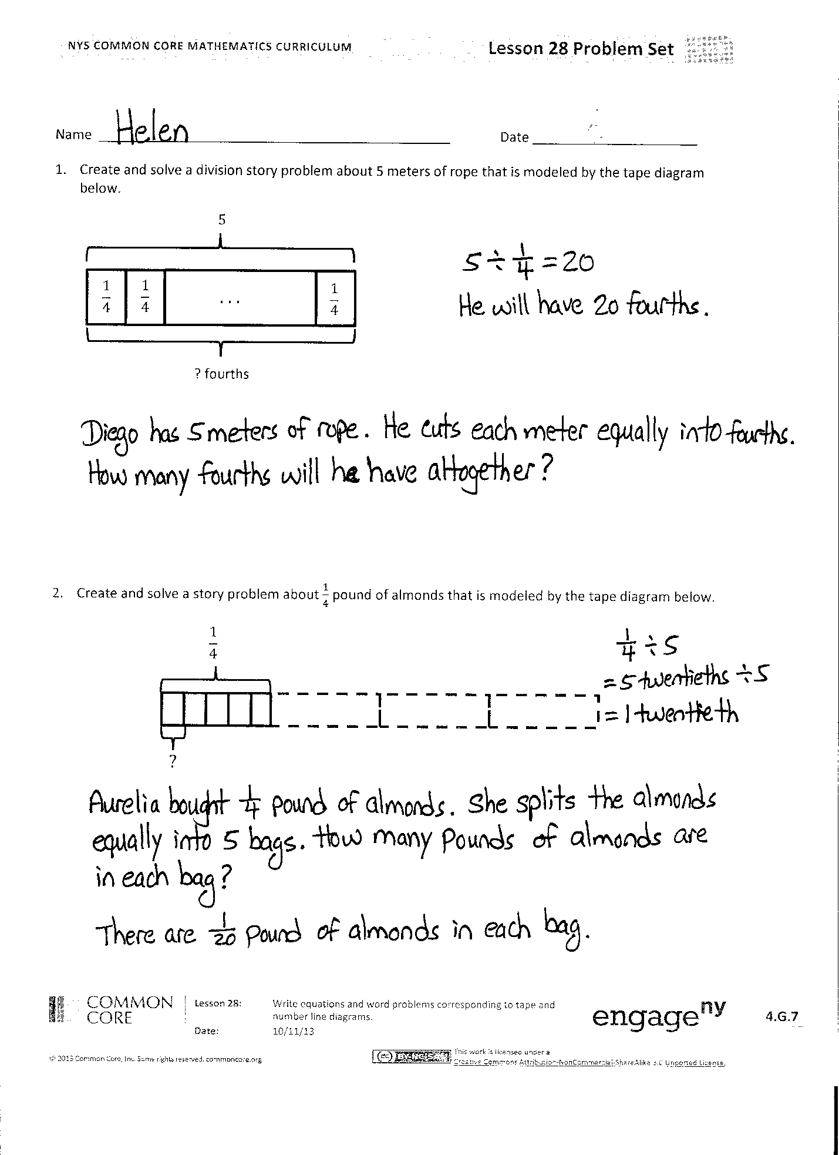
T: Work with a partner to draw a tape diagram for each expression. Then, write a story to match your diagram and solve. Be sure to use multiplication to check your work. (Possible responses appear on the student work example of the Problem Set. Be sure to include in the class discussion all the interpretations of division because some students may write stories that take on a multiplication quality.)
Problem Set (10 minutes)
The Problem Set forms the basis for today’s lesson. Please see the vignette in the Concept Development for modeling suggestions.
Student Debrief (10 minutes)
Lesson Objective: Write equations and word problems corresponding to tape and number line diagrams.
The Student Debrief is intended to invite reflection and active processing of the total lesson experience.
Invite students to review their solutions for the Problem Set. They should check work by comparing answers with a partner before going over answers as a class. Look for misconceptions or misunderstandings that can be addressed in the Debrief. Guide students in a conversation to debrief the Problem Set and process the lesson.
You may choose to use any combination of the questions below to lead the discussion.
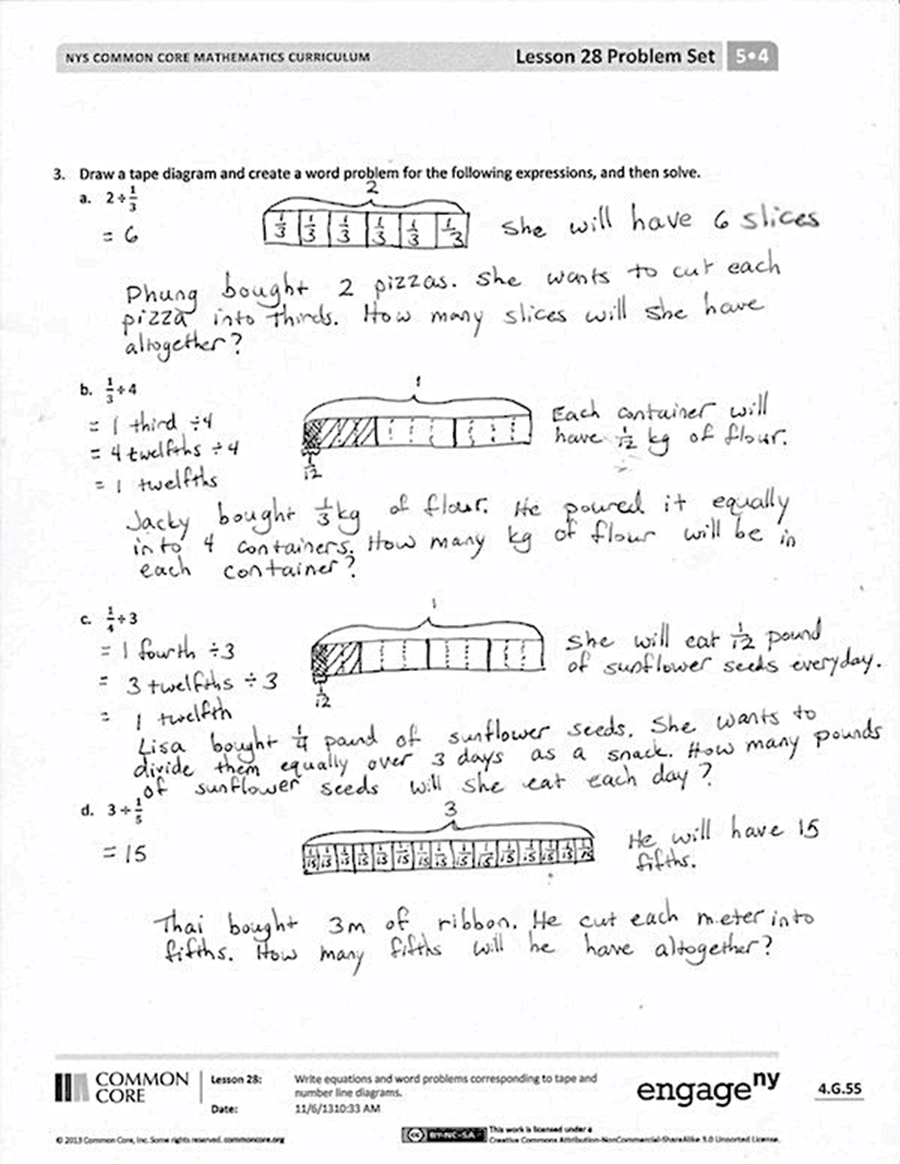
- In Problem 3, what do you notice about (a) and (b), (a) and (d), and (b) and (c)?
- Compare your stories and solutions for Problem 3 with a partner.
- Compare and contrast Problems 1 and 2. What are the similarities or differences of these two problems?
- Share your solutions for Problems 1 and 2 and explain them to a partner.
Exit Ticket (3 minutes)
After the Student Debrief, instruct students to complete the Exit Ticket. A review of their work will help you assess the students’ understanding of the concepts that were presented in the lesson today and plan more effectively for future lessons. You may read the questions aloud to the students.

NOTES ON
MULTIPLE MEANS
OF EXPRESSION AND ACTION:
Comparing and contrasting is often required in English language arts, science, and social studies classes. Use the same graphic organizers that are successfully used in these classes for math class. Although Venn diagrams are often used to help students organize their thinking when comparing and contrasting, this is not the only possible graphic organizer. To add variety, charts listing similarities in a center column and differences in two outer columns can also be used.

Name Date
- Create and solve a division story problem about 5 meters of rope that is modeled by the tape diagram below.
$$\frac{1}{4}$$
$$\frac{1}{4}$$
. . .
$$\frac{1}{4}$$
5
? fourths

- Create and solve a story problem about $\frac{1}{4}$ pound of almonds that is modeled by the tape diagram below.
$$\frac{1}{4}$$
?

- Draw a tape diagram and create a word problem for the following expressions, and then solve.
  - 2 ÷ $\frac{1}{3}$

  - $\frac{1}{3}$ ÷ 4

  - $\frac{1}{4}$ ÷ 3

  - 3 $÷\frac{1}{5}$

Name Date
Create a word problem for the following expressions, and then solve.
- 4 ÷ $\frac{1}{2}$

- $\frac{1}{2}$ ÷ 4

Name Date
- Create and solve a division story problem about 7 feet of rope that is modeled by the tape diagram below.
. . .
$$\frac{1}{2}$$
7
? halves

$$\frac{1}{2}$$
$$\frac{1}{2}$$

- Create and solve a story problem about $\frac{1}{3}$ pound of flour that is modeled by the tape diagram below.
$$\frac{1}{3}$$
?

3. Draw a tape diagram and create a word problem for the following expressions. Then, solve and check.
- 2 ÷ $\frac{1}{4}$

b. $\frac{1}{4}$ ÷ 2

c. $\frac{1}{3}$ ÷ 5

d. 3 ÷ $\frac{1}{10}$

