Lesson 27
Objective: Solve problems involving fraction division.

Suggested Lesson Structure
 Fluency Practice (12 minutes)
 Concept Development (38 minutes)
 Student Debrief (10 minutes)
Total Time (60 minutes)
Fluency Practice (12 minutes)
- Count by Fractions 5.NF.7 (6 minutes)
- Divide Whole Numbers by Unit Fractions 5.NF.7 (3 minutes)
- Divide Unit Fractions by Whole Numbers 5.NF.7 (3 minutes)
Count by Fractions (6 minutes)
Note: This fluency activity reviews Lesson 25.
T: Count by sixths to 12 sixths. (Write as students count.)
S: 1 sixth, 2 sixths, 3 sixths, 4 sixths, 5 sixths, 6 sixths, 7 sixths, 8 sixths, 9 sixths, 10 sixths, 11 sixths, 12 sixths.
T: Let’s count by sixths again. This time, when we arrive at a whole number, say the whole number. (Write as students count.)
S: 1 sixth, 2 sixths, 3 sixths, 4 sixths, 5 sixths, 1 whole, 7 sixths, 8 sixths, 9 sixths, 10 sixths, 11 sixths, 2 wholes.
T: Let’s count by sixths again. This time, change improper fractions to mixed numbers. (Write as students count.)
S: 1 sixth, 2 sixths, 3 sixths, 4 sixths, 5 sixths, 1 whole, 1 and 1 sixth, 1 and 2 sixths, 1 and 3 sixths, 1 and 4 sixths, 1 and 5 sixths, 2 wholes.
T: Let’s count by sixths again. This time, simplify 3 sixths to 1 half. (Write as students count.)
S: 1 sixth, 2 sixths, 1 half, 4 sixths, 5 sixths, 1 whole, 1 and 1 sixth, 1 and 2 sixths, 1 and 1 half, 1 and 4 sixths, 1 and 5 sixths, 2 wholes.
T: Let’s count by sixths again. This time, simplify 2 sixths to 1 third and 4 sixths to 2 thirds. (Write as students count.)
S: 1 sixth, 1 third, 1 half, 2 thirds, 5 sixths, 1 whole, 1 and 1 sixth, 1 and 1 third, 1 and 1 half, 1 and 2 thirds, 1 and 5 sixths, 2 wholes.
Continue the process counting by eighths to 8 eighths or, if time allows, 16 eighths.
Divide Whole Numbers by Unit Fractions (3 minutes)
Materials: (S) Personal white board
Note: This fluency activity reviews Lesson 25.
T: (Write 1 ÷ $\frac{1}{2}$.) Say the division sentence.
S: 1 ÷ $\frac{1}{2}$.
T: How many halves are in 1 whole?
S: 2.
T: (Write 1 ÷ $\frac{1}{2}$ = 2. Beneath it, write 2 ÷ $\frac{1}{2}$ = ____.) How many halves are in 2 wholes?
S: 4.
T: (Write 2 ÷ $\frac{1}{2}$ = 4. Beneath it, write 3 ÷ $\frac{1}{2}$ = ____.) How many halves are in 3 wholes?
S: 6.
T: (Write 3 ÷ $\frac{1}{2}$ = 6. Beneath it, write 6 ÷ $\frac{1}{2}$.) On your personal white board, write the division sentence with the answer.
S: (Write 6 ÷ $\frac{1}{2}$ = 12.)
Continue with the following possible suggestions: 1 ÷ $\frac{1}{3}$, 2 ÷ $\frac{1}{3}$, 7 ÷ $\frac{1}{3}$, 1 ÷ $\frac{1}{4}$, 2 ÷ $\frac{1}{4}$, 9 ÷ $\frac{1}{4}$, 5 ÷$\frac{1}{5}$, 6 ÷ $\frac{1}{6}$, and 8 ÷ $\frac{1}{8}$.
Divide Unit Fractions by Whole Numbers (3 minutes)
Materials: (S) Personal white board
Note: This fluency activity reviews Lesson 26.
T: (Write $\frac{1}{2}$ ÷ 2 = ____.) Say the division sentence with the answer.
S: $\frac{1}{2}$ ÷ 2 = $\frac{1}{4}$.
T: (Write $\frac{1}{2}$ ÷ 2 = $\frac{1}{4}$. Beneath it, write $\frac{1}{2}$ ÷ 3 = ____.) Say the division sentence with the answer.
S: $\frac{1}{2}$ ÷ 3 = $\frac{1}{6}$.
T: (Write $\frac{1}{2}$ ÷ 3 = $\frac{1}{6}$. Beneath it, write $\frac{1}{2}$ ÷ 4 = ____.) Say the division sentence with the answer.
S: $\frac{1}{2}$ ÷ 4 = $\frac{1}{8}$.
T: (Write $\frac{1}{2}$ ÷ 7 = ____.) On your personal white board, complete the number sentence.
S: (Write $\frac{1}{2}$ ÷ 7 = $\frac{1}{14}$.)
Continue with the following possible sequence: $\frac{1}{3}$ ÷ 2, $\frac{1}{3}$ ÷ 3, $\frac{1}{3}$ ÷ 4, $\frac{1}{3}$ ÷ 9, $\frac{1}{5}$ ÷ 3, $\frac{1}{5}$ ÷ 5, $\frac{1}{5}$ ÷ 7, $\frac{1}{4}$ ÷ 4, and $\frac{1}{8}$ ÷ 6.
Concept Development (38 minutes)
Materials: (S) Problem Set
Note: The time normally allotted for the Application Problem has been reallocated to the Concept Development to provide adequate time for solving the word problems.
Suggested Delivery of Instruction for Solving Lesson 27 Word Problems
- Model the problem.
Have two pairs of student work at the board while the others work independently or in pairs at their seats. Review the following questions before beginning the first problem:
- Can you draw something?
- What can you draw?
- What conclusions can you make from your drawing?
As students work, circulate. Reiterate the questions above. After two minutes, have the two pairs of students share only their labeled diagrams. For about one minute, have the demonstrating students receive and respond to feedback and questions from their peers.
MP.3
- Calculate to solve and write a statement.
Give everyone two minutes to finish work on that question, sharing his or her work and thinking with a peer. All students should write their equations and statements of the answer.
- Assess the solution for reasonableness.
Give students one to two minutes to assess and explain the reasonableness of their solution.
Problem 1
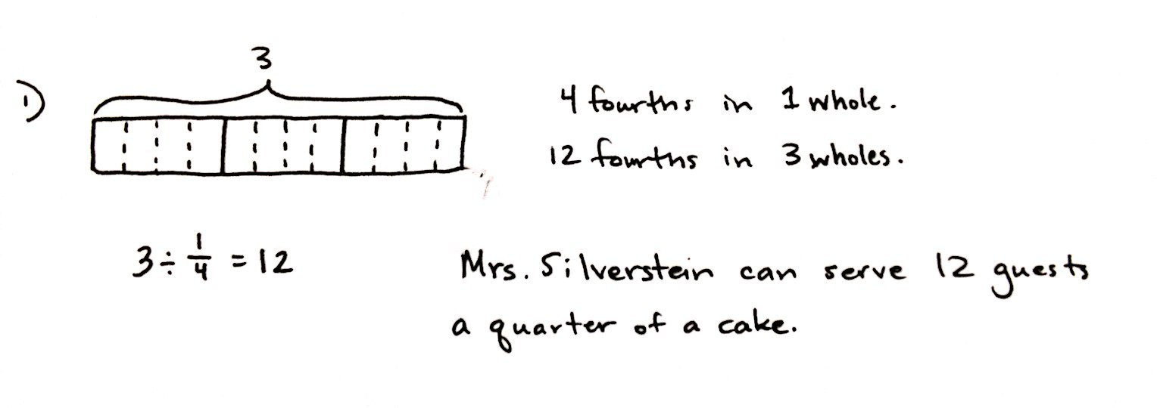
Mrs. Silverstein bought 3 mini cakes for a birthday party. She cuts each cake into quarters and plans to serve each guest 1 quarter of a cake. How many guests can she serve with all her cakes? Draw a model to support your response.
Method 1

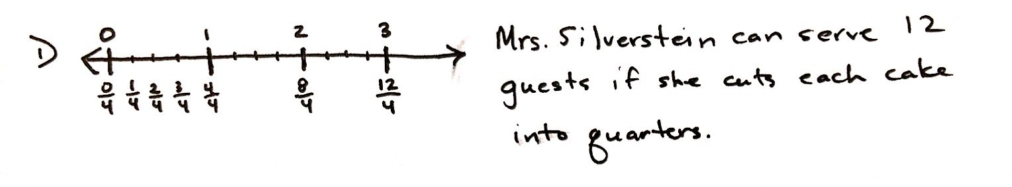
Method 2
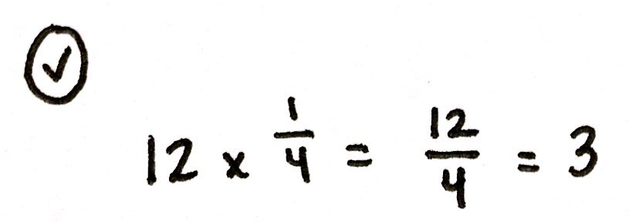
In this problem, students are asked to divide a whole number (3) by a unit fraction ($\frac{1}{4}$) and draw a model. A tape diagram or a number line would both be acceptable models to support their responses. The reference to the unit fraction as a quarter provides a bit of complexity. There are 4 fourths in 1 whole and 12 fourths in 3 wholes.
Problem 2
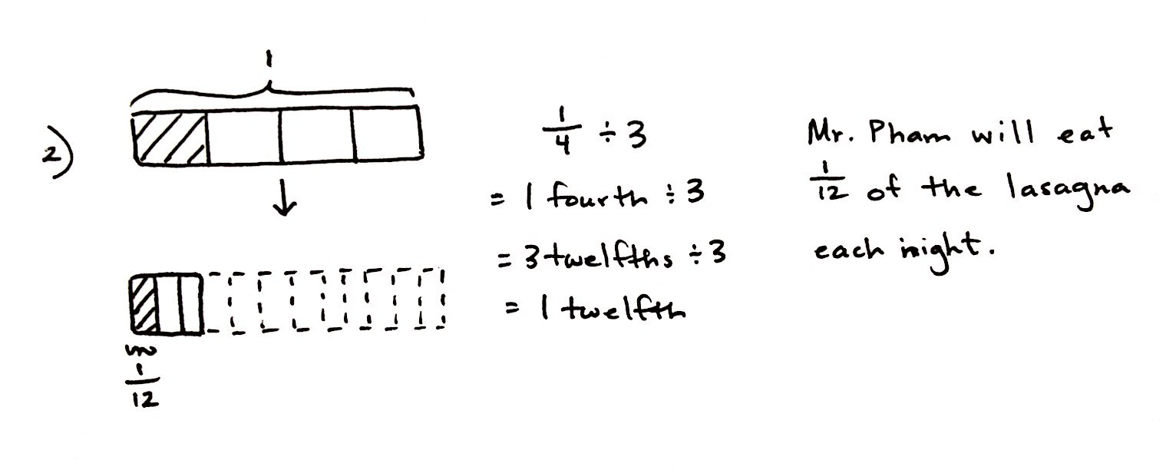
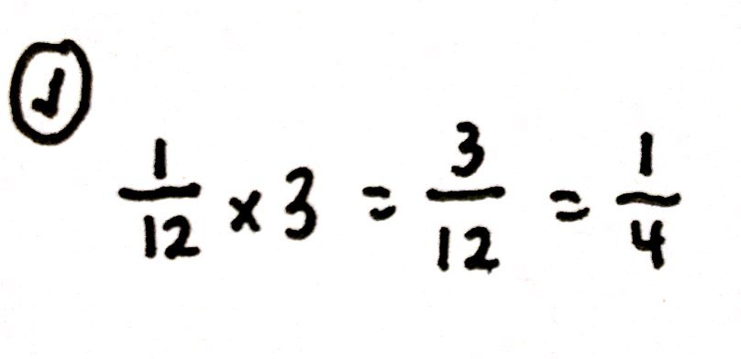
Mr. Pham has $\frac{1}{4}$ pan of lasagna left in the refrigerator. He wants to cut the lasagna into equal slices so he can have it for dinner for 3 nights. How much lasagna will he eat each night? Draw a picture to support your response.
Problem 2 is intentionally similar to Problem 1. Although the numbers used in the problems are identical, careful reading reveals that 3 is now the divisor rather than the dividend. While drawing a supporting tape diagram, students should recognize that dividing a fourth into 3 equal parts creates a new unit—twelfths. The model shows that the fraction $\frac{1}{4}$ is equal to $\frac{3}{12}$, and therefore, a division sentence using unit form (3 twelfths $\text{÷}$ 3) is easy to solve. Facilitate a quick discussion about the similarities and differences of Problems 1 and 2. What do students notice about the division expressions and the solutions?
Problem 3
The perimeter of a square is $\frac{1}{5}$ meter.
- Find the length of each side in meters. Draw a picture to support your response.
- How long is each side in centimeters?
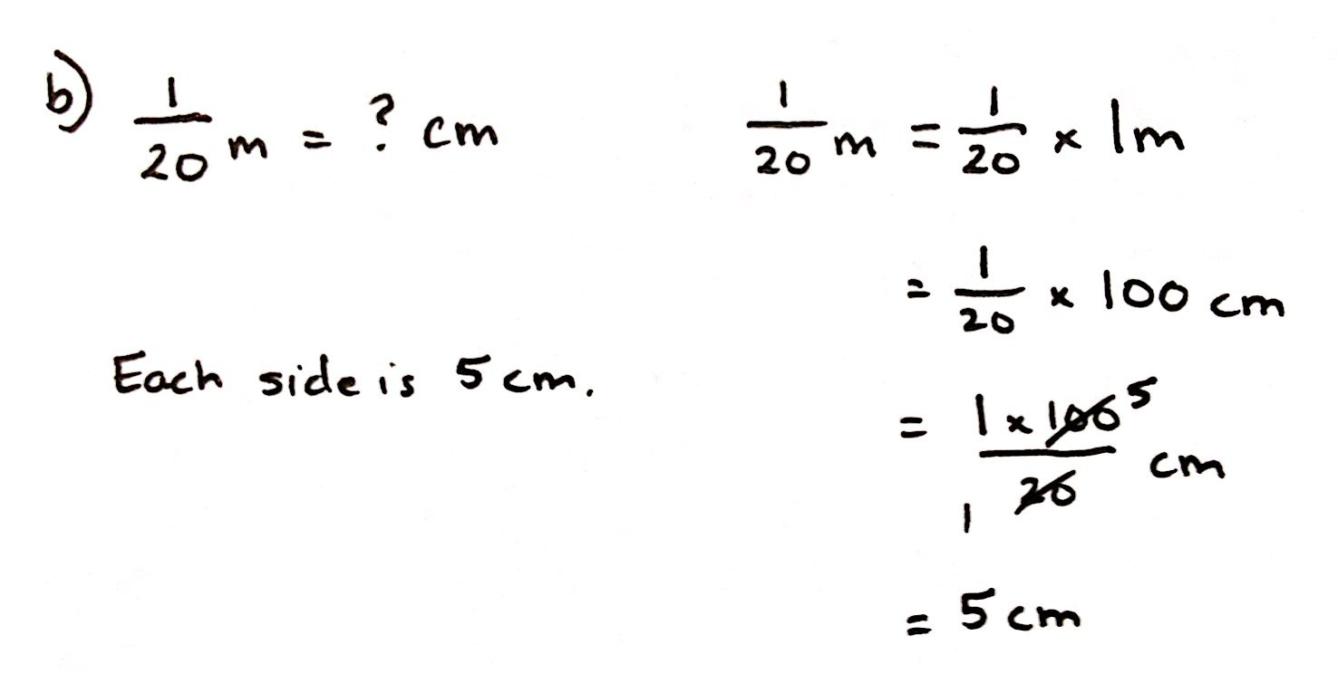
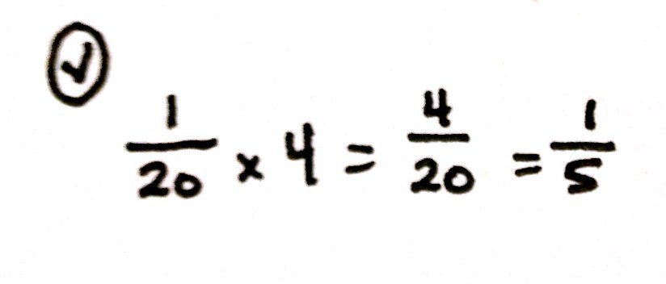
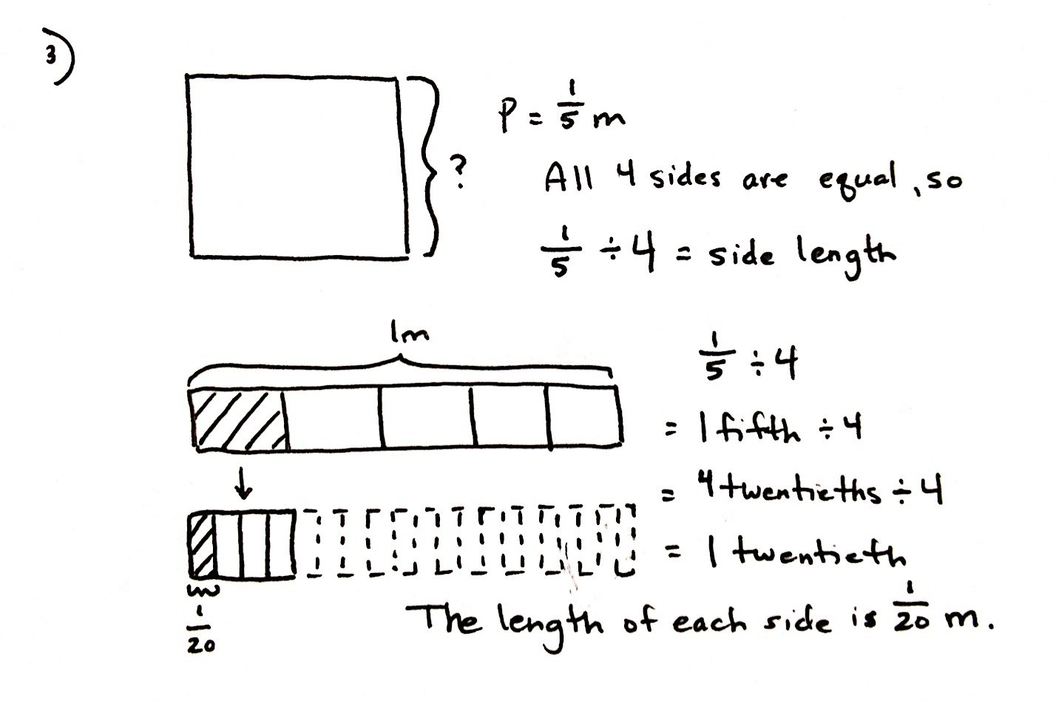

This problem requires students to recall their measurement work from Grade 3 and 4 involving perimeter. Students must know that all four side lengths of a square are equivalent, and therefore, the unknown side length can be found by dividing the perimeter by 4 ($\frac{1}{5}$ m $\text{÷}$4). The tape diagram shows clearly that dividing a fifth into 4 equal parts creates a new unit, twentieths, and that $\frac{1}{5}$ is equal to $\frac{4}{20}$. Students may use a division expression using unit form (4 twentieths $\text{÷}$ 4) to solve this problem very easily. This problem also provides an opportunity to point out a partitive division interpretation to students. While the model was drawn to depict 1 fifth divided into 5 equal parts, the question mark clearly asks “What is $\frac{1}{4}$ of $\frac{1}{5}$?” That is $\frac{1}{4} \text{×} \frac{1}{5}$.
Part (b) requires students to rename $\frac{1}{20}$ meter as centimeters. This conversion mirrors the work done in Lesson 20. Since 1 meter is equal to 100 centimeters, students can multiply to find that $\frac{1}{20}$ m is equivalent to $\frac{100}{20}$ cm, or 5 cm.
Problem 4
A pallet holding 5 identical crates weighs $\frac{1}{4}$ ton.
- How many tons does each crate weigh? Draw a picture to support your response.
- How many pounds does each crate weigh?
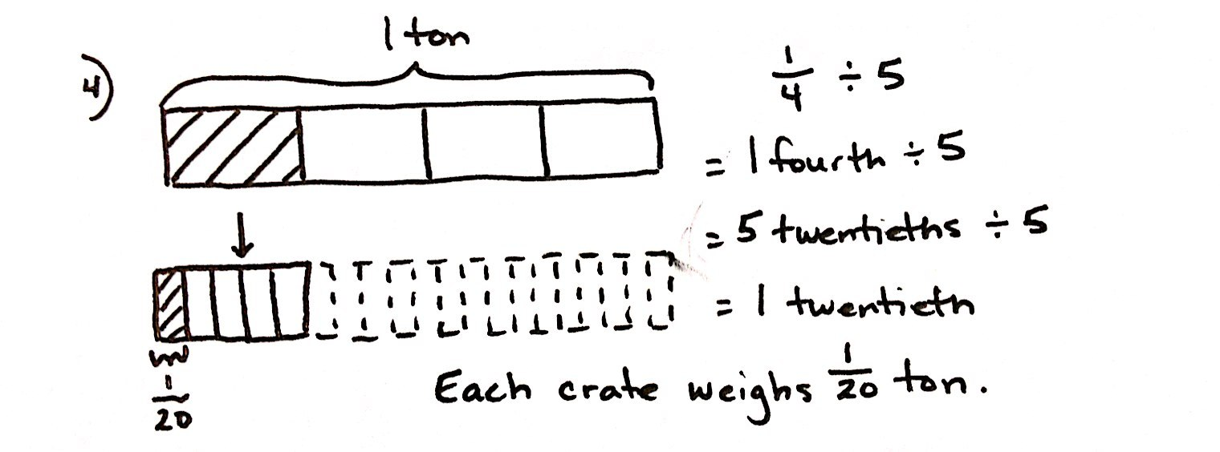
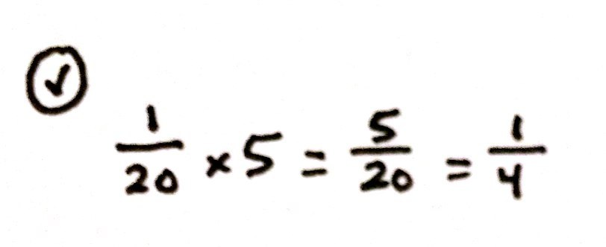
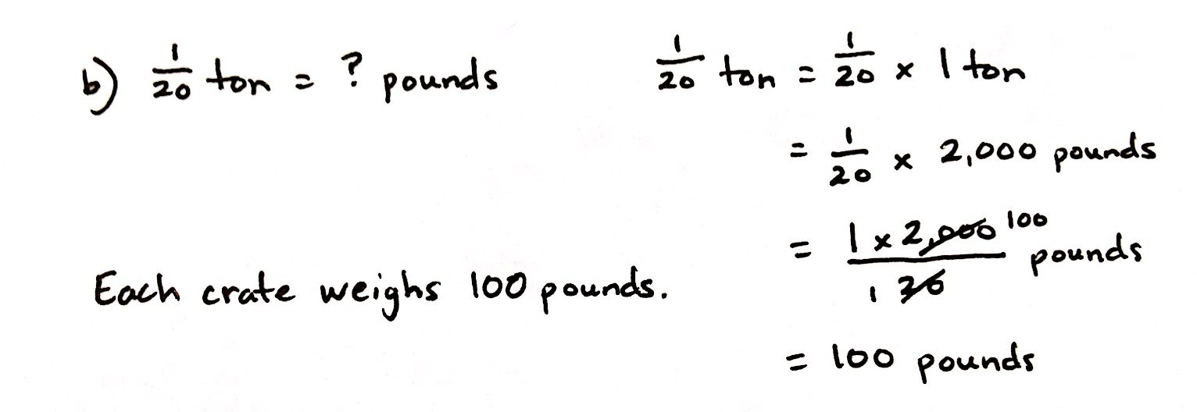

The numbers in this problem are similar to those used in Problem 3, and the resulting quotient is again $\frac{1}{20}$. Engage students in a discussion about why the answer is the same in Problems 3 and 4, but was not the same in Problems 1 and 2, despite both sets of problems using similar numbers. Is this just a coincidence? Additionally, Problem 4 presents another opportunity for students to interpret the division here as $\frac{1}{4}\text{=} \text{5} \text{×} ____$.

Problem 5
Faye has 5 pieces of ribbon, each 1 yard long. She cuts each ribbon into sixths.
- How many sixths will she have after cutting all the ribbons?
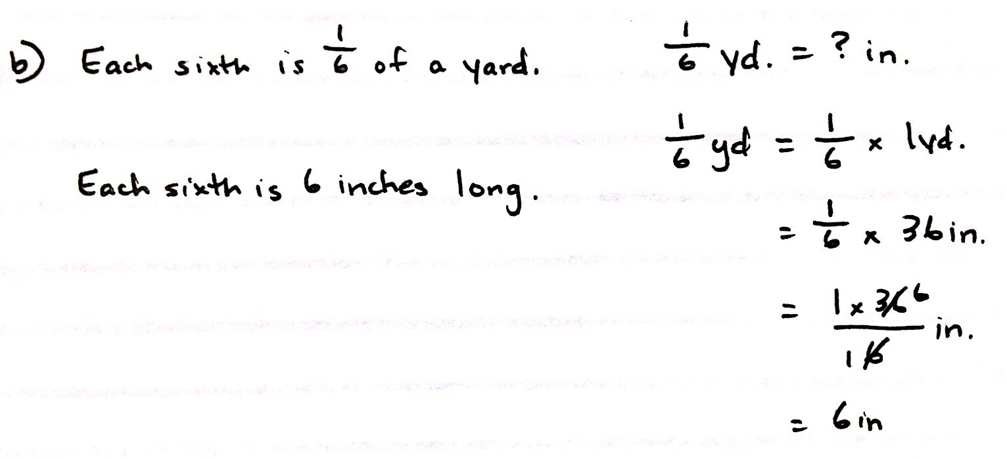
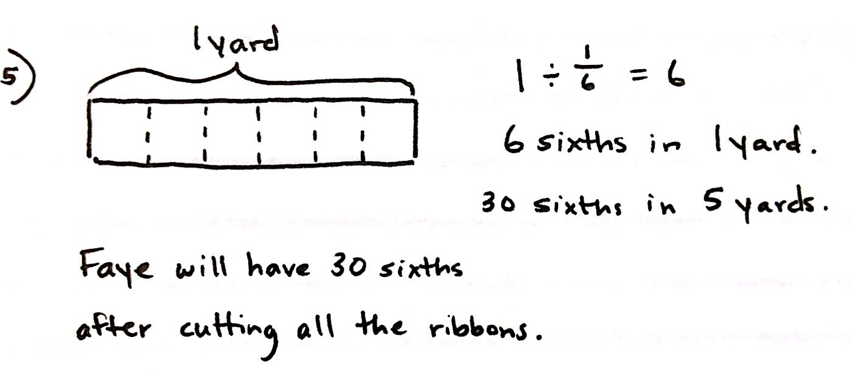
- How long will each of the sixths be in inches?

In Problem 5, since Faye has 5 pieces of ribbon of equal length, students have the choice of drawing a tape diagram showing how many sixths are in 1 yard (and then multiplying that number by 5) or drawing a tape diagram showing all 5 yards to find 30 sixths in total.
Problem 6
A glass pitcher is filled with water. $\frac{1}{8}$of the water is poured equally into 2 glasses.
- What fraction of the water is in each glass?
- If each glass has 3 fluid ounces of water in it, how many fluid ounces of water were in the full pitcher?
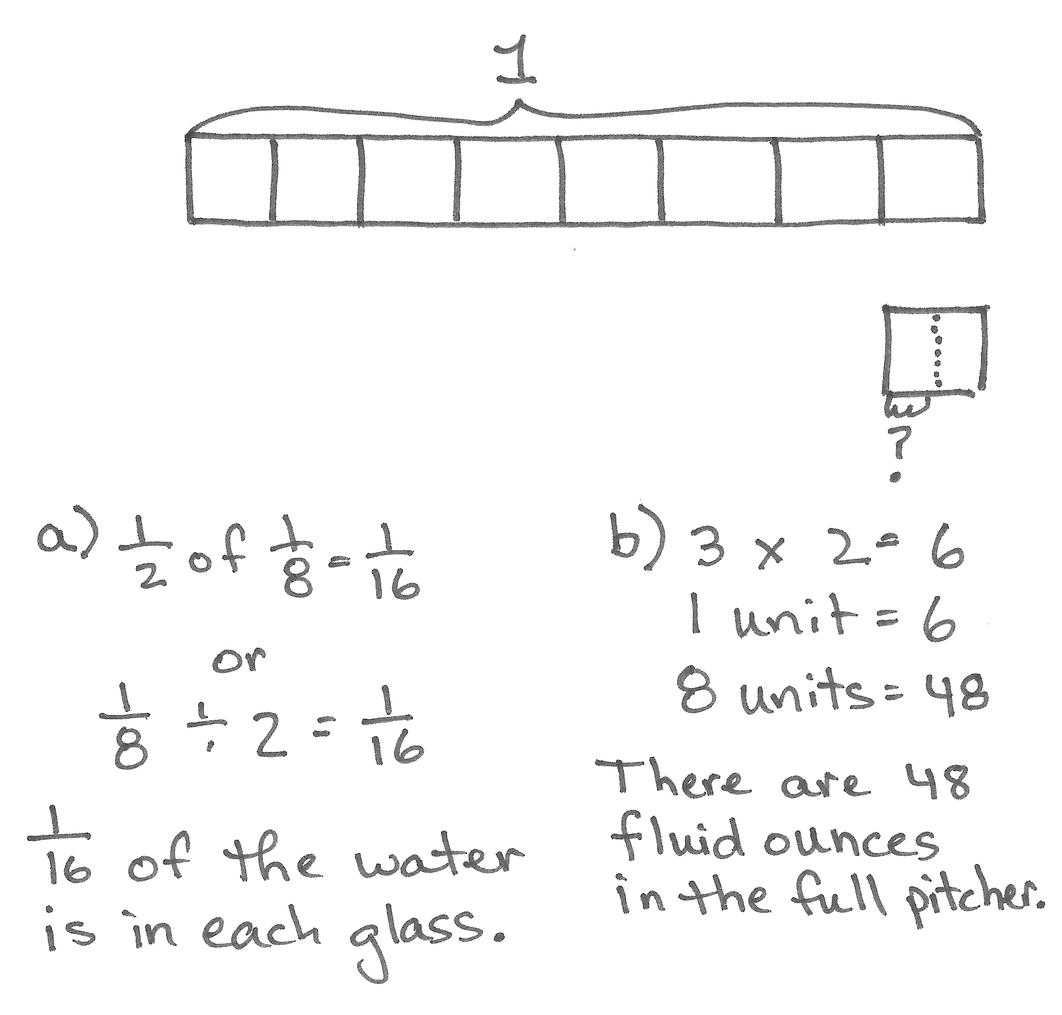
- If $\frac{1}{4}$ of the remaining water is poured out of the pitcher to water a plant, how many cups of water are left in the pitcher?

NOTES ON
MULTIPLE MEANS
OF ENGAGEMENT:
Problem 6 in this lesson may be especially difficult for English language learners. The teacher may wish to have students act out this problem to keep track of the different questions asked about the water.

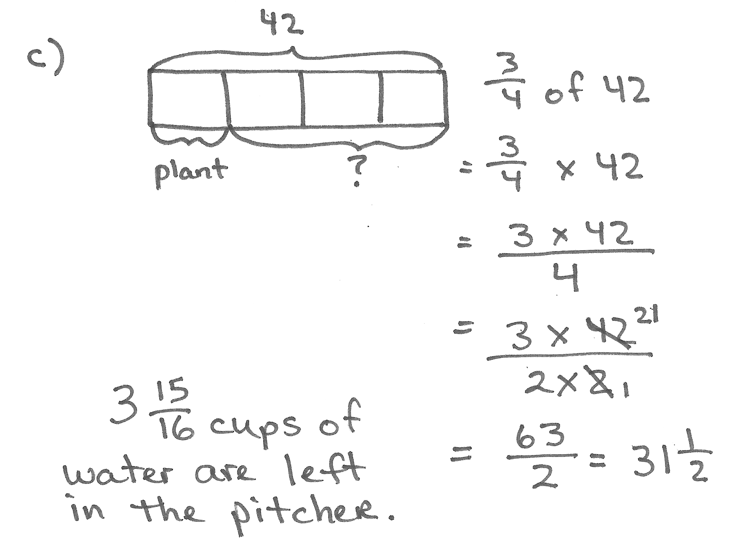
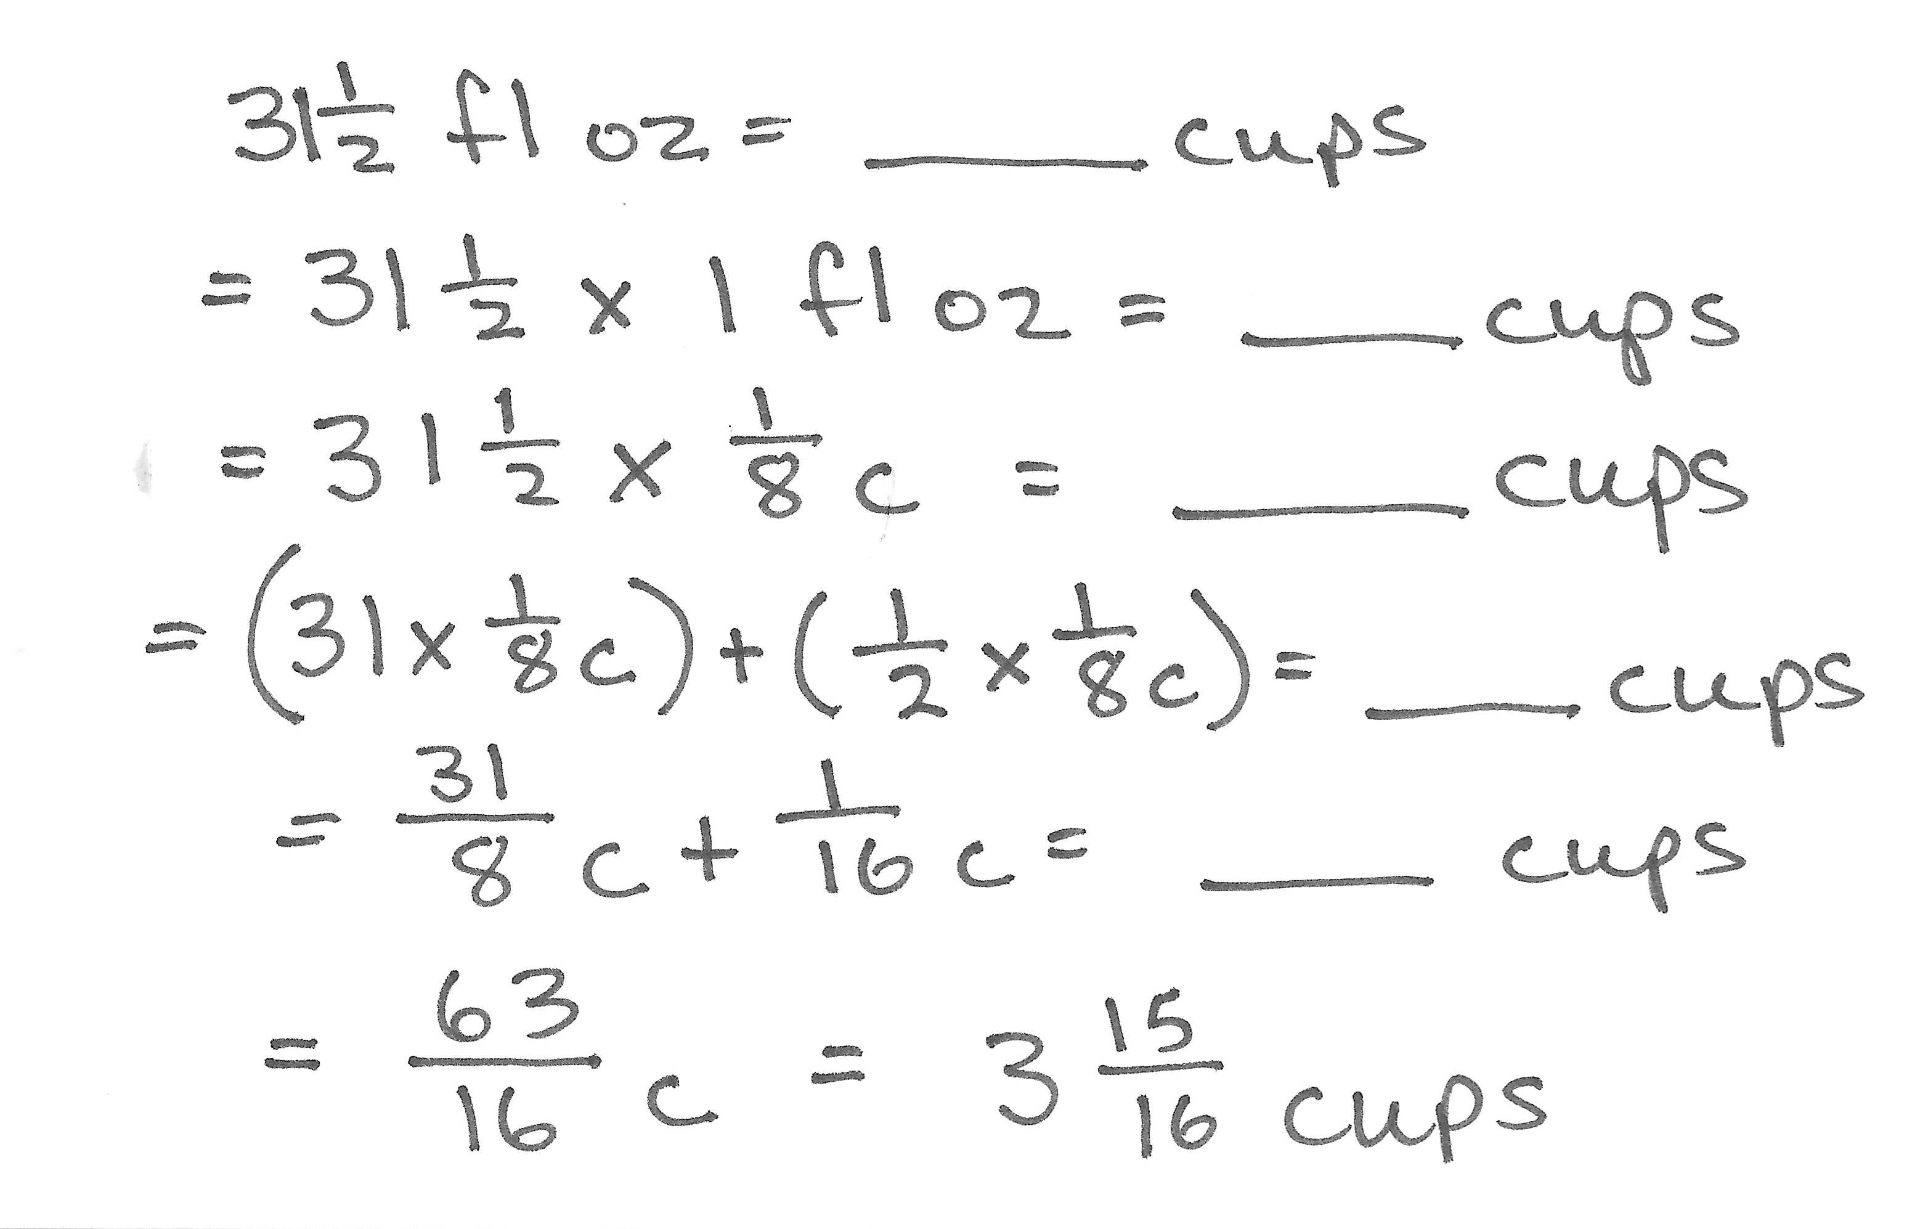
In Part (a), to find what fraction of the water is in each glass, students might divide the unit fraction ($\frac{1}{8}$) by 2 or multiply $\frac{1}{2}\text{×}\frac{1}{8}$. Part (b) requires students to show that, since both glasses hold 3 fluid ounces of water each, 1 unit (or $\frac{1}{8}$ of the total water) is equal to 6 fluid ounces. Multiplying 6 fluid ounces by 8 provides the total amount of water (48 fluid ounces) that was originally in the pitcher. Part (c) is a complex, multi-step problem that may require careful discussion. Since $\frac{1}{8}$ of the water (or 6 fluid ounces) has already been poured out, subtraction yields 42 fluid ounces of water left in the pitcher. After 1 fourth of the remaining water is used for the plant, $\frac{3}{4}$ of the water in the pitcher is 31 $\frac{1}{2}$ fluid ounces. Students must then convert 31 $\frac{1}{2}$ fluids ounces into cups.
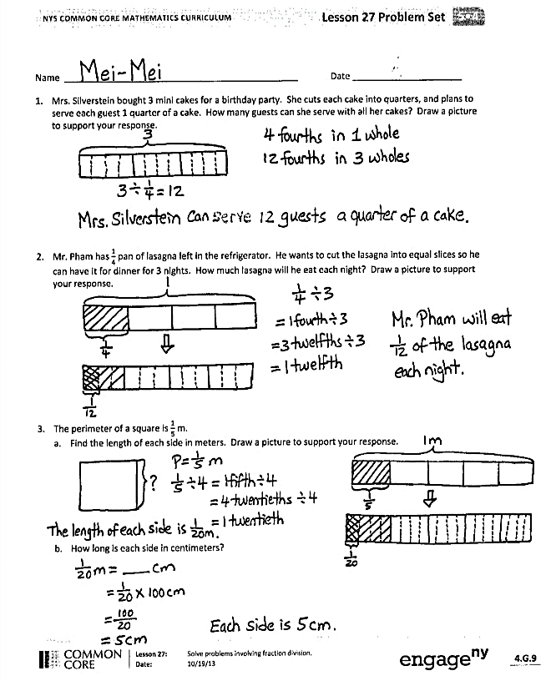
Student Debrief (10 minutes)
Lesson Objective: Solve problems involving fraction division.
The Student Debrief is intended to invite reflection and active processing of the total lesson experience.
Invite students to review their solutions for the Problem Set. They should check work by comparing answers with a partner before going over answers as a class. Look for misconceptions or misunderstandings that can be addressed in the Debrief. Guide students in a conversation to debrief the Problem Set and process the lesson.

You may choose to use any combination of the questions below to lead the discussion.
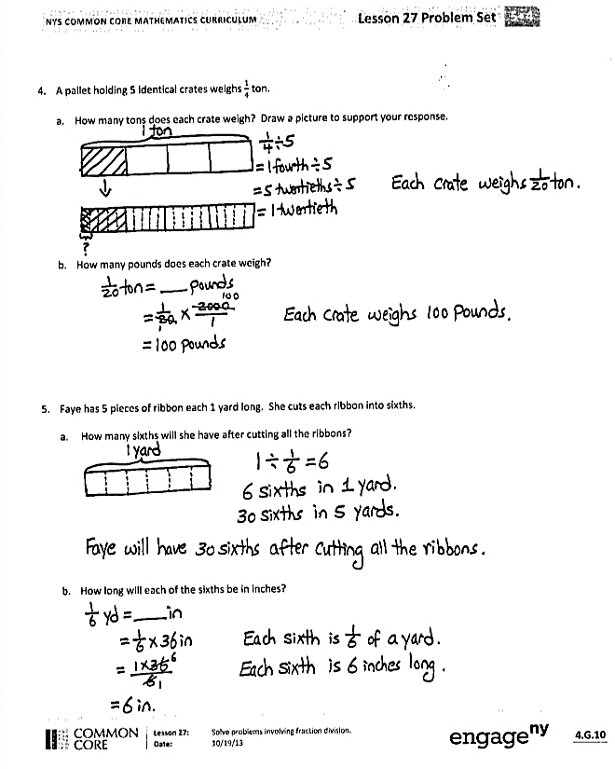
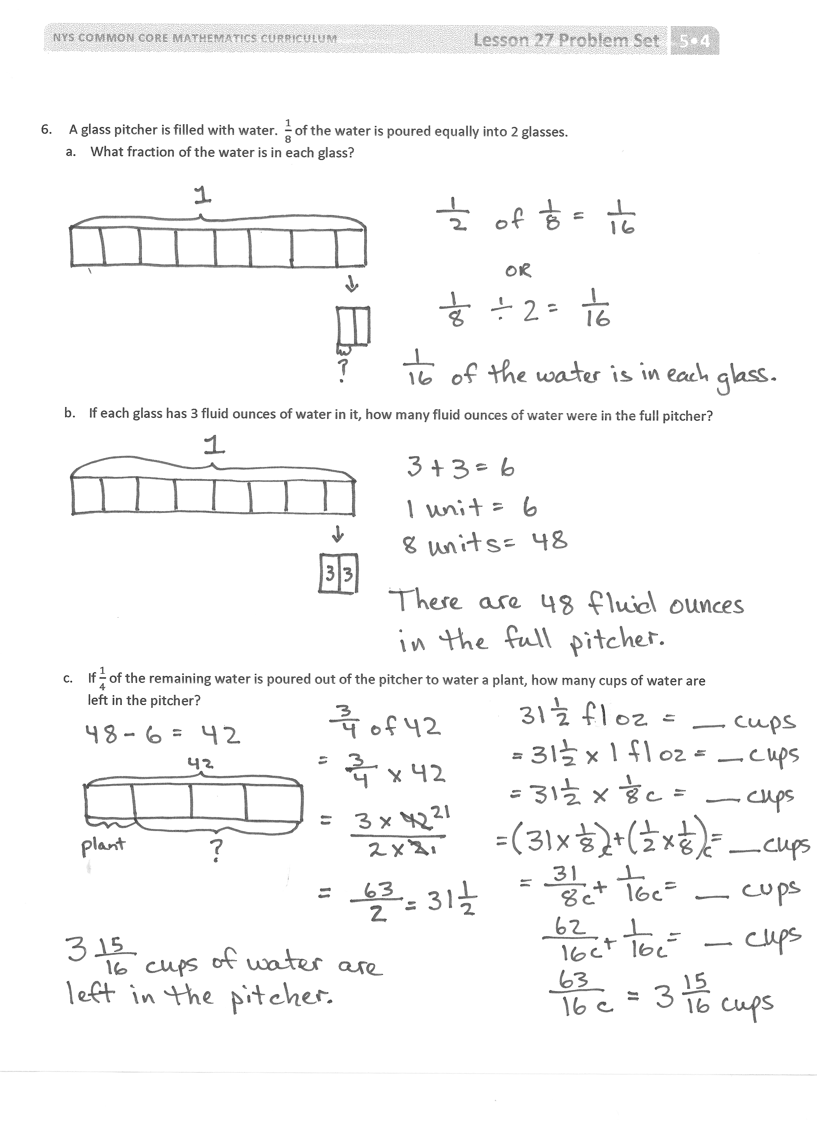
- What did you notice about Problems 1 and 2? What are the similarities and differences? What did you notice about the division expressions and the solutions?
- What did you notice about the solutions in Problems 3(a) and 4(a)? Share your answer and explain it to a partner.
- Why is the answer the same in Problems 3 and 4, but not the same in Problems 1 and 2, despite using similar numbers in both sets of problems? Is this just a coincidence? Can you create similar pairs of problems and see if the resulting quotient is always equivalent (e.g., $\frac{1}{3}\text{÷}$ 2 and
$\frac{1}{2}\text{÷}$ 3)?
- How did you solve for Problem 6? What strategy did you use? Explain it to a partner.
Exit Ticket (3 minutes)
After the Student Debrief, instruct students to complete the Exit Ticket. A review of their work will help you assess the students’ understanding of the concepts that were presented in the lesson today and plan more effectively for future lessons. You may read the questions aloud to the students.

Name Date
- Mrs. Silverstein bought 3 mini cakes for a birthday party. She cuts each cake into quarters and plans to serve each guest 1 quarter of a cake. How many guests can she serve with all her cakes? Draw a picture to support your response.

- Mr. Pham has $\frac{1}{4}$ pan of lasagna left in the refrigerator. He wants to cut the lasagna into equal slices so he can have it for dinner for 3 nights. How much lasagna will he eat each night? Draw a picture to support your response.

- The perimeter of a square is $\frac{1}{5}$ meter.
- Find the length of each side in meters. Draw a picture to support your response.

- How long is each side in centimeters?

- A pallet holding 5 identical crates weighs $\frac{1}{4}$ ton.
- How many tons does each crate weigh? Draw a picture to support your response.

- How many pounds does each crate weigh?

- Faye has 5 pieces of ribbon, each 1 yard long. She cuts each ribbon into sixths.
- How many sixths will she have after cutting all the ribbons?

- How long will each of the sixths be in inches?

- A glass pitcher is filled with water. $\frac{1}{8}$of the water is poured equally into 2 glasses.
- What fraction of the water is in each glass?

- If each glass has 3 fluid ounces of water in it, how many fluid ounces of water were in the full pitcher?

- If $\frac{1}{4}$ of the remaining water is poured out of the pitcher to water a plant, how many cups of water are left in the pitcher?
Name Date
- Kevin divides 3 pieces of paper into fourths. How many fourths does he have? Draw a picture to support your response.

- Sybil has $\frac{1}{2}$ of a pizza left over. She wants to share the pizza with 3 of her friends. What fraction of the original pizza will Sybil and her 3 friends each receive? Draw a picture to support your response.

Name Date
- Kelvin ordered four pizzas for a birthday party. The pizzas were cut in eighths. How many slices were there? Draw a picture to support your response.

- Virgil has $\frac{1}{6}$ of a birthday cake left over. He wants to share the leftover cake with 3 friends. What fraction of the original cake will each of the 4 people receive? Draw a picture to support your response.

- A pitcher of water contains $\frac{1}{4}$ liters of water. The water is poured equally into 5 glasses.
- How many liters of water are in each glass? Draw a picture to support your response.

- Write the amount of water in each glass in milliliters.

- Drew has 4 pieces of rope 1 meter long each. He cuts each rope into fifths.
- How many fifths will he have after cutting all the ropes?

- How long will each of the fifths be in centimeters?

- A container is filled with blueberries. $\frac{1}{6}$ of the blueberries is poured equally into two bowls.
- What fraction of the blueberries is in each bowl?

- If each bowl has 6 ounces of blueberries in it, how many ounces of blueberries were in the full container?

- If $\frac{1}{5}$ of the remaining blueberries are used to make muffins, how many pounds of blueberries are left in the container?

