Lesson 25
Objective: Divide a whole number by a unit fraction.

Suggested Lesson Structure
 Fluency Practice (12 minutes)
 Application Problem (7 minutes)
 Concept Development (31 minutes)
 Student Debrief (10 minutes)
Total Time (60 minutes)
Fluency Practice (12 minutes)
- Write Fractions as Decimals 5.NBT.2 (7 minutes)
- Multiply Fractions by Decimals 5.NBT.7 (5 minutes)
Write Fractions as Decimals (7 minutes)
Materials: (S) Personal white board
Note: This fluency activity reviews Lesson 23.
T: (Write $\frac{1}{2}$ = $\frac{}{100}.$) $\frac{1}{2}$ is how many hundredths?
T: (Write $\frac{1}{2}$ = $\frac{50}{100}.$) Write $\frac{1}{2}$ as a decimal.
S: (Write $\frac{1}{2}$ = 0.5 or $\frac{1}{2}$ = 0.50.)
T: (Write $\frac{1}{4}$ = $\frac{}{100}$.) $\frac{1}{4}$ is how many hundredths?
S: 25 hundredths.
T: (Write $\frac{1}{4}$ = $\frac{25}{100}$.) Write $\frac{1}{4}$ as a decimal.
S: (Write $\frac{1}{4}$ = 0.25.)
T: (Write $\frac{3}{4}$ = $\frac{}{100}$.) $\frac{3}{4}$ is how many hundredths?
S: 75 hundredths.
T: (Write $\frac{3}{4}$ = $\frac{75}{100}.$) Write $\frac{3}{4}$ as a decimal.
S: (Write $\frac{3}{4}$ = 0.75.)
T: (Write $1\frac{3}{4}$ = __.__.) Write $\text{1}\frac{3}{4}$ as a decimal.
S: (Write $1\frac{3}{4}$ = 1.75.)
Continue with the following possible sequence: $\frac{1}{25 }$ , $\frac{8}{25}$, $\text{3}\frac{8}{25}$ , $\frac{1}{5 }$ , $\frac{2}{5}$ , $\frac{7}{5}$ , $\frac{1}{20}$ , $\frac{9}{20}$ , $\text{4}\frac{9}{20}$ , $\frac{1}{50}$ , $\frac{7}{50}$ , $\frac{11}{50}$ , and $\text{3}\frac{11}{50}$.
Multiply Fractions by Decimals (5 minutes)
Materials: (S) Personal white board
Note: This fluency activity reviews Lesson 24.
T: (Write $\frac{1}{2}\text{×}$ $\frac{1}{2}$ = ____.) On your personal white board, write the multiplication sentence with the answer.
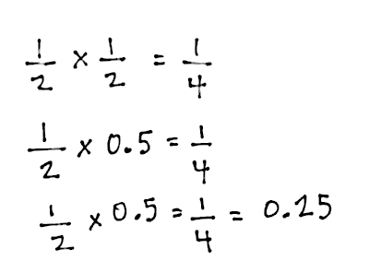
S: (Write $\frac{1}{2}$ $\text{×}$ $\frac{1}{2}$ = $\frac{1}{4}$.)
T: (Write $\frac{1}{2}$ $\text{×}$ $\frac{1}{2}$ = $\frac{1}{4}$. Beneath it, write $\frac{1}{2}$ $\text{×}$ 0.____ = $\frac{1}{4}.$) Fill in the missing digit.
S: (Write $\frac{1}{2}$ $\text{× }$0.5 = $\frac{1}{4}.$)
T: (Write $\frac{1}{2}$ $\text{×}$ 0.5 = $\frac{1}{4}$= __.__.) Complete the equation.
S: (Write $\frac{1}{2}$ $\text{×}$ 0.5 = $\frac{1}{4}$= 0.25.)
T: (Write $\frac{1}{2}$ $\text{×}$ $\frac{1}{50}$ = ___ = __.__.) On your personal white board, write the multiplication sentence with the answer as a fraction and decimal.
S: (Write $\frac{1}{2}$ $\text{×}$ $\frac{1}{50}$ = $\frac{1}{100}$ = 0.01.)
T: (Write 0.5 $\text{×}$ $\frac{1}{50}$ = __.__.) Complete the equation.
S: (Write 0.5 $\text{×}$ $\frac{1}{50}$ = 0.01.)
T: (Write $\frac{3}{5}$ $\text{×}$ 0.7 = __.__.) Rewrite the multiplication sentence as a fraction times a fraction.
S: (Write $\frac{6}{10}$ $\text{×}$ $\frac{7}{10}$ = 0.42.)
T: (Write 0.8 $\text{×}$ $\frac{2}{5}$ = __.__ × __.__ = = __.__.) Rewrite the multiplication sentence, filling in the blanks.
S: (Write 0.8 $\text{×}$ $\frac{2}{5}$ = 0.8 × 0.4 = $\frac{32}{100}$ = 0.32.)
T: (Write $\frac{4}{5}$ $\text{×}$ 0.9 = __.__ × __.__ = __.__.) Rewrite the multiplication sentence, filling in the blanks.
S: (Write $\frac{4}{5}$ $\text{×}$ 0.9 = 0.8 × 0.9 = 0.72.)
Application Problem (7 minutes)
The label on a 0.118–L bottle of cough syrup recommends a dose of 10 mL for children aged 6 to 10 years. How many 10–mL doses are in the bottle?
Note: This problem requires students to access their knowledge of converting among different size measurement units—a reference to Modules 1 and 2. Students may disagree on whether the final answer should be a whole number or decimal. There are only 11 complete
10-mL doses in the bottle, but many students will divide 118 by 10, and give 11.8 doses as their final answer. This invites interpretation of the remainder since both answers are correct.
Concept Development (31 minutes)
Materials: (S) Personal white board, 4″ × 2″ rectangular paper (several pieces per student), scissors
Problem 1
Jenny buys 2 pounds of pecans.

NOTES ON
MULTIPLE MEANS
OF REPRESENTATION:
In addition to tape diagrams and area models, students can also use region models to represent the information in these problems. For example, students can draw circles to represent the pounds of pecans and divide the circles in half to represent halves.
- If Jenny puts 2 pounds in each bag, how many bags can she make?
- If she puts 1 pound in each bag, how many bags can she make?
- If she puts $\frac{1}{2}$ pound in each bag, how many bags can she make?
- If she puts $\frac{1}{3}$ pound in each bag, how many bags can she make?
- If she puts $\frac{1}{4}$ pound in each bag, how many bags can she make?
Note: Continue this questioning sequence to include fifths and sixths.
T: (Post Problem 1(a) on the board, and read it aloud with the students.) Work with your partner to write a division sentence that explains your thinking. Be prepared to share.
S: (Work.)
T: Say the division sentence to solve this problem.
S: 2 ÷ 2 = 1.
T: (Record on the board.) How many bags of pecans can she make?
S: 1 bag.
T: (Post Problem 1(b).) Write a division sentence for this situation and solve.
S: (Solve.)
T: Say the division sentence to solve this problem.
S: 2 ÷ 1 = 2.
T: (Record directly beneath the first division sentence.) Answer the question in a complete sentence.
S: She can make 2 bags.
T: (Post Problem 1(c).) If Jenny puts 1 half-pound in each of the bags, how many bags can she make? What would that division sentence look like? Turn and talk.
S: We still have 2 as the amount that’s divided up, so it should still be 2 $\text{÷} \frac{1}{2}$. We are sort of putting pecans in half-pound groups, so 1 half will be our divisor, the size of the group.
It’s like asking how many halves are in 2.
T: (Write 2 $\text{÷} \frac{1}{2}$ directly beneath the other division sentences.) Will the answer be more or less than 2? Talk to your partner.
S: I looked at the other problems and saw a pattern. 2 ÷ 2 = 1, 2 ÷ 1 = 2, and now I think 2 ÷ $\frac{1}{2}$ will be more than 2. It should be more because we’re cutting each pound into halves so that will make more groups. I can visualize that each whole pound would have 2 halves, so there should be 4 half-pounds in 2 pounds.
T: Let’s use a piece of rectangular paper to represent 2 pounds of pecans. Cut it into 2 equal pieces. What does each piece represent?
S: 1 pound of pecans.
T: Fold each pound into halves and cut.
S: (Fold and cut.)
T: How many halves were in 2 wholes?
S: 4 halves.
T: Let me model what you just did using a tape diagram. The tape represents 2 wholes. (Label 2 on top.) Each unit is one whole. (Partition the tape with one line down the middle.) The dotted lines cut each whole into halves. (Partition each whole with a dotted line.) How many halves are in 1 whole?
MP.4
S: 2 halves.
T: How many halves are in 2 wholes?
S: 4 halves.
T: Yes. I’ll draw a number line underneath the tape diagram and label the wholes. (Label 0, 1, and 2 on the number line.) Now, I can put a tick mark for each half. Count the halves with me as I label. (Label $\frac{0}{2}, \frac{1}{2}, \frac{2}{2}, \frac{3}{2}, \frac{4}{2}$.)
S: $\frac{0}{2}, \frac{1}{2}, \frac{2}{2}, \frac{3}{2}, \frac{4}{2}$.
T: There are 4 halves in 2 wholes. (Write 2 ÷ $\frac{1}{2}$ = 4.) She can make 4 bags. But how can we be sure 4 halves is correct? How do we check a division problem? By what do we need to multiply the quotient?
MP.4
S: The divisor.
T: What is the quotient?
S: 4.
T: The divisor?
S: 1 half.
T: What would our checking expression be? Write it with your partner.
S: 4 $\text{×}\frac{\text{1}}{\text{2}}$.
T: Complete the number sentence. (Pause.) Read the complete sentence.
S: 4 $\text{×}\frac{\text{1}}{\text{2}}\text{=}$2 or $\frac{\text{1}}{\text{2}}\text{× }4=\frac{1 × 4}{2}=\frac{4}{2}=$2.
T: Were we correct?
S: Yes.
T: Let’s remember this thinking as we continue.
Repeat the modeling process with Problems 1(d) and (e), divisors of 1 third and 1 fourth.
Extend the dialogue when dividing by 1 fourth to search for patterns:
T: (Point to all the number sentences in the previous problems: 2 ÷ 2 = 1, 2 ÷ 1 = 2, 2 ÷ $\frac{1}{2}$ = 4, 2 ÷ $\frac{1}{3}$ = 6, and
2 ÷ $\frac{1}{4}$ = 8.) Take a look at these problems. What patterns do you notice? Turn and share.
S: The 2 pounds are the same, but each time, the answer is being divided into a smaller and smaller unit. The answer is getting larger and larger. When the 2 pounds is divided into smaller units, then the answer is bigger.
T: Explain to your partner why the quotient is becoming larger as it is divided by smaller units.
S: When we cut a whole into smaller parts, then we’ll get more parts. The more units we split from one whole, then the more parts we’ll have. That’s why the quotient is becoming larger.
T: Based on the patterns, solve how many bags Jenny can make if she puts $\frac{1}{5}$ pound into each bag. Draw a tape diagram and a number line on your personal white board to explain your thinking.
S: (Solve.)

NOTES ON
TABLE 2 OF THE COMMON CORE LEARNING STANDARDS:
It is important to distinguish between interpretations of division when working with fractions. When working with fractions, it may be easier to understand the distinction by using the word unit rather than group.
Number of units unknown (or number of groups unknown) is the measurement model of division, for example, for 12 ÷ 3 and 3 ÷ $\frac{1}{2}$ :
- 12 cards are put in packs of 3. How many packs are there?
- 3 meters of cloth are cut into $\frac{1}{2}$ meter strips. How many strips are cut?
Unknown unit (or group size unknown) is the partitive model of division, for example, for 12 ÷ 3 and 3 ÷ $\frac{1}{2}$ :
- 12 cards are dealt to 3 people. How many cards does each person receive?
- 3 miles is $\frac{1}{2}$ the trip. How far is the whole trip?
T: Say the division sentence.
S: 2 ÷ $\frac{1}{5}$ = 10.
T: Answer the question in a complete sentence.
S: She can make 10 bags.
Problem 2
Jenny buys 2 pounds of pecans.
- If this is $\frac{1}{2}$ the number she needs to make pecan pies, how many pounds will she need?
- If this is $\frac{1}{3}$ the number she needs to make pecan pies, how many pounds will she need?
- If this is $\frac{1}{4}$ the number she needs to make pecan pies, how many pounds will she need?
T: We can also ask different questions about Jenny and her two pounds of pecans. (Post Problem 2(a).) Two is half of what number?
S: 4.
T: Give me the division sentence.
S: It’s not division! It’s multiplication. It’s 2 twos. That’s four.
T: Give me the multiplication number sentence.
S: 2 $\text{×}$ 2 = 4. $\frac{1}{2}$ $\text{×}$ 4 = 2.
T: Hold on. Stop. Let’s try to write a division expression for this whole number situation. (Write 4 $\text{×}$____ = 8.)
S: What would the division expression be?
S: 8 ÷ 4.
T: Tell me the complete number sentence.
S: 8 ÷ 4 = 2.
T: (Write $\frac{\text{1}}{\text{2}}\text{ ×}$ ____ = 2.) Now, try the same process for this problem. Give me the division expression.
S: 2 ÷ $\frac{1}{2}$.
T: Tell me the complete number sentence.
S: 2 ÷ $\frac{1}{2}$ = 4.

T: Yes. We are finding how much is in one unit just like we did with 8 ÷ 2 = 4. In this case, the whole is the unit.
T: What is the whole unit in this story?
S: The whole number she needs for pecan pies.
T: Let’s go back and answer our question. Jenny buys 2 pounds of pecans. If this is $\frac{1}{2}$ the number she needs to make pecan pies, how many pounds will she need?
S: She will need 4 pounds of pecans.
T: Yes.
T: (Post Problem 2(b) on the board.) What’s the answer?
S: 6.
T: Give me the division sentence.
S: 2 ÷ $\frac{1}{3}=$ 6.
T: Explain to your partner why that is true.
S: We are looking for the whole number of pounds. Two is a third, so we divide it by a third. I still think of it as multiplication though—2 times 3 equals 6. However, the problem doesn’t mention 3, it says a third, so 2 ÷ $\frac{1}{3}$= 2 $\text{×}$ 3. So, dividing by a third is the same as multiplying by 3.
T: We can see in our tape diagram that this is true. (Write 2 ÷ $\frac{1}{3}$= 2 $\text{×}$ 3.) Explain to your partner why. If you like, use the story of the pecans.
Problem 3
Tien wants to cut $\frac{1}{4}$ foot lengths from a board that is 5 feet long. How many boards can he cut?

T: (Post Problem 3 on the board, and read it together with the class.) What is the length of the board Tien has to cut?
S: 5 feet.
T: How can we find the number of boards 1 fourth of a foot long? Turn and talk.
S: We have to divide. The division sentence is 5 ÷ $\frac{1}{4}$. I can draw 5 wholes and cut each whole into fourths. Then, I can count how many fourths are in 5 wholes.
T: On your personal white board, draw and solve this problem independently.
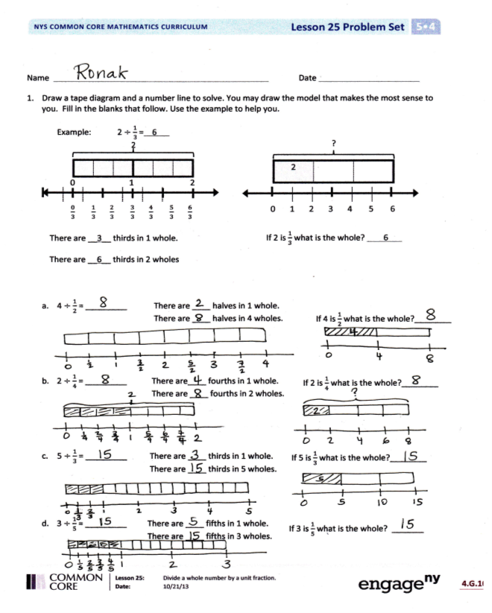
S: (Work.)
T: How many quarter feet are in 1 foot?
S: 4.
T: How many quarter feet are in 5 feet?
S: 20.
T: Say the division sentence.
S: 5 ÷ $\frac{1}{4}$ = 20.
T: Check your work, and then answer the question in a complete sentence.
S: Tien can cut 20 boards.
Problem Set (10 minutes)
Students should do their personal best to complete the Problem Set within the allotted 10 minutes. For some classes, it may be appropriate to modify the assignment by specifying which problems they work on first. Some problems do not specify a method for solving. Students should solve these problems using the RDW approach used for Application Problems.
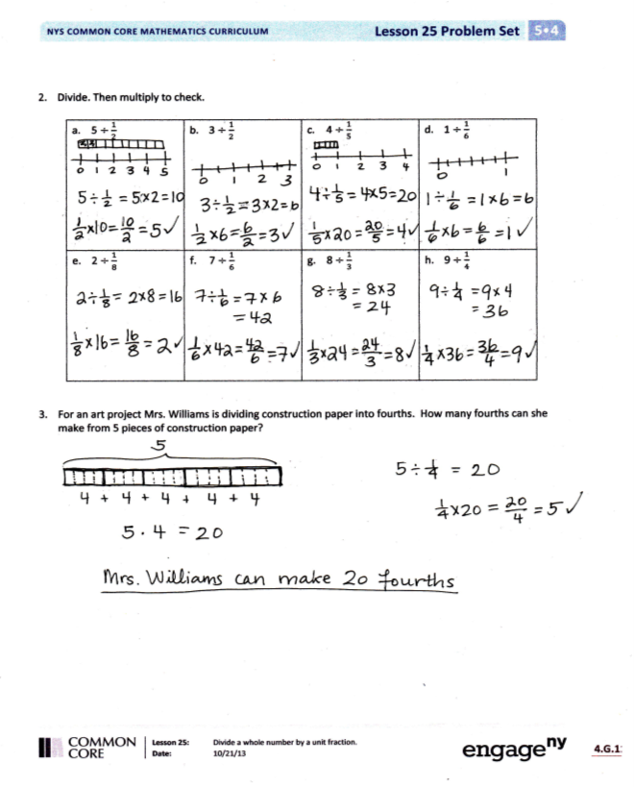
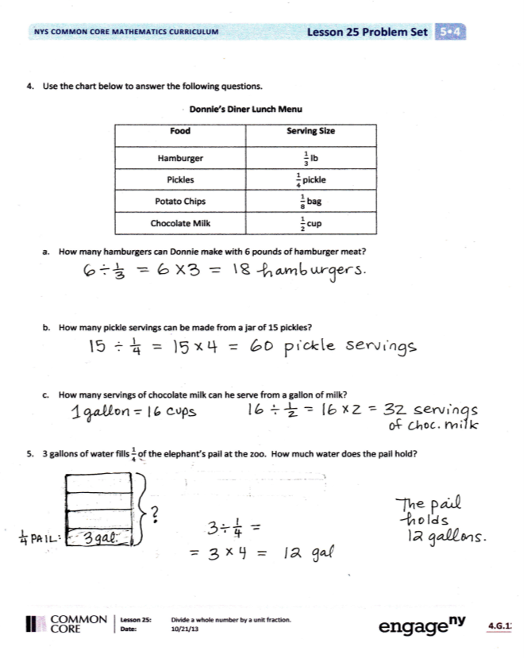

Student Debrief (10 minutes)

NOTES ON
MULTIPLE MEANS
OF ENGAGEMENT:
The second to last bullet in today’s Debrief brings out an interpretation of fraction division in a context that is particularly useful for Grade 6’s encounters with non-unit fraction division. In Grade 6, Problem 5 might read as follows:
$\frac{2}{3}$ gallon of water fills the pail to $\frac{3}{4}$ of its capacity. How much water does the pail hold?
This could be expressed as $\frac{2}{3}÷\frac{3}{4}$. That is, $\frac{2}{3}$ is 3 of the 4 groups needed to completely fill the pail. This type of problem can be thought of partitively as 2 thirds is 3 fourths of what number or $\frac{2}{3}\text{=} \frac{3}{4} \text{×} ____$. This leads to explaining the invert and multiply strategy. Working from a tape diagram, this problem would be stated as follows:
3 units = $\frac{2}{3}$
1 unit = $(\frac{2}{3} \text{÷} 3)$
We need 4 units to fill the pail:
4 units = $(\frac{2}{3} \text{÷} 3) \text{×} 4$
= $\frac{2}{3} \text{×}\frac{4}{3}$

Lesson Objective: Divide a whole number by a unit fraction.
The Student Debrief is intended to invite reflection and active processing of the total lesson experience.
Invite students to review their solutions for the Problem Set. They should check work by comparing answers with a partner before going over answers as a class. Look for misconceptions or misunderstandings that can be addressed in the Debrief. Guide students in a conversation to debrief the Problem Set and process the lesson.
You may choose to use any combination of the questions below to lead the discussion.
- In Problem 1, what do you notice about (a) and (b), and (c) and (d)? What are the whole and the divisor in the problems?
- Share your solution and compare your strategy for solving Problem 2 with a partner.
- Explain your strategy for solving Problems 3 and 4 with a partner.
- Problem 5 on the Problem Set is a partitive division problem. Students are not likely to interpret the problem as division and will more likely use a missing factor strategy to solve (which is certainly appropriate).
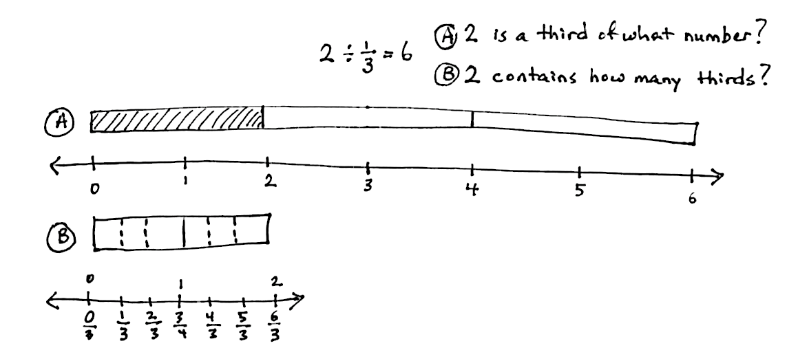
Problem 5 can be expressed as 3 $÷ \frac{1}{4}$. This could be thought of as “3 gallons is 1 out of 4 parts needed to fill the pail” or “3 is 1 fourth of what number?” Asking students to consider this interpretation will be beneficial in future encounters with fraction division. (See UDL box. The model to the right puts the two interpretations right next to each other.)

Exit Ticket (3 minutes)
After the Student Debrief, instruct students to complete the Exit Ticket. A review of their work will help you assess the students’ understanding of the concepts that were presented in the lesson today and plan more effectively for future lessons. You may read the questions aloud to the students.

Name Date
- Draw a tape diagram and a number line to solve. You may draw the model that makes the most sense to you. Fill in the blanks that follow. Use the example to help you.
Example: 2 $÷$ $\frac{1}{3}$ = 6
?
0 1 2 3 4 5 6
2

2

0 1 2
$\frac{0}{3}$ $\frac{1}{3}$ $\frac{2}{3}$ $\frac{3}{3}$ $\frac{4}{3}$ $\frac{5}{3}$ $\frac{6}{3}$

If 2 is $\frac{1}{3}$ , what is the whole? 6
There are __3__ thirds in 1 whole.

There are __6__ thirds in 2 wholes.

If 4 is $\frac{1}{2}$ , what is the whole? ________
- 4 $÷$ $\frac{1}{2}$ = _________ There are ____ halves in 1 whole.
There are ____ halves in 4 wholes.

If 2 is $\frac{1}{4}$ , what is the whole? ________
- 2 $÷$ $\frac{1}{4}$ = _________ There are ____ fourths in 1 whole.
There are ____ fourths in 2 wholes.

If 5 is $\frac{1}{3}$ , what is the whole? ________
- 5 $÷$ $\frac{1}{3}$ = _________ There are ____ thirds in 1 whole.
There are ____ thirds in 5 wholes.
If 3 is $\frac{1}{5}$ , what is the whole? _______

- 3 $÷$ $\frac{1}{5}$ = _________ There are ____ fifths in 1 whole. There are ____ fifths in 3 wholes.
- Divide. Then, multiply to check.

- 5 $÷\frac{1}{2}$ | - 3 $÷\frac{1}{2}$ | - 4 $÷\frac{1}{5}$ | - 1 $÷\frac{1}{6}$
- 2 $÷\frac{1}{8}$ | - 7 $÷\frac{1}{6}$ | - 8 $÷\frac{1}{3}$ | - 9 $÷\frac{1}{4}$

- For an art project, Mrs. Williams is dividing construction paper into fourths. How many fourths can she make from 5 pieces of construction paper?

- Use the chart below to answer the following questions.

Donnie’s Diner Lunch Menu
Food | Serving Size
Hamburger | $\frac{1}{3}$ lb
Pickles | $\frac{1}{4}$ pickle
Potato chips | $\frac{1}{8}$ bag
Chocolate milk | $\frac{1}{2}$ cup

- How many hamburgers can Donnie make with 6 pounds of hamburger meat?

- How many pickle servings can be made from a jar of 15 pickles?

- How many servings of chocolate milk can he serve from a gallon of milk?

- Three gallons of water fills $\frac{1}{4}$ of the elephant’s pail at the zoo. How much water does the pail hold?

Name Date
      - Draw a tape diagram and a number line to solve. Fill in the blanks that follow.

a. 5 $÷$ $\frac{1}{2}$ = _________ There are ____ halves in 1 whole.
There are ____ halves in 5 wholes.
5 is $\frac{1}{2}$ of what number? _______

b. 4 $÷$ $\frac{1}{4}$ = _________ There are ____ fourths in 1 whole.
There are ____ fourths in ____ wholes.
4 is $\frac{1}{4}$ of what number? _______

2. Ms. Leverenz is doing an art project with her class. She has a 3 foot piece of ribbon. If she gives each student an eighth of a foot of ribbon, will she have enough for her class of 22 students?

Name Date
1. Draw a tape diagram and a number line to solve. Fill in the blanks that follow.

- 3 $÷$ $\frac{1}{3}$ = _________ There are ____ thirds in 1 whole.
There are ____ thirds in 3 wholes.
If 3 is $\frac{1}{3}$ , what is the whole? _______

- 3 $÷$ $\frac{1}{4}$ = _________ There are ____ fourths in 1 whole.
There are ____ fourths in __ wholes.
If 3 is $\frac{1}{4}$, what is the whole? _______

- 4 $÷$ $\frac{1}{3}$ = _________ There are ____ thirds in 1 whole.
There are ____ thirds in __ wholes.
If 4 is $\frac{1}{3}$, what is the whole? _______

- 5 $÷$ $\frac{1}{4}$ = _________ There are ____ fourths in 1 whole.
There are ____ fourths in __ wholes.
If 5 is $\frac{1}{4}$, what is the whole? _______

2. Divide. Then, multiply to check.
- 2 $÷\frac{1}{4}$ | - 6 $÷\frac{1}{2}$ | - 5 $÷\frac{1}{4}$ | - 5 $÷\frac{1}{8}$
- 6 $÷\frac{1}{3}$ | - 3 $÷\frac{1}{6}$ | - 6 $÷\frac{1}{5}$ | - 6 $÷\frac{1}{10}$

3. A principal orders 8 sub sandwiches for a teachers’ meeting. She cuts the subs into thirds and puts the mini-subs onto a tray. How many mini-subs are on the tray?

4. Some students prepare 3 different snacks. They make $\frac{1}{8}$ pound bags of nut mix, $\frac{1}{4}$ pound bags of cherries, and $\frac{1}{6}$ pound bags of dried fruit. If they buy 3 pounds of nut mix, 5 pounds of cherries, and 4 pounds of dried fruit, how many of each type of snack bag will they be able to make?

