Lesson 24
Objective: Solve word problems using fraction and decimal multiplication.

Suggested Lesson Structure
 Fluency Practice (12 minutes)
 Concept Development (38 minutes)
 Student Debrief (10 minutes)
Total Time (60 minutes)
Fluency Practice (12 minutes)
- Compare the Size of a Product to the Size of One Factor 5.NF.5 (4 minutes)
- Write Fractions as Decimals 5.NBT.2 (5 minutes)
- Write the Scaling Factor 5.NBT.3 (3 minutes)
Compare the Size of a Product to the Size of One Factor (4 minutes)
Materials: (S) Personal white board
Note: This fluency activity reviews Lesson 21.
T: How many halves are in 1?
S: 2.
T: How many thirds are in 1?
S: 3.
T: How many fourths are in 1?
S: 4.
T: (Write 1 = $\frac{}{\text{10}}$.) On your personal white board, fill in the missing numerator.
S: (Write 1 = $\frac{\text{10}}{\text{10}}$.)
T: (Write 6 $\text{×}$ ____ = 6.) Say the missing factor.
S: 1.
T: (Write 6 $\text{×}\frac{}{\text{3}}$ = 6.) On your personal white board, write the equation, filling in the missing numerator.
S: (Write 6 $\text{×}$ $\frac{\text{3}}{\text{3}}$ = 6.)
T: (Write 6 $\text{×}$ $\frac{}{\text{3}}$ < 6.) Fill in a numerator to make a true number sentence.
S: (Write 6 $\text{×}$ $\frac{1}{3}$ < 6 or 6 $\text{×}$ $\frac{\text{2}}{\text{3}}$ < 6.)
T: (Write 9 $\text{×}$ $\frac{}{\text{6}}$ > 9.) Fill in a numerator to make a true number sentence.
S: (Write a number sentence, filling in a numerator greater than 6.)
Continue this process with the following possible sequence: $\frac{\text{2}}{}$ $\text{×}$ 5 = 5, $\frac{\text{2}}{}$ $\text{×}$ 5 < 5, $\frac{\text{2}}{}$ $\text{×}$ 5 > 5, $\frac{\text{4}}{}$ $\text{×}$ 9 < 9, $\frac{}{\text{6}}$ $\text{×}$ 8 = 8, and $\frac{\text{5}}{}$ $\text{×}$ 7 < 7.
Write Fractions as Decimals (5 minutes)
Materials: (S) Personal white board
Note: This fluency activity reviews Lesson 23.
T: (Write $\frac{\text{1}}{\text{50}}$ = $\frac{}{\text{100}}$.) How many fifties are in 100?
S: 2.
T: (Write $\frac{\text{1}}{\text{50}}$ $\text{×}$ $\frac{\text{2}}{\text{2}}$ = $\frac{}{\text{100}}$.) $\frac{\text{1}}{\text{50}}$ is the same as how many hundredths?
S: 2 hundredths.
T: (Write $\frac{\text{1}}{\text{50}}$ $\text{×}$ $\frac{\text{2}}{\text{2}}$ = $\frac{\text{2}}{\text{100}}$. Below it, write $\frac{\text{1}}{\text{50}}$ = ____.____.) On your personal white board, write $\frac{\text{1}}{\text{50}}$ as a decimal.
S: (Write $\frac{\text{1}}{\text{50}}$ = 0.02.)
Continue this process with the following possible sequence: $\frac{\text{3}}{\text{50}}$ , $\frac{\text{9}}{\text{50}}$, $\text{4}\frac{\text{9}}{\text{50}}$, $\frac{\text{1}}{\text{20}}$ , $\frac{\text{3}}{\text{20}}$ , $\text{4}\frac{\text{3}}{\text{20}}$ , $\frac{\text{1}}{\text{5}}$ , $\frac{\text{3}}{\text{5}}$ , $\frac{\text{8}}{\text{5}}$ , $\frac{\text{1}}{\text{25}}$ , $\frac{\text{9}}{\text{25}}$ , $\text{5}\frac{\text{9}}{\text{25}}$ ,
$\frac{\text{1}}{\text{4}}$ , $\frac{\text{3}}{\text{4}}$ , and $\frac{15}{4}$.
Write the Scaling Factor (3 minutes)
Materials: (S) Personal white board
Note: This fluency activity reviews Lesson 23.
T: (Write 3 $\text{×}$ ____ = 3.) Say the unknown whole number factor.
S: 1.
T: (Write 3.5 $\text{×}$ ____ = 3.5.) Say the unknown whole number factor.
S: 1.
T: (Write 4.2 $\text{×}$1 = ____.) Say the product.
S: 4.2.
T: (Write ____ $\text{×}$0.58 > 0.58.) Is the unknown factor greater or less than 1?
S: Greater than 1.
T: Fill in a factor to make a true number sentence.
S: (Write a number sentence filling in a decimal number greater than 1.)
T: (Write 7.03 $\text{×}$____ < 7.03.) Is the unknown factor greater or less than 1?
S: Less than 1.
T: Fill in a factor to make a true number sentence.
Continue this process with the following possible sequence: 6.07 $\text{×}$____ < 6.07, ____ $\text{×}$ 6.2 = 6.2, and
0.97 $\text{×}$ ____ > 0.97.
Concept Development (38 minutes)
Materials: (S) Problem Set
Note: The time normally allotted for the Application Problem has been included in the Concept Development portion of today’s lesson.
Suggested Delivery of Instruction for Solving Lesson 24 Word Problems
1. Model the problem.
Have two pairs of student who can successfully model the problem work at the board while the other students work independently or in pairs at their seats. Review the following questions before beginning the first problem:
- Can you draw something?
- What can you draw?
- What conclusions can you make from your drawing?
As students work, circulate. Reiterate the questions above. After two minutes, have the two pairs of students share only their labeled diagrams. For about one minute, have the demonstrating students receive and respond to feedback and questions from their peers.
2. Calculate to solve and write a statement.
Give students two minutes to finish work on that question, sharing their work and thinking with a peer. All students should write their equations and statements of the answer.
3. Assess the solution for reasonableness.
Give students one to two minutes to assess and explain the reasonableness of their solution.

Problem 1
A vial contains 20 mL of medicine. If each dose is $\frac{\text{1}}{\text{8}}$ of the vial, how many mL is each dose? Express your answer as a decimal.
In this fraction of a set problem, students are asked to find one-eighth of 20 mL. Since the final answer must be expressed as a decimal, students again have some choices in how they solve. As illustrated, some students may choose to multiply $\frac{\text{1}}{\text{8}}$ by 20 to find the fractional mL in each dose. This method requires students to then simply express $\text{2}\frac{\text{1}}{\text{2}}$as a decimal.
Other students may choose to first express $\frac{\text{1}}{\text{8}}$ as a decimal (0.125), and then multiply that by 20 to find 2.5 mL of medicine per dose. This method is perhaps more direct, but it does require that students recall that 8 is a factor of 1,000 to express $\frac{1}{8}$ as a decimal.
Problem 2
A container holds 0.7 liters of oil and vinegar. $\frac{\text{3}}{\text{4}}$ of the mixture is vinegar. How many liters of vinegar are in the container? Express your answer as both a fraction and a decimal.
In this fraction of a set problem, students are asked to find three-fourths of a set that is expressed using a decimal. Since the final answer needs to be expressed as both a fraction and decimal, students again have choices in their approaches. As illustrated, some students may choose to express 0.7 as a fraction, and then multiply by three-fourths to find the fractional liters of vinegar in the container. This method requires the slightly complex step of converting a fraction with a denominator of 40 to a decimal. This process is not extremely challenging, but perhaps unfamiliar to some students.
Other students may choose to first express $\frac{\text{3}}{\text{4}}$ as a decimal (0.75), and then multiply it by 0.7 to find that 0.525 liters of vinegar are in the container. The decimal 0.525 is easily written as $\frac{\text{525}}{\text{1}\text{,}\text{000}}$ as a fraction. Students may simplify this fraction, but it is not required.
Problem 3
Andres completed a 5-km race in 13.5 minutes. His sister’s time was $\text{1}\frac{\text{1}}{\text{2}}$ times longer than his time. How long, in minutes, did it take his sister to run the race?
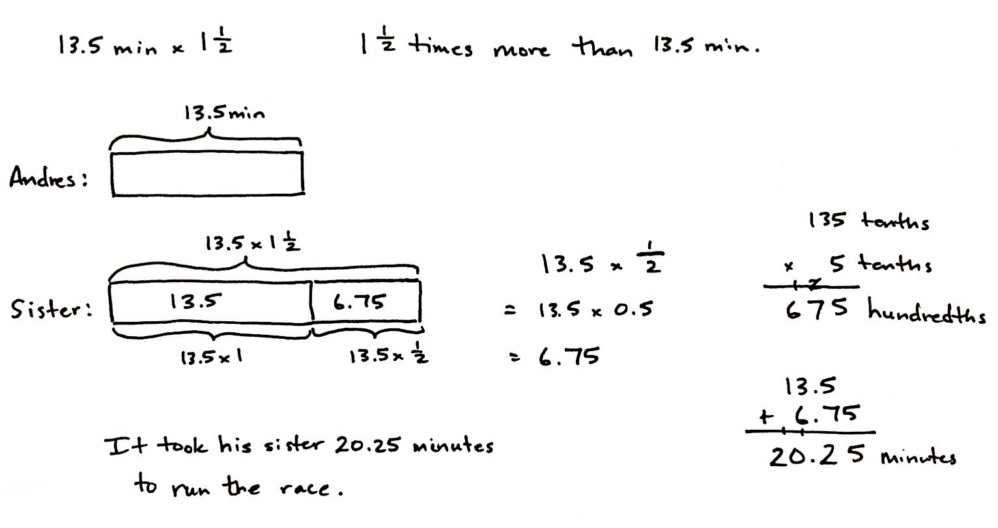

NOTES ON
MULTIPLE MEANS
OF REPRESENTATION:
Problems 3, 4, and 5 require students to compare quantities. For example, in Problem 3, students compare Andres’ race time to his sister’s time. Typically, when using tape diagrams to solve comparison word problems, at least two bars are used.
There is a strong connection between tape diagrams used with comparison story problems and bar graphs. The bars in bar graphs allow readers to compare quantities, which is similar to the bars used in comparison word problems. Although tape diagrams are typically drawn horizontally, they can be drawn vertically. Similarly, bar graphs can (and should) be drawn horizontally and vertically. In Problems 3, 4, and 5, it is easy to visualize additional data that would result in additional bars.

In this problem, Andres’ race time (13.5 minutes) is being multiplied by a scaling factor of $\text{1}\frac{\text{1}}{\text{2}}$. Students must interpret both a decimal and fractional factor, thus resulting in the expression of both factors as either decimals or fractions ($\text{13}\frac{\text{5}}{\text{10}} \text{×}\text{ 1}\frac{\text{1}}{\text{2}}$ or $\frac{\text{135}}{\text{10}} \text{×} \frac{\text{3}}{\text{2}}$). Alternatively, students may have chosen to draw a tape diagram showing Andres’ sister’s time as 1 and a half times more than his. In this manner, students must multiply to find the value of the half-unit that represents the additional time his sister spent running, and then add that sum to 13.5 minutes. The student’s choice of approach provides an opportunity to discuss the efficiency of both approaches during the Student Debrief. In any case, students should find that Andres’ sister completed the race in 20.25 (or $\text{20}\frac{\text{1}}{\text{4}}$) minutes.

Problem 4
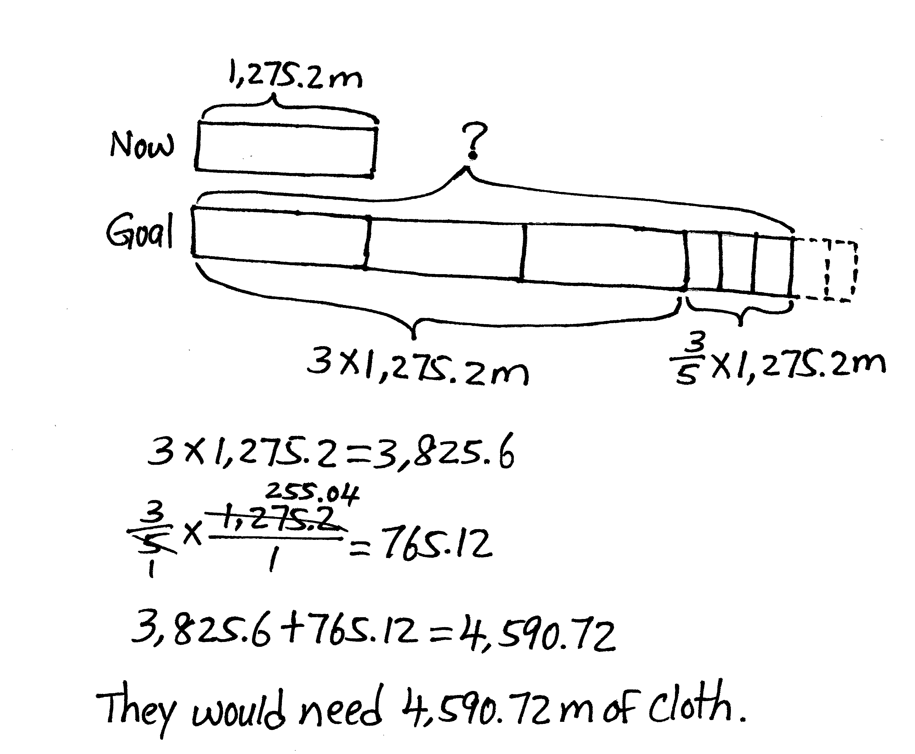
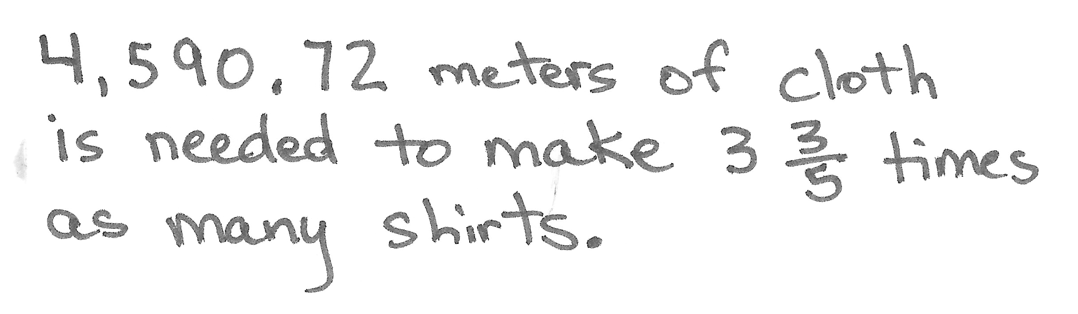
A clothing factory uses 1,275.2 meters of cloth a week to make shirts. How much cloth is needed to make $\text{3}\frac{\text{3}}{\text{5}}$ times as many shirts?

In this scaling problem, a length of cloth (1,275.2 m) is multiplied by a scaling factor of $\text{3}\frac{\text{3}}{\text{5}}$. Before students solve, ask them to identify the scaling factor and what comparison is being made (that of the initial amount of fabric and resulting amount). Though students do have the option of expressing both factors as fractions, the method of converting $\text{3}\frac{\text{3}}{\text{5}}$ to a decimal is far simpler. The efficiency of this approach can be a focus during the Student Debrief. Some students may also have chosen to draw a tape diagram showing 1,275.2 meters of cloth being scaled to $\text{3}\frac{\text{3}}{\text{5}}$ times its original length. In this manner, students could have tripled 1,275.2 first, and then found three-fifths of it before combining those two totals. In either case, students should find that the factory would need 4,590.72 meters of cloth.
Problem 5
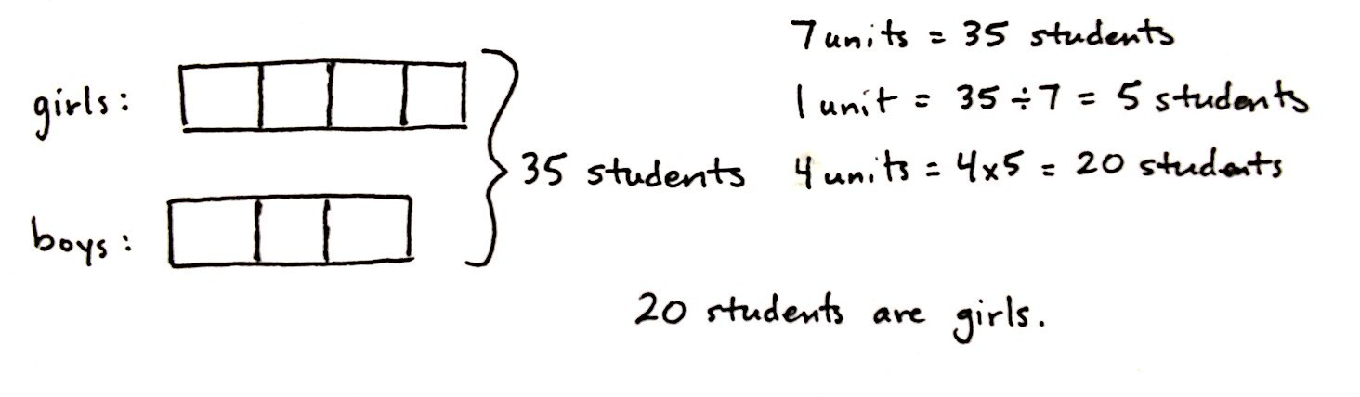
There are $\frac{\text{3}}{\text{4}}$ as many boys as girls in a class of fifth-graders. If there are 35 students in the class, how many are girls?
What may seem like a simple problem is actually rather challenging because students are required to work backwards as they solve. The word problem states that there are $\frac{\text{3}}{\text{4}}$ as many boys as girls in the class, yet the number of girls is unknown. Students should first reason that, since the number of boys is a scaled multiple of the number of girls, a tape should first be drawn to represent the girls. From that tape, students can draw a smaller tape (one that is three-fourths the size of the tape representing the girls) to represent the boys in the class. In this way, students can see that 3 units are boys, and 4 units are girls. Since there are 35 students in the class and 7 total units, each unit represents 5 students. Four of those units are girls, so there are 20 girls in the class.
Problem 6
Ciro purchased a concert ticket for $56. The cost of the ticket was $\frac{\text{4}}{\text{5}}$ the cost of his dinner. The cost of his hotel was $\text{2}\frac{\text{1}}{\text{2}}$ times as much as his ticket. How much did Ciro spend altogether for the concert ticket, hotel, and dinner?
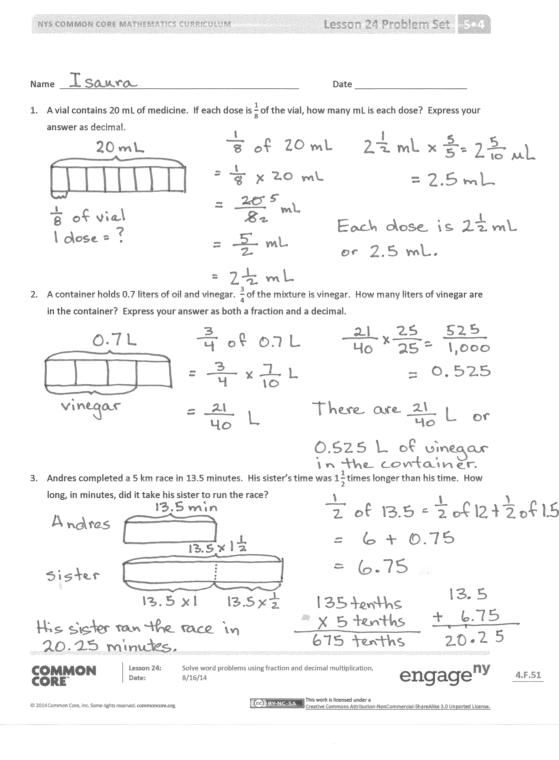
In this problem, students must read and work carefully to identify that the cost of the concert ticket plays two roles. In relation to the cost of the dinner, the ticket cost can be considered the scaling factor because it represents $\frac{\text{4}}{\text{5}}$ the cost of dinner. However, in relation to the cost of the hotel, the ticket cost should be considered the factor being scaled (because the hotel cost is $\text{2}\frac{\text{1}}{\text{2}}$ times greater). This understanding is crucial for drawing an accurate model and should be discussed thoroughly as students draw, as well as repeated during the Student Debrief.
Once the modeling is complete, the steps toward finding a solution are relatively simple. Since the ticket cost represents $\frac{\text{4}}{\text{5}}$ the cost of dinner, division shows that each unit (or fifth) is equal to $14. Therefore, 5 units (5 fifths), or the cost of dinner, is equal to $70. The model representing the cost of the hotel very clearly shows 2 units of $56 and a half unit of $56, which, in total, equals $140. Students must use addition to find the total cost of Ciro’s spending.
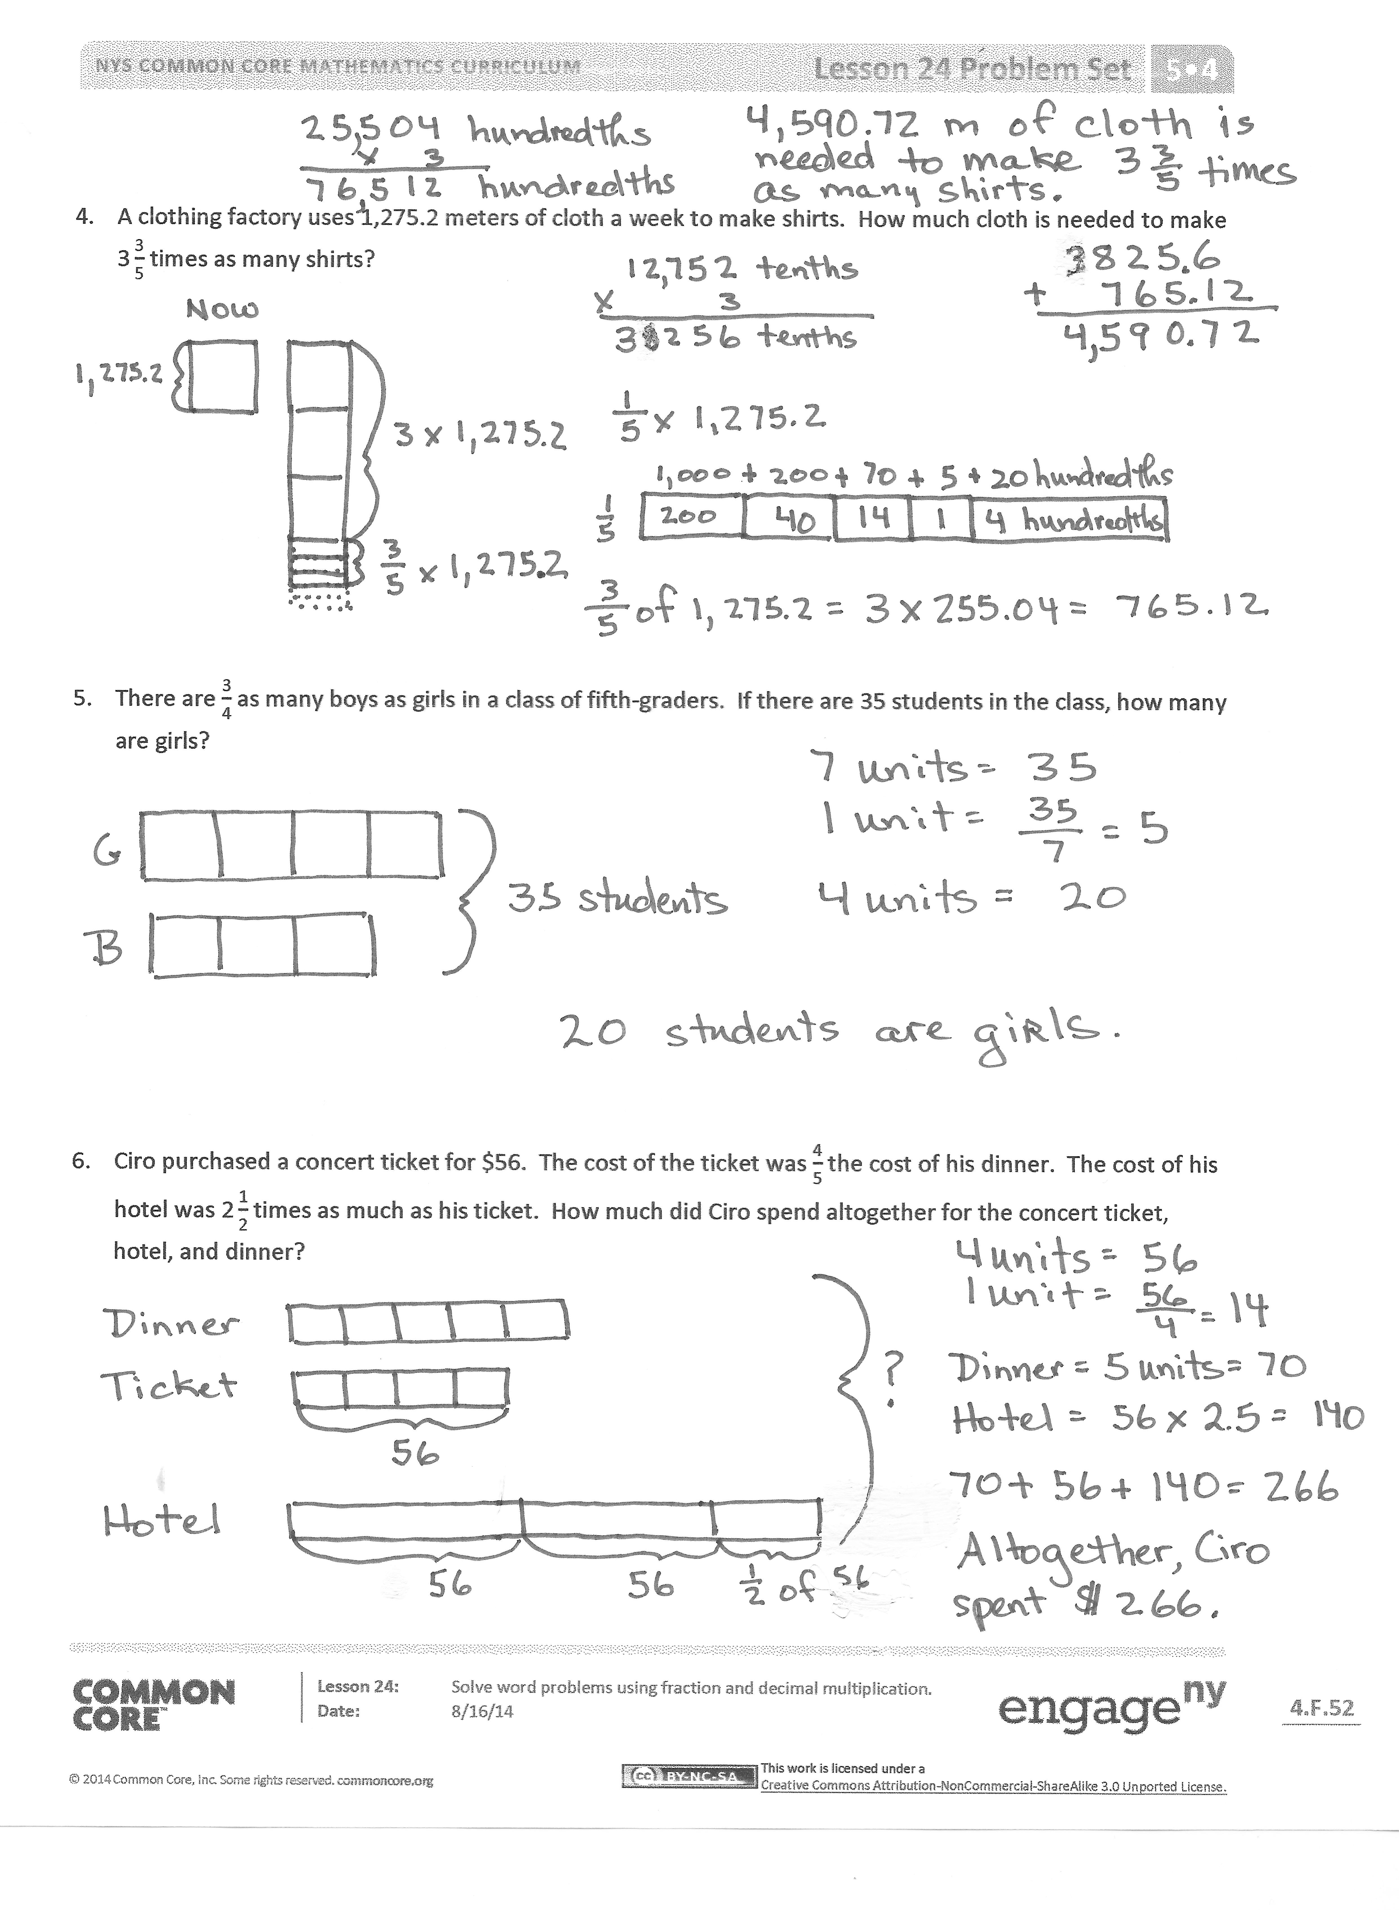
Student Debrief (10 minutes)
Lesson Objective: Solve word problems using fraction and decimal multiplication.
The Student Debrief is intended to invite reflection and active processing of the total lesson experience.
Invite students to review their solutions for the Problem Set. They should check work by comparing answers with a partner before going over answers as a class. Look for misconceptions or misunderstandings that can be addressed in the Debrief. Guide students in a conversation to debrief the Problem Set and process the lesson.
You may choose to use any combination of the questions below to lead the discussion.
- For all the problems in this Problem Set, there are several ways to solve for the solutions. With a partner, compare and share your strategies for each step in Problem 4.
- How did you solve Problem 5? Explain your strategy to a partner. Can you find how many boys there are in the classroom? How many more girls than boys are in the classroom?

NOTES ON
MULTIPLE MEANS
OF ENGAGEMENT:
A daily goal is to have students discuss their thinking. One possible strategy to achieve this goal is to partner each student with a peer who has a different perspective.
Ask students to separate themselves into groups that solved a specific problem in a similar way. Once these groups are formed, ask each student to partner with a peer in another group. Let these partners describe and discuss their strategies and solutions with each other. It is more difficult for students to explain different approaches than similar approaches.
- Did you make any drawings or tape diagrams for Problem 6? Share and compare with a partner. Does drawing a tape diagram help you solve this problem? Explain.
Exit Ticket (3 minutes)
After the Student Debrief, instruct students to complete the Exit Ticket. A review of their work will help you assess the students’ understanding of the concepts that were presented in the lesson today and plan more effectively for future lessons. You may read the questions aloud to the students.

Name Date
- A vial contains 20 mL of medicine. If each dose is $\frac{\text{1}}{\text{8}}$ of the vial, how many mL is each dose? Express your answer as a decimal.

- A container holds 0.7 liters of oil and vinegar. $\frac{\text{3}}{\text{4}}$ of the mixture is vinegar. How many liters of vinegar are in the container? Express your answer as both a fraction and a decimal.

- Andres completed a 5-km race in 13.5 minutes. His sister’s time was $\text{1}\frac{\text{1}}{\text{2}}$ times longer than his time. How long, in minutes, did it take his sister to run the race?

- A clothing factory uses 1,275.2 meters of cloth a week to make shirts. How much cloth is needed to make $\text{3}\frac{\text{3}}{\text{5}}$ times as many shirts?

- There are $\frac{\text{3}}{\text{4}}$ as many boys as girls in a class of fifth-graders. If there are 35 students in the class, how many are girls?

- Ciro purchased a concert ticket for $56. The cost of the ticket was $\frac{\text{4}}{\text{5}}$ the cost of his dinner. The cost of his hotel was $\text{2}\frac{\text{1}}{\text{2}}$ times as much as his ticket. How much did Ciro spend altogether for the concert ticket, hotel, and dinner?

Name Date
- An artist builds a sculpture out of metal and wood that weighs 14.9 kilograms. $\frac{\text{3}}{\text{4}}$ of this weight is metal, and the rest is wood. How much does the wood part of the sculpture weigh?

2. On a boat tour, there are half as many children as there are adults. There are 30 people on the tour. How many children are there?

Name Date
1. Jesse takes his dog and cat for their annual vet visit. Jesse’s dog weighs 23 pounds. The vet tells him his cat’s weight is $\frac{\text{5}}{\text{8}}$ as much as his dog’s weight. How much does his cat weigh?

- An image of a snowflake is 1.8 centimeters wide. If the actual snowflake is $\frac{\text{1}}{\text{8}}$ the size of the image, what is the width of the actual snowflake? Express your answer as a decimal.

- A community bike ride offers a short 5.7-mile ride for children and families. The short ride is followed by a long ride, $\text{5}\frac{\text{2}}{\text{3}}$ times as long as the short ride, for adults. If a woman bikes the short ride with her children, and then the long ride with her friends, how many miles does she ride altogether?

- Sal bought a house for $78,524.60. Twelve years later he sold the house for $\text{2}\frac{\text{3}}{\text{4}}$ times as much. What was the sale price of the house?

- In the fifth grade at Lenape Elementary School, there are $\frac{\text{4}}{\text{5}}$ as many students who do not wear glasses as those who do wear glasses. If there are 60 students who wear glasses, how many students are in the fifth grade?

- At a factory, a mechanic earns $17.25 an hour. The president of the company earns $\text{6}\frac{\text{2}}{\text{3}}$ times as much for each hour he works. The janitor at the same company earns $\frac{\text{3}}{\text{5}}$ as much as the mechanic. How much does the company pay for all three people employees’ wages for one hour of work?

