Lesson 23
Objective: Compare the size of the product to the size of the factors.

Suggested Lesson Structure
 Fluency Practice (12 minutes)
 Application Problem (7 minutes)
 Concept Development (31 minutes)
 Student Debrief (10 minutes)
Total Time (60 minutes)
Fluency Practice (12 minutes)
- Compare the Size of a Product to the Size of One Factor 5.NF.5 (5 minutes)
- Compare Decimal Numbers 5.NBT.2 (2 minutes)
- Write Fractions as Decimals 5.NBT.2 (5 minutes)
Compare the Size of a Product to the Size of One Factor (5 minutes)

NOTES ON
MULTIPLE MEANS
OF ACTION AND EXPRESSION:
It is very helpful for most learners to know and understand the objective of specific lessons. This knowledge helps them make connections to what they already know and what they need to learn. Each lesson in the modules has a stated objective. These objectives should be posted daily. Today’s goal, comparing the size of the factors to the size of the product, includes math vocabulary that students should know. For a quick visual review, write an equation below the objective and draw lines showing which number is the factor and which number is the product. The objective is discussed and explored daily during the Debrief.
Materials: (S) Personal white board
Note: This fluency activity reviews Lesson 21.
T: (Write 1 = $\frac{}{\text{6}}$.) On your personal white board, fill in the missing numerator.
S: (Write 1 = $\frac{\text{6}}{\text{6}}$.)
T: (Write 9 $\text{×}$ ____ = 9.) Say the missing whole number factor.
S: 1.
T: (Write 9 $\text{×}$ $\frac{}{\text{2}}$ = 9.) Fill in the missing numerator to make a true number sentence.
S: (Write 9 $\text{×}$ $\frac{\text{2}}{\text{2}}$ = 9.)
T: (Write 9 $\text{×}$ $\frac{}{\text{2}}$ < 9.) Fill in the missing numerator to make a true number sentence.
S: (Write 9 $\text{×}$ $\frac{\text{1}}{\text{2}}$ < 9.)
T: (Write 9 $\text{×}$ $\frac{}{2}$ > 9.) Fill in a missing numerator to make a true number sentence.
S: (Write the number sentence, filling in a numerator greater than 2.)
Continue this process with the following possible sequence: $\frac{\text{3}}{}$ $\text{×}$ 7 = 7, $\frac{\text{3}}{}$ $\text{×}$ 6 < 6, $\frac{3}{}$ $\text{×}$ 6 > 6, $\frac{\text{4}}{}$ $\text{×}$ 8 < 8,
$\frac{}{\text{5}}$ $\text{×}$ 9 = 9, and $\frac{\text{5}}{}$ $\text{×}$ 10 < 10.
Compare Decimal Numbers (2 minutes)
Materials: (S) Personal white board
Note: This fluency activity prepares students for today’s lesson.
T: (Write 1 ____ 9.) Say the greater number.
S: 9.
T: On your personal white board, write the symbol to make the number sentence true.
S: (Write 1 < 9.)
Continue this process with the following possible sequence: 1 ____ 0.9, 0.95 ____ 1, and 0.994 ____ 1.
Write Fractions as Decimals (5 minutes)
Materials: (S) Personal white board
Note: This fluency activity reviews Lesson 22.
T: (Write $\frac{\text{1}}{\text{50}}$ = $\frac{}{\text{100}}$.) How many fifties are in 100?
S: 2.
T: (Write $\frac{\text{1}}{\text{50}}$ $\text{×}$ $\frac{2}{2}$ = $\frac{}{\text{100}}$.) $\frac{\text{1}}{\text{50}}$ is the same as how many hundredths?
S: 2 hundredths.
T: (Write $\frac{\text{1}}{\text{50}}$ $\text{×}$ $\frac{\text{2}}{\text{2}}$ = $\frac{\text{2}}{\text{100}}$. Below it, write $\frac{\text{1}}{\text{50}}$ = ____.____.) On your personal white board, write $\frac{\text{1}}{\text{50}}$ as a decimal.
S: (Write $\frac{\text{1}}{\text{50}}$ = 0.02.)
Continue this process with the following possible sequence: $\frac{\text{3}}{\text{50}}$, $\frac{\text{7}}{\text{50}}$, $\text{3}\frac{\text{7}}{\text{50}}$, $\frac{\text{1}}{\text{20}}$, $\frac{\text{3}}{\text{20}}$, $\text{5}\frac{\text{3}}{\text{20}}$, $\frac{\text{1}}{\text{5}}$, $\frac{\text{2}}{\text{5}}$, $\frac{\text{6}}{\text{5}}$, $\frac{\text{1}}{\text{25}}$, $\frac{\text{7}}{\text{25}}$, $\text{4}\frac{\text{7}}{\text{25}}$, $\frac{\text{1}}{\text{4}}$, $\frac{\text{3}}{\text{4}}$, and $\frac{\text{11}}{\text{4}}$.

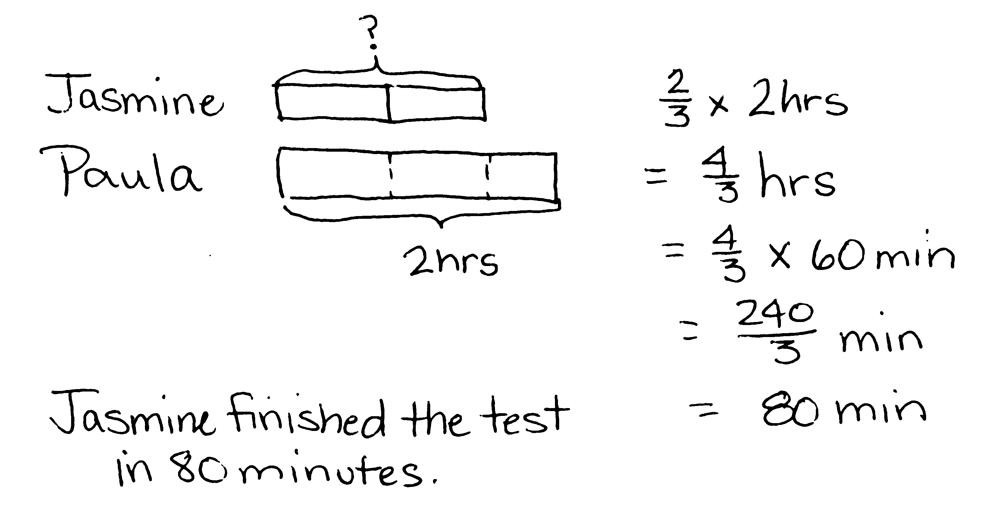
Application Problem (7 minutes)
Jasmine took $\frac{\text{2}}{\text{3}}$ as much time to take a math test as Paula. If Paula took 2 hours to take the test, how long did it take Jasmine to take the test? Express your answer in minutes.
Note: Scaling, as well as conversion, is required for today’s Application Problem. This reviews Topic E and prepares students for continuing a study of scaling with decimals in today’s lesson.
Concept Development (31 minutes)
Materials: (S) Personal white board
Problem 1: a. 2 meters $\text{×}\frac{\text{97}}{\text{100}}$ b. 2 meters $\text{×}\frac{\text{101}}{\text{100}}$ c. 2 meters $\text{×}\frac{\text{100}}{\text{100}}$
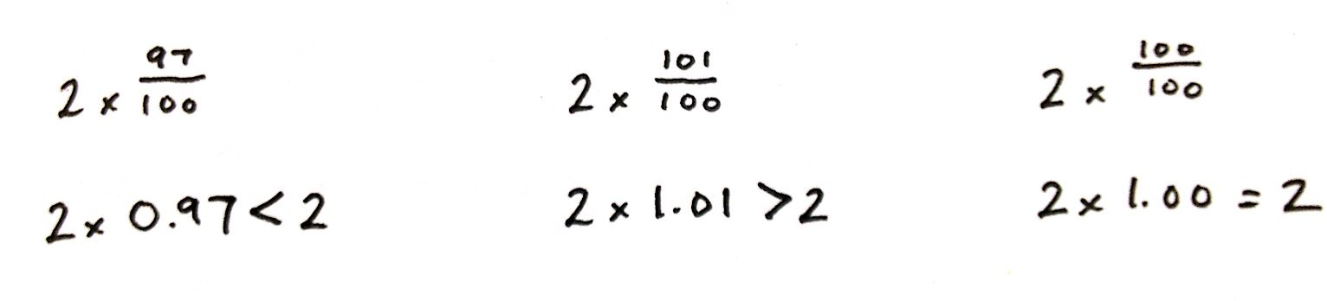
T: (Post Problem 1(a–c) on the board.) Let’s compare products to the 2 meters in each expression. Let’s notice what happens to 2 meters when we multiply, or scale, 2 meters by the other factors. Read the scaling factors out loud in the order they are written.
S: 97 hundredths, 101 hundredths, 100 hundredths.
T: Without evaluating them, turn and talk with a neighbor about which expression is greater than, less than, and equal to 2 meters. Be sure to explain your thinking.
S: 2 $\text{×}\frac{\text{100}}{\text{100}}$ would be equal to 2 meters because it’s being scaled by 1. 2 meters $\text{×}\frac{\text{97}}{\text{100}}$ would be less than 2 meters because it’s being scaled by a fraction less than 1. 2 meters$\text{×}$ $\frac{\text{101}}{\text{100}}$ would be more than 2 meters because it’s being scaled by a fraction more than 1.
T: Rewrite the expressions using decimals to express the scaling factors.
S: (Work and show 2 meters $\text{×}$ 0.97, 2 meters $\text{× }$1.01, and 2 meters $\text{× }$1.0.)
T: (Write decimal expressions below the fractional ones.) Which expression is greater than, less than, and equal to 2 meters? Turn and talk.
S: It’s the same as before: 2 times 1 is equal to 1, 2 times 0.97 is less than 2, and 2 times 1.01 is more than 2. Nothing has changed; we’ve just expressed the scaling factor as a decimal. We haven’t changed the value.
T: (Write 2 $\text{× }$____ $\text{<}$ 2 on the board.) Write three decimal scaling factors that would make this number sentence true.
S: (Work and show numbers less than 1.0.)
T: Finish my sentence. To get a product that is less than the number you started with, multiply by a scaling factor that is…
S: Less than 1.
T: (Write 2 $\text{× }$____ $\text{> }$2 on the board.) Show me some more decimal scaling factors that would make this number sentence true.
S: (Work and show numbers more than 1.0.)
T: Finish this sentence. To obtain a product that is more than the number you started with, multiply by a scaling factor that is….
S: More than 1.
Problem 2: a. 19.4 $\text{×}$ 0.96 b. 19.4 $\text{×}$ 0.02
T: (Post Problems 2(a) and (b) on the board.) Let’s compare our product to the first factor—19.4. Let’s consider the other factors the scaling factors. Read the scaling factors out loud in the order they are written.
S: 96 hundredths, 2 hundredths.
T: Look at the first expression. Will the product be more than, less than, or equal to 19.4? Tell a neighbor why.
S: The product will be less than 19.4 because the scaling factor is less than 1.
T: (Write $\text{<}$ 19.4 next to Problem 2(a).) Look at the second expression. Will the product be more than, less than, or equal to 19.4? Tell a neighbor why.
S: It’s also less than 19.4 because that scaling factor is also less than 1.
T: (Write $\text{<}$ 19.4 next to Problem 2(b).) So, we know that both scaling factors will result in a product that is less than the number we started with. Which expression will give a greater product? Why? Turn and talk.
S: 19.4 times 96 hundredths will give a greater product. Even though both scaling factors are less than 1, 96 hundredths is a much larger scaling factor than 2 hundredths. 96 hundredths is close to 1. 2 hundredths is almost zero. The first expression will be really close to 19.4, and the second expression will be closer to zero.
T: (Point to Problem 2(a).) What is the scaling factor here?
S: 96 hundredths.
T: What would the scaling factor need to be for the product to be equal to 19.4?
S: 1.
T: Isn’t 1 the same as 100 hundredths?
S: Yes.
T: So, this scaling factor, 96 hundredths, is slightly less than 1. True or false?
S: True.
T: If this is true, what can we say about the product of 19.4 and 0.96? Turn and talk.
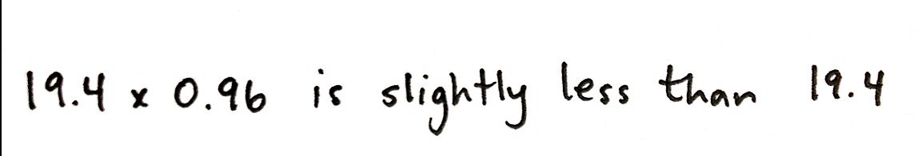
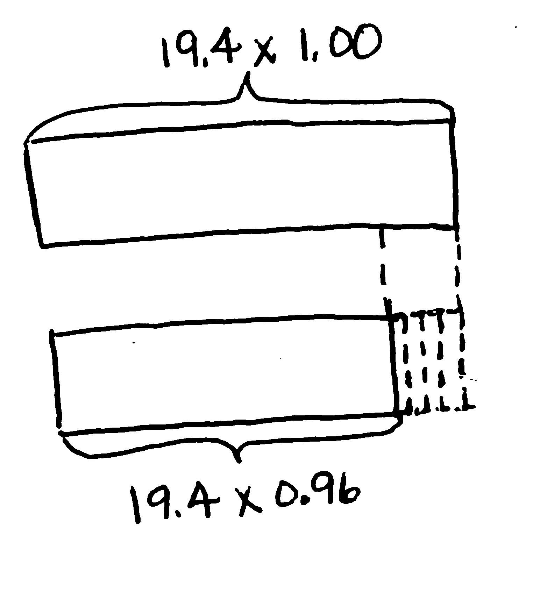
S: If we draw a tape diagram of 19.4 $\text{× 1}$, it would be 19.4 units long. Since 96 hundredths is just slightly less than 1, this means that 19.4 $\text{×}$ 0.96 is slightly less than 19.4 $\text{× }$1. The tape diagram should be slightly shorter than the first one we drew. The expression 19.4 times 96 hundredths is just slightly less than 19.4.
T: (Draw the first tape diagram as shown.) Imagine partitioning this tape into 100 equal parts. The tape for 19.4 times 96 hundredths should be as long as 96 of those hundredths, or just 4 hundredths less than this whole tape. (Draw a second tape diagram slightly shorter and label it 19.4 $\text{× }$0.96.)
T: Make a statement about this expression. Is 19.4 times 96 hundredths slightly less than 19.4, or a lot less than 19.4?
S: It is slightly less than 19.4.
T: (Write 19.4 $\text{×}$ 0.96 is slightly less than 19.4.) Let’s look at the other expression now. Is the scaling factor, 2 hundredths, slightly less than 1 or a lot less than 1? Turn and talk.
S: 1 is 100 hundredths; this is only 2 hundredths. It’s a lot less than 1. It’s a lot less than 1. In fact, it’s only slightly more than zero.
T: This scaling factor is a lot less than 1. Work with a partner to draw two tape diagrams. One should show 19.4, like we did before, and the other should show 19.4 times 2 hundredths.
S: (Work and share.)
T: Make a statement about this expression. Is 19.4 times 2 hundredths slightly less than 19.4, or a lot less than 19.4?
S: It is a lot less than 19.4.
T: (Write 19.4 $\text{×}$ 0.02 is a lot less than 19.4.)
Problem 3: a. 1.02 $\text{×}$ 1.73 b. 29.01 $\text{×}$ 1.73
T: (Post Problems 3(a) and (b) on the board.) Let’s compare our products to the second factor in these expressions. (Point to 1.73 in both expressions.) We’ll consider the first factors to be scaling factors. Read the scaling factors out loud in the order they are written.
S: 1 and 2 hundredths, 29 and 1 hundredth.
T: Think about these expressions. Will the products be more than, less than, or equal to 1.73? Tell your neighbor why.
S: They’ll both be more than 1.73 because both scaling factors are more than 1.
T: Let’s be more specific. Look at the first expression. Will the product be slightly more than 1.73, or a lot more than 1.73? Tell a neighbor.
S: The product will just be slightly more than 1.73. The scaling factor is just 2 hundredths more than 1. I can visualize two tape diagrams, and the one showing 1.73 times 1.02 is just a little bit longer, like 2 hundredths times longer than the tape showing 1.73. The product will be slightly more than what we started with because the scaling factor is just slightly more than 1.
T: (Write 1.02 $\text{×}$ 1.73 is slightly more than 1.73.) Think about the second expression. Will its product be slightly more than 1.73, or a lot more than 1.73? Tell a neighbor.
S: The product will just be a lot more than 1.73. The scaling factor is almost 30 times more than 1, so the product will be almost 30 times more, too. I can visualize two tape diagrams, and the one showing 1.73 times 29.01 is a lot longer, like 29 times longer than the tape showing just 1.73. The product will be a lot more than what we started with because the scaling factor is a lot more than 1.
Problem Set (10 minutes)
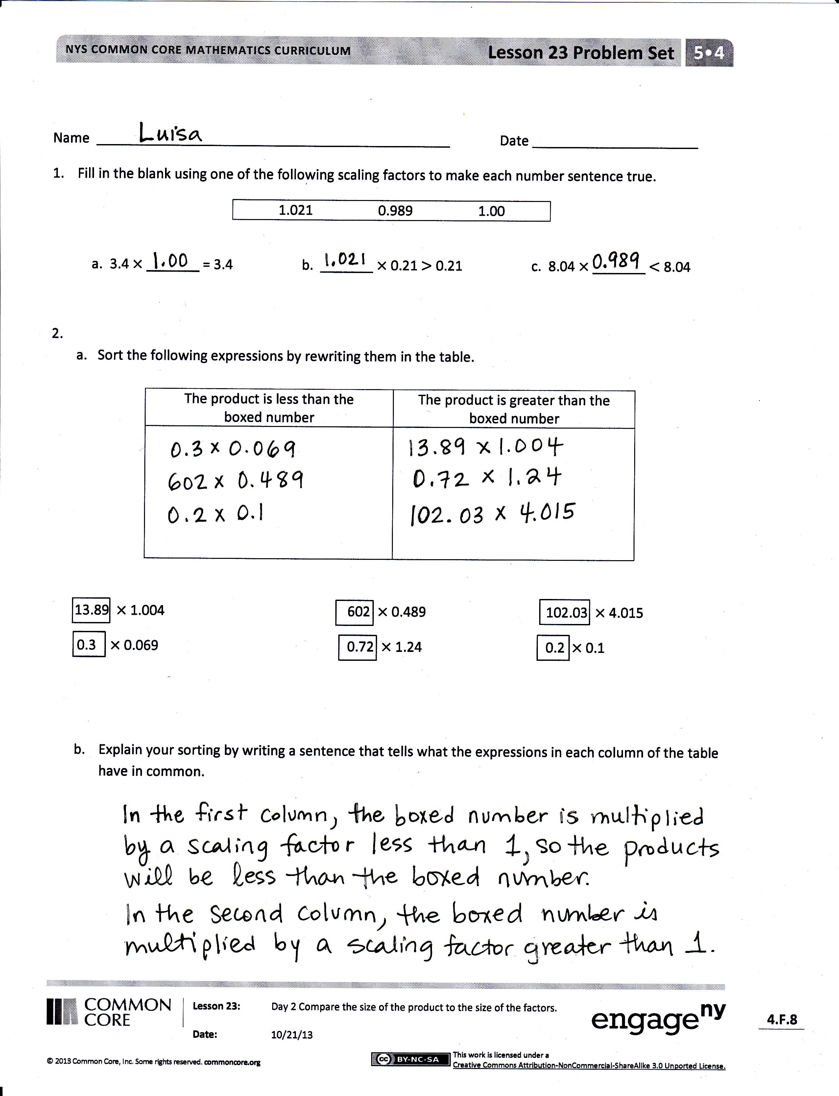
Students should do their personal best to complete the Problem Set within the allotted 10 minutes. For some classes, it may be appropriate to modify the assignment by specifying which problems they work on first. Some problems do not specify a method for solving. Students should solve these problems using the RDW approach used for Application Problems.
Student Debrief (10 minutes)
Lesson Objective: Compare the size of the product to the size of the factors.
The Student Debrief is intended to invite reflection and active processing of the total lesson experience.
Invite students to review their solutions for the Problem Set. They should check work by comparing answers with a partner before going over answers as a class. Look for misconceptions or misunderstandings that can be addressed in the Debrief. Guide students in a conversation to debrief the Problem Set and process the lesson.

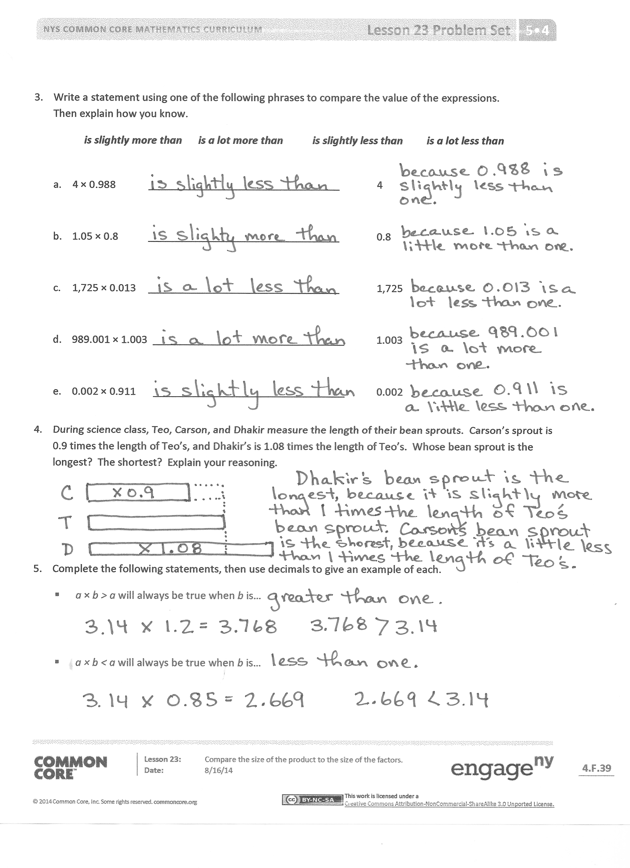
You may choose to use any combination of the questions below to lead the discussion.

- Share your solutions and explain your thought process for solving Problem 1 to a partner. How did you decide which number goes into which expression?
- Compare your solutions for Problem 2 with a partner. Did you have different answers? If so, explain your thinking behind each sorting.
- What was your strategy for solving Problem 3? Share it with a partner.
- How did you solve Problem 4? Did you make a drawing or tape diagram to compare the sprouts? Share it with and explain it to a partner.
- Share your decimal examples for Problem 5 with a partner. Did you have the same or different examples?
Exit Ticket (3 minutes)
After the Student Debrief, instruct students to complete the Exit Ticket. A review of their work will help you assess the students’ understanding of the concepts that were presented in the lesson today and plan more effectively for future lessons. You may read the questions aloud to the students.
Name Date
- Fill in the blank using one of the following scaling factors to make each number sentence true.
1.021 0.989 1.00

a. 3.4 $\text{×}$ _______ = 3.4 b. _______ $\text{×}$ 0.21 $\text{>}$ 0.21 c. 8.04 $\text{×}$ _______ $\text{<}$ 8.04

- a. Sort the following expressions by rewriting them in the table.

The product is less than the  boxed number: | The product is greater than the boxed number:

13.89 $\text{×}$1.004 602 $\text{×}$ 0.489 102.03 $\text{×}$ 4.015
0.3 $\text{×}$ 0.069 0.72 $\text{×}$ 1.24 0.2 $\text{×}$ 0.1

b. Explain your sorting by writing a sentence that tells what the expressions in each column of the table have in common.

3. Write a statement using one of the following phrases to compare the value of the expressions.
Then, explain how you know.
is slightly more than is a lot more than is slightly less than is a lot less than

- 4 $\text{×}$ 0.988 _________________________________ 4

- 1.05 $\text{×}$ 0.8 _________________________________ 0.8

- 1,725 $\text{×}$ 0.013 _________________________________ 1,725

- 989.001 $\text{×}$ 1.003 _________________________________ 1.003

- 0.002 $\text{×}$ 0.911 _________________________________ 0.002

- During science class, Teo, Carson, and Dhakir measure the length of their bean sprouts. Carson’s sprout is 0.9 times the length of Teo’s, and Dhakir’s is 1.08 times the length of Teo’s. Whose bean sprout is the longest? The shortest? Explain your reasoning.

- Complete the following statements, then use decimals to give an example of each.
- a$\text{×}$ b > a will always be true when b is…

- $\text{a} \text{×}$b < a will always be true when b is…

Name Date
- Fill in the blank using one of the following scaling factors to make each number sentence true.
1.009 1.00 0.898

a. 3.06 $\text{×}$ _______ $\text{<}$ 3.06 b. 5.2 $\text{×}$ _______ = 5.2 c. _______ $\text{×}$ 0.89 $\text{>}$ 0.89

- Will the product of 22.65 $\text{×}$ 0.999 be greater than or less than 22.65? Without calculating, explain how you know.

Name Date

  - Sort the following expressions by rewriting them in the table.

The product is less than the  boxed number: | The product is greater than the boxed number:

12.5 $\text{×}$1.989 828 $\text{×}$ 0.921 321.46 $\text{×}$ 1.26
0.007 $\text{ ×}$ 1.02 2.16 $\text{ ×}$ 1.11 0.05 $\text{×}$ 0.1

b. What do the expressions in each column have in common?

- Write a statement using one of the following phrases to compare the value of the expressions.
Then, explain how you know.
is slightly more than is a lot more than is slightly less than is a lot less than
- 14 $\text{×}$ 0.999 _______________________________ 14

- 1.01 $\text{×}$ 2.06 _______________________________ 2.06

- 1,955 $\text{×}$ 0.019 _______________________________ 1,955

- Two thousand $\text{×}$ 1.0001 _______________________________ two thousand

- Two-thousandths $\text{×}$ 0.911 _______________________________ two-thousandths
- Rachel is 1.5 times as heavy as her cousin, Kayla. Another cousin, Jonathan, weighs 1.25 times as much as Kayla. List the cousins, from lightest to heaviest, and explain your thinking.

- Circle your choice.
- a$\text{ × }$b > a
For this statement to be true, b must be greater than 1 less than 1

Write two expressions that support your answer. Be sure to include one decimal example.

- a $\text{×}$ b < a
For this statement to be true, b must be greater than 1 less than 1

Write two expressions that support your answer. Be sure to include one decimal example.

