Lesson 20
Objective: Convert mixed unit measurements, and solve multi-step word problems.

Suggested Lesson Structure
 Fluency Practice (12 minutes)
 Application Problem (6 minutes)
 Concept Development (32 minutes)
 Student Debrief (10 minutes)
Total Time (60 minutes)
Fluency Practice (12 minutes)
- Count by Fractions 5.NF.7 (3 minutes)
- Convert Measures 4.MD.1 (3 minutes)
- Multiply Decimals 5.NBT.7 (3 minutes)
- Find the Unit Conversion 5.MD.2 (3 minutes)
Count by Fractions (3 minutes)
Note: This fluency activity prepares students for Lesson 21.
1 2 3 4 5 6 7 8 9 10
$\frac{1}{2}$ $\frac{2}{2}$ $\frac{3}{2}$ $\frac{4}{2}$ $\frac{5}{2}$ $\frac{6}{5}$ $\frac{7}{2}$ $\frac{8}{2}$ $\frac{9}{2}$ $\frac{10}{2}$
$\frac{1}{2}$ 1 $\frac{3}{2}$ 2$\frac{4}{2}$ $\frac{5}{2}$ 3 $\frac{7}{2}$ 4$\frac{8}{2}$ $\frac{9}{2}$ 5
$\frac{1}{2}$ 1 $1\frac{1}{2}$ 2$\frac{4}{2}$ $2\frac{1}{2}$ 3 $3\frac{1}{2}$ 4$\frac{8}{2}$ $4\frac{1}{2}$ 5

T: Count by ones to 10. (Write as students count.)
S: 1, 2, 3, 4, 5, 6, 7, 8, 9, 10.
T: Count by halves to 10 halves. (Write as students count.)
S: 1 half, 2 halves, 3 halves, 4 halves, 5 halves, 6 halves, 7 halves, 8 halves, 9 halves, 10 halves.
T: Let’s count by halves again. This time, when we arrive at a whole number, say the whole number. (Write as students count.)
S: 1 half, 1 whole, 3 halves, 2 wholes, 5 halves, 3 wholes, 7 halves, 4 wholes, 9 halves, 5 wholes.
T: Let’s count by halves again. This time, change improper fractions to mixed numbers. (Write as students count.)
S: 1 half, 1, 1 and 1 half, 2, 2 and 1 half, 3, 3 and 1 half, 4, 4 and 1 half, 5.
Convert Measures (3 minutes)
Materials: (S) Personal white board, Grade 5 Mathematics Reference Sheet (Lesson 8 Reference Sheet)
Note: This fluency exercise reviews Lessons 19 and 20. Allow students to use the conversion reference sheet if they are confused, but encourage them to answer questions without referring to it.
T: (Write 1 ft = ____ in.) How many inches are equal to 1 foot?
S: 12 inches.
T: (Write 1 ft = 12 in. Below it, write 2 ft = ____ in.) 2 feet?
S: 24 inches.
T: (Write 2 ft = 24 in. Below it, write 4 ft = ____ in.) 4 feet?
S: 48 inches.
Continue with the following possible sequence: 1 pint = 2 cups, 7 pints = 14 cups, 1 yard = 3 feet,
6 yards = 18 feet, 1 gallon = 4 quarts, and 9 gallons = 36 quarts.
T: (Write 2 c = ____ pt.) How many pints are equal to 2 cups?
S: 1 pint.
T: (Write 2 c = 1 pt. Below it, write 4 c = ____ pt.) 4 cups?
S: 2 pints.
T: (Write 4 c = 2 pt. Below it, write 10 c = ____ pt.) 10 cups?
S: 5 pints.
Continue with the following possible sequence: 12 in = 1 ft, 36 in = 3 ft, 3 ft = 1 yd, 12 ft = 4 yd, 4 qt = 1 gal, and 28 qt = 7 gal.
Multiply Decimals (3 minutes)
3 × 3 = 9 3 × 0.3 = 0.9 0.3 × 0.3 = 0.09 0.03 × 0.3 = 0.009
2 × 8 = 16 2 × 0.8 = 1.6 0.2 × 0.8 = 0.16 0.02 × 0.8 = 0.016
5 × 5 = 25 0.5 × 5 = 2.5 0.5 × 0.5 = 0.25 0.5 × 0.05 = 0.025
Materials: (S) Personal white board
Note: This fluency activity reviews Lessons 17 and 18.
T: (Write 3 × 3 = ____.) Say the multiplication sentence with the answer.
S: 3 × 3 = 9.
T: (Write 3 × 0.3 = ____.) On your personal white board, write the number sentence and the answer.
S: (Write 3 × 0.3 = 0.9.)
T: (Write 0.3 × 0.3 = ____.) Try this problem.
S: (Write 0.3 × 0.3 = 0.09.)
T: (Write 0.03 × 0.3 = ____.) Try this problem.
S: (Write 0.03 × 0.3 = 0.009.)
Continue this process with the following possible sequence: 2 × 8, 2 × 0.8, 0.2 × 0.8, 0.02 × 0.8; 5 × 5, 0.5 × 5, 0.5 × 0.5, and 0.5 × 0.05.
Find the Unit Conversion (3 minutes)
Materials: (S) Personal white board
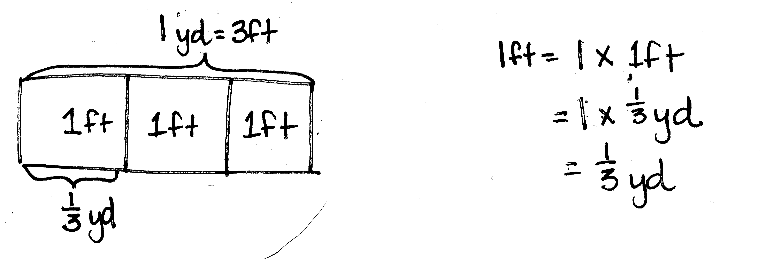
Note: This fluency exercise reviews Lesson 12.
T: How many feet are in 1 yard?
S: 3 feet.
T: (Write 3 ft = 1 yd. Below it, write 1 ft = ____ yd.) What fraction of 1 yard is 1 foot?
S: 1 third.
T: On your personal white board, draw a tape diagram to explain your thinking.
Continue with the following possible sequence: 2 ft = ____ yd, 5 in = ____ ft, 1 in = ____ ft, 1 oz = ____ lb,
9 oz = ____ lb, 1 pt = ____ qt, 3 pt = ____ qt, 4 days = ____ week, and 18 hours = ____ day.
Application Problem (6 minutes)
A recipe calls for $\frac{3}{4}$ lb of cream cheese. A small tub of cream cheese at the grocery store weighs 12 oz. Is this enough cream cheese for the recipe?
Note: This Application Problem builds on previous lessons involving unit conversions and multiplication of a fraction and a whole number. In addition to the method shown, students may also simply realize that $\frac{3}{4}$ is equal to $\frac{12}{16}$.
NOTES ON
MULTIPLE MEANS
OF REPRESENTATION:
Another approach to this Application Problem is to think of it as a comparison problem. (See Table 2 of the Common Core Learning Standards.) Students can draw two bars, one showing the amount needed for the recipe, and another showing the amount sold in the small tub. The tape diagram would help students recognize the need to convert one of the amounts, so that like units can be compared.
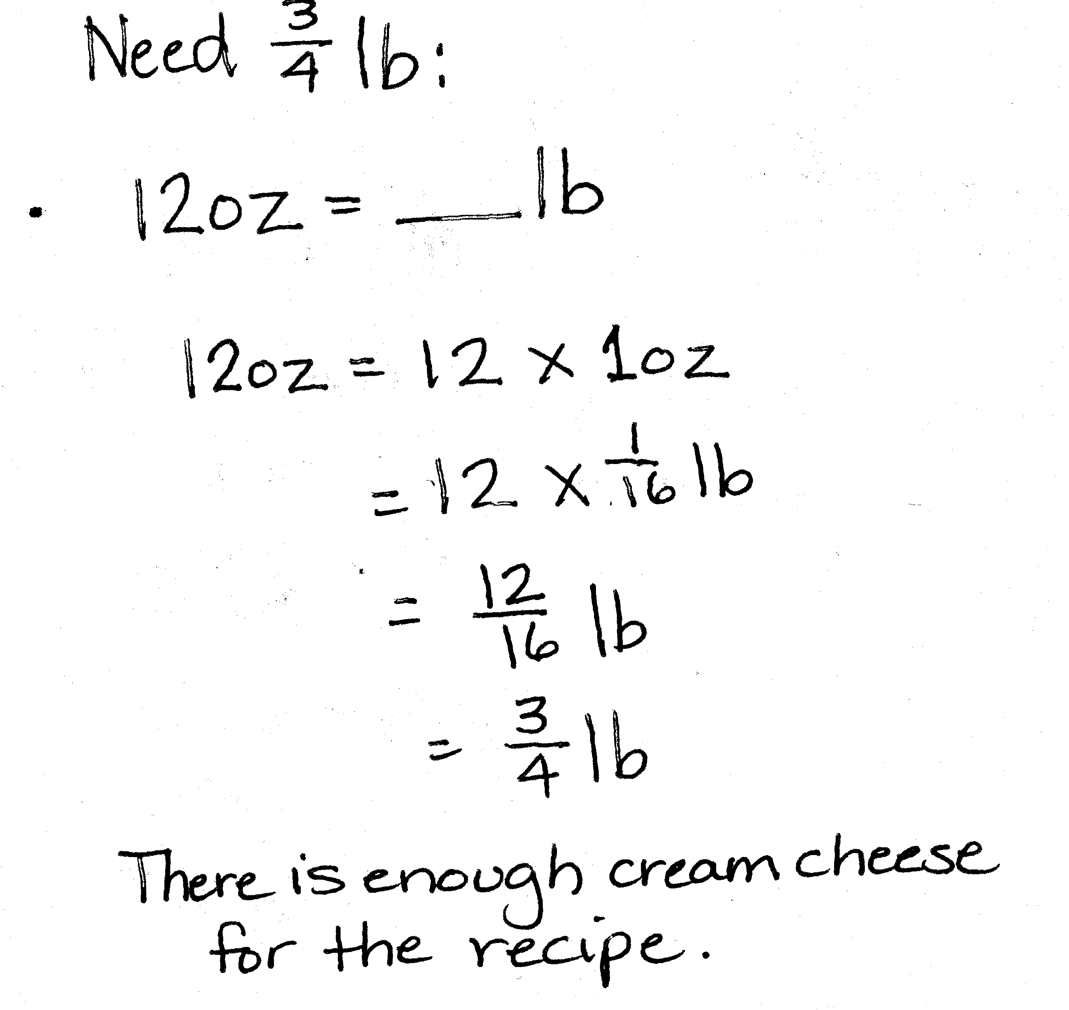

Concept Development (32 minutes)
Materials: (S) Personal white board
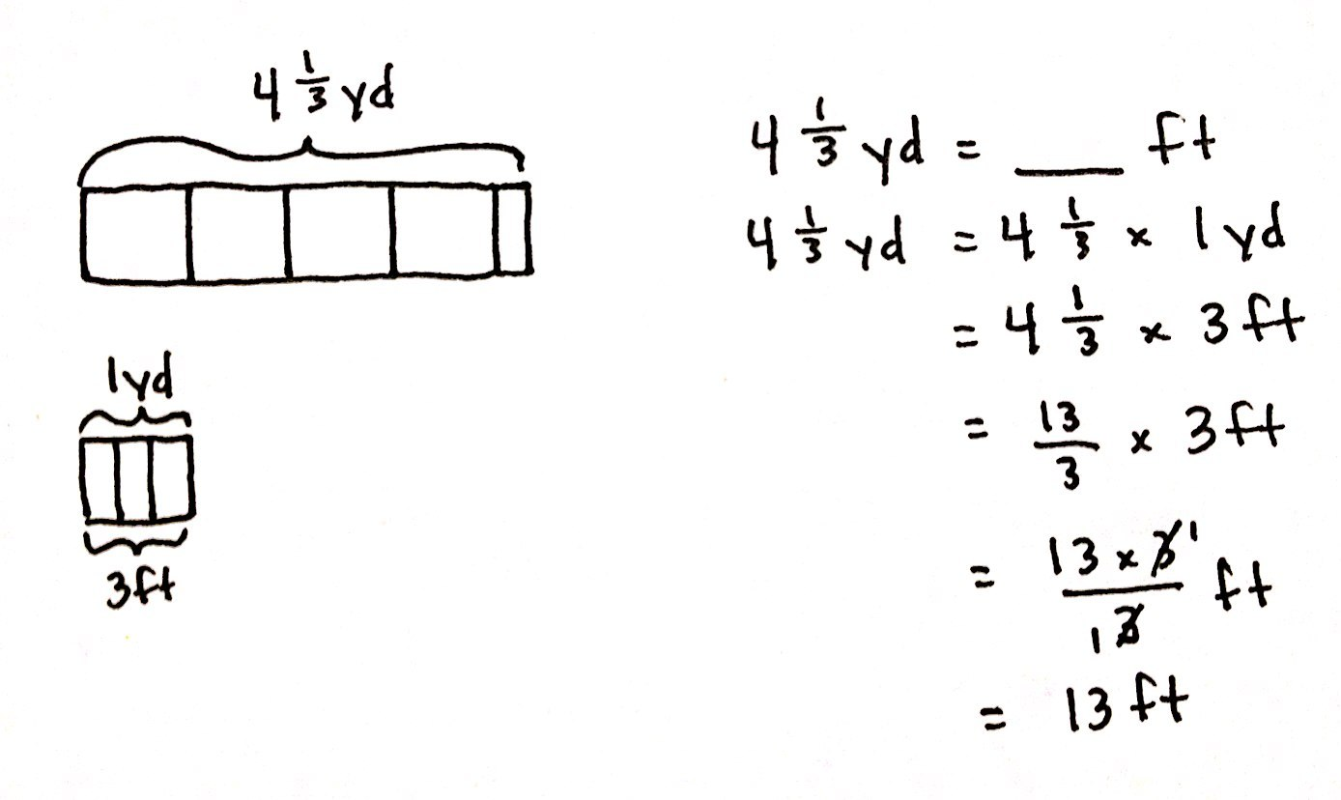
Problem 1: Convert larger units to smaller units.
$\text{4}\frac{1}{3}$ yd = ____ ft
T: (Write $\text{4}\frac{1}{3}$ yd = ____ ft on the board.) Which units are larger, yards or feet?
S: Yards.
T: Compare this problem with the conversions we worked on yesterday. What do you notice about the units? Turn and talk.
S: This is starting with larger units and converting to smaller ones. Yesterday every conversion we did was small units to large units. This is large to small conversion.
T: Let’s draw a tape diagram to model this problem. We want to name $\text{4}\frac{1}{3}$ yards using feet. (Draw a bar and label it $\text{4}\frac{1}{3}$ yd.) Let’s partition the bar into 4 equal units to represent the 4 whole yards and 1 smaller unit to represent $\frac{1}{3}$ of a yard. $\text{4}\frac{1}{3}$ yards is the same as $\text{4}\frac{1}{3}$ × 1 yard. (Write on the board.) How many feet are in 1 yard?
S: 3 feet.
NOTES ON
MULTIPLE MEANS
OF REPRESENTATION:
The lessons in this topic require students to know basic conversions, such as 16 ounces, are combined to make 1 pound. Teachers can provide this background knowledge in the form of posters or other graphic organizers.
Students may also need support with some of the abbreviations used. For example, the abbreviation for pound (lb) and the abbreviation for ounce (oz) may seem confusing to some students. Teachers can post this information on a poster or provide reference sheets for all students.
T: On your personal white board, draw a tape diagram to explain your thinking.
S: (Draw.)
T: (Show 1 yard equal to 3 feet below the tape diagram.) Write a new expression to rename the yard in feet.
S: (Write $\text{4}\frac{1}{3}$ × 3 ft.)
T: Before we multiply, let’s express $\text{4}\frac{1}{3}$ as an improper fraction. How many thirds are in 1 whole?
S: 3 thirds.
T: So how many thirds are in 4 wholes?
S: 12 thirds.
T: How many thirds are in 4 and 1 third?
S: 13 thirds.
T: Write a new multiplication expression that uses the improper fraction we just found.
S: (Write $\frac{13}{3}$ × 3 ft.)
T: Work with a partner to find the product of 13 thirds and 3.
S: (Work.)
T: (Point to the original problem.) Fill in the blank using a complete sentence.
S: $\text{4}\frac{1}{3}$ yd is equal to 13 ft.
As necessary, repeat the same process with the following problems.
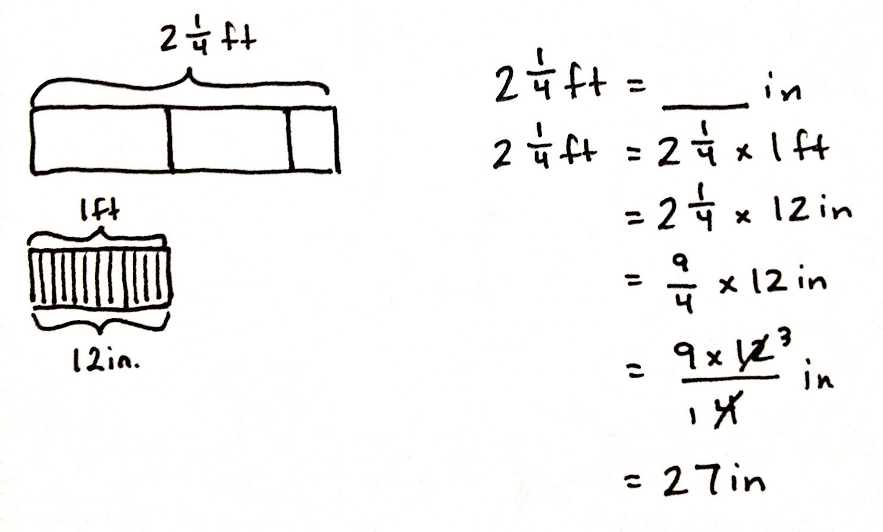
$\text{2}\frac{1}{4}$ ft = ____ in

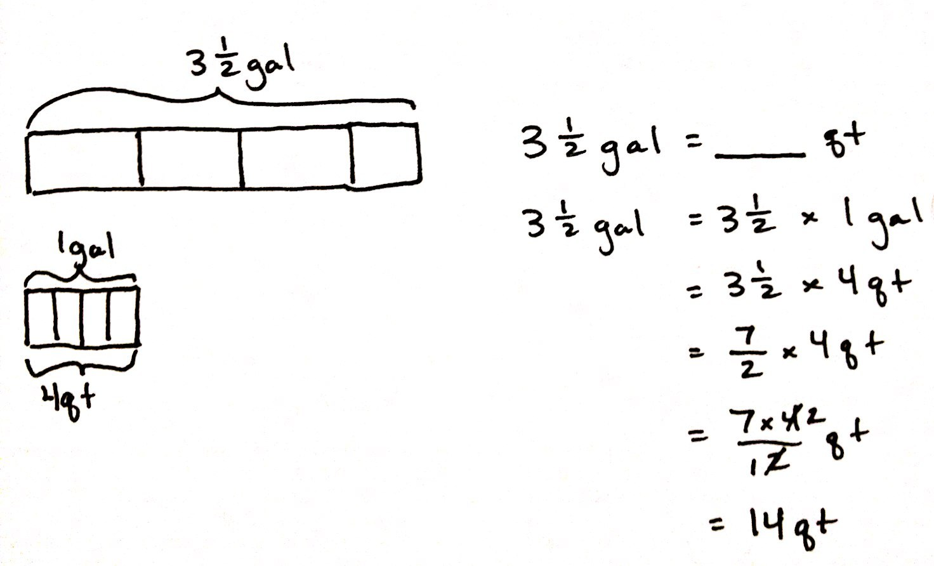
$\text{3}\frac{1}{2}$ gal = ____ qt

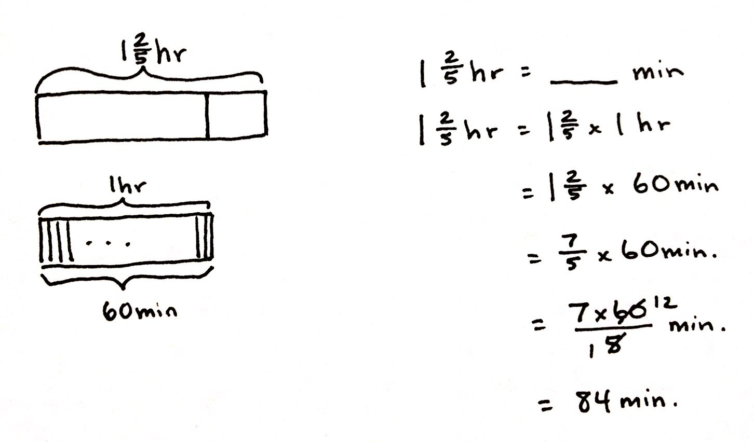
$\text{1}\frac{2}{5}$ hr = ____ min

Problem 2: Convert smaller units to larger units.
11 ft = ____ yd
T: (Write 11 ft = ____ yd on the board.) Which units are larger, feet or yards?
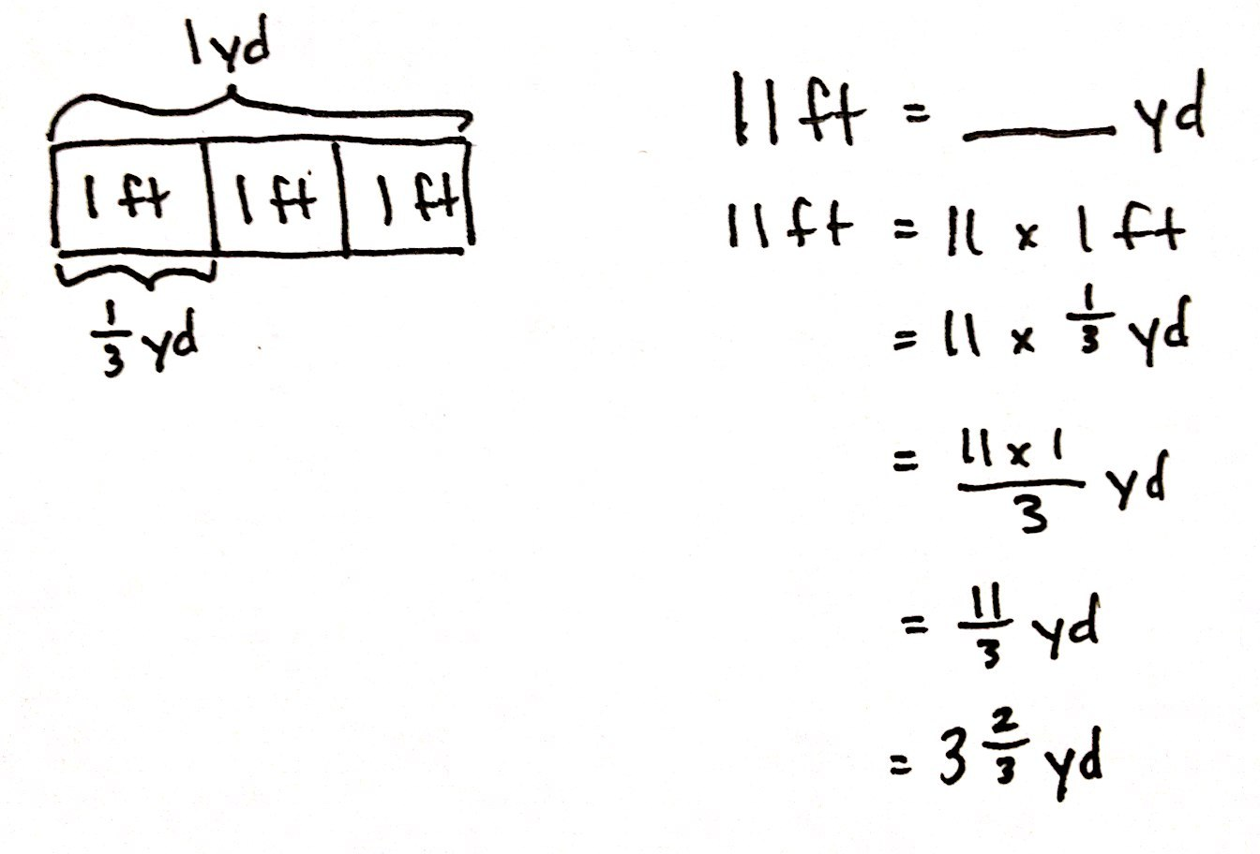
S: Yards.
T: Compare this problem to the others we’ve solved. Turn and share with a partner.
S: This one gives us the measurement in smaller units and wants the amount of larger units. This one goes from small units to large units such as the ones we did yesterday.
T: What fraction of 1 yard is 1 foot?
S: 1 third.
T: On your personal white board, draw a tape diagram to show the relationship between feet and yards.
S: (Draw.)
T: What two whole numbers of yards will 11 feet fall between? Turn and talk.
S: 9 feet is 3 yards, and 12 feet is 4 yards, so 11 feet must be somewhere between 3 and 4 yards.
T: We know that 11 ft = 11 $\text{×}$ 1 ft. (Write on the board.) Write a multiplication sentence that is equivalent to this one using yards.
S: (Work.)
T: Let’s record the equivalent expression beneath our first one. (Record as shown.) What is 11 $\text{×}\frac{1}{3}$?
S: 11 thirds.
T: Express 11 thirds as a mixed number.
S: $3\frac{2}{3}$.
T: Express your answer as yards.
S: 3 and 2 thirds yards.
Repeat the same process with the following as necessary.
$\text{5}\frac{1}{2}$ ft = ____ yd. $\text{3}\frac{1}{3}$ qt = ____ gal.
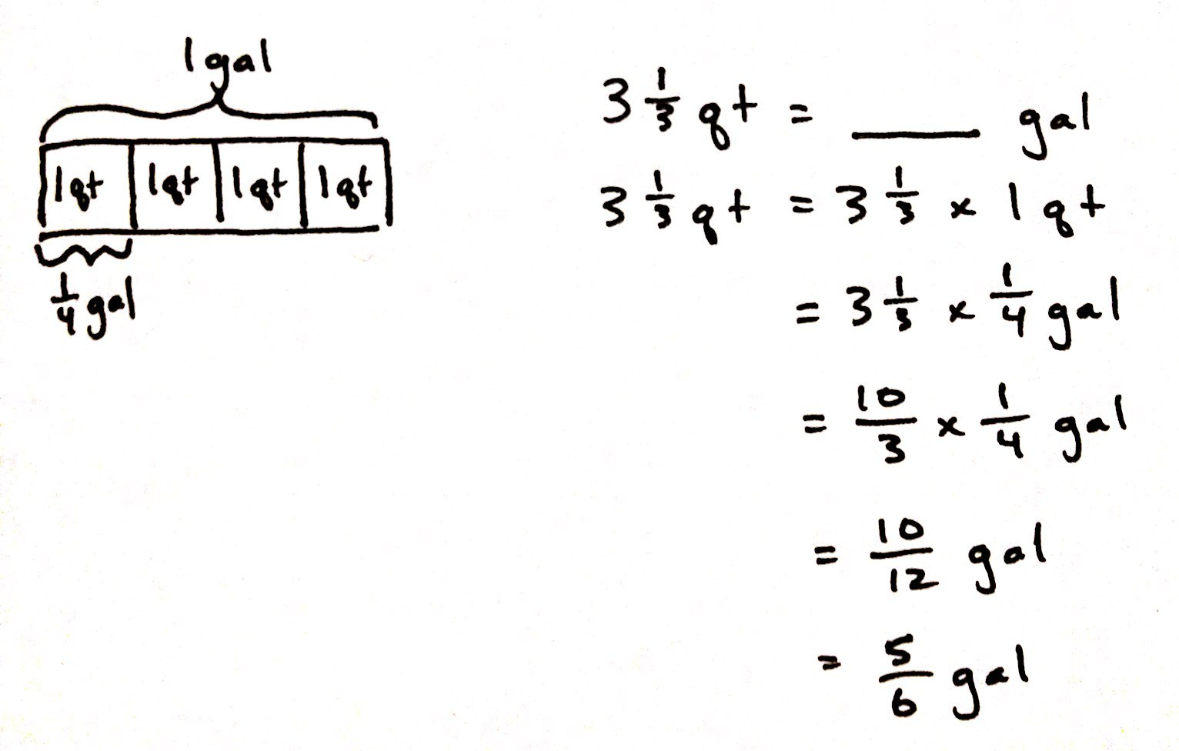
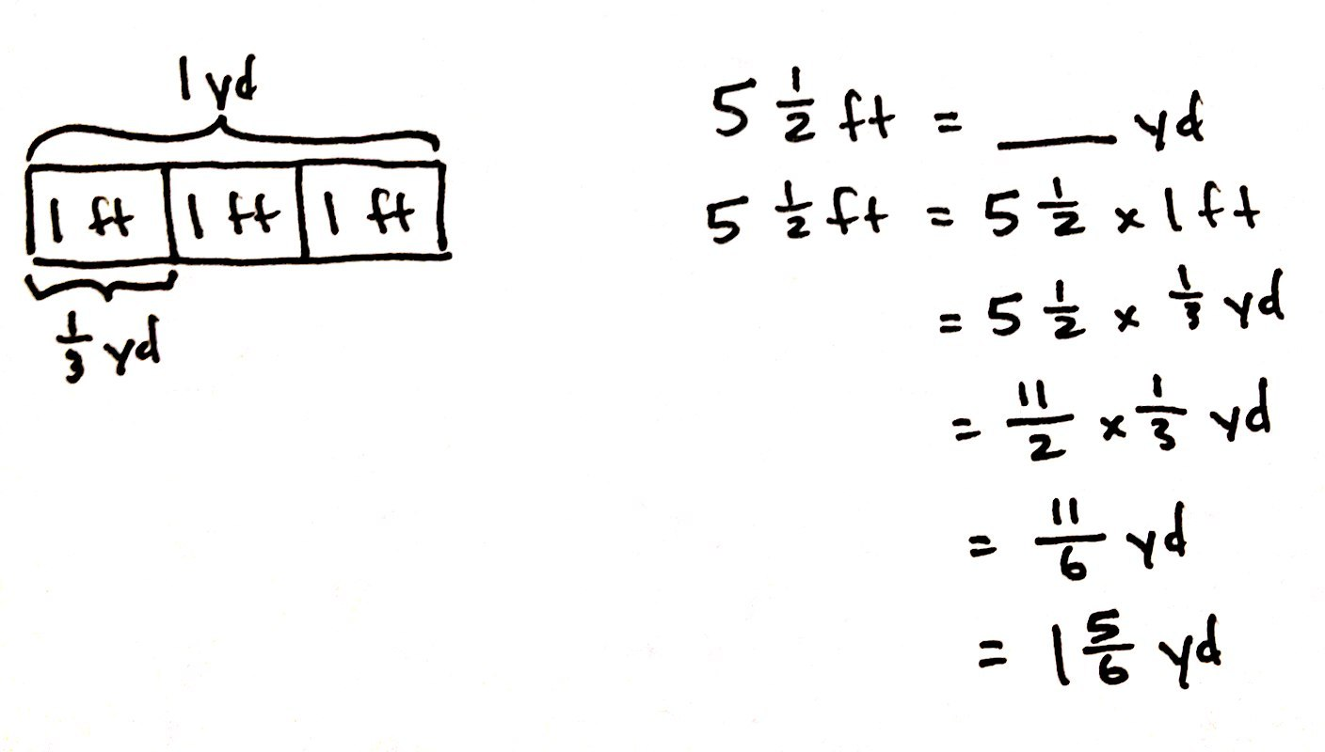

Note: If time permits, Problem 3 may be explored with students.
Problem 3: A container can hold $\text{4}\frac{1}{2}$ pints of water. How many cups of water can 2 containers hold?
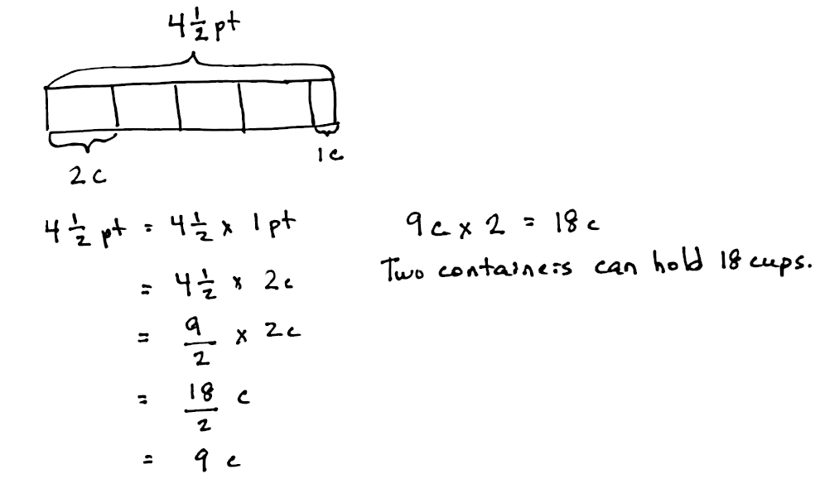
T: (Post Problem 3 on the board, and read it out loud with the students.) How do you solve this problem? Turn and share your idea with a partner.
MP.2
S: It’s a two-step problem. I first have to convert $\text{4}\frac{1}{2}$ pints to cups, and then I’ll have to double it.
T: Let’s draw a tape diagram for $\text{4}\frac{1}{2}$ pt. I’ll do it on the board, and you draw it on your personal white board.
S: (Draw and label.)
T: Say the multiplication expression to convert $\text{4}\frac{1}{2}$ pints to cups.
S: $\text{4}\frac{1}{2}$ × 2 cups.
T: Express $\text{4}\frac{1}{2}$ as an improper fraction and restate the expression.
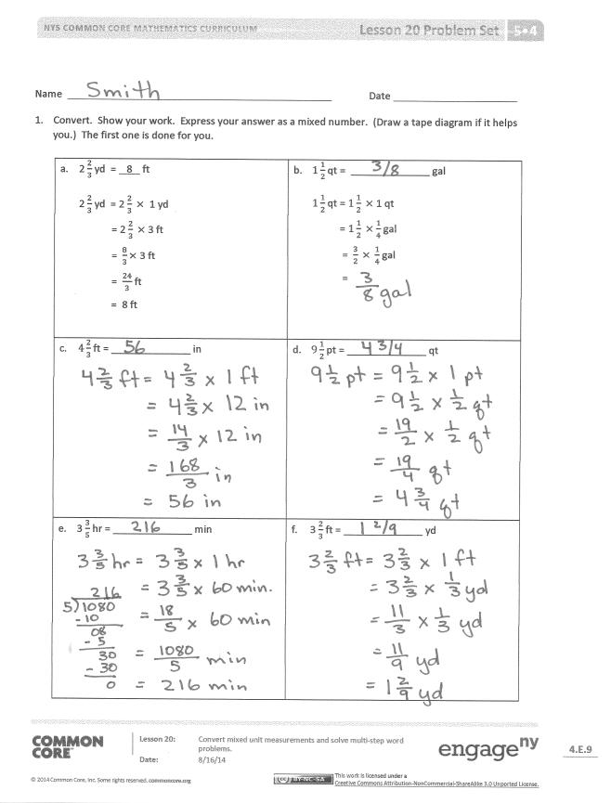
S: $\frac{9}{2}$ × 2 cups.
T: What’s the answer?
S: $\frac{18}{2}$cups.
T: How many whole cups is that?
S: 9 cups.
T: Finish by finding the amount of water in two containers. Turn and talk.
S: We have to find the water in 2 containers. Since 1 container holds 9 cups, then we’ll have to double it. 9 cups + 9 cups = 18 cups. To find the amount 2 containers hold, we have to multiply. 2 × 9 cups = 18 cups.
Problem Set (10 minutes)
Students should do their personal best to complete the Problem Set within the allotted 10 minutes. For some classes, it may be appropriate to modify the assignment by specifying which problems they work on first. Some problems do not specify a method for solving. Students should solve these problems using the RDW approach used for Application Problems.
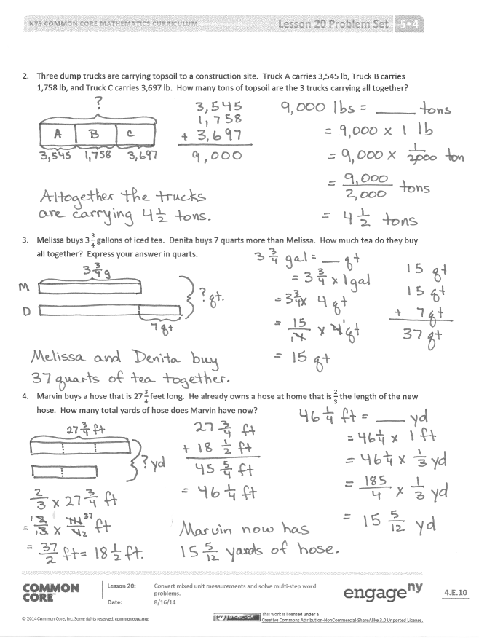
Student Debrief (10 minutes)
Lesson Objective: Convert mixed unit measurements, and solve multi-step word problems.
The Student Debrief is intended to invite reflection and active processing of the total lesson experience.
Invite students to review their solutions for the Problem Set. They should check work by comparing answers with a partner before going over answers as a class. Look for misconceptions or misunderstandings that can be addressed in the Debrief. Guide students in a conversation to debrief the Problem Set and process the lesson.
You may choose to use any combination of the questions below to lead the discussion.
- Compare and share your solutions for Problem 1 with your partner.
- Explain to your partner how to solve Problem 3. Did you have a different strategy than your partner?
- How did you solve for Problem 4? Explain your strategy to a partner.
Exit Ticket (3 minutes)
After the Student Debrief, instruct students to complete the Exit Ticket. A review of their work will help you assess the students’ understanding of the concepts that were presented in the lesson today and plan more effectively for future lessons. You may read the questions aloud to the students.
Name Date
- Convert. Show your work. Express your answer as a mixed number. (Draw a tape diagram if it helps you.) The first one is done for you.

- 2 $\frac{2}{3}$ yd = 8 ft  2 $\frac{2}{3}$ yd = 2 $\frac{2}{3} ×$ 1 yd  = 2 $\frac{2}{3} ×$3 ft  = $\frac{8}{3}×$ 3 ft  = $\frac{24}{3}$ ft  = 8 ft | - $1\frac{1}{2}$ qt = ______________ gal  $1\frac{1}{2}$ qt = $1\frac{1}{2} ×$ 1 qt  = $1\frac{1}{2} ×$ $\frac{1}{4}$ gal  = $\frac{3}{2} × \frac{1}{4}$ gal  =
- $4\frac{2}{3}$ ft = ______________ in | - $9\frac{1}{2}$ pt = ______________ qt
- 3 $\frac{3}{5}$ hr = ______________ min | - 3 $\frac{2}{3}$ ft = ______________ yd
- Three dump trucks are carrying topsoil to a construction site. Truck A carries 3,545 lb, Truck B carries 1,758 lb, and Truck C carries 3,697 lb. How many tons of topsoil are the 3 trucks carrying altogether?

- Melissa buys $\text{3}\frac{3}{4}$ gallons of iced tea. Denita buys 7 quarts more than Melissa. How much tea do they buy altogether? Express your answer in quarts.

- Marvin buys a hose that is $\text{27}\frac{3}{4}$ feet long. He already owns a hose at home that is $\frac{2}{3}$ the length of the new hose. How many total yards of hose does Marvin have now?

Name Date
Convert. Express your answer as a mixed number.

- $\text{2}\frac{1}{6}$ ft = ______________ in b. $\text{3}\frac{3}{4}$ ft = ______________ yd

- $\text{2}\frac{1}{2}$ c = ______________ pt d. $\text{3}\frac{2}{3}$ years = ______________ months

Name Date
- Convert. Show your work. Express your answer as a mixed number. The first one is done for you.

- $2\frac{2}{3}$ yd = 8 ft  $2\frac{2}{3}$ yd = $2\frac{2}{3} × 1$yd  = $2\frac{2}{3} × 3$ft  = $\frac{8}{3}$ $×$ 3 ft  = $\frac{24}{3}$ ft  = 8 ft | - $1\frac{1}{4}$ ft = ______________ yd  $1\frac{1}{4}$ ft = $1\frac{1}{4} ×$ 1 ft  = $1\frac{1}{4} ×$ $\frac{1}{3} \text{yd}$  = $\frac{5}{4}$ $×$ $\frac{1}{3} \text{yd}$  =
- $3\frac{5}{6}$ ft = ______________ in | - $7\frac{1}{2}$ pt = ______________ qt
- $4\frac{3}{10}$ hr = ______________ min | - $33$ months = ______________ years
- Four members of a track team run a relay race in 165 seconds. How many minutes did it take them to run the race?

- Horace buys $\text{2}\frac{3}{4}$ pounds of blueberries for a pie. He needs 48 ounces of blueberries for the pie. How many more pounds of blueberries does he need to buy?

- Tiffany is sending a package that may not exceed 16 pounds. The package contains books that weigh a total of $\text{9}\frac{3}{8}$ pounds. The other items to be sent weigh $\frac{3}{5}$ the weight of the books. Will Tiffany be able to send the package?

