Lesson 19
Objective: Convert measures involving whole numbers, and solve
multi-step word problems.

Suggested Lesson Structure
 Application Problem (8 minutes)
 Fluency Practice (8 minutes)
 Concept Development (34 minutes)
 Student Debrief (10 minutes)
Total Time (60 minutes)
Application Problem (8 minutes)
Angle A of a triangle is $\frac{1}{2}$ the size of angle C. Angle B is $\frac{3}{4}$ the size of angle C. If angle C measures 80 degrees, what are the measures of angle A and angle B?
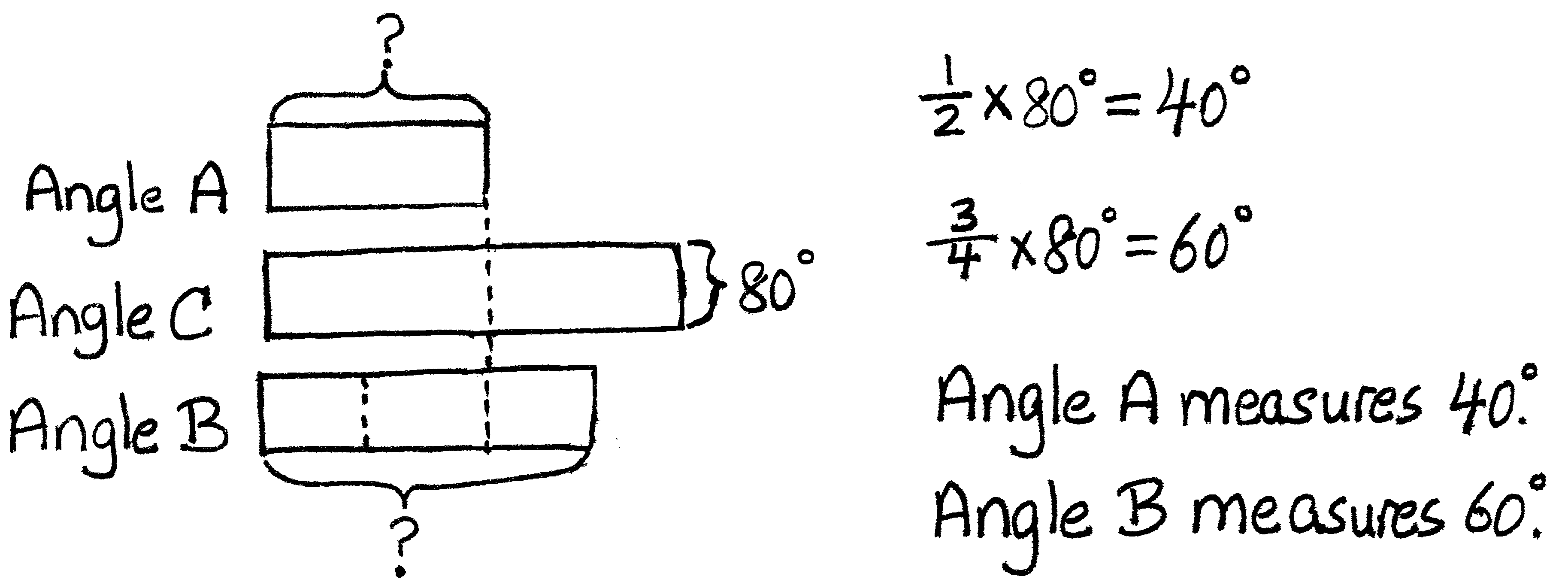
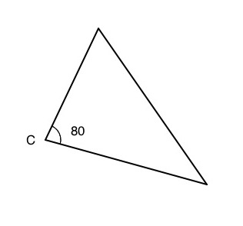
A
B
80$°$
?
?

Note: Because today’s fluency activity asks students to recall the content of Lesson 18, this Application Problem asks students to recall previous learning to find a fraction of a set. The presence of a third angle increases complexity.

Fluency Practice (8 minutes)
- Multiply Decimals 5.NBT.7 (4 minutes)
- Convert Measures 4.MD.1 (4 minutes)
Multiply Decimals (4 minutes)
Materials: (S) Personal white board
Note: This fluency activity reviews Lessons 17 and 18.
4 × 2 = 8 4 × 0.2 = 0.8 0.4 × 0.2 = 0.08 0.04 × 0.2 = 0.008
2 × 9 = 18 2 × 0.9 = 1.8 0.2 × 0.9 = 0.18 0.02 × 0.9 = 0.018
4 × 3 = 12 0.4 × 3 = 1.2 0.4 × 0.3 = 0.12 0.4 × 0.03 = 0.012
T: (Write 4 × 2 = ____.) Say the number sentence with the answer.
S: 4 × 2 = 8.
T: (Write 4 × 0.2 = ____.) On your personal white board, write the number sentence and the answer.
S: (Write 4 × 0.2 = 0.8.)
T: (Write 0.4 × 0.2 = ____.) Try this problem.
S: (Write 0.4 × 0.2 = 0.08.)
Continue this process with the following possible sequence: 2 × 9, 2 × 0.9, 0.2 × 0.9, 0.02 × 0.9, 4 × 3, 0.4 × 3, 0.4 × 0.3, and 0.4 × 0.03.
Convert Measures (4 minutes)
Materials: (S) Personal white board, Grade 5 Mathematics Reference Sheet (Lesson 8 Reference Sheet)
Note: This fluency activity prepares students for Lesson 19. Allow students to use the conversion reference sheet if they are confused, but encourage them to answer questions without looking at it.
T: (Write 1 yd = ____ ft.) How many feet are equal to 1 yard?
S: 3 feet.
T: (Write 1 yd = 3 ft. Below it, write 10 yd = ____ ft.) 10 yards?
S: 30 feet.
Continue with the following possible sequence: 1 pint = 2 cups, 8 pints = 16 cups, 1 ft = 12 in, 4 ft = 48 in, 1 gal = 4 qt, and 8 gal = 32 qt.
T: (Write 2 c = ____ pt.) How many pints are equal to 2 cups?
S: 1 pint.
T: (Write 2 c = 1 pt. Below it, write 16 c = ____ pt.) 16 cups?
S: 8 pints.
Continue with the following possible sequence: 12 in = 1 ft, 48 in = 4 ft, 3 ft = 1 yd, 24 ft = 8 yd, 4 qt = 1 gal, and 24 qt = 6 gal.
Concept Development (34 minutes)
Materials: (S) Personal white board
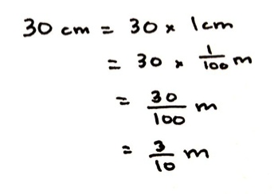
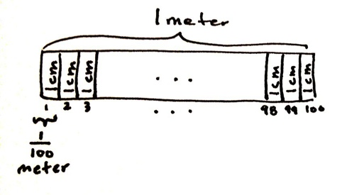
Problem 1: 30 centimeters = ________ meters
T: (Post Problem 1 on the board.) Which is a larger unit, centimeters or meters?
S: Meters.
T: So, we are expressing a smaller unit in terms of a larger unit.
Is 30 centimeters more or less than 1 meter?
S: Less than 1 meter.
T: Is it more than or less than half a meter? Talk to your partner about how you know.
S: It’s less than half a meter because 50 cm is half a meter, and this is only 30 cm. It’s less than half a meter because 30 out of a hundred is less than half.
T: Let’s keep that in mind as we work. We want to rename these centimeters using meters.
NOTES ON
MULTIPLE MEANS
OF ACTION AND EXPRESSION:
Provide students with meter sticks and centimeter rulers to help answer these important first questions of this Concept Development. These tools will help students see the relationship of centimeters to meters, and meters to centimeters.
T: (Write 30 cm = 30 × 1 cm.) We know that 30 cm is the same as 30 copies of 1 cm. Let’s rename 1 cm as a fraction of a meter. What fraction of a meter is 1 cm? Turn and talk.
S: It takes 100 cm to make a meter, so 1 cm would be 1 hundredth of a meter. 100 cm = 1 meter, so
1 cm = $\frac{1}{100}$ meter. 100 out of 100 cm makes 1 whole meter. We’re looking at 1 out of 100 cm, so that is 1 hundredth of a meter.
T: (Write = 30 × $\frac{1}{100}$ m.) How do you know this is true?
S: It’s true because we just renamed the centimeter as the same amount in meters. One centimeter is the same thing as 1 hundredth of a meter.
T: Now, we have 30 copies of $\frac{1}{100}$ meter. How many hundredths of a meter is that in all?
S: 30 hundredths of a meter.
T: Write it as a fraction on your personal white board, and then work with a neighbor to express it in simplest form.
S: (Work.)
T: Answer the question in simplest form.
S: 30 cm = $\frac{3}{10 }$ m.
T: (Write = $\frac{3}{10 }$ m.) Think about our estimate. Does this answer make sense?
S: Yes, we thought it would be less than a half meter, and $\frac{3}{10}$ meter is less than half a meter.
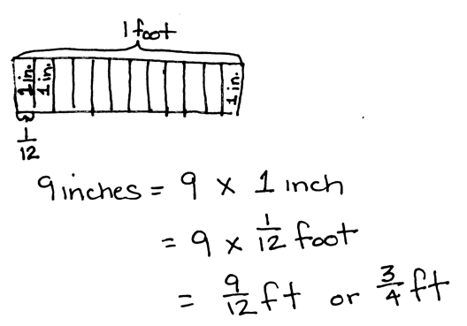
Problem 2: 9 inches = ________ foot
T: (Write 9 inches = 9 × 1 inch on the board.) 9 inches is 9 copies of 1 inch. What fraction of a foot is 1 inch? Draw a tape diagram if it helps you.
S: 1 twelfth of a foot.
T: Before we rename 1 inch, let’s estimate. Will 9 inches be more than half a foot or less than half a foot? Turn and tell your partner how you know.
S: Half a foot is 6 inches. Nine inches is more than 6 inches,
so it will be more than half a foot.
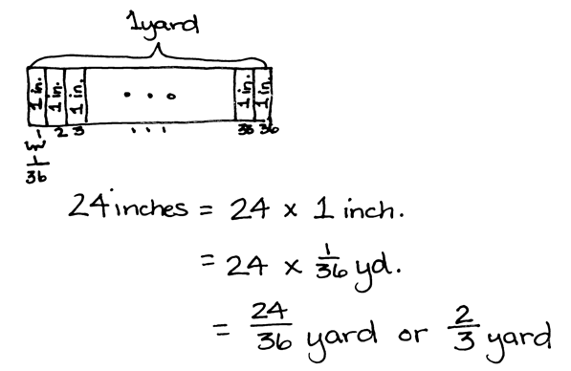
T: (Write = 9 × $\frac{1}{12}$ foot.) Let’s rename 1 inch as a fraction of a foot. Now, we have written 9 copies of $\frac{1}{12}$ foot. Are these expressions equivalent?
S: Yes.
T: Multiply. How many feet is the same amount as 9 inches?
S: 9 twelfths of a foot. 3 fourths of a foot.
T: Does this answer make sense? Turn and talk.
Repeat sequence for 24 inches = ________ yard.
Problem 3:
Koalas will often sleep for 20 hours a day. For what fraction of a day does a Koala often sleep?
T: (Post Problem 3 on the board.) What will we need to do to solve this problem? Turn and talk.
S: We’ll need to express hours in days. We’ll need to convert 20 hours into a fraction of a day.
T: Work with a partner to solve. Express your answer in its simplest form.
S: (Work, share, and show 20 hours = $\frac{5}{6}$day.)
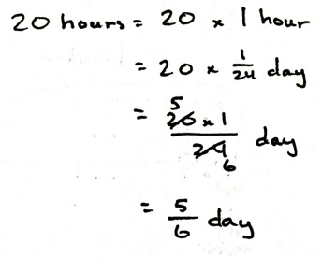
Problem 4: 15 inches = ________ feet
T: (Post Problem 4 on the board.) Compare this conversion to the others we’ve done. Turn and talk.
S: We’re still converting from a smaller unit to a larger unit. The last one converted something smaller than a whole day. This is converting something more than a whole foot. Fifteen inches is more than a foot, so our answer will be greater than 1. We still have to think about what fraction of a foot is 1 inch.
T: Yes, the process of converting will be the same, but our answer will be greater than 1. Let’s keep that in mind as we work. Write an equation showing how many copies of 1 inch we have.
S: (Work and show 15 inches = 15 $\text{×}$ 1 inch.)
T: What fraction of a foot is 1 inch? Turn and talk.
S: It takes 12 inches to make a foot, so 1 inch would be 1 twelfth of a foot. 12 inches = 1 foot,
so 1 inch = $\frac{1}{12}$ foot.
T: Now, we have 15 copies of $\frac{1}{12}$ foot. How many twelfths of a foot is that in all?
S: $\frac{15}{12}$ feet.
T: Work with a neighbor to express $\frac{15}{12}$ in its simplest form.
S: (Work and show 15 inches = $1\frac{1}{4}$ feet.)
Problem 5: 24 ounces = ________ pounds
T: (Post Problem 5 on the board.) Work independently to solve this conversion problem.
S: (Work.)
T: Show the conversion in its simplest form.
S: (Show 24 ounces = $\text{1}\frac{1}{2}$ pounds.)
Problem Set (10 minutes)
Students should do their personal best to complete the Problem Set within the allotted 10 minutes. For some classes, it may be appropriate to modify the assignment by specifying which problems they work on first. Some problems do not specify a method for solving. Students should solve these problems using the RDW approach used for Application Problems.

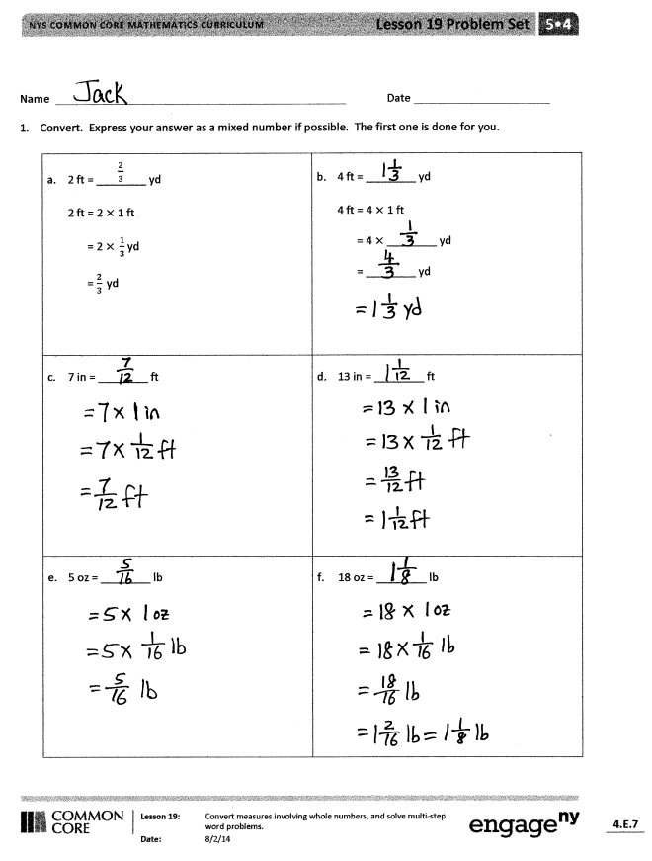
Student Debrief (10 minutes)
Lesson Objective: Convert measures involving whole numbers, and solve multi-step word problems.
The Student Debrief is intended to invite reflection and active processing of the total lesson experience.
Invite students to review their solutions for the Problem Set. They should check work by comparing answers with a partner before going over answers as a class. Look for misconceptions or misunderstandings that can be addressed in the Debrief. Guide students in a conversation to debrief the Problem Set and process the lesson.
You may choose to use any combination of the questions below to lead the discussion.
- In Problem 1, what did you notice about all of the problems in the left-hand column? The right-hand column? Did you solve the problems differently as a result?
- Explain your process for solving Problem 4. How did you convert from cups to gallons? What is a cup expressed as a fraction of a gallon? How did you figure that out?
NOTES ON
MULTIPLE MEANS
OF ACTION AND EXPRESSION:
Some students may struggle as they try to articulate their ideas. Some strategies that may be used to support these students are below.
- Ask students to repeat the teacher’s thinking in their own words.
- Ask students to add on to either the teacher’s thinking or another student’s thoughts.
- Give students time to practice with their partners before answering in a larger group.
- Pose a question and ask students to use specific vocabulary in their answers.
- In Problem 2, you were asked to find the fraction of a yard of craft trim Regina bought. Tell your partner how you solved this problem.
- How did today’s second fluency activity, Convert Measures, help prepare you for this lesson?
- Look back at Problem 1(e). Five ounces is equal to how many pounds? What would 6 ounces be equal to?
7 ounces? 8 ounces? 9 ounces? Think carefully.
$\frac{10}{16}$ pound equals how many ounces? $\frac{11}{16}$ pound? $\frac{12}{16}$ pound? $\frac{13}{16}$ pound? Talk about your thinking as you answered those questions.

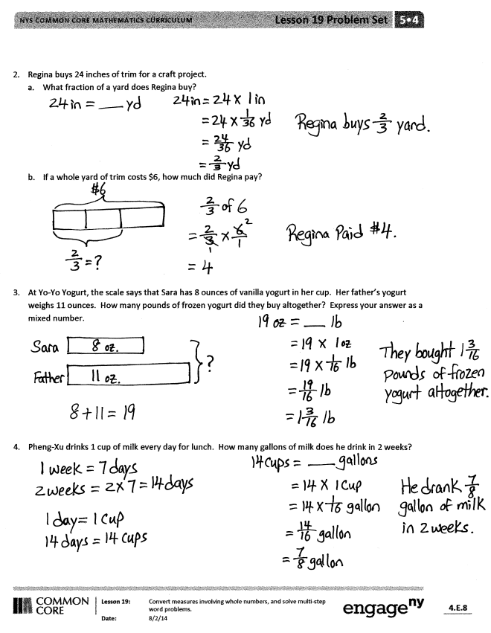
Exit Ticket (3 minutes)
After the Student Debrief, instruct students to complete the Exit Ticket. A review of their work will help you assess the students’ understanding of the concepts that were presented in the lesson today and plan more effectively for future lessons. You may read the questions aloud to the students.

Name Date
- Convert. Express your answer as a mixed number, if possible. The first one is done for you.

$\frac{2}{3}$  - 2 ft = ________ yd  2 ft = 2 $×$ 1 ft  = 2 $× \frac{1}{3}$ yd  = $\frac{2}{3} \text{yd}$ | - 4 ft = ________ yd  4 ft = 4 $×$ 1 ft  = 4 $×$________ yd  = ________ yd  =
- 7 in = ________ ft | - 13 in = ________ ft
- 5 oz = ________ lb | - 18 oz = ________ lb
- Regina buys 24 inches of trim for a craft project.
- What fraction of a yard does Regina buy?

- If a whole yard of trim costs $6, how much did Regina pay?

- At Yo-Yo Yogurt, the scale says that Sara has 8 ounces of vanilla yogurt in her cup. Her father’s yogurt weighs 11 ounces. How many pounds of frozen yogurt did they buy altogether? Express your answer as a mixed number.

- Pheng-Xu drinks 1 cup of milk every day for lunch. How many gallons of milk does he drink in 2 weeks?

Name Date
    - Convert. Express your answer as a mixed number, if possible.

- 5 in = ___________ ft b. 13 in = ___________ ft

- 9 oz = ___________ lb d. 18 oz = ___________ lb

Name Date
- Convert. Express your answer as a mixed number, if possible.

$\frac{2}{3}$  - 2 ft = ________ yd  2 ft = 2 $×$ 1 ft  = 2 $× \frac{1}{3}$ yd  = $\frac{2}{3} \text{yd}$ | - 6 ft = ________ yd  6 ft = 6 $×$ 1 ft  = 6 $×$ ________ yd  = ________ yd
- 5 in = ________ ft | - 14 in = ________ ft
- 7 oz = ________ lb | - 20 oz = ________ lb
- 1 pt = ________ qt | - 4 pt = ________ qt
- Marty buys 12 ounces of granola.
- What fraction of a pound of granola did Marty buy?

- If a whole pound of granola costs $4, how much did Marty pay?

- Sara and her dad visit Yo-Yo Yogurt again. This time, the scale says that Sara has 14 ounces of vanilla yogurt in her cup. Her father’s yogurt weighs half as much. How many pounds of frozen yogurt did they buy altogether on this visit? Express your answer as a mixed number.

- An art teacher uses 1 quart of blue paint each month. In one year, how many gallons of paint will she use?

