Lesson 18
Objective: Relate decimal and fraction multiplication.

Suggested Lesson Structure
 Fluency Practice (12 minutes)
 Application Problem (8 minutes)
 Concept Development (30 minutes)
 Student Debrief (10 minutes)
Total Time (60 minutes)
Fluency Practice (12 minutes)
- Sprint: Multiply Fractions 5.NF.4 (8 minutes)
- Multiply Whole Numbers and Decimals 5.NBT.7 (4 minutes)
Sprint: Multiply Fractions (8 minutes)
Materials: (S) Multiply Fractions Sprint
Note: This fluency activity reviews Lesson 13.
Multiply Whole Numbers and Decimals (4 minutes)
Materials: (S) Personal white board
3 × 2 = 6 3 × 0.2 = 0.6 0.3 × 0.2 = 0.06 0.03 × 0.2 = 0.006
2 × 7 = 14 2 × 0.7 = 1.4 0.2 × 0.7 = 0.14 0.02 × 0.7 = 0.014
5 × 3 = 15 0.5 × 3 = 1.5 0.5 × 0.3 = 0.15 0.5 × 0.03 = 0.015
Note: This fluency activity reviews Lesson 17.
T: (Write 3 $\text{×}$ 2.) Say the number sentence with the answer.
S: 3 $\text{×}$ 2 = 6.
T: (Write 3 $\text{×}$ 0.2.) On your personal white board, write the number sentence and solve.
S: (Write 3 $\text{×}$ 0.2 = 0.6.)
T: (Write 0.3 $\text{×}$ 0.2.) Try this problem.
S: (Write 0.3 $\text{×}$ 0.2 = 0.06.)
T: (Write 0.03 $\text{×}$ 0.2.) Try this problem.
S: (Write 0.03 $\text{×}$ 0.2 = 0.006.)
Continue this process with the following possible sequence: 2 $\text{×}$ 7, 2 $\text{×}$ 0.7, 0.2 $\text{×}$ 0.7, 0.02 $\text{×}$ 0.7, 5 $\text{×}$ 3, 0.5 × 3, 0.5 × 0.3, and 0.5 × 0.03.
Application Problem (8 minutes)
An adult female gorilla is 1.4 meters tall when standing upright. Her daughter is 3 tenths as tall. How much more will the young female gorilla need to grow before she is as tall as her mother?
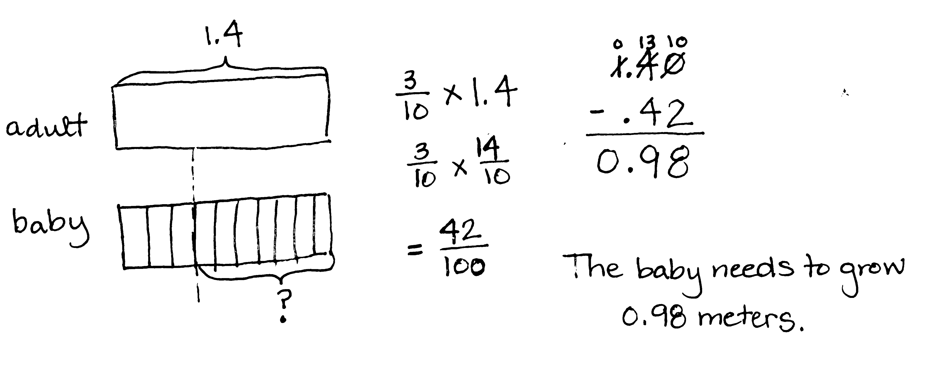
NOTES ON
MULTIPLE MEANS
OF ENGAGEMENT:
With reference to Table 2 of the Common Core Learning Standards, this Application Problem is classified as a compare with unknown product situation. Table 2 is a matrix that organizes story problems or situations into specific categories. Consider presenting this table in a student-friendly format as a tool to help students identify specific types of story problems.

Note: This Application Problem reinforces that multiplying a decimal number by tenths can be interpreted in fraction or decimal form (as practiced in Lesson 17). Students who solve this problem by converting to smaller units (centimeters or millimeters) should be encouraged to compare their process to solving the problem using 1.4 meters.
Concept Development (30 minutes)
Materials: (S) Personal white board
Problem 1: a. 3.2 $\text{×}$ 2.1 b. 3.2 $\text{×}$ 0.44 c. 3.2 $\text{×}$ 4.21
T: (Write 3.2 $\text{×}$ 2.1 on the board.) Rewrite this problem as a fraction multiplication expression.
S: (Write $\frac{32}{10}\text{×}\frac{21}{10}$.)
T: Before we multiply these two decimals, let’s estimate what our product will be. Turn and talk.
S: 3.2 is pretty close to 3, and 2.1 is pretty close to 2. I’d say our answer will be around 6. The product will be a little more than 6 because 3.2 is a little more than 3, and 2.1 is a little more than 2. It’s about twice as much as 3.
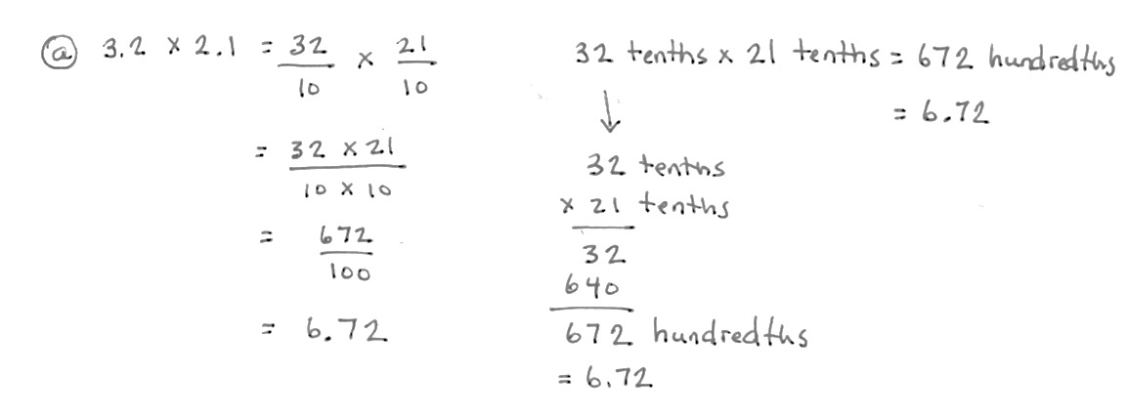
T: Now that we’ve estimated, let’s solve. (Write = $\frac{32}{10}\text{×}\frac{21}{10}$ on the board.) What do we get when we multiply tenths by tenths?

S: Hundredths.
T: Let’s use unit form to multiply 32 tenths and 21 tenths. Solve with your partner. (Allow students time to work and solve.)
T: (Write = $\frac{32 × 21}{10 × 10}$.) What is 32 tenths times 21 tenths?
S: 672 hundredths.
T: (Write = $\frac{672}{100}$.) Write this as a decimal.
S: (Write 6.72.)
T: Does this answer make sense given what we estimated the product to be earlier?
S: Yes.
T: (Write 3.2 $\text{×}$ 0.44.) Before we solve this one, turn and talk with your partner to estimate the product.
S: We are still multiplying by 3.2, but this time, we want about 3 copies of almost 1 half. That’s like 3 halves, so our answer will be around 1 and a half. This is about 3 times more than 4 tenths, so the answer will be around 12 tenths. It will be a little more because 3.2 is a little more than 3 times as much.
T: Work with a partner and rewrite this problem as a fraction multiplication expression.
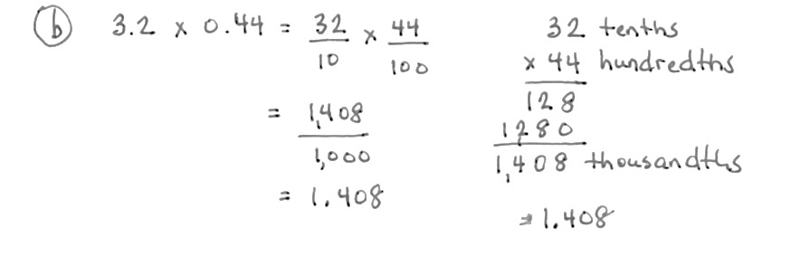
S: (Work and show $\frac{32}{10} \text{×} \frac{44}{100}$.)
T: What is 1 tenth of a hundredth?
S: 1 thousandth.
T: Work with a partner to multiply. Express your answer as a fraction and a decimal.
S: (Work and show $\frac{1,408}{1,000}$ = 1.408.)
T: Does this product make sense given our estimates?
S: Yes! It’s a little more than 1.2 and a little less than 1.5.
T: (Write 3.2 $\text{×}$ 4.21 on the board.) Estimate this product with your partner.
S: Three times as much as 4 is 12. This will be a little more than that because 3.2 is a little more than 3 and 4.21 is a little more than 4. It’s still multiplying by something close to 3. This time, it’s close to 4. 3 fours is 12.
T: Rewrite this problem as a fraction multiplication expression.
S: (Write $\frac{32}{10}\text{×}\frac{421}{100}$.)
T: (Write = $\frac{32}{10}\text{×}\frac{421}{100}$.) Solve independently. Express your answer as a fraction and a decimal.
S: (Write and solve $\frac{13,472}{1,000}$ = 13.472.)
T: Does our answer make sense? Turn and talk. (Allow students time to discuss with their partners.)

Problem 2: 2.6 $\text{×}$0.4
T: (Write 2.6 $\text{×}$0.4 on the board.) This time, let’s rewrite this problem vertically in unit form first.
2.6 is equal to how many tenths?
S: 26 tenths.
T: (Write = 26 tenths.) 0.4 is equal to how many tenths?
S: 4 tenths.
T: (Write $\text{×}$4 tenths.) Think, what does tenths times tenths result in?
S: Hundredths.
T: Our product will be named in hundredths. What is 26 times 4?
S: 104.
T: I’ll record 104 as the product. (Write 104 in the algorithm.) 104 what? What is our unit?
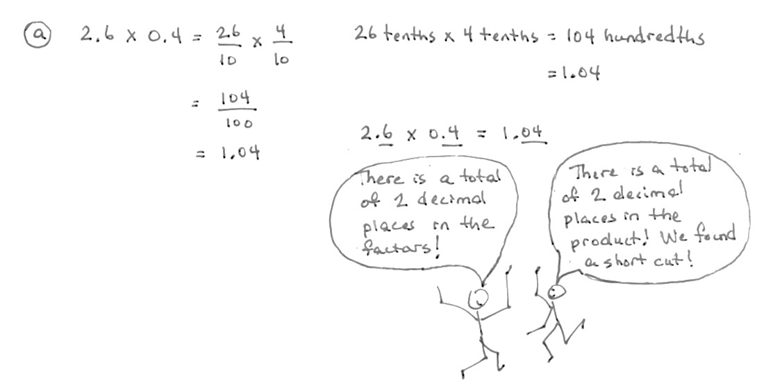
S: 104 hundredths.
T: Write it in standard form.
S: (Write = 1.04.)
T: Use fraction multiplication to confirm our product. (Allow students time to work.)
MP.2
T: What do you notice about the total number of decimal places in the factors and the number of decimal places in the product? Turn and talk.
S: There is one decimal place in each factor and two decimal places in the answer. I see a total of two decimal places in the factors and two decimal places in the product. They match. There is the same number of decimal places in both factors because there are decimal places in the product.
T: Keep this observation in mind as we continue our work. Let’s see if it’s always true.
Problem 3: a. 3.1 $\text{×}$ 1.4 b. 0.31 $\text{×}$ 1.4
T: (Write 3.1 $\text{×}$ 1.4 on the board.) Estimate the product with your partner.
S: It should be something close to 3 because 3 times 1 is 3. Something between 3 and 6 because 1.4 is close to the midpoint of 1 and 2. It’s close to 3 times 1 and a half. That’s 4 and a half.
T: Let’s use unit form with tenths to solve this. What will my multiplication expression be?
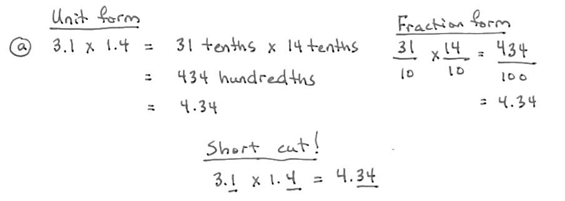
S: 31 tenths × 14 tenths.
T: What is the product?
S: 434 hundredths.
T: How do you know the unit is hundredths?
S: Tenths times tenths is hundredths. I could say 1 tenth of a tenth. That’s 1 hundredth. I can picture it on the place value chart.
T: Name the product as a decimal.
S: 4 and 34 hundredths. 4.34.
T: What do you notice about the decimal places in the factors and the product this time?
S: This is like before. We have a total of two decimal places in the factors and two decimal places in the answer. We multiplied tenths times tenths and got hundredths in our answer. That’s two decimal places. It’s just like last time.
T: (Write 0.31 $\text{×}$ 1.4 on the board.) Let’s think of 0.31 and 1.4 as whole numbers of units. 0.31 is the same as 31 what? 1.4 is the same as 14 what?
S: 31 hundredths and 14 tenths.
T: If we were using fractions to multiply these two numbers, is 31 × 14 the numerator or denominator?
S: The numerator.
T: What does the numerator of a fraction tell us?
S: The number of units we have.
T: This whole number multiplication problem is the same as our last one. What is 31 times 14?
S: 434.
T: While these digits are the same as last time, will our product be the same? Why or why not? Turn and talk.
S: We are multiplying hundredths and tenths this time, so our unit in the answer has to be thousandths. The answer is 434 thousandths. Last time, we had a total of two decimal places in our factors, so we had two decimal places in our product. This time, there is a total of three decimal places in the factors, so we should have thousandths in the answer. Last time, we were multiplying by about 3 times as much as 1 and a half. This time, we want about 3 tenths of 1 and a half. So, our answer is going to be a lot smaller
T: What is our product?
S: 434 thousandths.
T: Yes, remember that 1 hundredth times 1 tenth gives us the unit of 1 thousandth, the denominator of our fraction.

Problem 4: 4.2 × 0.12
NOTES ON
MULTIPLE MEANS
OF REPRESENTATION:
Another strategy for multiplying decimal numbers is compensation. Here’s an example.
2.3 × 4.5
(2.3 × 10) × (4.5 × 10) = 23 × 45 = 1,035
1,035 ÷ 10 ÷ 10 = 10.35
2.3 × 4.5 = 10.35
Each decimal factor was multiplied by a multiple of ten resulting in a whole number. To solve the original decimal multiplication, the whole number product had to be divided by the same number of multiples of 10.
T: (Write 4.2 × 0.12 on the board.) Work independently to solve this problem using either unit form or fraction form. When you’re done, count the decimal places in both factors and decimal places in the product. Compare your work with a neighbor. Did you get the same answer with your chosen method as you did when counting the digits?
S: (Work and discuss.) Yes!
T: What is the product of 4.2 × 0.12?
S: 0.504.
Problem Set (10 minutes)
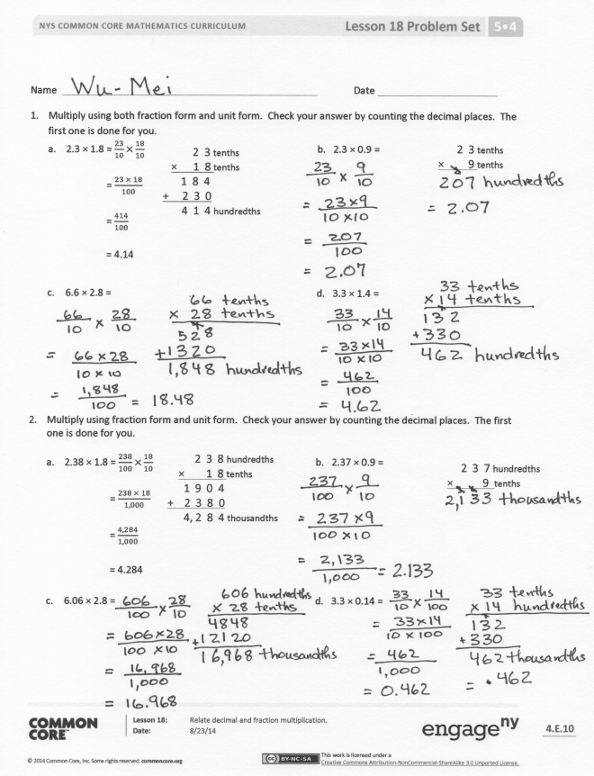
Students should do their personal best to complete the Problem Set within the allotted 10 minutes. For some classes, it may be appropriate to modify the assignment by specifying which problems they work on first. Some problems do not specify a method for solving. Students should solve these problems using the RDW approach used for Application Problems.
Student Debrief (10 minutes)
Lesson Objective: Relate decimal and fraction multiplication.
The Student Debrief is intended to invite reflection and active processing of the total lesson experience.
Invite students to review their solutions for the Problem Set. They should check work by comparing answers with a partner before going over answers as a class. Look for misconceptions or misunderstandings that can be addressed in the Debrief. Guide students in a conversation to debrief the Problem Set and process the lesson.
You may choose to use any combination of the questions below to lead the discussion.
- In Problem 1, what is the relationship between the answers for Parts (a) and (b) and the answers for Parts (c) and (d)? What pattern did you notice between 1(a) and 1(b)? (Part (a) is double Part (b). Part (c) is 4 times as large as Part (d).) Explain why that is the case.
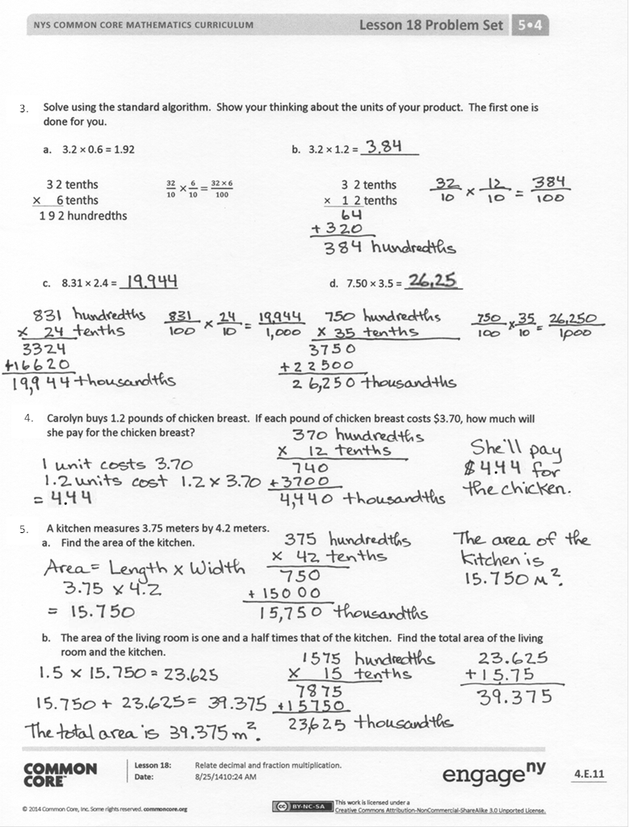
- Compare Problems 1(c) and 2(c). Why are the products not so different? Use estimation, and explain it to your partner.
- Compare Problems 1(d) and 2(d). Why do they have the same digits, but a different product? Explain it to your partner.
- What do you notice about the relationship between 3(a) and 3(b)? (Part (a) is half of Part (b).)
- For Problem 5, compare and share your solutions with a partner. Explain how you solved.
- In one sentence, explain to your partner the pattern that we discovered today in the number of decimal places in our factors compared to the number of decimal places in our products.
Exit Ticket (3 minutes)
After the Student Debrief, instruct students to complete the Exit Ticket. A review of their work will help you assess the students’ understanding of the concepts that were presented in the lesson today and plan more effectively for future lessons. You may read the questions aloud to the students.

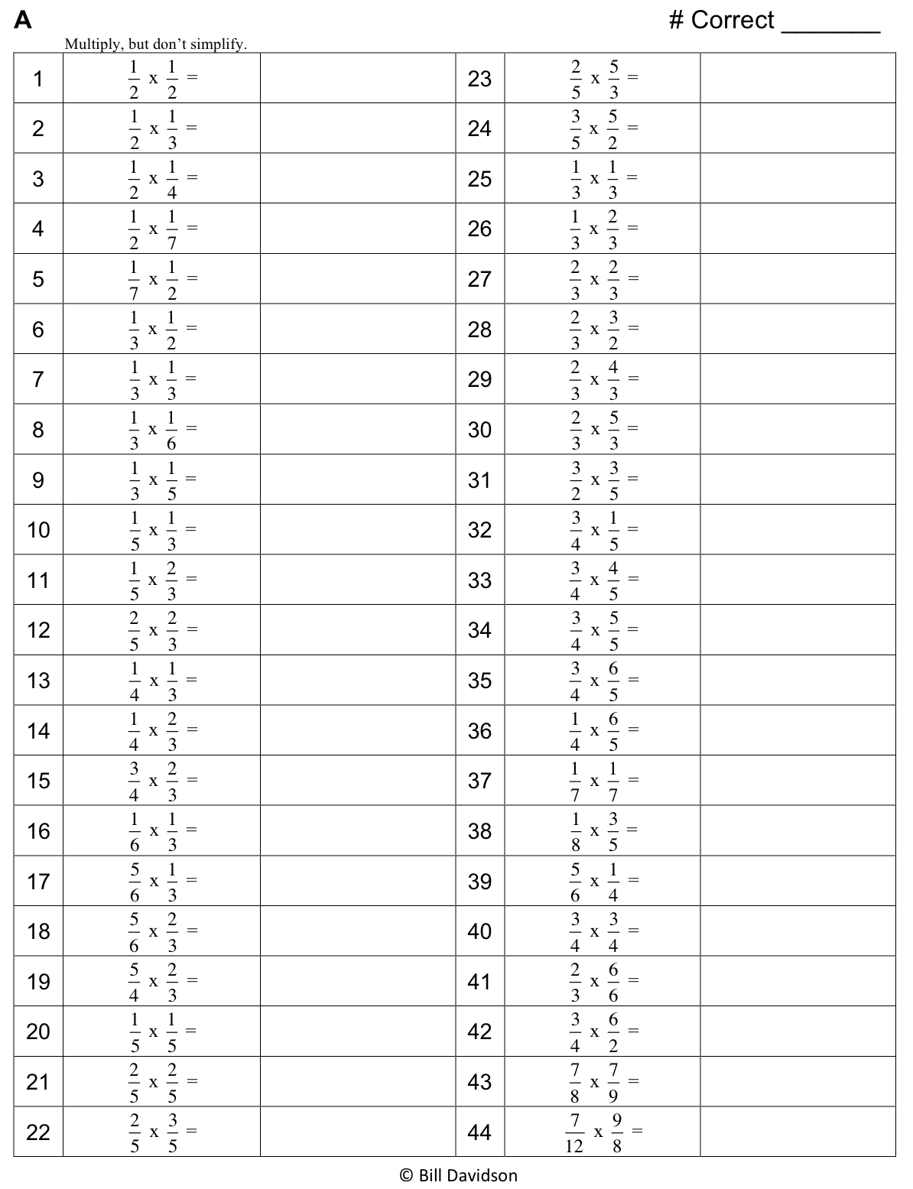

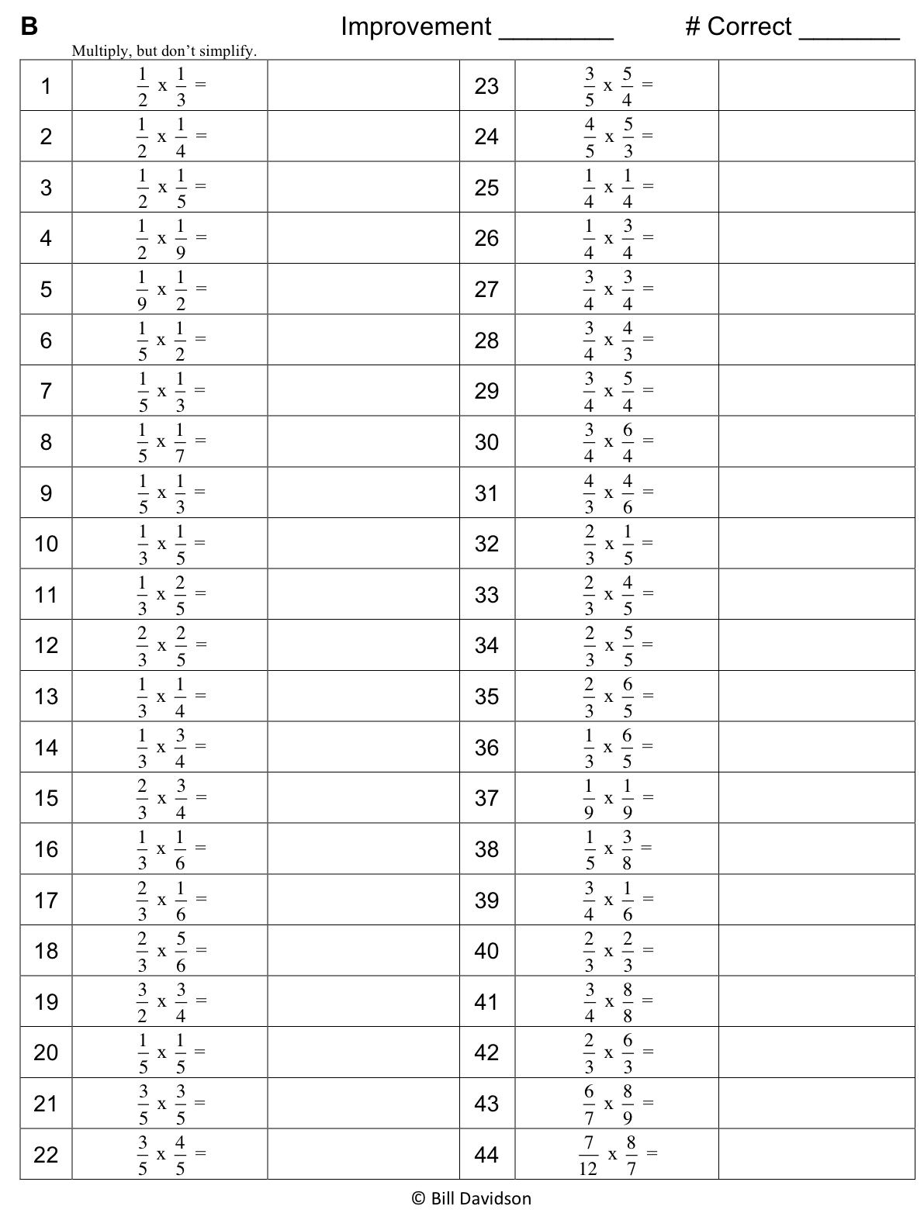

Name Date
- Multiply using both fraction form and unit form. Check your answer by counting the decimal places.
The first one is done for you.
2 3 tenths
× 9 tenths
- 2.3 × 1.8 = $\frac{23}{10}\text{×}\frac{18}{10}$ b. 2.3 × 0.9 =
2 3 tenths
× 1 8 tenths
1 8 4
+ 2 3 0
4 1 4 hundredths

= $\frac{23 × 18}{100}$

= $\frac{414}{100}$

= 4.14

- 6.6 × 2.8 = d. 3.3 × 1.4 =

- Multiply using fraction form and unit form. Check your answer by counting the decimal places.
The first one is done for you.
2 3 8 hundredths
× 1 8 tenths
1 9 0 4
+ 2 3 8 0
4, 2 8 4 thousandths

- 2.38 × 1.8 = $\frac{238}{100}×\frac{18}{10}$ b. 2.37 × 0.9 =
2 3 7 hundredths
× 9 tenths

= $\frac{238 × 18}{1,000}$

= $\frac{4,284}{1,000}$

= 4.284

- 6.06 × 2.8 = d. 3.3 × 0.14 =

- Solve using the standard algorithm. Show your thinking about the units of your product. The first one is done for you.

- 3.2 × 0.6 = 1.92 b. 3.2 × 1.2 = __________
3 2 tenths
× 1 2 tenths
3 2 tenths
$×$ 6 tenths
1 9 2 hundredths

$$\frac{32}{10}×\frac{6}{10}=\frac{192}{100}$$
$$\frac{32}{10} ×\frac{6}{10}=\frac{32 × 6}{100}$$

- 8.31 × 2.4 = __________ d. 7.50 × 3.5 = __________

- Carolyn buys 1.2 pounds of chicken breast. If each pound of chicken breast costs $3.70, how much will she pay for the chicken breast?

- A kitchen measures 3.75 meters by 4.2 meters.
- Find the area of the kitchen.

- The area of the living room is one and a half times that of the kitchen. Find the total area of the living room and the kitchen.

Name Date
- Multiply. Do at least one problem using unit form and at least one problem using fraction form.
- 3.2 × 1.4 = b. 1.6 × 0.7 =

- 2.02 × 4.2 = d. 2.2 × 0.42 =

Name Date
1. Multiply using fraction form and unit form. Check your answer by counting the decimal places.
The first one is done for you.
3 3 tenths
× 8 tenths
- 3.3 × 1.6 = $\frac{33}{10}×\frac{16}{10}$ b. 3.3 × 0.8 =
3 3 tenths
× 1 6 tenths
1 9 8
+ 3 3 0
5 2 8 hundredths

= $\frac{33 × 16}{100}$

= $\frac{528}{100}$

= 5.28

- 4.4 × 3.2 = d. 2.2 × 1.6 =

- Multiply. The first one is partially done for you.

- 3.36 × 1.4 = $\frac{336}{100}×\frac{14}{10}$ b. 3.35 × 0.7 =
3 3 5 hundredths
× 7 tenths
3 3 6 hundredths
× 1 4 tenths

= $\frac{336 × 14}{1,000}$

= $\frac{4,704}{1,000}$

= 4.704

- 4.04 × 3.2 = d. 4.4 × 0.16 =

- Solve using the standard algorithm. Show your thinking about the units of your product. The first one is done for you.
$$\frac{32}{10} ×\frac{6}{10}=\frac{32 × 6}{100}$$

- 3.2 × 0.6 = 1.92 b. 2.3 × 2.1 = __________
2 3 tenths
× 2 1 tenths
3 2 tenths
× 6 tenths
1 9 2 hundredths

$$\frac{32}{10}×\frac{6}{10}=\frac{192}{100}$$

- 7.41 × 3.4 = __________ d. 6.50 × 4.5 = __________

- Erik buys 2.5 pounds of cashews. If each pound of cashews costs $7.70, how much will he pay for the cashews?

- A swimming pool at a park measures 9.75 meters by 7.2 meters.
- Find the area of the swimming pool.

- The area of the playground is one and a half times that of the swimming pool. Find the total area of the swimming pool and the playground.

