Lesson 31
Objective: Solve two-step word problems within 100.

Suggested Lesson Structure
 Fluency Practice (10 minutes)
 Concept Development (40 minutes)
 Student Debrief (10 minutes)
Total Time (60 minutes)
Fluency Practice (10 minutes)
- Find the Total 2.NBT.5 (5 minutes)
- Find the Difference 2.NBT.5 (5 minutes)
Find the Total (5 minutes)
Materials: (S) Personal white board
Note: Reviewing this mental math fluency prepares students to solve word problems in today’s lesson.
T: (Write 32 + 64 =____.) Solve using any method.
T: Write 1 hundred to change 32 to 132. What is the total now?
S: 196.
Repeat process with the following possible sequence: 25 + 74, 125 + 74; 58 + 32, 158 + 32; 32 + 48, 132 + 48.
Find the Difference (5 minutes)
Materials: (S) Personal white board
Note: Reviewing subtraction problems in sets prepares students to solve word problems in today’s lesson.
T: (Write 48 – 24 =____.) Write a subtraction sentence horizontally or vertically.
Repeat process with the following possible sequence: 48 – 24, 40 – 24; 56 – 15, 50 – 15, 52 – 15; 64 – 38, 60 − 38, 61 – 38.

Concept Development (40 minutes)
Materials: (S) Math journal or personal white board
Note: Prepare Problems 1 through 4 in advance for either display or distribution to students.
Suggested Delivery of Instruction for Solving Lesson 31’s Word Problems
1. Model the problem.

NOTES ON
MULTIPLE MEANS
OF ENGAGEMENT:
Students who are struggling will also benefit from an opportunity to model the problems on the board. Encourage them to try. Guide them if they are stuck, or encourage them to seek help from a friend. Praise their hard work when they successfully achieve the desired results.

Invite two pairs of students, who can successfully model the problem, to work at the board while the others work independently or in pairs at their seats. Review the following questions before solving the first problem.
- Can you draw something?
- What can you draw?
- What conclusions can you make from your drawing?
As students work, circulate. Reiterate the questions above and guide them in drawing their tape diagrams.
After two minutes, have the two pairs of students share only their labeled diagrams.
For about one minute, encourage the demonstrating students to respond to feedback and questions from their peers.
2. Solve and write a statement.
Discuss strategies for solving problems, drawing attention to the strategy chart created during the Debrief in Lesson 5. Give students two minutes to solve and complete the question, sharing their work and thought processes with a peer.
Then instruct students to write their equations and statements of the answer.
3. Assess the solution for reasonableness.
Give students one to two minutes to assess and explain the reasonableness of their solution.

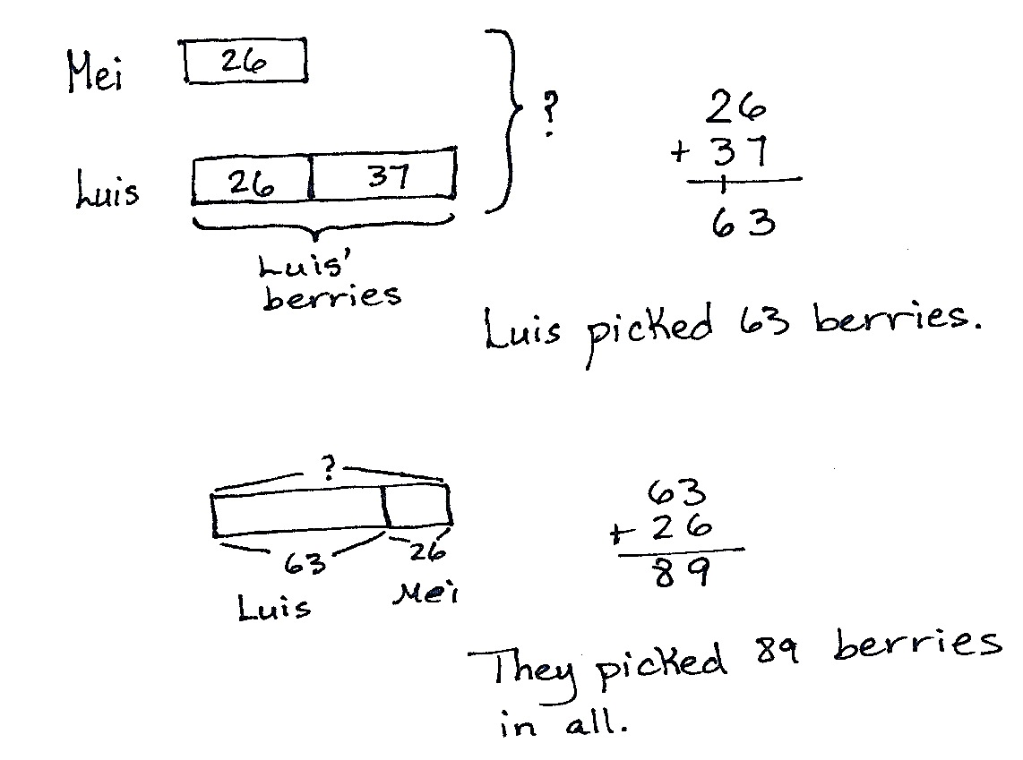
Problem 1
Solve a two-step add to with result unknown word problem using a tape diagram.
Mei picked 26 berries. Luis picked 37 more berries than Mei.
- How many berries did Luis pick?
- How many berries did they pick in all?
Circulate and ask guiding questions as needed to help students identify the steps in the problem and to determine if they are looking for the whole or a missing part. Once they draw their tape diagram, they may solve using any written method that they can explain and relate to their drawings.

NOTES ON
MULTIPLE MEANS
OF ACTION AND EXPRESSION:
Encourage students who haven’t mastered the computation methods to focus on understanding the word problem and using manipulatives to compute the answers.

Problem 2
Solve a two-step take from/add to with result unknown word problem by drawing a tape diagram. Then, students may use any strategy they have learned to solve.
Kevin had 53 balloons. His cat popped 17 of them. His father gives him 18 more balloons. How many balloons does Kevin have now?
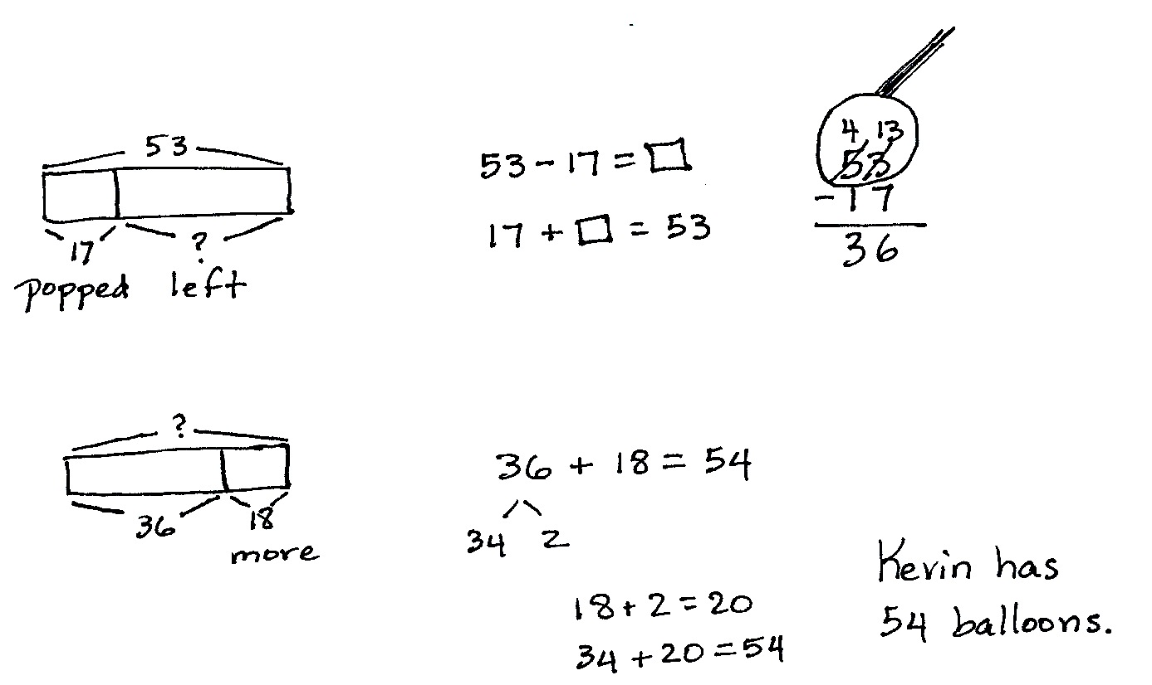
Drawing tape diagrams is essential to understanding the relationships within the problem. Equally important is that teachers encourage students to be flexible in their thinking while solving. A student might recognize, for example, that 17 balloons were popped and 18 given,
so Kevin has 1 more than he started with.
MP.1
Problem 3
Solve a two-step change unknown problem by drawing a tape diagram.
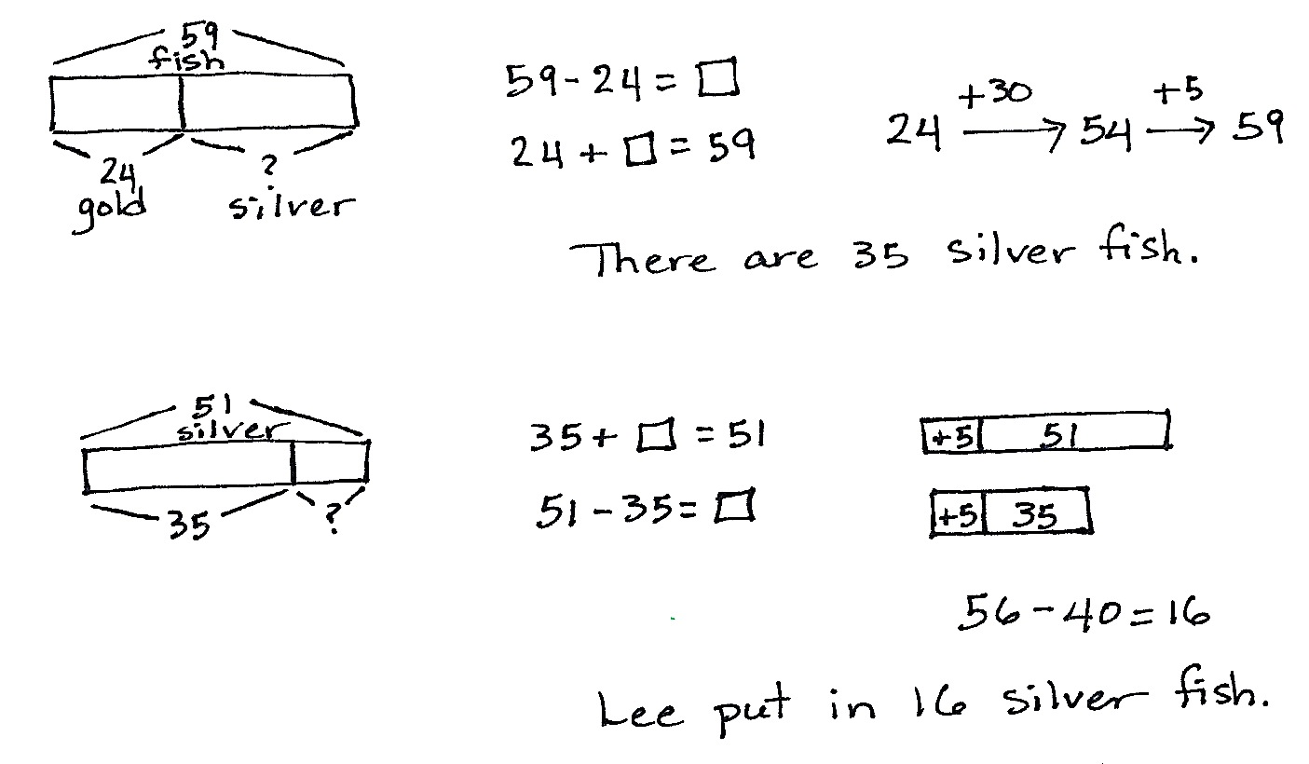
Lee’s fish tank has 24 goldfish and some silver fish. In all, there are 59 fish in the aquarium. Lee puts in some more silver fish. Now, there are 51 silver fish.
How many silver fish did Lee put in the tank?
Solve this as a guided practice. Have students talk through each piece of information in the problem, drawing and labeling as they go. Prompt them with the question, “What do we know?” Then, write an equation that matches that situation. Allow students to solve using methods they are comfortable with; problem solving is about sense-making. Mental math is acceptable.
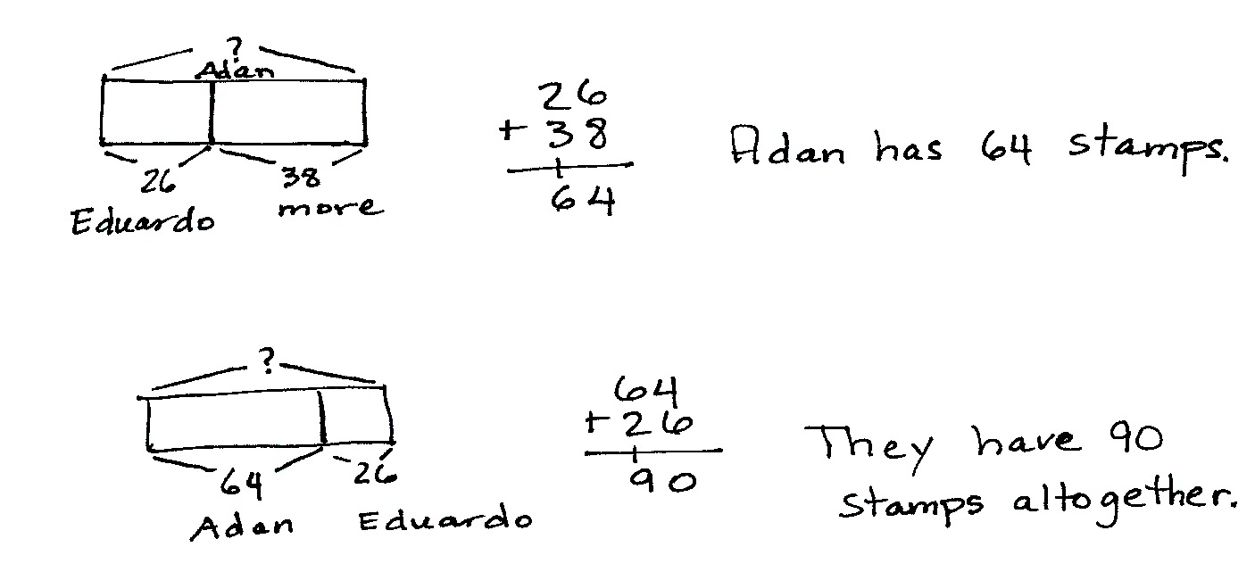
Problem 4
Solve a two-step comparison problem by drawing a tape diagram and using a preferred method to solve.
MP.1
Eduardo collects 26 stamps. Adan collects 38 more than Eduardo. How many stamps do they have altogether?
Circulate and encourage students to use their favorite method to solve. Remind them to be prepared to explain their strategy using place value language.
Problem Set (10 minutes)
Students should do their personal best to complete the Problem Set within the allotted 10 minutes. For some classes, it may be appropriate to modify the assignment by specifying which problems they work on first. Some problems do not specify a method for solving. Students should solve these problems using the RDW approach used for Application Problems.
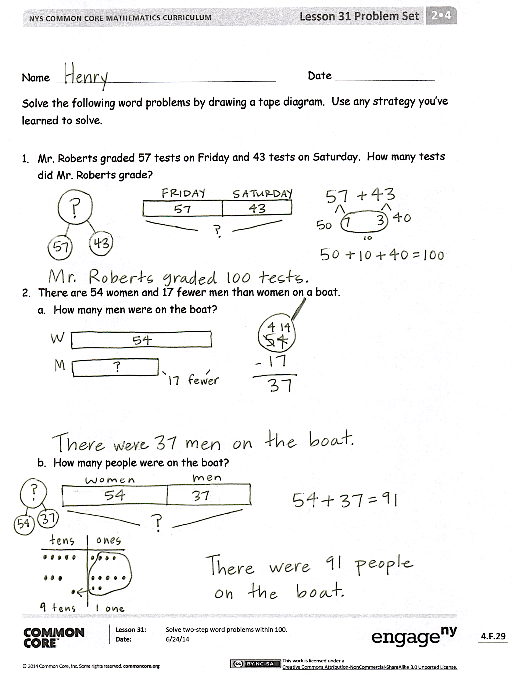
Student Debrief (10 minutes)
Lesson Objective: Solve two-step word problems within 100.
The Student Debrief is intended to invite reflection and active processing of the total lesson experience.
Invite students to review their solutions for the Problem Set. They should check work by comparing answers with a partner before going over answers as a class. Look for misconceptions or misunderstandings that can be addressed in the Debrief. Guide students in a conversation to debrief the Problem Set and process the lesson.
You may choose to use any combination of the questions below to lead the discussion.
- Explain the strategy you used to solve Problem 1. Use place value language to defend the reasonableness of your solution.
- How did you draw a tape diagram for Problem 3(a)? Explain to your partner the conclusions you can make from your drawing. How did your drawing help you to choose a strategy to solve?

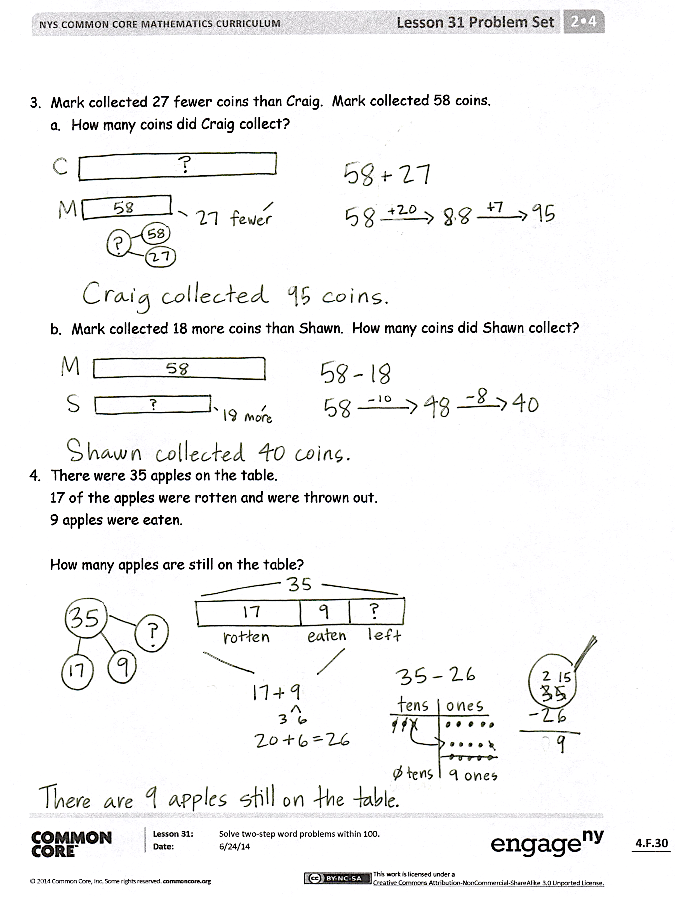
- In Problem 3(b), what is tricky about the word more? How did you represent this situation in your tape diagram? Explain the strategy you used to solve.
- In Problem 4, how did you match each piece of information in the problem with your labeled tape diagram? Which strategy did you use to solve? Why?
- What steps do you recommend for solving word problems? What questions do you ask yourself before, during, and after solving?
Exit Ticket (3 minutes)
After the Student Debrief, instruct students to complete the Exit Ticket. A review of their work will help you assess the students’ understanding of the concepts that were presented in the lesson today and plan more effectively for future lessons. You may read the questions aloud to the students.

Name Date
Solve the following word problems by drawing a tape diagram. Use any strategy you have learned to solve.

- Mr. Roberts graded 57 tests on Friday and 43 tests on Saturday. How many tests did Mr. Roberts grade?

- There are 54 women and 17 fewer men than women on a boat.
  - How many men are on the boat?

  - How many people are on the boat?

- Mark collected 27 fewer coins than Craig. Mark collected 58 coins.
- How many coins did Craig collect?

- Mark collected 18 more coins than Shawn. How many coins did Shawn collect?

- There were 35 apples on the table.
17 of the apples were rotten and were thrown out.
9 apples were eaten.

How many apples are still on the table?

Name Date
Solve the following word problems by drawing a tape diagram. Then, use any strategy that you’ve learned to solve.
- Sandra has 46 fewer coins than Martha. Sandra has 57 coins.
  - How many coins does Martha have?

  - How many coins do Sandra and Martha have together?

- There are 32 brown dogs and 19 white dogs at the park. 16 more brown dogs come to the park. How many dogs are there now at the park?

Name Date
- Melissa had 56 pens and 37 more pencils than pens.
  - How many pencils did Melissa have?

  - How many pens and pencils did Melissa have?

- Antonio gave 27 tomatoes to his neighbor and 15 to his brother. He had 72 tomatoes before giving some away. How many tomatoes does Antonio have left?

- The bakery made 92 muffins. Seventeen were blueberry, 23 were cranberry, and the rest were chocolate chip. How many chocolate chip muffins did the bakery make?

- After spending $43 on groceries and $19 on a book, Mrs. Groom had $16 left.
How much money did Mrs. Groom have to begin with?

