Lesson 30

Objective: Compare totals below to new groups below as written methods.

Suggested Lesson Structure

 Fluency Practice (13 minutes)

 Application Problem (6 minutes)

 Concept Development (31 minutes)

 Student Debrief (10 minutes)

**Total Time (60 minutes)**

Fluency Practice (13 minutes)

* Find the Difference **2.NBT.5** (4 minutes)
* Sprint: Subtraction Crossing a Ten  **2.NBT.5** (9 minutes)

Find the Difference (4 minutes)

Materials: (S) Personal white board

Note: Reviewing subtraction problems in sets prepares students for understanding the importance of the subtraction algorithm.

T: (Write 44 – 3 =____.) Write a subtraction sentence horizontally or vertically.

Continue with the following possible sequence: 40 – 5, 41 – 5; 57 –6, 50 – 6, 51 – 6; 68 – 7, 60 – 7, and 61 – 7.

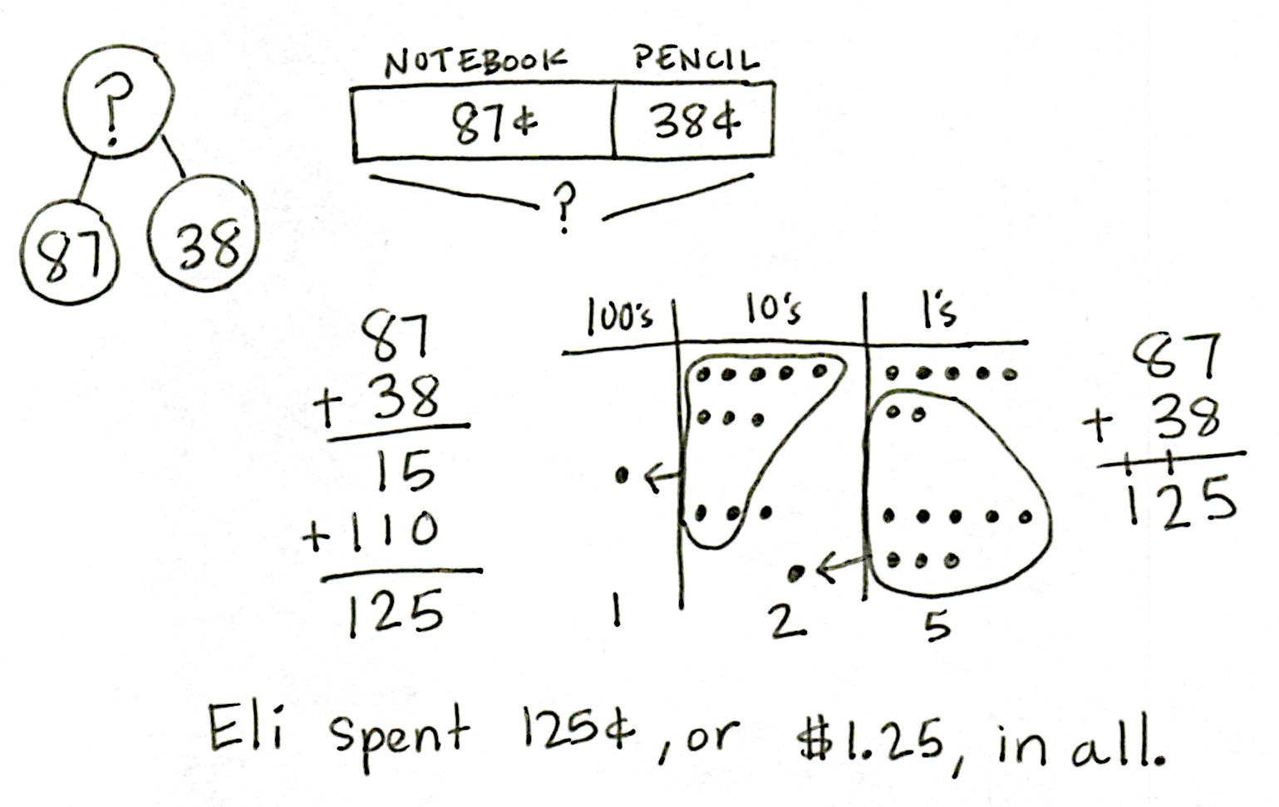Sprint: Subtraction Crossing a Ten (9 minutes)

Materials: (S) Subtraction Crossing a Ten Sprint

Note: Students use mental math strategies to mentally unbundle when subtracting.

Application Problem (6 minutes)

Eli spent 87 cents for a notebook and 38 cents for a pencil. How much money did he spend in all?

Note: Direct students to draw both a tape diagram and chip model. Then, have students use both the totals below and new groups below methods to solve this problem. When students have finished, have them share their work with a partner, using place value language to relate their work to their drawings. This leads directly into today’s Concept Development, in which students compare the two written methods.

Concept Development (31 minutes)

**MP.3**

Materials: (S) Math journal or paper

As students compare the two written methods, circulate, observe student work, and listen for place value language to share with the class.

Problem 1: 134 + 28

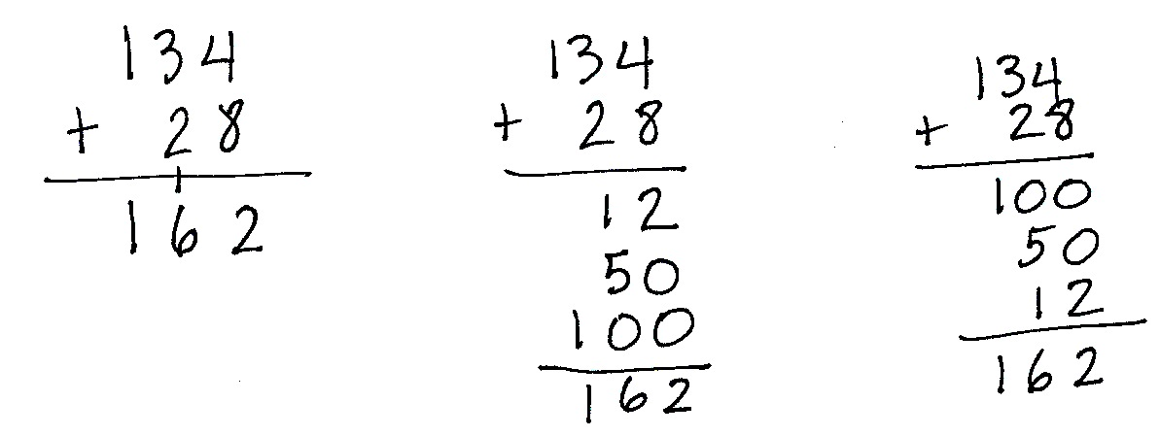T: Let’s look at different ways I can solve this problem. (Solve 134 + 28 on the board as shown.)

T: Talk with your partner. Compare these different methods and explain why they all work. You can make a math drawing or use numbers, but you must use place value language to explain.

Project selected student work on the board. Invite students to stand next to their work so they can point to the parts and clarify their explanations. Invite remaining students to ask questions and to provide feedback; give presenters time to defend their answers.

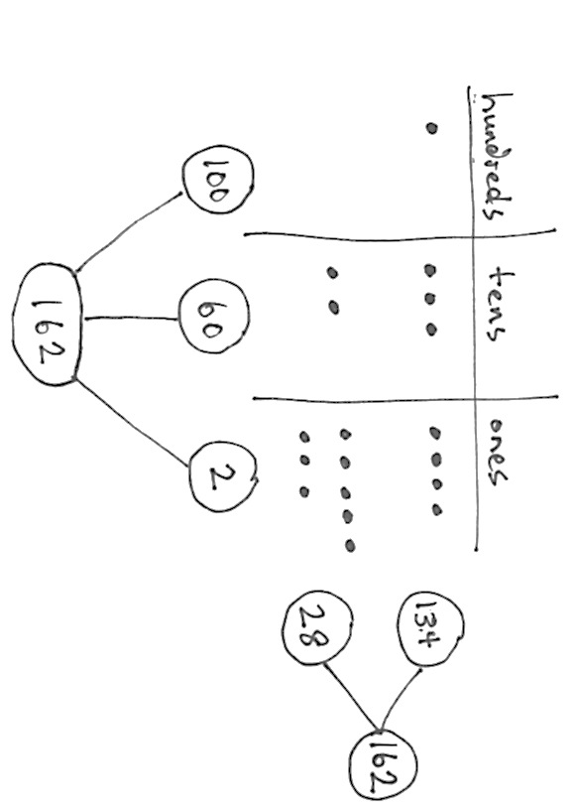

S1: I drew a number bond to show why the algorithm works. The total is 162, and the parts are 134 and 28.

S2: I drew a number bond to show why the totals below method works. 162 is the whole, and, since we added 134 and 28, the parts are 12, 50, and 100. We added the hundreds, tens, and ones by themselves to get each of the numbers we see below the problem. Then, we added those parts up!

S3: I drew a chip model that shows why they all work. It shows the parts that are 134 and 28 by themselves, but when you circle the dots to rename, you can see how 1 hundred 5 tens 12 ones becomes 1 hundred 6 tens 2 ones.

Problem 2: 176 + 59

|  |  |
| --- | --- |
|  | A NOTE ON  MULTIPLE MEANS  OF ENGAGEMENT: |
| If a student says, “I solved it using mental math,” praise her, and then ask her to use place value language to explain how she solved it mentally. | |

T: Now, it’s your turn. (Write 176 + 59 on the board horizontally.)

T: Solve this problem using totals below and new groups below.

T: While you’re solving, think about which method is easiest for you. Why? Which is most efficient, or fastest?

Project student work on the board and encourage students to share their thinking.

S: I like writing all the totals because I like starting in the hundreds place. 🡪 I like writing all the totals because you can add the value of the digits in each place.   
🡪 I like to write the addition problem vertically and put the new tens and hundreds on the line below. New groups below is fastest!

|  |  |
| --- | --- |
|  | A NOTE ON  MULTIPLE MEANS  OF REPRESENTATION: |
| Continue to support struggling students with Hide Zero cards, horizontal notation, and chip models to help them see the value of the digits in each number. | |

**MP.3**

Problem 3: 105 + 89, 149 + 39, 118 + 82

T: This time, solve using either method. You decide!

Circulate to check for understanding. As students demonstrate proficiency with both methods, allow them to work on the Problem Set independently.

Problem Set (10 minutes)

Students should do their personal best to complete the Problem Set within the allotted 10 minutes. For some classes, it may be appropriate to modify the assignment by specifying which problems they work on first. Some problems do not specify a method for solving. Students should solve these problems using the RDW approach used for Application Problems.

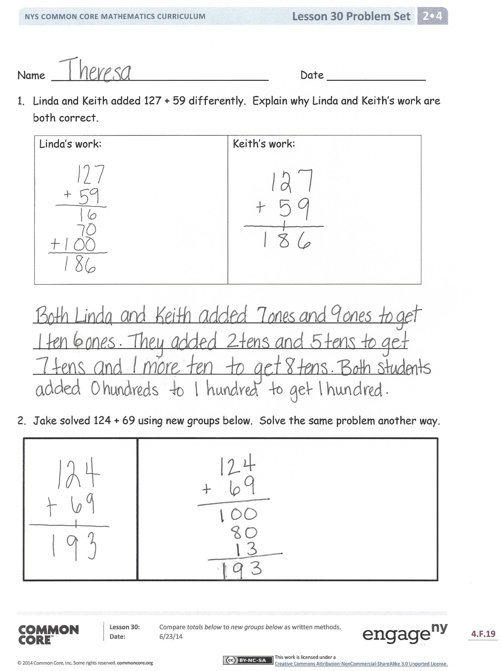Student Debrief (10 minutes)

**Lesson Objective:** Compare totals below with new groups below as written methods.

The Student Debrief is intended to invite reflection and active processing of the total lesson experience.

Invite students to review their solutions for the Problem Set. They should check work by comparing answers with a partner before going over answers as a class. Look for misconceptions or misunderstandings that can be addressed in the Debrief. Guide students in a conversation to debrief the Problem Set and process the lesson.

You may choose to use any combination of the questions below to lead the discussion.

* For Problem 1, explain to your partner why Linda and Keith are both correct. How did each method show the addition of the ones, 7 + 9?
* Explain the other strategy you used to solve Problem 2.
* For Problem 3, explain to your partner how you solved one of the problems two different ways (i.e., new groups below and totals below)? How were they the same and different?
* 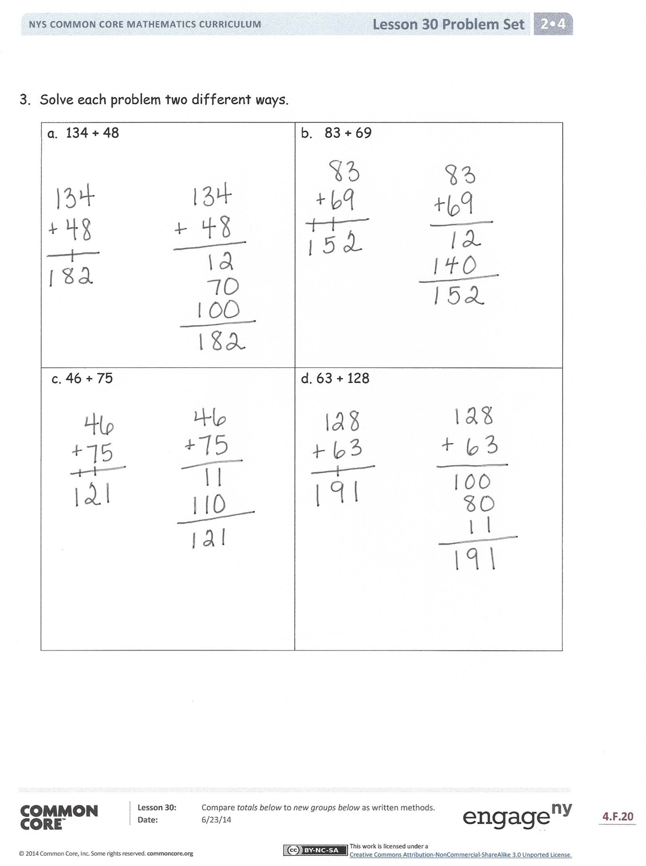What do you need to know before you can record totals below correctly? How is this method similar to writing numbers in expanded form?
* Which method, new groups below or totals below, is fastest and/or easiest for you? Why?

Exit Ticket (3 minutes)

After the Student Debrief, instruct students to complete the Exit Ticket. A review of their work will help you assess the students’ understanding of the concepts that were presented in the lesson today and plan more effectively for future lessons. You may read the questions aloud to the students.





Name Date

1. Linda and Keith added 127 + 59 differently. Explain why Linda’s work and Keith’s work are both correct.

|  |  |
| --- | --- |
| *Linda’s work:* | *Keith’s work:* |

_________________________________________________________

_________________________________________________________

_________________________________________________________

1. Jake solved 124 + 69 using new groups below. Solve the same problem another way.

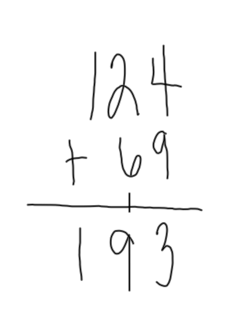

1. Solve each problem two different ways.

|  |  |
| --- | --- |
| a. 134 + 48 | b. 83 + 69 |
| c. 46 + 75 | d. 63 + 128 |

Name Date

1. Kevin solved 166 + 25 using totals below. Solve the same problem another way.

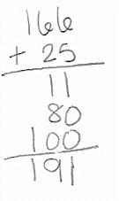

1. Explain how Kevin’s work and your work are similar.

________________________________________________________________________________

________________________________________

Name Date

1. Kari and Marty solved 136 + 56.

|  |  |
| --- | --- |
| *Kari’s work:* | *Marty’s work:* |

Explain what is different about how Kari and Marty solved the problem.

________________________________________________________________________________

________________________________________

1. Here is one way to solve 145 + 67. For (a), solve 145 + 67 another way.

|  |  |
| --- | --- |
| 1 4 5  + 6 7  1  1  2 1 2 | a. |

b. Explain how the two ways to solve 145 + 67 are similar.

________________________________________________________________________________

________________________________________

1. Show another way to solve 142 + 39.

|  |  |
| --- | --- |
|  |  |