Lesson 29

Objective: Use and explain the totals belowwritten method using words, math drawings, and numbers.

Suggested Lesson Structure

 Fluency Practice (10 minutes)

 Application Problem (6 minutes)

 Concept Development (34 minutes)

 Student Debrief (10 minutes)

**Total Time (60 minutes)**

Fluency Practice (10 minutes)

* Crossing a Ten **2.NBT.5** (5 minutes)
* Rename the Units: Choral Response  **2.NBT.1** (5 minutes)

Crossing a Ten (5 minutes)

Note: Crossing a Ten reviews making a multiple of 10 to solve problems with up to four addends.

T: (Write on the board: 8 + ____ = 10.) How many more does 8 need to make ten?

S: 2 more.

T: Give the complete number sentence.

S: 8 + 2 = 10.

T: 10 + 1.

S: 11.

T: 8 + 2 + 1.

S: 11.

T: 8 + 3.

S: 11.

Continue with the following possible sequence: 7 + 3, 7 + 3 + 1, 7 + 4, 7 + 5, 9 + 1, 9 + 1 + 1, 9 + 1 + 4, and  
19 + 1 + 4.

Rename the Units: Choral Response (5 minutes)

Note: This fluency activity reviews foundations that lead into today’s lesson.

T: (Write 10 tens = _____ hundred.) Say the number sentence.

S: 10 tens = 1 hundred.

T: (Write 11 tens = 1 hundred _____ ten.) Say the number sentence.

S: 11 tens = 1 hundred 1 ten.

T: (Write 14 tens = 1 hundred _____ tens.) Say the number sentence.

S: 14 tens = 1 hundred 4 tens.

Repeat the process for teen numbers of tens up to 20 tens.

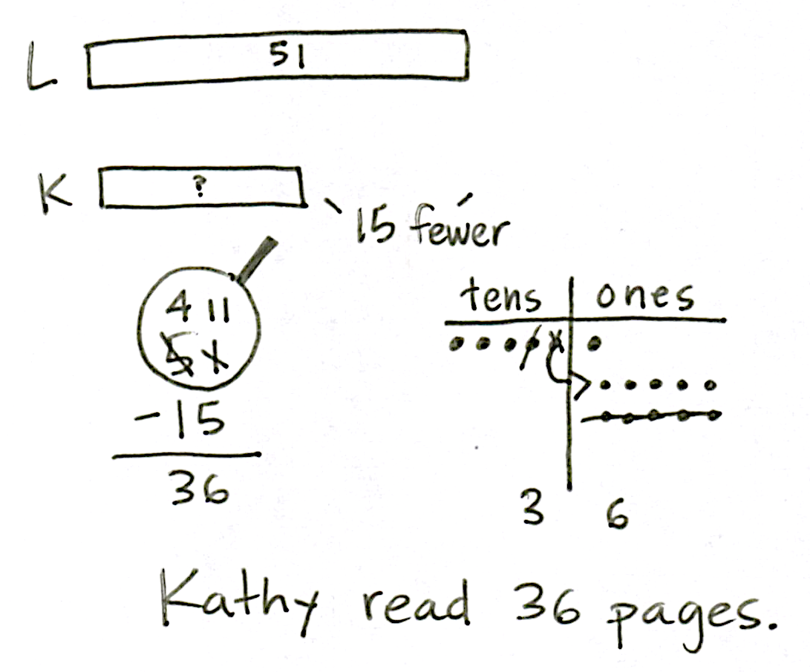Application Problem (6 minutes)

Kathy read 15 fewer pages than Lucy. Lucy read 51 pages. How many pages did Kathy read?

Note: Encourage students to use the RDW process to reason through the relationships in this problem. Can they draw a number bond or tape diagram to represent the part–whole relationship? What place value strategies can they use to solve? Invite students to share their strategies using place value language.

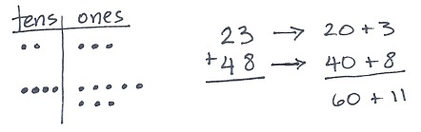Concept Development (34 minutes)

Materials: (S) Math journal or paper

Method 1: New Groups Below

T: (Draw a chip model of 23 + 48.) What expression am I modeling?

S: 23 + 48.

T: (Write vertically.) We know how to do this. (Record while talking through the algorithm to solve.)

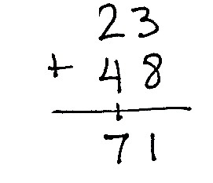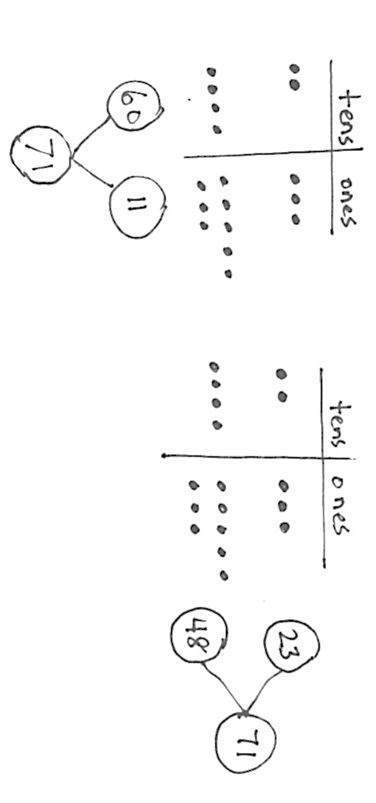

T: Let’s look at this as a number bond. (Draw the bond as they answer.) What are the parts?

S: 23 and 48.

T: What is the total?

S: 71.

Method 2: Totals Below

|  |  |
| --- | --- |
|  | A NOTE ON  MULTIPLE MEANS  OF ENGAGEMENT: |
| While the totals below strategy is conceptually useful for all students, some will be able to solve the problems without it. After demonstrating proficiency with this method, allow students to solve problems using either totals below or new groups below. | |

T: Let’s look at this same place value model another way. (See image below right.) How do we write 23 in expanded form?

S: 20 + 3.

T: (Record as shown.) How do we write 48 in expanded form?

S: 40 + 8.

T: (Record as shown.) 20 + 40…?

S: 60.

T: (Record 60 as shown.) 3 + 8…?

S: 11.

T: (Record 11 as shown.) Let’s record these **totals below** the line while we add our numbers vertically.

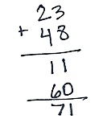T: 3 ones + 8 ones…?

S: 11 ones.

T: The Say Ten way? (Point to each digit in 11.)

S: Ten 1.

T: Can I write it like this? (Point to each digit in 11.) 1 ten 1 one? (Write it as a full total as pictured.)

|  |  |
| --- | --- |
|  | A NOTE ON  MULTIPLE MEANS  OF REPRESENTATION: |
| Use a ten-row Rekenrek to model  23 + 48 for students who need a concrete representation. Show the number bond by having the addends in separate groups; then, combine them to show the steps to 71. | |



S: Yes!

T: Now, let’s add the tens. 2 tens and 4 tens…?

S: 6 tens.

T: (Record 60.) Let’s add to see what these two totals equal. Talk to your partner about the sum of 60 and 11.

S: 60 + 10 + 1 is 71. 🡪 It’s one more than 70. 🡪 Just add ten and add one more, 71.

T: We added the ones first and then the tens. Talk with your partner. Would we get the same answer if we added the tens first and then added the ones?

**MP.1**

S: Yes, because the number of tens and ones would still be the same. 🡪 Yes, we would still get 11 and 60 because we’re adding the same parts. 🡪 Yes, we can add in either direction!

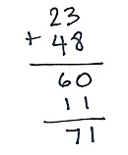T: Let’s see if that’s true. (Write the totals below method again. Add the tens first, then the ones as pictured.)

T: What do you notice?

S: The total is the same!

T: Yes! So, we can add in either direction! When we add this way, no matter where we start, we can see the different parts, 11 ones and 6 tens.

**MP.1**

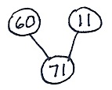T: Let’s make a number bond of the parts when we add in this totals below method. What are the parts? (Draw the bond as they answer. Point to 11 ones and 6 tens on the chip model.)

S: 60 and 11.

T: So, 71 isn’t just 23 + 48. It’s also 60 and 11.

T: Talk with your partner. How are these written methods the same and different? How do they relate to the math drawings?

Invite students to the board to point to the parts of the drawings or written methods as they explain their thinking.

S: They all equal 71. 🡪Both models show adding like units to find the total. 🡪 When I look at the chip model, I can see 23 and 48, but I also see 60 and 11.

T: Let’s practice doing some problems the totals below way.

Repeat this procedure with the following possible sequence: 45 + 37, 179 + 18, 56 + 82, 65 + 47, and 125 + 75. See images below for 125 + 75.

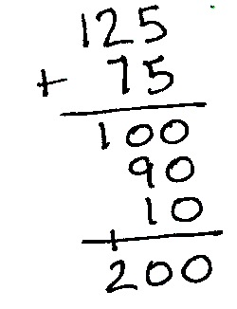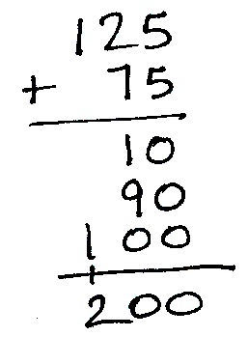

As students demonstrate proficiency with the totals below method, allow them to work on the Problem Set independently.

Problem Set (10 minutes)

Students should do their personal best to complete the Problem Set within the allotted 10 minutes. For some classes, it may be appropriate to modify the assignment by specifying which problems they work on first. Some problems do not specify a method for solving. Students should solve these problems using the RDW approach used for Application Problems.

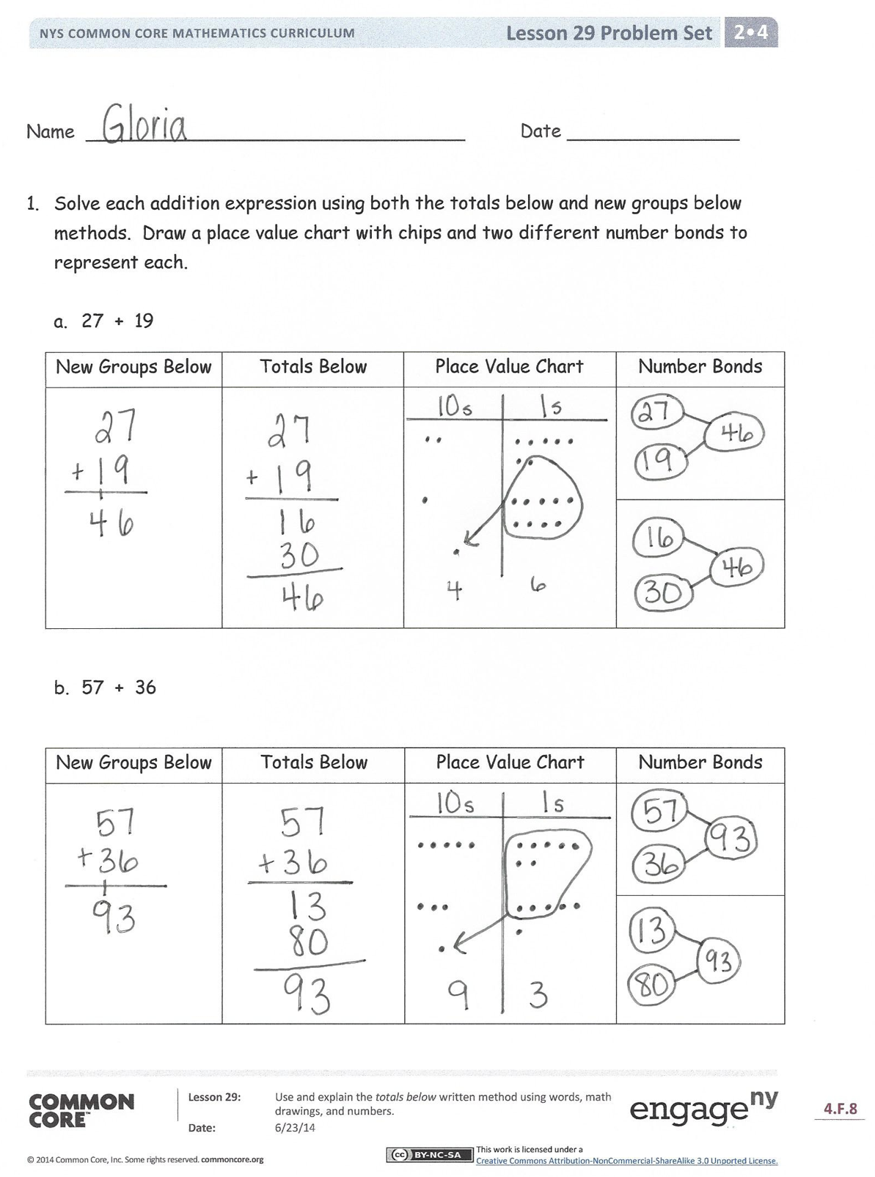Student Debrief (10 minutes)

**Lesson Objective:** Use and explain the totals below written method using words, math drawings, and numbers.

The Student Debrief is intended to invite reflection and active processing of the total lesson experience.

Invite students to review their solutions for the Problem Set. They should check work by comparing answers with a partner before going over answers as a class. Look for misconceptions or misunderstandings that can be addressed in the Debrief. Guide students in a conversation to debrief the Problem Set and process the lesson.

You may choose to use any combination of the questions below to lead the discussion.

* For Problem 1, what connections can you make between the **totals below** method and number bonds? Place value chart?
* 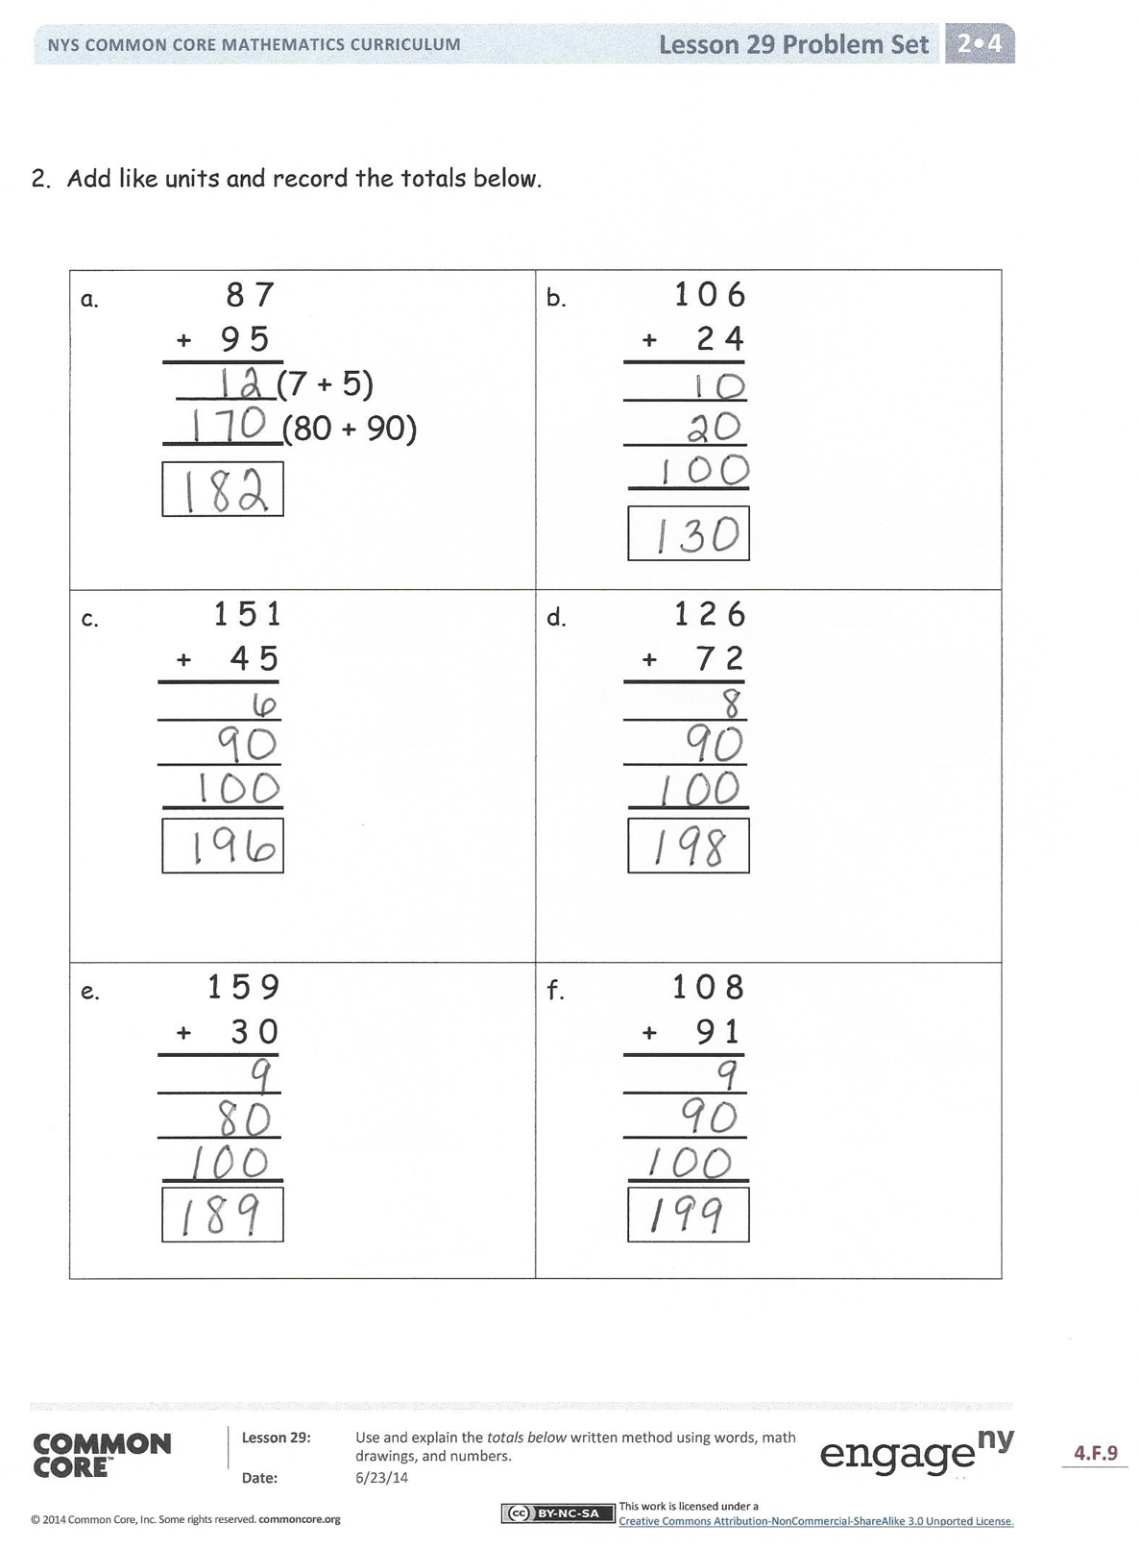For Problem 1(b), how were the two written methods the same and different? How did you show your understanding of place value?
* In Problem 2(a), how did you record the totals below? Why does the answer include a hundred when you are only adding tens and ones?
* For Problem 2(b), let’s make a chip model to show the addition (draw on board). How does our model relate to the totals below method?
* Pretend you are explaining the totals below method to a first grader: Why are we decomposing numbers first and then adding?

Exit Ticket (3 minutes)

After the Student Debrief, instruct students to complete the Exit Ticket. A review of their work will help you assess the students’ understanding of the concepts that were presented in the lesson today and plan more effectively for future lessons. You may read the questions aloud to the students.

Name Date

1. Solve each addition expression using both the totals below and new groups below methods. Draw a place value chart with chips and two different number bonds to represent each.
   1. 27 + 19

|  |  |  |  |
| --- | --- | --- | --- |
| New Groups Below | Totals Below | Place Value Chart | Number Bonds |
|  |  |  |  |
|  |

* 1. 57 + 36

|  |  |  |  |
| --- | --- | --- | --- |
| New Groups Below | Totals Below | Place Value Chart | Number Bonds |
|  |  |  |  |
|  |

2. Add like units and record the totals below.

|  |  |
| --- | --- |
| a. 8 7  + 9 5   _____**­** (7 + 5)  (80 + 90) | b. 1 0 6  + 2 4 |
| c. 1 5 1  + 4 5 | d. 1 2 6  + 7 2 |
| e. 1 5 9  + 3 0 | f. 1 0 8  + 9 1 |

Name Date

Add like units and record the totals below.

|  |  |
| --- | --- |
| 1. 45  + 64 | 2. 109  + 72 |
| 3. 144  + 58 | 4. 167  + 52 |

Name Date

1. Add like units and record the totals below.

|  |  |
| --- | --- |
| a.  48  + 27   ____  ____ | b.  118  + 73   ____  ____  ____ |
| c.  156  + 62   ____  ____  ____ | d.  137  + 82   ____  ____  ____ |

|  |  |
| --- | --- |
| e.  147  + 35   ____  ____  ____ | f.  149  + 51   ____  ____  ____ |
| g.  188  + 22   ____  ____  ____ | h.  126  + 65   ____  ____  ____ |

2. Daniel counted 67 apples on one tree and 79 apples on another tree. How many  
 apples were on both trees? Add like units and record the totals below to solve.