Lesson 28
Objective: Subtract from 200 and from numbers with zeros in the tens place.

Suggested Lesson Structure
 Fluency Practice (10 minutes)
 Application Problem (7 minutes)
 Concept Development (33 minutes)
 Student Debrief (10 minutes)
Total Time (60 minutes)
Fluency Practice (10 minutes)
- Subtraction Fact Flash Cards 2.OA.2 (2 minutes)
- Rename the Units: Choral Response 2.NBT.1 (6 minutes)
- Take from the Tens or Ones 2.NBT.5 (2 minutes)
Subtraction Fact Flash Cards (2 minutes)
Materials: (T) Subtraction fact flash cards set 1 (Lesson 24 Fluency Template)
Note: By practicing subtraction facts, students gain fluency subtracting within 20.
Rename the Units: Choral Response (6 minutes)
Note: This fluency activity reviews foundations that will lead into today’s lesson.
T: (Write 10 ones = _____ ten.) Say the number sentence.
S: 10 ones = 1 ten.
T: (Write 20 ones = 1 ten ____ ones.) Say the number sentence.
S: 20 ones = 1 ten 10 ones.
T: (Write 24 ones = 1 ten ____ ones.) Say the number sentence.
S: 24 ones = 1 ten 14 ones.
Repeat the process for the following possible sequence: 27, 30, 32, 38, 40, 41, 46, 50, 63, and 88.
T: (Write 100 = 9 tens ____ ones.) Say the number sentence.
S: 100 = 9 tens 10 ones.
T: (Write 101 = 9 tens ____ ones.) Say the number sentence.
S: 101 = 9 tens 11 ones.
T: 9 tens 11 ones is…?
S: 101.
T: 9 tens 12 ones is…?
S: 102.
Repeat the process for the following possible sequence: 103, 104, 105, 106, 107, 108, 109, and 110.
Take from the Tens or Ones (2 minutes)
Note: This fluency activity helps students know when to unbundle a ten to subtract. This is a foundational skill for the lesson.
T: For every number sentence I say, you tell me if I take from the tens or the ones. When I say 46 – 5, you say take from the ones, but If I say 46 – 7, you say take from the tens. Ready?
T: 46 – 6.
S: Take from the ones.
T: 46 – 9.
S: Take from the tens.
Continue with the following possible sequence: 52 – 1, 52 – 4, 63 – 6, 64 – 5, 65 – 4, 68 – 8, and 70 – 3.
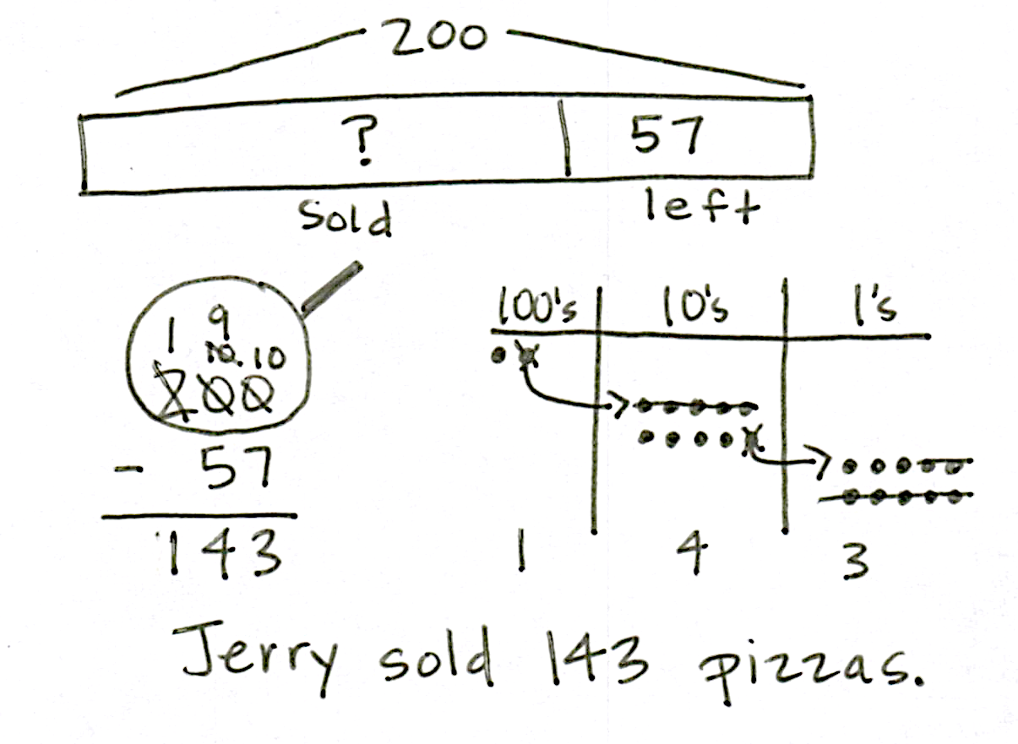
Application Problem (7 minutes)
Jerry made 200 pizzas. He sold some of them and had 57 pizzas left. How many did he sell?
Note: Instruct students to set up a place value chart to solve this Application Problem. Some students may relate this problem to Lesson 27 by drawing place value disks on their place value charts. Others may choose to represent the problem using a tape diagram or the arrow way.
Concept Development (33 minutes)

A NOTE ON
MULTIPLE MEANS
OF ACTION AND EXPRESSION:
Have manipulatives available for students who have not yet mastered the ability to solve these problems without a concrete representation.

Materials: (S) Personal white board
Note: This Concept Development is intentionally designed for students to practice concepts taught in Lesson 27. Encourage students to choose any accurate math drawing to represent the subtraction. While some students may be comfortable drawing chip models, others may choose to represent the problem using place value disk drawings. In either case, all students should relate their drawings to the vertical form.
Problem 1: 106 – 58
MP.4
T: (Write 106 – 58 on the board.)
T: Let’s solve 106 – 58 using a math drawing. Choose whether you want to use a disk drawing or a chip model. What number are we going to draw?
S: 106.
T: And, what should I draw on my model to show that number?
S: 1 hundred and 6 ones.
T: Great. Which place do we look at first to see if we need to do any renaming?
S: The ones!
T: Are we ready to subtract in the ones place?
S: No.
T: What should we do? Turn and talk to your partner.
S: There are no tens either, so let’s rename a hundred as 9 tens and 10 ones. That makes it 9 tens and 16 ones, because we already had 6 ones. We can change 1 hundred into 10 tens, and then change 10 tens into 9 tens 10 ones.
T: Okay, let’s do it. Record each change.
T: Are we ready to subtract in the ones?
S: Yes.
T: In the tens?
S: Yes.
T: Show your answer in the written subtraction. What is our first step? Tell the units.
S: 16 ones – 8 ones.
T: (Model on your drawing and algorithm.) How many ones are left?
S: 8.
T: Great. Let’s try the tens. What is our problem?
S: 9 tens ─ 5 tens.
T: How many tens do we have left?
S: 4 tens. (Show this on the drawing and using the algorithm.)
T: Do we subtract any hundreds?
S: No!
Invite students to share their work. Analyze the parts and join them to see if they total 106.

Problem 2: 200 – 67
MP.4
T: (Write 200 – 67 on the board.)
T: We are now going to do the same thing with another problem. Make a math drawing that represents the number we will be subtracting from. (Give them time to make their drawings.)
T: What did you draw?
S: 200. 2 hundreds.
T: How can we rename 200 to solve 200 – 67? Turn and talk.
S: We can rename it as 1 hundred, 9 tens, and 10 ones.
Since you can’t subtract from the ones or tens, we can unbundle a hundred, then unbundle a ten.
T: In which place will you start subtracting?

A NOTE ON
MULTIPLE MEANS
OF ENGAGEMENT:
Allow students who prefer to work in groups to work with a partner on the Problem Set; likewise, allow students who concentrate better alone to work independently.

S: The ones.
T: On your own, solve 200 ─ 67 using a math drawing. Again, record each change and show your answer in the written subtraction.
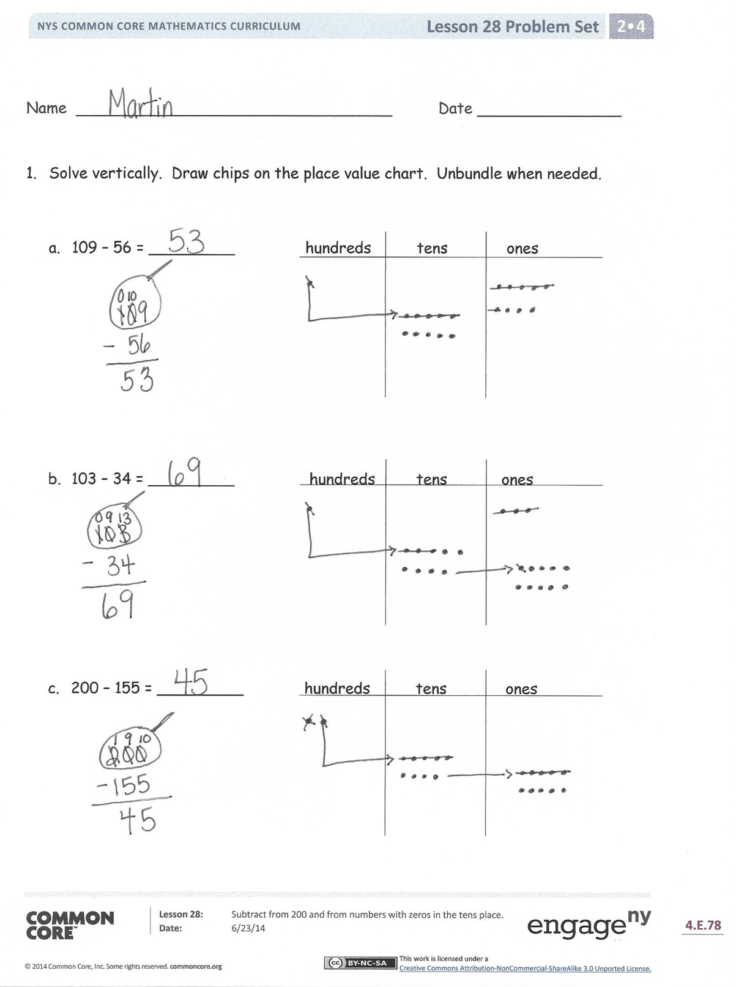
Repeat the above activity with the following possible sequence:
200 – 33, 103 – 59, and 200 – 49. Before students begin each problem, instruct them to rename the whole. Emphasize the renaming of 200 as 1 hundred, 9 tens, 10 ones. As you circulate, remind students to draw the magnifying glass, to represent the problem using a math drawing, and to record each step in the written subtraction.
Problem Set (10 minutes)
Students should do their personal best to complete the Problem Set within the allotted 10 minutes. For some classes, it may be appropriate to modify the assignment by specifying which problems they work on first. Some problems do not specify a method for solving. Students should solve these problems using the RDW approach used for Application Problems.
Student Debrief (10 minutes)
Lesson Objective: Subtract from 200 and from numbers with zeroes in the tens place.
The Student Debrief is intended to invite reflection and active processing of the total lesson experience.
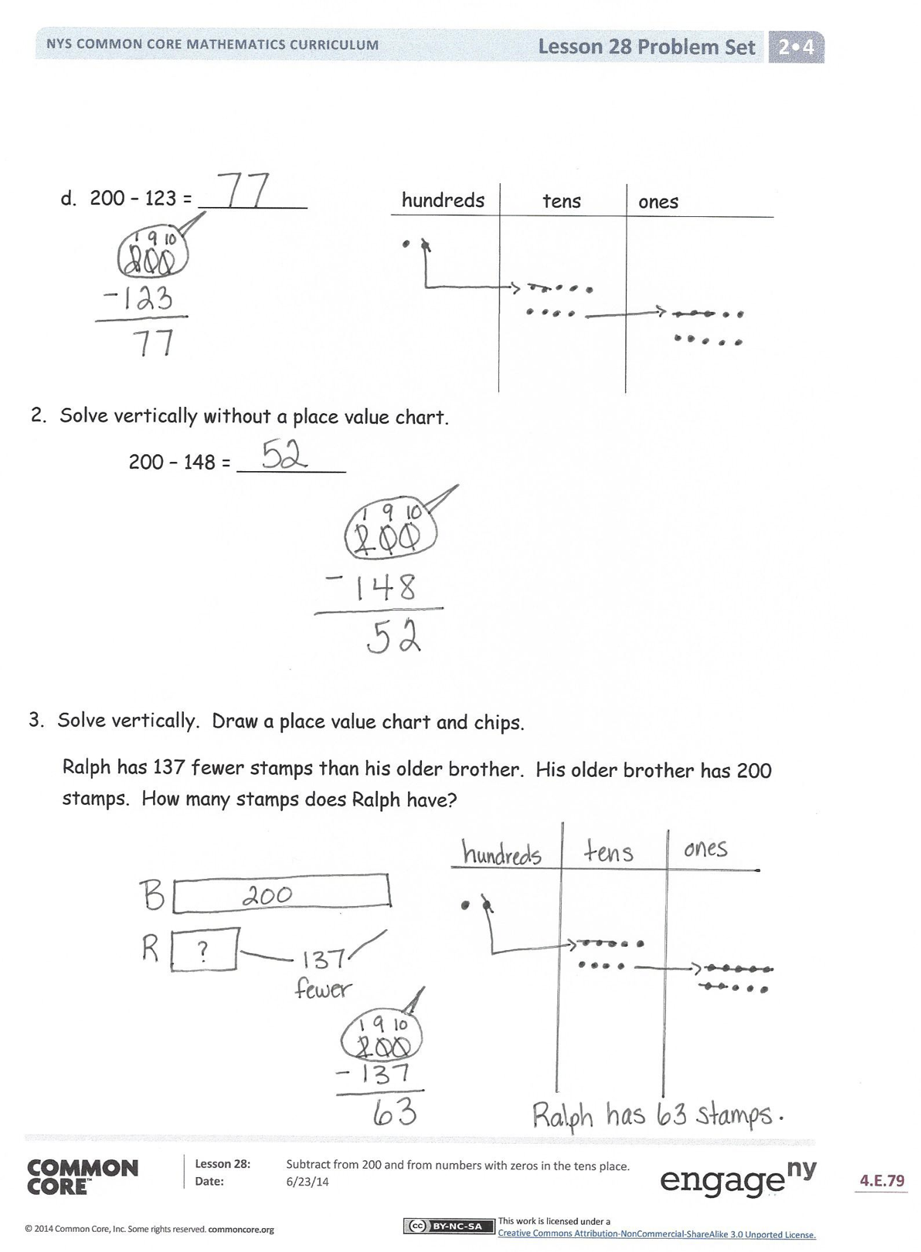
Invite students to review their solutions for the Problem Set. They should check work by comparing answers with a partner before going over answers as a class. Look for misconceptions or misunderstandings that can be addressed in the Debrief. Guide students in a conversation to debrief the Problem Set and process the lesson.
You may choose to use any combination of the questions below to lead the discussion.
- Look at Problem 1, Parts (a) and (b). When you are subtracting and the whole (i.e., larger number) has a zero in the tens place, what do you know for sure? How do you know if that zero will become a 10 or a 9?
- For Problem 1, Part (c), how did you unbundle 200 on your place value chart? Did you do it in one or two steps?
- For Problem 1, Part (d), how did you unbundle 200 on your place value chart? Why did you show 200 that way? How did it match your written subtraction?
- Problem 2, 200 – 148, asked you to solve vertically. Could you also have solved mentally? How? Which way is quicker and easier?
- In your work today, how was unbundling 200 similar to and different from unbundling 100?
Exit Ticket (3 minutes)
After the Student Debrief, instruct students to complete the Exit Ticket. A review of their work will help you assess the students’ understanding of the concepts that were presented in the lesson today and plan more effectively for future lessons. You may read the questions aloud to the students.

Name Date
- Solve vertically. Draw chips on the place value chart. Unbundle when needed.

- 109 − 56 = _________ hundreds tens ones

- 103 − 34 = _________ hundreds tens ones

- 200 − 155 = _________ hundreds tens ones

- 200 − 123 = _________ hundreds tens ones

- Solve vertically without a place value chart.
200 − 148 = _________

- Solve vertically. Draw a place value chart and chips.
Ralph has 137 fewer stamps than his older brother. His older brother has 200 stamps. How many stamps does Ralph have?

Name Date
Solve vertically. Draw chips on the place value chart. Unbundle when needed.

- 108 − 79 = _________ hundreds tens ones

- 200 − 126 = _________ hundreds tens ones

Name Date
- Solve vertically. Draw chips on the place value chart. Unbundle when needed.

- 136 − 94 = _________ hundreds tens ones

- 105 − 57 = _________ hundreds tens ones

- 200 − 61 = _________ hundreds tens ones

- 200 − 107 = _________ hundreds tens ones

- 200 − 143 = _________ hundreds tens ones

- Herman collected 200 shells on the beach. Of those, he kept 136 shells and left the rest on the beach. How many shells did he leave on the beach?

