Lesson 27

Objective: Subtract from 200 and from numbers with zeros in the tens place.

Suggested Lesson Structure

 Fluency Practice (14 minutes)

 Application Problem (5 minutes)

 Concept Development (31 minutes)

 Student Debrief (10 minutes)

**Total Time (60 minutes)**

Fluency Practice (14 minutes)

* Subtraction Fact Flash Cards **2.OA.2** (2 minutes)
* Subtraction from Tens **2.NBT.5** (3 minutes)
* Sprint: Subtraction from a Ten or a Hundred  **2.NBT.5** (9 minutes)

Subtraction Facts Flash Cards (2 minutes)

Materials: (T) Subtraction fact flash cards set 1 (Lesson 24 Fluency Template)

Note: By practicing subtraction facts, students gain fluency subtracting within 20.

Subtraction from Tens (3 minutes)

Materials: (S) Personal white board

Note: This allows students to see how their take-from-ten facts help them to solve many, many problems. It also prepares them for today’s Sprint.

T: When I say a basic fact, you add ten to the whole and continue until I say to stop. So, after 10 – 8, you would solve 20 – 8, and then…?

S: 30 – 8, 40 – 8, 50 – 8.

T: Yes. Solve as many as you can on your personal white board before I give the signal to stop. Let's begin. 10 – 8.

S: (Work.)

When you see every student has completed at least 2 problems, stop the class and give the next expression.

Continue with the following possible sequence: 100 – 80, 10 – 6, 100 – 60, and 100 – 59.

Sprint: Subtraction from a Ten or a Hundred (9 minutes)

Materials: (S) Subtraction from a Ten or a Hundred Sprint

Note: Students are given the opportunity to use mental math strategies when subtracting from 10 or 100.

Application Problem (5 minutes)

Mr. Ramos has 139 pencils and 88 erasers. How many more pencils than erasers does he have?

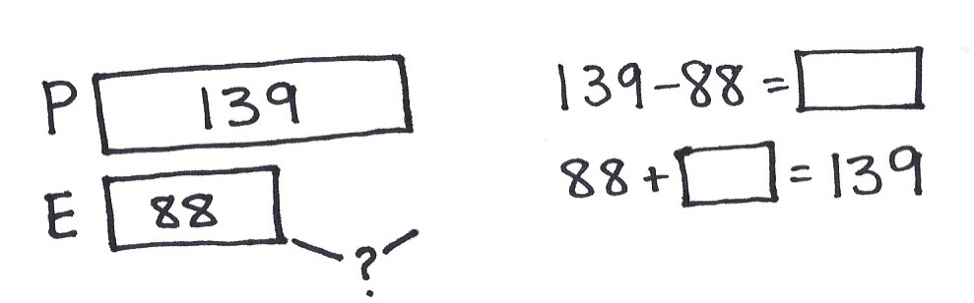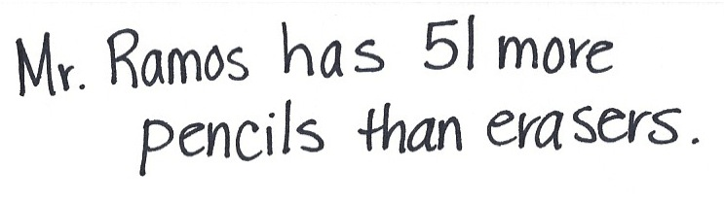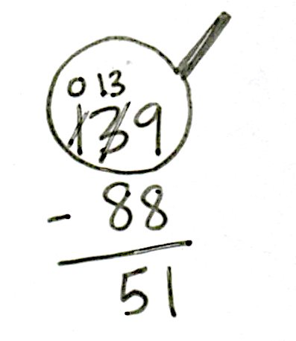

Note: Allow students to use varied strategies. Invite pairs of students committed to different strategies to solve at the board while others work at their seats. Have those who worked at the board quickly present their solutions to their peers.

Concept Development (31 minutes)

Materials: (S) Personal white board

Note: In the previous lesson, students used the chip model to subtract with up to two decompositions. We will be modeling today’s lesson with place value disk drawings; students can work with the representation that best suits their level of development. Simple to complex representation include bills, place value disks (concrete and then drawn), bundles of straws, and the chip model.

Problem 1: Model 100 as 9 tens and 10 ones and relate to a number written with changed units.

**MP.4**

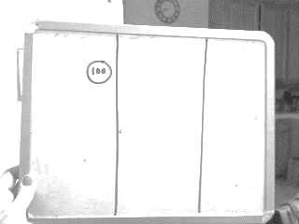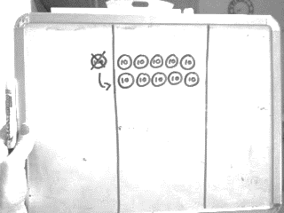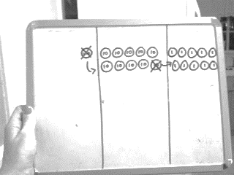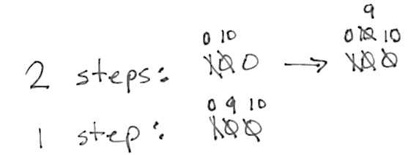

T: Show me 100 with the fewest disks possible.

T: What is the value of your disk?

S: 100.

T: Change 1 hundred for 10 tens.

S: (Draw 10 tens arranged in 5-groups.)

T: Say the number in hundreds.

S: 1 hundred.

T: Now, say the number in tens and then count.

S: 10 tens. 10, 20, 30…100.

T: Did the value change?

S: No!

T: Show me 100 by changing 1 ten for 10 ones.

T: Say the number in hundreds.

S: 1 hundred.

**MP.4**

|  |  |
| --- | --- |
|  | NOTES ON  MULTIPLE MEANS  OF ACTION AND EXPRESSION: |
| Give students enough time to come up with the answers. While they may be obvious to adults, these questions are new to the children and necessitate some processing time. | |

T: Say the number in tens and ones.

S: 9 tens and 10 ones.

T: Let’s count.

S: 10, 20, 30 …90, 91, 92, 93…100!

T: Did the value change?

S: No! It’s still a hundred!

T: Let’s write the number 100 and show how we renamed it. (See image on previous page.)

T: How does the way the change is recorded relate to what we just did with the disks.

S: In the first way, you change 1 hundred to 0 hundreds and 10 tens. Then you change 10 tens to   
9 tens and 10 ones. 🡪 Or, you can do it all at once, and just change 1 hundred to 0 hundreds,   
9 tens, and 10 ones. It makes it easier for me. 90 + 10 = 100.

Problem 2: Model 200 as 1 hundred, 9 tens, and 10 ones, and relate to a number written with changed units.

T: Show me 200 with the fewest disks possible.

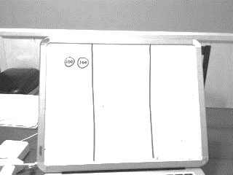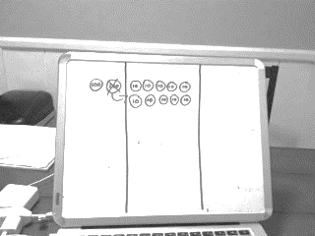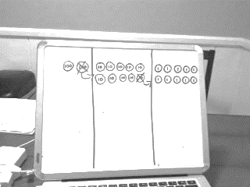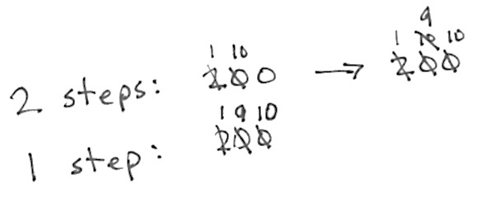

S: (Draw 2 hundreds disks.)

T: Change 1 hundred for 10 tens.

T: Say the number in hundreds.

S: 2 hundreds.

T: Say the number in hundreds and tens.

S: 1 hundred 10 tens.

T: Did the value change?

S: No!

T: Now show me 200 by unbundling a ten.

S: (Draw 1 hundred 9 tens 10 ones.)

T: Say the number in hundreds, tens, and ones.

S: 1 hundred 9 tens 10 ones.

T: Did the value change?

S: No!

T: Relate your work with the disks to these numbers showing the changed units.

S: In the first way, you change 2 hundreds to 1 hundred and 10 tens. Then, you change 10 tens to   
9 tens and 10 ones. 🡪 In the faster way, you just change 2 hundreds to 1 hundred, 9 tens, and   
10 ones. 190 + 10 = 200.

Problem 3: 100 – 83

**MP.4**

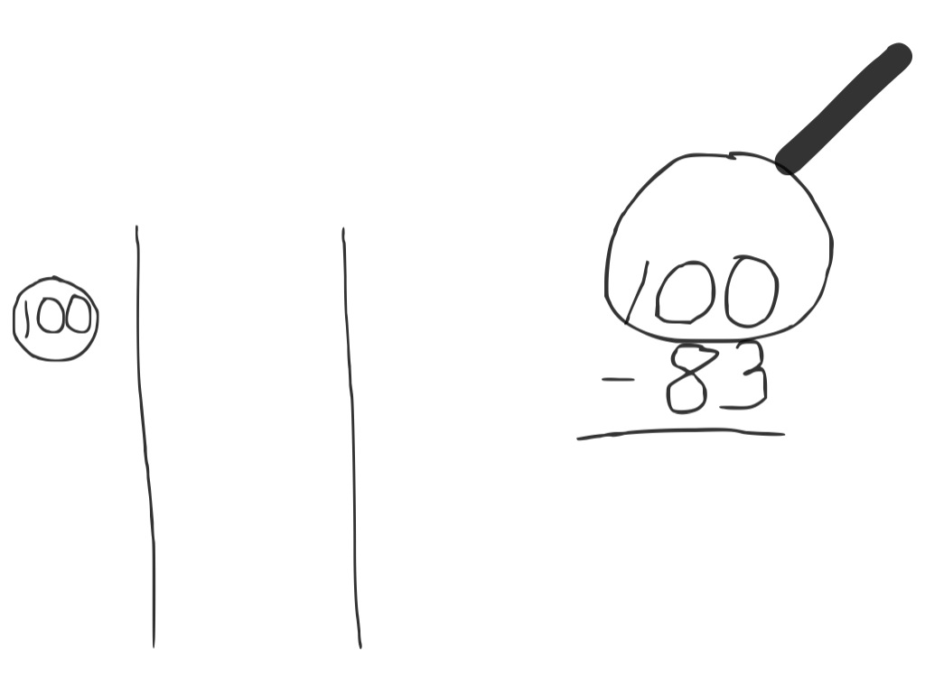

T: Why would we want to show 100 as 9 tens and 10 ones?

S: Sometimes when you subtract, both the tens and the ones need more. 🡪 You need ones if you want to subtract ones. 🡪 9 tens 10 ones is the same as 100.

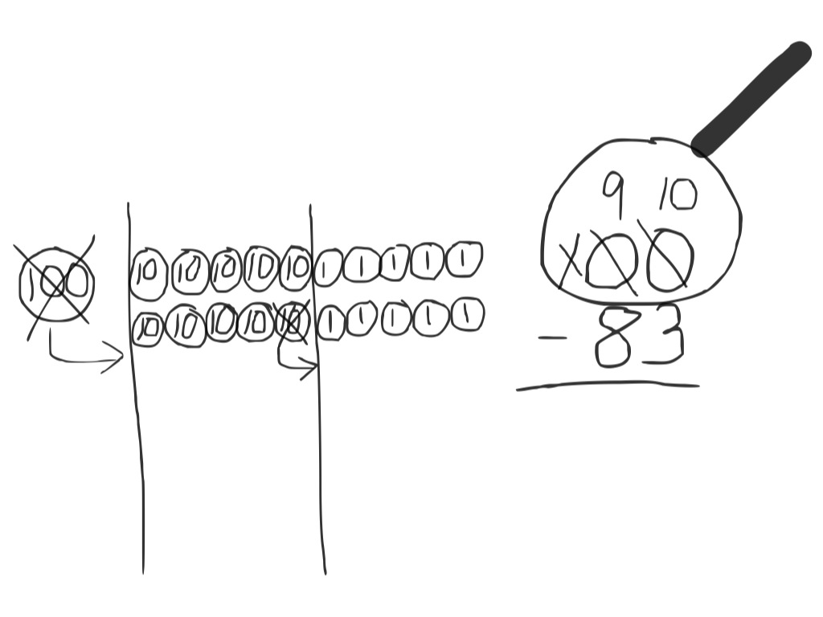T: Let’s see how knowing this will help us to solve some subtraction problems today.   
(Write 100 – 83 on the board in the vertical form.)

T: What do we do first?

T: When I set up to subtract, I am going to draw my place value disks to show the whole. (Draw 100 in place value disks.) How many do you see on my place value chart?

S: 1 hundred 0 tens 0 ones.

T: Can we subtract 3 ones from 0 ones?

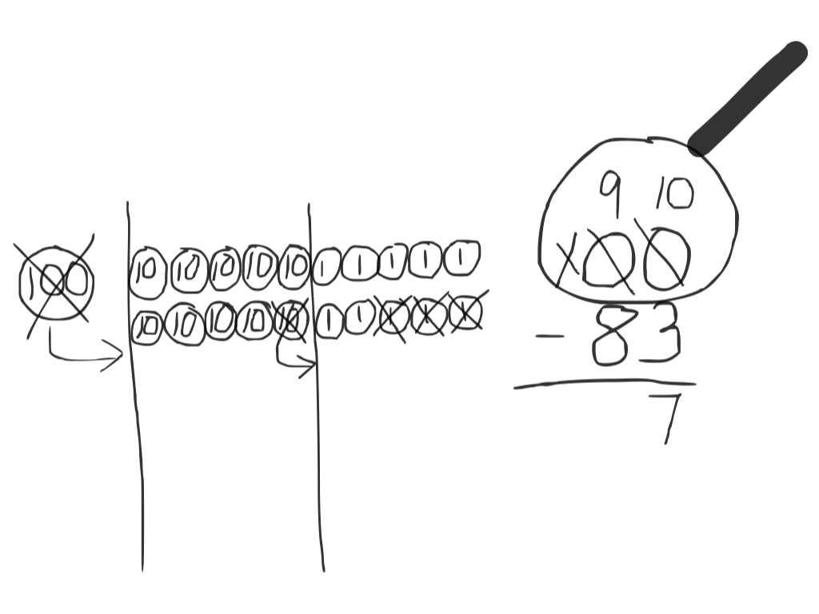S: No! We need to change 1 ten for 10 ones.

T: But there are no tens. Does that mean we are stuck?

S: No, because a hundred has tens in it. 🡪 Yeah, from the tens we can get some ones. 🡪 It’s what we just did. Let’s change 1 hundred for   
9 tens and ten ones.

T: Okay. Let’s do that. Tell me what to do.

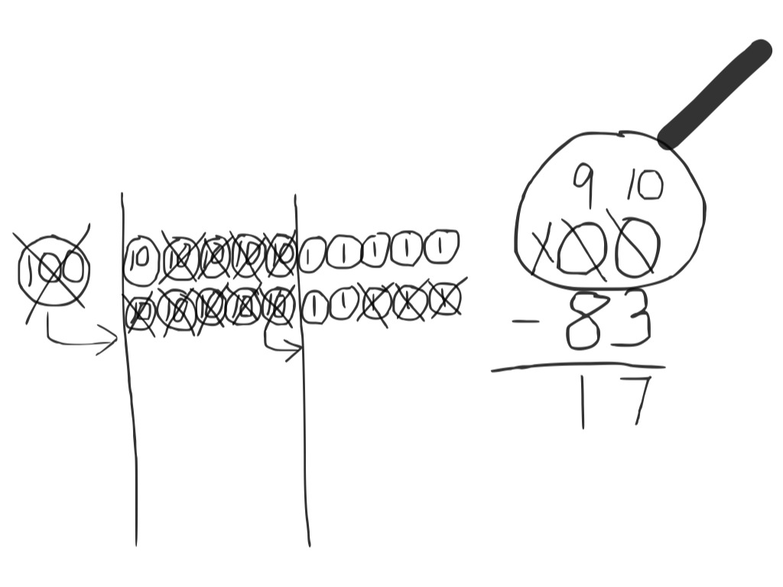S: Just what she said. Change 1 hundred for 9 tens and 10 ones, and show that on your numbers, too, by crossing out.

T: (Work with disks and numbers.) Now, am I ready to subtract in the ones place?

S: Yes!

T: Am I ready to subtract in the tens place?

S: Yes!

T: 10 ones – 3 ones is…?

S: 7 ones.

T: 9 tens – 8 tens is…?

S: 1 ten.

|  |  |
| --- | --- |
|  | NOTES ON  MULTIPLE MEANS  OF ENGAGEMENT: |
| If you see some students demonstrating proficiency during the lesson, have one or more lead the class in modeling these problems. | |

T: Read me the full number sentence.

S: 100 – 83 = 17.

T: So, the missing part was 17. How can I check to see if my subtraction is correct?

S: Add the two parts to see if you get the whole.

T: What are the two parts?

S: 17 and 83.

T: The whole?

S: 100.

T: When we add the two parts, do we get the whole?

S: Yes. 80 + 10 = 90, 90 + 3 + 7 = 90 + 10 = 100. 🡪 8 tens, 1 ten, and 10 ones is 100.

Problem 4: 200 – 8

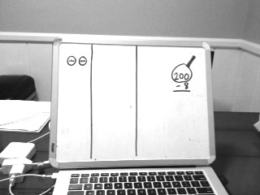T: (Draw 2 hundreds on the place value chart, and write 200 – 8 on the board. Draw the magnifying glass.) Let’s start at the ones place. Can I subtract 8 ones from 0 ones?

S: No!

T: Where am I going to find some ones? Talk to your partner.

**MP.4**

S: It’s like the last problem we did. 🡪 After you decompose 1 hundred, you have 1 hundred, 9 tens, and 10 ones.  🡪 Unbundle a hundred; then unbundle a ten. 🡪 You can make 200 into 1 hundred,   
10 tens, and then change 1 of the tens for 10 ones. 🡪 You can change 1 hundred for 10 tens, and then change a ten for 10 ones.

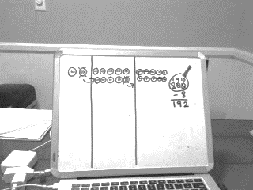T: (Unbundle 200 to make 1 hundred 9 tens 10 ones.) Are we ready to subtract?

S: Yes!

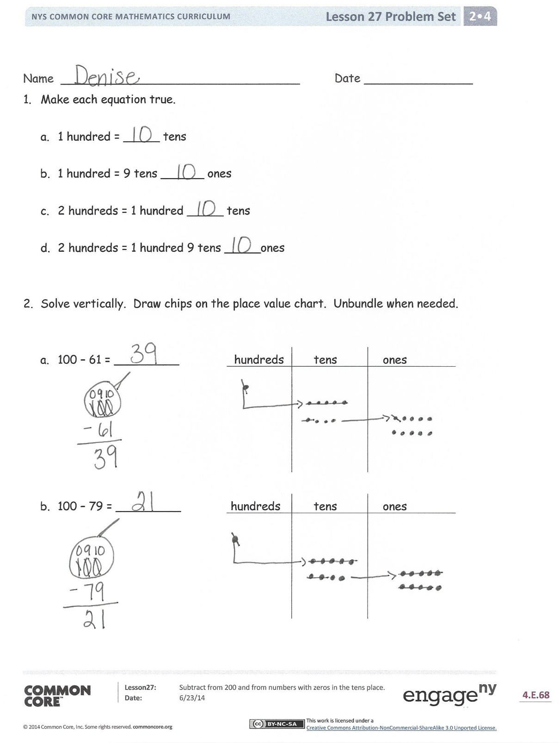T: Solve the problem by crossing out place value disks, starting with the ones, and recording each step in the written form.

Have the students analyze the problem for parts and wholes as in Problem 1 and check to see the total of the parts is 200.

Guide students through solving two or three more problems that require renaming 200 as 1 hundred, 9 tens, and 10 ones. You might use the following suggested sequence: 200 – 78, 200 – 143, and 200 – 111. As students show proficiency, allow them to work independently on the Problem Set.

Problem Set (10 minutes)

Students should do their personal best to complete the Problem Set within the allotted 10 minutes. For some classes, it may be appropriate to modify the assignment by specifying which problems they work on first. Some problems do not specify a method for solving. Students should solve these problems using the RDW approach used for Application Problems.

Student Debrief (10 minutes)

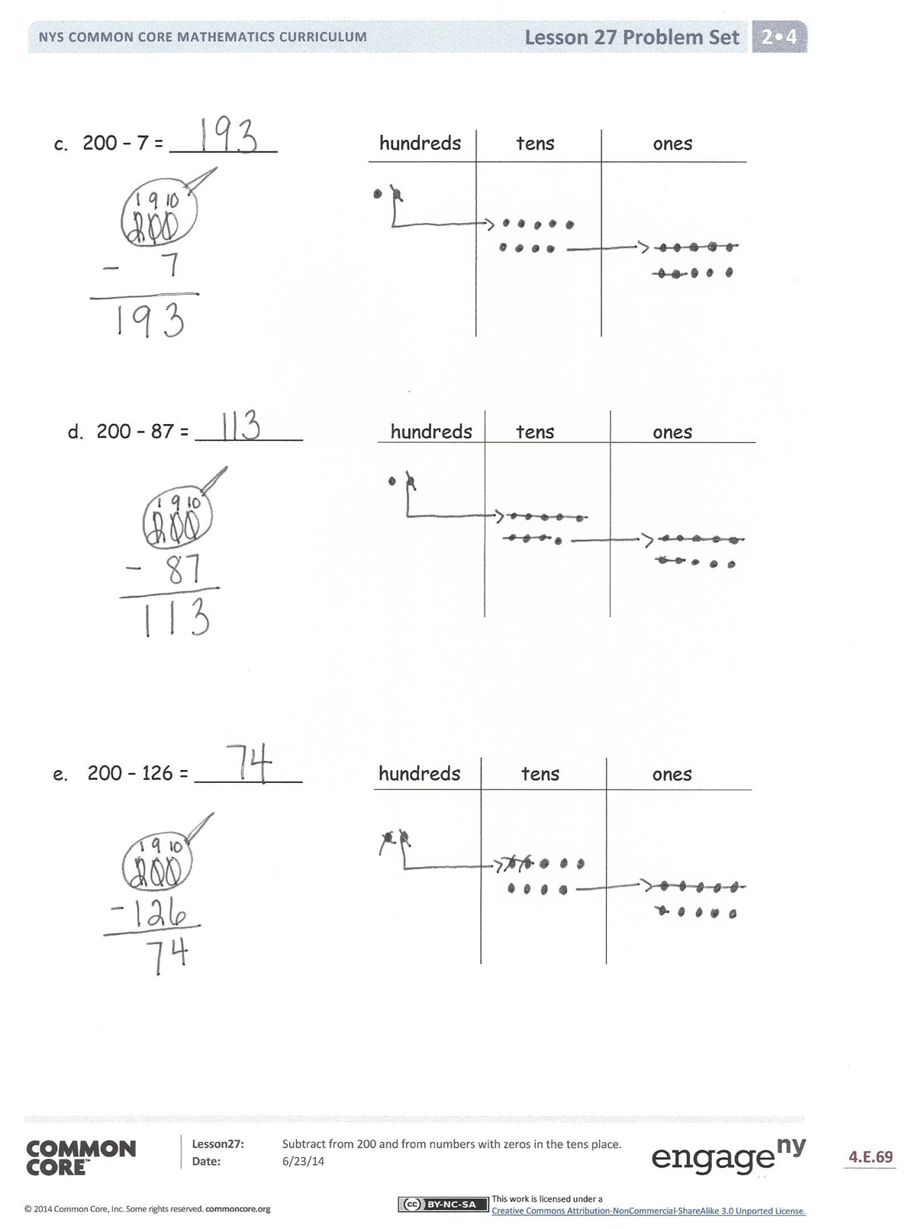**Lesson Objective:** Subtract from 200 and from numbers with zeros in the tens place.

The Student Debrief is intended to invite reflection and active processing of the total lesson experience.

Invite students to review their solutions for the Problem Set. They should check work by comparing answers with a partner before going over answers as a class. Look for misconceptions or misunderstandings that can be addressed in the Debrief. Guide students in a conversation to debrief the Problem Set and process the lesson.

You may choose to use any combination of the questions below to lead the discussion.

* Look at Problem 1. What possible combinations of tens and ones do you notice within a unit of 100?
* How can I unbundle 100 on a place value chart? How can I do it in two steps? How can I do it in one step?
* What are two different ways that I can unbundle 200 using hundreds, tens, and ones? Now, look at Problem 2, Part (c). Which way did you choose to decompose? Why?
* How is Problem 2, Part (d) significantly different from Problem 2, Part (b)?
* Explain to your partner how you unbundled Problem 2, Part (d), 200 – 87. Did you do it in one or two steps? Which way is easier for you?
* When you are subtracting, what clues tell you that you will have to unbundle a hundred?

Exit Ticket (3 minutes)

After the Student Debrief, instruct students to complete the Exit Ticket. A review of their work will help you assess the students’ understanding of the concepts presented in the lesson today and plan more effectively for future lessons. You may read the questions aloud to the students.





Name Date

1. Make each equation true.
   1. 1 hundred = _____ tens
   2. 1 hundred = 9 tens ______ ones
   3. 2 hundreds = 1 hundred _____ tens
   4. 2 hundreds = 1 hundred 9 tens _____ones
2. Solve vertically. Draw chips on the place value chart. Unbundle when needed.
3. 100 − 61 = _________ hundreds tens ones
4. 100 − 79 = _________ hundreds tens ones
5. 200 − 7 = _________ hundreds tens ones
6. 200 − 87 = _________ hundreds tens ones

1. 200 − 126 = _________ hundreds tens ones

Name Date

Solve vertically. Draw chips on the place value chart. Unbundle when needed.

* + 1. 100 − 44 = _______ hundreds tens ones

1. 200 − 76 = ________ hundreds tens ones

Name Date

1. Solve vertically. Draw chips on the place value chart. Unbundle when needed.
2. 100 − 37 = _________ hundreds tens ones
3. 100 − 49 = _________ hundreds tens ones
4. 200 − 49 = _________ hundreds tens ones
5. 200 − 57 = _________ hundreds tens ones

1. 200 − 83 = _________ hundreds tens ones
2. Susan solved 200 − 91 and decided to add her answer to 91 to check her work. Explain why this strategy works.

|  |  |
| --- | --- |
| *Susan’s work:* | Explanation:  ______________________________________  ______________________________________  ______________________________________  ______________________________________ |