Lesson 26

Objective: Use math drawings to represent subtraction with up to two decompositions and relate drawings to a written method.

Suggested Lesson Structure

 Fluency Practice (13 minutes)

 Application Problem (6 minutes)

 Concept Development (31 minutes)

 Student Debrief (10 minutes)

**Total Time (60 minutes)**

Fluency Practice (13 minutes)

* Subtraction Fact Flash Cards **2.OA.2** (2 minutes)
* Subtraction from Tens **2.NBT.5** (3 minutes)
* Sprint: Subtraction Patterns  **2.NBT.5** (8 minutes)

Subtraction Fact Flash Cards (2 minutes)

Materials: (T) Subtraction fact flash cards set 1 (Lesson 24 Fluency Template)

Note: By practicing subtraction facts, students gain fluency subtracting within 20.

Subtraction from Tens (3 minutes)

Materials: (S) Personal white board

Note: This fluency activity allows students to see how their take-from-ten facts help them to solve many problems. It also prepares them for today’s Sprint.

T: When I say a basic fact, you add ten to the whole and continue until I say to stop. So, after   
10 – 5 = 5, you would solve 20 – 5, and then…?

S: 30 – 5 = 25, 40 – 5 = 35, 50 – 5 = 45.

T: Yes, as high as you can before I give the signal to stop. Let’s begin. 10 – 5.

S: (Work.)

T: (Stop everyone when you see that all students have solved at least two problems.)

Continue with the following possible sequence: 10 – 8 and 11 – 2.

Sprint: Subtraction Patterns (8 minutes)

Materials: (S) Subtraction Patterns Sprint

Note: Students are given the opportunity to use mental math strategies when crossing tens to subtract.

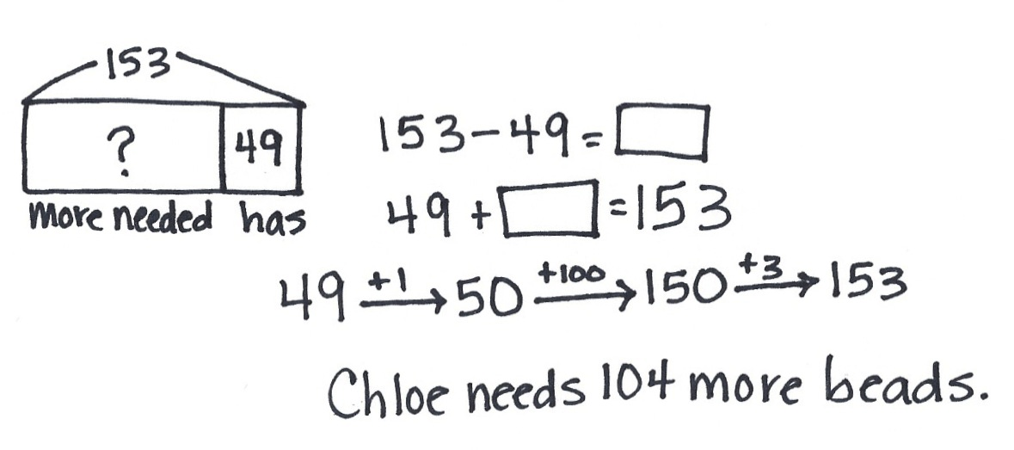Application Problem (6 minutes)

Chloe needs 153 beads to make a bag. She only has 49. How many more beads does she need?

Note: This Application Problem serves as practice of Lesson 25’s Concept Development.

Concept Development (31 minutes)

Materials: (S) Personal white board

**Problem 1: 172 – 56**

**MP.6**

T: (Write 172 – 56 in vertical form on the board.) Turn and talk. Use place value language to tell your partner how you could show this problem with a chip model.

|  |  |
| --- | --- |
|  | NOTES ON  MULTIPLE MEANS  OF REPRESENTATION: |
| Engage struggling students with technology. If you have access to iPads or other tablets, use an app such as Number Pieces to represent the problem with manipulatives that can be unbundled. | |

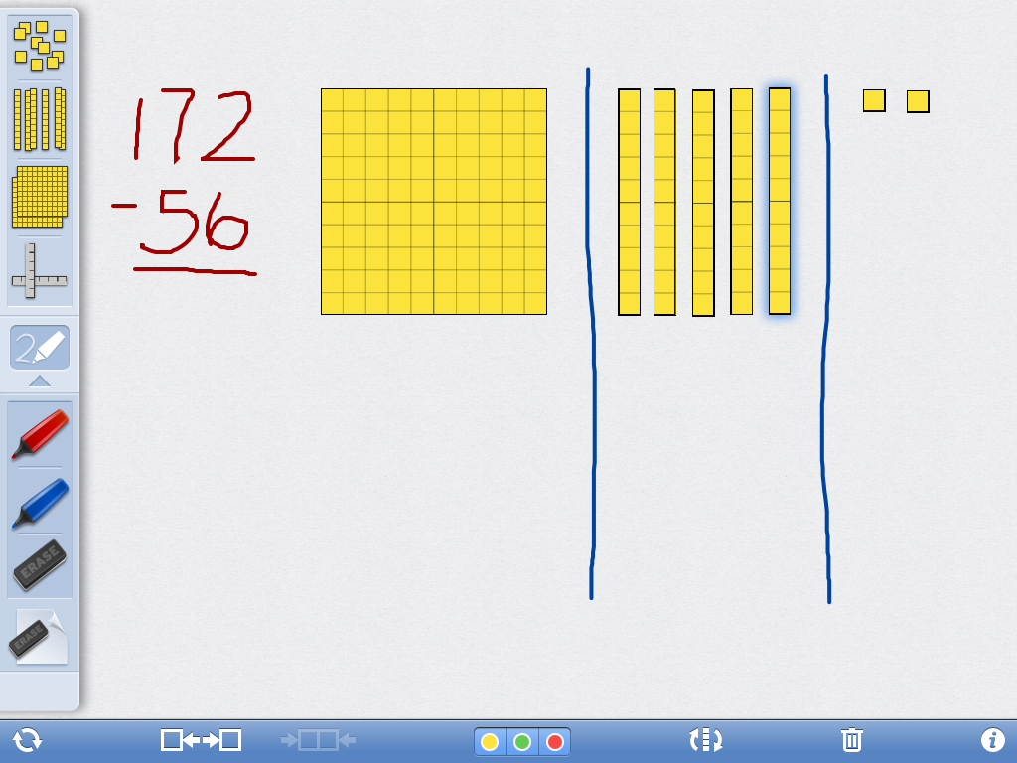

S: Draw 1 chip in the hundreds, 7 chips in the tens, and   
2 chips in the ones. 🡪 I know that you only show the whole, so I would show 1 hundred, 7 tens, and 2 ones by drawing chips in the correct columns on my chart.

T: (Create a chip model to solve 172 – 56. Remind students that when subtracting, we only draw the whole.) Let’s record our work in writing as we solve. When we are subtracting, what should we always do first?

S: Set up the problem for subtraction. 🡪 Make sure we have enough ones and tens to solve. 🡪 Get ready to subtract.

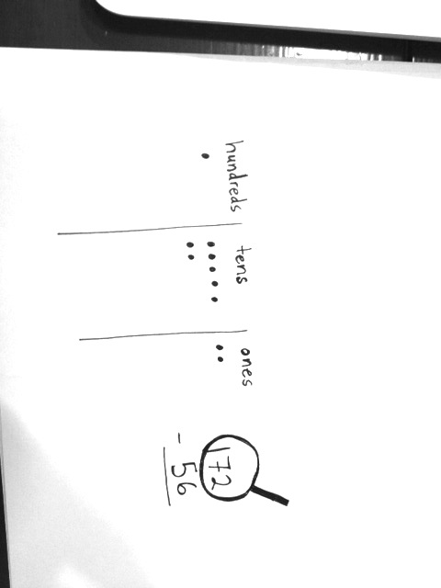T: Yes. Let’s draw our magnifying glass to help us do that.

T: Can we subtract 6 ones from 2 ones?

S: No! We need to unbundle a ten.

T: Could I get the ones I need from the hundred?

S: No, just tens. 🡪 Yes, you can. Hey, can we unbundle the hundred instead? 🡪 Do you want 100 chips? That’s not easy. Let’s just change 1 ten for 10 ones.

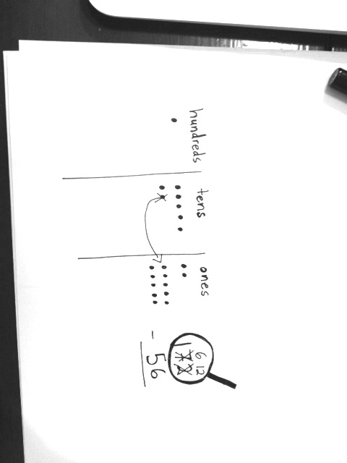T: Yes, changing 1 ten for 10 ones is a lot simpler; though, I like that you realize there are ones inside the hundred, too.

**MP.6**

T: (Cross out a chip in the tens place, adding 10 chips to the ones place. Record the change on the problem.)

T: Can we subtract 5 tens from 6 tens?

S: Yes!

T: Are we ready to subtract?

S: Yes!

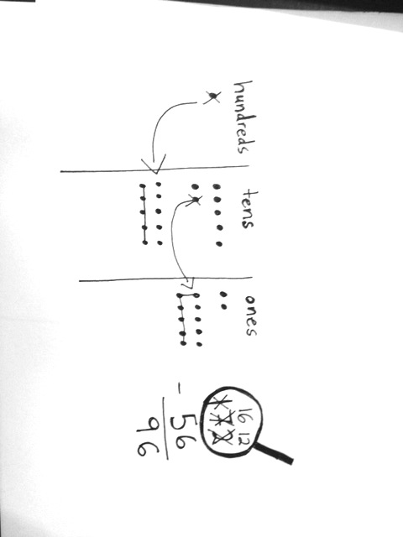

T: What is 12 ones minus 6 ones?   
(Cross out 6 chips in the ones column on the chip model.)

S: 6 ones.

T: (Record the ones on the problem.)   
What is 6 tens minus 5 tens? (Cross out 5 chips in the tens place on the chip model.)

S: 1 ten.

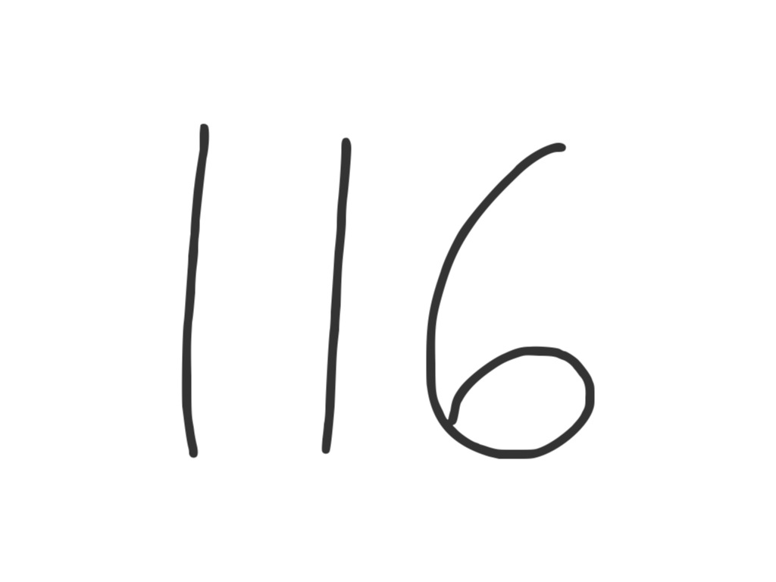

T: (Record the tens on the problem.)   
What is 1 hundred minus 0 hundreds?

S: 1 hundred.

T: Read the answer the Say Ten way.

S: 11 tens 6.

T: The regular way?

S: One hundred sixteen.

Problem 2: 137 – 45

|  |  |
| --- | --- |
|  | NOTES ON  MULTIPLE MEANS  OF ACTION AND EXPRESSION: |
| Some students may be able to go directly from the previous lesson with concrete models to the vertical written method. Allow those students to demonstrate proficiency with the chip model in the first few problems of the Problem Set and then continue without drawing. Have them write challenging problems for each other to solve, after solving them first, if they finish early. | |

T: This time, you do what I do. (Write 137 – 45 on the board in vertical form as students do the same on their personal white boards. Ask students to leave space on the left for a place value chart. Draw a chip model to represent 137 – 45 as students do the same.) What should we do first with our written numbers?

S: Set up the problem for subtraction. 🡪 Make sure we have enough ones and tens to subtract.

T: Can we subtract 5 ones from 7 ones?

S: Yes!

T: Are we ready to subtract in the ones?

S: Yes!

T: Can we subtract 4 tens from 3 tens?

S: No! Unbundle the hundred.

T: (Cross out the chip in the hundreds place, adding 10 chips to the tens place. Record the change on the problem. Instruct students to do the same.) Are we ready to subtract in the tens?

S: Yes!

**MP.6**

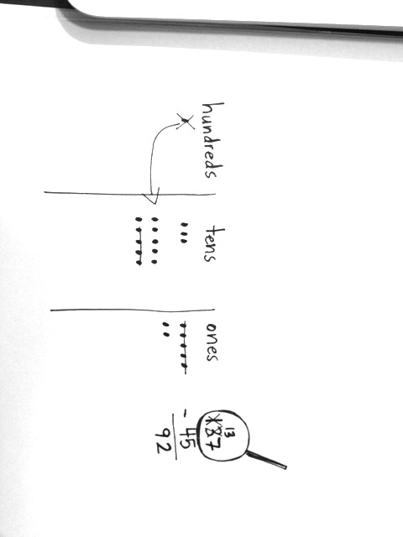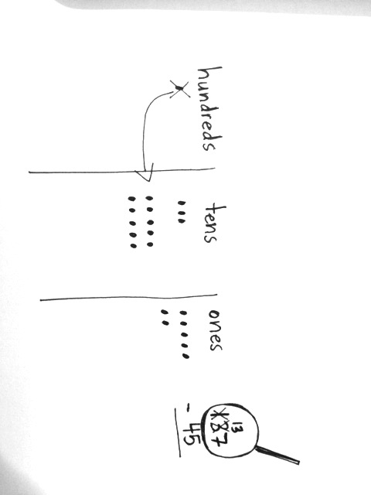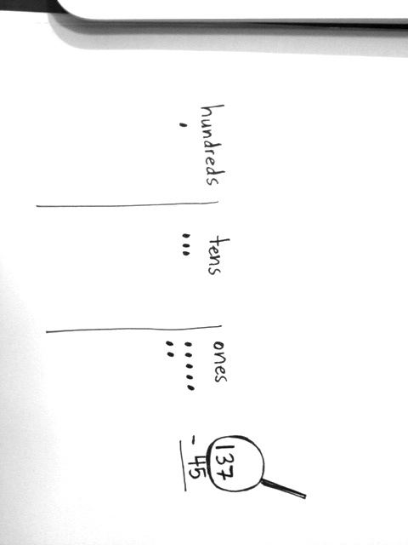

T: Let’s begin. What is 7 ones minus 5 ones? (Cross out 5 chips in the ones place on the chip model as students do the same.)

S: 2 ones.

T: Let’s record that using the algorithm. (Write 2 in the ones place as students do the same.) What is 13 tens minus 4 tens? (Cross out 4 chips in the tens place on the chip model as students do the same.)

S: 9 tens.

T: Let’s record that on the problem. (Write 9 in the tens place as students do the same.) What is 137 – 45?

S: 92.

T: The Say Ten way?

S: 9 ten 2.

Repeat the above process with 112–75. If students show proficiency, allow them to move on to the Problem Set. Those who need more support might be guided through the following sequence: 127–19, 116–36, and 123–86.

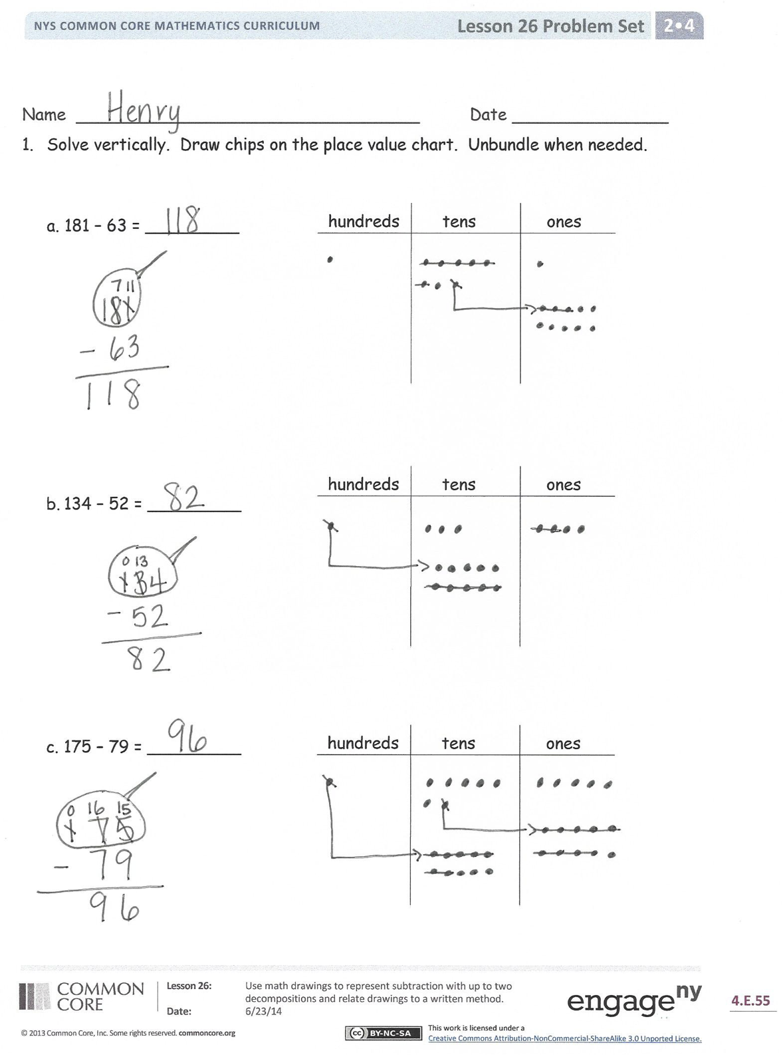Problem Set (10 minutes)

Students should do their personal best to complete the Problem Set within the allotted 10 minutes. For some classes, it may be appropriate to modify the assignment by specifying which problems they work on first. Some problems do not specify a method for solving. Students should solve these problems using the RDW approach used for Application Problems.

Student Debrief (10 minutes)

**Lesson Objective:** Use math drawings to represent subtraction with up to two decompositions and relate drawings to a written method.

The Student Debrief is intended to invite reflection and active processing of the total lesson experience.

Invite students to review their solutions for the Problem Set. They should check work by comparing answers with a partner before going over answers as a class. Look for misconceptions or misunderstandings that can be addressed in the Debrief. Guide students in a conversation to debrief the Problem Set and process the lesson.

You may choose to use any combination of the questions below to lead the discussion.

* 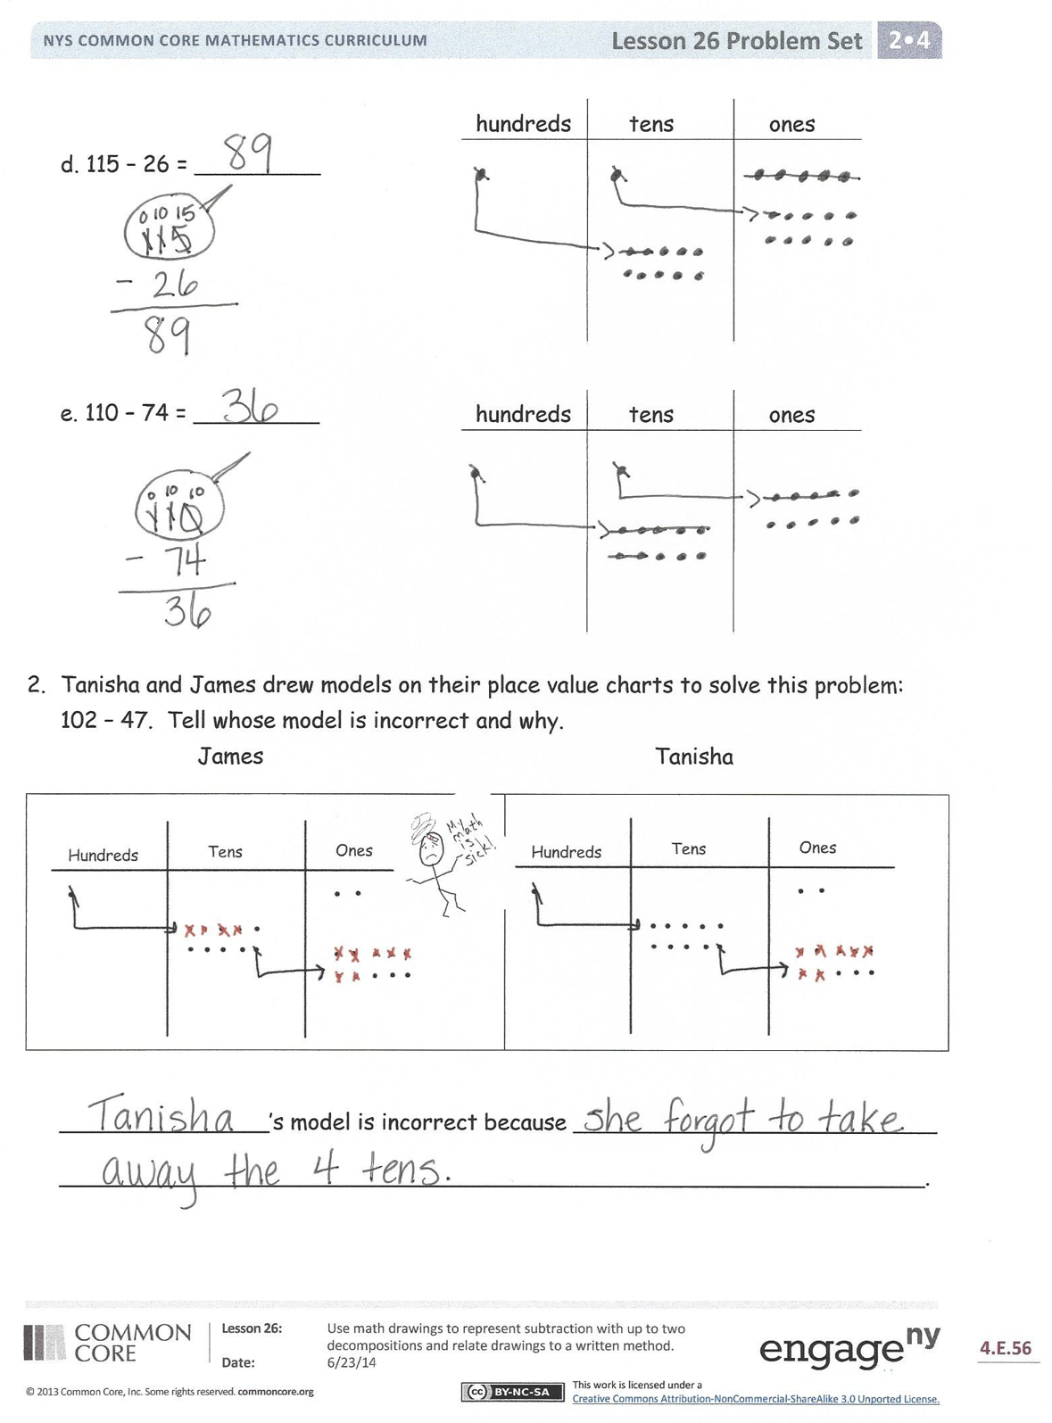Explain to your partner how you solved Problem 1, Parts (a) and (b). Compare the unbundling you had to do for each of these problems. How was it different and how was it the same?
* For Problem 1, Part (c), use place value language to explain to your partner how your chip model matches the algorithm. Could you have used a mental strategy to solve, too?
* How does Problem 1, Part (e) help you understand that 110 is the same as 10 tens and 10 ones?
* For Problem 2, explain to your partner whose drawing was incorrect and why. Use place value language to defend your reasoning.

Exit Ticket (3 minutes)

After the Student Debrief, instruct students to complete the Exit Ticket. A review of their work will help you assess the students’ understanding of the concepts presented in the lesson today and plan more effectively for future lessons. You may read the questions aloud to the students.





Name Date

1. Solve vertically. Draw chips on the place value chart. Unbundle when needed.

hundreds tens ones

* 1. 181 − 63 = \_\_\_\_\_\_\_\_\_

hundreds tens ones

* 1. 134 − 52 = \_\_\_\_\_\_\_\_\_

hundreds tens ones

* 1. 175 − 79 = \_\_\_\_\_\_\_\_\_
  2. 115 − 26 = \_\_\_\_\_\_\_\_\_

hundreds tens ones

hundreds tens ones

* 1. 110 − 74 = \_\_\_\_\_\_\_\_\_

1. Tanisha and James drew models on their place value charts to solve this problem: 102 − 47. Tell whose model is incorrect and why.

*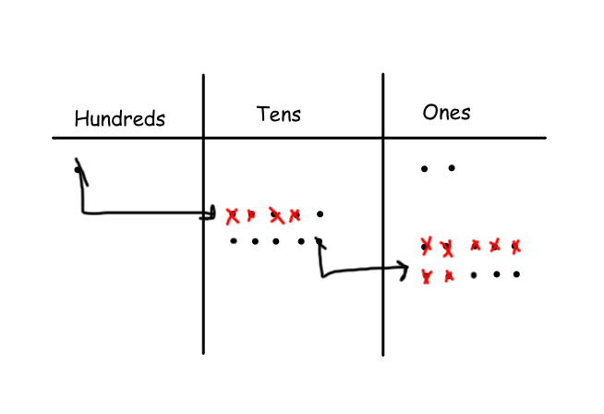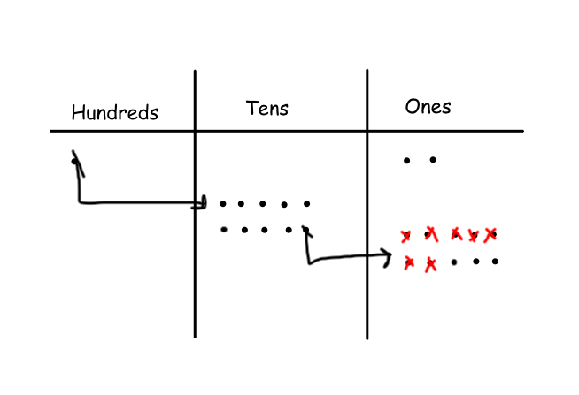 James*  *Tanisha*

|  |  |
| --- | --- |
| Simple Things:Users:simple:Google Drive:Common Core:Images:IMG_0322.JPG |  |

\_\_\_\_\_\_\_\_\_\_\_\_\_\_\_’s model is incorrect because \_\_\_\_\_\_\_\_\_\_\_\_\_\_\_\_\_\_\_\_\_\_\_\_\_\_

\_\_\_\_\_\_\_\_\_\_\_\_\_\_\_\_\_\_\_\_\_\_\_\_\_\_\_\_\_\_\_\_\_\_\_\_\_\_\_\_\_\_\_\_\_\_\_\_\_\_\_\_\_\_\_\_\_\_\_\_\_\_.

Name Date

Solve vertically. Draw chips on the place value chart. Unbundle when needed.

hundreds tens ones

1. 153 − 46 = \_\_\_\_\_\_\_\_\_

hundreds tens ones

1. 118 − 79 = \_\_\_\_\_\_\_\_\_

Name Date

1. Solve vertically. Draw chips on the place value chart. Unbundle when needed.

hundreds tens ones

1. 114 − 65 = \_\_\_\_\_\_\_\_\_

hundreds tens ones

1. 120 − 37 = \_\_\_\_\_\_\_\_\_

hundreds tens ones

1. 141 − 89 = \_\_\_\_\_\_\_\_\_

hundreds tens ones

1. 136 − 77 = \_\_\_\_\_\_\_\_\_

hundreds tens ones

1. 154 − 96 = \_\_\_\_\_\_\_\_\_
2. **Extension**: Fill in the missing number to complete the problem. Draw a place value chart and chips to model.

|  |  |
| --- | --- |
| 1 2 3  − 5  6 9 |  |