Lesson 25
Objective: Relate manipulative representations to a written method.

Suggested Lesson Structure
 Fluency Practice (11 minutes)
 Application Problem (6 minutes)
 Concept Development (33 minutes)
 Student Debrief (10 minutes)
Total Time (60 minutes)
Fluency Practice (11 minutes)
- Subtraction Fact Flash Cards 2.OA.2 (3 minutes)
- Zap to Zero 2.NBT.5 (3 minutes)
- Rename the Units: Choral Response 2.NBT.1 (5 minutes)
Subtraction Fact Flash Cards (3 minutes)
Materials: (T) Subtraction fact flash cards set 1 (Lesson 24 Fluency Template)
Note: By practicing subtraction facts, students gain fluency subtracting within 20.
Zap to Zero (3 minutes)
Note: Practice using place value concepts to mentally subtract helps lay a foundation for this lesson’s content.
T: (Write 184.) If I say zap the digit 8 to zero, you say subtract 80. Ready?
T: Zap the digit 8 to zero.
S: Subtract 80.
T: What is the number sentence?
S: 184 – 80 = 104.
T: Start again with 184. Zap the digit 1 to zero.
S: Subtract 100.
T: What is the number sentence?
S: 184 – 100 = 84.
Repeat using the following possible sequence: 173 and 256.
Rename the Units: Choral Response (5 minutes)
Note: This fluency activity reviews foundations that lead into today’s lesson.
T: (Write 30 ones = tens.) Say the number sentence.
S: 30 ones = 3 tens.
T: (Write 20 ones = 1 ten ones.) Say the number sentence.
S: 20 ones = 1 ten 10 ones.
T: (Write 24 ones = 1 ten ones.) Say the number sentence.
S: 24 ones = 1 ten 14 ones.
Repeat the process for 27, 30, 32, 38, 40, 41, 46, 50, 63, and 88.
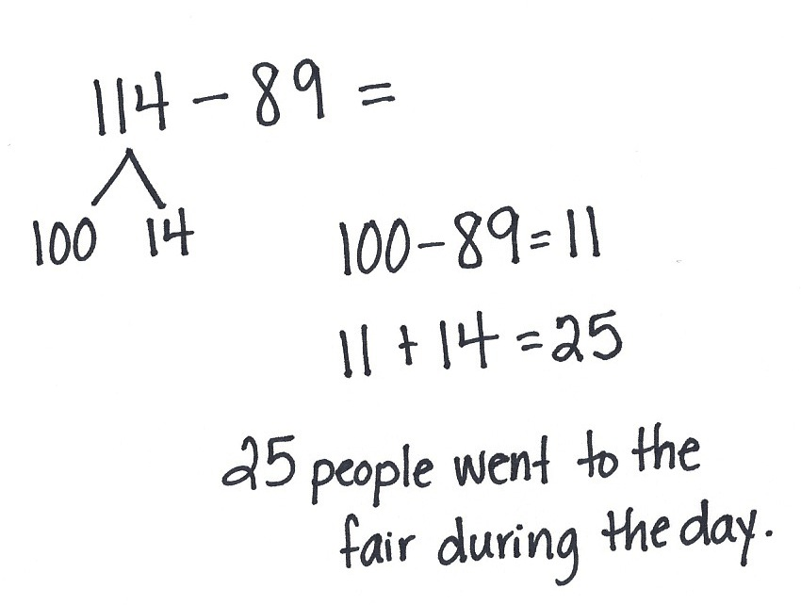
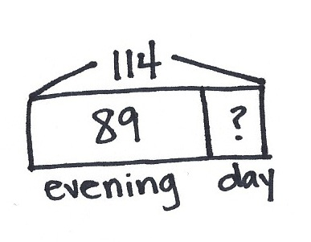
Application Problem (6 minutes)
114 people went to the fair. 89 of them went in the evening. How many went during the day?
Note: Allow students to choose the strategy to solve the Application Problem. Students may decompose 100, use the arrow way, or use place value disks.
Concept Development (33 minutes)
Materials: (T) Place value disks, unlabeled hundreds place value chart (Lesson 18 Template) (S) Personal white boards, place value disks, unlabeled hundreds place value chart (Lesson 18 Template), place value disks (Lesson 6 Template)
Note: It may be better to have one student use the place value disks and one student use the written method, and then switch.
Problem 1: 175 – 56

NOTES ON
MULTIPLE MEANS
OF ENGAGEMENT:
Some students may need scaffolding with three-digit minuend problems that only require one unbundling step in the tens. Once they have demonstrated proficiency with these problems, introduce unbundling only the hundreds. Finally, introduce problems with unbundling in both the hundreds and the tens.

.
T: Today, let’s use place value disks to help us solve problems in vertical form when the numbers are larger. (Write 175 – 56 in vertical form on the board.) What should I do first?
S: Get ready to subtract!
T: (Draw the magnifying glass as shown on the next page.) What next?
S: Count out your place value disks.
T: (Model counting 1 hundred, 7 tens, and 5 ones as you place them on your place value chart.) Why do we only show 1 hundred, 7 tens, and 5 ones? Turn and talk.
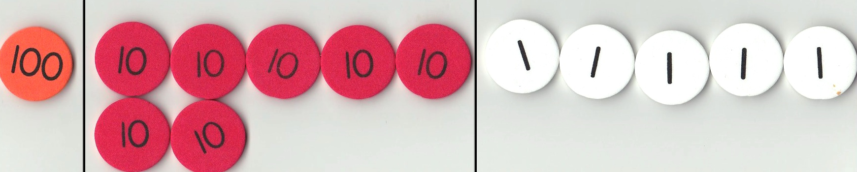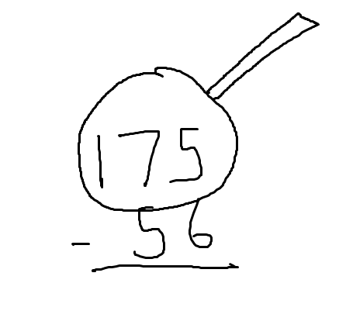S: Because when you subtract, you only show the whole. We will subtract from 175. We are subtracting one part, and the amount that is left is the other part.
T: Okay, what next?
S: Look at the ones column. See if you have enough ones to subtract.
T: Can we subtract 8 ones from 5 ones?
S: No!
T: Turn and talk. What can we do to find some more ones?
S: We have to unbundle a ten. We have to change a ten for 10 ones.
T: Why don’t we get more ones from the hundred? Turn and talk.
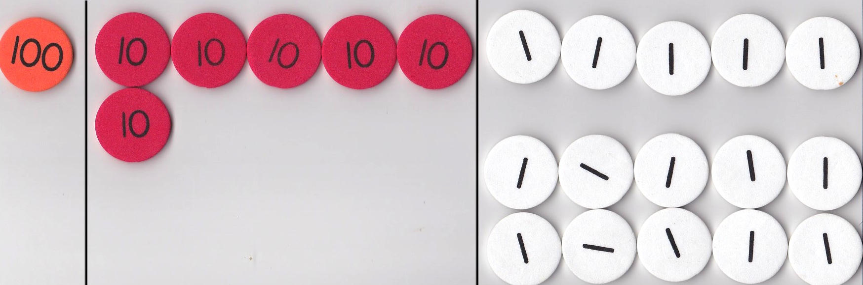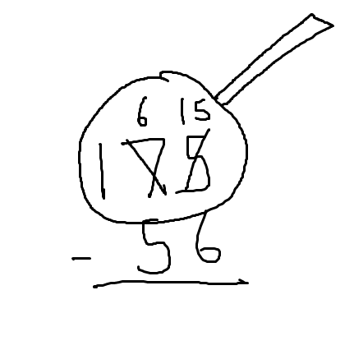S: Because 100 would give us 10 tens, not 10 ones. A hundred changes into 100 ones. That’s too many. We go one place to the left, not two places.
T: (Remove a tens disk from the place value chart, counting out 10 ones and arranging them in
5-groups as shown to the right.) How do we represent our model in the vertical form?
S: Cross out the 7 and make it a 6. Change the 5 to 15. Change the 7 tens to 6 tens and the 5 ones to 15 ones.
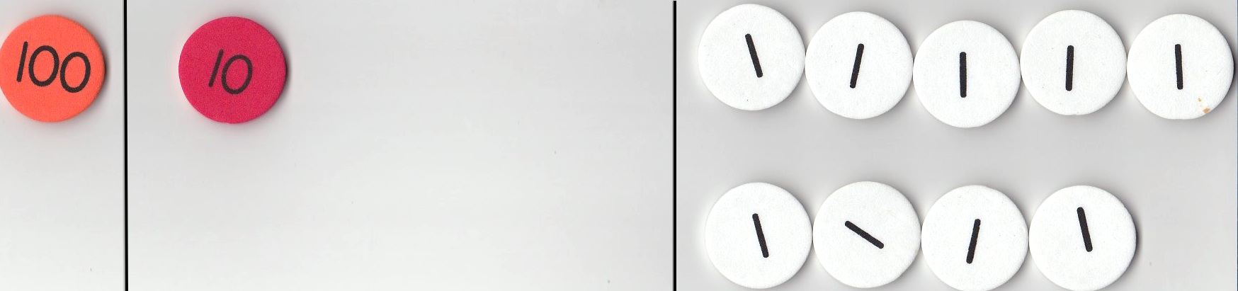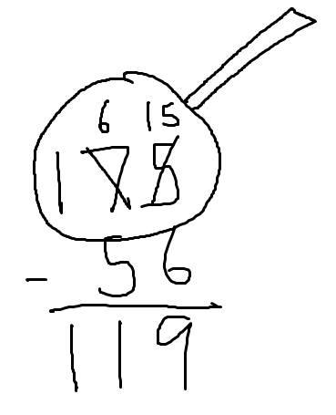T: (Change the tens to 6 tens and change the ones to 15 ones.) Now, can we subtract 5 tens from 6 tens?
S: Yes!
T: Are we ready to subtract using the vertical form?
S: Yes!
T: How many is 15 ones minus 6 ones?
S: 9 ones.
T: (Remove 6 ones disks from the place value chart, and record the work on the problem.) Whatever we do to our place value disks, we must also do to the numbers. What next?
S: Subtract the tens.
T: How many is 6 tens minus 5 tens?
S: 1 ten.
T: (Remove 1 tens disk on the place value chart, and record the work in the vertical form.) 175 – 56 is how many?
S: 19.
T: The Say Ten way?
S: 1 ten 9.
Problem 2: 115 – 56

NOTES ON
MULTIPLE MEANS
OF ACTION AND EXPRESSION:
Challenge students performing above grade level to find three different ways to solve 111 – 99. Have them illustrate their work and journal their thinking, and then present the results to the class.

.
T: This time, solve with me. What I do, you do. (Write 115 – 56 on the board.) Count out your place value disks with me.
S: 1 hundred, 1 ten, 5 ones.
T: (Arrange the place value disks on the place value chart and instruct students to do the same.) What should we always do first?
S: Get ready to subtract!
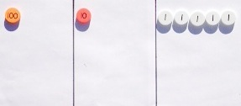
T: Turn and talk. How should we set up the problem for subtraction?
S: You can’t take 6 ones from 5 ones, so you have to unbundle a ten. Check to make sure we can subtract in each place. Change the whole to
10 tens, 15 ones. Ask yourself if you have enough ones and tens to subtract.
T: Can we subtract in the ones place?
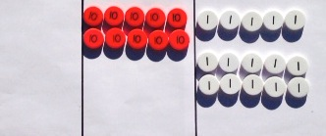
S: No! We need to unbundle a ten.
T: Show me on your place value charts. (Remove a tens disk from the place value chart, and add 10 ones disks as students do the same.) What we do with the disks we must also do in the vertical form. Show me on the problem. (Cross out the 1, and write a 0 above it. Cross out the 5, and write a 15 above it. Students do the same.)
T: Can we subtract 5 tens from 0 tens?
S: No way! We must unbundle a hundred. We have to change 1 hundred for 10 tens.
T: Show me on your place value charts and using the algorithm. (Remove a hundreds disk from the place value chart and add 10 tens. Record the change in the vertical form as students do the same.)
MP.2
T: Are we ready to subtract?
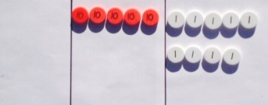
S: Yes!
T: What is 15 ones minus 6 ones?
S: 9 ones.
T: (Record the answer on the problem as students do the same.) What is 10 tens minus 5 tens?
S: 5 tens.
T: (Record the answer on the problem as students do the same.) What is 0 hundreds minus 0?
S: 0!
T: Read the problem and answer using the Say Ten way.
S: 10 tens 15 ones minus 5 tens 6 ones equals 5 tens 9 ones.
T: Now the regular way.
S: 115 minus 56 equals 59.
MP.2
Repeat the above process with the following possible sequence: 165 – 74, 156 – 78, and 112 – 89. Guide the students towards proficiency by encouraging them to work more independently on each problem. As students show proficiency, allow them to move on to the Problem Set.
Problem Set (10 minutes)
Students should do their personal best to complete the Problem Set within the allotted 10 minutes. For some classes, it may be appropriate to modify the assignment by specifying which problems they work on first. Some problems do not specify a method for solving. Students should solve these problems using the RDW approach used for Application Problems.
Student Debrief (10 minutes)
Lesson Objective: Relate manipulative representations to a written method.
The Student Debrief is intended to invite reflection and active processing of the total lesson experience.
Invite students to review their solutions for the Problem Set. They should check work by comparing answers with a partner before going over answers as a class. Look for misconceptions or misunderstandings that can be addressed in the Debrief. Guide students in a conversation to debrief the Problem Set and process the lesson.
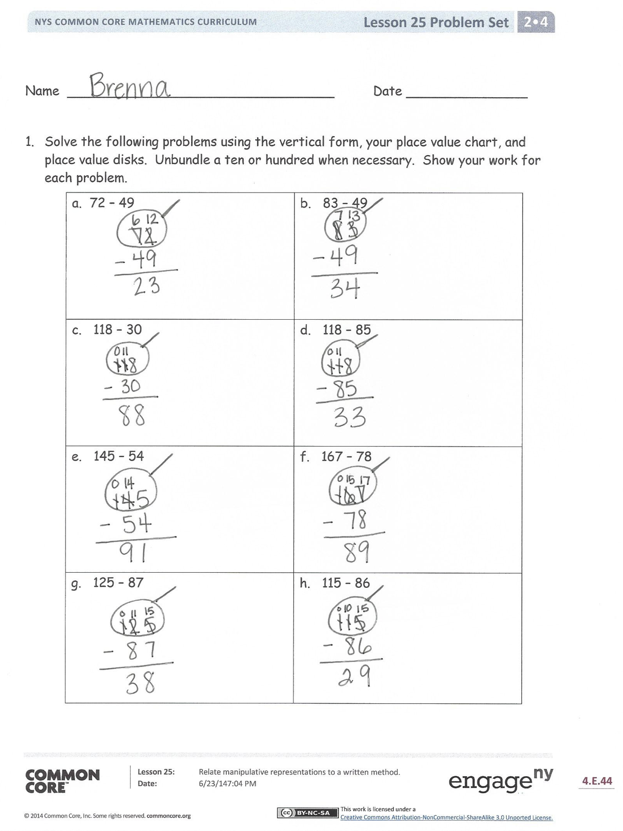
You may choose to use any combination of the questions below to lead the discussion.
- In Problem 1, which problems could you have solved mentally?
- How did you solve Problem 1, Part (e), 145 – 54? How did you show this on your place value chart? How did you show this with your numbers?
- Explain to your partner how you used place value disks to solve Problem 1, Part (f), 167 – 78. How did your place value chart match the vertical form?
- In Problem 2, what part did Mrs. Tosh have left? Did anyone write an equation to find the missing addend (or part) and solve by using a simplifying strategy? How does subtraction connect to our understanding that two parts make a whole?

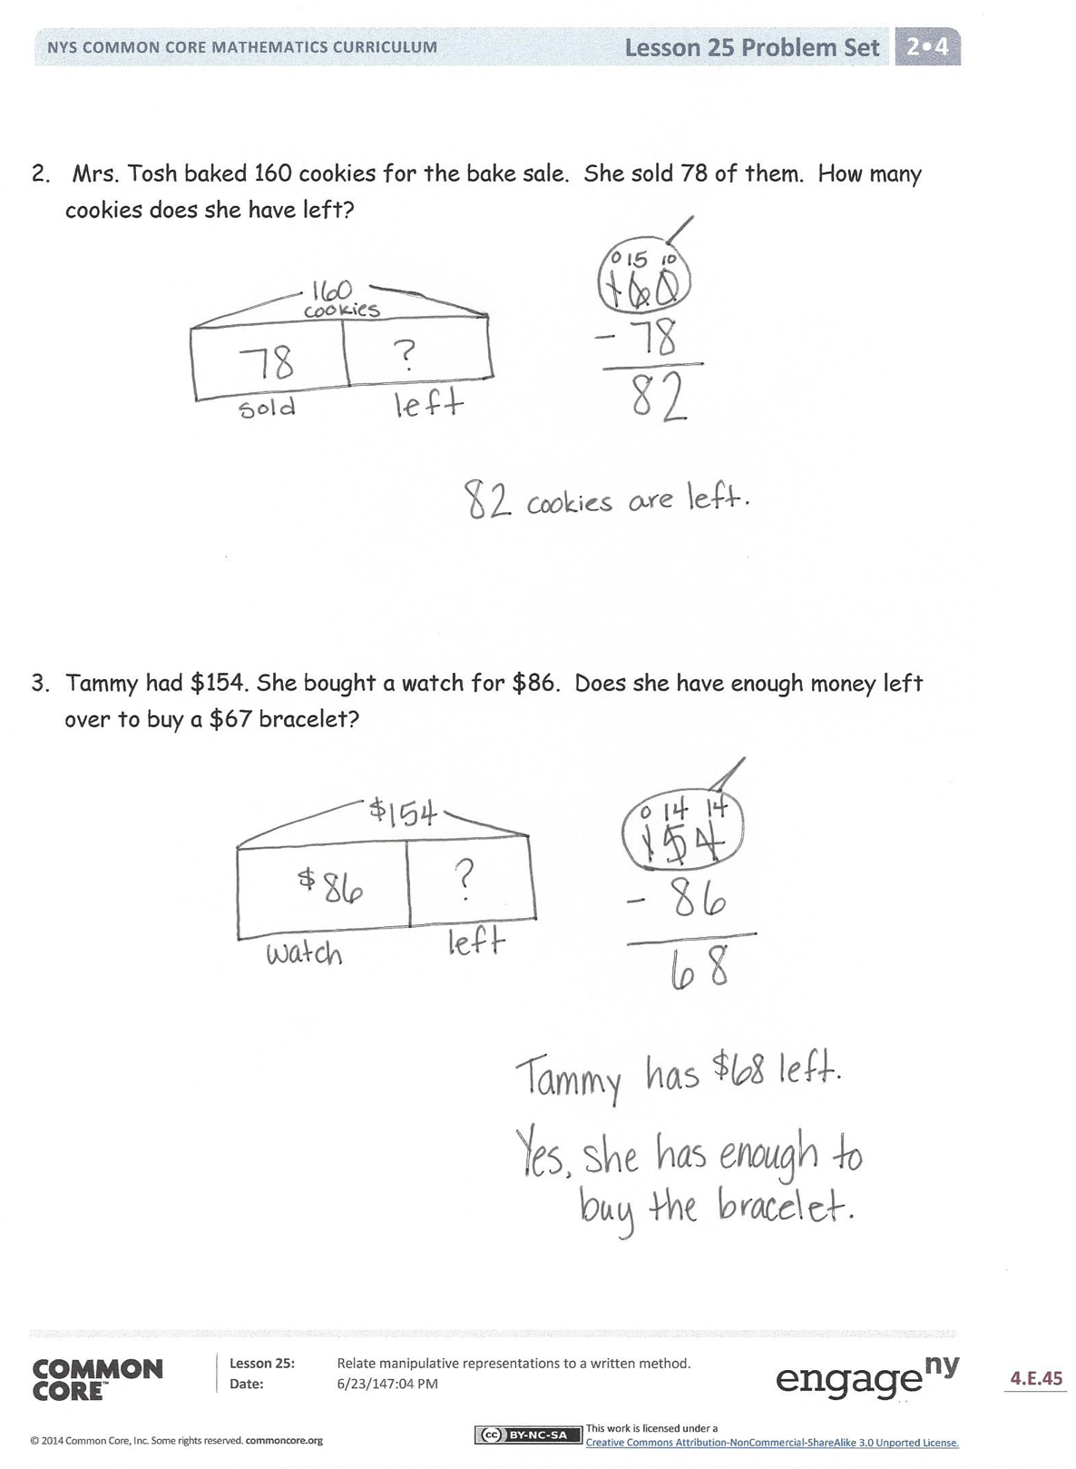
Exit Ticket (3 minutes)
After the Student Debrief, instruct students to complete the Exit Ticket. A review of their work will help you assess the students’ understanding of the concepts presented in the lesson today and plan more effectively for future lessons. You may read the questions aloud to the students.
Name Date
- Solve the following problems using the vertical form, your place value chart, and place value disks. Unbundle a ten or hundred when necessary. Show your work for each problem.
a. 72 − 49 | b. 83 − 49
c. 118 − 30 | d. 118 − 85
e. 145 − 54 | f. 167 − 78
g. 125 − 87 | h. 115 − 86

- Mrs. Tosh baked 160 cookies for the bake sale. She sold 78 of them. How many cookies does she have left?

- Tammy had $154. She bought a watch for $86. Does she have enough money left over to buy a $67 bracelet?

Name Date
Solve the following problems using the vertical form, your place value chart, and place value disks. Unbundle a ten or hundred when necessary. Show your work for each problem.
- 97 − 69

- 121 − 65

Name Date
- Solve the following problems using the vertical form, your place value chart, and place value disks. Unbundle a ten or hundred when necessary. Show your work for each problem.
a. 65 − 38 | b. 66 − 49
c. 111 − 60 | d. 120 − 67
e. 163 − 66 | f. 184 − 95
g. 114 − 98 | h. 154 − 85

- Dominic has $167. He has $88 more than Mario. How much money does Mario have?

- Which problem will have the same answer as 133 − 77? Show your work.
  - 155 − 66
  - 144 − 88
  - 177 − 33
  - 139 − 97

