Lesson 24
Objective: Use manipulatives to represent subtraction with decompositions of 1 hundred as 10 tens and 1 ten as 10 ones.

Suggested Lesson Structure
 Fluency Practice (10 minutes)
 Application Problem (6 minutes)
 Concept Development (34 minutes)
 Student Debrief (10 minutes)
Total Time (60 minutes)
Fluency Practice (10 minutes)
- Subtraction Fact Flash Cards 2.OA.2 (3 minutes)
- Adding to 1 Hundred 2.NBT.5 (3 minutes)
- Take from a Ten or from the Ones 2.NBT.5 (4 minutes)
Subtraction Fact Flash Cards (3 minutes)
Materials: (T) Subtraction fact flash cards set 1 (Fluency Template)
Note: By practicing subtraction facts, students gain fluency subtracting within 20.
Adding to 1 Hundred (3 minutes)
Note: Students practice adding to 1 hundred in preparation for the lesson.
T: What is the number sentence for 15 more than 100?
S: 100 + 15 = 115.
T: 30 more than 100…?
S: 100 + 30 = 130.
T: 41 more than 100…?
S: 100 + 41 = 141.
Continue with the following possible sequence: 45 more, 60 more, 62 more, 68 more, 80 more, 84 more, and 89 more.

Take from a Ten or from the Ones (4 minutes)
Note: This fluency activity helps students know when to unbundle a ten to subtract. This is a foundational skill for the lesson.
T: For every number sentence I say, you tell me if I take from a ten or the ones. When I say 46 – 5, you say take from the ones, but if I say 46 – 7, you say take from a ten. Ready?
T: 46 – 6.
S: Take from the ones.
T: 46 – 9.
S: Take from a ten.
Continue with the following possible sequence: 56 – 5, 52 – 4, 63 – 6, 67 – 5, 65 – 4, 68 – 8, and 70 – 3.
Application Problem (6 minutes)
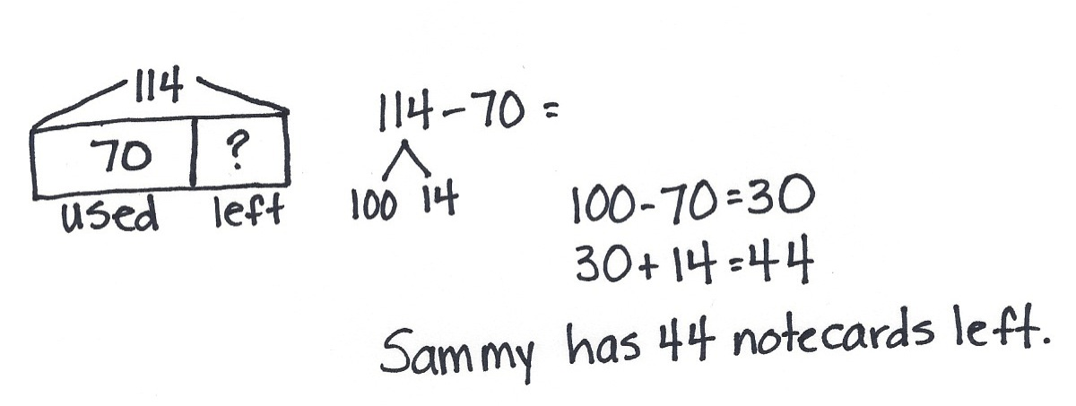
Sammy bought 114 notecards. He used 70 of them. How many unused notecards did he have left?
Note: This Application Problem provides practice in taking from the hundred, as taught in Lesson 23. To encourage flexible thinking, you might invite some students to count up using the arrow way and invite others to solve by subtracting from the hundred. This serves as a bridge to today’s Concept Development in which students use place value disks to decompose a hundred and a ten to subtract.
Concept Development (34 minutes)
Materials: (T) Place value disks (1 hundreds, 18 tens, 18 ones) (S) Place value disks (1 hundreds, 18 tens, 18 ones), unlabeled hundreds place value chart (Lesson 18 Template), personal white board, place value disks (Lesson 6 Template)
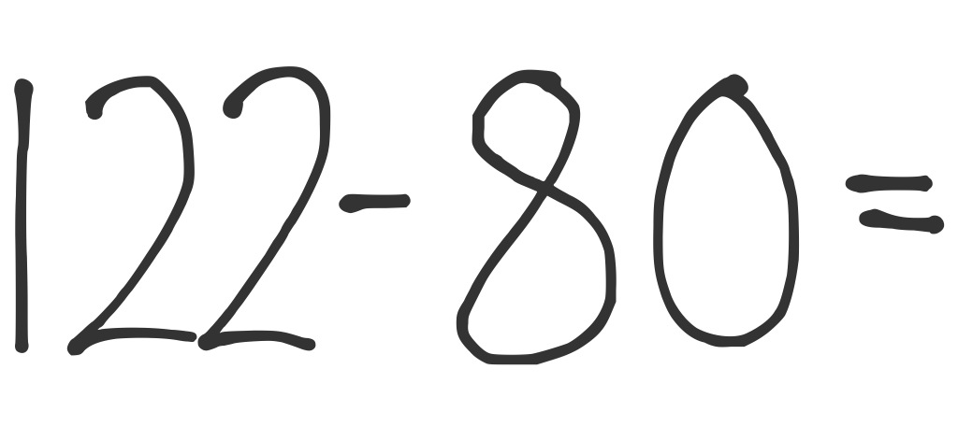
Problem 1: 122 – 80
T: (Write 122 – 80 on the board.) Let’s read the problem together.
T: Yesterday, we used number bonds to subtract from the hundred. Today, we are going to use place value disks to unbundle the hundred before subtracting. What should I do first?
MP.4
S: Count out your place value disks.
T: What number should I model?
S: 122.
T: Turn and talk. Why do I only need to model 122 and not 80?
S: Because when we subtract, we only show the whole. 122 is the whole and 80 is a part. We take away the part.

NOTES ON
MULTIPLE MEANS
OF REPRESENTATION:
For students unclear about the part−whole relationship in subtraction, draw a number bond for the problem. Instruct them to draw a number bond for the problem when they are unable to determine how to solve.

T: (Count to 122 using place value disks, and arrange them on your place value chart as shown on the previous page.) Can I subtract 0 ones from 2 ones?
S: Yes!
T: We are ready to subtract in the ones place.
T: Let’s move on to the tens. Can I subtract 8 tens from
2 tens?
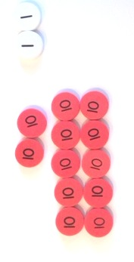
S: No!
T: I need more tens. What should I do? Turn and talk.
S: A hundred has 10 tens in it. Decompose 100. Take 100 apart and break it into 10 tens.
T: That’s right! Just as we can unbundle a ten for 10 ones, we can also unbundle a hundred for 10 tens.
T: Watch what I do with my place value disks to unbundle a hundred. (Remove a hundreds disk from the place value chart, counting 10 tens, and arrange them in
5-groups in the tens place.)
MP.4
T: Say the number in tens and ones.
S: 12 tens 2 ones.
T: Can I subtract 8 tens from 12 tens?
S: Yes!
T: Great! Now we are ready to subtract in both the ones and the tens places.
T: 2 ones minus 0 ones is how many?
S: 2 ones.
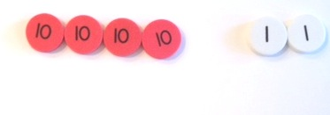
T: (Write 2 on the board as shown at right.) 12 tens minus 8 tens is how many? (Remove 8 tens disks from the place value chart.)
S: 4 tens.
T: What is 122 – 80 the Say Ten way?
S: 4 tens 2.
T: The regular way?
S: 42.

Problem 2: 174 – 56
T: This time, work with me. What I do, you do. (Write 174 – 56 on the board.) What number should I show on my place value chart now?
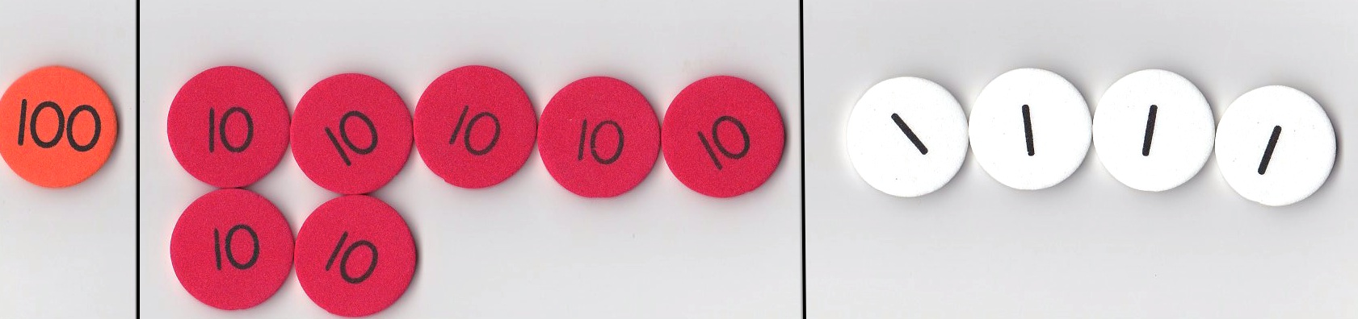
S: 174.
T: Show me 174 with your disks. (Give students time to do so.) What number is in the ones place?
S: 4!
T: How many ones do we need to subtract?
S: 6!
T: Can we subtract 6 from 4?
S: No!
T: So what do we do?
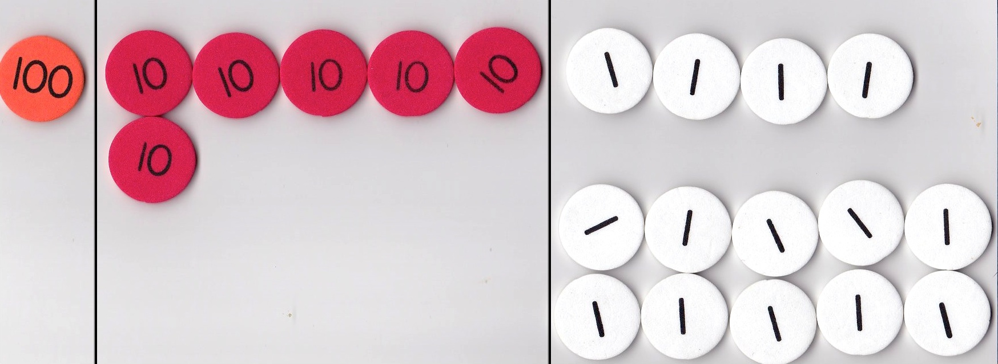
S: Decompose a ten. Change a ten for 10 ones.
T: Let’s do it together.
T: (Show taking a tens disk off the chart, counting out 10 ones, and arranging them on the place value chart as shown at right. Students do the same.) How many ones do we have now?
MP.4
S: 14 ones.
T: Can we subtract 6 ones from 14 ones?
S: Yes!
T: What about the tens place? How many tens do we have left?
S: 6 tens.
T: Do we have enough tens to take 5 tens away?
S: Yes!
T: I think we are ready to subtract.
T: (Remove 6 ones and record the answer. Then, remove 5 tens and record the answer.)
T: I see we have 1 hundred. How many hundreds are we taking away?
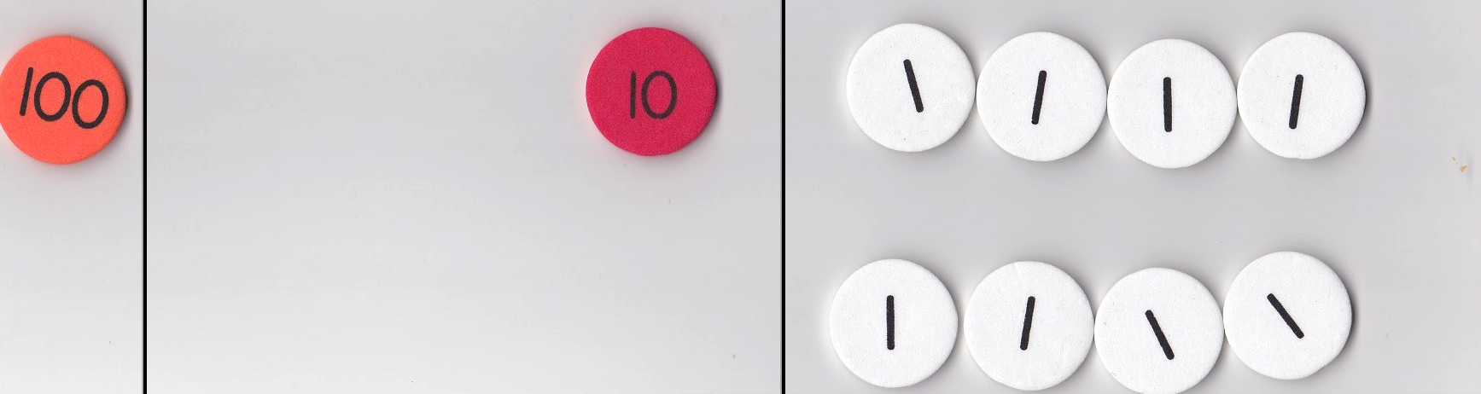
S: None.
T: So, how many hundreds do we have left?
S: 1 hundred.
T: (Record this on the board.) What is 174 – 56?
S: 118.
T: How many hundreds in 118?
S: 1 hundred.
T: How many tens are in a hundred?
S: 10 tens.
T: How many is 10 tens plus 1 ten?
S: 11 tens.
T: So, how many tens in 118?
S: 11 tens.
T: How many ones in the ones place in 118?
S: 8 ones.
T: What is 174 – 56 the Say Ten way?
S: 11 ten 8.
T: The regular way?
S: 118!
Problem 3: 136 – 57
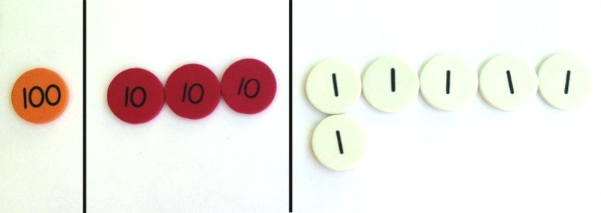
T: Let’s try another problem. Again, what I do, you do. (Write 136 – 57 on the board.) What should we do first?
S: Set up the problem with place value disks by counting out 1 hundred, 3 tens, and 6 ones.
T: (Allow time to do so.) Can we subtract 7 ones from 6 ones?
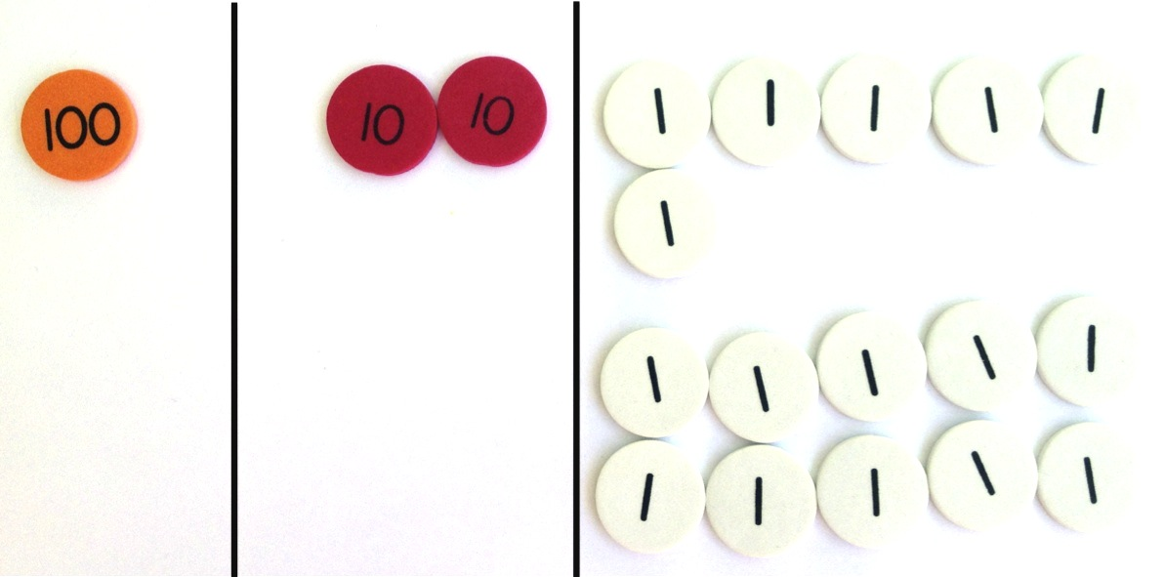
S: No!
T: What should we do?
S: Unbundle a ten.
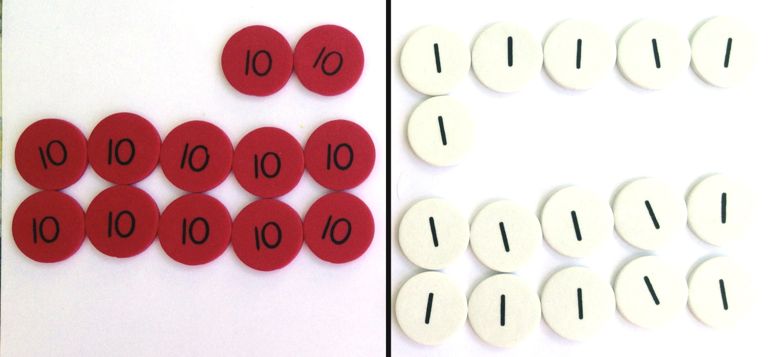
T: Do this with me. (Model taking a tens disk off the chart, counting out 10 ones, and arranging them on the place value chart as shown at right.) How many ones do we have now?
MP.4
S: 16 ones.
T: Can we subtract 7 ones from 16 ones?
S: Yes!
T: We are ready to subtract in the ones place. Let’s move on to the tens. Can we subtract 5 tens from 2 tens?

NOTES ON
MULTIPLE MEANS
OF ACTION AND EXPRESSION:
Provide straws or similar manipulatives for students to practice literally unbundling if they are unable to grasp the concept with the place value disks.

S: No!
T: What should we do?
S: Unbundle the hundred. Take a hundred and rename it as 10 tens. Change 1 hundred for 10 tens.
T: (Remove the hundred from the place value chart, counting out 10 tens, and arranging them in 5-groups on the place value chart as students do the same.) How many tens do we have?
S: 12 tens.
T: How many hundreds?
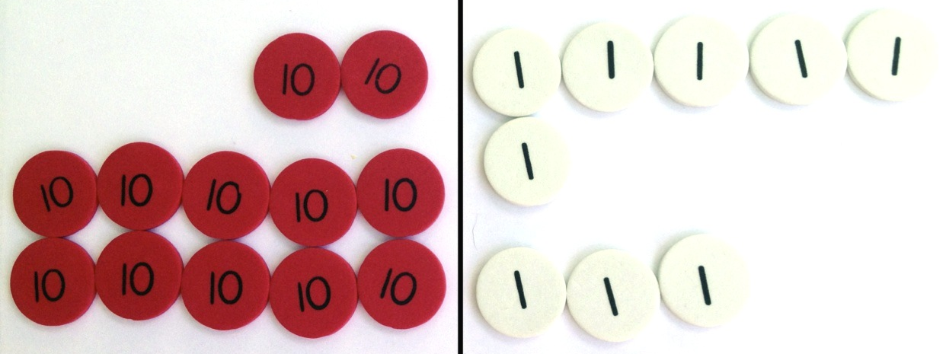
S: Zero. None.
T: Can I subtract 5 tens from 12 tens?
S: Yes, we are ready to subtract.
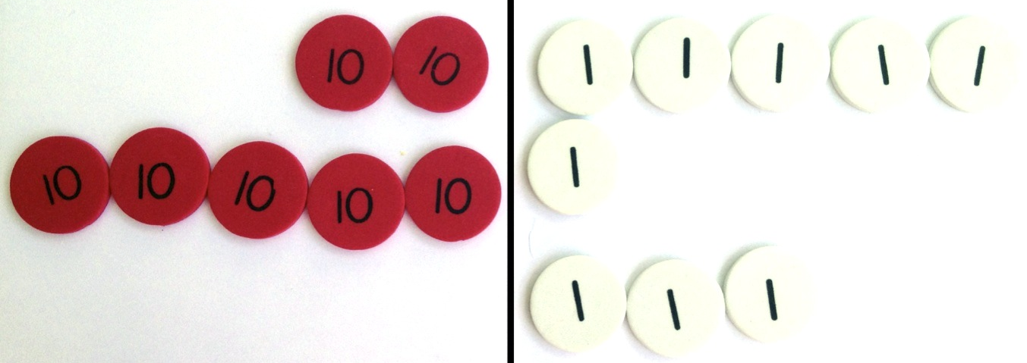
T: (Remove 7 ones and record the answer. Then, remove 5 tens and record the answer.) What is 136 – 57 the Say Ten way?
MP.4
S: 7 ten 9.
T: The regular way?
S: 79!
T: Now, it’s your turn.
Depending on students’ proficiency levels, you may choose to walk them through another two or three problems. Otherwise, instruct them to complete the following suggested problems, 146 – 67, 137 – 58, and 112 – 34. Allow them to move on to the Problem Set as they show proficiency.
Problem Set (10 minutes)
Students should do their personal best to complete the Problem Set within the allotted 10 minutes. For some classes, it may be appropriate to modify the assignment by specifying which problems they work on first. Some problems do not specify a method for solving. Students should solve these problems using the RDW approach used for Application Problems.
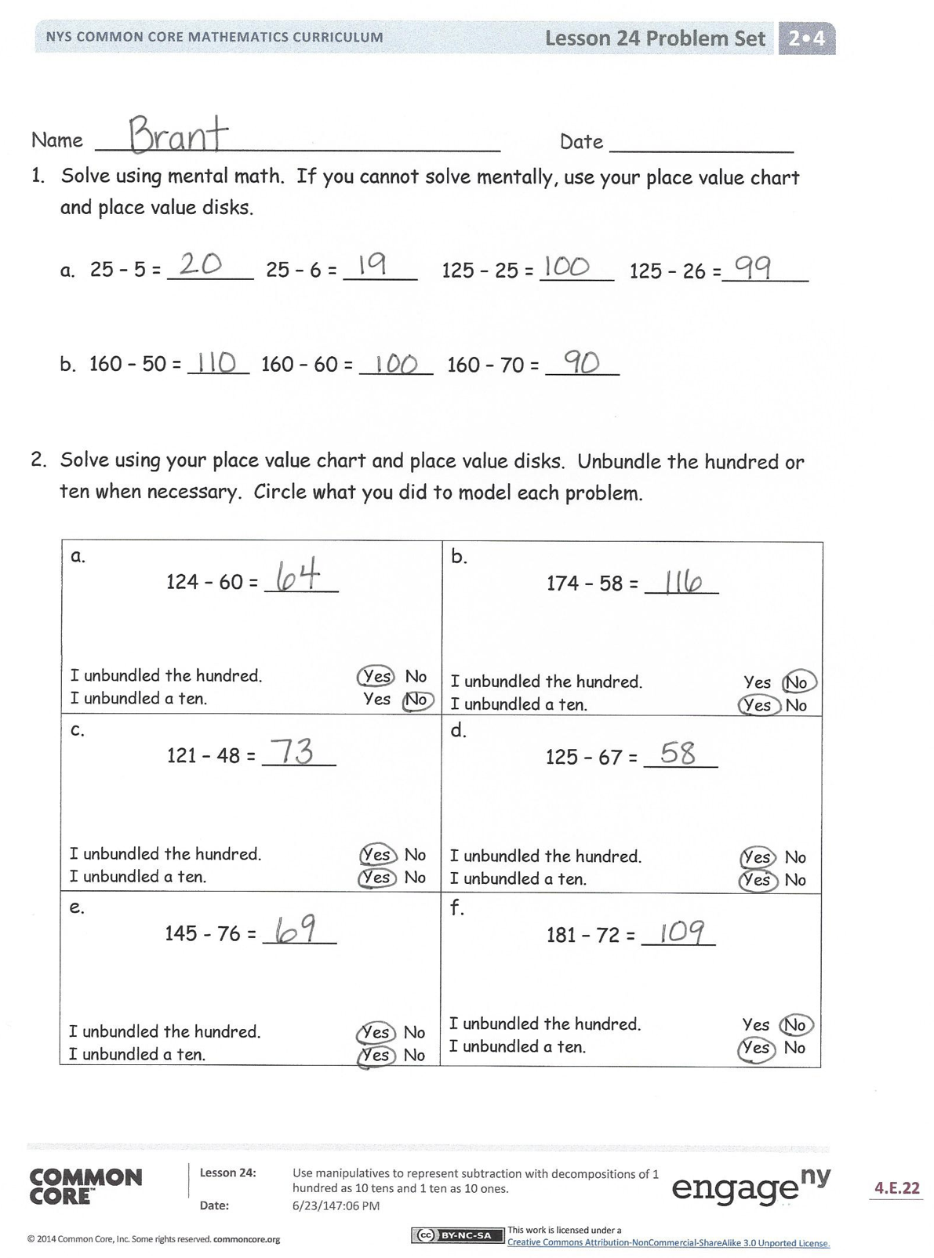
Student Debrief (10 minutes)
Lesson Objective: Use manipulatives to represent subtraction with decompositions of 1 hundred as 10 tens and 1 ten and 10 ones.
The Student Debrief is intended to invite reflection and active processing of the total lesson experience.
Invite students to review their solutions for the Problem Set. They should check work by comparing answers with a partner before going over answers as a class. Look for misconceptions or misunderstandings that can be addressed in the Debrief. Guide students in a conversation to debrief the Problem Set and process the lesson.
You may choose to use any combination of the questions below to lead the discussion.
- Tell your partner how you solved the problems in Problem 1 mentally.
- How did the sequence in Problem 1, Part (a) help you to solve 125 – 26 mentally?
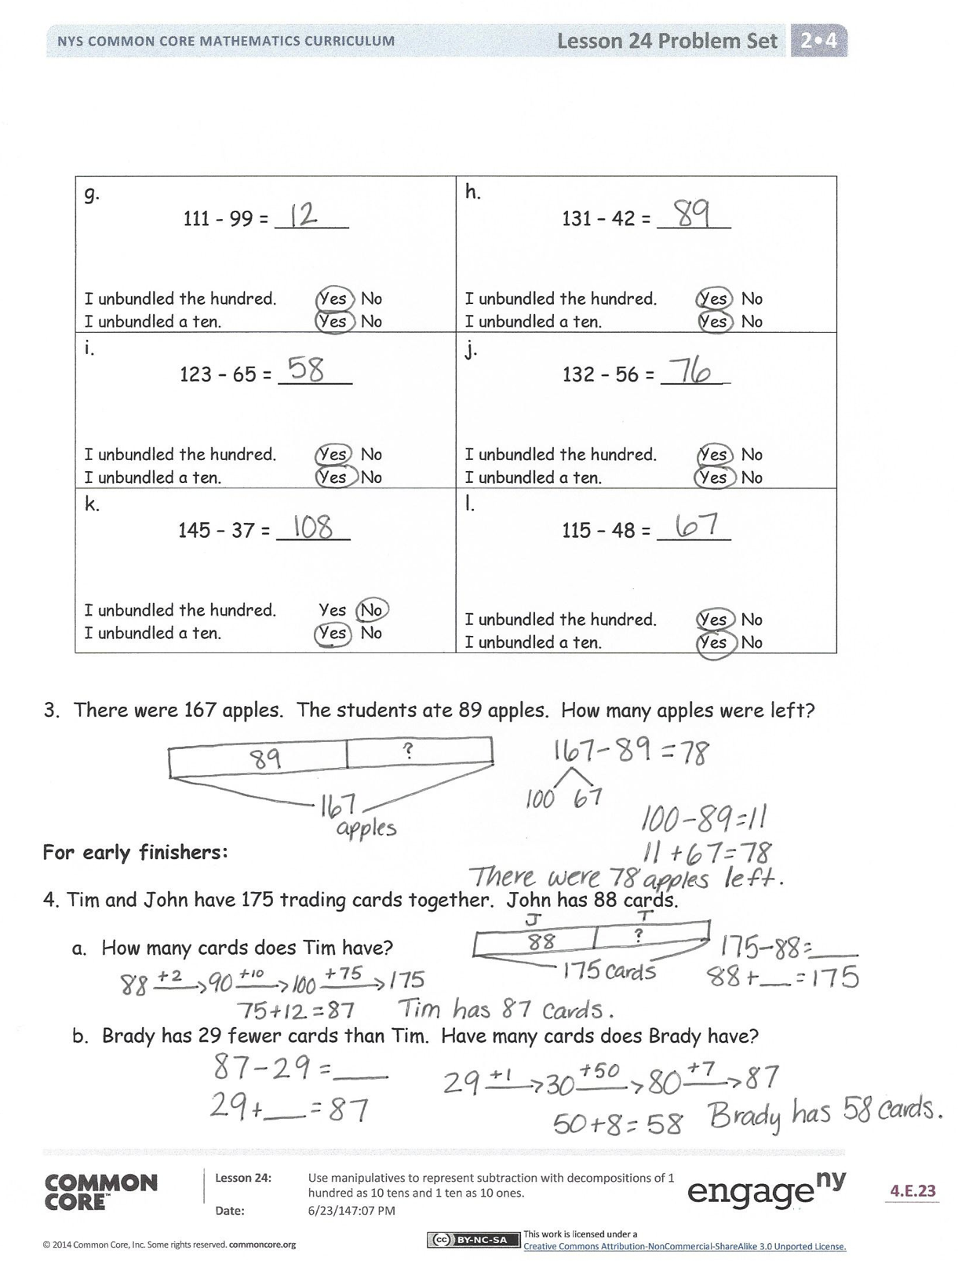
- Charlie showed how he solved Problem 2,
Part (b), 174 – 58. (Represent problem with place value disks.) Since there were not enough ones to subtract, he decomposed a hundred. He explained that since you can remove 5 tens disks, you decompose the hundred. Charlie’s answer was 26. How was Charlie’s reasoning incorrect? What does he need to learn?
- For Problem 2, Part (g), did you decompose a hundred or a ten? Why or why not? Could anyone solve this in a different way? What simplifying strategy could you use to solve?
- Explain how you know when to unbundle a hundred or a ten. What is the same about changing these larger units for smaller units? What is different?
Exit Ticket (3 minutes)
After the Student Debrief, instruct students to complete the Exit Ticket. A review of their work will help you assess the students’ understanding of the concepts that were presented in the lesson today and plan more effectively for future lessons. You may read the questions aloud to the students.
Name Date
- Solve using mental math. If you cannot solve mentally, use your place value chart and place value disks.
  - 25 – 5 = _______ 25 – 6 = ______ 125 – 25 = ______ 125 – 26 = _______

  - 160 – 50 = _____ 160 – 60 = ______ 160 – 70 = ______

- Solve using your place value chart and place value disks. Unbundle the hundred or ten when necessary. Circle what you did to model each problem.

124 – 60 = ______  I unbundled the hundred. Yes No  I unbundled a ten. Yes No | 174 – 58 = ______  I unbundled the hundred. Yes No  I unbundled a ten. Yes No
121 – 48 = ______  I unbundled the hundred. Yes No  I unbundled a ten. Yes No | 125 – 67 = ______  I unbundled the hundred. Yes No  I unbundled a ten. Yes No
145 - 76 = ______  I unbundled the hundred. Yes No  I unbundled a ten. Yes No | 181 – 72 = ______  I unbundled the hundred. Yes No  I unbundled a ten. Yes No

111 - 99 = ______  I unbundled the hundred. Yes No  I unbundled a ten. Yes No | 131 – 42 = ______  I unbundled the hundred. Yes No  I unbundled a ten. Yes No
123 – 65 = ______  I unbundled the hundred. Yes No  I unbundled a ten. Yes No | 132 – 56 = ______  I unbundled the hundred. Yes No  I unbundled a ten. Yes No
145 – 37 = ______  I unbundled the hundred. Yes No  I unbundled a ten. Yes No | 115 – 48 = ______  I unbundled the hundred. Yes No  I unbundled a ten. Yes No

- There were 167 apples. The students ate 89 apples. How many apples were left?

For early finishers:
4. Tim and John have 175 trading cards together. John has 88 cards.
  - How many cards does Tim have?

  - Brady has 29 fewer cards than Tim. Have many cards does Brady have?

Name Date
Solve using your place value chart and place value disks. Change 1 hundred for 10 tens and change 1 ten for 10 ones when necessary. Circle what you need to do to model each problem.

1.  157 – 74 = ______  I unbundled the hundred. Yes No  I unbundled a ten. Yes No | 2.  124 – 46 = ______  I unbundled the hundred. Yes No  I unbundled a ten. Yes No

Name Date
- Solve using mental math. If you cannot solve mentally, use your place value chart and place value disks.
  - 38 – 8 = ______ 38 – 9 = ______ 138 – 38 = ______ 138 – 39 = _______

  - 130 – 20 = ______ 130 – 30 = ______ 130 – 40 = ______

- Solve using your place value chart and place value disks. Unbundle the hundred or ten when necessary. Circle what you did to model each problem.

115 – 50 = ______  I unbundled the hundred. Yes No  I unbundled a ten. Yes No | 125 – 57 = ______  I unbundled the hundred. Yes No  I unbundled a ten. Yes No
88 – 39 = ______  I unbundled the hundred. Yes No  I unbundled a ten. Yes No | 186 – 39 = ______  I unbundled the hundred. Yes No  I unbundled a ten. Yes No
162 - 85 = ______  I unbundled the hundred. Yes No  I unbundled a ten. Yes No | 172 – 76 = ______  I unbundled the hundred. Yes No  I unbundled a ten. Yes No

121 - 89 = ______  I unbundled the hundred. Yes No  I unbundled a ten. Yes No | 131 - 98 = ______  I unbundled the hundred. Yes No  I unbundled a ten. Yes No
140 – 65 = ______  I unbundled the hundred. Yes No  I unbundled a ten. Yes No | 150 – 56 = ______  I unbundled the hundred. Yes No  I unbundled a ten. Yes No
163 – 78 = ______  I unbundled the hundred. Yes No  I unbundled a ten. Yes No | 136 – 87 = ______  I unbundled the hundred. Yes No  I unbundled a ten. Yes No

- 96 crayons in the basket are broken. The basket has 182 crayons. How many crayons are not broken?

9 - 2 | 10 - 2
11 - 2 | 12 - 2
13 - 2 | 14 - 2
15 - 2 | 16 - 2
17 - 2 | 18 - 2
19 - 2 | 20 - 2
9 - 3 | 10 - 3
11 - 3 | 12 - 3
13 - 3 | 14 - 3
15 - 3 | 16 - 3
17 - 3 | 18 - 3
19 - 3 | 20 - 3
9 - 4 | 10 - 4
11 - 4 | 12 - 4
13 - 4 | 14 - 4
15 - 4 | 16 - 4
17 - 4 | 18 - 4
19 - 4 | 20 - 4
9 - 5 | 10 - 5
11 - 5 | 12 - 5
13 - 5 | 14 - 5
15 - 5 | 16 - 5
17 - 5 | 18 - 5
19 - 5 | 20 - 5
9 - 6 | 10 - 6
11 - 6 | 12 - 6
13 - 6 | 14 - 6
15 - 6 | 16 - 6
17 - 6 | 18 - 6
19 - 6 | 20 - 6
9 - 7 | 10 - 7
11 - 7 | 12 - 7
13 - 7 | 14 - 7
15 - 7 | 16 - 7
17 - 7 | 18 - 7
19 - 7 | 20 - 7
9 - 8 | 10 - 8
11 - 8 | 12 - 8
13 - 8 | 14 - 8
15 - 8 | 16 - 8
17 - 8 | 18 - 8
19 - 8 | 20 - 8
9 - 9 | 10 - 9
11 - 9 | 12 - 9
13 - 9 | 14 - 9
15 - 9 | 16 - 9
17 - 9 | 18 - 9
19 - 9 | 20 - 9

subtraction fact flash cards set 1
subtraction fact flash cards set 1
subtraction fact flash cards set 1
subtraction fact flash cards set 1
subtraction fact flash cards set 1
subtraction fact flash cards set 1
subtraction fact flash cards set 1
subtraction fact flash cards set 1
subtraction fact flash cards set 1
subtraction fact flash cards set 1
subtraction fact flash cards set 1
subtraction fact flash cards set 1

