Lesson 23

Objective: Use number bonds to break apart three-digit minuends and subtract from the hundred.

Suggested Lesson Structure

 Fluency Practice (13 minutes)

 Application Problem (7 minutes)

 Concept Development (30 minutes)

 Student Debrief (10 minutes)

**Total Time (60 minutes)**

Fluency Practice (13 minutes)

* Take from the Ten **2.OA.2** (2 minutes)
* Adding to 1 Hundred  **2.NBT.7** (2 minutes)
* Sprint: Subtraction Patterns **2.NBT.5** (9 minutes)

Take from the Ten (2 minutes)

Note: Students practice subtracting from the ten as the foundation for subtracting from the hundred in the lesson.

T: 16 – 9. Take 9 from the ten or the ones?

S: Ten.

T: Say the number sentence.

S: 10 – 9 = 1.

T: Now add back the ones.

S: 1 + 6 = 7.

T: Say the complete number sentence for 16 – 9.

S: 16 – 9 = 7.

Continue with the following possible sequence: 15 – 7, 14 – 8, 13 – 6, 18 – 9, 12 – 7, 16 – 7.

Adding to 1 Hundred (2 minutes)

Note: Students practice adding to 1 hundred in preparation for the lesson.

T: What is the number sentence for 10 more than 100?

S: 100 + 10 = 110.

T: 25 more than 100.

S: 100 + 25 = 125.

T: 34 more than 100.

S: 100 + 34 = 134.

Continue with the following possible sequence: 42 more, 50 more, 67 more, 69 more, 70 more, 78 more, and 88 more.

Sprint: Subtraction Patterns (9 minutes)

Materials: (S) Subtraction Patterns Sprint

Note: Students are given the opportunity to use mental math strategies when crossing tens to subtract.

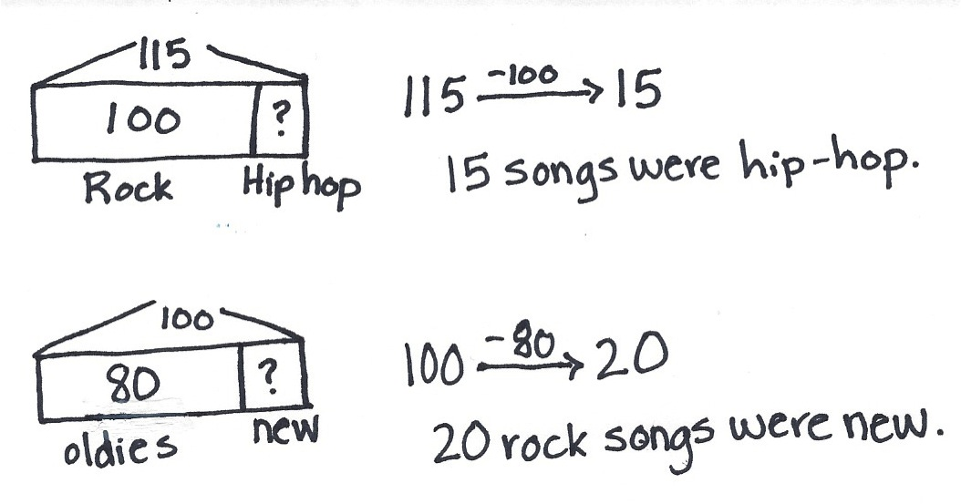Application Problem (7 minutes)

Yossef downloaded 115 songs. 100 of them were rock songs. The rest were hip-hop songs.

1. How many of Yossef’s songs were hip-hop?
2. 80 of his rock songs were oldies rock. How many rock songs were new?

This Application Problem serves to anticipate the day’s Concept Development.

Concept Development (30 minutes)

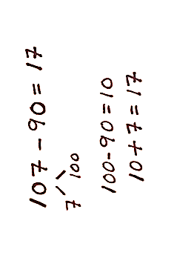Materials: (S) Personal white board

Problem 1: 107 – 90

**MP.2**

T: (Write 107 – 90 on the board with number bond arms under 107. Pull out the hundred as shown to the right.) Can we break apart 107 by making 100 and some ones? Give me the number sentence.

S: 100 + 7 = 107.

T: Great! Now we can make an easier problem and subtract from the hundred.

T: What is 100 – 90? Turn and talk.

S: 90 plus 10 is 100, so the answer is 10. 🡪 100 – 90 = 10. 🡪 10 tens – 9 tens is 1 ten.

T: Yes, ten! Am I finished? Does 107 – 90 equal 10?

S: No. What about the 7?

T: You’re right, I need to add back the 7 ones! What is 10 + 7?

S: 17.

T: Yes! 107 – 90 = 17.

Problem 2: 127 – 70

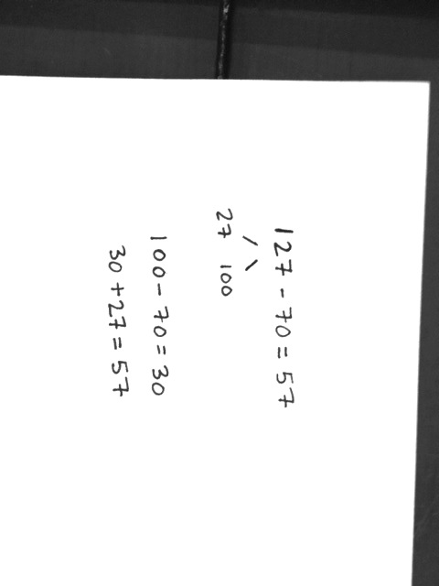T: Let’s try another one together.

T: (Write 127 – 70 on the board.) Can you take out the 100?

S: Yes!

T: Show me how to break apart 127 into 100 and some more. (Wait as students complete the number bond.)

T: If you take out the 100, how many are left in 127?

S: 27.

T: Now we can subtract easily! What’s 100 – 70?

|  |  |
| --- | --- |
|  | NOTES ON  MULTIPLE MEANS  OF ENGAGEMENT: |
| Post a hundreds chart on the wall. Count down from 100 by tens at the start of the lesson. Ask, “What do you notice about the pattern of counting back?” Guide students to realize that the pattern of counting back from 100 by tens is the same as counting back from 10 by ones, with the only difference being place value. | |

S: 30!

T: Great! Now, look at your number bond and add back the rest. Show me your work. (Call on students to share.)

S: I know that 100 – 70 is 30. I added the 27 back on and I got 57. 🡪 30 + 27 = 57.

**MP.2**

Problem 3: 133 – 60

T: Let’s try a harder one. (Write 133 – 60 on the board.) What should we do first?

S: Break apart 133. 🡪 Take out the 100.

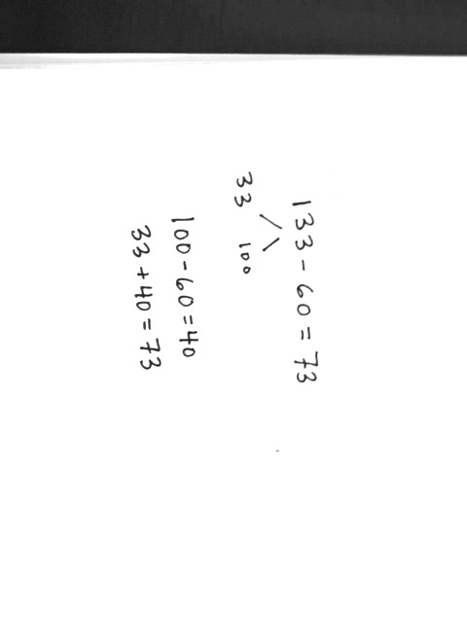T: Show me.

S: (Decompose 133 on personal white boards.)

T: (Call on students to share their number bonds.)

S: 133 is 100 + 33. 🡪 133 – 33 = 100.

T: What next?

S: Subtract 60 from 100.

T: Yes! Subtract and show me.

S: (Subtract 100 – 60, and show their work as pictured to the right.)

T: How much is 100 – 60?

S: 40.

T: What next?

S: Put the parts together. 🡪 Add 40 + 33.

T: Yes! Put the parts together and show me.

S: (Add on their personal white boards and hold up their work.)

T: What is 133 – 60?

S: 73.

Repeat the above process for the following possible sequence: 128 – 70, 138 – 70, and 139 – 60. As you move through the problems, allow students more independence. For the first problem, ask them to set up the problem by decomposing 128 before they show you their boards. For the second problem, ask them to decompose 138 and subtract 70. For the last problem, allow students to complete the whole problem independently as you circulate to offer support. If needed, provide more practice before moving on to the Problem Set.

Problem Set (10 minutes)

Students should do their personal best to complete the Problem Set within the allotted 10 minutes. For some classes, it may be appropriate to modify the assignment by specifying which problems they work on first. Some problems do not specify a method for solving. Students should solve these problems using the RDW approach used for Application Problems.

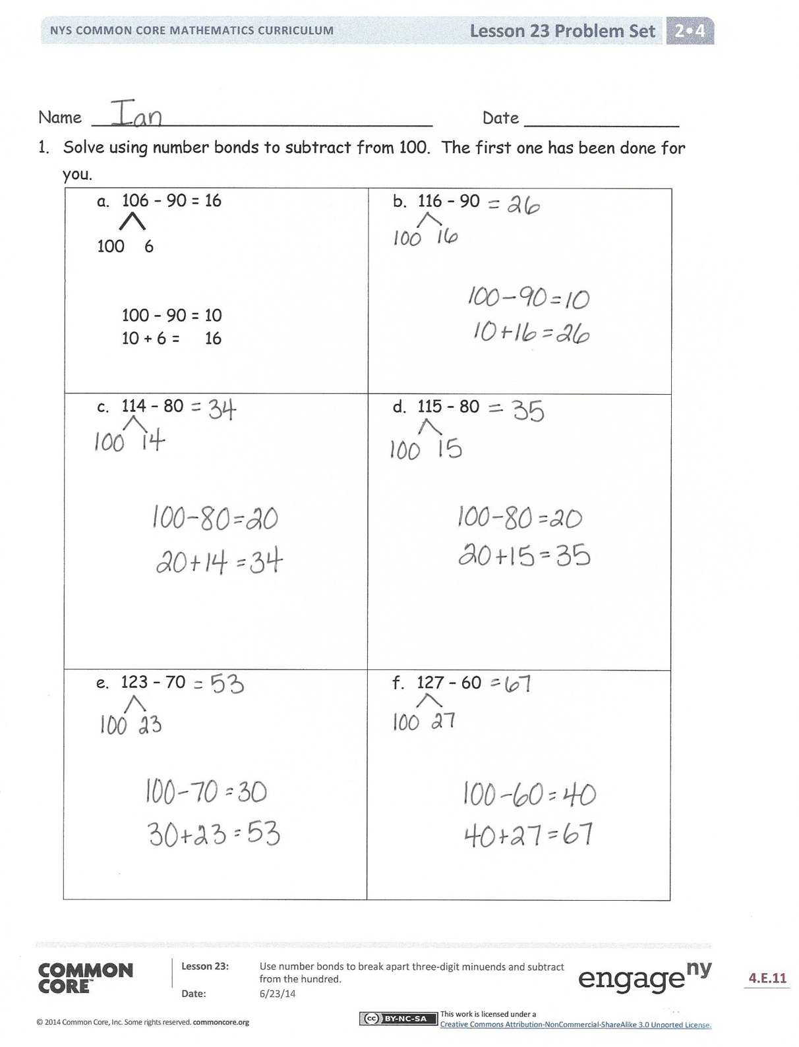Student Debrief (10 minutes)

**Lesson Objective:** Use number bonds to break apart three-digit minuends and subtract from the hundred.

The Student Debrief is intended to invite reflection and active processing of the total lesson experience.

Invite students to review their solutions for the Problem Set. They should check work by comparing answers with a partner before going over answers as a class. Look for misconceptions or misunderstandings that can be addressed in the Debrief. Guide students in a conversation to debrief the Problem Set and process the lesson.

You may choose to use any combination of the questions below to lead the discussion.

* For Problem 1, explain how you used a number bond to make the problem easier to solve. How did you show subtracting from the hundred?
* How did the number bond in Problem 1, Part (a) help you to solve Part (b)? What was different about your number bond for Part (b)? How did this affect the answer in comparison to Part (a)?
* What was the same and different about solving Problem 1, Parts (c) and (d)? How did you know that the answer to Part (d) would be one more than Part (c)?
* Explain to your partner how to solve Problem 1, Part (e) in three simple steps. Why does the third step involve addition when this is a subtraction problem?
* 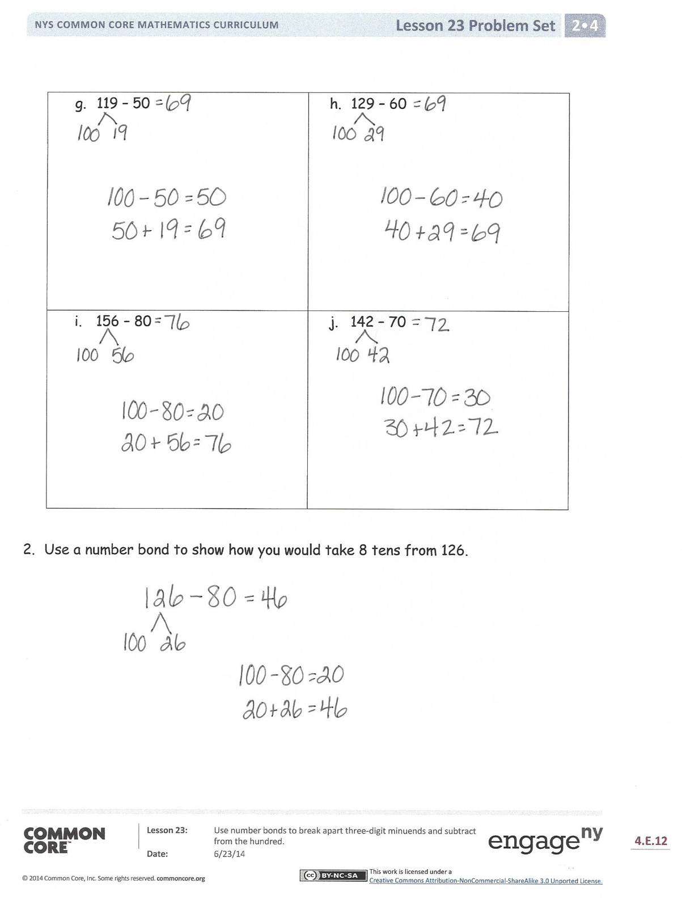How are Problem 1, Parts (g) and (h) related? Why are their answers the same even though their number bonds are different?
* When is subtracting from the hundred a good mental strategy?

Exit Ticket (3 minutes)

After the Student Debrief, instruct students to complete the Exit Ticket. A review of their work will help you assess the students’ understanding of the concepts presented in the lesson today and plan more effectively for future lessons. You may read the questions aloud to the students.





Name Date

1. Solve using number bonds to subtract from 100. The first one has been done for you.

|  |  |
| --- | --- |
| * 1. 106 – 90 = 16   100 6  100 – 90 = 10  10 + 6 = 16 | * 1. 116 – 90 |
| * 1. 114 – 80 | * 1. 115 – 80 |
| * 1. 123 – 70 | * 1. 127 – 60 |
| * 1. 119 – 50 | * 1. 129 – 60 |
| * 1. 156 – 80 | * 1. 142 – 70 |

1. Use a number bond to show how you would take 8 tens from 126.

Name Date

Solve using number bonds to subtract from 100.

1. 114 – 50
2. 176 – 90
3. 134 – 40

Name Date

1. Solve using number bonds to subtract from 100. The first one has been done for you.

|  |  |  |
| --- | --- | --- |
| * 1. 105 – 90 = 15   100 5  100 – 90 = 10  10 + 5 = 15 | * 1. 121 – 90 | |
| * 1. 112 – 80 | * 1. 135 – 70 | |
| * 1. 136 – 60 | * 1. 129 – 50 | |
| * 1. 156 – 80 | * 1. 138 – 40 |

1. Monica incorrectly solved 132 – 70 to get 102. Show her how to solve it correctly.

|  |  |
| --- | --- |
| *Monica’s work:* | Correct way to solve 132 **−** 70: |

1. Billy sold 50 fewer magazines than Alex. Alex sold 128 magazines. How many magazines did Billy sell? Solve using a number bond.