Topic D:
Nets and Surface Area
6.G.A.2, 6.G.A.4
Focus Standard: | 6.G.A.2 | Find the volume of a right rectangular prism with fractional edge lengths by packing it with unit cubes of the appropriate unit fraction edge lengths, and show that the volume is the same as would be found by multiplying the edge lengths of the prism. Apply the formulas V = l w h and V = b h to find volumes of right rectangular prisms with fractional edge lengths in the context of solving real-world and mathematical problems.
 | 6.G.A.4 | Represent three-dimensional figures using nets made up of rectangles and triangles, and use the nets to find the surface area of these figures. Apply these techniques in the context of solving real-world and mathematical problems.
Instructional Days: | 5
Lesson 15: | Representing Three-Dimensional Figures Using Nets (M)
Lesson 16: | Constructing Nets (E)
Lesson 17: | From Nets to Surface Area (P)
Lesson 18: | Determining Surface Area of Three-Dimensional Figures (P)
Lesson 19: | Surface Area and Volume in the Real World (P)
Lesson 19a: | Addendum Lesson for Modeling―Applying Surface Area and Volume to Aquariums  (Optional) (M)

Topic D begins with students constructing three-dimensional figures through the use of nets in Lesson 15. They determine which nets make specific solid figures and also determine if nets can or cannot make a solid figure. Students use physical models and manipulatives to do actual constructions of three-dimensional figures with the nets. Then, in Lesson 16, students move to constructing nets of three-dimensional objects using the measurements of a solid’s edges. Using this information, students will move from nets to determining the surface area of three-dimensional figures in Lesson 17. In Lesson 18, students determine that a right rectangular prism has six faces: top and bottom, front and back, and two sides. They determine that surface area is obtained by adding the areas of all the faces and develop the formula
$SA=2lw+2lh+2wh$. They develop and apply the formula for the surface area of a cube as $SA=6s^{2}$.
For example:
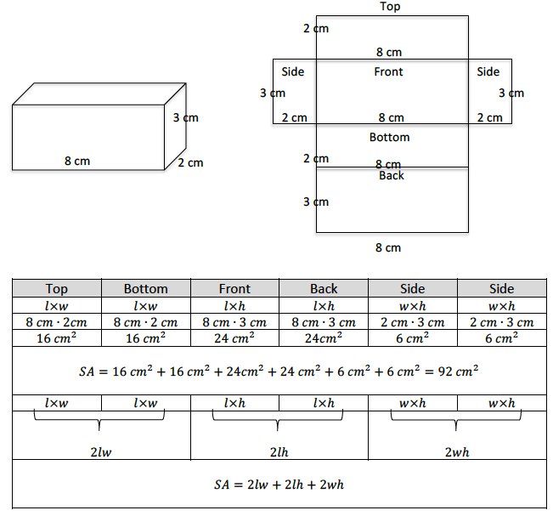

Topic D concludes with Lesson 19, in which students determine the surface area of three-dimensional figures in real-world contexts. To develop skills related to application, students are exposed to contexts that involve both surface area and volume. Students are required to make sense of each context and apply concepts appropriately.

Lesson Structure Key: P-Problem Set Lesson, M-Modeling Cycle Lesson, E-Exploration Lesson, S-Socratic Lesson

