Topic C:
Replacing Letters with Numbers
6.EE.A.2c, 6.EE.A.4
Focus Standard: | 6.EE.A.2c | Write, read, and evaluate expressions in which letters stand for numbers.  - Evaluate expressions at specific values of their variables. Include expressions that arise from formulas used in real-world problems. Perform arithmetic operations, including those involving whole-number exponents, in the conventional order when there are no parentheses to specify a particular order (Order of Operations). For example, use the formulas $V=s^{3}$ and $A=6s^{2}$ to find the volume and surface area of a cube with sides of length $s=\frac{1}{2}$.
 | 6.EE.A.4 | Identify when two expressions are equivalent (i.e., when the two expressions name the same number regardless of which value is substituted into them). For example, the expressions $y+y+y$ and $3y$ are equivalent because they name the same number regardless of which number $y$ stands for.
Instructional Days: | 2
Lesson 7: | Replacing Letters with Numbers (P)
Lesson 8: | Replacing Numbers with Letters (S)

Students begin substituting, or replacing, letters with numbers and numbers with letters in Topic C in order to evaluate expressions with a given number and to determine expressions to create identities. In Lesson 7, students replace letters with a given number in order to evaluate the expression to one number. They continue to practice with exponents in this lesson in order to determine the area of squares and rectangles as shown below.

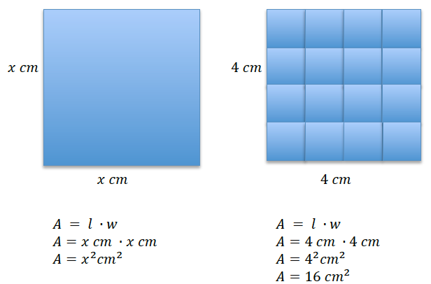
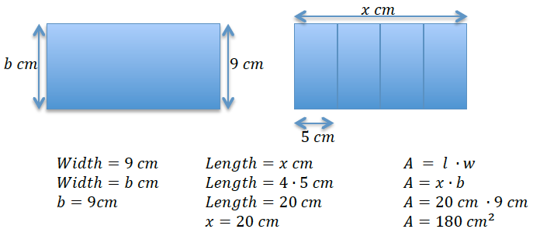

In Lesson 8, students understand that a number in an expression can be replaced with a letter to determine identities. Through replacement of numbers, students discover and build identities such as $a+b=b+a$, $a×b=b×a$, $g×1=g$, $g+0=g$, $g÷1=g$, $g÷g=1$, $1÷g=\frac{1}{g}$. These identities will aid in solving equations with variables, as well as problem solving with equations.
$$4×1=4 \\ 4÷1=4 \\ 4×0=0 \\ 1÷4=\frac{1}{4}$$ |  | $$g×1=g \\ g÷1=g \\ g×0=0 \\ 1÷g=\frac{1}{g}$$
$$3+4=4+3 \\ 3×4=4×3 \\ 3+3+3+3=4×3 \\ 3÷4=\frac{3}{4}$$ |  | $$a+4=4+a \\ a×4=4×a \\ a+a+a+a=4×a \\ a÷4=\frac{a}{4}$$

Lesson Structure Key: P-Problem Set Lesson, M-Modeling Cycle Lesson, E-Exploration Lesson, S-Socratic Lesson

