Topic B:
Special Notations of Operations
6.EE.A.1, 6.EE.A.2c
Focus Standards: | 6.EE.A.1 | Write and evaluate numeric expressions involving whole-number exponents.
 | 6.EE.A.2c | Write, read, and evaluate expressions in which letters stand for numbers.  - Evaluate expressions at specific values of their variables. Include expressions that arise from formulas used in real-world problems. Perform arithmetic operations, including those involving whole-number exponents, in the conventional order when there are no parentheses to specify a particular order (Order of Operations). For example, use the formulas $V=s^{3}$ and $A=6s^{2}$ to find the volume and surface area of a cube with sides of length $s=\frac{1}{2}$.
Instructional Days: | 2
Lesson 5: | Exponents (S)
Lesson 6: | The Order of Operations (P)

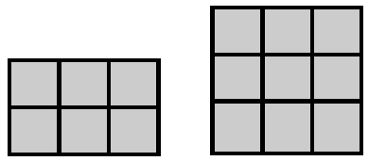
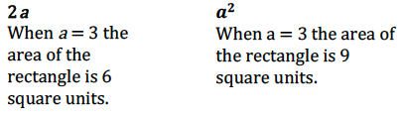
In Topic B, students differentiate between the product of two numbers and whole numbers with exponents. They differentiate between the two through exploration of patterns, specifically noting how squares grow from a $1×1$ measure. They determine that a square with a length and width of three units in measure is constructed with nine square units. This expression is represented as $3^{2}$ and is evaluated as the product of $3×3=9$, not the product of the base and exponent, $6$. They further differentiate between the two by comparing the areas of two models with similar measures, as shown below.

Once students understand that the base is multiplied by itself the number of times as stated by the exponent, they make a smooth transition into bases that are represented with positive fractions and decimals. They know that for any number $a$, we define $a^{m}$ to be the product of $m$ factors of $a$. The number $a$ is the base, and $m$ is called the exponent (or the power) of $a$.
In Lesson 6, students build on their previous understanding of the order of operations by including work with exponents. They follow the order of operations to evaluate numerical expressions. They recognize that, in the absence of parentheses, exponents are evaluated first. Students identify when the order of operations is incorrectly applied and determine the applicable course to correctly evaluate expressions. They understand that the placement of parentheses can alter the final solution when evaluating expressions, as in the following example:
$$2^{4}∙\left(2+8\right)-16 \\ 2^{4}∙10-16 \\ 16∙10-16 \\ 160-16 \\ 144$$ | $$2^{4}∙2=8-16 \\ 16∙2+8-16 \\ 32+8-16 \\ 40-16 \\ 24$$
Students continue to apply the order of operations throughout the module as they evaluate numerical and algebraic expressions.

Lesson Structure Key: P-Problem Set Lesson, M-Modeling Cycle Lesson, E-Exploration Lesson, S-Socratic Lesson

