Lesson 22
Objective: Solve additions with up to four addends with totals within 200 with and without two compositions of larger units.

Suggested Lesson Structure
 Fluency Practice (11 minutes)
 Application Problem (9 minutes)
 Concept Development (30 minutes)
 Student Debrief (10 minutes)
Total Time (60 minutes)
Fluency Practice (11 minutes)
- Addition Facts Flash Cards 2.OA.2 (2 minutes)
- Subtraction from Tens 2.NBT.5 (5 minutes)
- Crossing a Ten 2.NBT.5 (4 minutes)
Addition Facts Flash Cards (2 minutes)
Materials: (T) Addition flash cards (Lesson 19 Fluency Template)
Note: By practicing addition facts, students gain fluency adding within 20.
Subtraction from Tens (5 minutes)
Materials: (S) Personal white board
Note: This allows students to see how their take-from-ten facts help them to solve many, many problems.
T: I say a basic fact. You add 10 to the whole and continue until I say to stop. So, after 10 – 6, you would then solve 20 – 6.
S: 30 – 6, 40 – 6, 50 – 6.
T: Yes, go as high as you can before I give the signal to stop. Let’s begin. 10 – 6.
S: (Work.)
T: (Stop everyone when you see that all students have solved at least two problems.)
Continue with the following possible sequence: 10 – 8, 11 – 2, 12 – 4, and 11 – 5.
Crossing a Ten (4 minutes)
Note: Crossing a Ten prepares students for making a multiple of 10 as they solve problems with up to four addends.
T: (Write on board: 8 + ____ = 10.) How many more does 8 need to make 10?
S: 2 more.
T: Complete the number sentence.
S: 8 + 2 = 10.
T: 10 + 1.
S: 11.
T: 8 + 2 + 1.
S: 11.
T: 8 + 3.
S: 11.
Continue with the following possible sequence: 7 + 3, 7 + 3 + 1, 7 + 4, 7 + 5, 9 + 1, 9 + 1 + 1, 9 + 1 + 4, and
19 + 1 + 4.
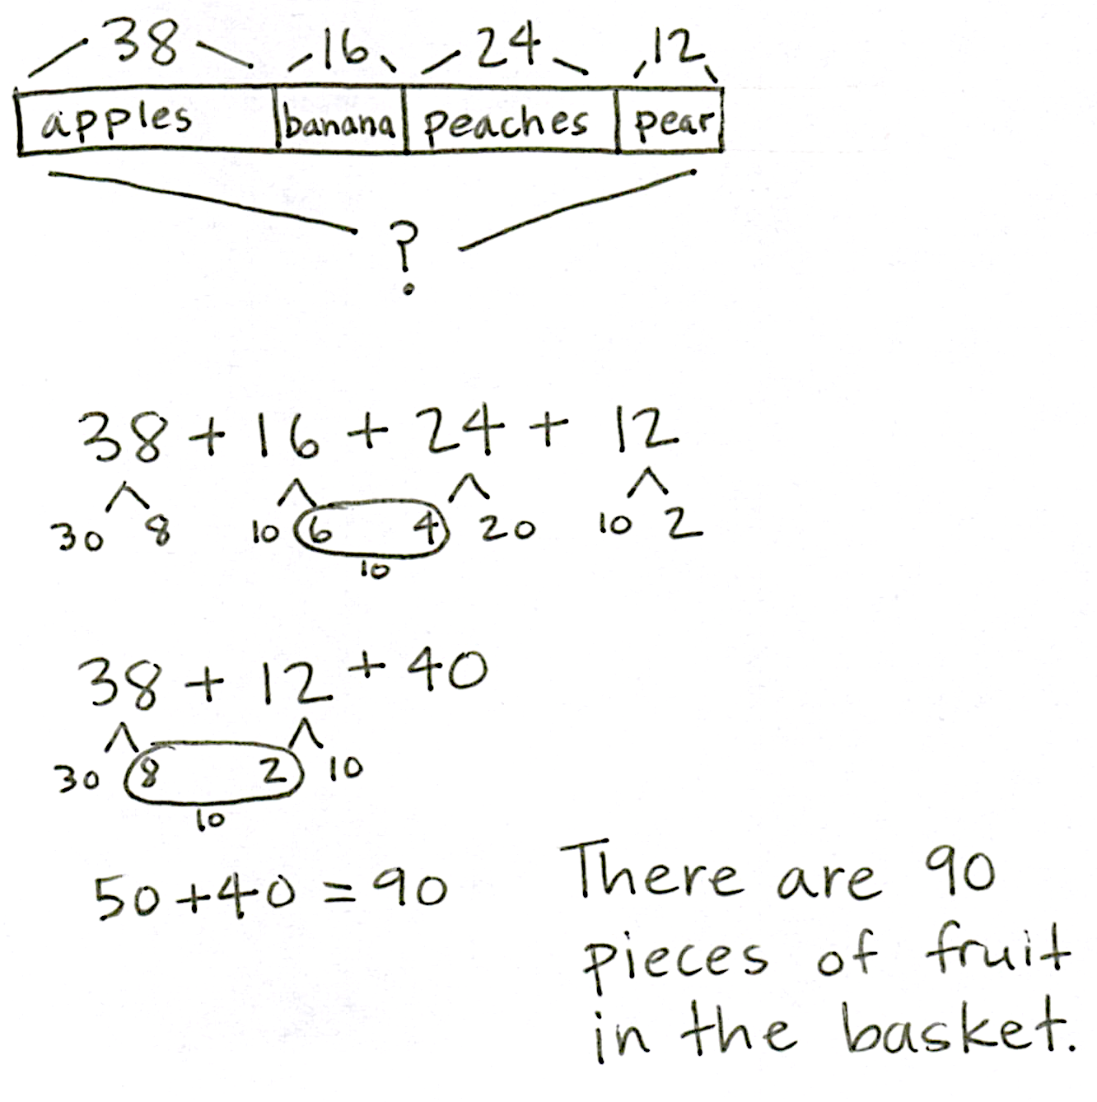
Application Problem (9 minutes)
There are 38 apples, 16 bananas, 24 peaches, and 12 pears in the fruit basket. How many pieces of fruit are in the basket?
Note: In this problem, students apply existing skills, but with more addends. Encourage the use of multiple simplifying strategies. When students have finished, invite them to share different strategies and to explain their thinking. Seeing other methods encourages flexibility in problem solving and can provide access for all learners.
Concept Development (30 minutes)
Materials: (S) Personal white board
For each problem within the set, guide students to look for partners to 10 ones or 10 tens to solve, using the associative property to group the numbers. Within each set of problems, encourage students to relate problems to each other.
MP.3
Problems 1–3: 3 + 7 + 6, 23 + 27 + 16, 123 + 27 + 16
T: (Write 3 + 7 + 6 on the board.) Raise your hand when you think you know the answer.
S: 16!
T: What helped you solve so quickly?
MP.3
S: 3 + 7 equals 10, and 10 + 6 is 16!
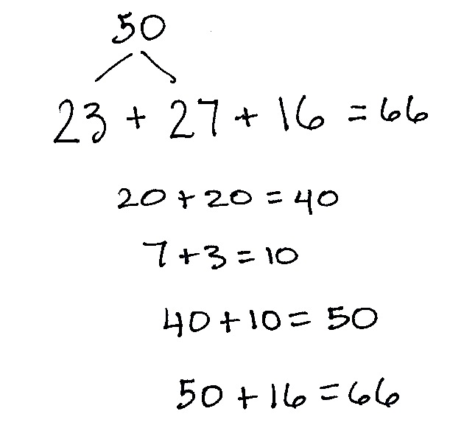
T: (Write 23 + 27 + 16 directly below 3 + 7 + 6 so that the ones are aligned.) Don’t use vertical addition to solve; use mental math. Talk to your partner using place value language to explain how you can solve this problem mentally. Then, show your work.
S: I added 23 + 27 first. I added the 2 tens, so 20 + 20 = 40. Then, I added the ones. 7 + 3 equals 10, and 40 + 10 is 50. 50 plus 16 equals 66.
I did the same thing, but I said 4 tens + 1 ten is 5 tens, plus another ten is 6 tens. Then, I added 6 ones, which equals 66. I added all the tens first, and then I added the ones. So, 20 + 20 + 10 = 50. Plus, the 10 from 7 ones and 3 ones makes 60. Then, I added 6 more, which equals 66.
It’s the same as the first problem, just with tens. So, you add 50 more!
T: Oh, I like the way you used the first problem to solve the second one! (Write 123 + 27 + 16 directly below the prior equation.) Talk with your partner. How is this problem the same as and different from the first two?

NOTES ON
MULTIPLE MEANS
OF ENGAGEMENT:
Have struggling students circle pairs of addends with ones digits that add up to ten. Review and practice partners to ten with students who need it, using number bonds, ten frames, or a Rekenrek.

S: The ones are the same in all the problems. In the second and third problems, the tens and ones are the same, but now there’s a hundred. In the first problem, all the numbers have one digit, and then in the next one they have two digits. And in the last problem, one number has three digits. You can break apart 123 into 100 + 23; then, it’s the same as the second problem with an added hundred.
T: On your board, show your favorite strategy; then, share your work with your partner.
If time permits or students need more practice, repeat the procedure above with the following possible sequence: 2 + 8 + 5, 32 + 28 + 45, and 132 + 28 + 45.
Problems 4–6: 1 + 3 + 9 + 7, 31 + 23 + 19 + 47, 61 + 53 + 19 + 27
T: (Write 1 + 3 + 9 + 7 on the board.) Now, we’re adding four addends. Talk with your partner about how you can solve this easily.
S: Add the numbers that make ten. 1 + 9 is 10 and 3 + 7 is 10, so 20.
T: Does this mean we can add numbers in any order?
S: Yes!
T: (Write 31 + 23 + 19 + 47.) How is this problem the same as the first problem?
S: The ones are the same.
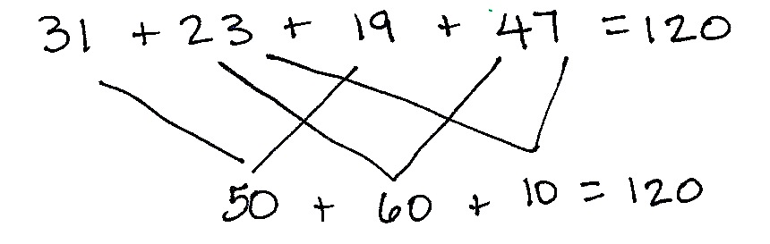
T: How is it different?
S: Now there are tens.
T: Choose a strategy to solve. Then, use place value language to explain your strategy to your partner.
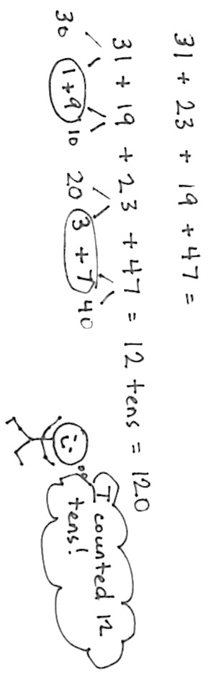
T: Who would like to show his work and explain his thinking? (Choose volunteers.)
S: I added all the tens, 30 + 20 + 10 + 40. That’s 50 + 50, which is 100. Then, I added the ones. 10 + 10 equals 20. 100 + 20 = 120.
MP.3
S: I put 31 and 19 together. 1 + 9 is 10.
30 + 10 is 40. 40 + 10 is 50. Then, I added
23 and 47. 3 + 7 is 10. 20 + 40 is 60.
50 + 60 + 10 is 120.
Repeat the procedure above for 61 + 53 + 19 + 27. As students are able to solve using place value strategies, allow them to work on the Problem Set independently.
Problem Set (10 minutes)
Students should do their personal best to complete the Problem Set within the allotted 10 minutes. For some classes, it may be appropriate to modify the assignment by specifying which problems they work on first. Some problems do not specify a method for solving. Students should solve these problems using the RDW approach used for Application Problems.
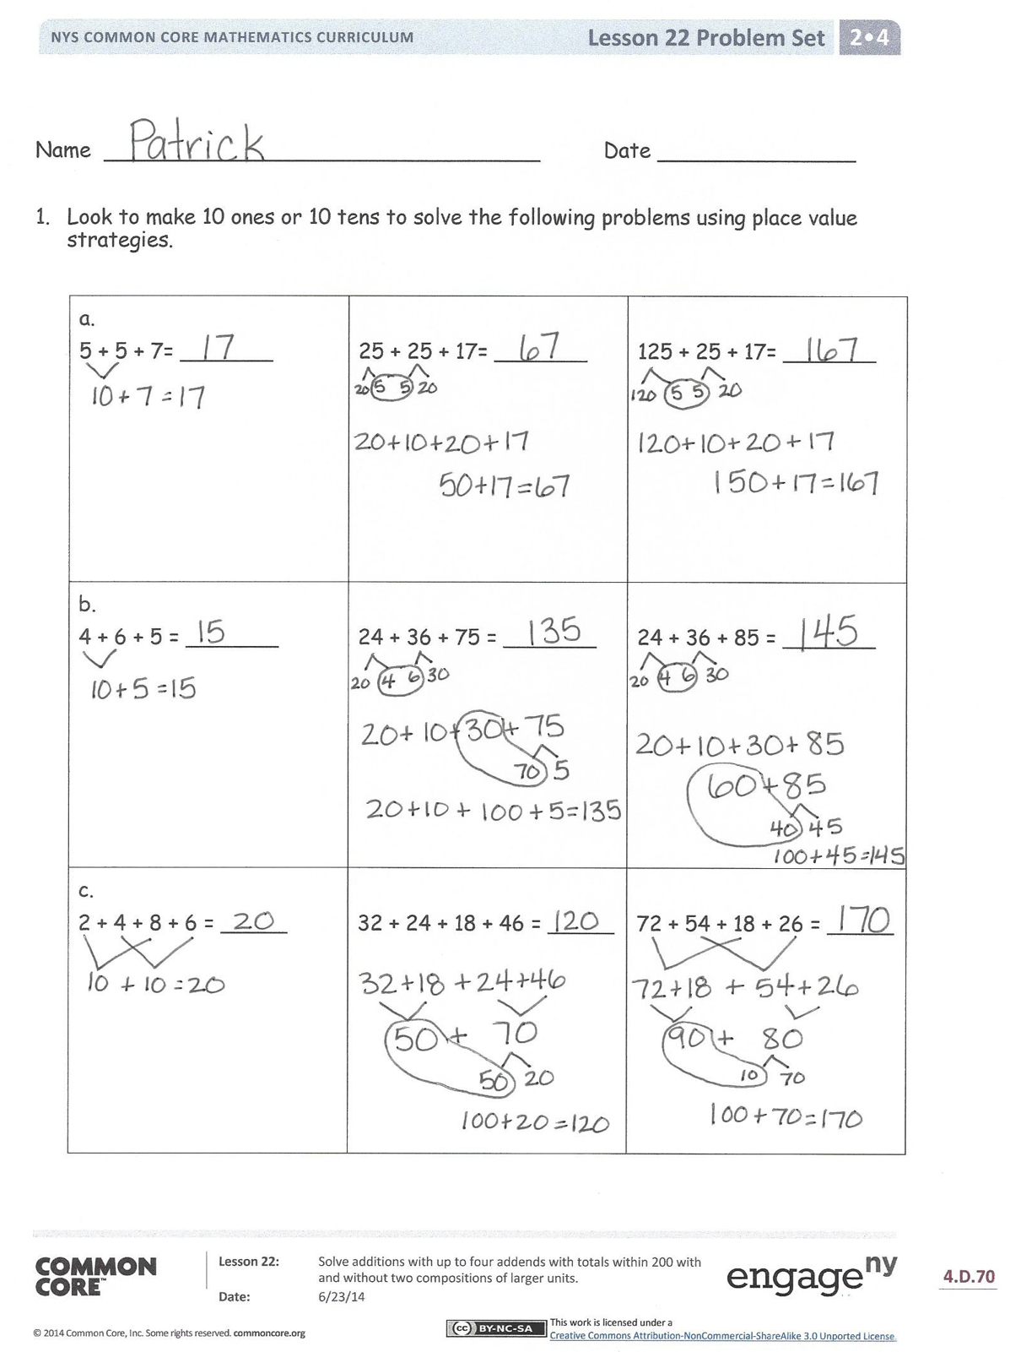
Student Debrief (10 minutes)
Lesson Objective: Solve additions with up to four addends with totals within 200 with and without two compositions of larger units.
The Student Debrief is intended to invite reflection and active processing of the total lesson experience.
Invite students to review their solutions for the Problem Set. They should check work by comparing answers with a partner before going over answers as a class. Look for misconceptions or misunderstandings that can be addressed in the Debrief. Guide students in a conversation to debrief the Problem Set and process the lesson.
You may choose to use any combination of the questions below to lead the discussion.
- For Problems 1(a–c), how are the three columns related? How do the columns build upon each other?
- In Problem 1(a), how many tens are in
125 + 25 + 17? How do you know?
- In Problem 1(b), how did you group the tens and ones to solve an easy problem? What did you do with 15 ones?
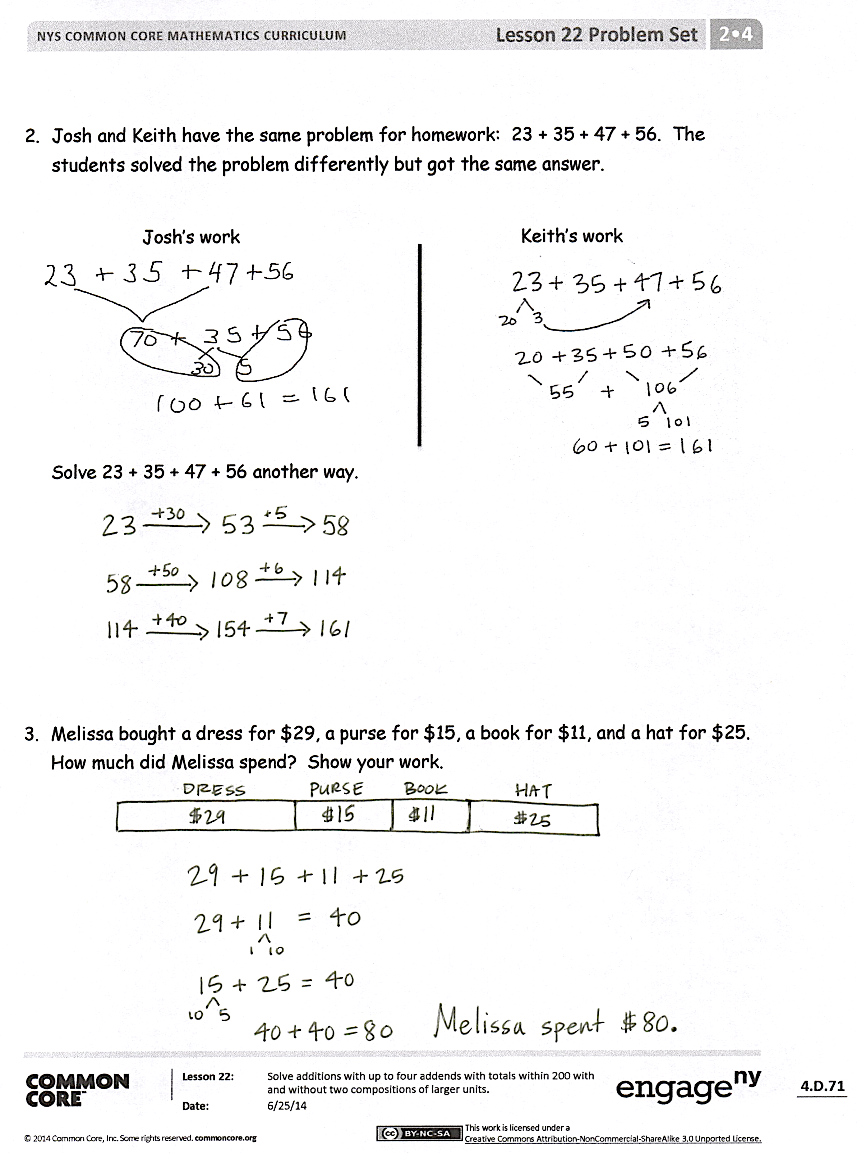
- In Problem 1(c), how did you change the order of the addends to make a simpler problem to solve?
- How did you solve Problem 2 differently from Josh and Keith? Did you change the order of the addends? Did you make 10 ones? How about 10 tens?
- Could we use the vertical method to solve these problems?
Exit Ticket (3 minutes)
After the Student Debrief, instruct students to complete the Exit Ticket. A review of their work will help you assess the students’ understanding of the concepts that were presented in the lesson today and plan more effectively for future lessons. You may read the questions aloud to the students.

Name Date
- Look to make 10 ones or 10 tens to solve the following problems using place value strategies.
5 + 5 + 7= _______ | 25 + 25 + 17= _______ | 125 + 25 + 17= _______
4 + 6 + 5 = _______ | 24 + 36 + 75 = _______ | 24 + 36 + 85 = _______
2 + 4 + 8 + 6 = _____ | 32 + 24 + 18 + 46 = _____ | 72 + 54 + 18 + 26 = _____

- Josh and Keith have the same problem for homework: 23 + 35 + 47 + 56. The students solved the problem differently, but got the same answer.
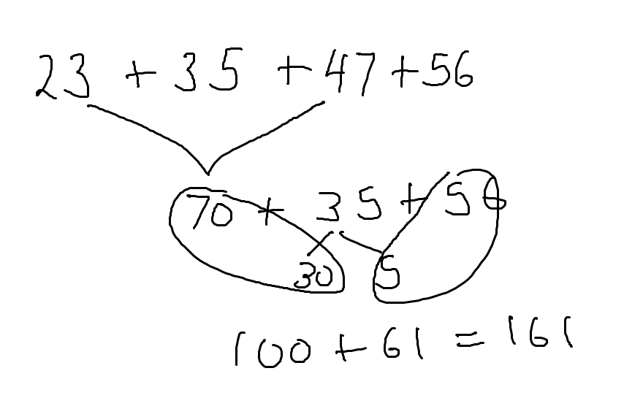
Josh’s work
Keith’s work
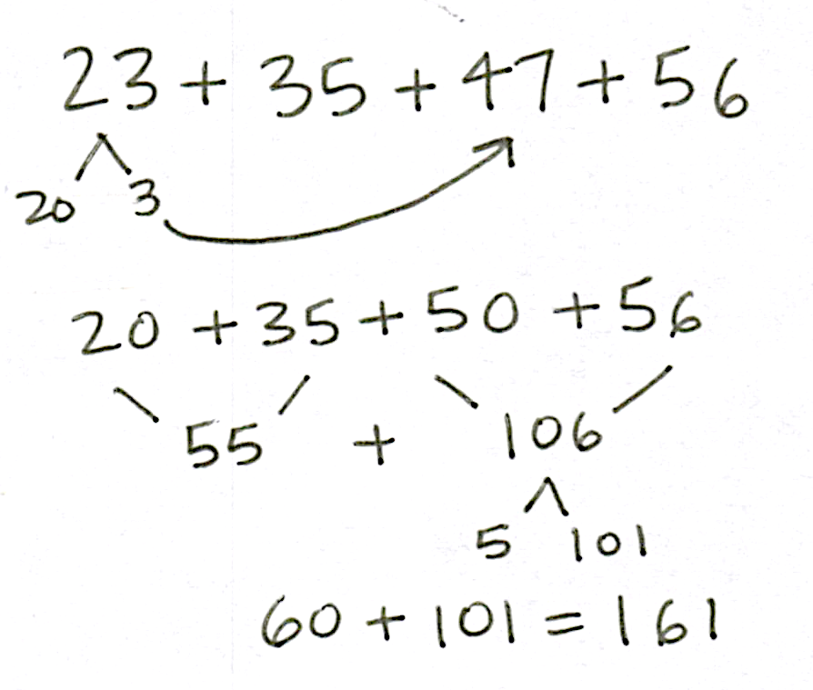

Solve 23 + 35 + 47 + 56 another way.

- Melissa bought a dress for $29, a purse for $15, a book for $11, and a hat for $25. How much did Melissa spend? Show your work.

Name Date
Look to make 10 ones or 10 tens to solve the following problems using place value strategies.
- 17 + 33 + 48

- 35 + 56 + 89 + 18

Name Date
- Look to make 10 ones or 10 tens to solve the following problems using place value strategies.

6 + 3 + 7= _______ | 36 + 23 + 17= _______ | 126 + 23 + 17= _______
8 + 2 + 5 = _______ | 38 + 22 + 75 = _______ | 18 + 62 + 85 = _______
9 + 4 + 1 + 6 = _____ | 29 + 34 + 41 + 16 = _____ | 81 + 34 + 19 + 56 = _____

- The table shows the top six soccer teams and their total points scored this season.
Teams | Points
Red | 29
Yellow | 38
Green | 41
Blue | 76
Orange | 52
Black | 24

- How many points did the yellow and orange teams score together?

- How many points did the yellow, orange, and blue teams score together?

- How many points did the red, green, and black teams score together?

- Which two teams scored a total of 70 points?

- Which two teams scored a total of 100 points?

