Lesson 21
Objective: Use math drawings to represent additions with up to two compositions and relate drawings to a written method.

Suggested Lesson Structure
 Application Problem (6 minutes)
 Fluency Practice (12 minutes)
 Concept Development (32 minutes)
 Student Debrief (10 minutes)
Total Time (60 minutes)
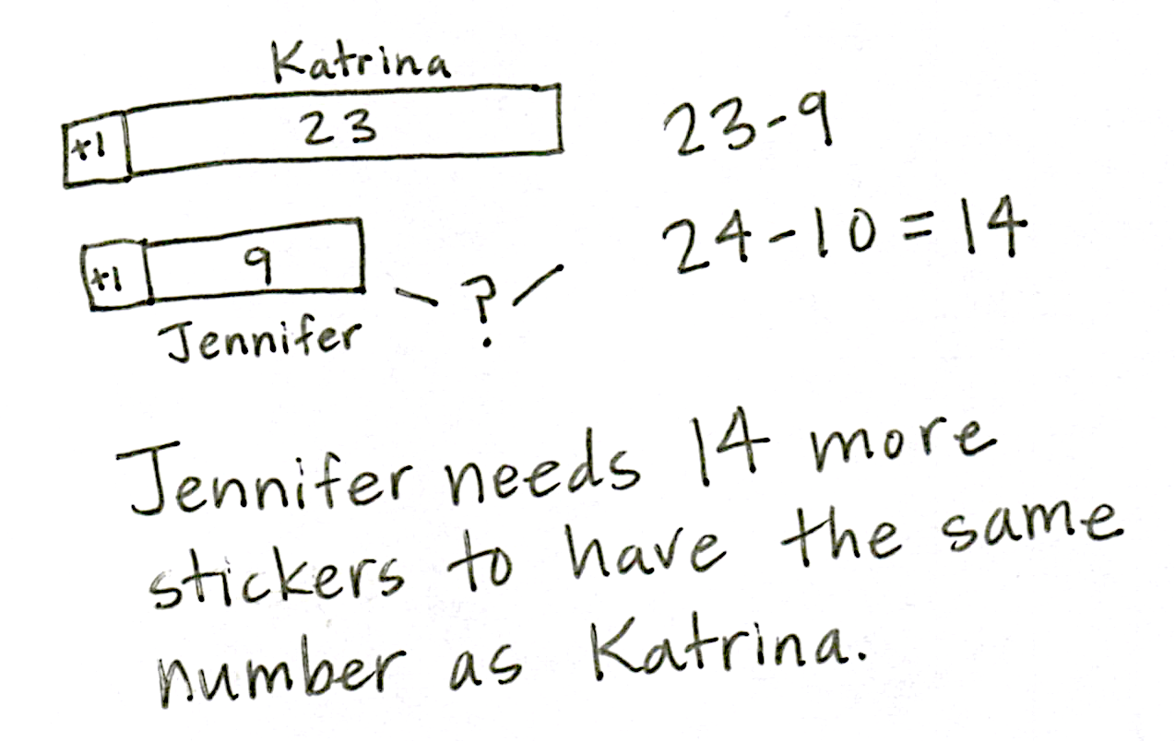
Application Problem (6 minutes)
Katrina has 23 stickers, and Jennifer has 9. How many more stickers does Jennifer need to have as many as Katrina?
Note: Guide the students through the use of a comparison tape diagram to represent this compare with difference unknown problem type. Remember that, if possible, Application Problems can be completed at a time of day other than the regular math time if they do not directly flow into the lesson, as is the case here.
Fluency Practice (12 minutes)
- Addition Fact Flash Cards 2.OA.2 (2 minutes)
- Place Value 2.NBT.1 (5 minutes)
- Rename the Units: Choral Response 2.NBT.1 (5 minutes)
Addition Fact Flash Cards (2 minutes)
Materials: (T) Addition flash cards (Lesson 19 Fluency Template)
Note: By practicing addition facts, students gain fluency adding within 20.
Place Value (5 minutes)
Note: Practicing place value skills solidifies understanding the reason for bundling.
T: (Write 103.) Say the number.
S: 103.
T: Which digit is in the tens place?
S: 0.
T: (Underline 0.) What’s the value of the 0?
S: 0.
T: State the value of the 1.
S: 1 hundred.
T: State the value of the 3.
S: 3 ones.
Repeat using the following possible sequence: 173, 281, and 428.
Rename the Units: Choral Response (5 minutes)
Note: This fluency activity reviews foundational concepts that support today’s lesson.
T: (Write 10 ones = _____ ten ____ ones.) Say the number sentence.
S: 10 ones = 1 ten 0 ones.
T: (Write 20 ones = 1 ten _____ ones.) Say the number sentence.
S: 20 ones = 1 ten 10 ones.
T: (Write 24 ones = 1 ten _____ ones.) Say the number sentence.
S: 24 ones = 1 ten 14 ones.
T: (30 ones = 2 tens ___ ones.) Say the number sentence.
S: 30 ones = 2 tens 10 ones.
Repeat the process for 32, 38, 40, 41, 46, 50, 63, and 88.
Concept Development (32 minutes)

NOTES ON
MULTIPLE MEANS
OF REPRESENTATION:
Return to the concrete stage (i.e., manipulatives) if a student is unable to grasp concepts at this pictorial stage. Ensure that the student has enough time to practice with manipulatives before moving on to the pictorial stage again.

Materials: (S) Math journal or paper
This lesson is designed to give students ample time working with bare numbers and chip models to develop conceptual understanding of the algorithm when there are two compositions.
T: Copy the following problem on your paper in vertical form: 48 + 93.
T: Next to the written addition, draw a chip model to solve, and record each change in the written addition.
T: When you’re finished, check your work with a partner, and explain how your model matches the written addition. Use place value language to explain each step.
Circulate to listen in on conversations and to offer support as needed.
T: Who would like to share his or her work with the class? Use place value language to explain how the model helps you to understand the written addition. (Choose a student.)
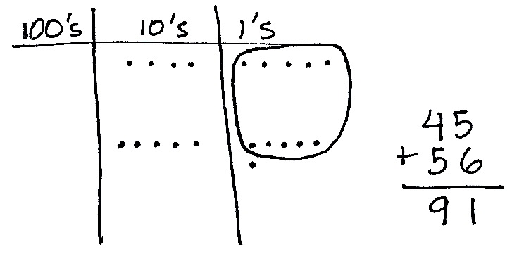
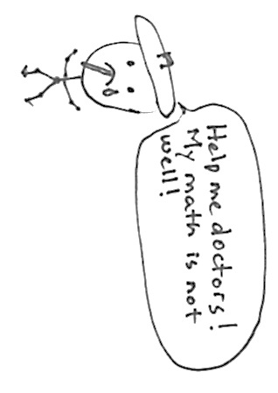
Repeat the procedure above, using the following possible sequence: 37 + 85, 28 + 82, 139 + 26, and 142 + 58.
When students have finished, write 45 + 56 on the board in vertical form. Draw a model that shows the problem solved incorrectly.
(See image to the right.)
T: This problem is not feeling well. It is wrong.
T: Talk with your partner. Use place value language to explain why it is incorrect. Be a math doctor. Figure out how to make it right.
S: You didn’t rename (or bundle) 10 ones as 1 ten. You circled 10 ones, but you forgot to show the new ten in your drawing or in the problem.
5 ones + 6 ones is 11 ones. You wrote the number of ones below the line, but you didn’t write the new ten on the line below the tens place. The answer is 101 because 4 tens + 5 tens + another ten is 10 tens, or 100! And you wrote the ones right!
MP.3

NOTES ON
MULTIPLE MEANS OF ENGAGEMENT:
When selecting a “doctor” (a student to correct the mistake), choose someone who has been struggling with the concept. Once the student successfully discovers the mistake (with or without support), praise the student for her hard work and persistence. This models the importance of hard work in achievement and moves the focus of accomplishment away from only those who find the concept easy.

T: Who can come up and correct my work? (Choose a student.)
T: How is renaming ones the same as and different from renaming tens?
S: You do the same thing for both; you look for partners to ten to make a new unit. It’s the same because it means you have ten or more in the ones place and the tens place. It’s different because when you rename ones, you make a ten. When you rename tens, you make a hundred.
Continue to support students who need assistance. Once students demonstrate proficiency with the models and the algorithm, allow them to work on the Problem Set independently.

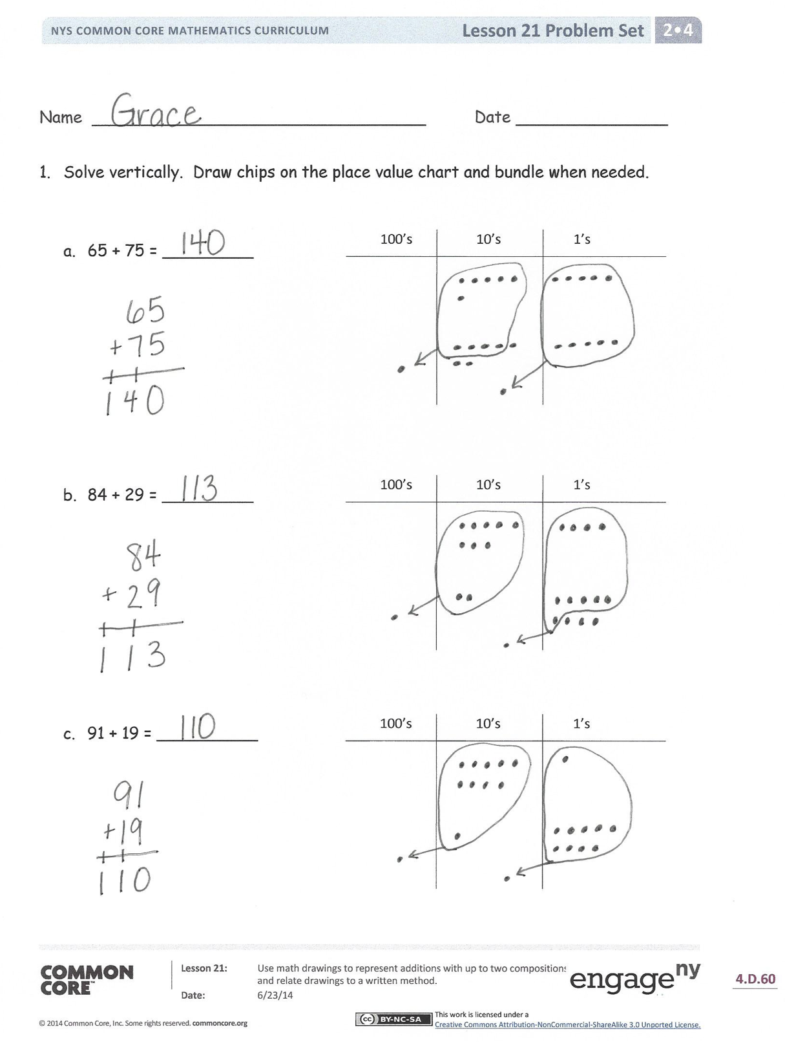
Problem Set (10 minutes)
Students should do their personal best to complete the Problem Set within the allotted 10 minutes. For some classes, it may be appropriate to modify the assignment by specifying which problems they work on first. Some problems do not specify a method for solving. Students should solve these problems using the RDW approach used for Application Problems.
Student Debrief (10 minutes)
Lesson Objective: Use math drawings to represent additions with up to two compositions and relate drawings to a written method.
The Student Debrief is intended to invite reflection and active processing of the total lesson experience.
Invite students to review their solutions for the Problem Set. They should check work by comparing answers with a partner before going over answers as a class. Look for misconceptions or misunderstandings that can be addressed in the Debrief. Guide students in a conversation to debrief the Problem Set and process the lesson.
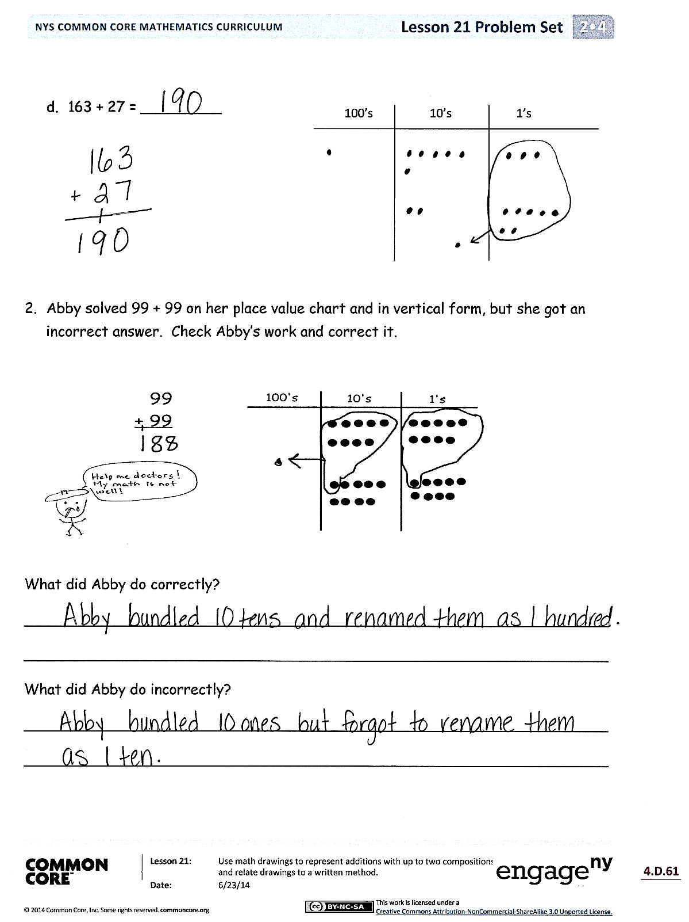
You may choose to use any combination of the questions below to lead the discussion.
- Explain to your partner how you solved Problems 1(a) and (b). How can you tell immediately if you are going to need to bundle ones? Tens?
- Could you have solved Problems 1(a) and (b) mentally? Which strategies would be easiest?
- For Problem 1(c), how does knowing partners to ten help you to solve this problem?
- For Problem 1(d), use place value language to explain to your partner how your model matches the written addition.
- Share your responses to Problem 2 with a partner. What does Abby understand about addition? If you were Abby’s teacher, what would you focus on teaching her in the next lesson? Why?
Exit Ticket (3 minutes)
After the Student Debrief, instruct students to complete the Exit Ticket. A review of their work will help you assess the students’ understanding of the concepts that were presented in the lesson today and plan more effectively for future lessons. You may read the questions aloud to the students.

Name Date
- Solve vertically. Draw chips on the place value chart and bundle, when needed.
100’s
10’s
1’s
- 65 + 75 = _________

100’s
10’s
1’s
- 84 + 29 = _________

100’s
10’s
1’s
- 91 + 19 = __________

- 163 + 27 = _________
100’s
10’s
1’s

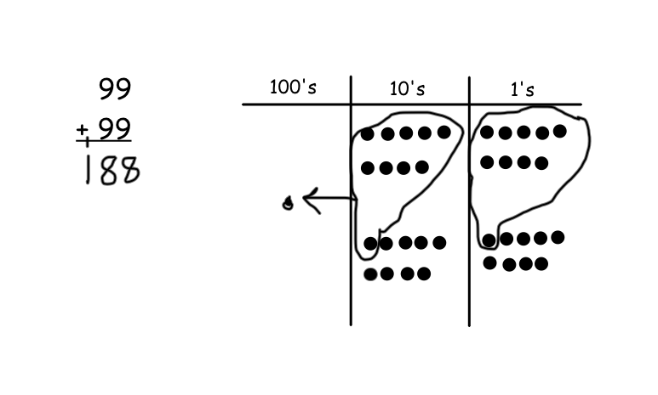
- Abby solved 99 + 99 on her place value chart and in vertical form, but she got an incorrect answer. Check Abby’s work, and correct it.

What did Abby do correctly?
_________________________________________________________________
_________________________________________________________________
What did Abby do incorrectly?
_________________________________________________________________
_________________________________________________________________

Name Date
Solve vertically. Draw chips on the place value chart and bundle, when needed.
100’s
10’s
1’s
- 58 + 67 = _________

100’s
10’s
1’s
- 43 + 89 = _________

Name Date
- Solve vertically. Draw chips on the place value chart and bundle, when needed.
100’s
10’s
1’s
100’s
10’s
1’s
- 45 + 76 = _________

- 62 + 89 = _________

100’s
10’s
1’s
- 97 + 79 = __________

- 127 + 78 = _________
100’s
10’s
1’s

- The blue team scored 37 fewer points than the white team. The blue team scored 69 points.
- How many points did the white team score?

- How many points did the blue and white teams score altogether?

