Lesson 20

Objective: Use math drawings to represent additions with up to two compositions and relate drawings to a written method.

Suggested Lesson Structure

 Fluency Practice (10 minutes)

 Application Problem (6 minutes)

 Concept Development (34 minutes)

 Student Debrief (10 minutes)

**Total Time (60 minutes)**

Fluency Practice (10 minutes)

* Addition Fact Flash Cards **2.OA.2** (2 minutes)
* Sprint: Addition Crossing a Ten  **2.NBT.5** (8 minutes)

Addition Fact Flash Cards (2 minutes)

Materials: (T) Addition flash cards (Lesson 19 Fluency Template)

Note: By practicing addition facts, students gain fluency adding within 20.

Sprint: Addition Crossing a Ten (8 minutes)

Materials: (S) Addition Crossing a Ten Sprint

Note: This Sprint reviews crossing the ten when adding a two-digit and a one-digit number.

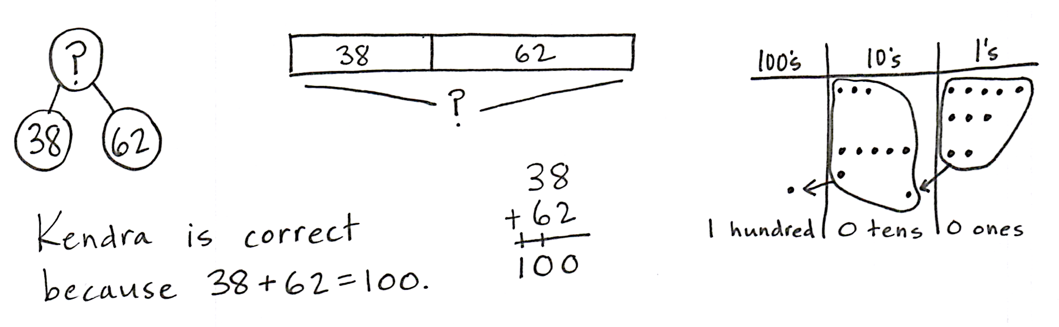Application Problem (6 minutes)

Kendra and Jojo are counting their marbles. Kendra has 38, and Jojo has 62. Kendra says they have 100 marbles altogether, but Jojo says they have 90. Use words, numbers, or a model to prove who is correct.

Note: This problem assesses students’ understanding of composing a new unit—in this case, a ten. Students may use mental strategies, solve vertically, or draw a chip model to explain their reasoning. Encourage students to work independently; afterwards, invite them to share which method they used to solve the problem.

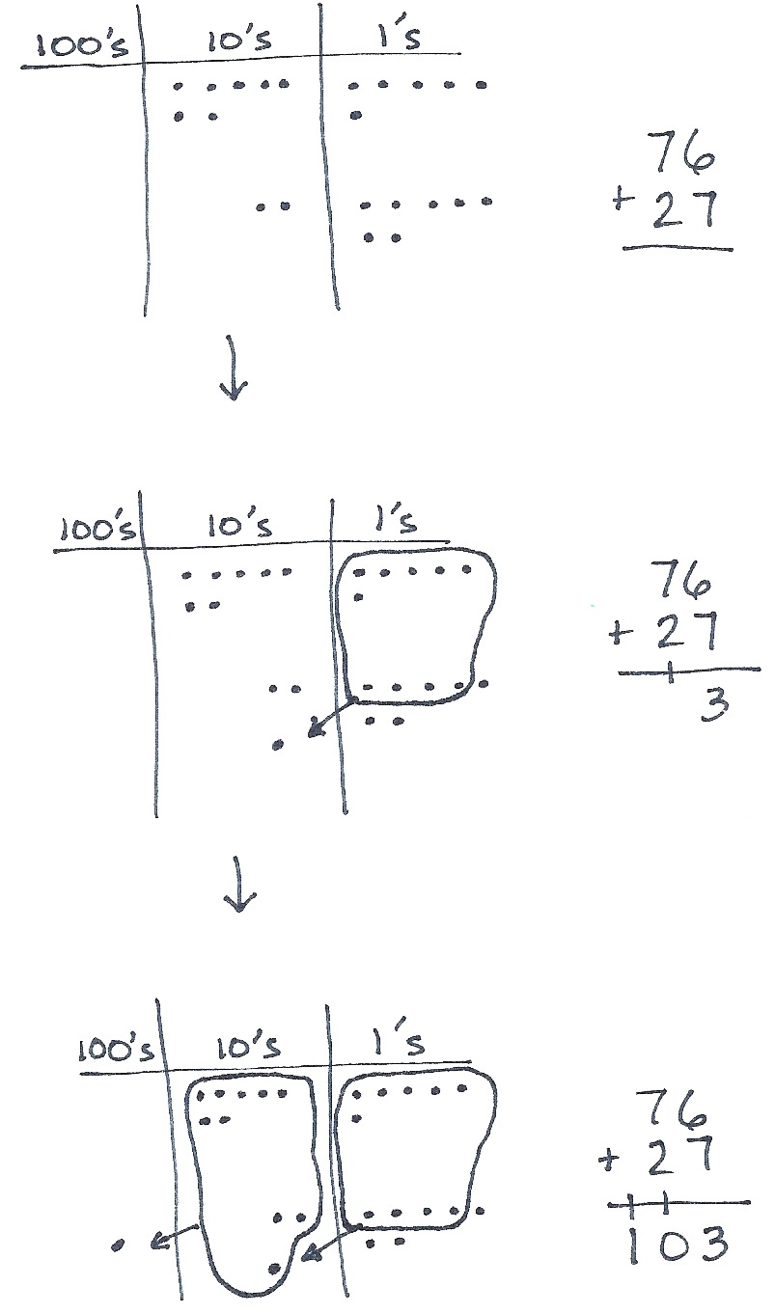Concept Development (34 minutes)

Materials: (S) Math journal or paper

As students write addition problems vertically and make math drawings, remind them to be precise in aligning the digits and in drawing their chips in neat 5-groups.

**MP.6**

Problem 1: 76 + 27

T: Write 76 + 27 the vertical way on your paper.

T: Now, we’ll model it by drawing a place value chart. Draw your chart like mine. (Draw hundreds, tens, and ones chart.)

T: Label the hundreds place, the tens place, and the ones place.

T: Draw a model of each addend. Since each place on our chart is labeled, we don’t need to label disks. We’ll just draw chips. Remember, the place tells us the value, or how much each chip is worth.

T: Whisper-count as you draw your model. (Draw a chip model of 76 + 27. See image to the right.)

S: (Make a chip model.) 10, 20, 30 … 76. 10, 20, 21 … 27.

T: Use place value language to tell your partner how your model matches the vertical form.

|  |  |
| --- | --- |
|  | NOTES ON MULTIPLE MEANS  OF ENGAGEMENT: |
| As the number of digits increases, it becomes more challenging to keep the places aligned. Remember that lined paper turned 90 degrees, so the lines are vertical, makes a convenient guide to help students line up their numbers. | |

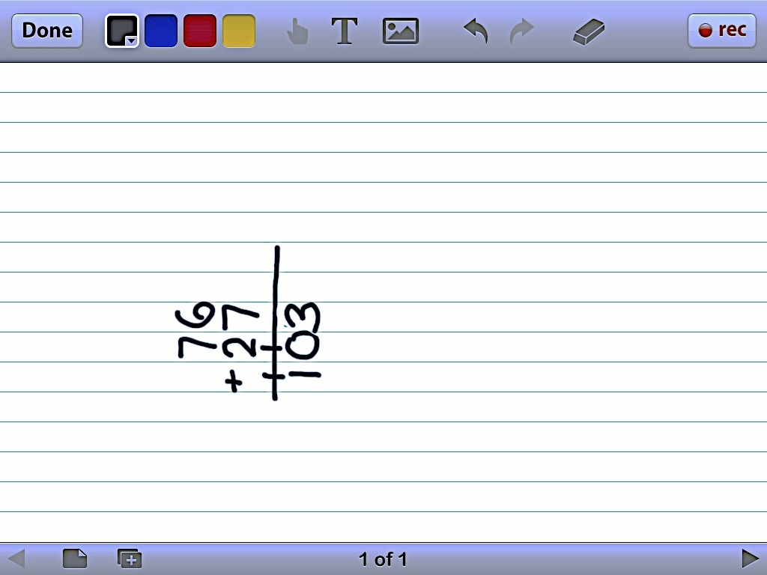

S: My model shows 7 tens 6 ones and 2 tens 7 ones. That’s the same as 76 + 27.

T: Look at the ones first. What is 6 ones + 7 ones?

S: 13 ones!

T: The Say Ten way?

S: Ten 3.

T: Tell your partner what to do on your model and on your written problem.

S: Circle 10 ones and draw an arrow to the tens place; then, put a dot to show the new ten. 🡪 Write a 3 in the ones place and the new ten on the line below the tens place. 🡪 Rename 13 ones as 1 ten 3 ones.

T: Let’s show that on our models and on the written addition, or vertical form.

S: (Circle 10 ones, draw an arrow to the tens place and a chip representing the new unit, and write 1 on the line below the tens place. See above image.)

T: Partners, check each other’s work to be sure it is correct.

T: On your written addition, you have written a 1 on the line. On your chart, point to what the 1 stands for. It’s the new…?

**MP.6**

S: (Point to the new ten on the model and respond chorally.) Ten!

T: Yes! (Point to each part.) 6 ones + 7 ones is 13 ones, 1 ten, and 3 ones, so we write 1 new ten on the line below the tens place, and we write 3 ones below the line in the ones place. What do we do next?

S: Add the tens.

T: What is 7 tens + 2 tens + 1 ten?

S: 10 tens! 100!

T: Tell your partner what to do on your model and on your written addition.

S: Circle 10 tens, draw an arrow to the hundreds place, and then draw a chip to show the new hundred.   
🡪 Write 1 on the line below the hundreds place.

|  |  |
| --- | --- |
|  | NOTES ON  MULTIPLE MEANS  OF ACTION AND EXPRESSION: |
| Encourage those students who prefer to solve these problems mentally using the arrow way, or compensation, to do so in order to confirm their answers and to practice this method. Explain that as the number of digits increases, it is more challenging to solve these problems mentally.  Some students will benefit from more challenging problems with a greater number of digits. Encourage these students to write problems for each other to solve once they have completed their classwork. | |

T: Show this next step on your model and on the written addition.

S: (Model and write. See image on the previous page.)

T: What’s the value of the 1 on the line below the hundreds place? Point to it on your chart.

S: (Point to the new hundred.) 100!

T: Yes! And how many tens should we write below the line in the tens place? Look at your drawing.

S: 0!

T: Read the entire problem.

S: 76 + 27 = 103.

T: Point to where each digit is represented in your drawing.

T: How many times did you rename or bundle?

S: Two times.

T: Tell your partner how you know when to rename.

S: When I have more than 9 in one place, and I can make a bundle of 10 of that unit. 🡪 It’s a pattern! When you have 10 or more in one place, you make 1 of the next biggest unit.

Follow the procedure above to guide students as they model, write, and solve 42 + 96. Have students share how each step in the drawing matches each step in the written addition.

Continue with the following possible sequence: 42 + 67, 53 + 97, 86 + 48, and 99 + 99. Continue to support students who struggle, but as students demonstrate understanding, instruct them to work on the Problem Set independently.

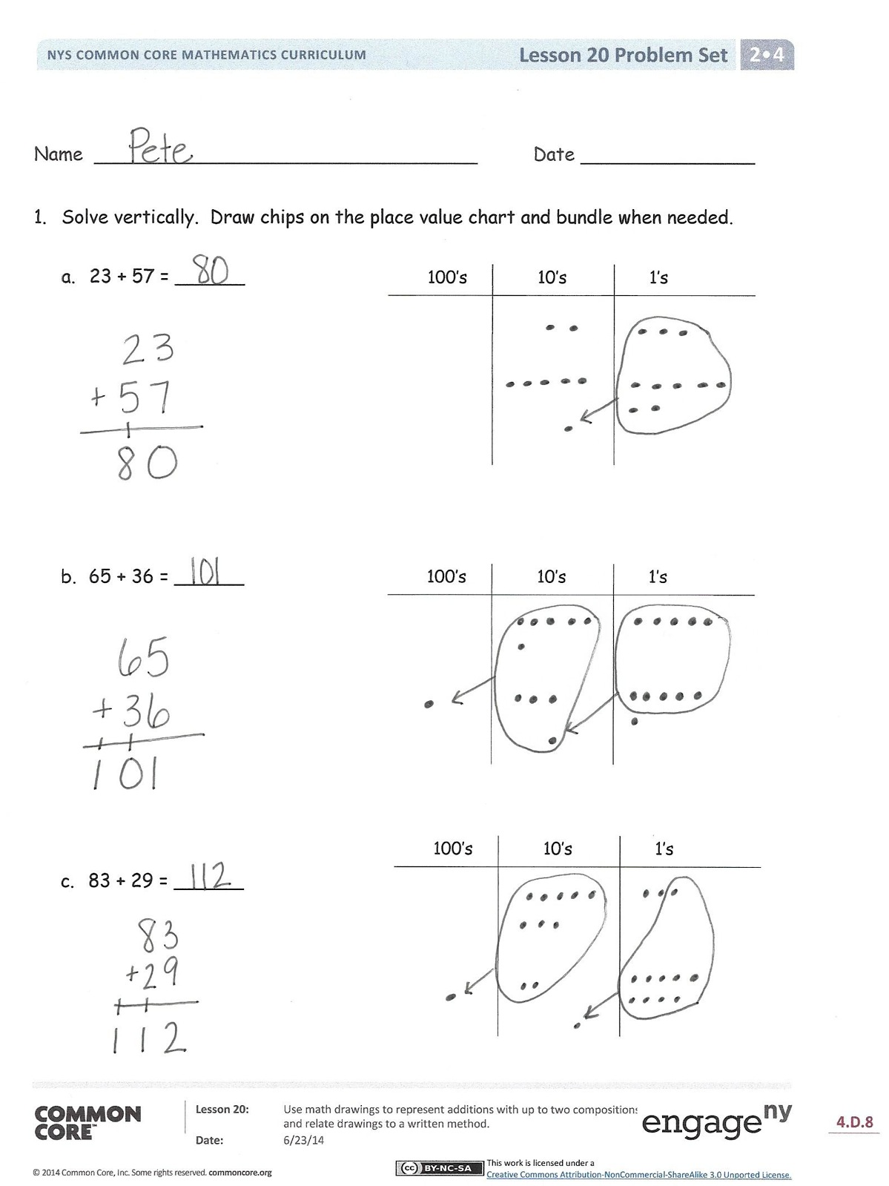Problem Set (10 minutes)

Students should do their personal best to complete the Problem Set within the allotted 10 minutes. For some classes, it may be appropriate to modify the assignment by specifying which problems they work on first. Some problems do not specify a method for solving. Students should solve these problems using the RDW approach used for Application Problems.

Student Debrief (10 minutes)

**Lesson Objective:** Use math drawings to represent additions with up to two compositions and relate drawings to a written method.

The Student Debrief is intended to invite reflection and active processing of the total lesson experience.

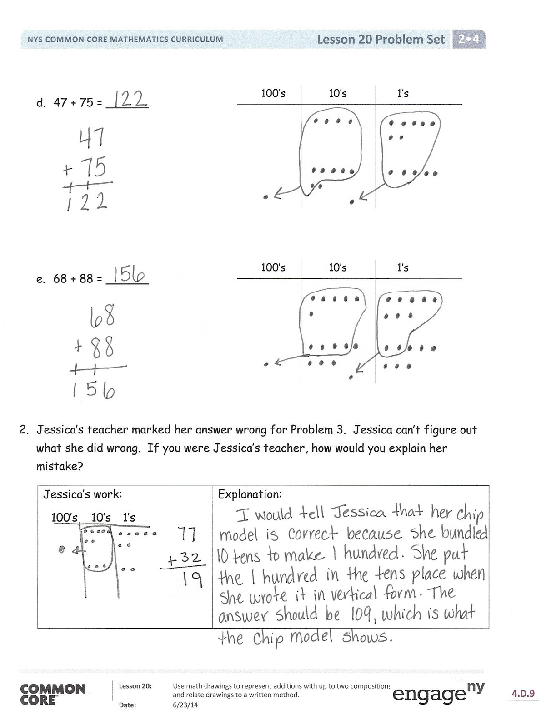Invite students to review their solutions for the Problem Set. They should check work by comparing answers with a partner before going over answers as a class. Look for misconceptions or misunderstandings that can be addressed in the Debrief. Guide students in a conversation to debrief the Problem Set and process the lesson.

You may choose to use any combination of the questions below to lead the discussion.

* Explain to your partner how you solved Problems 1(a) and (b). What significant differences do you notice about the place value charts for these two parts of the problem? Why?
* For Problem 1(c), use place value language to explain to your partner how your model matches vertical form.
* One student’s answer for Problem 1(d), 47 + 75, was 112. Was she correct? What mistake did she make in vertical form?
* Look carefully at Problem 1(e), 68 + 88. Could you have solved this problem mentally? How?
* Think about your math drawings. How did you know when to rename ones? Tens? What did that look like in vertical form?

Exit Ticket (3 minutes)

After the Student Debrief, instruct students to complete the Exit Ticket. A review of their work will help you assess the students’ understanding of the concepts that were presented in the lesson today and plan more effectively for future lessons. You may read the questions aloud to the students.





Name Date

1. Solve vertically. Draw chips on the place value chart and bundle, when needed.

100’s

10’s

1’s

1. 23 + 57 = ______

100’s

10’s

1’s

1. 65 + 36 = ______

100’s

10’s

1’s

1. 83 + 29 = ______
2. 47 + 75 = ______

100’s

10’s

1’s

100’s

10’s

1’s

1. 68 + 88 = ______
2. Jessica’s teacher marked her work incorrect for the following problem. Jessica cannot figure out what she did wrong. If you were Jessica’s teacher, how would you explain her mistake?

|  |  |
| --- | --- |
| *Jessica’s work:*  100’s 10’s 1’s | Explanation: |

Name Date

Solve vertically. Draw chips on the place value chart and bundle, when needed.

100’s

10’s

1’s

1. 46 + 65 = ______

100’s

10’s

1’s

1. 74 + 57 = ______

Name Date

1. Solve vertically. Draw chips on the place value chart and bundle, when needed.

100’s

10’s

1’s

1. 41 + 39 = ______

100’s

10’s

1’s

1. 54 + 26 = ______

100’s

10’s

1’s

1. 96 + 39 = ______
2. 84 + 79 = ______

100’s

10’s

1’s

100’s

10’s

1’s

1. 65 + 97 = ______
2. For each box, find and circle two numbers that add up to 150.

|  |  |  |
| --- | --- | --- |
| 67 63  73 83  57 | 48 92  68 62  58 | 75 55  65 45  75 |