Lesson 19
Objective: Relate manipulative representations to a written method.

Suggested Lesson Structure
 Fluency Practice (10 minutes)
 Application Problem (8 minutes)
 Concept Development (32 minutes)
 Student Debrief (10 minutes)
Total Time (60 minutes)
Fluency Practice (10 minutes)
- Addition Fact Flash Cards 2.OA.2 (2 minutes)
- Adding Ones to Make Tens 2.NBT.5 (4 minutes)
- Adding Tens and Ones 2.NBT.5 (4 minutes)
Addition Fact Flash Cards (2 minutes)
Materials: (T) Addition flash cards (Fluency Template)
Note: This is a teacher-directed, whole-class activity. By practicing addition facts, students gain fluency adding within 20.
Adding Ones to Make Tens (4 minutes)
Note: Students practice changing ones for tens in preparation for today’s lesson.
T: What is 1 more than 29 ones?
S: 30 ones.
T: How many tens are in 30 ones?
S: 3 tens.
T: 2 more than 58 ones.
S: 60 ones.
T: How many tens are in 60 ones?
S: 6 tens.
Continue with the following possible sequence: 3 more than 37 ones, 5 more than 75 ones, and 8 more than 92 ones.
Adding Tens and Ones (4 minutes)
Note: This fluency activity supports students adding like units by seeing the addends in expanded form.
T: (Write 60 + 20 = _____.)
60 + 20 = 80
6 + 4 = 10
66 + 24 = 90
T: 60 + 20 is…?
S: 80.
T: (Write 6 + 4 below 60 + 20.) 6 + 4 is…?
S: 10.
T: 80 + 10 is…?
S: 90.
T: (Write 66 + 24 below 6 + 4.) 66 + 24 is…?
S: 90.
Continue with the following possible sequence: 35 + 25, 44 + 26, 57 + 33, 58 + 52, and 66 + 64.
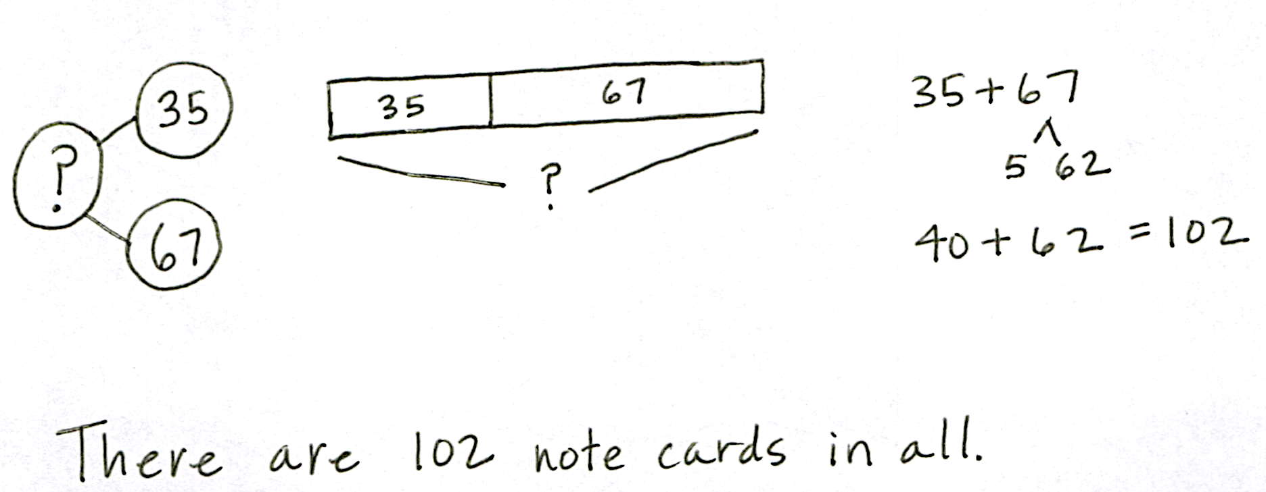
Application Problem (8 minutes)
There are 35 note cards in one box. There are 67 note cards in another box. How many note cards are there in all?
Note: This problem provides a simple context for students to focus on their place value model and the calculation. Encourage students to use the RDW process and to solve independently using the vertical form and a place value chart.
Concept Development (32 minutes)
Materials: (T) Place value disks, unlabeled hundreds place value chart (Lesson 18 Template)
(S) Per pair: personal white board, unlabeled hundreds place value chart (Lesson 18 Template), place value disks (2 hundreds, 18 tens, 18 ones), place value disks (Lesson 6 Template)
Note: Throughout the Concept Development, students work with a partner. For each problem, students whisper-count as they take turns modeling and writing each addend. They may count the regular way (10, 20, 30, …) or the Say Ten way (1 ten, 2 tens, …). One student records each change in vertical form step by step as the other partner moves the place value disks.
Project or draw a place value chart on the board.
T: Partner A, write 54 + 68 on your personal white board. (Write 54 + 68 on the board vertically.)
MP.4
T: Whisper-count as Partner B models 54 and 68 on your place value chart. Remember to place your disks from left to right and create 5-groups whenever possible.
T: Where do we begin adding?
S: In the ones place.
MP.4

NOTES ON
MULTIPLE MEANS
OF ENGAGEMENT:
For students who are not fluent with their partners to ten, choose from a variety of tools to promote automaticity such as the ones listed below:
- Number bond flash cards.
- Music videos such as “They’re Friends of Ten,” at http://www.youtube.com/watch?v=o0bKIeYdvCc.
- A Rekenrek, where they can see and handle the pairs that make ten.
As you choose supplementary materials, consider what best suits each individual student needing remediation.

T: Look at your ones column. Can we make a unit of 10?
S: Yes!
T: Now look at the vertical form. Use place value language to explain to your partner how you know, just by looking at the digits in the ones place, if you need to rename (or bundle) the ones.
S: 8 only needs 2 to make 10, and 4 is more than 2.
4 ones and 8 ones is 12 ones. That’s 1 ten and 2 ones.
T: Rename 12 ones on your place value chart. How do we show this in vertical form?
S: Write the new ten on the line below the tens place and write 2 below the line in the ones place.
T: Partner A, let’s record that. (Model the step in vertical form.) What should we do next?
S: Add the tens.
T: This time, look at the digits in the tens place before using the disks. Tell your partner whether you’ll need to rename, and explain why.

NOTES ON
MULTIPLE MEANS
OF ACTION AND EXPRESSION:
If students think of creative methods to solve the problem, invite them to demonstrate these to the rest of the class. For example,
S: I added 54 to 68 by remembering my doubles, so 50 + 50 = 100 with one ten left over, which makes 110; then, 4 + 8 = 12, so the whole thing is 122.

S: We need to rename because I know my partners to ten. 5 only needs 5 more to make a ten.
5 tens + 6 tens + 1 ten is 12 tens. That’s 120.
50 + 60 + 10 is 120.
T: Rename 12 tens on your place value chart.
S: (Rename 12 tens as 1 hundred 2 tens.)
T: How do we show this with the algorithm?
S: Write the new hundred on the line below the hundreds place, and write 2 below the line in the tens place.
T: Let’s record that. (Model the step in vertical form.) How many hundreds do we have?
S: 1 hundred.
T: Read the entire problem.
S: 54 + 68 = 122.
T: Talk with your partner. Explain each change you made on your place value chart and how you showed each step in vertical form.
T: Partners, it’s time to solve some addition problems on your own! Be sure to explain how each change you make on the place value chart matches each step in vertical form.
Repeat the procedure above with the following possible sequence: 38 + 65, 19 + 92, 126 + 57, and 115 + 85. Circulate to check for understanding. As students demonstrate proficiency in relating the place value disks and charts to the vertical form, allow them to work independently on the Problem Set.
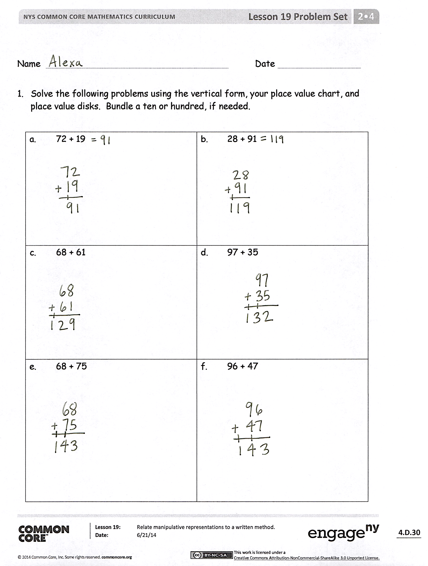
Problem Set (10 minutes)
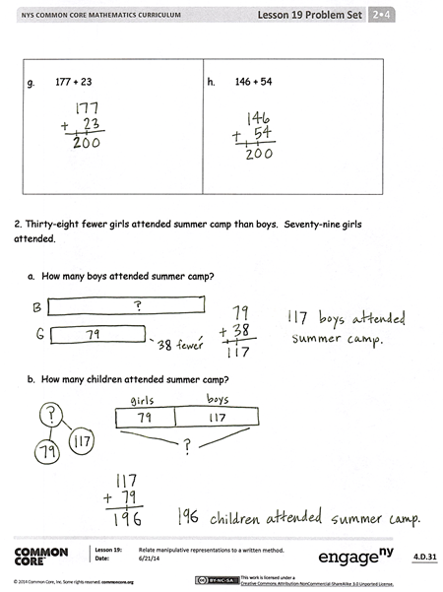
Students should do their personal best to complete the Problem Set within the allotted 10 minutes. For some classes, it may be appropriate to modify the assignment by specifying which problems they work on first. Some problems do not specify a method for solving. Students should solve these problems using the RDW approach used for Application Problems.
Student Debrief (10 minutes)
Lesson Objective: Relate manipulative representations to a written method.
The Student Debrief is intended to invite reflection and active processing of the total lesson experience.
Invite students to review their solutions for the Problem Set. They should check work by comparing answers with a partner before going over answers as a class. Look for misconceptions or misunderstandings that can be addressed in the Debrief. Guide students in a conversation to debrief the Problem Set and process the lesson. You may choose to use any combination of the questions below to lead the discussion.
- For Problems 1(a) and (b), did you compose a ten? A hundred? How did you show it on your place value chart?
- Explain to your partner how to solve Problems 1(c) and (d). How did you show a new unit of ten or hundred on your place value chart and in vertical form?
- What do you notice about the totals in Problems 1(e) and 1(f)?
- For Problem 1(e), what did you need to be sure to do when you were solving 68 + 75 using vertical form? Did anyone try to solve this mentally? How?
- What is the answer for Problem 1(f), 96 + 47? How many tens and ones are in the answer (i.e., 143 = ____ tens ____ ones)? How did you rename those tens in the algorithm?
- Look again at Problem 1(h), 146 + 54. How could you have used a number bond as a simplifying strategy to solve this problem?
Exit Ticket (3 minutes)
After the Student Debrief, instruct students to complete the Exit Ticket. A review of their work will help you assess the students’ understanding of the concepts that were presented in the lesson today and plan more effectively for future lessons. You may read the questions aloud to the students.
Name Date
- Solve the following problems using the vertical form, your place value chart, and place value disks. Bundle a ten or hundred, if needed.
- 72 + 19 | - 28 + 91
- 68 + 61 | - 97 + 35
- 68 + 75 | - 96 + 47
- 177 + 23 | - 146 + 54

- Thirty-eight fewer girls attended summer camp than boys. Seventy-nine girls attended.
  - How many boys attended summer camp?

  - How many children attended summer camp?

Name Date
Solve the following problems using the vertical form, your place value chart, and place value disks. Bundle a ten or hundred, if needed.

- 47 + 85

- 128 + 39

Name Date
- Solve the following problems using the vertical form, your place value chart, and place value disks. Bundle a ten or hundred, if needed.
- 84 + 37 | - 42 + 79
- 58 + 56 | - 46 + 96
- 75 + 69 | - 48 + 94
- 162 + 38 | - 156 + 44

- Seventy-four trees were planted in the garden. Forty-nine more bushes were planted than trees in the garden.
  - How many bushes were planted?

  - How many trees and bushes were planted?

9 +_=10 | 2 + 9
9 + 3 | 4 + 9
5 +_=14 | 9 + 6
7 + 9 | 9 +_=17
9 + 9 | 10 + 9
8 +_= 9 | 2 + 8
8 + 3 | 4 + 8
5 + 8 | 8 + 6
8 +_=15 | 8 + 8
9 +_=17 | 10 + 8
1 + 7 | 2 +_= 9
7 + 3 | 4 + 7
5 +_=12 | 6 + 7
7 +_=14 | 7 + 8
9 + 7 | 7 + 10
1 + 6 | 6 + 2
6 +_=9 | 4 + 6
6 + 5 | 6 +_=12
7 + 6 | 8 + 6
9 +_=15 | 6 + 10
5 + 1 | 2 + 5
5 +_=8 | 4 +_=9
5 + 5 | 6 +_=11
7 + 5 | 5 + 8
5 +_=14 | 10 + 5
4 + 1 | 2 + 4
4 +_=7 | 4 +_=8
4 + 5 | 6 +_=10
7 + 4 | 4 + 8
4 +_=13 | 10 + 4
1 + 3 | 2 + 3
3 +_=6 | 4 + 3
3 + 5 | 6 + 3
7 +_=10 | 3 +_=11
3 + 9 | 13=3+_
2 + 1 | 2 + 2
3 +_=5 | 4 + 2
2 + 5 | 6 + 2
7 +_=9 | 8 + 2
2 + 9 | 10 + 2

addition flash cards
addition flash cards
addition flash cards
addition flash cards
addition flash cards
addition flash cards
addition flash cards
addition flash cards
addition flash cards
addition flash cards

