Lesson 17
Objective: Use mental strategies to relate compositions of 10 tens as
1 hundred to 10 ones as 1 ten.

Suggested Lesson Structure
 Fluency Practice (10 minutes)
 Concept Development (32 minutes)
 Application Problem (8 minutes)
 Student Debrief (10 minutes)
Total Time (60 minutes)
Fluency Practice (10 minutes)
- Compensation 2.NBT.5 (5 minutes)
- Rename the Units 2.NBT.1 (5 minutes)
Compensation (5 minutes)
Note: This fluency exercise reviews the mental math strategy taught in Lesson 4, using compensation to add the same amount to each addend. By making a multiple of 10, students solve a much simpler addition problem.
T: (Write 42 + 19 = _____.) Let’s use a mental math strategy to add. How much more does 19 need to make the next ten?
S: 1 more.
T: Where can 19 get 1 more from?
S: From the 42!
T: Take 1 from 42 and give it to 19. Say the simplified number sentence, with the answer.
S: 41 + 20 = 61.
T: 37 + 19. Say the simplified number sentence, with the answer.
S: 36 + 20 = 56.
Continue with the following possible sequence: 29 + 23, 38 + 19, 32 + 19, 24 + 17, and 34 + 19.

Rename the Units (5 minutes)
Note: This fluency exercise reviews foundational concepts that support today’s lesson.
T: (Write 10 ones = _____ ten ____ ones.) Say the number sentence.
S: 10 ones = 1 ten 0 ones.
T: (Write 20 ones = 1 ten _____ ones.) Say the number sentence.
S: 20 ones = 1 ten 10 ones.
T: (Write 24 ones = 1 ten _____ ones.) Say the number sentence.
S: 24 ones = 1 ten 14 ones.
T: (30 ones = 2 tens ___ ones.) Say the number sentence.
S: 30 ones = 2 tens 10 ones.
Repeat the process for 32, 38, 40, 41, 46, 50, 63, and 88.

NOTES ON
MULTIPLE MEANS
OF ENGAGEMENT:
Have the students skip-count by tens from 0 to 200 and back to 0. Improve concentration by having the students touch their lifted right knee with their left hand, and vice versa, alternating with each count.

Concept Development (32 minutes)
T: Show me your magic counting sticks.
S: (Hold up all 10 fingers).
T: Give them a value of one. Count with me.
S: 1, 2, …10! (On 10, students clasp their hands together with a loud clap, interlacing their fingers to make one unit of 10.)
T: How many ones in 1 ten?
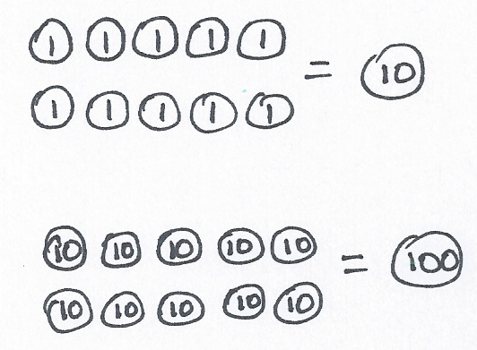
S: 10 ones!
T: Yes! (Draw image at right on the board.) 10 ones equal 1 ten.
T: Hold up your magic counting sticks again. This time, give them each a value of ten. Count with me.
S: 10, 20, …100!
T: How many tens in 1 hundred?
S: 10 tens!
T: Correct! (Draw image at right on the board.) 10 tens equal 1 hundred.
T: (Write 1 one + ___ = 10 ones = 1 ten.) Read these sentences aloud, filling in the blanks.
S: 1 one plus 9 ones equals 10 ones equals 1 ten.
T: (Write 1 ten + ___ = 10 tens = 1 hundred.) Read these sentences.
S: 1 ten plus 9 tens equals 10 tens equals 1 hundred.
T: Talk with your partner. How are these statements the same and different?

S: Both have 1 plus 9. The only thing that changes is if it’s ones or tens. They both have a group of 10, but when you add 10 ones, you make a ten, and when you add 10 tens, you make a hundred.
T: How is making a ten similar to making a hundred?
S: It’s the same, but instead of using ones to make a ten, you use tens to make a hundred.
10 ones make a ten, and 10 tens make a hundred. Ten of the same unit makes 1 of the next higher unit, like 10 ones makes 1 ten, and 10 tens makes 1 hundred. Ten of the same unit makes a unit of the next higher place value.
T: What’s 6 ones + 4 ones?
S: 10 ones! 1 ten!

NOTES ON
MULTIPLE MEANS
OF REPRESENTATION:
Explain to students who are struggling with the concept that adding tens is like adding apples. If you add 12 apples and 5 apples, you get 17 apples. It is the same with tens: If you add 12 tens (120) and 5 tens (50), you get 17 tens (170). Demonstrate with place value disks if students continue to struggle.

T: 6 tens + 4 tens is…?
S: 10 tens! 1 hundred!
T: 60 + 40 is…?
S: 100!
T: 7 ones + 6 ones is…?
S: 13 ones.
T: 7 + 6 is…?
S: 13.
T: 7 tens + 6 tens is…?
S: 13 tens.
T: 13 tens equals is…?
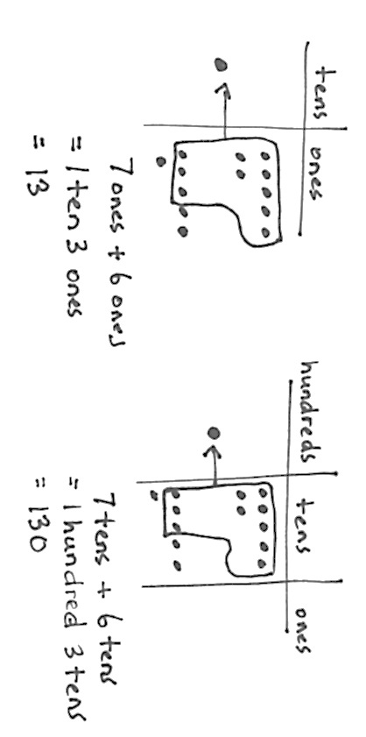
S: 130.
T: 70 + 60 is…?
S: 130.
T: Pretend your partner is a family member. How can you prove to her that 13 tens is the same as 130?
S: Count by tens 13 times. Show 13 tens on a place value chart. When you circle 10 tens, you get a hundred, and there are still 3 tens left. Show her 13 tens the break apart way, so she sees 13 tens is the same as
10 tens + 3 tens, 100 + 30 = 130!
MP.3
T: Excellent reasoning! So, 10 tens is…?
S: 100!
T: 11 tens is…?
S: 110!
T: 16 tens is…?
S: 160!
T: 19 tens is…?
S: 190!
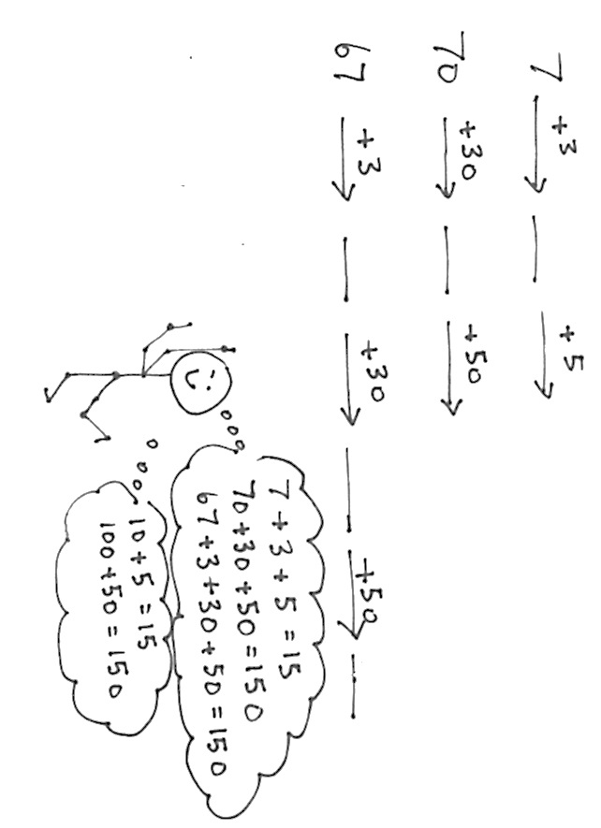
T: 20 tens…?
S: 200!
T: Now, let’s make tens and hundreds. (On the board, write the problem pictured at right.)
T: Talk with your partner. What numbers go into the blanks?
S: The numbers in the blanks were 10, 15, and 100, 150 and 70, 100, 150. I see a pattern.
T: Find the total in each problem.
S: 15 and 150!
T: Explain the relationship between the first problem and the two last problems.
S: First, we made a ten; then, we made a hundred. And all the answers are alike, 15 ones and
15 tens. The last one had an extra step because we had to get to the ten.
Repeat with the following possible sequence: 64 + 6 + 10 + 10 + 10, 85 + 5 + 10 + 100, and 171 + 9 + 20.
As students demonstrate an understanding of adding 10 or 100, allow them to work on the Problem Set independently.
Problem Set (10 minutes)
Students should do their personal best to complete the Problem Set within the allotted 10 minutes. For some classes, it may be appropriate to modify the assignment by specifying which problems they work on first. Some problems do not specify a method for solving. Students should solve these problems using the RDW approach used for Application Problems.
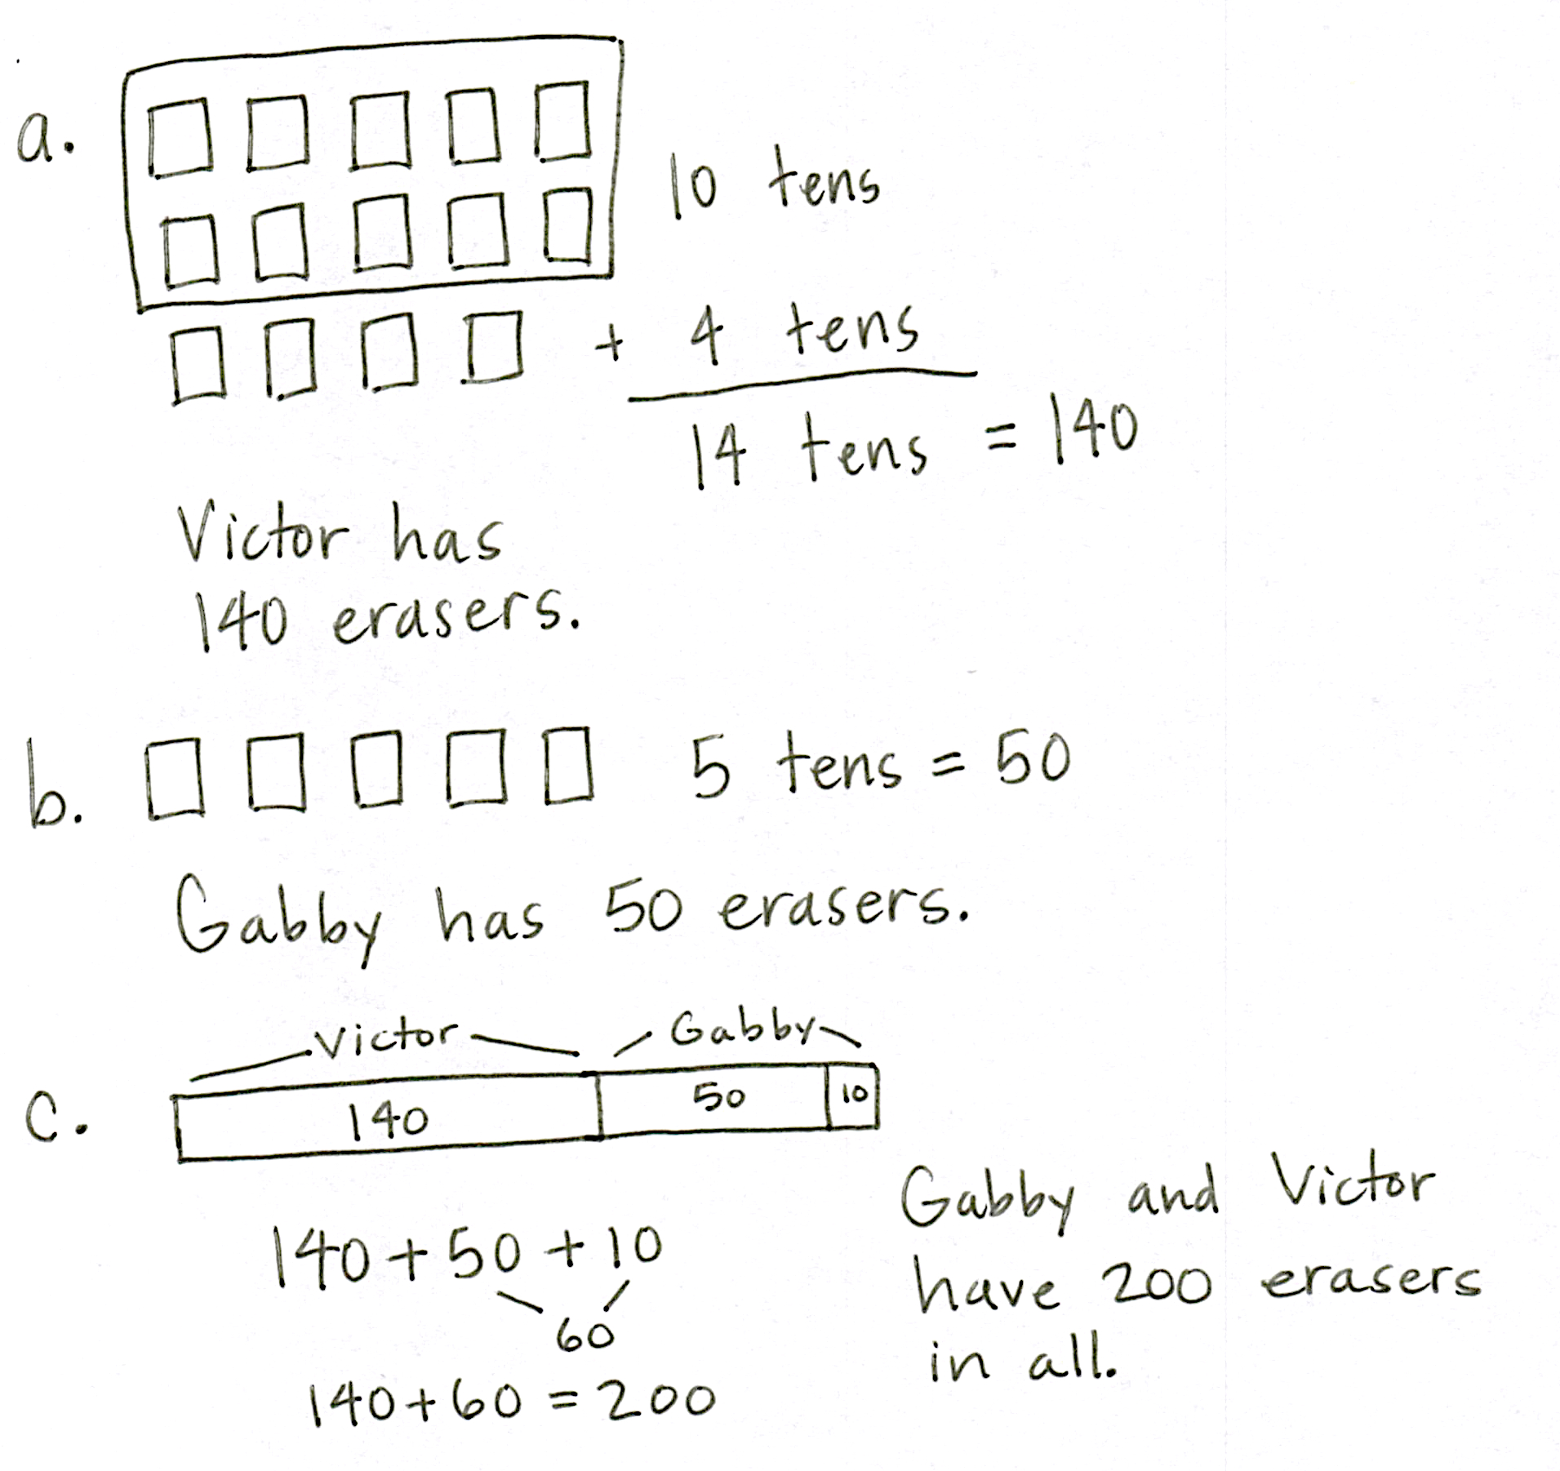
Application Problem (8 minutes)
Erasers come in boxes of 10. Victor has 14 boxes. Gabby has 5 boxes.
- How many erasers does Victor have?
- How many erasers does Gabby have?
- If Gabby gets another box, how many erasers do they have in all?
Note: This Application Problem follows the Concept Development, inviting students to apply their understanding of mental strategies for composing 1 hundred and 1 ten to a real world context.
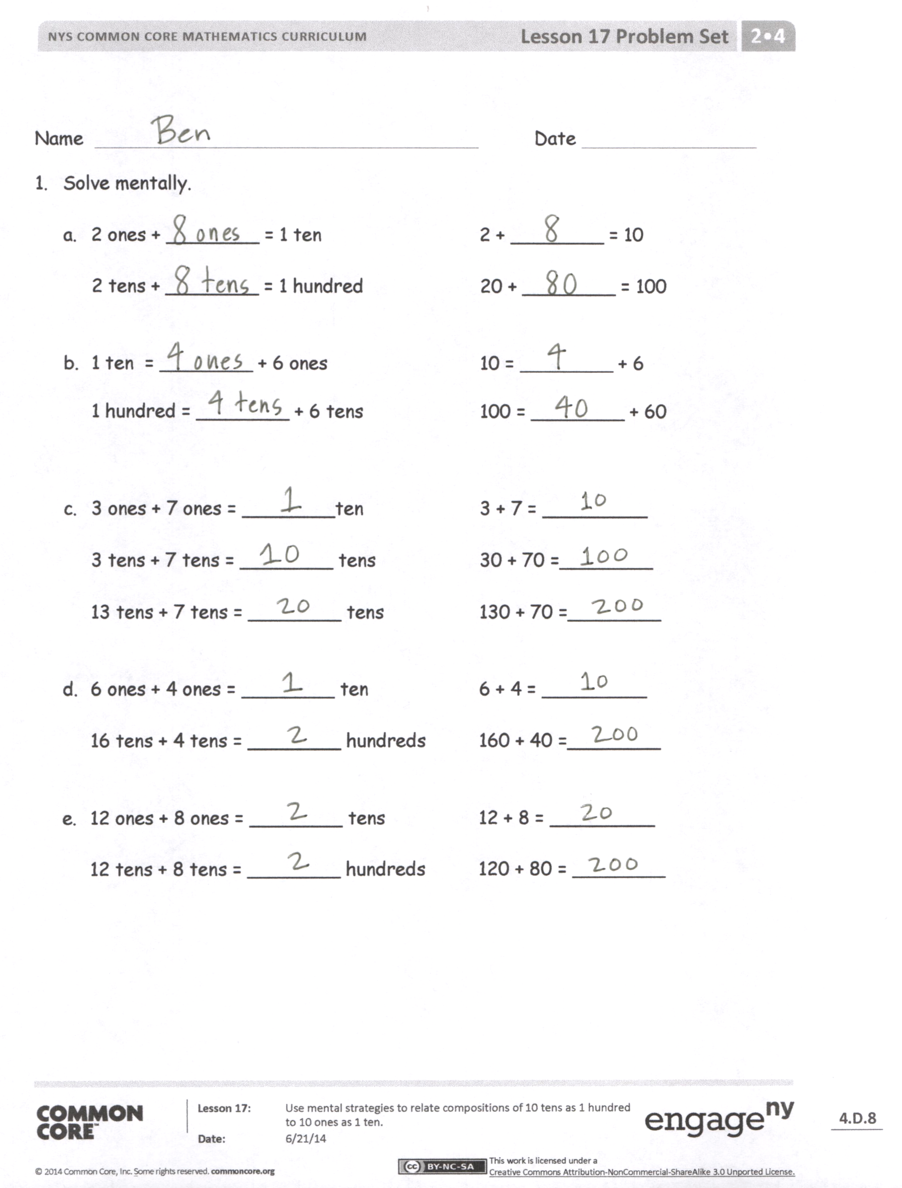
Student Debrief (10 minutes)
Lesson Objective: Use mental strategies to relate compositions of 10 tens as 1 hundred to 10 ones as 1 ten.
The Student Debrief is intended to invite reflection and active processing of the total lesson experience.
Invite students to review their solutions for the Problem Set. They should check work by comparing answers with a partner before going over answers as a class. Look for misconceptions or misunderstandings that can be addressed in the Debrief. Guide students in a conversation to debrief the Problem Set and process the lesson.
You may choose to use any combination of the questions below to lead the discussion.
- What was the total for each problem in 1(c)? What pattern do you notice? What is the relationship between the first problem and the other two problems?
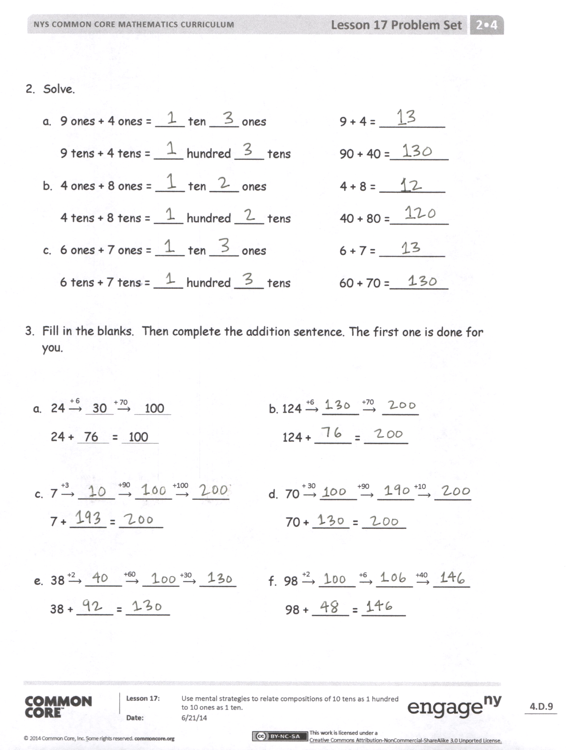
- For Problem 1(d), prove to your partner that 16 tens is the same as 160. Use what you know about the place value chart to support your reasoning.
- How are the problems in 2(a) the same and different? What is the relationship between them?
- For Problems 3(a) and (b), why do we add 6 ones first? How does adding 6 ones and then 7 tens change the totals in each problem?
- Ones, tens, and hundreds are part of a base ten system. Why do you think it is called base ten? What important connection did we make today between ones, tens, and hundreds?
Exit Ticket (3 minutes)
After the Student Debrief, instruct students to complete the Exit Ticket. A review of their work will help you assess the students’ understanding of the concepts that were presented in the lesson today and plan more effectively for future lessons. You may read the questions aloud to the students.

Name Date
- Solve mentally.

  - 2 ones + ________ = 1 ten 2 + ________ = 10
2 tens + ________ = 1 hundred 20 + ________ = 100

  - 1 ten = ________ + 6 ones 10 = ________ + 6
1 hundred = ________ + 6 tens 100 = ________ + 60

  - 3 ones + 7 ones = ________ten 3 + 7 = _________

3 tens + 7 tens = ________ tens 30 + 70 = ________

13 tens + 7 tens = ________ tens 130 + 70 = ________

  - 6 ones + 4 ones = ________ ten 6 + 4 = _________

16 tens + 4 tens = ________ hundreds 160 + 40 = ________

  - 12 ones + 8 ones = ________ tens 12 + 8 = _________
12 tens + 8 tens = ________ hundreds 120 + 80 = ________

- Solve.

  - 9 ones + 4 ones = ____ ten ____ ones 9 + 4 = _________

9 tens + 4 tens = ____ hundred ____ tens 90 + 40 = ________

  - 4 ones + 8 ones = ____ ten ____ ones 4 + 8 = _________
4 tens + 8 tens = ____ hundred ____ tens 40 + 80 = ________

  - 6 ones + 7 ones = ____ ten ____ ones 6 + 7 = _________
6 tens + 7 tens = ____ hundred ____ tens 60 + 70 = ________

- Fill in the blanks. Then, complete the addition sentence. The first one is done for you.
+ 70
+ 6
+6
+70
- 24 $⟶$ 30 $⟶$ 100 b. 124 $⟶$ _____ $⟶$ _____
24 + 76 = 100 124 + _____ = ______
+90
+10
+3
+100
+90
+ 30
c. 7 $⟶$ _____ $⟶$ _____ $⟶$ _____ d. 70 $⟶$ _____ $⟶$ _____ $⟶$ _____
7 + _____ = ______ 70 + _____ = ______
+30
+2
+60
+2
+6
+40
e. 38 $⟶$ _____ $⟶$ _____ $⟶$ _____ f. 98 $⟶$ _____ $⟶$ _____ $⟶$ _____
38 + _____ = ______ 98 + _____ = ______

Name Date
- Solve mentally.

  - 4 ones + ________ = 1 ten 4 + ________ = 10
4 tens + ________ = 1 hundred 40 + ________ = 100

  - 2 ones + 8 ones = ________ ten 2 + 8 = ________
2 tens + 18 tens = ________ hundreds 20 + 180 = ________

- Fill in the blanks. Then, complete the addition sentence.
+ 10
+ 10
+ 10
+ 7
63 $⟶$ _____ $⟶$ _____ $⟶$ _____ $⟶$ _____
63 + _____ = ______

Name Date
- Solve mentally.

  - 4 ones + ________ = 1 ten 4 + ________ = 10

4 tens + ________ = 1 hundred 40 + ________ = 100

  - 1 ten = ________ + 7 ones 10 = ________ + 7
1 hundred = ________ + 7 tens 100 = ________ + 70

  - 1 ten more than 9 ones = ________ 10 + 9 = _________
1 hundred more than 9 ones = ________ 100 + 9 = _________
1 hundred more than 9 tens = ________ 100 + 90 = _________

  - 2 ones + 8 ones = ________ ten 2 + 8 = _________

2 tens + 8 tens = ________ hundred 20 + 80 = ________

  - 5 ones + 6 ones = ____ten(s) ____ one(s) 5 + 6 = _________
5 tens + 6 tens = ____hundred(s) ____ ten(s) 50 + 60 = ________

  - 14 ones + 4 ones = ____ ten(s) ____ one(s) 14 + 4 = _________
14 tens + 4 tens = ____ hundred(s) ____ tens(s) 140 + 40 = ________

- Solve.
- 6 ones + 5 ones = ____ ten ____ one 6 + 5 = _________

6 tens + 5 tens = ____ hundred ____ ten 60 + 50 = ________

- 5 ones + 7 ones = ____ ten ____ ones 5 + 7 = _________
5 tens + 7 tens = ____ hundred ____ tens 50 + 70 = ________

  - 9 ones + 8 ones = ____ ten ____ ones 9 + 8 = _________
9 tens + 8 tens = ____ hundred ____ tens 90 + 80 = ________

- Fill in the blanks. Then, complete the addition sentence. The first one is done for you.
+ 10
+ 10
+ 2
+ 30
+ 60
+ 4
- 36 $⟶$ 40 $⟶$ 100 $⟶$ 130 b. 78 $⟶$ _____ $⟶$ _____ $⟶$ _____
36 + 94 = 130 78 + _____ = ______
+ 100
+10
+9
+ 10
+ 10
c. 61 $⟶$ _____ $⟶$ _____ $⟶$ _____ $⟶$ _____ $⟶$ _____
61 + _____ = ______
+ 100
+70
+3
d. 27 $⟶$ _____ $⟶$ _____ $⟶$ _____
27 + _____ = ______

