Lesson 16
Objective: Solve one- and two-step word problems within 100 using strategies based on place value.

Suggested Lesson Structure
 Fluency Practice (10 minutes)
 Concept Development (40 minutes)
 Student Debrief (10 minutes)
Total Time (60 minutes)
Fluency Practice (10 minutes)
- Find the Total 2.NBT.5 (5 minutes)
- Find the Difference 2.NBT.5 (5 minutes)
Find the Total (5 minutes)
Materials: (S) Personal white board
Note: Reviewing this mental math fluency prepares students for understanding the importance of the addition algorithm. Students add to solve word problems in today’s lesson.
T: (Write 25 + 73 =____.) Solve using any method.
T: Change 25 to 125 by writing a one in the hundreds place. What is the total now?
S: 198.
Repeat the process and sequence with 35 + 54 and 135 + 54; 38 + 22 and 138 + 22; 42 + 38 and 142 + 38.
Find the Difference (5 minutes)
Materials: (S) Personal white board
Note: Reviewing subtraction problems in sets prepares students for understanding the importance of the subtraction algorithm. Students subtract to solve word problems in today’s lesson.
T: (Write 48 – 24 =____.) Solve the subtraction problem horizontally or vertically.
Repeat the process and sequence for 48 – 24, 40 – 24; 56 – 15, 50 – 15, 52 – 15; 40 – 38, 60 – 38, and
61 – 38.
Concept Development (40 minutes)
Materials: (S) Math journal or personal white board
Note: This Concept Development is devoted to problem solving. Therefore, the Application Problem is embedded in the lesson. Prepare Problems 1 through 4 in advance for either display or distribution to students.
Suggested Delivery of Instruction for Solving Lesson 16’s Word Problems
1. Model the problem.
Invite two pairs of students, who can successfully model the problem, to work at the board while the others work independently or in pairs at their seats. Review the following questions before solving the first problem.
- Can you draw something?
- What can you draw?
- What conclusions can you make from your drawing?
As students work, circulate. Reiterate the questions above and guide them in drawing their tape diagrams.
After two minutes, have the two pairs of students share only their labeled diagrams.

NOTES ON
MULTIPLE MEANS
OF ENGAGEMENT:
For students who still struggle with making tape diagrams, start with easier subtraction problems that require no regrouping. When they are proficient with drawing the tape diagrams for easier problems, raise the level of difficulty.

For about one minute, encourage the demonstrating students to respond to feedback and questions from their peers.
2. Solve and write a statement.
Discuss strategies for solving problems, drawing attention to the strategy chart created during the Debrief in Lesson 5. Give students two minutes to solve and complete the question and share their work and thought processes with a peer.
Then, instruct students to write their equations and statements of the answer.
3. Assess the solution for reasonableness.
Give students one to two minutes to assess and explain the reasonableness of their solutions.

Problem 1: Solve a single-step take from with change unknown word problem using a tape diagram and chip model.
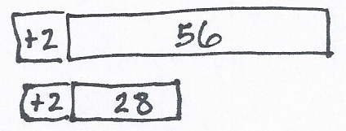
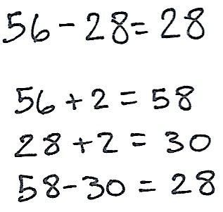
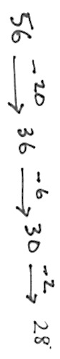
Seneca put 56 beads on a necklace. Some beads fell off, but he still has 28 left. How many beads did he lose?

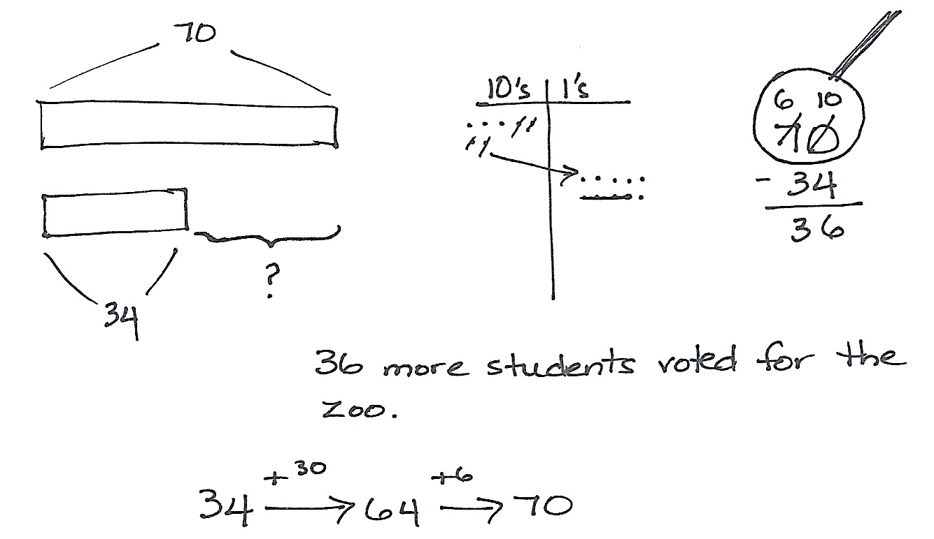

NOTES ON
MULTIPLE MEANS
OF REPRESENTATION:
Remind students that tape diagrams are like part-part-whole (or part-part-part-whole) representations of the problem. If they can identify which are the parts and which is the whole and which of those they need to find, then they will find it easy to solve the problems.

Circulate and ask guiding questions as needed to help students see that we know the whole and one part; therefore, we subtract. By now, students have many strategies at their disposal. As they become successful with the tape diagram and chip model, encourage students to show more than one way to solve. For example, some students may use compensation and show 56 – 28 = 58 – 30 = 28.
Problem 2: Solve a single-step word problem by drawing a tape diagram and chip model.
70 students voted for a field trip to the zoo. 34 students voted for the museum. How many more students voted for the zoo than the museum?
Support students by eliciting the response that we are comparing numbers; we subtract to find how much more 70 is than 34. Again, encourage students to solve in multiple ways once they have correctly modeled and solved using the tape diagram and chip model.
Problem 3: Solve a two-step problem by drawing a tape diagram and chip model.
- Suki has 44 cents. She spends 25 cents on a pencil. How much money does she have left?
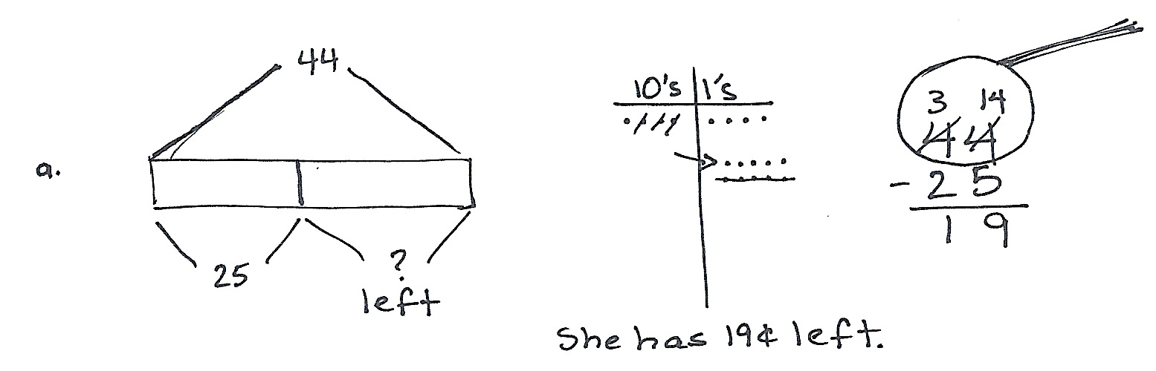
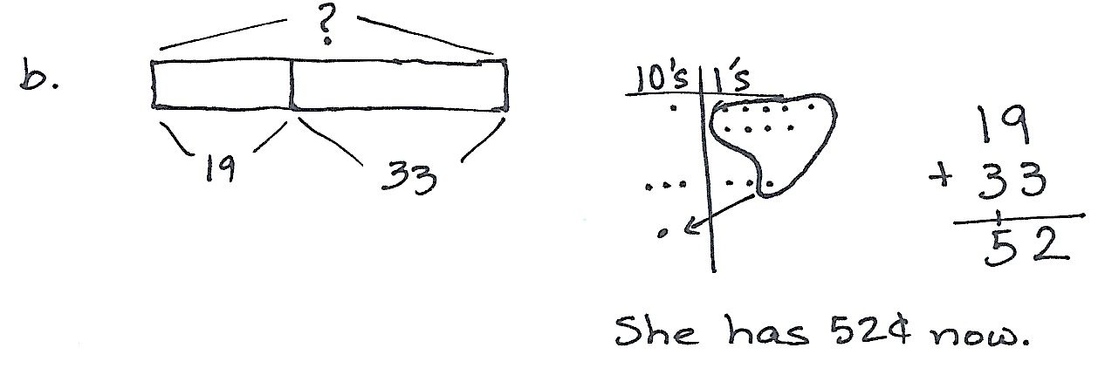
- She finds 33 cents more. How much money does she have now?

Circulate and ask guiding questions as needed to remind students that for each step they must decide if they are finding a missing part or a total.
Problem 4: Solve a two-step problem by using a preferred method.
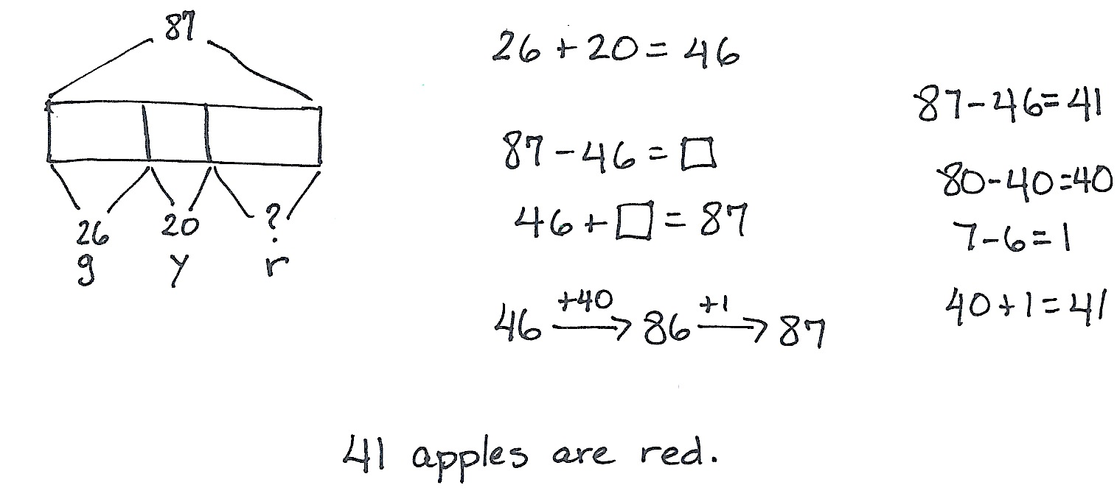
Farmer Ben picks 87 apples. 26 apples are green, 20 are yellow, and the rest are red. How many apples are red?
Circulate and encourage students to use their favorite method to solve. Students should be alert to the relationships of the numbers and recognize when mental strategies are most efficient. Remind them to be prepared to explain their strategy using place value language.
Problem Set (10 minutes)
Students should do their personal best to complete the Problem Set within the allotted 10 minutes. For some classes, it may be appropriate to modify the assignment by specifying which problems they work on first. Some problems do not specify a method for solving. Students should solve these problems using the RDW approach used for Application Problems.

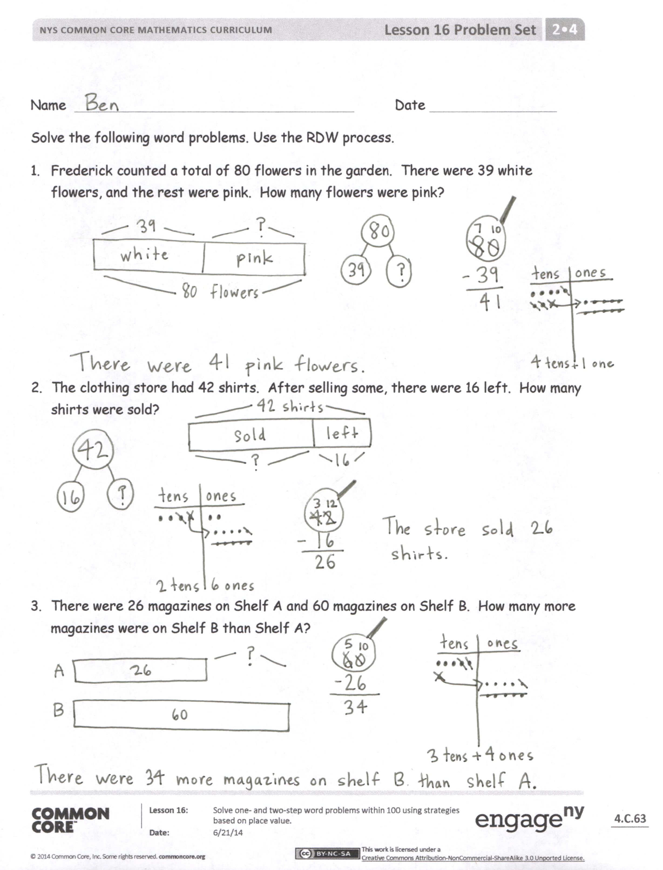
Student Debrief (10 minutes)
Lesson Objective: Solve one- and two-step word problems within 100 using strategies based on place value.
Invite students to review their solutions for the Problem Set. They should check work by comparing answers with a partner before going over answers as a class. Look for misconceptions or misunderstandings that can be addressed in the Debrief. Guide students in a conversation to debrief the Problem Set and process the lesson.
You may choose to use any combination of the questions below to lead the discussion.
- How could you use a tape diagram to solve Problem 1? Which strategy did you use to solve? Could you have used a different simplifying strategy?
- Which operation did you choose to solve Problem 2? Why? How does a tape diagram help you to show the situation?
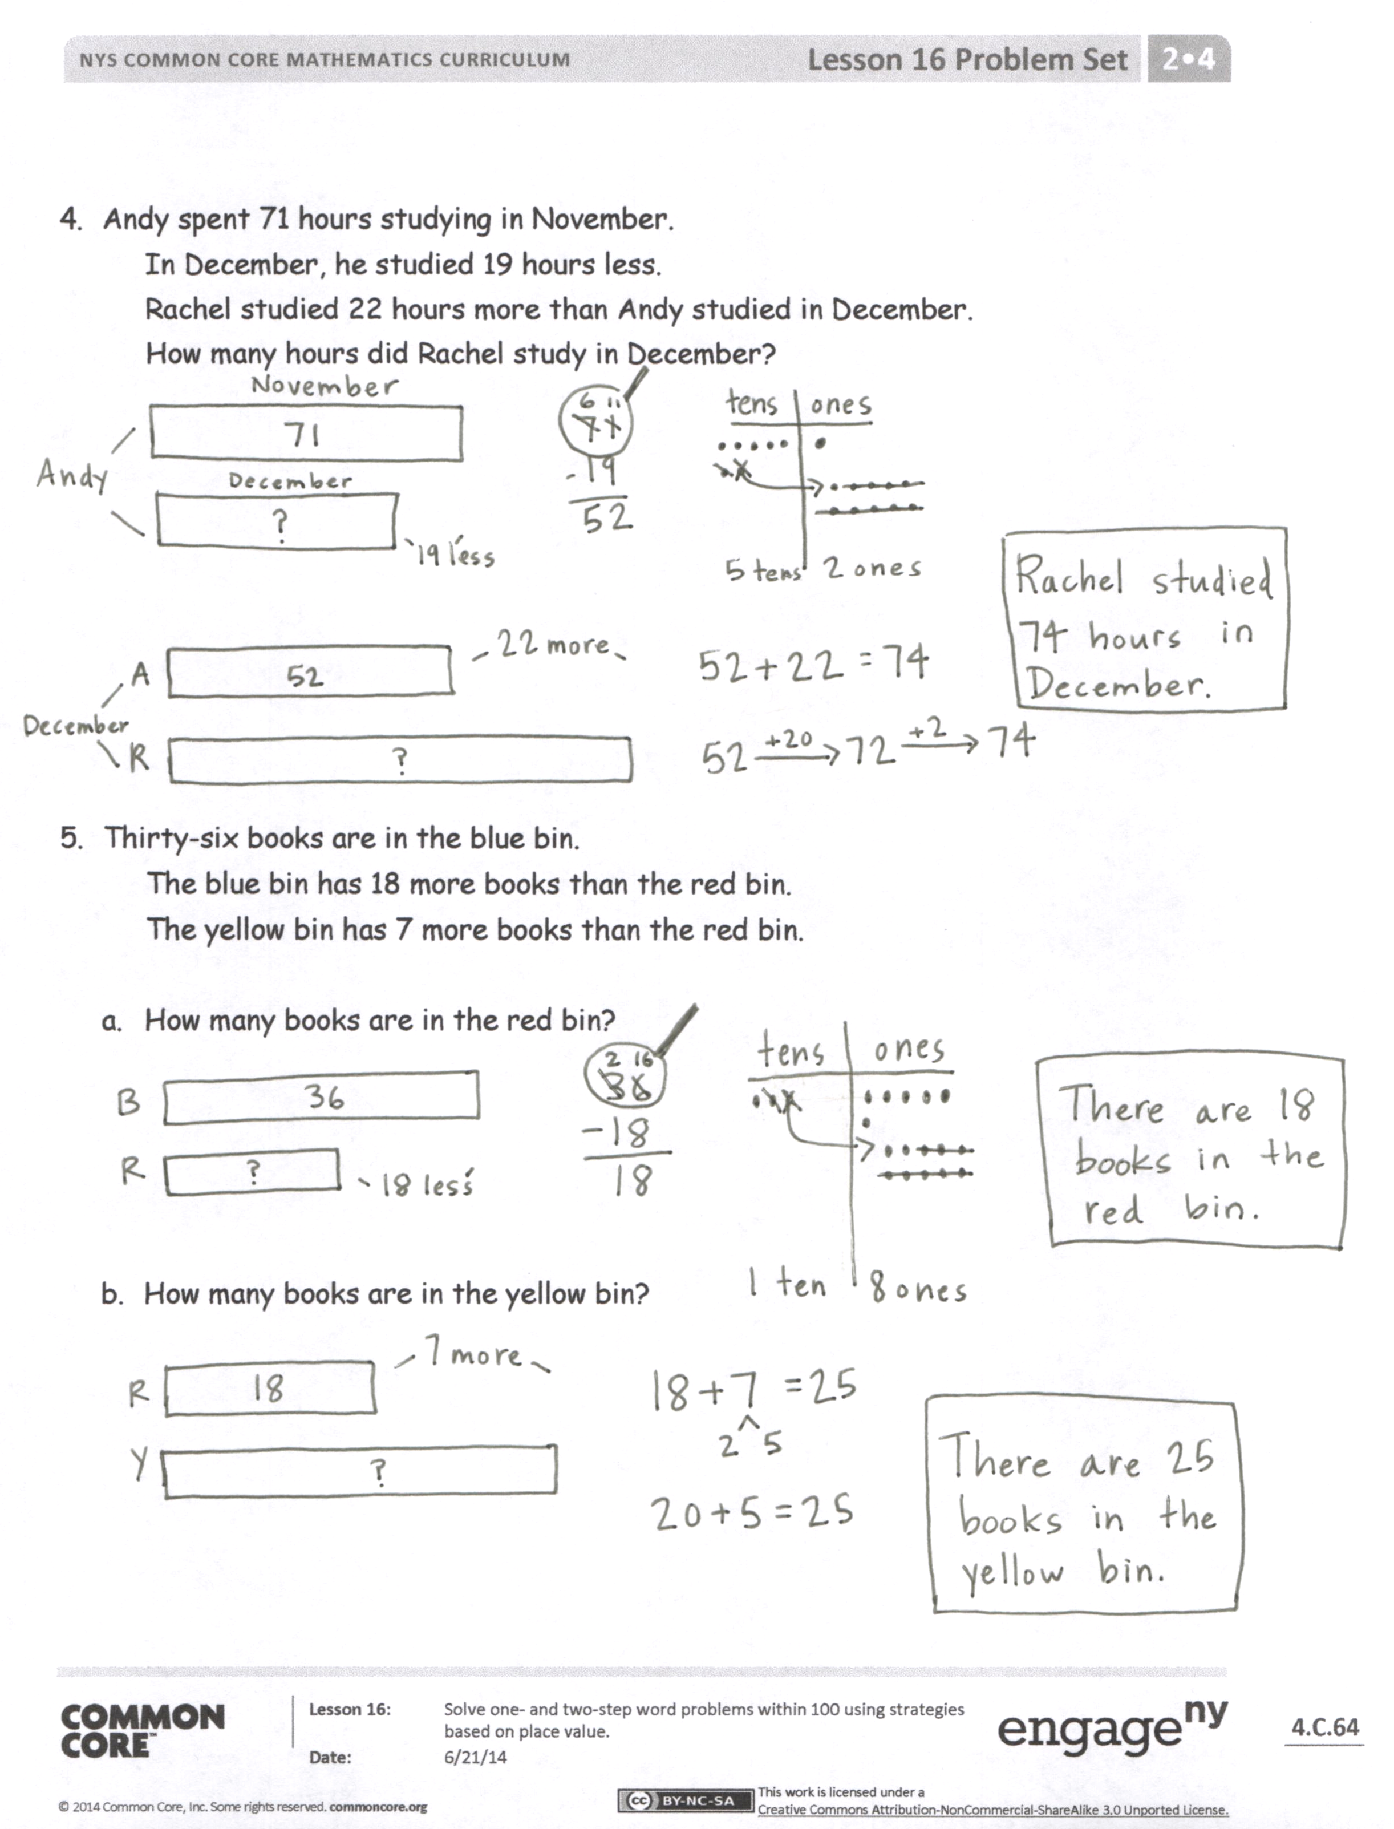
- How did you show your thinking in Problem 3? What simplifying strategy can you use to solve? Why choose that one?
- Explain to your partner the steps you took to solve Problem 4. How did you represent this multi-step problem? What simplifying strategy did you use instead of unbundling a ten for the first portion of the problem?
- For Problem 5, share your drawings with a partner. What did you need to know before you could figure out how many books were in the yellow bin? How did you show it?
Exit Ticket (3 minutes)
After the Student Debrief, instruct students to complete the Exit Ticket. A review of their work will help you assess the students’ understanding of the concepts that were presented in the lesson today and plan more effectively for future lessons. You may read the questions aloud to the students.
Name Date
Solve the following word problems. Use the RDW process.
- Frederick counted a total of 80 flowers in the garden. There were 39 white flowers, and the rest were pink. How many flowers were pink?

- The clothing store had 42 shirts. After selling some, there were 16 left. How many shirts were sold?

- There were 26 magazines on Shelf A and 60 magazines on Shelf B. How many more magazines were on Shelf B than Shelf A?

- Andy spent 71 hours studying in November.
In December, he studied 19 hours less.
Rachel studied 22 hours more than Andy studied in December.
How many hours did Rachel study in December?

- Thirty-six books are in the blue bin.
The blue bin has 18 more books than the red bin.
The yellow bin has 7 more books than the red bin.

- How many books are in the red bin?

- How many books are in the yellow bin?

Name Date
Solve the following word problems. Use the RDW process.
- The bookstore sold 83 books on Monday.
On Tuesday, it sold 46 fewer books than on Monday.

- How many books were sold on Tuesday?

- The bookstore sold 28 more books on Tuesday than on Wednesday.
How many books did the bookstore sell on Wednesday?

Name Date
Solve the following word problems. Use the RDW process.
- Vicki modeled the following problem with a tape diagram.

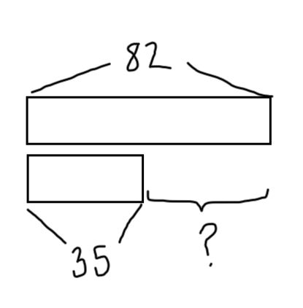
Eighty-two students are in the math club. 35 students are in the science club. How many more students are in the math club than science club?

Show another model to solve the problem. Write your answer in a sentence.

- Forty-six birds sat on a wire. Some flew away, but 29 stayed. How many birds flew away? Show your work.

- Ian bought a pack of 47 water balloons. 19 were red, 16 were yellow, and the rest were blue. How many water balloons were blue? Show your work.

- Daniel read 54 pages of his book in the morning. He read 27 fewer pages in the afternoon. How many pages did Daniel read altogether? Show your work.

