Lesson 14
Objective: Represent subtraction with and without the decomposition when there is a three-digit minuend.

Suggested Lesson Structure
 Application Problem (5 minutes)
 Fluency Practice (10 minutes)
 Concept Development (35 minutes)
 Student Debrief (10 minutes)
Total Time (60 minutes)
Application Problem (5 minutes)
The total length of a red string and a purple string is 73 cm. The red string is 18 cm long. How long is the purple string?
Extension:
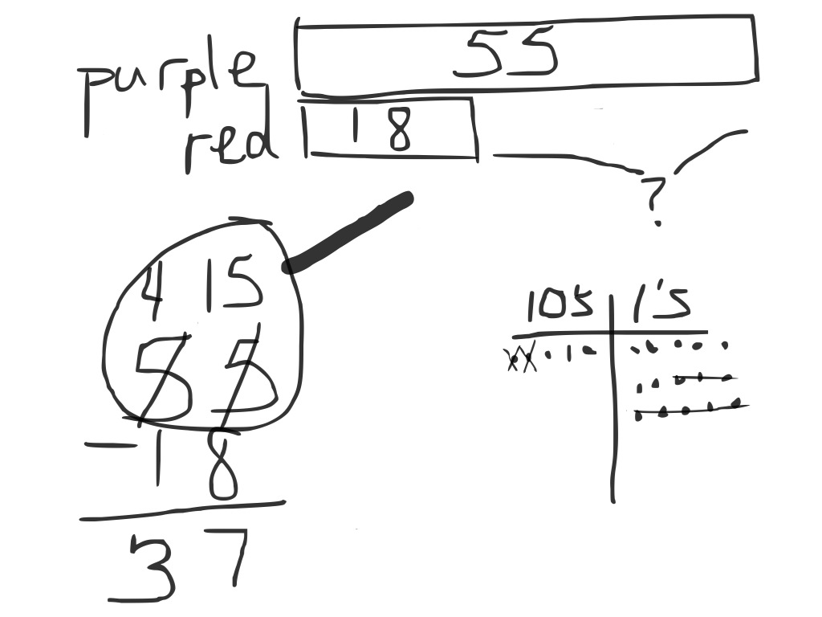
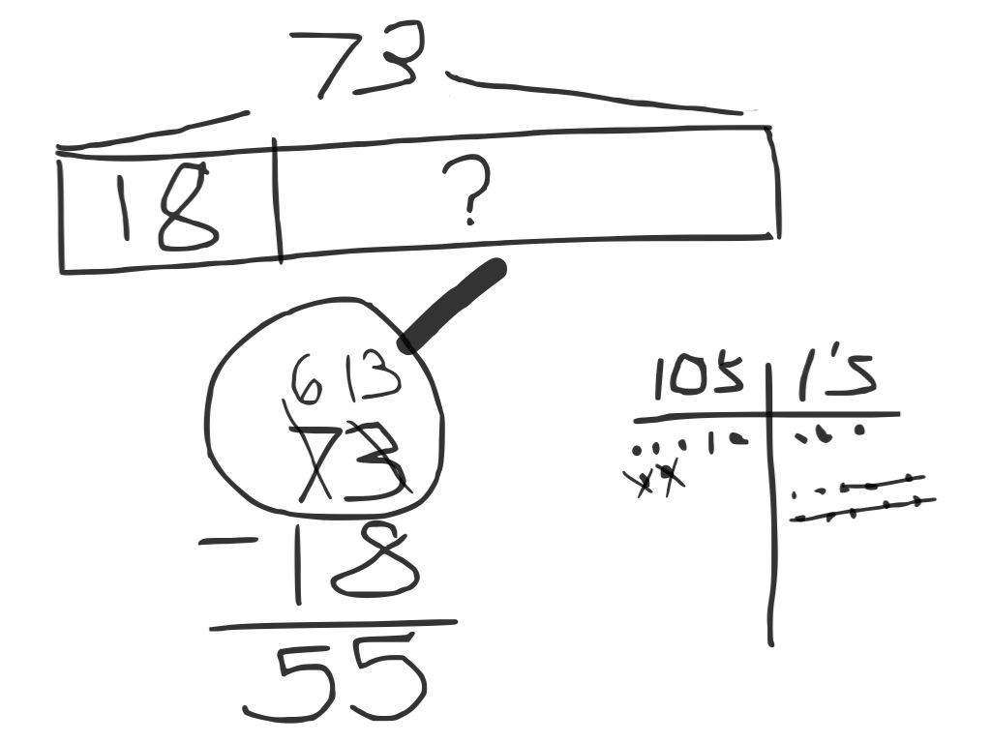
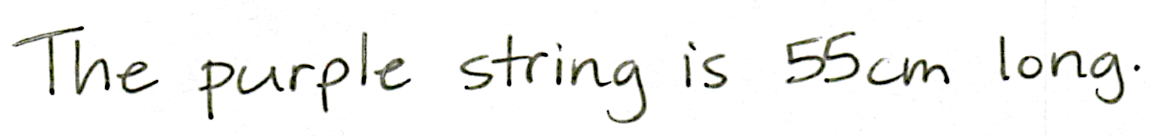
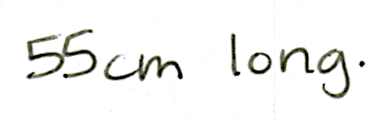
Note: This Application Problem allows students to practice the skill from Lesson 13. In order to keep their work simple, perhaps draw the tape diagram together, and then let them solve the subtraction and write their solutions independently.
Extension: Find the difference in length between the two strings.

Fluency Practice (10 minutes)
- Place Value 2.NBT.1 (3 minutes)
- Rename the Units: Choral Response 2.NBT.1 (5 minutes)
- Take from the Tens or Ones 2.NBT.5 (2 minutes)
Place Value (3 minutes)
Note: Practicing these skills in isolation helps lay a foundation for conceptual understanding of today’s lesson.
T: (Write 184.) Say the number in standard form.
S: 184.
T: What digit is in the tens place?
S: 8.
T: (Underline 8.) What’s the value of the 8?
S: 80.
T: State the value of the digit 1.
S: 100.
T: 4?
S: 4.
Repeat using the following possible sequence: 173, 256, and 398.
Rename the Units: Choral Response (5 minutes)
Note: This fluency activity reviews foundations that lead into today’s lesson.
T: (Write 10 ones = ____ ten.) Say the number sentence.
S: 10 ones = 1 ten.
T: (Write 20 ones = 1 ten ____ ones.) Say the number sentence.
S: 20 ones = 1 ten 10 ones.
T: (Write 24 ones = 1 ten ____ ones.) Say the number sentence.
S: 24 ones = 1 ten 14 ones.
T: (30 ones = 2 tens ____ ones.) Say the number sentence.
S: 30 ones = 2 tens 10 ones.
Repeat the process for 30, 32, 38, 40, 41, 46, 50, 63, and 88.

Take from the Tens or Ones (2 minutes)
Note: This fluency activity helps students know when and when not to unbundle a ten when subtracting. This is a foundational skill for today’s lesson.
T: For every number sentence I say, you tell me if I take from the tens or the ones. If I say 46 – 5, you say take from the ones. If I say 46 – 7, you say take from the tens. Ready?
T: 46 – 6.
S: Take from the ones.
T: 46 – 9.
S: Take from the tens.
Continue with the following possible sequence: 52 – 1, 52 – 4, 63 – 6, 64 – 5, 65 – 4, 68 – 8, and 70 – 3.
Concept Development (35 minutes)
Materials: (S) Math journal or paper
T: Write 126 – 19 the vertical way on your paper.
T: Let’s draw a magnifying glass around the total, 126. (Draw the magnifying glass as students do the same.)
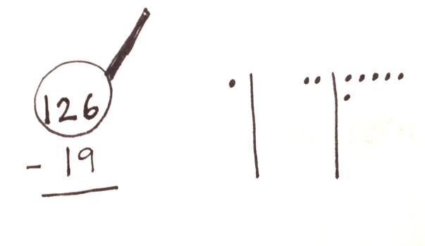
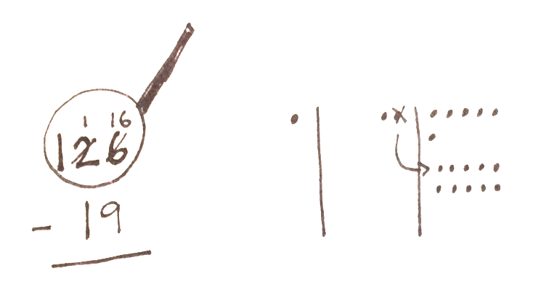
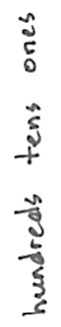
T: Draw your place value chart. (Or, use a template with the units already labeled.)
T: Whisper count the Say Ten way as you draw the place value units of 126. (Model drawing chips to represent the minuend as students do the same.)
MP.6
S: 1 hundred, 1 hundred 1 ten, 1 hundred 2 tens, 1 hundred 2 tens 1 … 1 hundred 2 tens 6.
T: Use place value language to tell your partner how your model matches the vertical form.
S: I drew 1 chip in the hundreds place, 2 chips in the tens place, and 6 chips in the ones place, so that is one hundred twenty-six. 1 hundred 2 tens 6 ones is the same as one hundred twenty-six.
T: What next?
S: Check to see if you can subtract ones. See if there are enough ones to subtract.
T: Can I subtract 9 ones from 6 ones?
S: You have to unbundle a ten. Rename a ten as 10 ones.
T: What I draw, you draw. (Model crossing out a chip in the tens place, drawing an arrow to show the exchange and adding 10 ones to the ones column as students do the same.)
T: What should I do in the vertical form?
S: Cross out 2 tens, make 1 ten; cross out the 6 ones, make it 16 ones. Change 1 ten for 10 ones.
T: Now that we’ve renamed, let’s say the new problem using place value language.
S: 1 hundred 1 ten 16 ones minus 1 ten 9 ones.
T: Are we ready to subtract?
S: Yes!
Work through the tens and ones, subtracting using the language of units.
T: Now, this part is new. We have 1 hundred. Discuss. What do you think we will have to do next?
S: 1 hundred minus 0 is 1 hundred. Subtract 0 from 1.

NOTES ON
MULTIPLE MEANS OF REPRESENTATION:
Use the Rekenrek to represent subtraction with decomposing a ten as an alternate method for students who have trouble grasping the concept.

T: If I have 1 hundred and I take away 0, how many hundreds do I have left?
S: 1.
T: Should I change my chip model?
S: No.
T: Then, where do I record my answer?
MP.6
S: In the hundreds place in vertical form!
Model writing 1 in the hundreds place as students do the same.
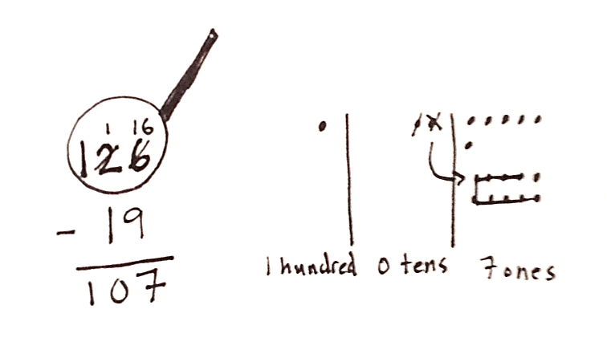
T: Read the answer the Say Ten way.
S: 1 hundred, 7.
T: The regular way?
S: One hundred seven.
T: Talk with your partner. How does having a hundred change how you solved the problem?
S: We had to draw a hundreds place on our charts.
We solved the same way; we subtracted the ones and tens like before.
Follow the procedure above to guide students as they write, model, and solve 137 – 28. At each step, remind students to be precise in aligning the digits and in drawing their chips in neat 5-groups. Have them share how each step in the drawing matches each step in the vertical form.
Continue with the following possible sequence: 165 – 18, 153 – 29, and 186 − 47. Continue to support students who struggle. As students demonstrate proficiency, instruct them to work on the Problem Set independently.
Problem Set (10 minutes)
Students should do their personal best to complete the Problem Set within the allotted 10 minutes. For some classes, it may be appropriate to modify the assignment by specifying which problems they work on first. Some problems do not specify a method for solving. Students should solve these problems using the RDW approach used for Application Problems.
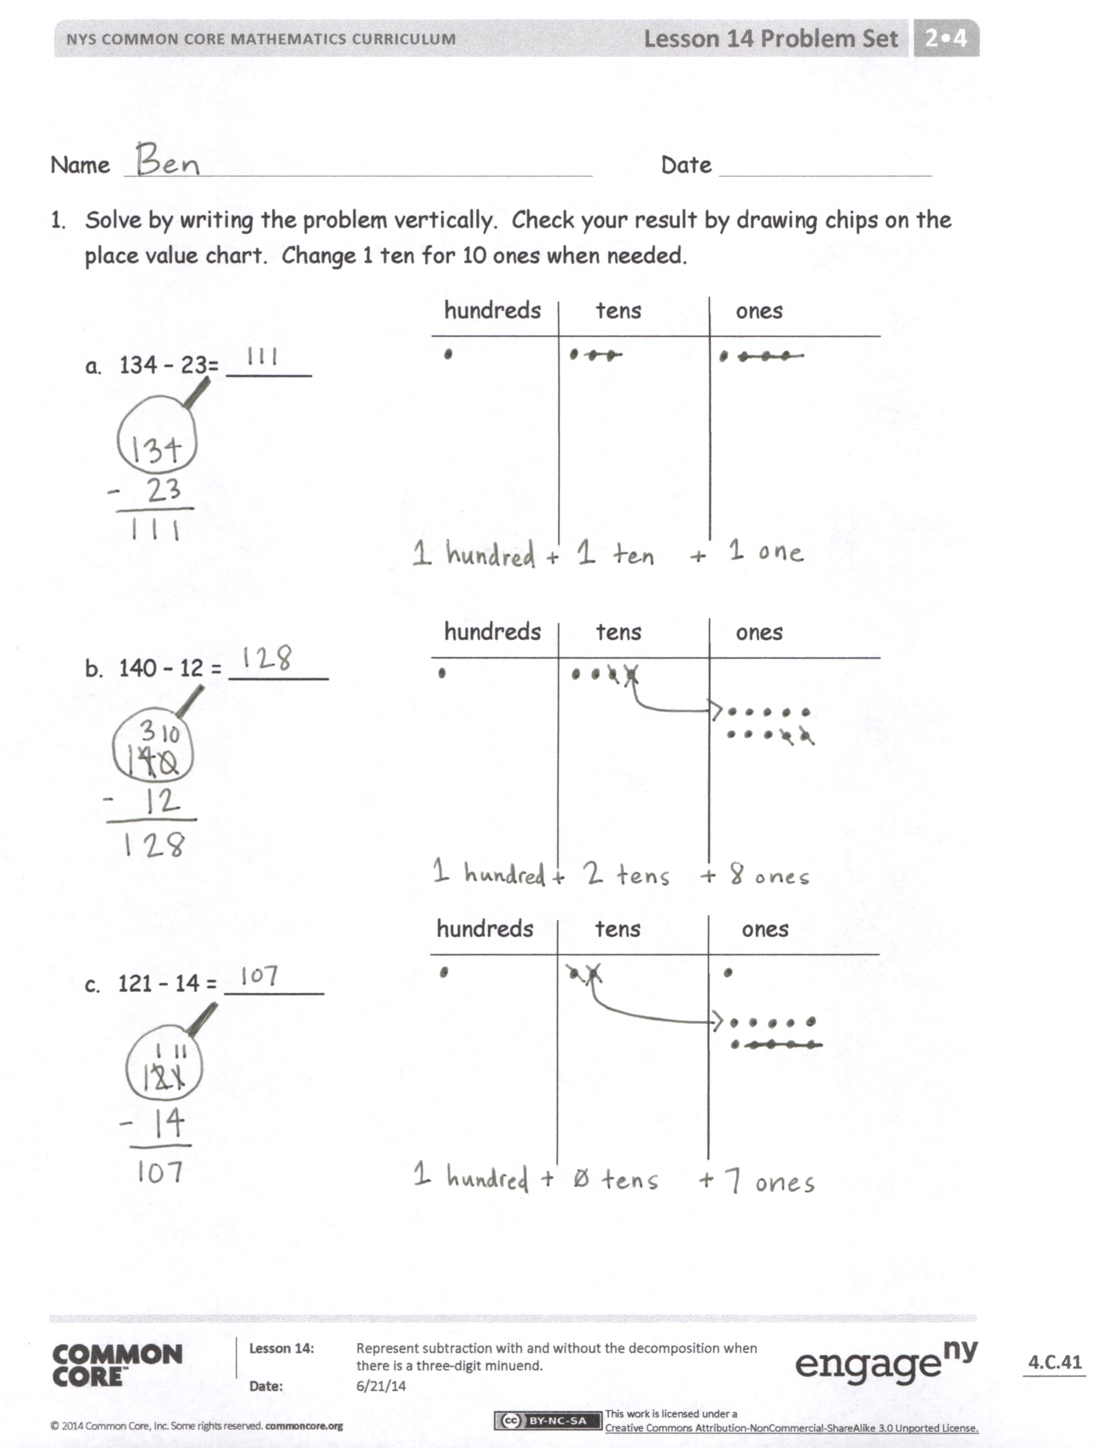
Student Debrief (10 minutes)
Lesson Objective: Represent subtraction with and without the decomposition when there is a three-digit minuend.
The Student Debrief is intended to invite reflection and active processing of the total lesson experience.
Invite students to review their solutions for the Problem Set. They should check work by comparing answers with a partner before going over answers as a class. Look for misconceptions or misunderstandings that can be addressed in the Debrief. Guide students in a conversation to debrief the Problem Set and process the lesson. You may choose to use any combination of the questions below to lead the discussion.
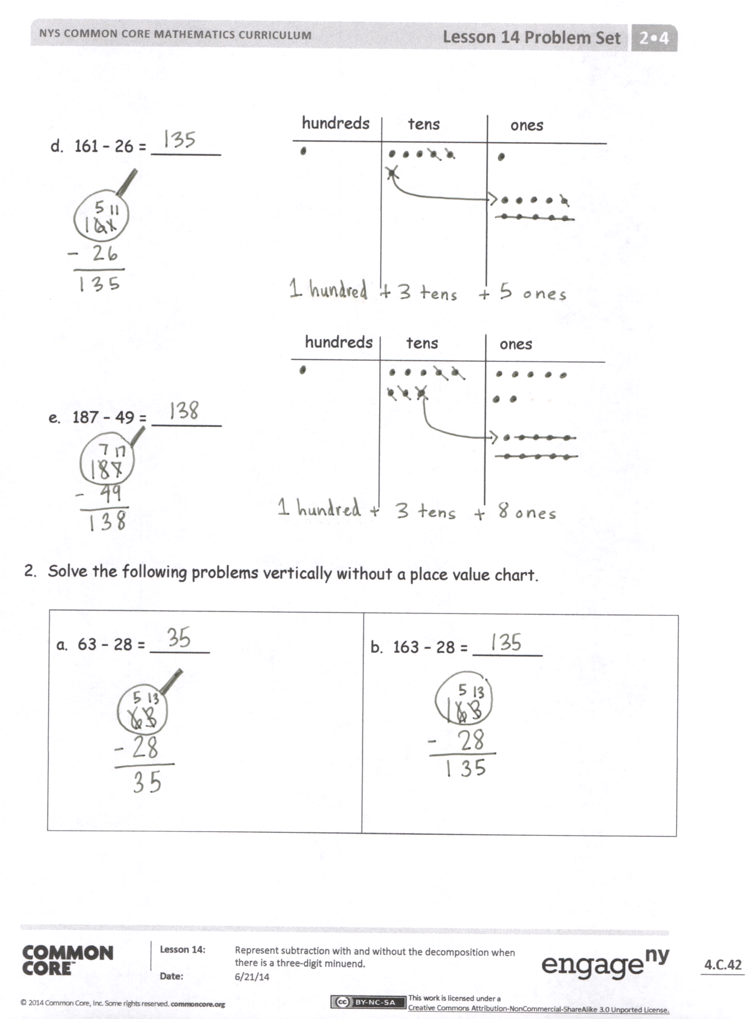
- Explain to your partner how you solved Problems 1(a) and (b). What significant differences do you notice about the vertical form and place value charts for these two problems, (i.e., did you have to unbundle a ten)? Why?
- For Problem 1(c), use place value language to explain to your partner how your model matches the vertical form. Why does your answer include a zero in the tens place?
- One student’s answer for Problem 1(e), 187 – 49, was 148. What mistake did she make in the vertical form? How would the chip model have helped her to figure out the correct answer?
- For Problem 2(b), how did having a three-digit addend (as opposed to two-digit) change the way you solved the problem?
- How are your math drawings and vertical forms today similar to and different from the ones you did in the last lesson?
Exit Ticket (3 minutes)
After the Student Debrief, instruct students to complete the Exit Ticket. A review of their work will help you assess the students’ understanding of the concepts that were presented in the lesson today and plan more effectively for future lessons. You may read the questions aloud to the students.
Name Date
- Solve by writing the problem vertically. Check your result by drawing chips on the place value chart. Change 1 ten for 10 ones, when needed.
hundreds tens ones
- 134 – 23= ______

hundreds tens ones
- 140 – 12 = _______

hundreds tens ones
- 121 – 14 = _______

hundreds tens ones
- 161 – 26 = _______

hundreds tens ones

- 187 – 49 = _______

- Solve the following problems vertically without a place value chart.

a. 63 – 28 = ______ | b. 163 – 28 = _______

Name Date
Solve by writing the problem vertically. Check your result by drawing chips on the place value chart. Change 1 ten for 10 ones, when needed.
- 145 – 28 = ________ hundreds tens ones
- 151 – 39 = __________ hundreds tens ones

Name Date
- Solve by writing the problem vertically. Check your result by drawing chips on the place value chart. Change 1 ten for 10 ones, when needed.

- 156 – 42 = ________ hundreds tens ones

- 150 – 36 = ________ hundreds tens ones

- 163 – 45 = ________ hundreds tens ones

- Solve the following problems without a place value chart.
a.  1 3 4  – 2 9 | b.  1 5 4  – 3 7

- Solve and show your work. Draw a place value chart and chips, if needed.
- Aniyah has 165 seashells. She has 28 more than Ralph. How many seashells does Ralph have?

- Aniyah and Ralph each give 19 seashells to Harold. How many seashells does Aniyah have left? How many seashells does Ralph have left?

