Lesson 12
Objective: Relate manipulative representations to a written method.

Suggested Lesson Structure
 Fluency Practice (11 minutes)
 Application Problem (5 minutes)
 Concept Development (34 minutes)
 Student Debrief (10 minutes)
Total Time (60 minutes)
Fluency Practice (11 minutes)
- Using 10 to Subtract 2.NBT.5 (3 minutes)
- Get the Ten Out to Subtract 2.NBT.5 (5 minutes)
- How Many More Tens 2.NBT.5 (3 minutes)
Using 10 to Subtract (3 minutes)
Repeat the fluency activity from Lesson 11.
Get the Ten Out and Subtract (5 minutes)
Note: Students practice taking out the ten and subtracting to prepare for unbundling a ten in today’s lesson.
T: For every number sentence I give, subtract the ones from ten. When I say 12 – 4, you say 10 – 4 = 6. Ready?
T: 12 – 4.
S: 10 – 4 = 6.
T: 13 – 7.
S: 10 – 7 = 3.
Practice taking the ten out of number sentences fluently before adding the ones back.
T: Now let’s add back the ones.
T: 12 – 4. Take from ten.
S: 10 – 4 = 6.
T: Now add back the ones.
MP.4
MP.4
S: 6 + 2 = 8.
Continue with the following possible sequence: 13 – 7, 11 – 8, 13 – 9, 15 – 7, 14 – 8.
How Many More Tens? (3 minutes)
Materials: (S) Personal white board
Note: Practice adding and subtracting multiples of 10 prepares students for the lesson.
T: If I say 45 – 35, you say 10. To say how many more tens in a sentence, you say 45 is 10 more than 35. Ready?
T: 65 – 45.
S: 20.
T: Say it in a sentence.
S: 65 is 20 more than 45.
Continue with the following possible sequence: 85 – 45, 74 – 24, 59 – 29, 38 – 18, and 99 – 19.
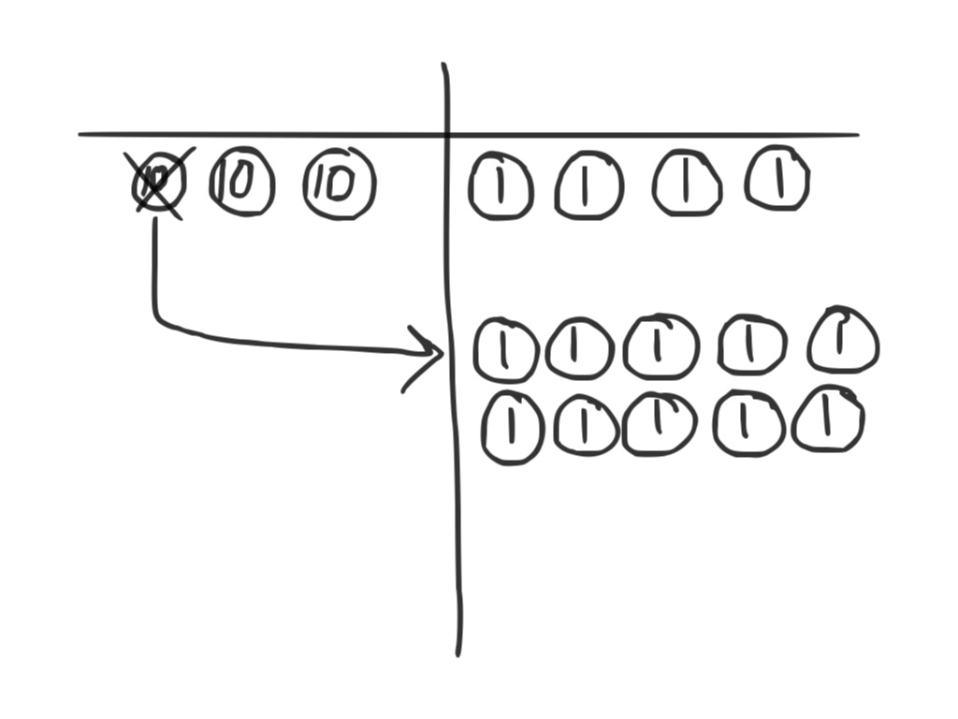
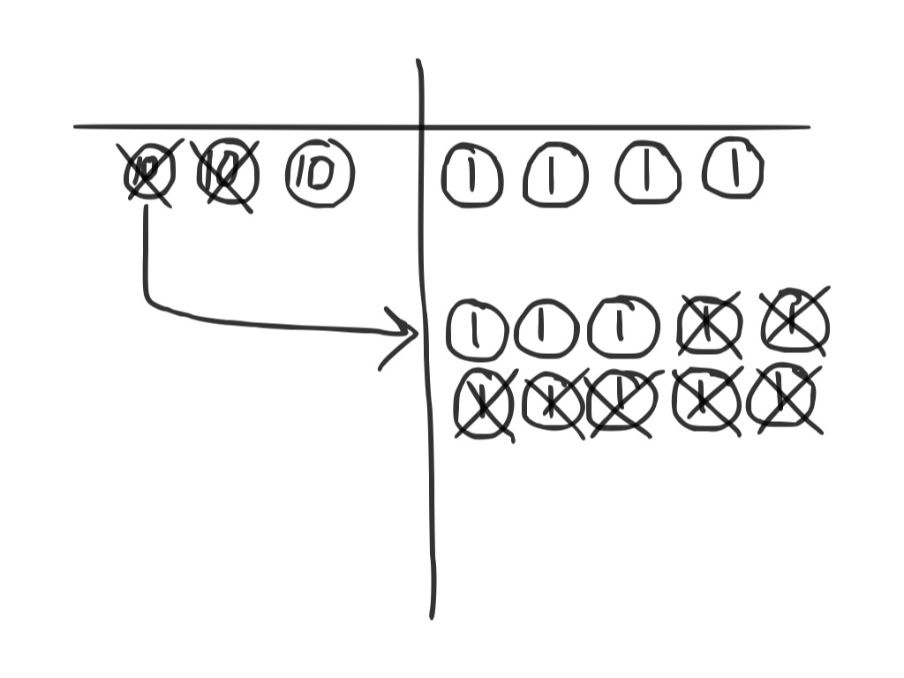
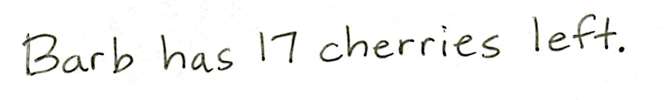
Application Problem (5 minutes)
Barb has a bag of 34 cherries. She eats 17 cherries for a snack. How many cherries does she have left?
Note: This problem is designed for independent practice and serves to reinforce the concept of decomposing 1 ten as 10 ones with manipulatives. Allow students to use place value disks when solving. If students need support, guide them through the process of unbundling a ten with place value disks.
Concept Development (34 minutes)
Materials: (T) Place value disks (19 ones and 9 tens), unlabeled tens place value chart (Lesson 1 Template) (S) Place value disks (19 ones and 9 tens), unlabeled tens place value chart (Lesson 1 Template), personal white board, place value disks (Lesson 6 Template)
Problem 1: 25 – 11
MP.2
T: (Write 25 – 11 on the board.) Read this problem with me.
S: 25 minus 11. (Read the problem chorally.)
T: (Draw a blank number bond on the board.) What is the whole?
S: 25.
T: What is the part that we know?
S: 11.
T: What do we need to find?
S: The missing part.
T: That’s right. When we use place value disks to solve a subtraction problem, we only put the whole on our chart. Turn to your neighbor, and tell him or her why we only show the whole when subtracting.
S: You will take away one part from the whole. You are not adding two parts; you are taking away. 11 is inside 25, and we are finding it and taking it out.
T: Count the total value of the disks as I place them. Say the units, too. 1 ten, 2 tens, 2 tens 1 one,
2 tens 2 ones, 2 tens 3 ones, 2 tens 4 ones, 2 tens 5 ones. (Place 2 tens 5 ones on your place value chart. Direct students to do the same.)
T: Today, as we solve subtraction problems, we are going to record our work in vertical form.
(Write the problem in vertical form.)
T: What is the whole we are subtracting from?
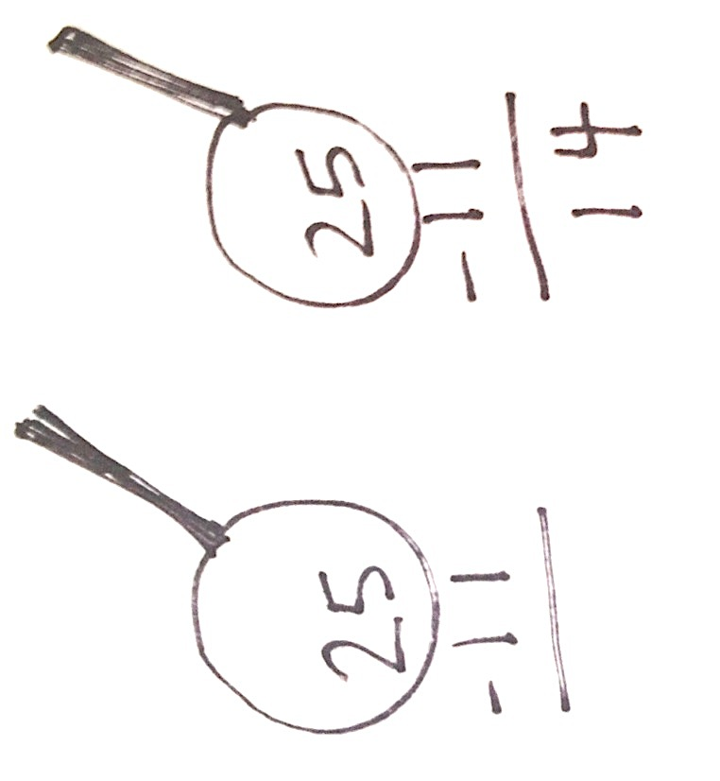
S: 25.
T: We want to look carefully at the whole when subtracting, like a detective, to see if we need to do any unbundling. Let’s draw an imaginary magnifying glass around 25. (Draw the magnifying glass as shown to the right.)
MP.2
T: Let’s start by looking at the smallest place value, the ones: Can we take
1 one disk from 5 ones disks?
S: Yes!
T: Let’s move to the tens column. Can I take 1 ten from 2 tens?
S: Yes!
T: We are ready to subtract because we have checked to make sure we have enough units in each place value.
MP.3
T: Take 1 one from the 5 ones. (Remove 1 one from the place value chart. Students do the same.)
T: How many ones are left?
S: 4 ones.
T: (Record 4 in the ones column.) Take 1 ten from 2 tens. (Remove 1 ten from the place value chart and record the answer in the answer space. Students do the same.)
T: What is 25 – 11?
S: 14.
Problem 2: 22 – 13
T: Let’s try another problem together. This time I want you to record your answers vertically as I do. (Write 22 – 13 on the board in vertical form. Students do the same.)
T: What should I do first?
S: Find out if we need to unbundle.
T: (Draw the magnifying glass with enough space to write renaming, and instruct students do the same.)
T: Okay, I’m looking closely at it. Where do I start?
S: Start in the ones column. Check to see if you can subtract the ones.
T: Can I subtract 3 ones from 2 ones?
MP.2
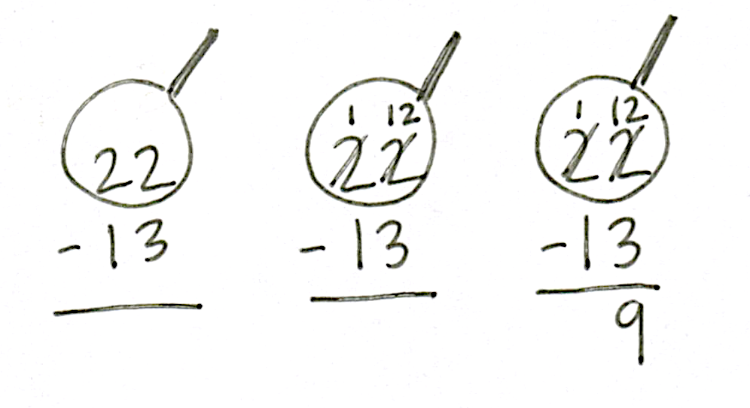
S: No!
T: What should I do?
S: Decompose a ten.
T: (Change a ten for 10 ones. Arrange them in 5-groups on the place value chart. Instruct students to do the same.)
T: Whatever I do to my place value disks, I must also do to the numbers in vertical form. How should I record unbundling a ten?
S: Cross out the 2 in the tens place and write 1 above it. Cross out the 2 in the ones place and write 12 above it. Change 2 tens to 1 ten and 2 ones to 12 ones.
T: Now how many tens and ones do you see on my place value chart?
S: 1 ten 12 ones.

NOTES ON
MULTIPLE MEANS
OF ENGAGEMENT:
Encourage students to use the place value disks for the Problem Set until they are comfortable enough with the process to use the vertical form alone. If a student is comfortable using the algorithm without the disks, allow him to work without them.

T: Can I subtract 3 ones now?
S: Yes!
T: Can I subtract 1 ten now?
S: Yes!
T: Then, we are ready to subtract! What are we?
S: Ready to subtract!
T: Then, let’s subtract!
T: 12 ones minus 3 ones is?
S: 9 ones.
T: 1 ten minus 1 ten is?
S: 0 tens.
T: What is the answer to 22 – 13?
S: 9.
Repeat the process above with the following possible sequence: 31 – 18, 46 – 28, and 32 – 19.
Problem Set (10 minutes)
Students should do their personal best to complete the Problem Set within the allotted 10 minutes. For some classes, it may be appropriate to modify the assignment by specifying which problems they work on first. Some problems do not specify a method for solving. Students should solve these problems using the RDW approach used for Application Problems.

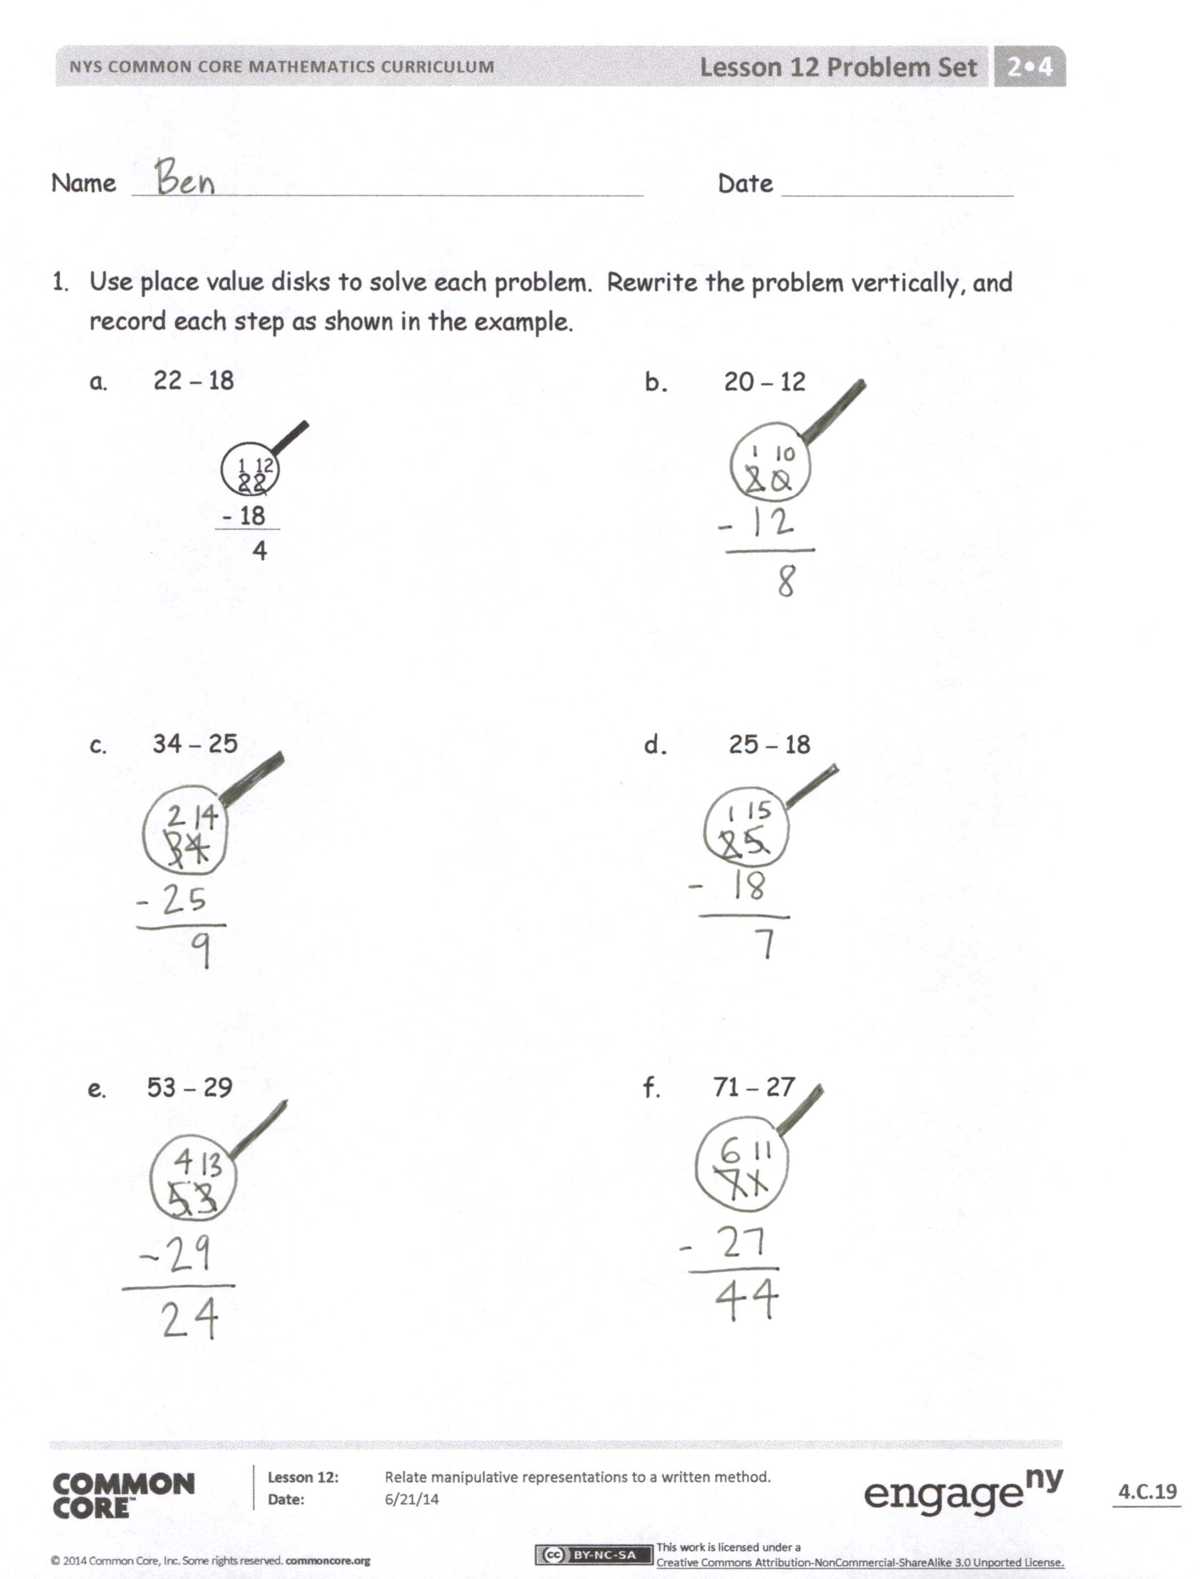
Student Debrief (10 minutes)
Lesson Objective: Relate manipulative representations to a written method.
The Student Debrief is intended to invite reflection and active processing of the total lesson experience.
Invite students to review their solutions for the Problem Set. They should check work by comparing answers with a partner before going over answers as a class. Look for misconceptions or misunderstandings that can be addressed in the Debrief. Guide students in a conversation to debrief the Problem Set and process the lesson.
You may choose to use any combination of the questions below to lead the discussion.
- How did unbundling a ten help you to solve Problem 1(b)?
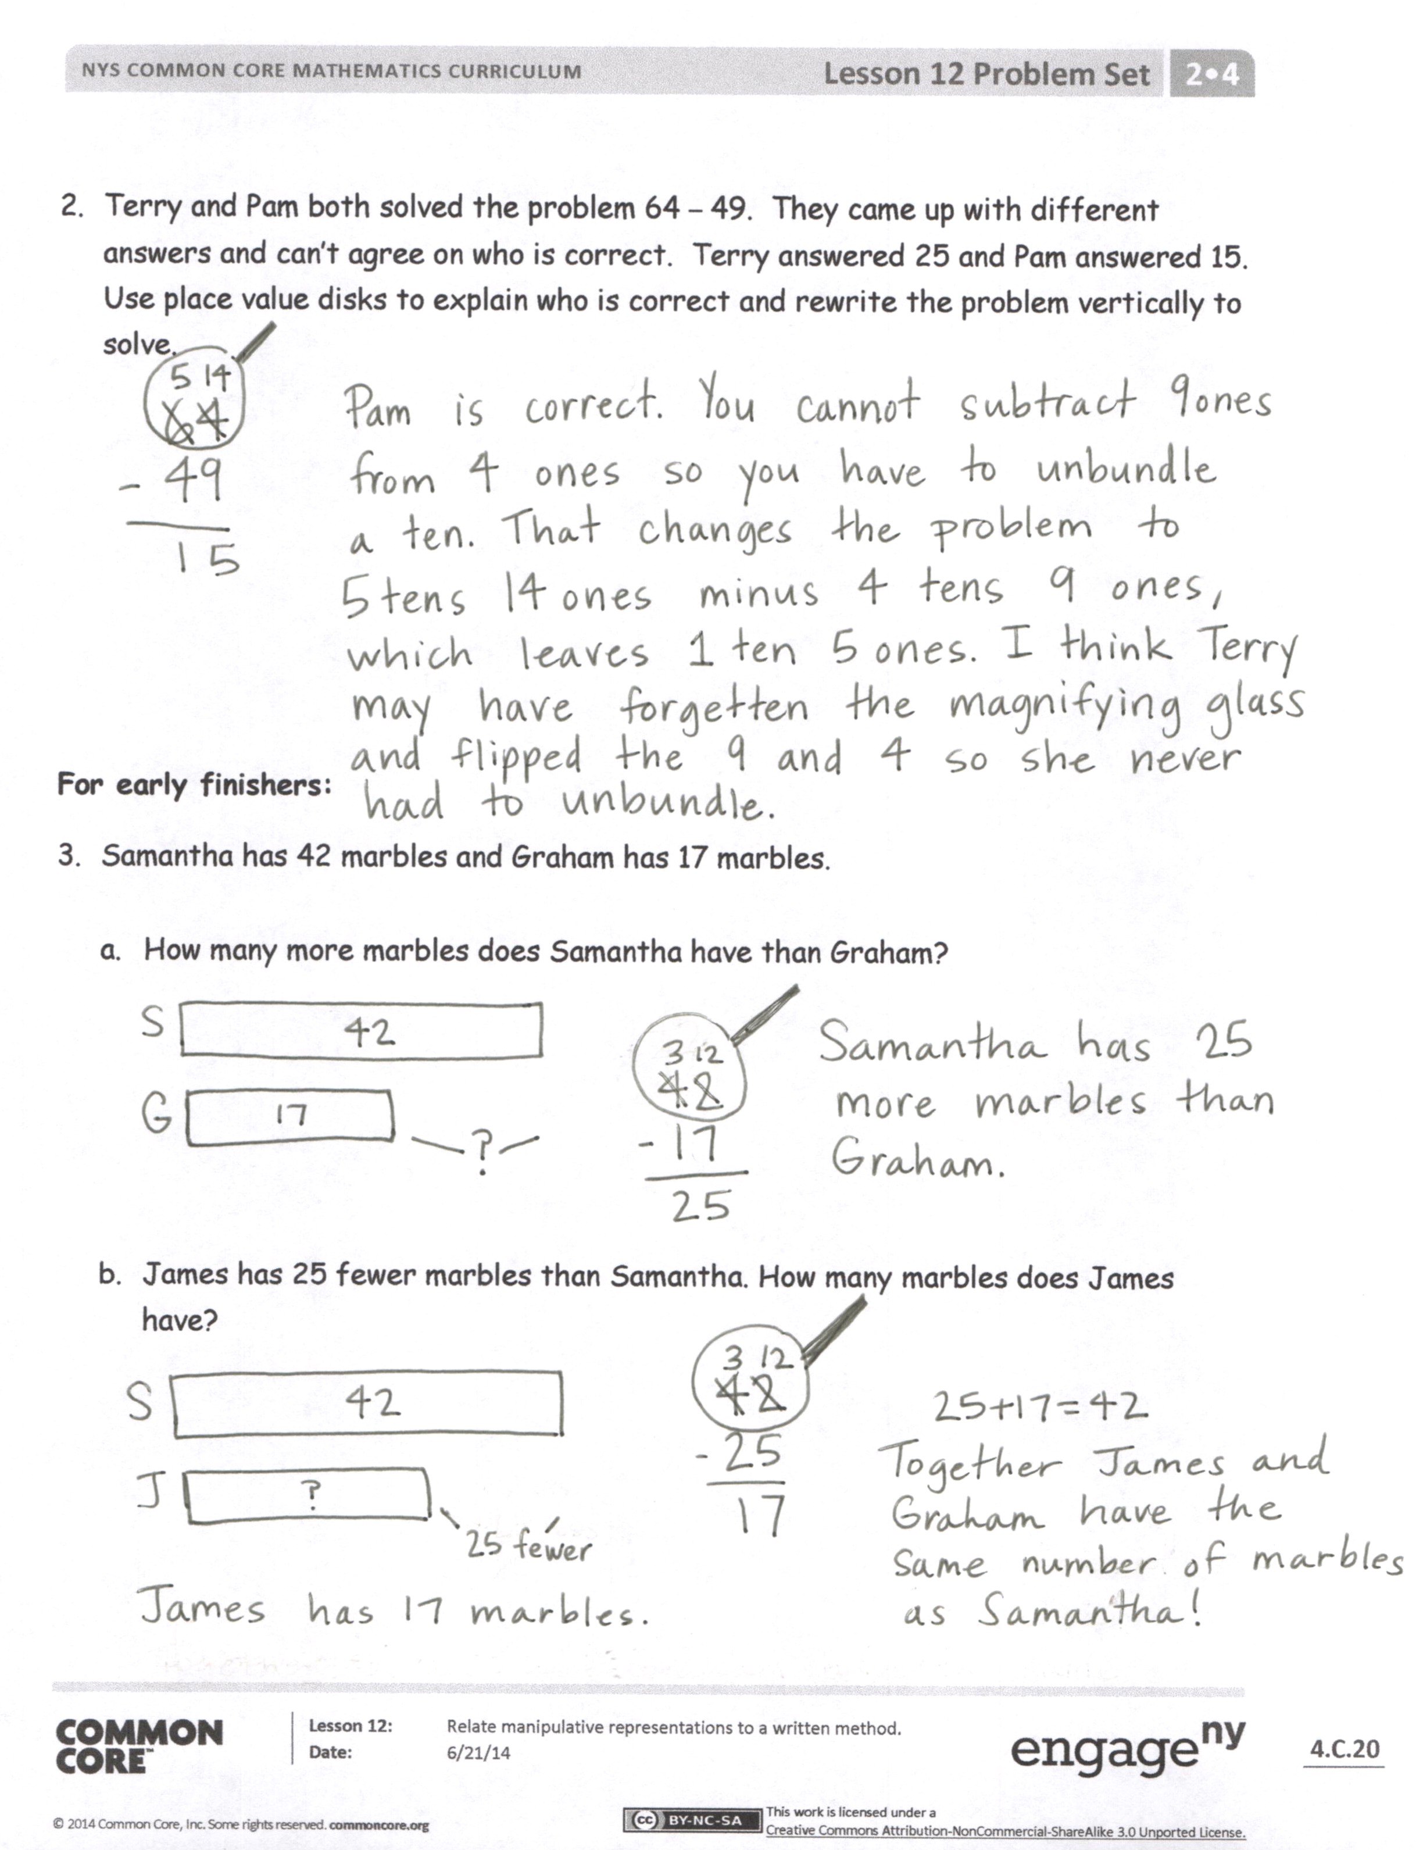
- How did you solve Problem 1(c)? How did you use the place value disks on the chart to show decomposing a ten?
- Explain to your partner how you used place value disks to solve Problem 1(d). How did your work with the place value disks match the vertical form?
- How did you solve Problem 1(e) using place value disks and the vertical form? How could you have solved this problem differently using a simplifying strategy?
- For Problem 2, explain to your partner how you know who is correct, Terry or Pam?
- How does Problem 3(a) help us to solve Problem 3(b)?
Exit Ticket (3 minutes)
After the Student Debrief, instruct students to complete the Exit Ticket. A review of their work will help you assess the students’ understanding of the concepts that were presented in the lesson today and plan more effectively for future lessons. You may read the questions aloud to the students.
Name Date
- Use place value disks to solve each problem. Rewrite the problem vertically, and record each step as shown in the example.
a. 22 – 18 b. 20 – 12

1
12
22
- 18
4

c. 34 – 25 d. 25 – 18

e. 53 – 29 f. 71 – 27
- Terry and Pam both solved the problem 64 – 49. They came up with different answers and cannot agree on who is correct. Terry answered 25 and Pam answered 15. Use place value disks to explain who is correct, and rewrite the problem vertically to solve.

For early finishers:
- Samantha has 42 marbles and Graham has 17 marbles.
  - How many more marbles does Samantha have than Graham?

  - James has 25 fewer marbles than Samantha. How many marbles does James have?
Name Date
Sherry made a mistake while subtracting. Explain her mistake.
Sherry’s Work:  14  44  -26  28 | Explanation:

Name Date
- Use place value disks to solve each problem. Rewrite the problem vertically, and record each step as shown in the example.
a. 34 – 18 b. 41 – 16

14
2
34
- 18
16

c. 33 – 15 d. 46 – 18

e. 62 – 27 f. 81 – 34
- Some first- and second-grade students voted on their favorite drink. The table shows the number of votes for each drink.
Types of Drink | Number of Votes
Milk | 28
Apple Juice | 19
Grape Juice | 16
Fruit Punch | 37
Orange Juice | 44

- How many more students voted for fruit punch than for milk? Show your work.

- How many more students voted for orange juice than for grape juice? Show your work.

- How many fewer students voted for apple juice than for milk? Show your work.

