Lesson 11
Objective: Represent subtraction with and without the decomposition of
1 ten as 10 ones with manipulatives.

Suggested Lesson Structure
 Fluency Practice (11 minutes)
 Application Problem (6 minutes)
 Concept Development (33 minutes)
 Student Debrief (10 minutes)
Total Time (60 minutes)
Fluency Practice (11 minutes)
- 2 Less 2.NBT.5 (2 minutes)
- Using 10 to Subtract 2.NBT.5 (3 minutes)
- Subtract Common Units 2.NBT.5 (6 minutes)
2 Less (2 minutes)
Note: Practicing giving 2 less helps students to use the nearest ten in order to subtract fluently.
T: For every number I say, you say 2 less. If I say 10, you say 8. Ready?
T: 10.
S: 8.
T: 11.
S: 9.
Continue with the following possible sequence: 20, 21, 30, 31, 40, 41, 51, and 61.
Using 10 to Subtract (3 minutes)
Note: Reviewing the first grade skill of counting up and down to 10 to subtract gives students a mental strategy to subtract fluently.
T: (Write 16 – 9 on the board.)
T: The answer is…? Wait for the signal. (Wait for all to be ready.)
S: 7.
T: (Use a number bond to express 16 as 10 and 6.) 10 – 9 is…?
S: 1.
T: 1 + 6 is…?
S: 7.
Continue with the following possible sequence: 15 – 9, 13 – 8, 15 – 7, 16 – 7, 12 – 9, and 13 – 7.
Subtract Common Units (6 minutes)
Materials: (S) Personal white board
Note: Reviewing this mental math fluency prepares students for understanding the importance of the subtraction algorithm.
T: (Project 77.) Say the number in unit form.
S: 7 tens 7 ones.
T: (Write 77 – 22 = ____.) Say the subtraction sentence and answer in unit form.
S: 7 tens 7 ones – 2 tens 2 ones = 5 tens 5 ones.
T: Write the subtraction sentence on your personal white board.
Repeat the process and sequence for 88 – 33, 99 – 22, 66 – 44, 166 – 44, 55 – 33, and 155 – 33.
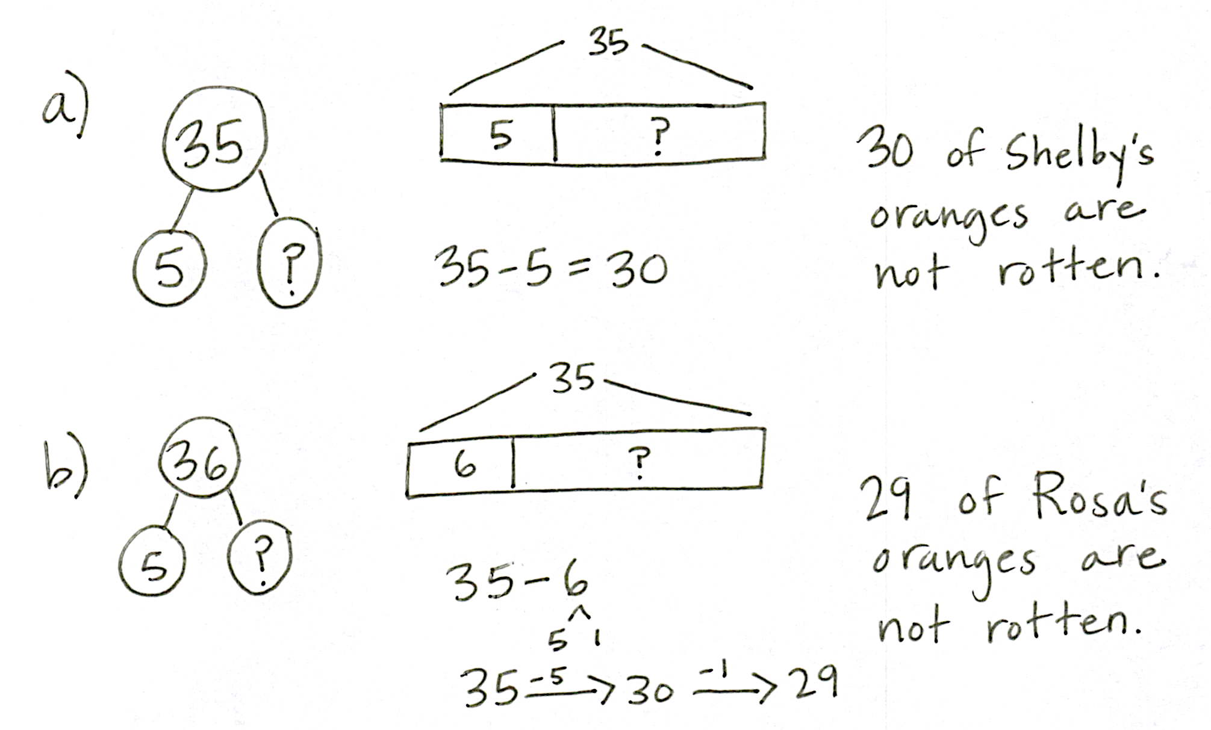
Application Problem (6 minutes)
Shelby picks 35 oranges. 5 are rotten.
- How many of Shelby’s oranges are not rotten?
- Rosa picks 35 oranges, too, but 6 are rotten.
How many of Rosa’s oranges are not rotten?
Note: This problem shifts students’ attention to subtraction and anticipates the opening of the Concept Development. In debriefing the problem, have students notice that Rosa has 29 while Shelby has 30 oranges.

NOTES ON
MULTIPLE MEANS
OF ACTION AND EXPRESSION:
If students struggle with these mental math problems, encourage them to discuss solutions with a partner before responding to the questions. Partners can also jot problems and answer to one another on personal white boards to check for accuracy.

Concept Development (33 minutes)
Materials: (T) Place value disks (19 ones, 9 tens), unlabeled tens place value chart (Lesson 1 Template)
(S) Place value disks (19 ones, 9 tens), unlabeled tens place value chart (Lesson 1 Template), place value disks (Lesson 6 Template)

Problem 1: 35 – 9

NOTES ON
MULTIPLE MEANS
OF ENGAGEMENT:
Offer a relatable example to scaffold understanding.
- Imagine you have 2 cookies. You have 3 friends come over. Do you have enough cookies for each friend to get one?
- Imagine you have 5 cookies. You have 9 people over. Can you give each person a whole cookie?
Offer similar examples until the students demonstrate understanding.

T: 35 – 5 is …?
S: 30.
T: 35 – 6 is …?
S: 29.
T: (Continue with two to three more sequences: 24 – 4, 24 – 5; 17 – 7, 17 – 8.)
T: (Write 35 – 9 on the board.) How can you solve 35 – 9?
S: Count back. Use the arrow method to add 1, then 20, and 5 more. Subtract 10 and then put 1 back.
I can show that with arrows too! Add 1 to both numbers to make it an easier problem, like 36 – 10.
T: Those are great strategies. Let me show you another one.
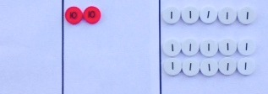
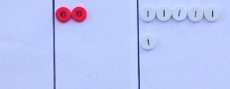
Show 35 on the place value chart using place value disks as shown at right.
T: How many tens do you see?
S: 3 tens.
T: How many ones?
S: 5 ones.
T: How many am I subtracting?
S: 9 ones.
T: Can I subtract 9 ones from 5 ones?
S: No.
T: How many ones are in a unit of ten?
S: 10.
T: I can break apart, or unbundle, a unit of ten into 10 ones. We also call this decomposing.
So, if I decompose one of these tens to make 10 ones, how many ones will I have?
MP.4
S: 15!
T: Yes! So, will I have enough ones to subtract 9 ones?
S: Yes!
T: Take 1 ten and change it for 10 ones. (Remove a ten, counting out 10 ones. Place the 10 ones in
5-groups as shown to the right.)
T: Now, I have 15 ones on my chart, and I can subtract 9 ones. (Take away 9 ones as shown above.)
T: How many tens and ones do you see?
S: 2 tens 6 ones.

Problem 2: 46 – 18
MP.4
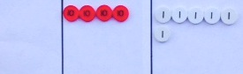
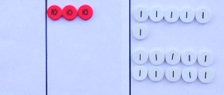
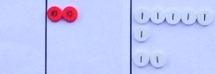
T: Let’s do another problem. This time, use your place value disks. (Write 46 – 18 on the board.)
T: Do you have to show 18 with your disks?
S: No!
T: No, we don’t because now we are finding a missing part, not the total. We are going to remove a part, 18, from the whole, 46.
T: Model with your place value disks the number 46.
Count the Say Ten way as you put out your place value disks.
S: 1 ten, 2 tens, 3 tens, 4 tens, 4 tens 1, 4 tens 2….4 tens 6. (Arrange the place value disks on the place value chart as shown to the right. Direct students to arrange their place value disks in the same way.)
T: Let’s start with the ones. Can I subtract 8 ones from
6 ones?
S: No. You need to decompose a ten. No, we have to change 1 ten for 10 ones.
T: (Model unbundling a ten. Direct students to do the same, arranging the ten ones in 5-groups.)
T: Now, I can subtract 8 ones. Do it with me. (Count chorally as you remove 8 ones from the place value chart.)
T: Am I done?
S: No. You need to subtract a ten.
T: (Remove a ten while students do the same.)
T: So 46 – 18 is…?
S: 28.
T: The Say Ten way? (Point to disks.)
S: 2 tens 8.
If necessary, repeat with the following possible sequence until students show proficiency: 46 – 12, 22 – 15, 41 – 23, and 32 – 29. Then, allow students to begin working on the Problem Set independently as they are able.
Problem Set (10 minutes)
Students should do their personal best to complete the Problem Set within the allotted 10 minutes. For some classes, it may be appropriate to modify the assignment by specifying which problems they work on first. Some problems do not specify a method for solving. Students should solve these problems using the RDW approach used for Application Problems.
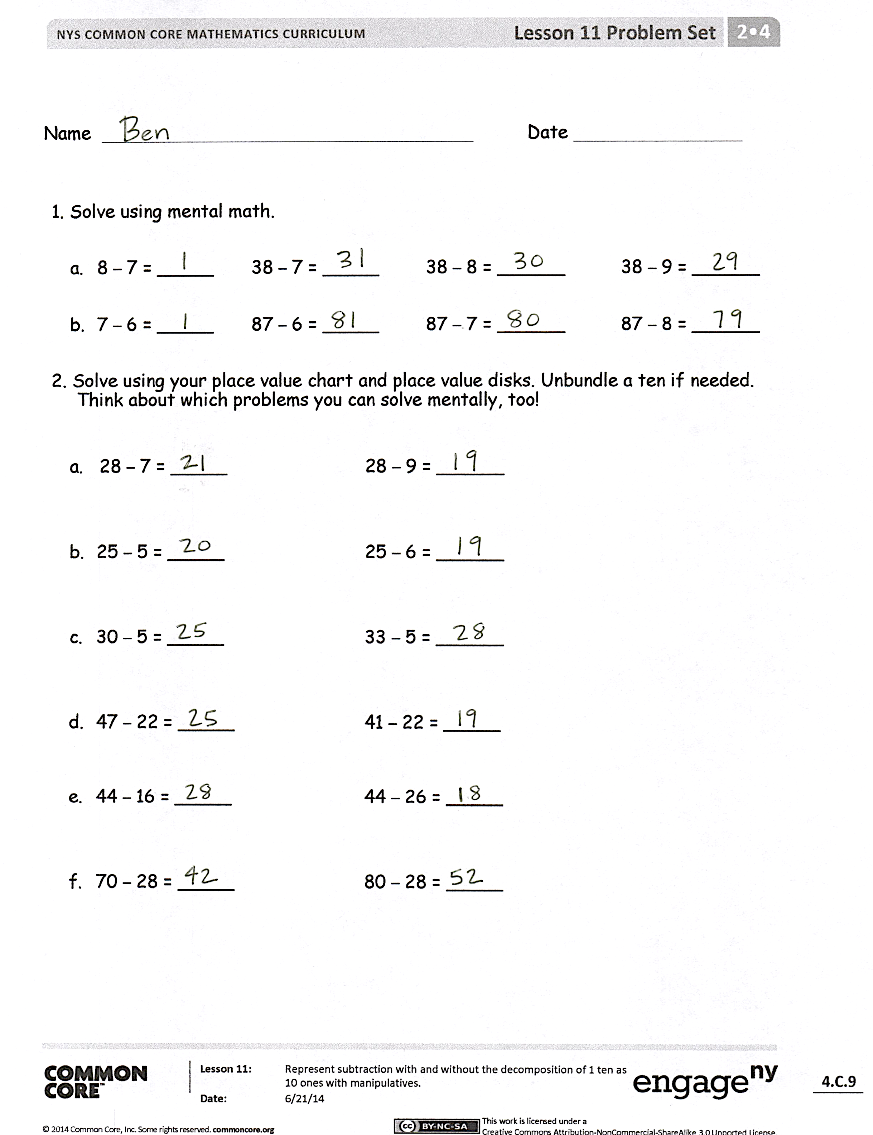
Student Debrief (10 minutes)
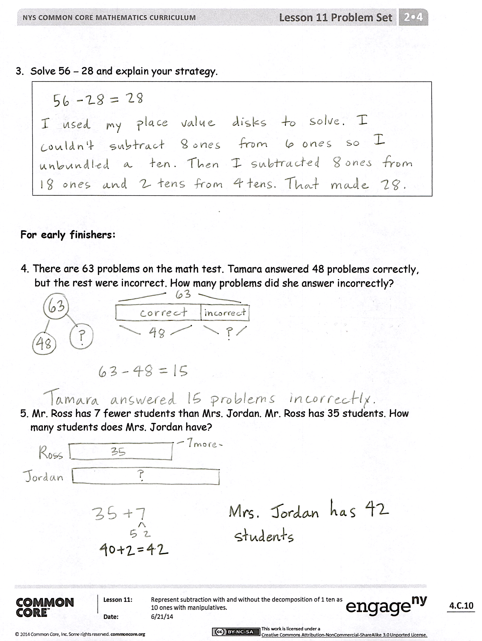
Lesson Objective: Represent subtraction with and without the decomposition of 1 ten as 10 ones with manipulatives.
The Student Debrief is intended to invite reflection and active processing of the total lesson experience.
Invite students to review their solutions for the Problem Set. They should check work by comparing answers with a partner before going over answers as a class. Look for misconceptions or misunderstandings that can be addressed in the Debrief. Guide students in a conversation to debrief the Problem Set and process the lesson.
You may choose to use any combination of the questions below to lead the discussion.
- How did the sequence in Problem 1(a) help you to solve 38 – 9 mentally? Did you need to decompose a ten to solve?
- Look at Problem 2. How could you avoid the extra work of modeling the problems in the second column? Use the words more or less to describe how the second column relates to the first one.
- Explain to your partner how to solve Problem 3. Did you need to unbundle a ten to solve? How did you know?
- For Problem 4, did you decompose a unit of ten? Could you have solved this problem differently?
- How do you know when you must unbundle a ten to subtract? Must you always unbundle when solving a problem like 86 – 39?
Exit Ticket (3 minutes)
After the Student Debrief, instruct students to complete the Exit Ticket. A review of their work will help you assess the students’ understanding of the concepts that were presented in the lesson today and plan more effectively for future lessons. You may read the questions aloud to the students.
Name Date
- Solve using mental math.
- 8 – 7 = _____ 38 – 7 = _____ 38 – 8 = ______ 38 – 9 = ______

- 7 – 6 = _____ 87 – 6 = _____ 87 – 7 = ______ 87 – 8 = ______

- Solve using your place value chart and place value disks. Unbundle a ten, if needed. Think about which problems you can solve mentally, too!
a. 28 – 7 = _____ 28 – 9 = ______

- 25 – 5 = _____ 25 – 6 = ______

- 30 – 5 = _____ 33 – 5 = ______

- 47 – 22 = _____ 41 – 22 = _____

- 44 – 16 = _____ 44 – 26 = _____

- 70 – 28 = _____ 80 – 28 = _____
- Solve 56 – 28, and explain your strategy.

For early finishers:

- There are 63 problems on the math test. Tamara answered 48 problems correctly, but the rest were incorrect. How many problems did she answer incorrectly?

- Mr. Ross has 7 fewer students than Mrs. Jordan. Mr. Ross has 35 students. How many students does Mrs. Jordan have?
Name Date
Solve for the missing part. Use your place value chart and place value disks.
1.
56

71

2.
38

84

Name Date
- Solve using mental math.

- 6 – 5 = _____ 26 – 5 = _____ 26 – 6 = ______ 26 – 7 = ______

- 8 – 7 = _____ 58 – 7 = _____ 58 – 8 = ______ 58 – 9 = ______

- Solve using your place value chart and place value disks. Unbundle a ten, if needed. Think about which problems you can solve mentally, too!

- 36 – 5 = _____ 36 – 7 = _____

- 37 – 6 = _____ 37 – 8 = _____

- 40 – 5 = _____ 41 – 5 = _____

- 58 – 32 = _____ 58 – 29 = _____

- 60 – 26 = _____ 62 – 26 = _____

- 70 – 41 = _____ 80 – 41 = _____
- Solve, and explain your strategy.
a.
41 – 27 = _____

b.
67 – 28 = _____

- The number of marbles in each jar is marked on the front. Miss Clark took 37 marbles out of each jar. How many marbles are left in each jar? Complete the number sentence to find out.
52
45

a. _____ – _____ = _____ b. _____ – _____ = _____
55
48

c. _____ – _____ = _____ d. _____ – _____ = ______

