Lesson 8
Objective: Use math drawings to represent the composition and relate drawings to a written method.

Suggested Lesson Structure
 Application Problem (6 minutes)
 Fluency Practice (10 minutes)
 Concept Development (34 minutes)
 Student Debrief (10 minutes)
Total Time (60 minutes)
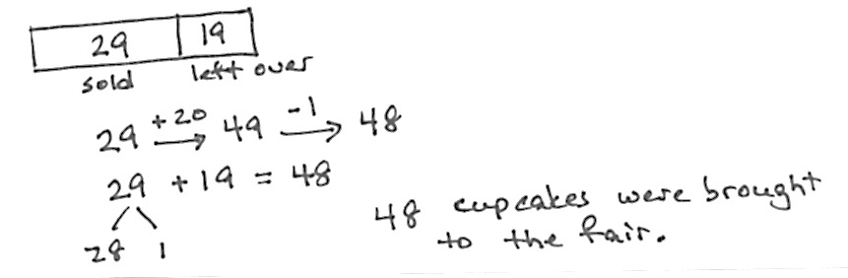
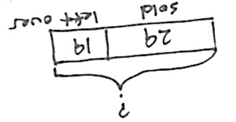
Application Problem (6 minutes)
At the school fair, 29 cupcakes were sold and 19 were left over. How many cupcakes were brought to the fair?
Note: This problem is intended for guided practice to help students gain familiarity with the take from with start unknown problem type. The language of these problem types can be confusing to students. Guide students to see that when both parts are known, we add to find the total.
Fluency Practice (10 minutes)
- Number Patterns 2.NBT.2 (6 minutes)
- Sums to the Teens 2.NBT.4 (4 minutes)
Number Patterns (6 minutes)
Materials: (S) Personal white board
Note: Students apply knowledge of adding and subtracting multiples of 10 and 1 to complete patterns.
T: (Write on board 124, 134, 144, ____.) What is the place value of the digit that’s changing?
S: Tens.
T: Count with me, saying the value of the digit I’m pointing to.
S: (Point to the tens digit as students count.) 20, 30, 40.
T: On your personal white board, write the number that comes next in the pattern.
S: (Write and show 154.)
T: What is the pattern?
S: Add 10.
Repeat with the following possible sequence, using place value disks if students are struggling:
278 268 258 ______
99 109 119 ______
380 379 378 ______
522 542 562 ______
125 225 325 ______
Sums to the Teens (4 minutes)
Materials: (S) Personal white board
Note: This fluency activity readies students for the day’s lesson and allows them to work at different rates. Give about 20 seconds per problem.
T: (Write 9 + 3.)
T: This is the basic problem for a pattern. Once you have solved this problem, solve 19 + 3, 29 + 3… What would come next?
S: 39 + 3.
T: Yes. Continue until I say stop, and I will give you a new basic problem. Begin with 9 + 6. Go!
When you see everyone has completed at least 2 problems, stop the class and give the next expression.
Use the following possible sequence: 9 + 6, 9 + 4, 8 + 4, 8 + 6, 7 + 4, and 7 + 6.
Concept Development (34 minutes)
Materials: (T) Place value disks (S) Math journal or paper
As students learn to make math drawings to represent the written vertical form, it is important to teach precision: aligning digits in their proper place, drawing place value disks in clear 5-groups, and showing new groups below in the correct place. For this reason, in the beginning, students should use pencil and paper which allows greater precision than a white board marker.
MP.6
T: (Show place value disks.) We’ve been modeling addition with place value disks, but we don’t have to use these disks. We can draw them! Watch.

Problem 1: 32 + 24
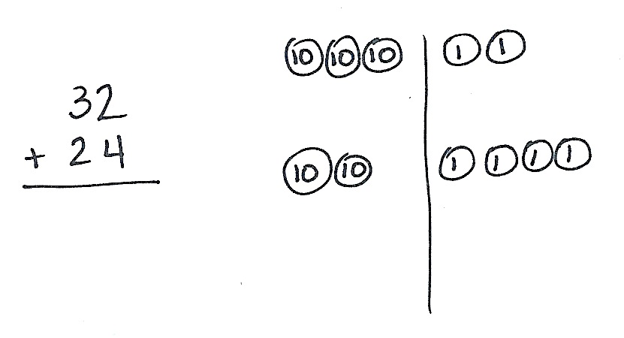
T: (Write 32 + 24 vertically. Draw a long vertical line, which serves as the place value chart, next to the vertical form. (See image at right.)
T: How many tens in 32?
S: 3 tens.
T: Count them as I draw. (Draw.)
S: 10, 20, 30.
T: How many ones should I draw?
S: 2 ones.

NOTES ON
MULTIPLE MEANS
OF ENGAGEMENT:
To help students line up their problems according to place value, have them use lined paper turned 90 degrees (landscape orientation) and write their numbers between the lines.

T: (Draw 2 ones disks.) Let’s count to be sure my drawing is correct. (Point to each disk as students count.)
S: 10, 20, 30, 31, 32.
T: Now I’ll add 24 to my drawing. How many tens?
S: 2 tens.
T: (Draw 2 tens disks below the 3 tens.) How many ones should I draw?
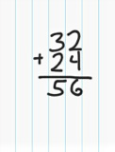
S: 4 ones.
MP.6
T: (Draw 4 ones disks below the 2 ones.) Let’s count to be sure my model is correct.
S: 10, 20, 21, 22, 23, 24.
T: Look how easy! And, now we solve. Do 2 ones and 4 ones make a ten?
S: No!
T: So we simply write the number of ones, 6, below the line in the ones place.
T: 3 tens + 2 tens is…?
S: 5 tens!
T: So we write 5 below the line in the tens place. Read the whole problem with me.
S: 32 + 24 equals 56.
T: Talk with your partner about how the drawing matches the vertical form.
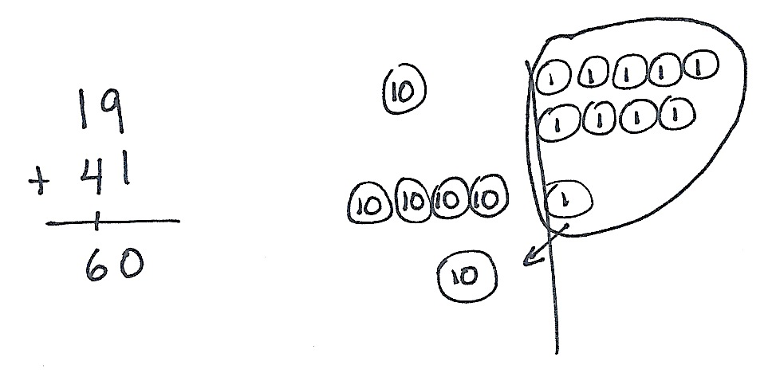
Problem 2: 19 + 41
T: Let’s work through another problem together. (Repeat the above process to model 19 + 41.)
T: Begin by adding the ones. Look at the vertical form and the model. Tell your partner what you notice. How are they the same?
S: 9 + 1 is 10. We need to bundle 10 ones as 1 ten. They both show 9 + 1, but one is numbers, and the other is a picture of the numbers.
T: Yes, they are the same! And, what we do on the model, we do to the numbers. We composed a ten, so we circle the 10 ones and draw an arrow into the tens place, where we draw the new unit of ten. (See image above.)
T: On the vertical form, we show this new unit of ten by writing a 1 on the line below the tens place. This way, we remember to add it in when we count the ten.
T: We write 0 below the line in the ones place. Looking at the model, we see there are no ones left.
T: Now, we add the tens. Remember to add in the new unit. 1 ten + 4 tens + 1 ten is…?
S: 6 tens!
T: Read the entire problem.
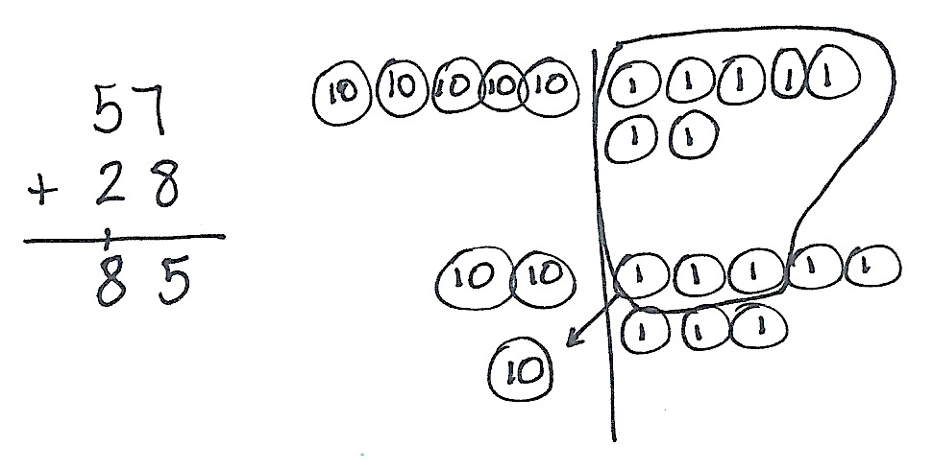
S: 19 + 41 equals 60.
T: Talk with your partner. How do we show the bundling, or renaming, of 10 ones as a unit of ten in the drawing and in the vertical form? (Allow one or two minutes for discussion.)
MP.6
T: Now it’s your turn. Draw and solve 57 + 28 while I walk around to see how it’s going.
Follow the procedure above to guide students as they write
57 + 28, model it, and solve. At each step, remind students to be precise in lining up the digits and in drawing their number disks in neat 5-groups. (See image at right.) Have them share the ways in which each step in the drawing matches what they do in the vertical form.

NOTES ON
MULTIPLE MEANS
OF ACTION AND EXPRESSION:
Provide colored pencils or crayons for students to draw tens and ones disks in two different colors. These may start by matching the colors of the disks. Then, encourage students to use the same colors as they used for the disks for the numbers in the tens and ones places when solving their problems. This may be especially helpful for students who struggle with place value.
Change the color daily to be used for the disks, so that students continue to read the values rather than relying on a certain color as a signal.

Continue with the following possible sequence: 15 + 68,
29 + 52, 64 + 27, and 56 + 38. Continue to support struggling students, but as students demonstrate proficiency, instruct them to work on the Problem Set independently.
Problem Set (10 minutes)
Students should do their personal best to complete the Problem Set within the allotted 10 minutes. For some classes, it may be appropriate to modify the assignment by specifying which problems they work on first. Some problems do not specify a method for solving. Students should solve these problems using the RDW approach used for Application Problems.

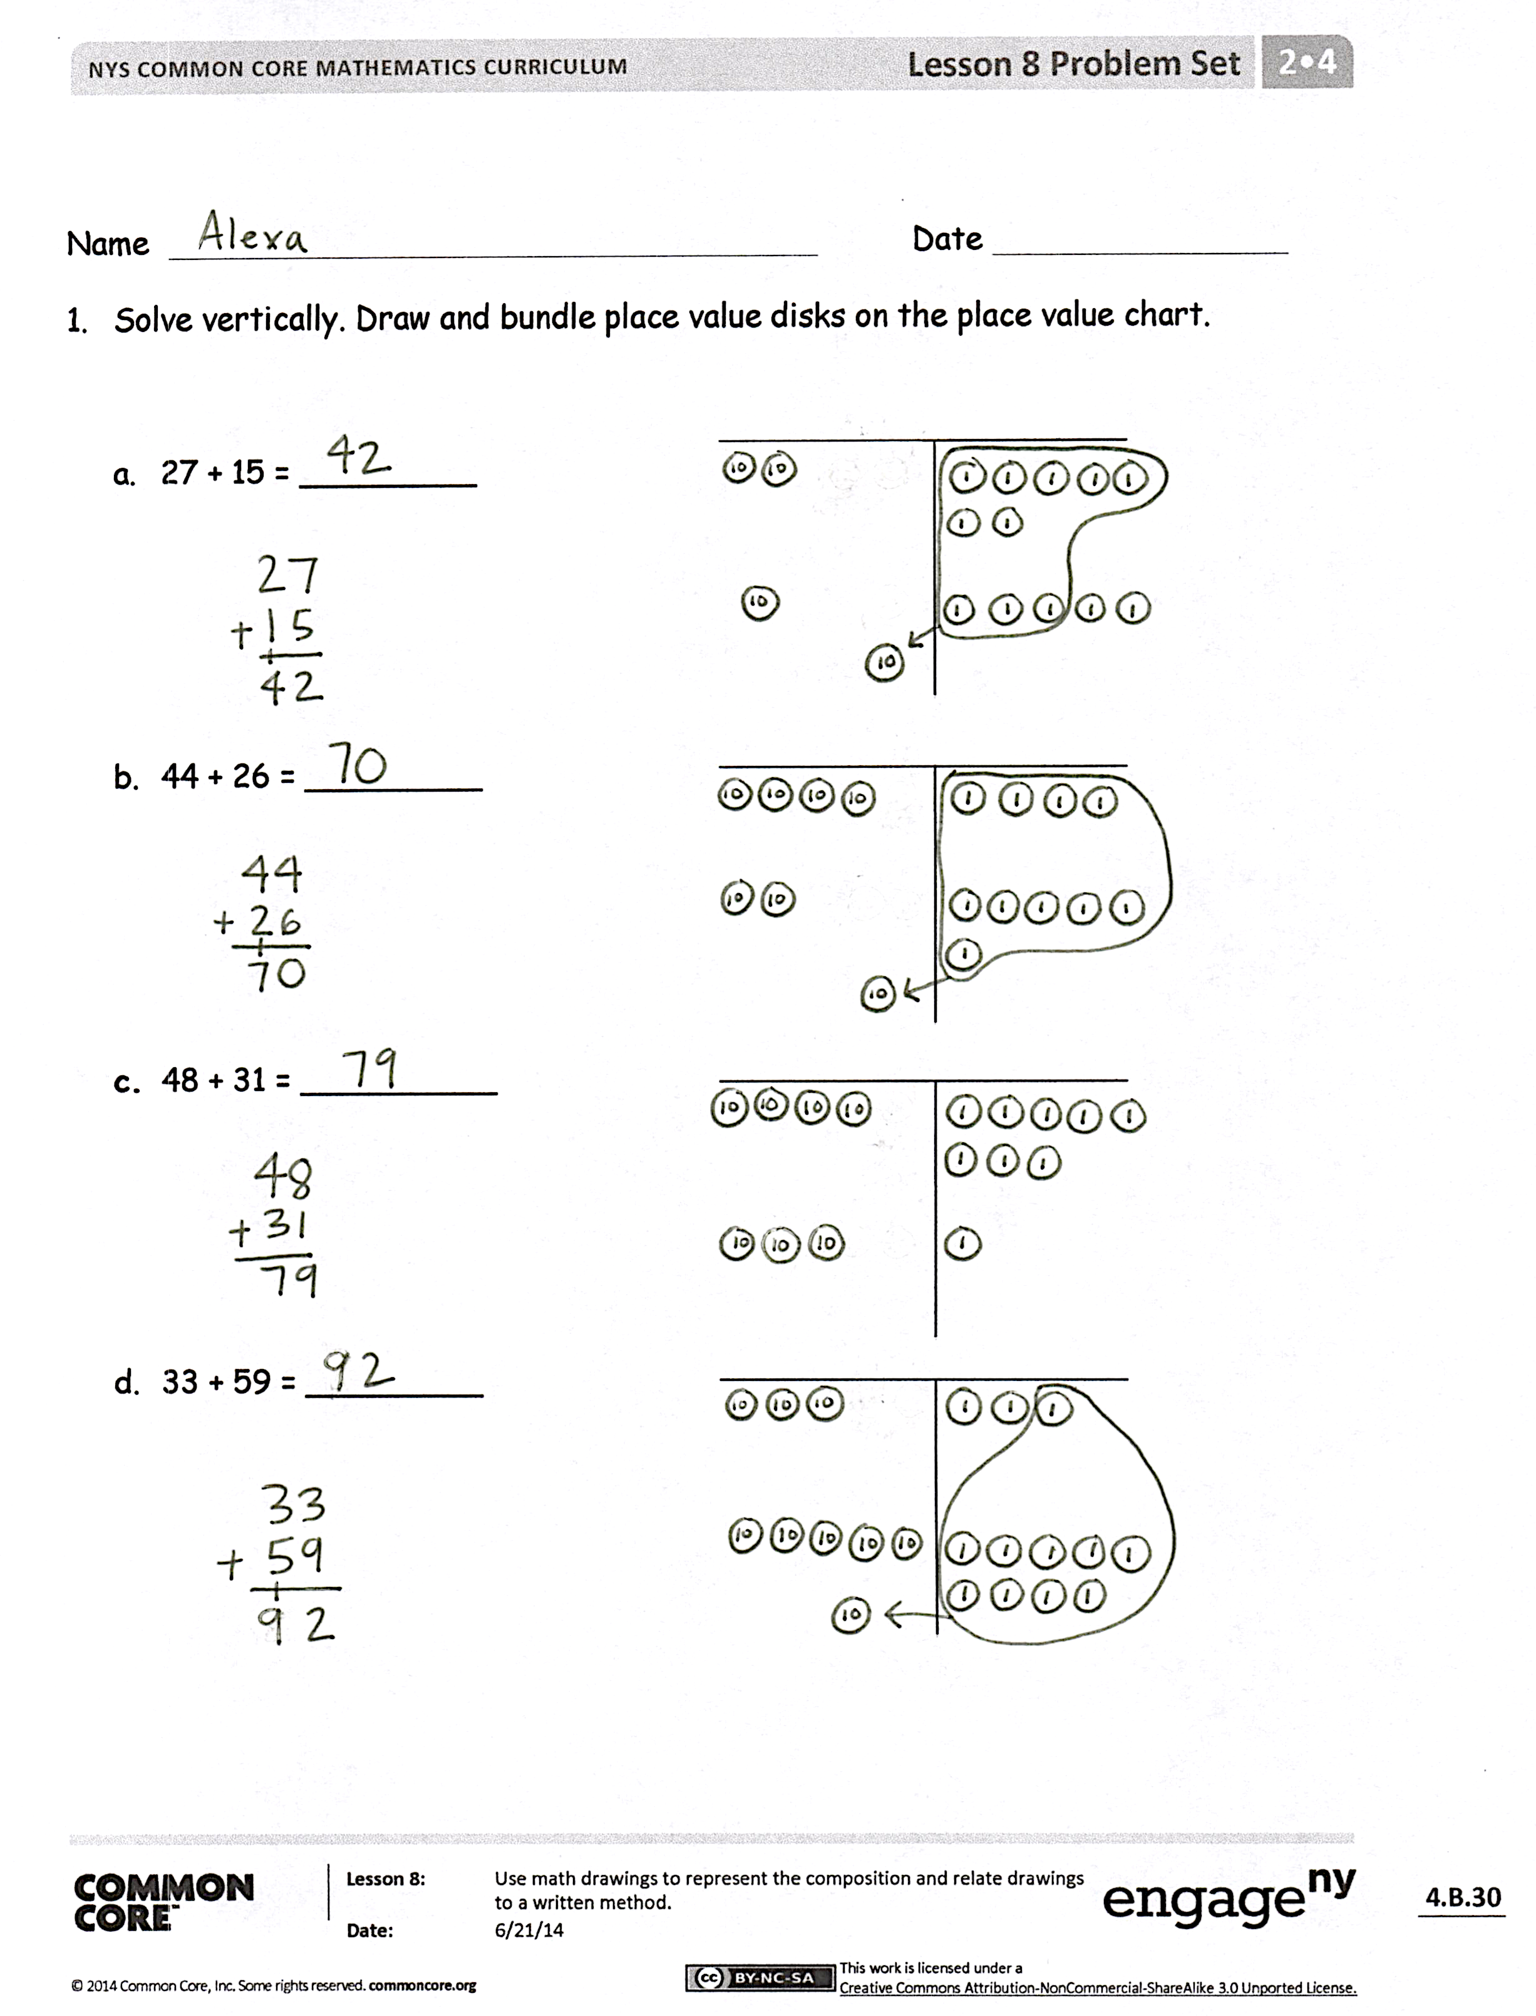
Student Debrief (10 minutes)
Lesson Objective: Use math drawings to represent the composition and relate drawings to a written method.
The Student Debrief is intended to invite reflection and active processing of the total lesson experience.
Invite students to review their solutions for the Problem Set. They should check work by comparing answers with a partner before going over answers as a class. Look for misconceptions or misunderstandings that can be addressed in the Debrief. Guide students in a conversation to debrief the Problem Set and process the lesson.
You may choose to use any combination of the questions below to lead the discussion.
- For Problem 1, Part (a), did you compose a ten? Why? How many ones were leftover? How did you show it on your place value chart?
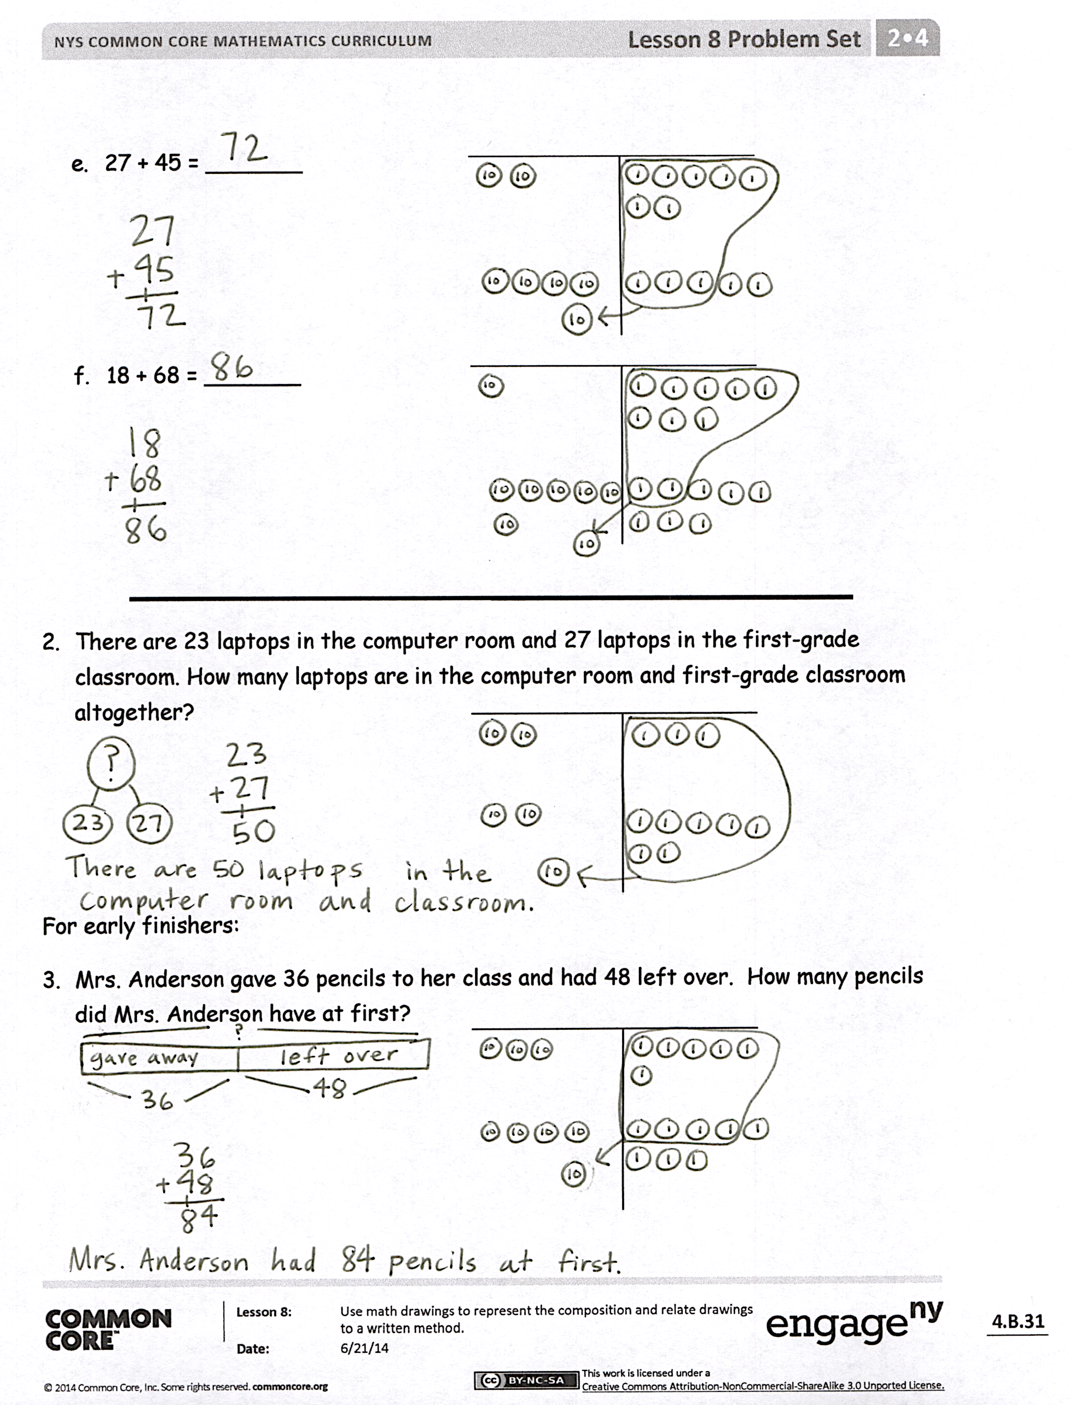
- Explain to your partner how to solve Problem 1, Part (b). How did you show a new unit of ten on your model and on the vertical form?
- For Problem 1, Part (d), what did you need to be sure to do when you were solving 33 + 59 using the vertical form?
- How did you rename the ones in Problem 1, Part (f)? How is practicing the Say Ten way helpful when we are adding larger numbers?
- With your partner, compare Problem 1, Parts (a) and (e). Could you have used Problem 1, Part (a) to solve Part (e) mentally (i.e., without composing a ten)?
Exit Ticket (3 minutes)
After the Student Debrief, instruct students to complete the Exit Ticket. A review of their work will help you assess the students’ understanding of the concepts that were presented in the lesson today and plan more effectively for future lessons. You may read the questions aloud to the students.

Name Date
- Solve vertically. Draw and bundle place value disks on the place value chart.

- 27 + 15 = _________

- 44 + 26 = _________

- 48 + 31 = __________

- 33 + 59 = _________

- 27 + 45 = _______

- 18 + 68 = _______

- There are 23 laptops in the computer room and 27 laptops in the first-grade classroom. How many laptops are in the computer room and first-grade classroom altogether?

For early finishers:
- Mrs. Anderson gave 36 pencils to her class and had 48 left over. How many pencils did Mrs. Anderson have at first?

Name Date
Use place value language to explain Zane’s mistake. Then, solve using the vertical form. Draw and bundle place value disks on your place value chart.

Zane’s Answer  59 + 35 = _______  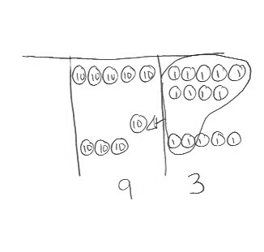 | Zane’s Mistake
My Answer

Name Date
- Solve vertically. Draw and bundle place value disks on the place value chart.

  - 26 + 35 = _______

  - 28 + 14 = _______

  - 35 + 27 = _______

- 23 + 46 = _______

- 32 + 59 = _______

- Twenty-eight second-grade students went on a field trip to the zoo. The other 24 second-grade students stayed at school. How many second grade students are there?

3. Alice cut a 27 cm piece of ribbon and had 39 cm of ribbon left over. How much ribbon did Alice have at first?

