Lesson 6
Objective: Use manipulatives to represent the composition of 10 ones as 1 ten with two-digit addends.

Suggested Lesson Structure
 Fluency Practice (10 minutes)
 Application Problem (3 minutes)
 Concept Development (37 minutes)
 Student Debrief (10 minutes)
Total Time (60 minutes)
Fluency Practice (10 minutes)
- Finding Doubles 2.NBT.5 (2 minutes)
- Say Ten Counting 2.NBT.1 (3 minutes)
- Say Ten Counting to the Next Ten 2.NBT.1 (5 minutes)
Finding Doubles (2 minutes)
Note: Finding doubles gives students another mental strategy for adding.

NOTES ON
MULTIPLE MEANS
OF ACTION AND EXPRESSION:
Some students may combine addition and subtraction with double facts. For example, with 5 + 4, they may think 5 + 5 – 1. Encourage students to be versatile in their thinking, and praise different approaches that work.

T: I’ll say a number sentence. You say the doubles fact within the number sentence and add on the rest. So, if I say 5 + 6, you say 5 + 5 + 1. Ready?
T: 4 + 5.
S: 4 + 4 + 1.
T: Answer.
S: 9.
T: 8 + 7.
S: 7 + 7 + 1.
T: Answer.
S: 15.
Continue with the following possible sequence: 4 + 3, 8 + 9, 7 + 6, 10 + 11, and 12 + 13.
Say Ten Counting (3 minutes)
Materials: (T) Rekenrek
Note: Reviewing and practicing saying numbers the Say Ten way in isolation prepares students for success when adding numbers during this lesson. Use a Rekenrek to model the first few to help students visualize.
T: Let’s count the Say Ten way. When I say 46, you say 4 tens 6. Ready? 57.
S: 5 tens 7.
T: 78.
S: 7 tens 8.
T: 100.
S: 10 tens.
T: 113.
S: 11 tens 3.
Continue with following possible sequence: 103, 123, 127, 137, 132, 142, 143, 163, 168, 188, 198, and 200. Be aware that the Say Ten way could also mean reading the numbers as 1 hundred 2 tens 3. The focus today however, is just reading tens.
Say Ten Counting to the Next Ten (5 minutes)
Note: Practicing this fluency helps students see a connection with counting the Say Ten way and making a ten. It provides practice adding ones to make a multiple of 10.
T: Let’s add to make the next ten the Say Ten way. I say 4 tens 2, you say 4 tens 2 + 8 = 5 tens. Ready?
6 tens 2.
S: 6 tens 2 + 8 = 7 tens.
T: 5 tens 1.
S: 5 tens 1 + 9 = 6 tens.
T: 7 tens 8.
S: 7 tens 8 + 2 = 8 tens.
Continue with the following possible sequence: 8 tens 4, 8 tens 5, 8 tens 9, 9 tens 6, 9 tens 3, and 9 tens 9.
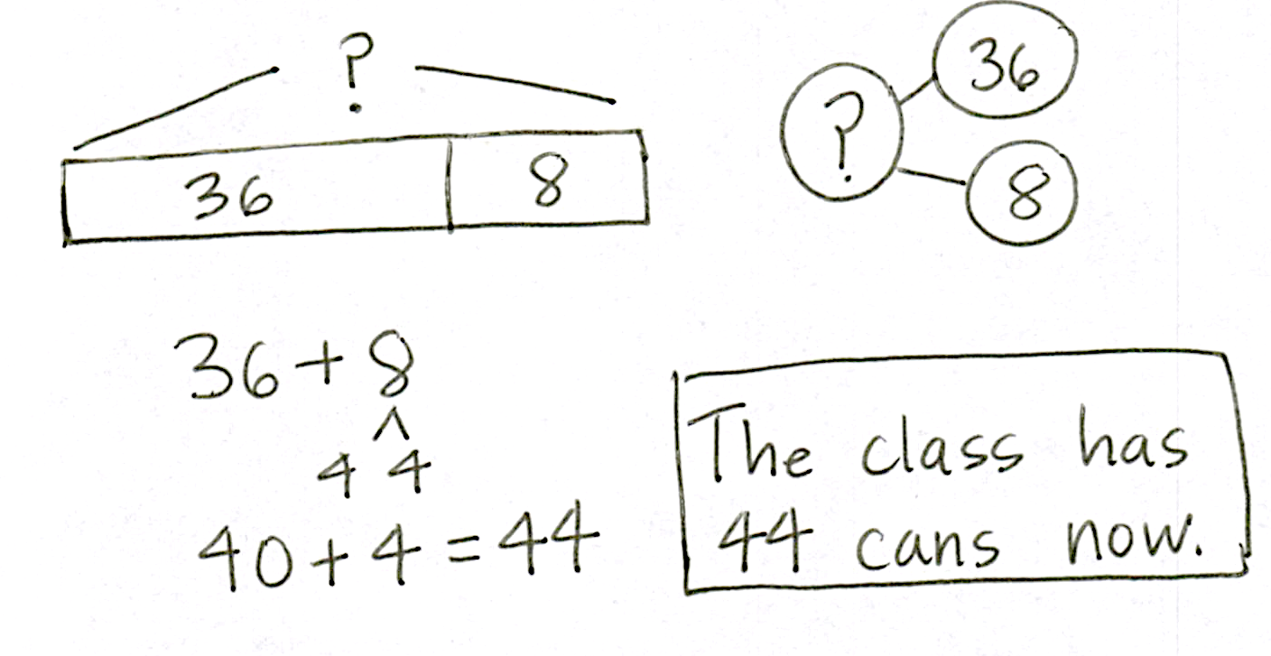
Application Problem (3 minutes)
Mr. Wally’s class collects 36 cans for the recycling program. Then, Azniv brings in 8 more cans. How many cans does the class have now?
Note: This problem is intended as independent work. It primes students to connect the make a ten strategy with the composition of 10 ones as 1 ten that is the focus of today’s Concept Development.
Concept Development (37 minutes)
Materials: (T) Place value disks, unlabeled tens place value chart (Lesson 1 Template) (S) Per pair: place value disks (9 tens, 18 ones), unlabeled tens place value chart (Lesson 1 Template), place value disks (Template)
Note: The place value disk template is provided to support students as they complete their homework. Students may cut it apart and store the disks in a baggy for use at home.
Project or draw unlabeled place value chart on the board.
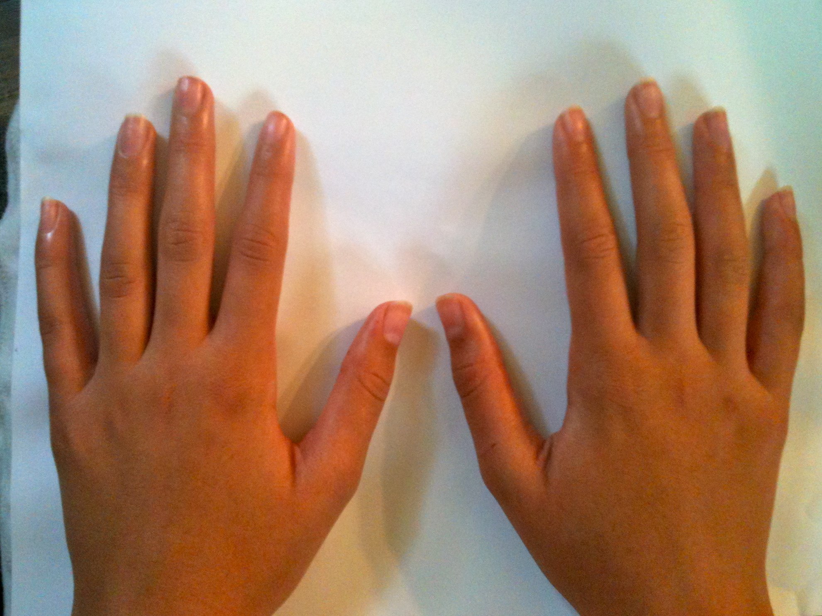
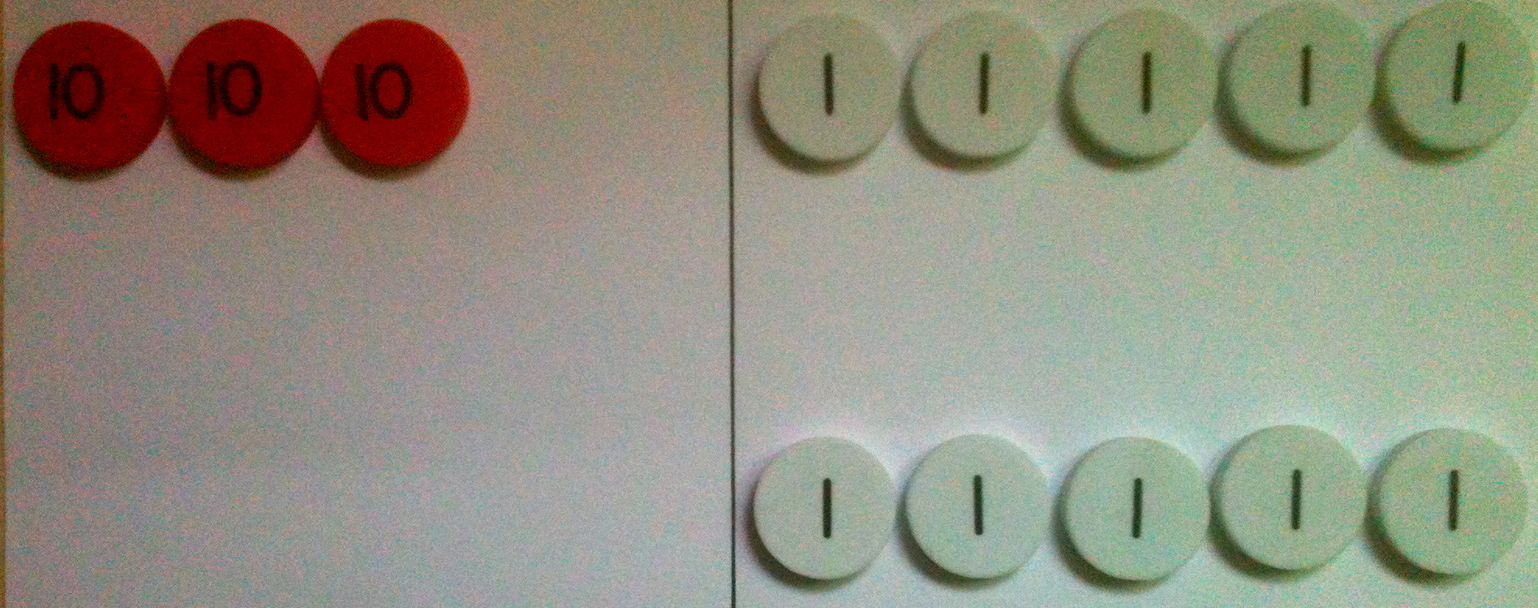
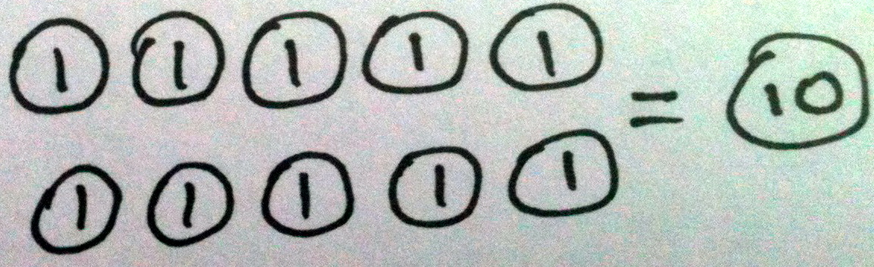
T: Watch as I model 35 + 5 on my place value chart. (See image at right.)
T: What do you notice in the ones place?
S: There are two 5-groups. You can make a ten.
T: I can! Show me your magic counting sticks. (Students hold up all 10 fingers.) Each finger represents one. Count with me.
S: One, two, … 10! (On 10, students clasp their hands together with a loud clap, interlacing their fingers to make one unit of 10.)
T: What happens when we add the ones and get a total of 10 or more?
S: We bundle it! 10 ones equals 1 ten!
T: Yes! (Draw image at right on the board.) 10 ones equals 1 ten. We can compose, or make, a ten.
T: Where do units of 10 belong?
S: In the tens place!
T: (Point to the model.) So we bundle 10 ones as 1 ten. (Gather and remove the 10 ones and put a tens disk in the tens place.) I change these 10 ones for 1 ten.
T: 3 tens and a new ten equals?
MP.4
S: 4 tens!

NOTES ON
MULTIPLE MEANS
OF REPRESENTATION:
For students who are struggling with place value disks, create a station in the classroom with a Rekenrek so they can model the problems. Once they have mastered this, encourage students to move to the place value disks and place value chart.

Pass out place value disks and a template to each pair of students.
T: Your turn! Partner A, show 35 on your place value chart. Partner B, show 6. Be sure to arrange the disks in 5-groups.
S: (Model the addends.)
T: Partner A, move the disks to add the ones.
5 ones + 6 ones?
S: (Partner A moves the ones together to make a ten.)
11 ones!
T: The Say Ten way?
S: 1 ten 1!
T: You’ve composed a unit of 10! 11 ones is the same as 1 ten 1. Partner B, changes 10 ones disks for 1 tens disk.
S: (Partner B removes 10 ones and places a tens disk in the tens place.)
T: How many ones in the ones place?
S: 1!
T: How many tens in the tens place?
S: 4!
T: 35 + 6 the Say Ten way?
S: 4 tens 1!
T: Let’s model another addition problem. Partner B, show 35. Partner A, show 26.
T: How is this problem different from the first one?
S: Now you’re adding 2 tens. It’s 20 more than the one we just did.
T: Partner B, move the disks to add the ones. How many ones?
MP.4
S: 11 ones!
T: Partner B, change 10 ones disks for 1 ten disk.
S: (Partner B removes 10 ones and places a ten disk in the tens place.)
T: How many ones in the ones place?
S: 1!
T: Partner A, add the tens disks. How many tens?
S: 6 tens!
T: 35 + 26 the Say Ten way?
S: 6 tens 1!
T: Talk with your partner. What patterns do you notice as we’re adding?
S: I add the ones together, and then I add the tens. If we see partners to ten, we know we have to make a new ten. We change 10 ones for 1 ten, and we put the new ten in the tens place.
Continue with the following possible sequence: 48 + 37, 59 + 23, 66 + 18, 74 + 19, 28 + 58, and 18 + 39. Have partners take turns composing the ten. Release students to work on the Problem Set as they show proficiency composing 1 ten from 10 ones.
Problem Set (10 minutes)
Students should do their personal best to complete the Problem Set within the allotted 10 minutes. For some classes, it may be appropriate to modify the assignment by specifying which problems they work on first. Some problems do not specify a method for solving. Students should solve these problems using the RDW approach used for Application Problems.

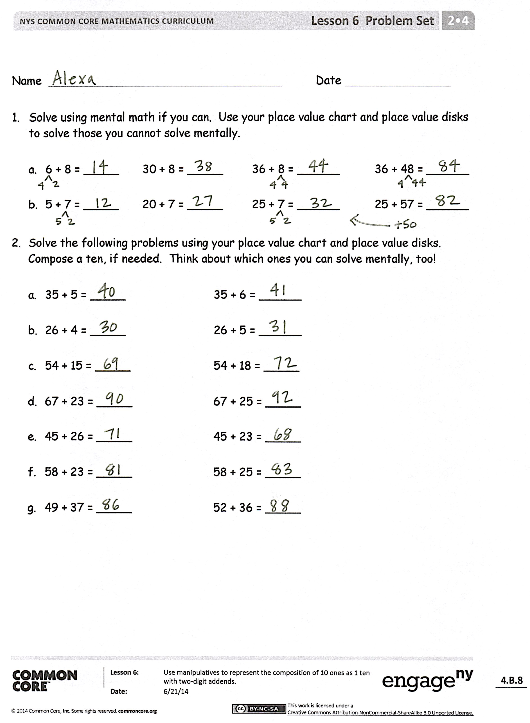
Student Debrief (10 minutes)
Lesson Objective: Use manipulatives to represent the composition of 10 ones as 1 ten with two-digit addends.
The Student Debrief is intended to invite reflection and active processing of the total lesson experience.
Invite students to review their solutions for the Problem Set. They should check work by comparing answers with a partner before going over answers as a class. Look for misconceptions or misunderstandings that can be addressed in the Debrief. Guide students in a conversation to debrief the Problem Set and process the lesson.
You may choose to use any combination of the questions below to lead the discussion.
- How did the sequence in Problem 1, Part (a) help you to solve 36 + 48 mentally? Did you need to compose a ten to solve?
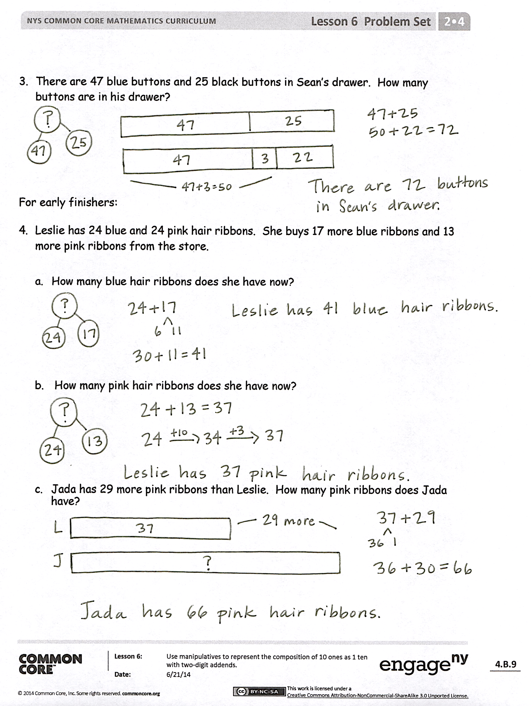
- Look at the two columns in Problem 2. Did you need to model the problems in the second column? (For example, did you need to compose a ten?)
- Explain to your partner how to solve Problem 3. Did you need to compose a ten to solve? How did you know?
- For Problem 2, in rows (c), (e), and (g), did you compose a new unit of 10 in both problems? Why or why not? How could you know that you would not need to compose a new unit in one of the problems?
Exit Ticket (3 minutes)
After the Student Debrief, instruct students to complete the Exit Ticket. A review of their work will help you assess the students’ understanding of the concepts presented in the lesson today and plan more effectively for future lessons. You may read the questions aloud to the students.
Name Date
- Solve using mental math, if you can. Use your place value chart and place value disks to solve those you cannot solve mentally.

- 6 + 8 = _____ 30 + 8 = _____ 36 + 8 = ______ 36 + 48 = ______

- 5 + 7 = _____ 20 + 7 = _____ 25 + 7 = ______ 25 + 57 = ______

- Solve the following problems using your place value chart and place value disks. Compose a ten, if needed. Think about which ones you can solve mentally, too!

- 35 + 5 = _____ 35 + 6 = ______

- 26 + 4 = _____ 26 + 5 = ______

- 54 + 15 = _____ 54 + 18 = _____

- 67 + 23 = _____ 67 + 25 = _____

- 45 + 26 = _____ 45 + 23 = _____

- 58 + 23 = _____ 58 + 25 = _____

- 49 + 37 = _____ 52 + 36 = _____

- There are 47 blue buttons and 25 black buttons in Sean’s drawer. How many
buttons are in his drawer?

For early finishers:
- Leslie has 24 blue and 24 pink hair ribbons. She buys 17 more blue ribbons and 13 more pink ribbons from the store.

- How many blue hair ribbons does she have now?

- How many pink hair ribbons does she have now?

- Jada has 29 more pink ribbons than Leslie. How many pink ribbons does Jada have?

Name Date
Solve using your place value chart and place value disks. Compose a ten, if needed. Think about which ones you can solve mentally, too!
- 53 + 19 = _______

- 44 + 27 = _______

- 64 + 28 = _______

Name Date
- Solve using mental math, if you can. Use your place value chart and place value disks to solve those you cannot do mentally.

- 4 + 9 = _____ 30 + 9 = _____ 34 + 9 = ______ 34 + 49 = ______

- 6 + 8 = _____ 20 + 8 = _____ 26 + 8 = ______ 26 + 58 = ______

- Solve the following problems using your place value chart and place value disks. Compose a ten, if needed. Think about which ones you can solve mentally, too!

- 21 + 9 = _____ 22 + 9 = ______

- 28 + 2 = _____ 28 + 4 = ______

- 32 + 16 = _____ 34 + 17 = _____

- 47 + 23 = _____ 47 + 25 = _____

- 53 + 35 = _____ 58 + 35 = _____

- 58 + 42 = _____ 58 + 45 = _____

- 69 + 32 = _____ 36 + 62 = _____

- 77 + 13 = _____ 16 + 77 = _____

- 59 + 34 = _____ 31 + 58 = _____

Solve using a place value chart.
- Melissa has 36 more crayons than her brother. Her brother has 49 crayons. How many crayons does Melissa have?

- There were 67 candles on Grandma’s birthday cake and 26 left in the box. How many candles were there in all?

- Frank’s mother gave him $25 to save. If he already had $38 saved, how much money does Frank have saved now?

