Lesson 5
Objective: Solve one- and two-step word problems within 100 using strategies based on place value.

Suggested Lesson Structure
 Fluency Practice (10 minutes)
 Concept Development (40 minutes)
 Student Debrief (10 minutes)
Total Time (60 minutes)
Fluency Practice (10 minutes)
- Rename the Units: Choral Response 2.NBT.1 (1 minute)
- Sprint: Add and Subtract Ones and Tens 2.NBT.5 (9 minutes)
Rename the Units: Choral Response (1 minute)
Note: This fluency reviews place value relationships that lead into Lesson 6.
T: (Write 10 ones = ____ ten. Draw 10 ones place value disks on the board in ten-frame format and circle them when the students say 10 ones = 1 ten.) I’m going to give you a number in ones form. Pull out as many tens as you can and tell me how many tens and ones there are. If there are no ones, only say the tens. Ready?
T: Say the number sentence.
S: 10 ones = 1 ten.
T: (Write 20 ones = ____ tens.) Say the number sentence.
S: 20 ones = 2 tens.
T: 23 ones.
S: 23 ones = 2 tens 3 ones.
Repeat the process for the following possible sequence: 60 ones, 63 ones, 70 ones, 75 ones, 79 ones, 90 ones, and 97 ones.
Sprint: Add and Subtract Ones and Tens (9 minutes)
Materials: (S) Two-Digit Addition and Subtraction Sprint (repeated from Lesson 3)
Note: This Sprint reviews addition and subtraction of multiples of 10 and some ones.
Concept Development (40 minutes)

A NOTE ON
LESSON STRUCTURE:
Today’s Concept Development focuses on solving word problems. For this reason, the Application component is embedded in the lesson.

Materials: (S) Math journal or personal white board
Note: Prepare Problems 1 through 4 in advance for either display or distribution to students.
Suggested Delivery of Instruction for Solving Word Problems
1. Model the problem.
Invite two pairs of students who can successfully model the problem to work at the board while the others work independently or in pairs at their seats. Review the following questions before solving the first problem.
- Can you draw something?
- What can you draw?
- What conclusions can you make from your drawing?
As students work, circulate. Reiterate the questions above and guide them in drawing their tape diagrams.
After two minutes, have the two pairs of students share only their labeled diagrams.
For about one minute, encourage the demonstrating students to respond to feedback and questions from their peers.

NOTES ON
MULTIPLE MEANS
OF ACTION AND EXPRESSION:
Invite students who finish early to write their own word problems similar to the ones that have been modeled. After they have checked their own solutions, instruct students to swap problems with a partner, solve, and share problem solving strategies.
Students working below grade level
may continue to need additional
support in adding numbers together using place value charts and place value disks.

2. Solve and write a statement.
Discuss strategies for solving, such as arrow way, number bond, and tape diagram. Give students two minutes to solve and complete the question and share their work and thought processes with a peer.
Then, instruct students to write their equations and statements of the answer.
3. Assess the solution for reasonableness.
Give students one or two minutes to assess and explain the reasonableness of their solution.
Problem 1: Solve a single-step word problem using a tape diagram and the arrow way.
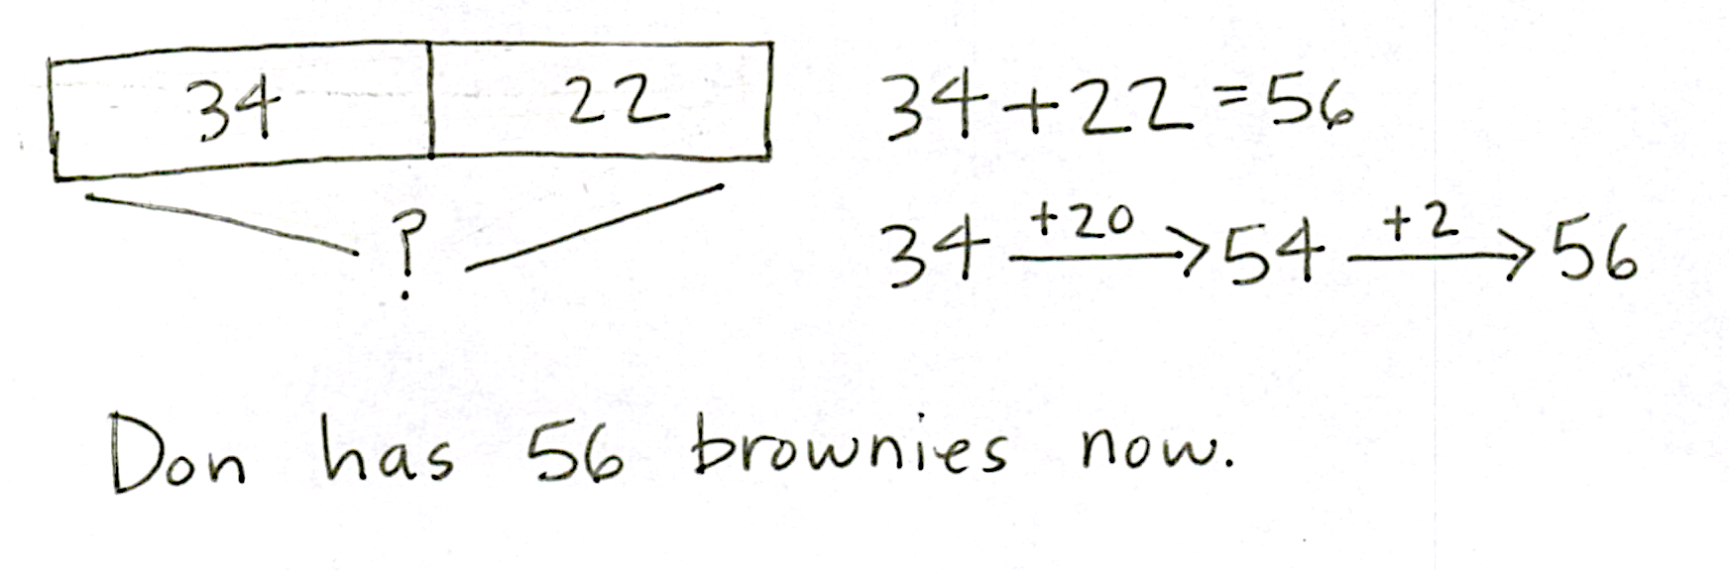
Don has 34 brownies. He bakes 22 more. How many brownies does he have now?

NOTES ON
MULTIPLE MEANS
OF ENGAGEMENT:
Provide graph paper for students who need support to make tape diagrams.

Support students by eliciting the response that we know both parts and need to find the whole. Students may use a number bond or tape diagram to represent the missing whole and then apply the arrow way to solve.
Problem 2: Solve a single-step word problem by drawing a tape diagram and using a number bond or the arrow way to solve.
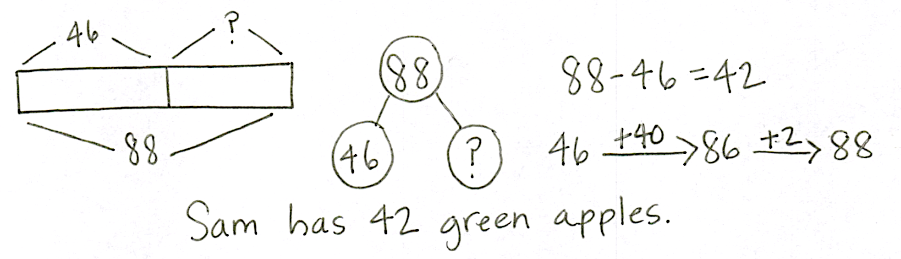
Sam has 46 red apples and some green apples. He has a total of 88 apples. How many green apples does he have?
Circulate and support students by guiding them to the realization that the unknown is a missing part.
MP.1
Problem 3: Solve a two-step problem by drawing a tape diagram and using a number bond to solve.
- There are 31 students on the red bus. There are 29 more students on the yellow bus than on the red bus. How many students are on the yellow bus?
- How many students are on both buses combined?
Note: Many students will want to draw this as a single bar, showing the total number of students to start. This works. However, the second step will most likely require a new double bar to compare the number of students on each bus. It is likely that the second step will need to be modeled for the students.
Problem 4: Solve a two-step problem by drawing a tape diagram and using the arrow way to solve.
- Ms. Lopez cut 46 cm of yarn. Ms. Hamilton cut 22 cm less than Ms. Lopez. How many centimeters of yarn did Ms. Hamilton cut?
- How many centimeters of yarn did they have altogether?
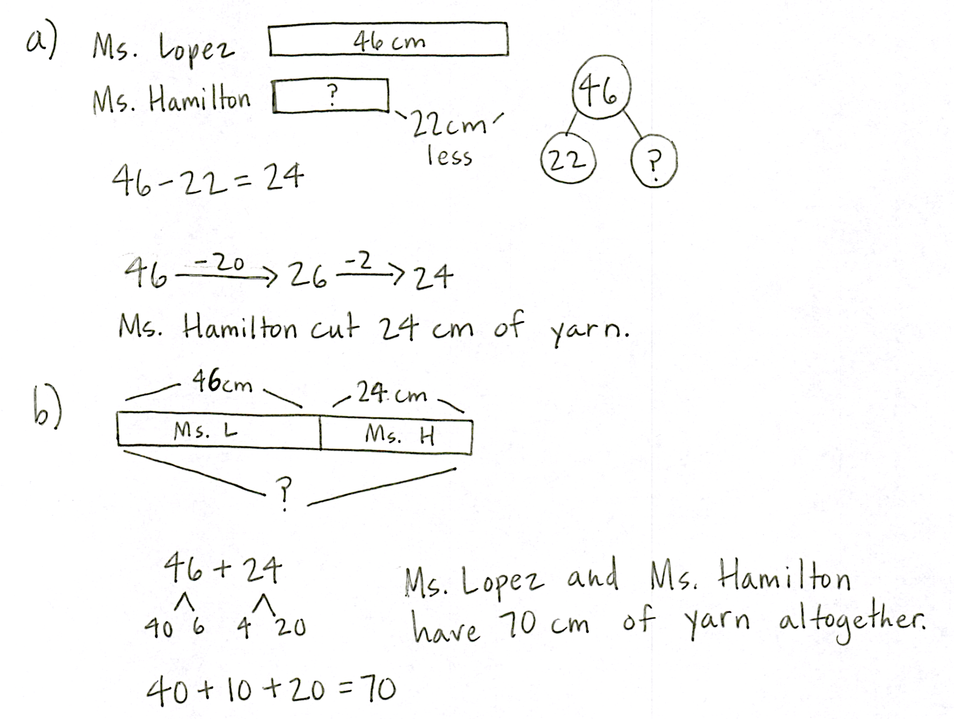
MP.1

Circulate and guide students toward realizing again that the unknown is a missing part of the whole; therefore, we subtract or count on to find the answer.
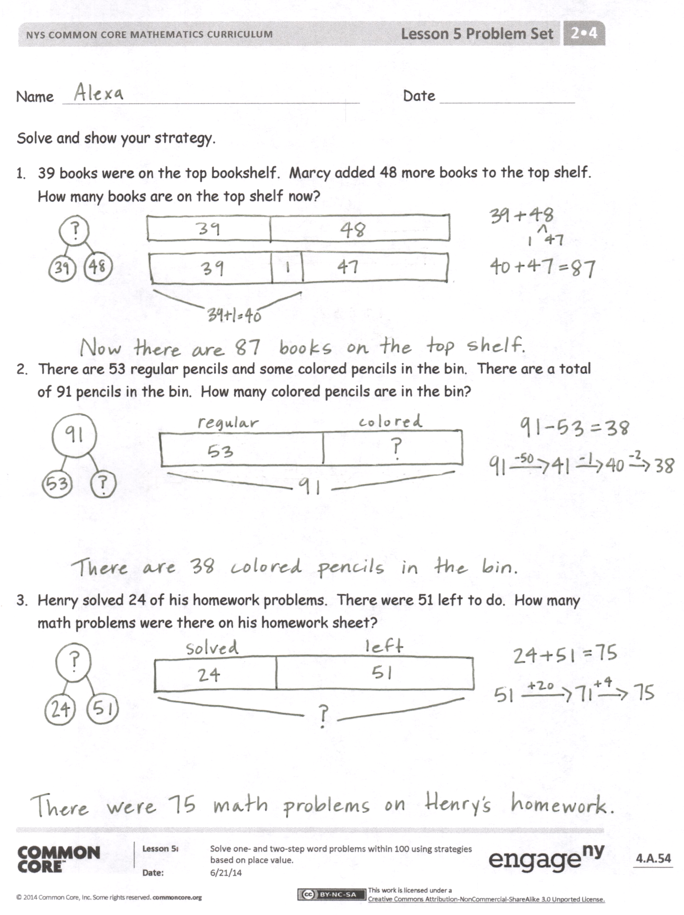
Problem Set (10 minutes)
Be aware that the timing of this lesson will vary widely based on your students’ experience with problem solving. You may not get to the Problem Set at all. It might be used by a small group while you work with others. It might be used by the whole class.
Student Debrief (10 minutes)
Lesson Objective: Solve one- and two-step word problems within 100 using strategies based on place value.
The Student Debrief is intended to invite reflection and active processing of the total lesson experience.
Invite students to review their solutions for the Problem Set. They should check work by comparing answers with a partner before going over answers as a class. Look for misconceptions or misunderstandings that can be addressed in the Debrief. Guide students in a conversation to debrief the Problem Set and process the lesson.
You may choose to use any combination of the questions below to lead the discussion.
- Let’s chart the different problem-solving strategies we have used today (to be referenced in future lessons throughout the module). What did today’s problem-solving strategies have in common?
- Explain how you decide whether to use a single bar or a double bar tape diagram when solving problems like Problem 3 or Problem 4 from today’s lesson.
- Looking at the Problem Set, which simplifying strategy did you use to solve Problem 1? Why did you choose that strategy? Could you have solved this problem another way?
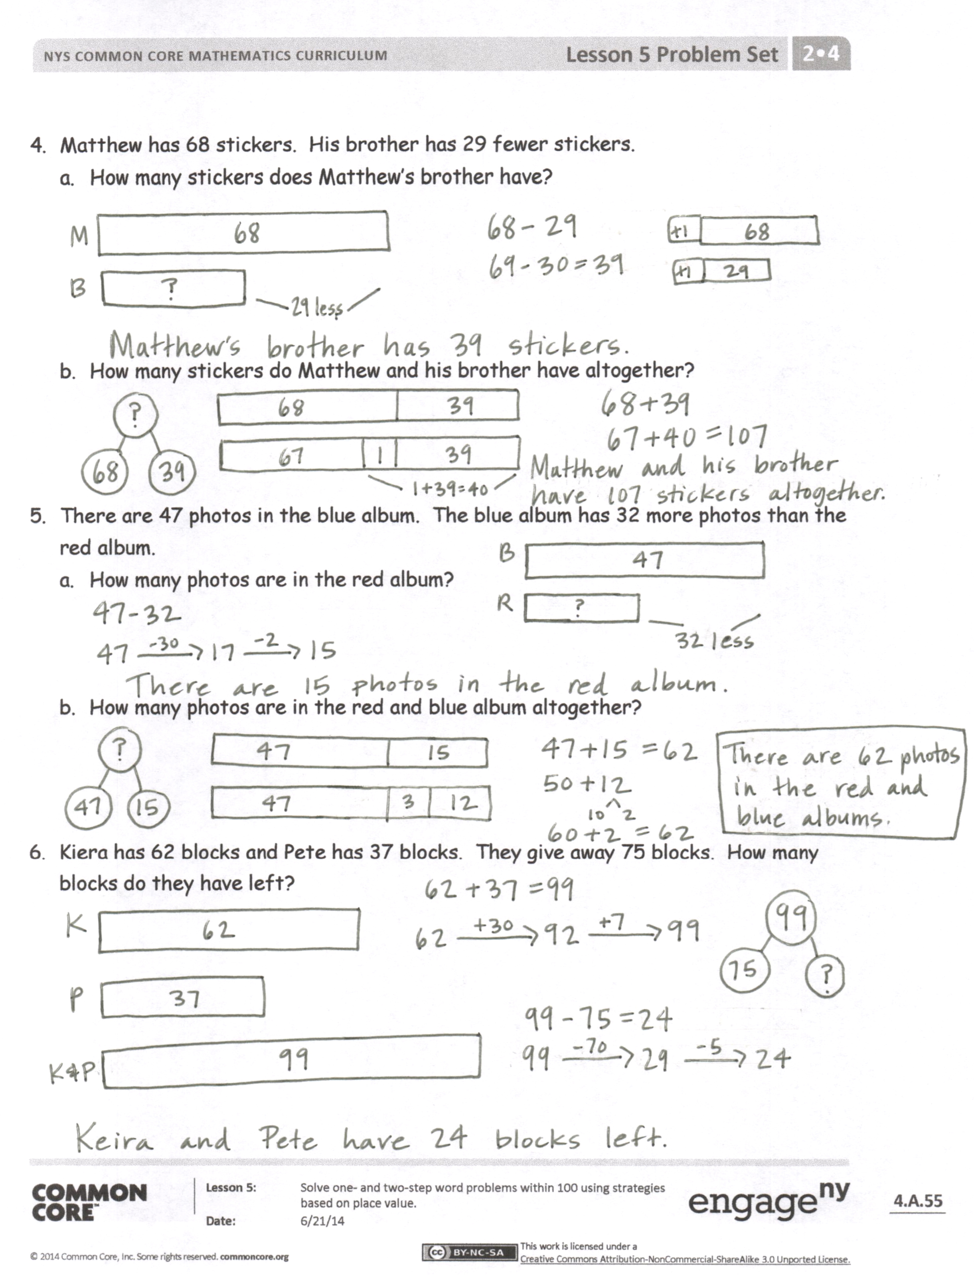
- Which operation did you choose to solve Problem 2? Why? How did drawing a tape diagram help you to solve?
- How did you show your thinking in Problem 4, Part (a)? Can you write an equation that describes the situation in this problem? Did you use this same operation to solve?
- What is the most challenging part about drawing a tape diagram for Problem 5, Part (a)? Based on that diagram, which simplifying strategy did you choose to solve?
Exit Ticket (3 minutes)
After the Student Debrief, instruct students to complete the Exit Ticket. A review of their work will help you assess the students’ understanding of the concepts that were presented in the lesson today and plan more effectively for future lessons. You may read the questions aloud to the students.
Name Date
Solve and show your strategy.
- 39 books were on the top bookshelf. Marcy added 48 more books to the top shelf. How many books are on the top shelf now?

- There are 53 regular pencils and some colored pencils in the bin. There are a total of 91 pencils in the bin. How many colored pencils are in the bin?

- Henry solved 24 of his homework problems. There were 51 left to do. How many math problems were there on his homework sheet?
- Matthew has 68 stickers. His brother has 29 fewer stickers.
  - How many stickers does Matthew’s brother have?

  - How many stickers do Matthew and his brother have altogether?

- There are 47 photos in the blue album. The blue album has 32 more photos than the red album.
- How many photos are in the red album?

- How many photos are in the red and blue albums altogether?

- Kiera has 62 blocks and Pete has 37 blocks. They give away 75 blocks. How many blocks do they have left?
Name Date
Solve and show your strategy.
- A store sold 58 t-shirts and had 25 t-shirts left.
  - How many t-shirts did the store have at first?

  - If 17 t-shirts are returned, how many t-shirts does the store have now?

- Steve swam 23 laps in the pool on Saturday, 28 laps on Sunday, and 36 laps on Monday. How many laps did Steve swim?
Name Date
Solve and show your strategy.
- 38 markers were in the bin. Chase added the 43 markers that were on the floor to the bin. How many markers are in the bin now?

- There are 29 fewer big stickers on the sticker sheet than little stickers. There are 62 little stickers on the sheet. How many big stickers are there?

- Rose has 34 photos in a photo album and 41 photos in a box. How many photos does Rose have?
- Halle has two ribbons. The blue ribbon is 58 cm. The green ribbon is 38 cm longer than the blue ribbon.
  - How long is the green ribbon?

  - Halle uses 67 cm of green ribbon to wrap a present. How much green ribbon is left?

- Chad bought a shirt for $19 and a pair of shoes for $28 more than the shirt.
  - How much was the pair of shoes?

  - How much money did Chad spend on the shirt and shoes?

  - If Chad had $13 left over, how much money did Chad have before buying the shirt and shoes?

