Lesson 4
Objective: Add and subtract multiples of 10 and some ones within 100.

Suggested Lesson Structure
 Fluency Practice (10 minutes)
 Concept Development (32 minutes)
 Application Problem (8 minutes)
 Student Debrief (10 minutes)
Total Time (60 minutes)
Fluency Practice (10 minutes)
- Place Value 2.NBT.1 (3 minutes)
- Making a Ten Drill 2.NBT.5 (2 minutes)
- Making the Next Ten to Add 2.NBT.5 (5 minutes)
Place Value (3 minutes)
Note: Reviewing and practicing place value skills in isolation prepares students for success with adding and subtracting tens and ones.
T: (Write 174.) Say the number.
S: 174.
T: What digit is in the tens place?
S: 7.
T: (Underline 7.) What’s the value of the 7?
S: 70.
T: State the value of the 1.
S: 100.
T: State the place of the 4.
S: Ones place.
Repeat for the following possible sequence: 258, 734, 860, and 902.
Making a Ten Drill (2 minutes)
Note: This fluency activity reviews foundations that lead into today’s lesson.
T: (Post 6 + ___ = 10 on the board.) Let’s find missing part to make ten. If I say 6, you say 4.
T: Ready? 6.
S: 4.
T: Number sentence.
S: 6 + 4 = 10.
T: Ready? 16.
S: 4.
T: Number sentence.
S: 16 + 4 = 20
Continue with the following possible sequence: 7, 17, 13, 23, 27, 42, 48, and 58.
Making the Next Ten to Add (5 minutes)
Post on board:
9 + 4 = _____
/\
1 3

10
Note: This fluency activity reviews foundations that lead into today’s lesson.
T: When I say 9 + 4, you say 10 + 3. Ready? 9 + 4.
S: 10 + 3.
T: Answer.
S: 13.
Continue with the following possible sequence: 19 + 4, 29 + 4, 49 + 4, 79 + 4, 9 + 6, 19 + 6, 29 + 6, 59 + 6, 8 + 3, 18 + 3, 48 + 3, 8 + 5, 18 + 5, 88 + 5, 7 + 6, 17 + 6, 27 + 6, 7 + 4, 17 + 4, and 67 + 4.
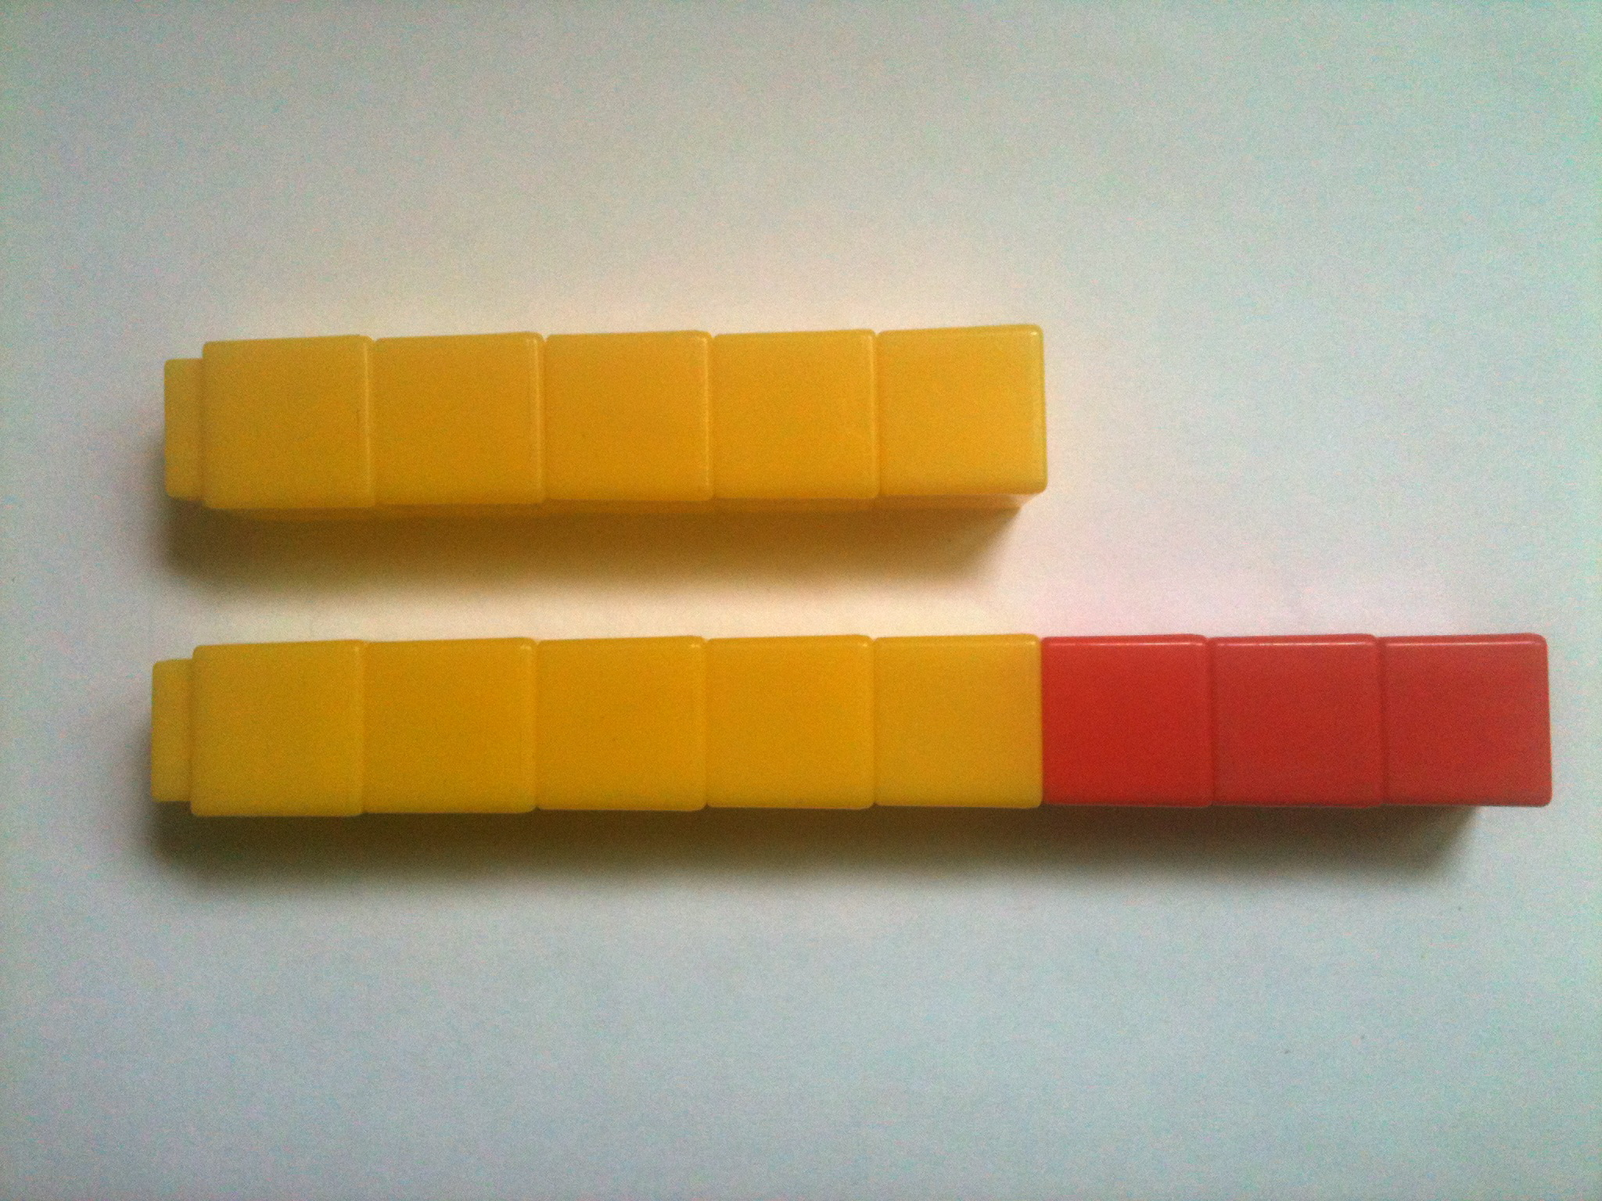
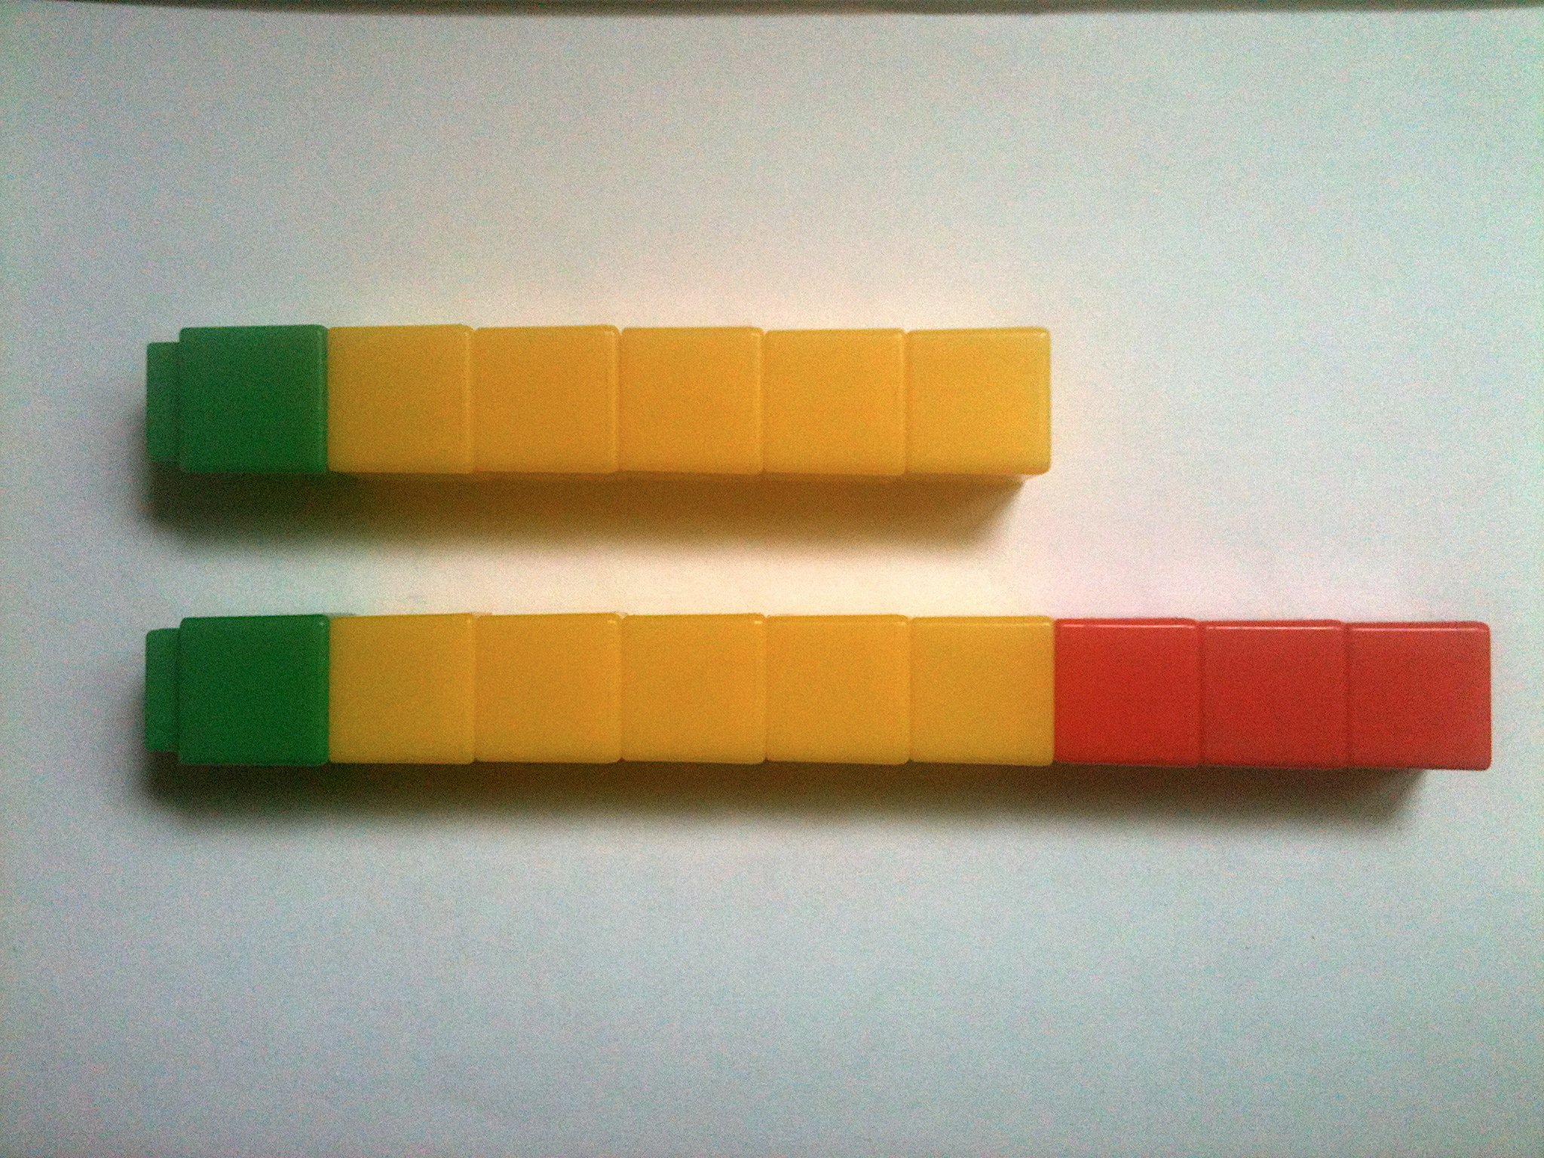
Concept Development (32 minutes)
8 – 5 = 9 – 6
Materials: (T) Linking cubes in three colors (S) Personal white board
Show two rows of 5 linking cubes in one color (shown in yellow). Add 3 linking cubes of another color to one row (shown in red).
T: There are 5 yellow cubes. How many linking cubes am I holding in this stick? (Hold up stick of 8.)
S: 8!
T: How many in this stick? (Show 5.)
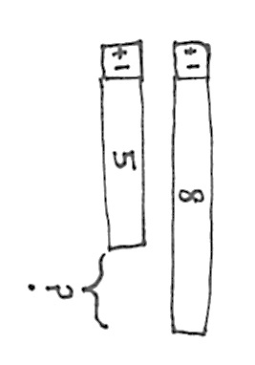
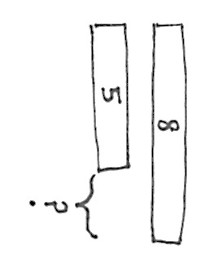
S: 5.
8 – 5 = 9 - 6
T: What is the difference between 8 and 5? (Break off the 3 cubes that represent the difference.)
MP.2
S: 3.
T: What number sentence could I use to represent the difference between 8 and 5?
S: 8 – 5 = 3.
T: (Add one green cube to each stick.)
T: Has the difference changed?
S: No. (Break off the difference again.)
T: But what new number sentence can I use to represent the difference between my two sticks?
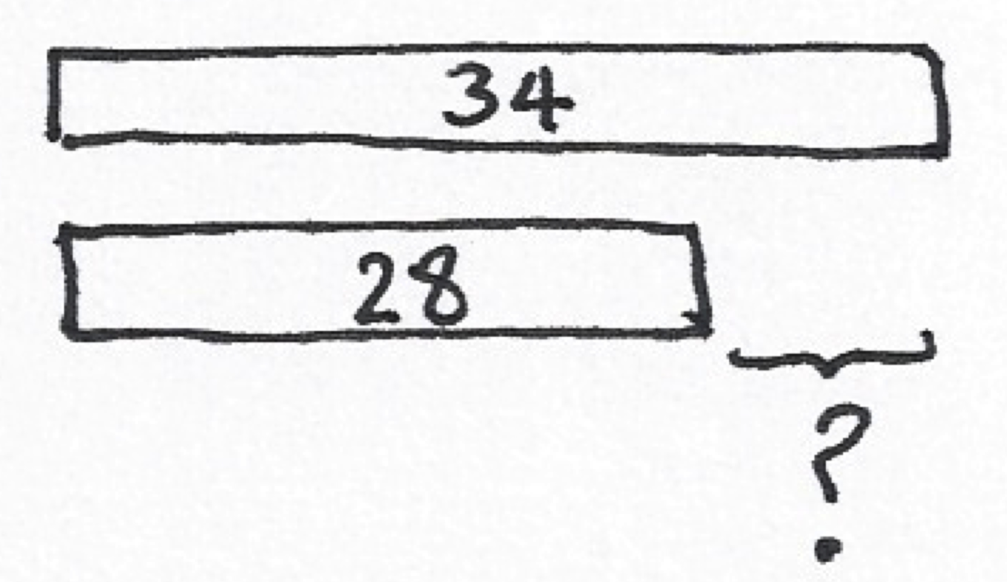
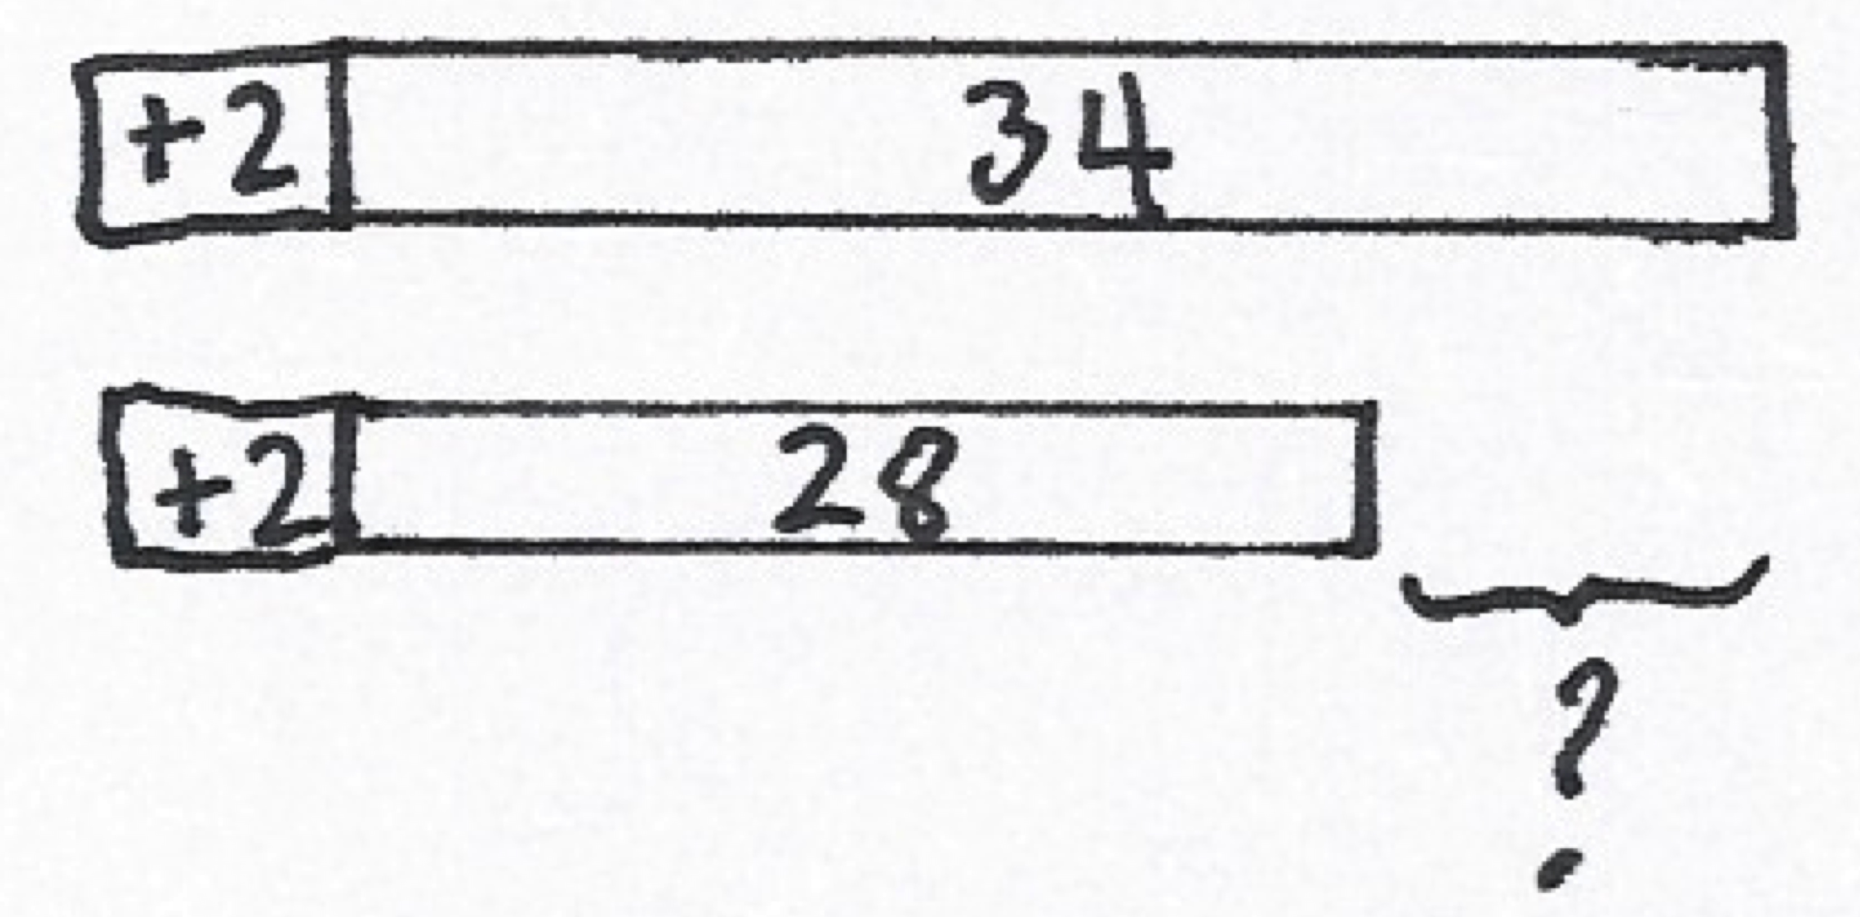
S: 9 – 6 = 3.
34 – 28 = 36 – 30
T: The difference is still 3?
S: Yes!
T: (Draw a two-bar tape diagram to represent the two sets of cubes.)
T: I add one more to each bar. (Model as shown on the previous page.) Did the difference change?
S: No!
T: Let’s test this idea. When we add the same amount to each number in a subtraction sentence, the difference stays the same.
T: Now let’s try this with a new problem. (Write 34 – 28 on the board.) Now that is challenging!
T: Try this one first. 36 – 30.
S: 6!

T: How did you know the answer so fast?

NOTES ON
MULTIPLE MEANS
OF REPRESENTATION:
- Use a ruler to remind students that the length of an object, for example, a pencil, remains the same regardless of where it starts on the ruler.
- Use a number line to show that age differences do not change when people age. For example, Mark and Robert are 8 and 6 years old now. How old will they be in 3 years? What will be the difference in their ages?
.
S: Just take away 3 tens! 3 tens – 3 tens = 0 tens, so you know you only have 6 ones left.
MP.2
T: Yes! Is it easier to subtract just tens!
Draw a tape diagram on the board to represent 34 – 28. Direct students to do the same. Call a student volunteer forward to label the tape diagram.
T: Now, can you tell me how 34 – 28 and my other problem,
36 – 30, are related? Turn and talk.
S: 34 – 28 is the same as 36 – 30, but you added two more to each number. The difference is the same.
Call a volunteer to add two to each bar on the board to change the model to 36 – 30. Students do the same at their seats.
T: Now, how long is each bar?
S: The top bar is 36, and the bottom bar is 30.
T: We added 2 to each bar to make the problem easy!
T: Exactly! We can add the same amount to both numbers to make an equivalent but easier problem!
T: Now it’s your turn. On your personal white board, solve these problems by making a tape diagram. Add on to both numbers to make the problem easier. (Write on the board: 22 – 8, 26 – 19, 33 – 18.)
T: There are 6 red cubes on one end and 4 red on the other end. How many yellows are in the middle?
S: 1!
T: The total number of cubes is?
S: 11.
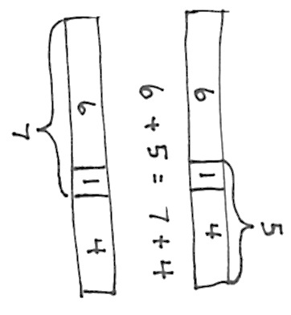
T: Let’s make 2 different addition sentences. Join the 1 yellow with 4 red. (Point.) What is the addition sentence for the total number of cubes?
S: 6 + 5 = 11
T: Now, instead join the 1 yellow with the 6 red.
S: 7 + 4 = 11
T: How do you know this is true: 6 + 5 = 7 + 4? (Draw the model.)
S: Both equal eleven. It’s just the 1 yellow cube moved from one number to the other number. You can see that the number of cubes didn’t change.
T: Let’s use that same idea with larger numbers to make tens.

NOTES ON
MULTIPLE MEANS
OF ENGAGEMENT:
Students with dysgraphia may benefit from using the model drawing tools on www.thinkingblocks.com.

MP.2
T: Let’s solve 28 + 36.
T: (Draw a bar and label it 28.)
T: What does 28 need to be the next ten?
S: 2. (Add another chunk of 2 to the right end of the bar of 28.)
T: What is 2 less than 36?
S: 34. (Draw the second bar to show the 34.)
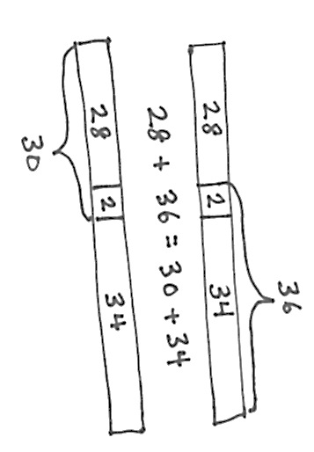
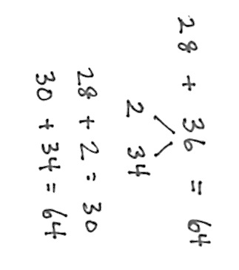
T: Why did I draw 34 instead of 36? Explain to your partner.
S: Because you used 2 to make 28 into 30. Because it’s easy to add tens so we put 2 more on 28 to have
3 tens.
T: How do you know this is true: 28 + 36 = 30 + 34?
S: You can see on the model. The two can go with the 28 or the 34. It was easy to make 28 to 30 because it is close to the next ten.
T: We can also show 2 more for 28 with our number bond.
Write the number bond pictured to the right, working interactively with students.
Repeat with the following possible sequence: 19 + 35, 36 + 29, 78 + 24, and 37 + 46.

Problem Set (10 minutes)
Students should do their personal best to complete the Problem Set within the allotted 10 minutes. For some classes, it may be appropriate to modify the assignment by specifying which problems they work on first.
If you find that students need additional practice with tape diagrams or number bonds, provide more practice with those models. For example, if students struggle to complete Problem 1, give them more problems where they will add on to the subtrahend to make a multiple of 10.
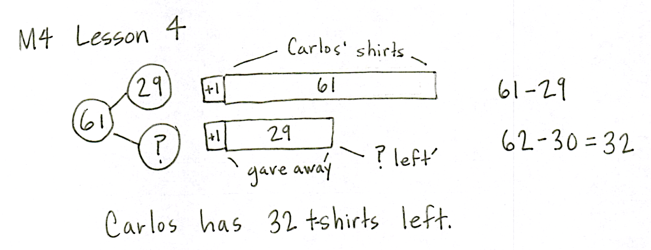
Application Problem (8 minutes)
Carlos bought 61 t-shirts. He gave 29 of them to his friends. How many t-shirts does Carlos have left?
Note: This Application Problem comes after the Concept Development so that students can apply what they have learned about making easy numbers (i.e., a multiple of 10) to subtract. You may choose to lead students through the RDW process or have students work independently and then share their work.
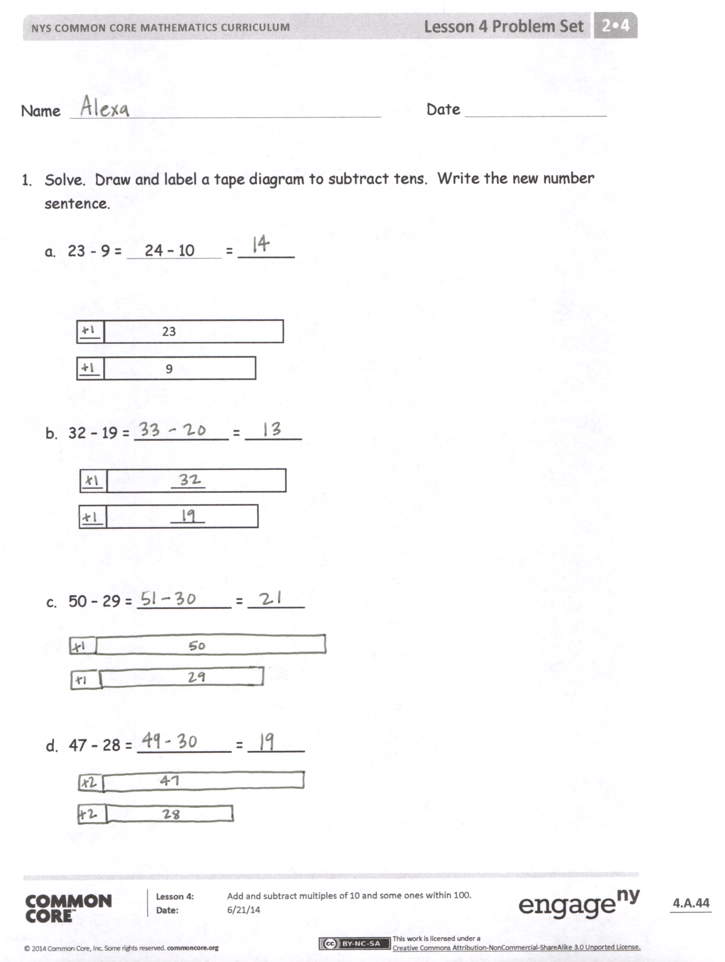
Student Debrief (10 minutes)
Lesson Objective: Add and subtract multiples of 10 and some ones within 100.
The Student Debrief is intended to invite reflection and active processing of the total lesson experience.
Invite students to review their solutions for the Problem Set. They should check work by comparing answers with a partner before going over answers as a class. Look for misconceptions or misunderstandings that can be addressed in the Debrief. Guide students in a conversation to debrief the Problem Set and process the lesson.
You may choose to use any combination of the questions below to lead the discussion.
- How did you label your tape diagram in Problem 1, Part (b)? Why?
- Share your tape diagram for Problem 2, Part (b) with a partner. How did you label it to add tens?
- Look at Problem 2, Part (c): 61 + 29 = 60 + 30. Is this true? How do you know?

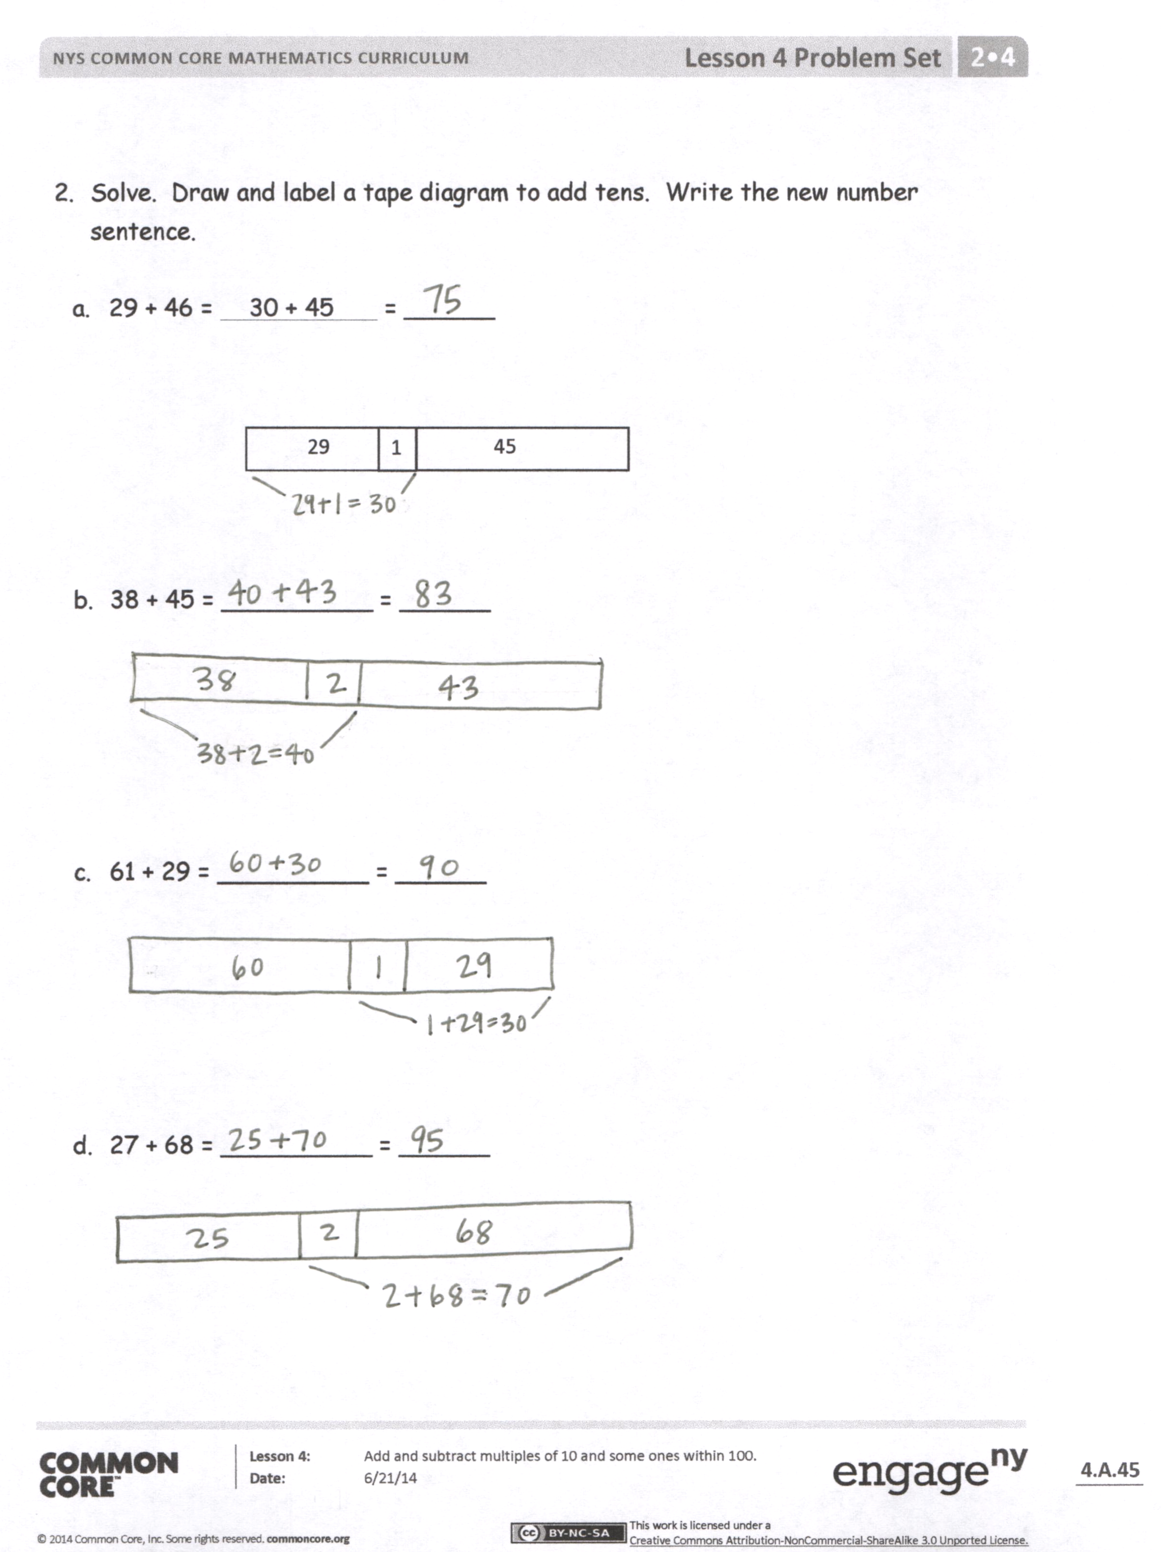
- What other special strategy could you use to solve Parts (a–d) of Problem 1? How could you use the arrow way to solve these problems?
- What do you notice about the numbers in the Problem Set today?
- When is the best time to use the tape diagram to solve? What is the goal in using the tape diagram as a simplifying strategy?
Exit Ticket (3 minutes)
After the Student Debrief, instruct students to complete the Exit Ticket. A review of their work will help you assess the students’ understanding of the concepts that were presented in the lesson today and plan more effectively for future lessons. You may read the questions aloud to the students.
Name Date
- Solve. Draw and label a tape diagram to subtract tens. Write the new number sentence.

- 23 − 9 = 24 − 10 = ______

___

23
9
___

- 32 − 19 = __________ = ______
___
_____

_____

___

- 50 − 29 = __________ = ______

- 47 − 28 = __________ = ______

- Solve. Draw and label a tape diagram to add tens. Write the new number sentence.

  - 29 + 46 = 30 + 45 = ______

1
29
45

  - 38 + 45 = __________ = ______

  - 61 + 29 = __________ = ______

  - 27 + 68 = __________ = ______

Name Date
- Solve. Draw a tape diagram or number bond to add or subtract tens. Write the new number sentence.

  - 26 + 38 = __________ = ______

  - 83 – 46 = __________ = ______

- Craig checked out 28 books at the library. He read and returned some books. He still has 19 books checked out. How many books did Craig return? Draw a tape diagram or number bond to solve.

Name Date
    - Solve. Draw and label a tape diagram to subtract 10, 20, 30, 40, etc.

- 17 – 9 = 18 – 10 = ______
18

17
___
+ 1
10
?
9
+ 1
___

- 33 – 19 = __________ = ______

___
_____
_____
___

- 60 – 29 = __________ = ______

- 56 – 38 = __________ = ______

    - Solve. Draw a number bond to add 10, 20, 30, 40, etc.
- 28 + 43 = 30 + 41 = _____
/\
2 41

- 49 + 26 = _________ = _____

- 43 + 19 = _________ = _____

- 67 + 28 = _________ = ______

    - Kylie has 28 more oranges than Cynthia. Kylie has 63 oranges. How many oranges does Cynthia have? Draw a tape diagram or number bond to solve.

