Lesson 2
Objective: Add and subtract multiples of 10 including counting on to subtract.

Suggested Lesson Structure
 Fluency Practice (10 minutes)
 Concept Development (32 minutes)
 Application Problem (8 minutes)
 Student Debrief (10 minutes)
Total Time (60 minutes)
Fluency Practice (10 minutes)

NOTES ON
MULTIPLE MEANS
OF ENGAGEMENT:
Before the lesson, have students skip-count by tens to one hundred and back down to zero while doing a physical activity, e.g., jumping jacks.
During the lesson, encourage one or more students to lead the class in an example, e.g., 48 – 30. These may be students who are struggling to grasp the concept and would benefit from personal guidance or students who grasp the concept quickly and would thrive on leadership opportunities. Praise their use of place value language to explain their thinking.

- Place Value 2.NBT.1, 2.NBT.5 (7 minutes)
- How Many More Tens? 2.NBT.5 (3 minutes)
Place Value (7 minutes)
Materials: (T) Unlabeled tens place value chart (Lesson 1 Template) (S) Unlabeled tens place value chart (Lesson 1 Template), personal white board
Note: Practicing place value skills prepares students for adding and subtracting multiples of 10.
T: (Project unlabeled tens place value chart template. Have students insert template inside personal white boards.) Draw place value disks to show 1 ten and 3 ones. Write the number below it.
S: (Draw 1 ten and 3 ones on their place value charts and write 13 below it.)
T: Say the number in unit form.
S: 1 ten 3 ones.
T: Say the number in standard form.
S: 13.
T: Add 2 tens to your chart. How many tens do you have now?
S: 3 tens.
T: What is 20 more than 13?
S: 33.
T: Add 3 tens to 33. How many tens do you have now?
S: 6 tens.
T: What is 30 more than 33?
S: 63.
T: Say the number in unit form.
S: 6 tens 3 ones.
T: Now, subtract 4 tens from 63. What is 40 less than 63?
S: 23.
Continue with the following possible sequence: 23 + 70, 93 – 40, 53 + 30, and 83 – 80.
How Many More Tens? (3 minutes)
Materials: (S) Personal white board
Note: Subtracting multiples of 10 prepares students for the lesson.
T: If I say 34 ─ 24, you say 10. To say it in a sentence, you say 34 is 10 more than 24. Ready?
T: 64 – 44.
S: 20.
T: Say it in a sentence.
S: 64 is 20 more than 44.
Continue with the following possible sequence: 85 – 45, 68 – 38, 59 – 49, 47 – 17, and 99 – 19.
Concept Development (32 minutes)
Materials: (T) Rekenrek (S) Personal white board
Show 34 beads on the Rekenrek.
T: In Lesson 1, we added and subtracted 1 ten. Today, let’s add 2 tens, then 3 tens, and more!
T: How many do you see?
S: 34!
T: The Say Ten way?
S: 3 tens 4!
T: (Add 2 tens.) How many do you see?
S: 5 tens 4!
T: I am going to add 2 more tens. Turn and talk, what will happen to the number when I add 2 tens?
S: The number in the tens place will get bigger by 2. The number will get bigger by 20. It will be 74.
T: (Add 2 tens.) What is 54 + 20?
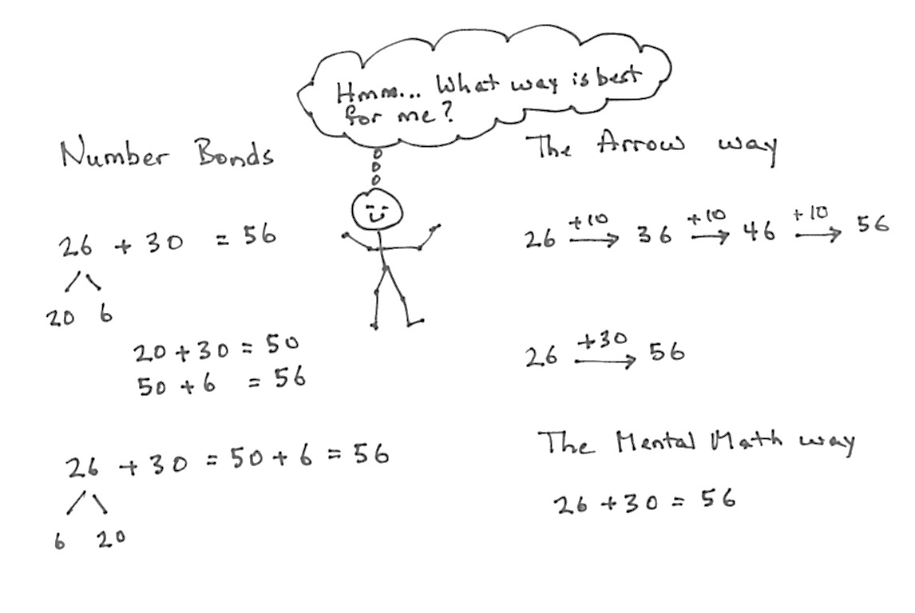
S: 74!
T: The Say Ten way?
S: 7 tens 4!
T: If I asked you to add 3 tens to 26, how could you solve that?
S: Count on by ten three times.
Change the 2 to 5 because 2 tens plus 3 tens is 5 tens. Add 3 tens on the Rekenrek.
T: Let’s show that on the board using both simplifying strategies, the arrow way and number bonds. I know many of you can just do mental math!
T: I can write adding 3 tens the arrow way, as we did yesterday. (Demonstrate and involve the students as you write.) I can also break apart the tens and ones with a number bond, add the tens, and then add the ones. (Demonstrate and involve the students as you write.)
T: No matter which way I write it, when I add tens to a number, the ones stay the same!
Note: The number bond’s decomposition is one choice for solving the problem that may not work for some students as a solution strategy but is beneficial for all to understand. Students should be encouraged to make connections between different solution strategies and to choose what works best for a given problem or for their way of thinking.
MP.3
T: Now it’s your turn. On your personal white board, solve 18 + 20. Show your board when you have an answer.
Repeat this process using the following possible sequence: 25 + 50, 38 + 40, and 40 + 27.
Show 74 beads on the Rekenrek.

NOTES ON
MULTIPLE MEANS
OF REPRESENTATION:
When counting up by tens and on by ones, use a number line to provide visual support. For example, when counting from 30 to 42, have students point to the jump between 30 and 40, then point to 41, 42. The number line correlates very well to the arrow notation.

T: Now, let’s subtract 2 tens, then 3 tens, and more!
T: How many do you see?
S: 74!
T: The Say Ten way?
S: 7 tens 4!
T: (Subtract 2 tens.) How many do you see?
S: 5 tens 4!
T: I am going to subtract 2 more tens. Turn and talk, what will happen to the number when I subtract 2 tens?

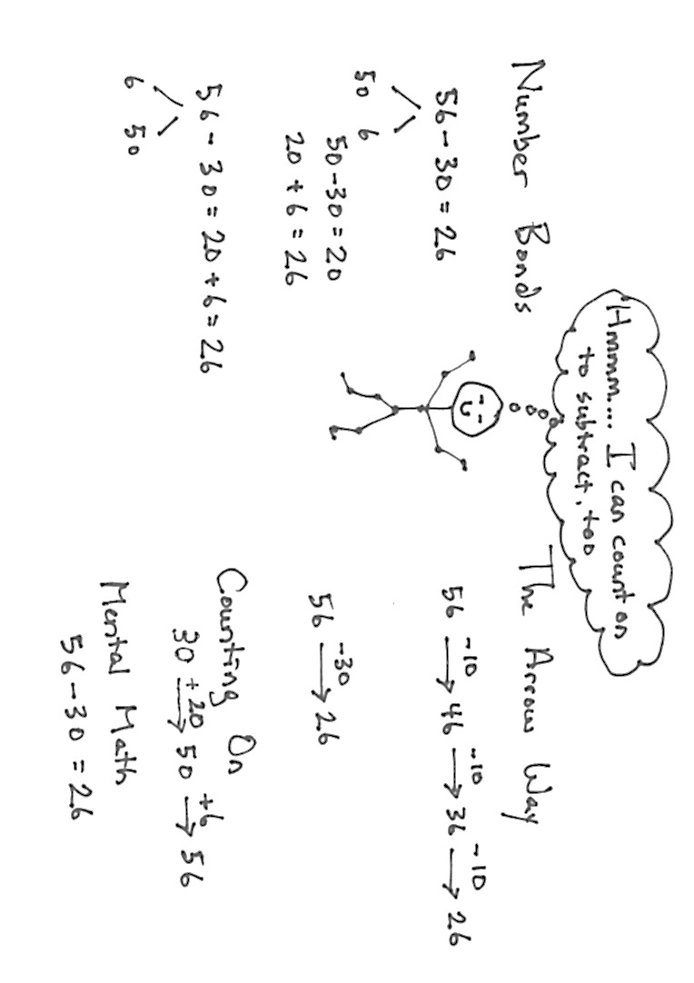
S: The digit in the tens place will get smaller by 2. The number will get smaller by 20. It will be 34.
T: (Add 2 tens.) What is 54 ─ 20?
S: 34!
T: The Say Ten way?
S: 3 tens 4!
T: Okay. Now, subtract 3 tens from 56. Take a moment and work on your personal white board to solve 56 – 30. (Show the work on the board as students work out this first problem using number bonds and the arrow way.)
MP.3
T: (Model both the number bonds and arrow methods from their work.) We have an extra simplifying strategy when we are subtracting. We can count up from the part we know.
T: What is the whole?
S: 56.
T: What is the part we know?
S: 30.
T: How could we show the missing part with an addition problem?
S: 30 + ___ = 56. ___ + 30 = 56.
T: We can use the arrow way, counting first by either tens or ones. Try it with a partner.
Guide students through this or let them work independently. Starting at 30, they might add 2 tens first and then 6 ones, or add 6 ones first and then add 3 tens.
Repeat with 62 – 40, 51 – 20, and 77 – 30.

NOTES ON
MULTIPLE MEANS
OF ACTION AND EXPRESSION:
Encourage students to explain their thinking about adding or subtracting tens. For Problem 2, Parts (c) and (d), facilitate a discussion in which different students share which problem solving method they prefer and why. Ask students, “How can you tell when one strategy might be better than another?” Students may learn as much from each other’s reasoning as from the lesson.

Problem Set (10 minutes)
Students should do their personal best to complete the Problem Set within the allotted 10 minutes. For some classes, it may be appropriate to modify the assignment by specifying which problems they work on first. Some problems do not specify a method for solving. Students should solve these problems using the RDW approach used for Application Problems.

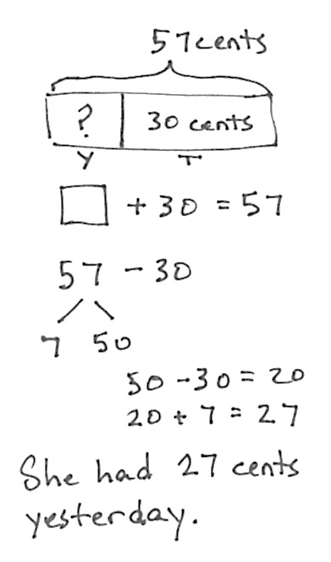
Application Problem (8 minutes)
Susan has 57 cents in her piggy bank. If she just put in 30 cents today, how much did she have yesterday?
Note: This add to with start unknown problem gives students a chance to apply their new learning. It also provides an opportunity to work through a common mistake; many students will add and give the answer 87 cents. Encourage students to draw a tape diagram to show what is known. This will help them identify the whole and one part, guiding them to subtract to find the missing part.
This Application Problem comes after the Concept Development so that students can apply what they have learned about adding and subtracting multiples of 10. You may choose to lead students through the RDW process or have students work independently and then share their work.
Student Debrief (10 minutes)
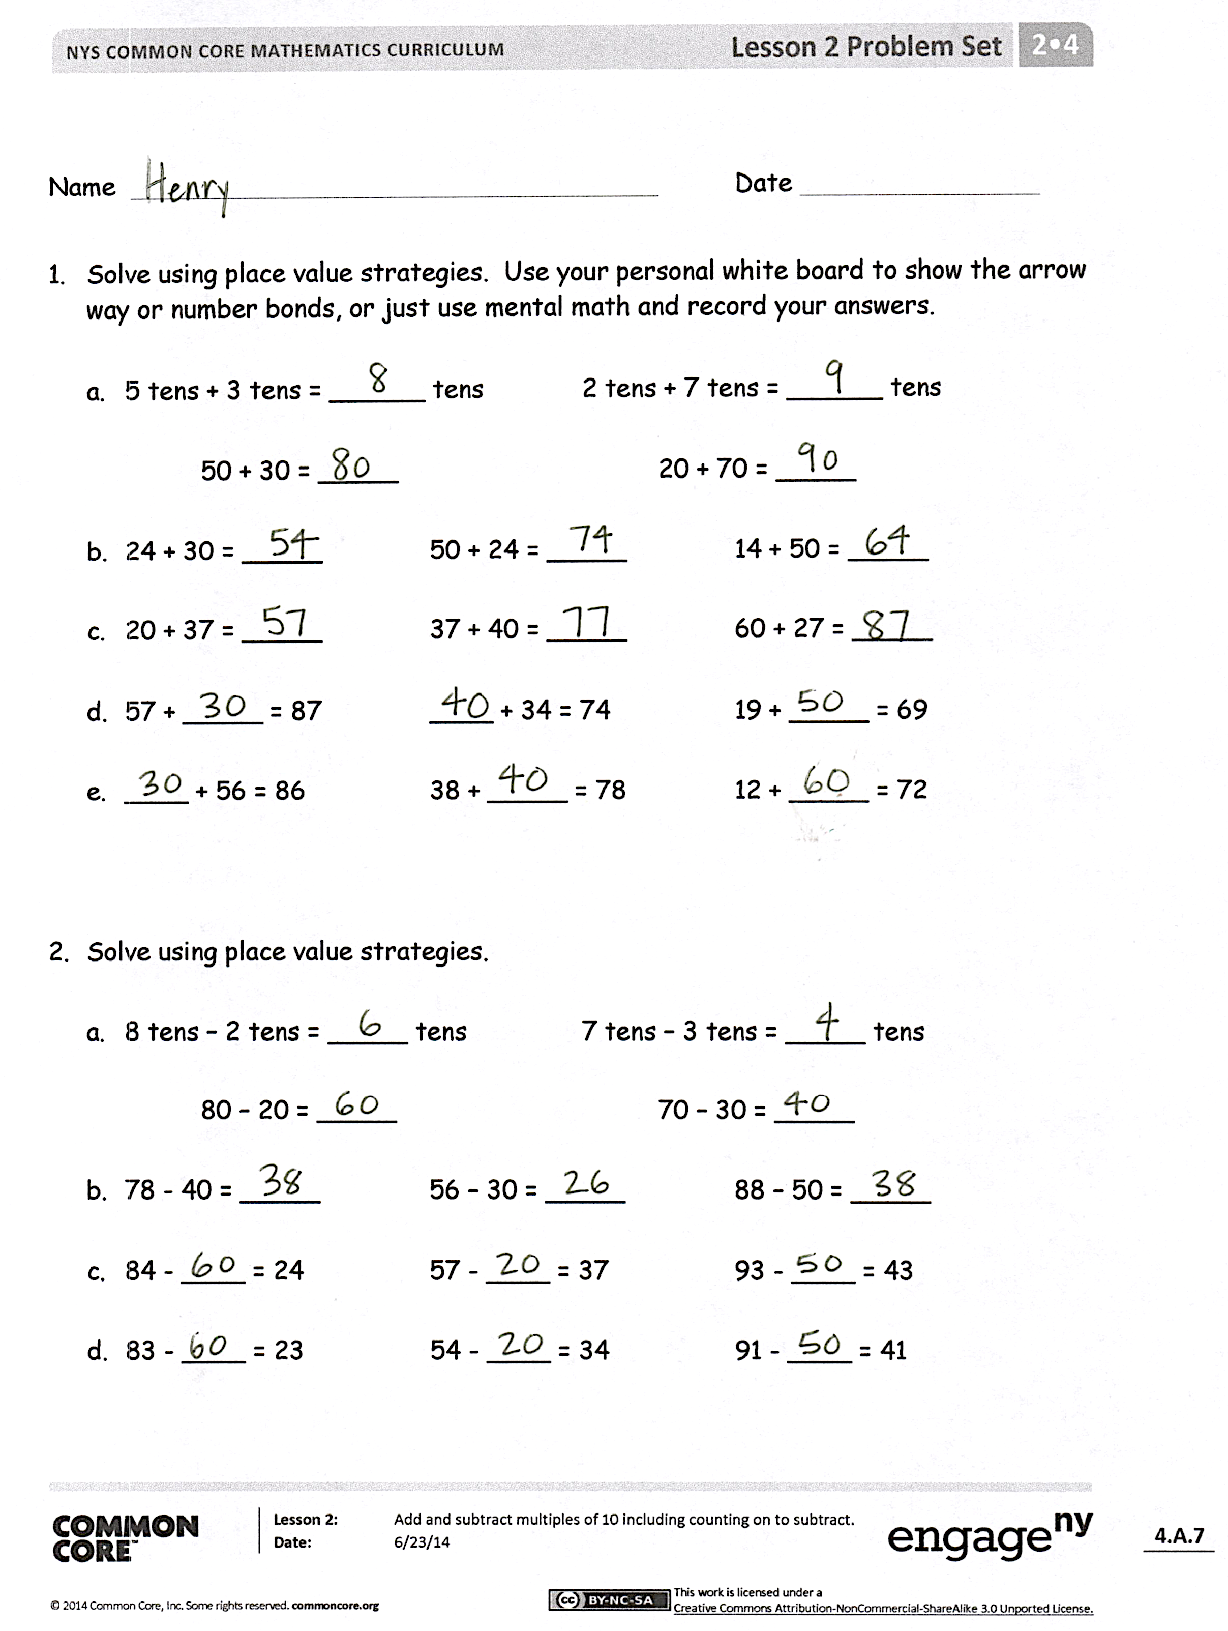
Lesson Objective: Add and subtract multiples of 10 including counting on to subtract.
The Student Debrief is intended to invite reflection and active processing of the total lesson experience.
Invite students to review their solutions for the Problem Set. They should check work by comparing answers with a partner before going over answers as a class. Look for misconceptions or misunderstandings that can be addressed in the Debrief. Guide students in a conversation to debrief the Problem Set and process the lesson.
You may choose to use any combination of the questions below to lead the discussion.
- Which simplifying strategy did you use to solve the sequence in Problem 1, Part (d)? Why is the arrow way a good choice for counting up?
- Explain to your partner how you solved the sequence in Problem 2, Part (c). How did they help you to solve the problems in Problem 2, Part (d)? What was similar about them?
- How was solving Problem 3, Part (e) different from solving the other parts of Problem 3? What did you need to do?
- Explain to your partner how you used the arrow way to solve Problem 4. Why did this strategy work well?
- What connections can you make between the number bond strategy and the arrow way? What is the goal of these simplifying strategies?
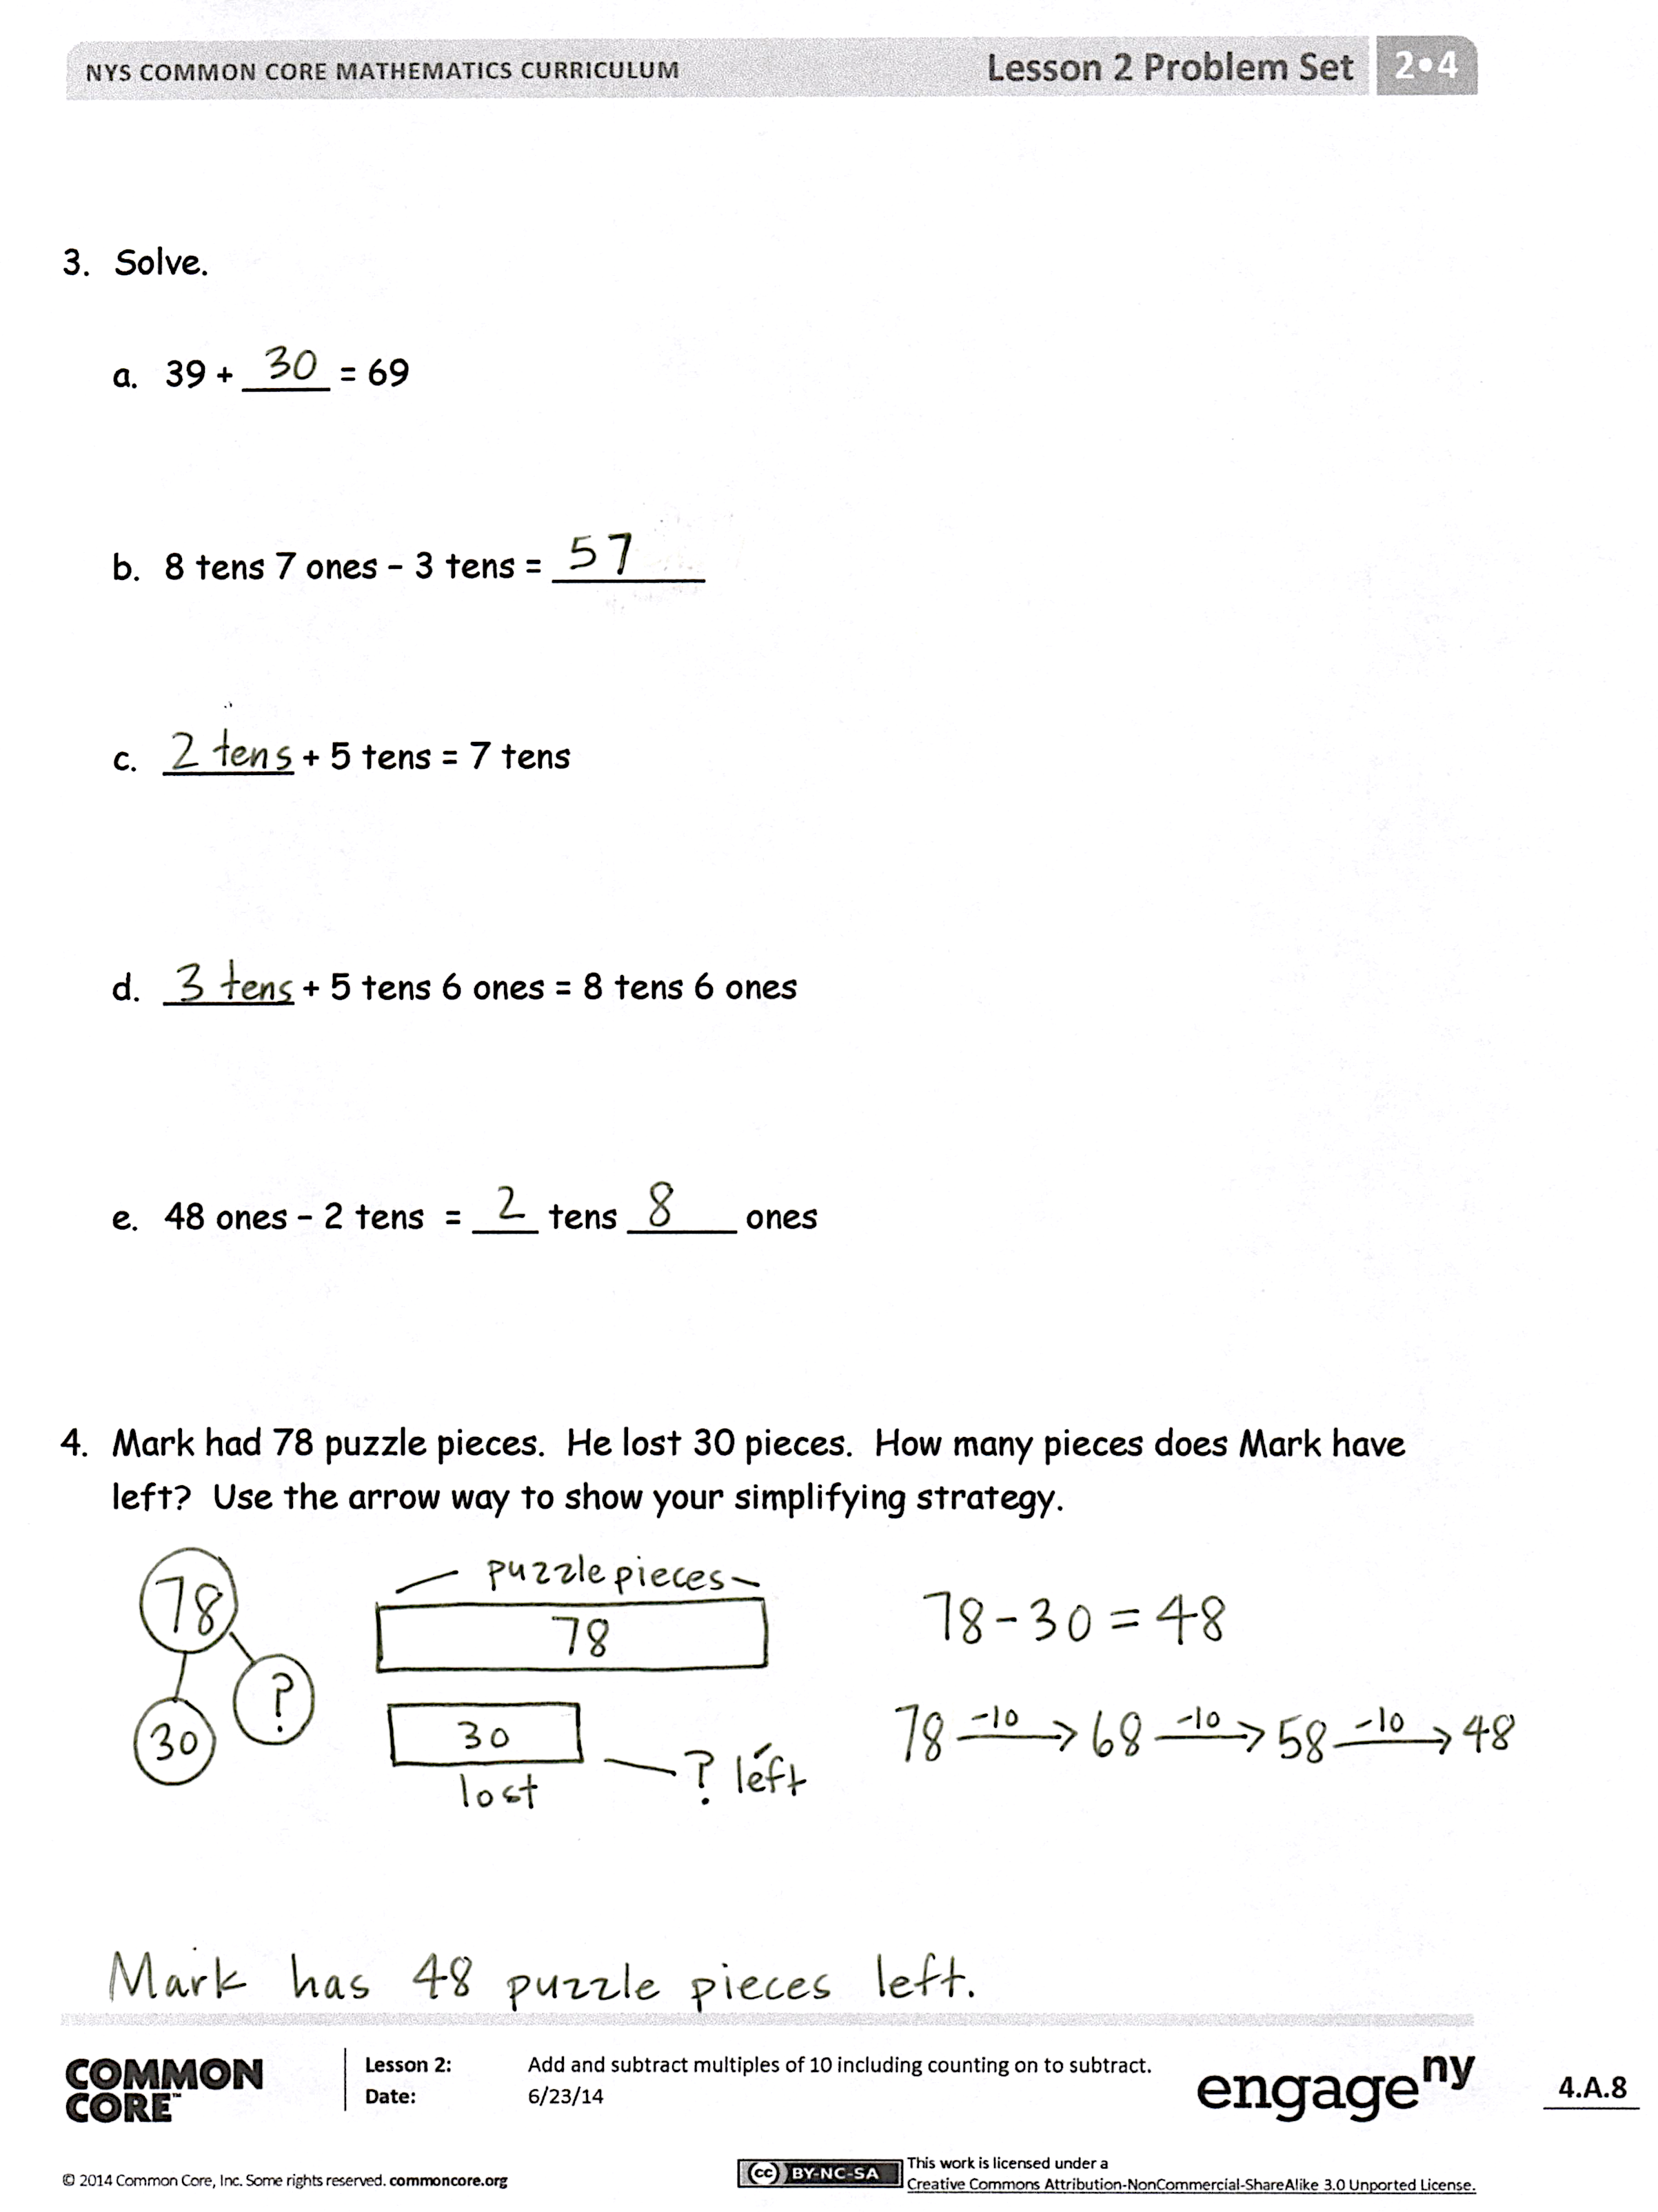
Exit Ticket (3 minutes)
After the Student Debrief, instruct students to complete the Exit Ticket. A review of their work will help you assess the students’ understanding of the concepts presented in the lesson today and plan more effectively for future lessons. You may read the questions aloud to the students.

Name Date
- Solve using place value strategies. Use your personal white board to show the arrow way or number bonds, or just use mental math, and record your answers.

  - 5 tens + 3 tens = ______ tens 2 tens + 7 tens = ______ tens

50 + 30 = _____ 20 + 70 = _____

  - 24 + 30 = _____ 50 + 24 = _____ 14 + 50 = _____

  - 20 + 37 = _____ 37 + 40 = _____ 60 + 27 = _____

  - 57 + _____ = 87 _____ + 34 = 74 19 + _____ = 69

  - _____ + 56 = 86 38 + _____ = 78 12 + _____ = 72

- Solve using place value strategies.

- 8 tens – 2 tens = _____ tens 7 tens – 3 tens = _____ tens

80 – 20 = _____ 70 – 30 = _____

- 78 - 40 = _____ 56 – 30 = _____ 88 – 50 = _____

- 84 - ____ = 24 57 - ____ = 37 93 - ____ = 43

- 83 - ____ = 23 54 - ____ = 34 91 - ____ = 41
- Solve.
- 39 + ____ = 69

- 8 tens 7 ones – 3 tens = _______

- ______ + 5 tens = 7 tens

- ______ + 5 tens 6 ones = 8 tens 6 ones

- 48 ones – 2 tens = ___ tens _____ ones

- Mark had 78 puzzle pieces. He lost 30 pieces. How many pieces does Mark have left? Use the arrow way to show your simplifying strategy.

Name Date

Fill in the missing number to make each statement true.

        - 50 + 20 = ______

        - 4 tens + 3 tens = _____ tens
        - 7 tens - ____ tens = 5 tens

        - _____ - 20 = 63
        - 6 tens + 1 ten 4 ones = 9 tens 4 ones - _____ tens

Name Date
- Solve using place value strategies. Use scrap paper to show the arrow way or number bonds, or just use mental math and record your answers.

- 2 tens + 3 tens = ____ tens  20 + 30 = _____  2 tens 4 ones + 3 tens = __ tens __ ones  24 + 30 = _____ | - 5 tens + 4 tens = ___ tens  50 + 40 = ____  5 tens 9 ones + 4 tens = __ tens __ ones  59 + 40 = ____

- 28 + 40 = _____ 18 + 30 = _____ 60 + 38 = _____

- 30 + 25 = _____ 35 + 50 = _____ 15 + 20 = _____

- 37 + _____ = 47 ____ + 27 = 57 17 + _____ = 87

- ____ + 22 = 62 29 + _____ = 79 11 + _____ = 91

- Find each sum. Then use >, <, or = to compare.

- 23 + 40 _____ 20 + 33
- 50 + 18 _____ 48 + 20
- 19 + 60 _____ 39 + 30
- 64 + 10 _____ 49 + 20
- 70 + 21 _____ 18 + 80
- 35 + 50 _____ 26 + 60

- Solve using place value strategies.

- 6 tens − 2 tens = ___ tens  60 − 20 = ____  6 tens 3 ones – 3 tens = __ tens __ ones  63 − 30 = _____ | - 8 tens − 5 tens = ___ tens  80 − 50 = ____  8 tens 9 ones – 5 tens = __ tens __ ones  89 − 50 = ____

- 55 − 20 = _____ 75 − 30 = _____ 85 − 50 = _____

- 72 − ____ = 22 49 − ____ = 19 88 − ____ = 28

- 67 − ____ = 47 71 − ____ = 51 99 − ____ = 69

- Complete each more than or less than statement.

  - 20 less than 58 is ______. b. 36 more than 40 is ______.

- 40 less than _____ is 28. d. 50 more than ______ is 64.

- There were 68 plates in the sink at the end of the day. There were 40 plates in the sink at the beginning of the day. How many plates were added throughout the day? Use the arrow way to show your simplifying strategy.

