Lesson 1
Objective: Relate 1 more, 1 less, 10 more, and 10 less to addition and subtraction of 1 and 10.

Suggested Lesson Structure
 Fluency Practice (10 minutes)
 Application Problem (10 minutes)
 Concept Development (30 minutes)
 Student Debrief (10 minutes)
Total Time (60 minutes)
Fluency Practice (10 minutes)
- Place Value 2.NBT.1, 2.OA.2 (6 minutes)
- More/Less 2.NBT.5 (4 minutes)
Place Value (6 minutes)
Materials: (T) Unlabeled tens place value chart (Template) (S) Unlabeled tens place value chart (Template), personal white board
Note: Practicing place value skills prepares students for adding and subtracting 1 and 10 in today’s lesson.
T: (Draw or project place value chart template.) Slide the place value chart into your personal white board. Draw place value disks to show 5 ones. Write the number below it.
S: (Draw 5 ones disks and write 5 below it.)
T: Show 2 tens disks and write the number below it.
S: (Draw 2 tens disks and write 2 at the bottom of the tens column.)
T: Say the number in unit form.
S: 2 tens 5.
T: Say the number in standard form.
S: 25.
T: Add 1 to your chart. What is 1 more than 25?
S: 26.
T: Now add 1 ten to your chart. What is 10 more than 26?
S: 36.
T: Subtract 1 from 36 by crossing out a one. What is 1 less than 36?
S: 35.
T: Now subtract 10 from 35 by crossing out 1 ten. What is 10 less than 35?
S: 25.
Continue with the following possible sequence: 4 tens 7 ones, 1 ten 8 ones, and 6 tens 9 ones.
More/Less (4 minutes)
Note: Practice with giving 1 or 10 more (or less) prepares students to add and subtract 1 and 10 fluently.
T: For every number I say, you say a number that is 1 more. When I say 5, you say 6. Ready?
T: 5.
S: 6.
T: 8.
S: 9.
Continue with the following possible sequence: 9, 16, 19, 28, 38, 39, 44, 49, 54, and 60.
T: Now for every number I say, you say a number that is 10 more. When I say 50, you say 60. Ready?
T: 50.
S: 60.
T: 10.
S: 20.
Continue with the following possible sequence: 80, 40, 20, 21, 28, 30, 35, 45, and 56.
T: Let’s try saying 1 less for every number I say. When I say 6, you say 5. Ready?
T: 6.
S: 5.
T: 9.
S: 8.
Continue with the following possible sequence: 11, 14, 19, 20, 30, 31, 51, and 50.
T: Now for every number I say, you say a number that is 10 less. When I say 50, you say 40. Ready?
T: 50.
S: 40.
T: 30.
S: 20.
Continue with the following possible sequence: 80, 70, 60, 61, 41, 46, 48, 28, and 18.

Application Problem (10 minutes)
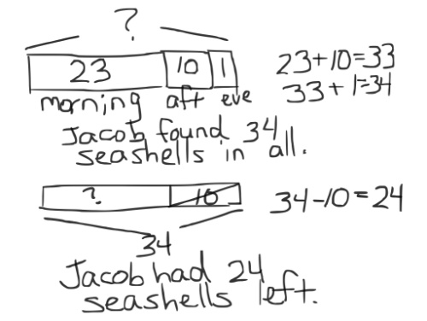
In the morning, Jacob found 23 seashells on the beach. In the afternoon, he found 10 more. In the evening, he found 1 more. How many seashells did Jacob find in all? If he gives 10 to his brother, how many seashells will Jacob have left?
Note: This problem is designed to lead into the Concept Development for the day’s lesson, relating 10 more and 10 less to addition and subtraction. Students will complete this problem independently to provide insight into the kinds of mental strategies they currently use.
Review the RDW procedure for problem solving.
Directions: Read the problem, draw and label, write an equation, and write a word sentence. The more students participate in reasoning through problems with a systematic approach, the more they internalize those behaviors and thought processes.
(Excerpted from “How to Implement A Story of Units.”)
Concept Development (30 minutes)
Materials: (T) Sentence frames:
___ is 1 more than ___. 1 more than ___ is ___.
1 less than ___ is ___. ___ is 1 less than ___.
10 more than ___ is ___. ___ is 10 more than ___. 10 less than ___ is ___. ___ is 10 less than ___.
(S) Place value disks: 9 tens disks, 9 ones disks, unlabeled tens place value chart (Template), personal white board

NOTES ON
MULTIPLE MEANS
OF REPRESENTATION:
Use different models to demonstrate the change in 1 more, 1 less, 10 more, 10 less.
- With a hundreds chart on the wall and student copies, point to different numbers and have students show more and less changes by sliding their finger. Ask questions to foster conceptual understanding: “What patterns do you notice in the rows? Columns? What happens to the digits? Value of the number?” Invite one or two students to lead the class and model problems. Then, have students work in pairs.
- Use concrete objects other than disks, such as a Rekenrek or bundled straws, to show groups of tens and ones.

Post more sentence frames on one side of the board and less frames on the other side. Pass out charts and disks.
T: Use your place value disks to show me 36 on your place value chart.
S: (Show 3 tens 6 ones.)
T: Show me 1 more.
S: (Add a ones disk to show 3 tens 7 ones.)
T: Use a sentence frame to describe adding one to 36.
S: 37 is 1 more than 36. 1 more than 36 is 37.
T: What did you do to change 36?
S: We added one to the ones place.
T: Give me an addition sentence starting with 36.
S: 36 + 1 = 37.
T: Start with 37.

NOTES ON
MULTIPLE MEANS
OF ACTION AND EXPRESSION:
Listen intently as students use place value language to talk with their partners. Use place value disks and the place value chart to help students navigate the following vocabulary: place value, tens, ones, digit, value, unit. Post key vocabulary on the wall and point to words accompanied by a visual (e.g., 56 is 5 tens and 6 ones).

S: 37 = 1 + 36. 37 = 36 + 1.
Repeat the process for 1 less than 36.
T: Show me 36 again. (Pause as students reset their place value charts.)
T: Show me 10 more than 36.
S: (Add a tens disk to show 4 tens 6 ones.)
T: Use a sentence frame to describe adding ten to 36.
S: 46 is 10 more than 36. 10 more than 36 is 46.
T: What did you do to change 36?
S: We added another ten.
T: Be specific. Where did you add the ten?
S: In the tens place.
T: Yes!
T: Give me an addition sentence starting with 36.
S: 36 + 10 = 46.
T: Start with 46.
S: 46 = 10 + 36. 46 = 36 + 10.
Repeat the process for 10 less than 36.
T: Talk with your partner. Use place value language to explain what you understand about 1 more,
1 less, 10 more, and 10 less. (Allow about one minute for discussion.)
S: 1 more is just adding 1, and 10 more is adding 10. 1 less and 10 less are the same as taking away 1 or 10. We have to subtract and add the same units, so the ones place changes when we add or subtract 1. The same for the tens place.
T: (Collect the place value disks and charts.) Listen as I say a number pattern. Raise your hand when you know the more or less rule for my pattern.
T: For example, if I say, “45, 46, 47, 48, 49,” you say, “1 more.” Wait for my signal. Ready?
T: 23, 33, 43, 53, 63.
S: 10 more!
T: 76, 75, 74, 73, 72.
S: 1 less!
Continue until students can readily identify the rule.
T: Take out your personal white board. Now, I’ll write a series of numbers on the board. You write the rule and the next three numbers. The rules are + 1, − 1, + 10, and − 10.
T: Turn your board over when you have written your answer. Wait until I say, “Show me.” Ready?
T: (Write 18, 17, 16, ___, ___, ___. Pause.) Show me.
S: (Show − 1 and 15, 14, 13.)
Continue to give students practice with each rule.
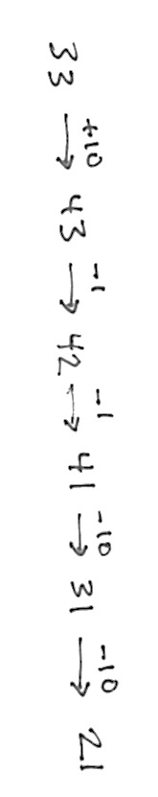
In this next activity, model arrow notation by recording the following sequence on the board step by step as students write each answer.
-1
-10
-10
-1
+10
33 $⟶$ ___ $⟶$ ___ $⟶$ ___ $⟶$ ___ $⟶$ ___.
+10
T: Let’s try something different. (Write 33 $⟶$ ___ on the board.) What is 33 + 10? Show me.
S: (Write 43.)
-1
T: Minus 1? (Continue to record the sequence by filling in 43 and writing $⟶$ ___.)
S: (Write 42.)

-1
T: Minus 1? (Fill in 42 and write $⟶$ ___.)
S: (Write 41.)
-10
T: Minus 10? (Fill in 41 and write $⟶$ ___.)
S: (Write 31.)
-10
T: Minus 10? (Fill in 31 and write $⟶$ ___.)
S: (Write 21.)
T: (Point to the completed sequence on the board.) This is a simplifying strategy called arrow notation. We can also call it the arrow way. Pretend your partner is a family member. Explain how and why you changed each number. Be sure to use place value language.
MP.3
S: You add or subtract 1 or 10 and the arrows point to what the number becomes after you change it. It shows that you are changing the ones or the tens place and whether it is more or less.
10 more than 33 is 43, and 1 less is 42, and 1 less is 41. Then, 10 less than 41 is 31, and
10 less than 31 is 21.
If necessary or if time permits, model another example with the following:

62 – 23.
-1
-1
-1
-10
-10
62 $⟶$ ___ $⟶$ ___ $⟶$ ___ $⟶$ ___ $⟶$ ___.

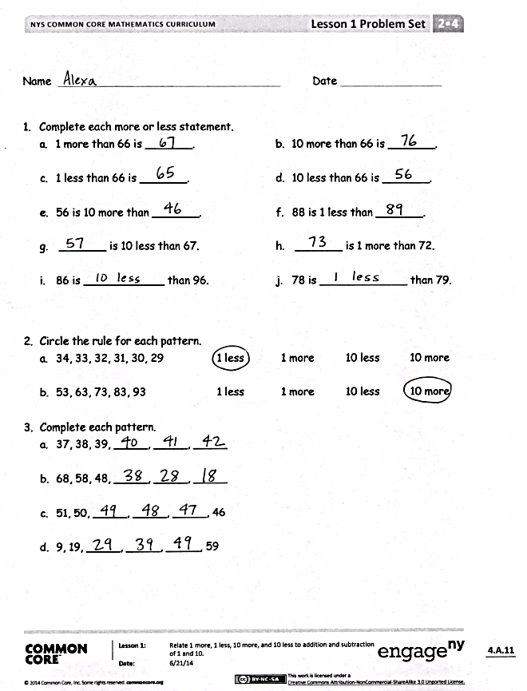
Problem Set (10 minutes)
Students should do their personal best to complete the Problem Set within the allotted 10 minutes. Some problems do not specify a method for solving. This is an intentional reduction of scaffolding that invokes MP.5, Use Appropriate Tools Strategically. Students should solve these problems using the RDW approach used for Application Problems.
For some classes, it may be appropriate to modify the assignment by specifying which problems students should work on first. With this option, let the purposeful sequencing of the Problem Set guide your selections so that problems continue to be scaffolded. Balance word problems with other problem types to ensure a range of practice. Consider assigning incomplete problems for homework or at another time during the day.
Student Debrief (10 minutes)
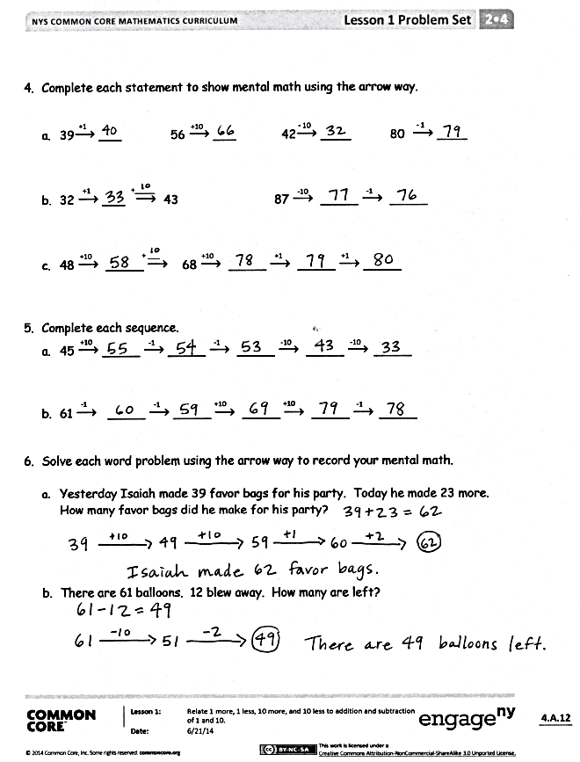
Lesson Objective: Relate 1 more, 1 less, 10 more, and 10 less to addition and subtraction of 1 and 10.
The Student Debrief is intended to invite reflection and active processing of the total lesson experience.
Invite students to review their solutions for the Problem Set. They should check work by comparing answers with a partner before going over answers as a class. Look for misconceptions or misunderstandings that can be addressed in the Debrief. Guide students in a conversation to debrief the Problem Set and process the lesson.
You may choose to use any combination of the questions below to lead the discussion.
- What do you need to know to complete each pattern in Problem 3?
- Look at Problem 4. What are we actually doing when we talk about 10 more, 10 less, 1 more, or 1 less than a number?
- What helpful strategy did we use today to record a sequence of numbers? Can we use an equal sign instead of an arrow? Is this statement: 33 + 10 = 43 – 1 = 42 – 1 = 41 true?
- In Problem 4, Part (c), what total quantity did you add to 48 to arrive at 80? How do you know? How can we show it as an equation?
- What simplifying strategy did you use to answer Problem 6? How could you use what you know from Problem 5 to answer Problem 6?
- What important connection did we make today?
Exit Ticket (3 minutes)
After the Student Debrief, instruct students to complete the Exit Ticket. A review of their work will help you assess the students’ understanding of the concepts presented in the lesson today and plan more effectively for future lessons. You may read the questions aloud to the students.

Name Date

- Complete each more or less statement.

- 1 more than 66 is _______.

- 1 less than 66 is _______.

- 56 is 10 more than _______.

- _______ is 10 less than 67.

- 86 is ____________ than 96.

- 10 more than 66 is _______.

- 10 less than 66 is _______.

- 88 is 1 less than _______.

- _______ is 1 more than 72.

- 78 is _____________ than 79.

- Circle the rule for each pattern.
- 34, 33, 32, 31, 30, 29 1 less 1 more 10 less 10 more

- 53, 63, 73, 83, 93 1 less 1 more 10 less 10 more
- Complete each pattern.
- 37, 38, 39, _____, _____, _____
- 68, 58, 48, _____, _____, _____
- 51, 50, _____, _____, _____, 46
- 9, 19, _____, _____, _____, 59

- Complete each statement to show mental math using the arrow way.

+1
+10
- 10
- 1
- 39$⟶$ _____ 56 $⟶$ _____ 42$⟶$ _____ 80$⟶$ _____

+_____
-1
-10
+1
- 32 $⟶$ _____ $⟶$ 43 87 $⟶$ _____ $⟶$ _____

+ _____
+1
+1
+10
+10
- 48 $⟶$ _____ $⟶$ 68 $⟶$ _____ $⟶$ _____ $⟶$ _____

- Complete each sequence.
-10
-10
-1
-1
+10
- 45 $⟶$ _____ $⟶$ _____ $⟶$ _____ $⟶$ _____ $⟶$ _____
-1
+10
+10
-1
-1
- 61 $⟶$ _____ $⟶$ _____ $⟶$ _____ $⟶$ _____ $⟶$ _____

- Solve each word problem using the arrow way to record your mental math.

- Yesterday Isaiah made 39 favor bags for his party. Today he made 23 more. How many favor bags did he make for his party?

- There are 61 balloons. 12 blew away. How many are left?

Name Date

- Complete each pattern.

- 48, 47, 46, 45, 44, _______, _______, _______

- 78, 68, 58, 48, 38, _______, _______, _______

- 35, 34, 44, 43, 53, _______, _______, _______

- Create two patterns using one of these rules for each: +1, -1, +10, or –10.

- _______, _______, ________, ________

Rule for Pattern (a): _________________

- _______, _______, ________, ________

Rule for Pattern (b): _________________

Name Date
      - Complete each more or less statement.

a. 1 more than 37 is _______.

c. 1 less than 37 is _______.
e. 58 is 10 more than _______.
g. _______ is 10 less than 45.
i. 49 is ____________ than 50.
b. 10 more than 37 is ______.

d. 10 less than 37 is _______.
f. 29 is 1 less than _______.
h. _______ is 1 more than 38.
j. 32 is _____________ than 22.

      - Complete each pattern and write the rule.
- 44, 45, ____, ____, 48 Rule: ________________________

- 44, ____, 24, ____, 4 Rule: ________________________

- 44, ____, ____, 74, 84 Rule: ________________________

- ____, 43, 42, ____, 40 Rule: ________________________

- ____, ____, 44, 34, ____ Rule: ________________________

- 41, ____, ____, 38, 37 Rule: ________________________

      - Label each statement as true or false.
- 1 more than 36 is the same as 1 less than 38. ______________
- 10 less than 47 is the same as 1 more than 35. _____________
- 10 less than 89 is the same as 1 less than 90. ______________
- 10 more than 41 is the same as 1 less than 43. _____________
      - Below is a chart of balloons at the county fair.
Color of Balloons | Number of Balloons
Red | 59
Yellow | 61
Green | 65
Blue
Pink

- Use the following to complete the chart and answer the question.
  - The fair has 1 more blue than red balloons.
  - There are 10 fewer pink than yellow balloons.
Are there more blue or pink balloons?

- If 1 red balloon pops and 10 red balloons fly away, how many red balloons are left? Use the arrow way to show your work.

unlabeled tens place value chart

