Lesson 21

Objective: Complete a pattern counting up and down.

Suggested Lesson Structure

 Fluency Practice (12 minutes)

 Application Problem (8 minutes)

 Concept Development (30 minutes)

 Student Debrief (10 minutes)

**Total Time (60 minutes)**

Fluency Practice (12 minutes)

* Sprint: Differences **2.OA.2** (12 minutes)

Sprint: Differences 2.OA.2 (12 minutes)

Materials: (S) Differences Sprint

Lesson 21’s Sprint is a review of the *take from ten* facts. This is in preparation for Module 4, in which students will work towards mastery of the sums *and* differences to 20. Run a few extra copies to give to students to take home; quite a few will want to. For students struggling for fluency with these basic facts, find time if possible in your instructional day to time their improvement, or allow them to time themselves.

Application Problem (8 minutes)

Rahim is reading a really exciting book! He’s on page 98. If he reads 10 pages every day, on what page will he be in 3 days?

Lead students as necessary through the sequence of questions we want them to internalize.

* 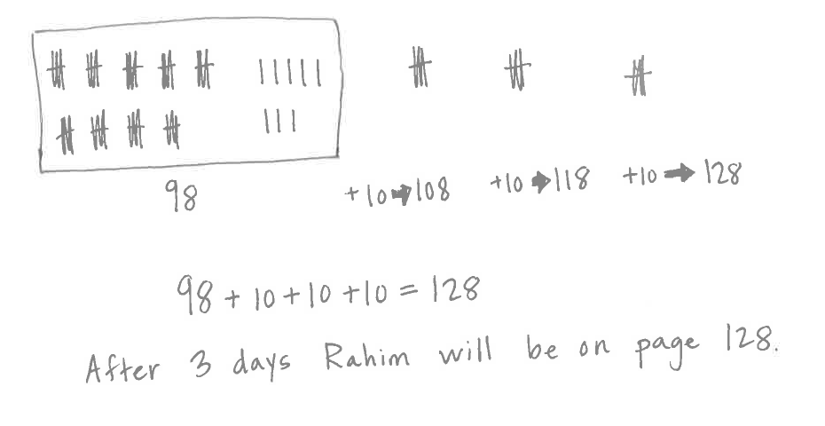What do you see?
* Can you draw something?
* What can you draw?
* What conclusions can you make from your drawing?

T: Use the RDW process.

T: Talk with your partner about different ways you can solve this problem using what you’ve learned.

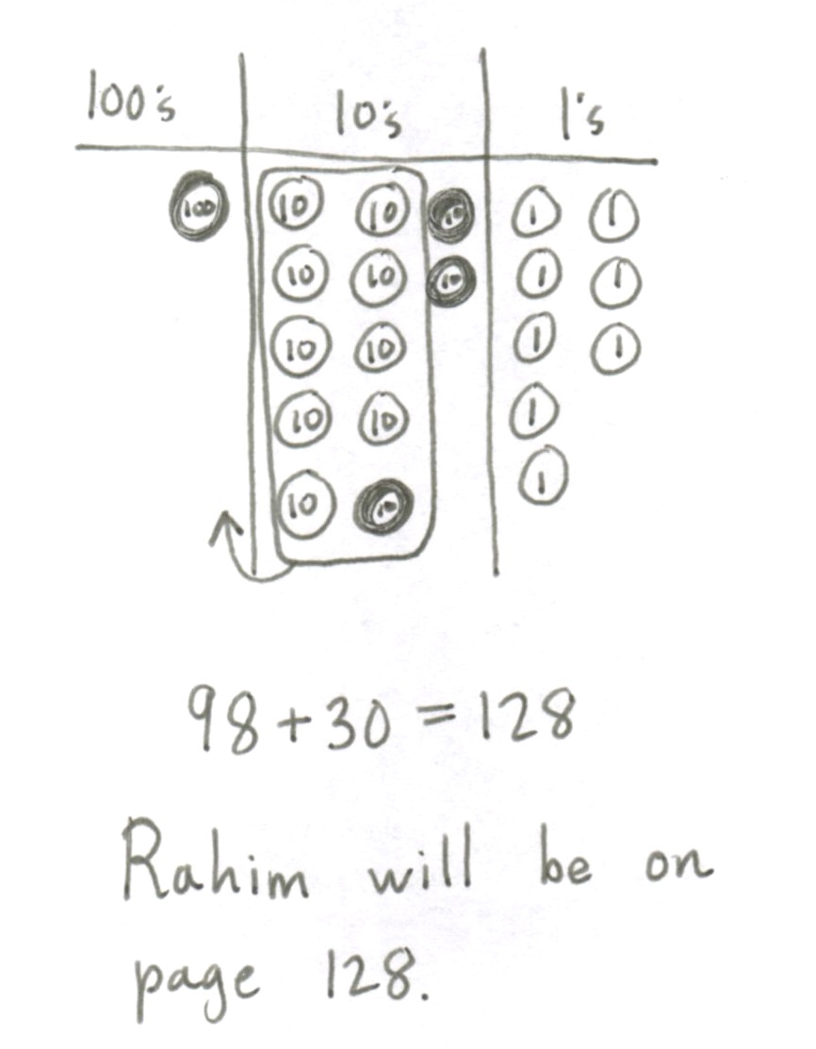T: (Invite students to share their work and explain their thinking. Then, encourage their classmates to ask them questions.)

S: I drew bundles to show the number of pages he read, 98, and then I added 3 more bundles of 10 because he reads 10 pages every day.

S: I wrote 98, and then I drew 3 circles to be the 3 days and put 10 in each to show the pages he read every day. Then, I skip-counted by 10.

S: I drew a place value chart and place value disks to show 98. Then, I added a ten disk for the first day, and then a ten disk for the second day, and a ten disk for the third day because he reads 10 pages every day.

T: These are wonderfully clear drawings, and I like the way you   
explained how each piece relates to the story problem.

T: All three of these drawings help us see the pattern. Can someone explain how the numbers changed?

S: They got bigger by 10.

T: So, how were we counting?

S: We were skip-counting by 10.

T: What page will Rahim be on in 3 days?

S: Rahim will be on page 128.

T: Please add this statement to your paper.

Concept Development (30 minutes)

Concrete (10 minutes)

|  |  |
| --- | --- |
|  | NOTES ON  MULTIPLE MEANS  OF ACTION AND EXPRESSION: |
| When counting back by hundreds, students may stumble when the numbers change from three-digit to two-digit numbers (e.g., 178 to 78). Have students think–pair–share beforehand on a similar problem to prepare them for the change. | |

Materials: (S) Unlabeled hundreds place value chart (Lesson 8 Template), place value disks (hundreds, tens, and ones) per pair

T: Show 266 with place value disks.

S: (Show.)

T: Use place value disks to count out loud by ones from 266 to 272.

S: 267, 268, 269, 270, 271, 272.

T: What unit can you make?

S: A ten.

T: Go ahead and trade ones for a ten.

S: (Trade.)

T: Use place value disks to skip-count out loud by hundreds from 272 to 772.

S: 372, 472, 572, 672, 772.

|  |  |
| --- | --- |
|  | NOTES ON  MULTIPLE MEANS  OF ACTION AND EXPRESSION: |
| Allow students who are challenged by the Problem Set charts to work together in partners or in small groups. Encourage them to verbalize what they notice about the pattern and movement of the numbers before coming to the Debrief. This will give them the confidence to contribute during the discussion. | |

T: Say the next two numbers in our pattern.

S: 872, 972!

T: Good. Use place value disks to complete another ten. Count out loud.

S: 773, 774, 775, 776, 777, 778, 779, 780.

T: Say the next two numbers in our pattern, counting up by ones.

S: 781, 782.

T: Good. Trade your ones for a ten.

S: (Trade.)

T: Use place value disks to skip-count out loud by tens   
from 780 to 700.

S: 770, 760, 750, 740, 730, 720, 710, 700.

T: Say the next two numbers in our pattern.

S: 690, 680.

T: Good. Change your place value chart to show 1 more than 700.

S: (Show 701.)

T: Use place value disks to count down by tens out loud from 701 to 671.

S: 691, 681, 671.

T: (Write ____, ____, 641, 631 on the board.) Say the numbers missing from our pattern.

S: 661 and 651!

T: Yes. Use place value disks to count down by hundreds out loud from 671 to 371.

S: 571, 471, 371.

T: (Write ____, ____, 71 on the board.) Say the numbers missing from our pattern.

S: 271 and 171.

T: Nice work. Use place value disks to count out loud by ones from 371 to 375.

S: 372, 373, 374, 375.

T: (Write ____, 377, ____, ____, 380 on the board.) Say the pattern, filling in the blanks.

S: 376, 377, 378, 379, 380.

Pictorial (10 minutes)

Materials: (T) Pocket chart (S) 4 large index cards per pair

Students work as partners. Each partnership belongs to group *more* or group *less*.

T: With your partner, make a number pattern. You choose if your pattern shows counting by ones, tens, or hundreds.

T: Talk to your partner and decide now. Take 15 seconds.

S: (Partners discuss and decide.)

T: Your pattern must count down if you are in the *less* group and up if you are in the *more* group.

T: Turn and confirm with your partner: “We will count down by ____,” or “We will count up by ____.”

S: We will count down by tens. 🡪 We will count up by hundreds. 🡪 We will count down by ones.

T: Pick a number between 40 and 600. Partner A, write the number on a card and hold it up.

S: (Pick a number, write it, and hold up the card.)

T: Start with that number. Use the other cards to write the rest of the numbers in your sequence.

S: (Work together.)

T: On the blank side of each card, draw the number you wrote. Take two minutes.

S: (Create their cards.)

T: Stack the cards in order with the drawings face up and bring them to the rug with your partner.

(Students are seated at the rug.)

T: Molly and Ken, share first. Bring your cards to the pocket chart.

T: Say each number, placing one drawing at a time in the pocket. Go slowly so your friends can figure out your pattern.

T: Class, count along with Molly and Ken when you’ve figured out their pattern.

S: (Molly and Ken count and place, others chime in.) 236… 336… (all) oh! 436, 536!

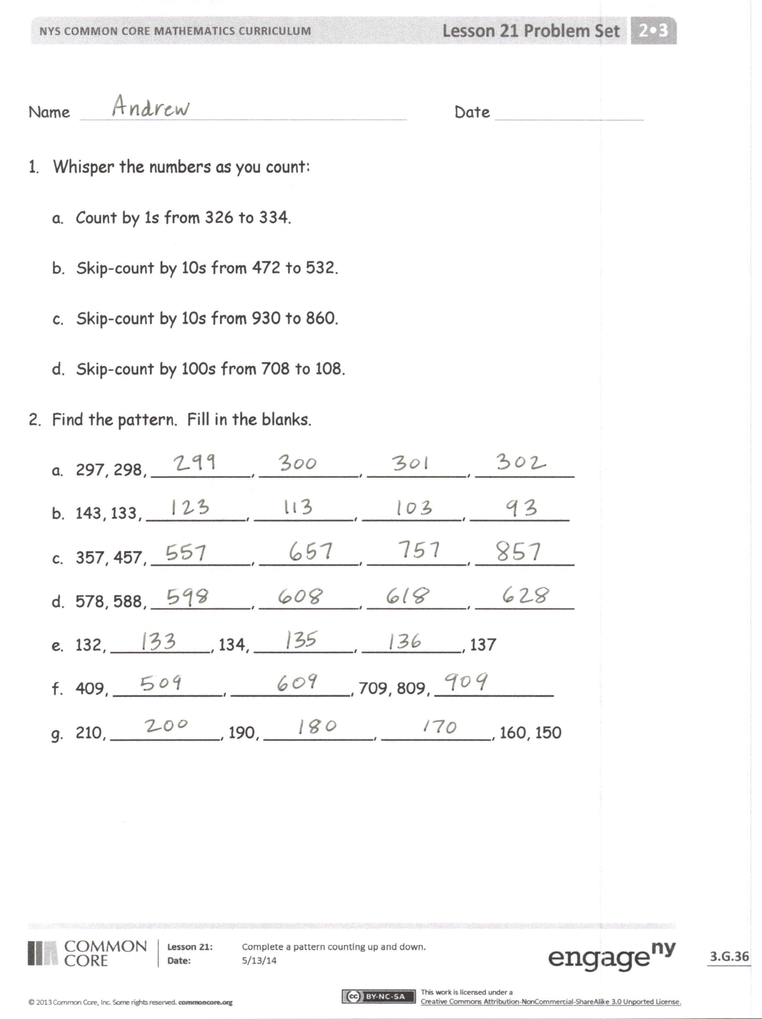T: Name Molly and Ken’s pattern.

S: 100 more!

T: Ken and Molly, can you confirm?

S: That’s it!

Continue whole group or have groups share to each other and rotate. Show some patterns with numbers rather than drawings. For others, show alternating numbers and let the class fill in blanks.

Problem Set (10 minutes)

Students should do their personal best to complete the Problem Set within the allotted 10 minutes. For some classes, it may be appropriate to modify the assignment by specifying which problems they work on first. Some problems do not specify a method for solving. Students should solve these problems using the RDW approach used for Application Problems.

Instruct students to whisper the numbers as they count, find the pattern, fill in the blanks, and complete the chart.

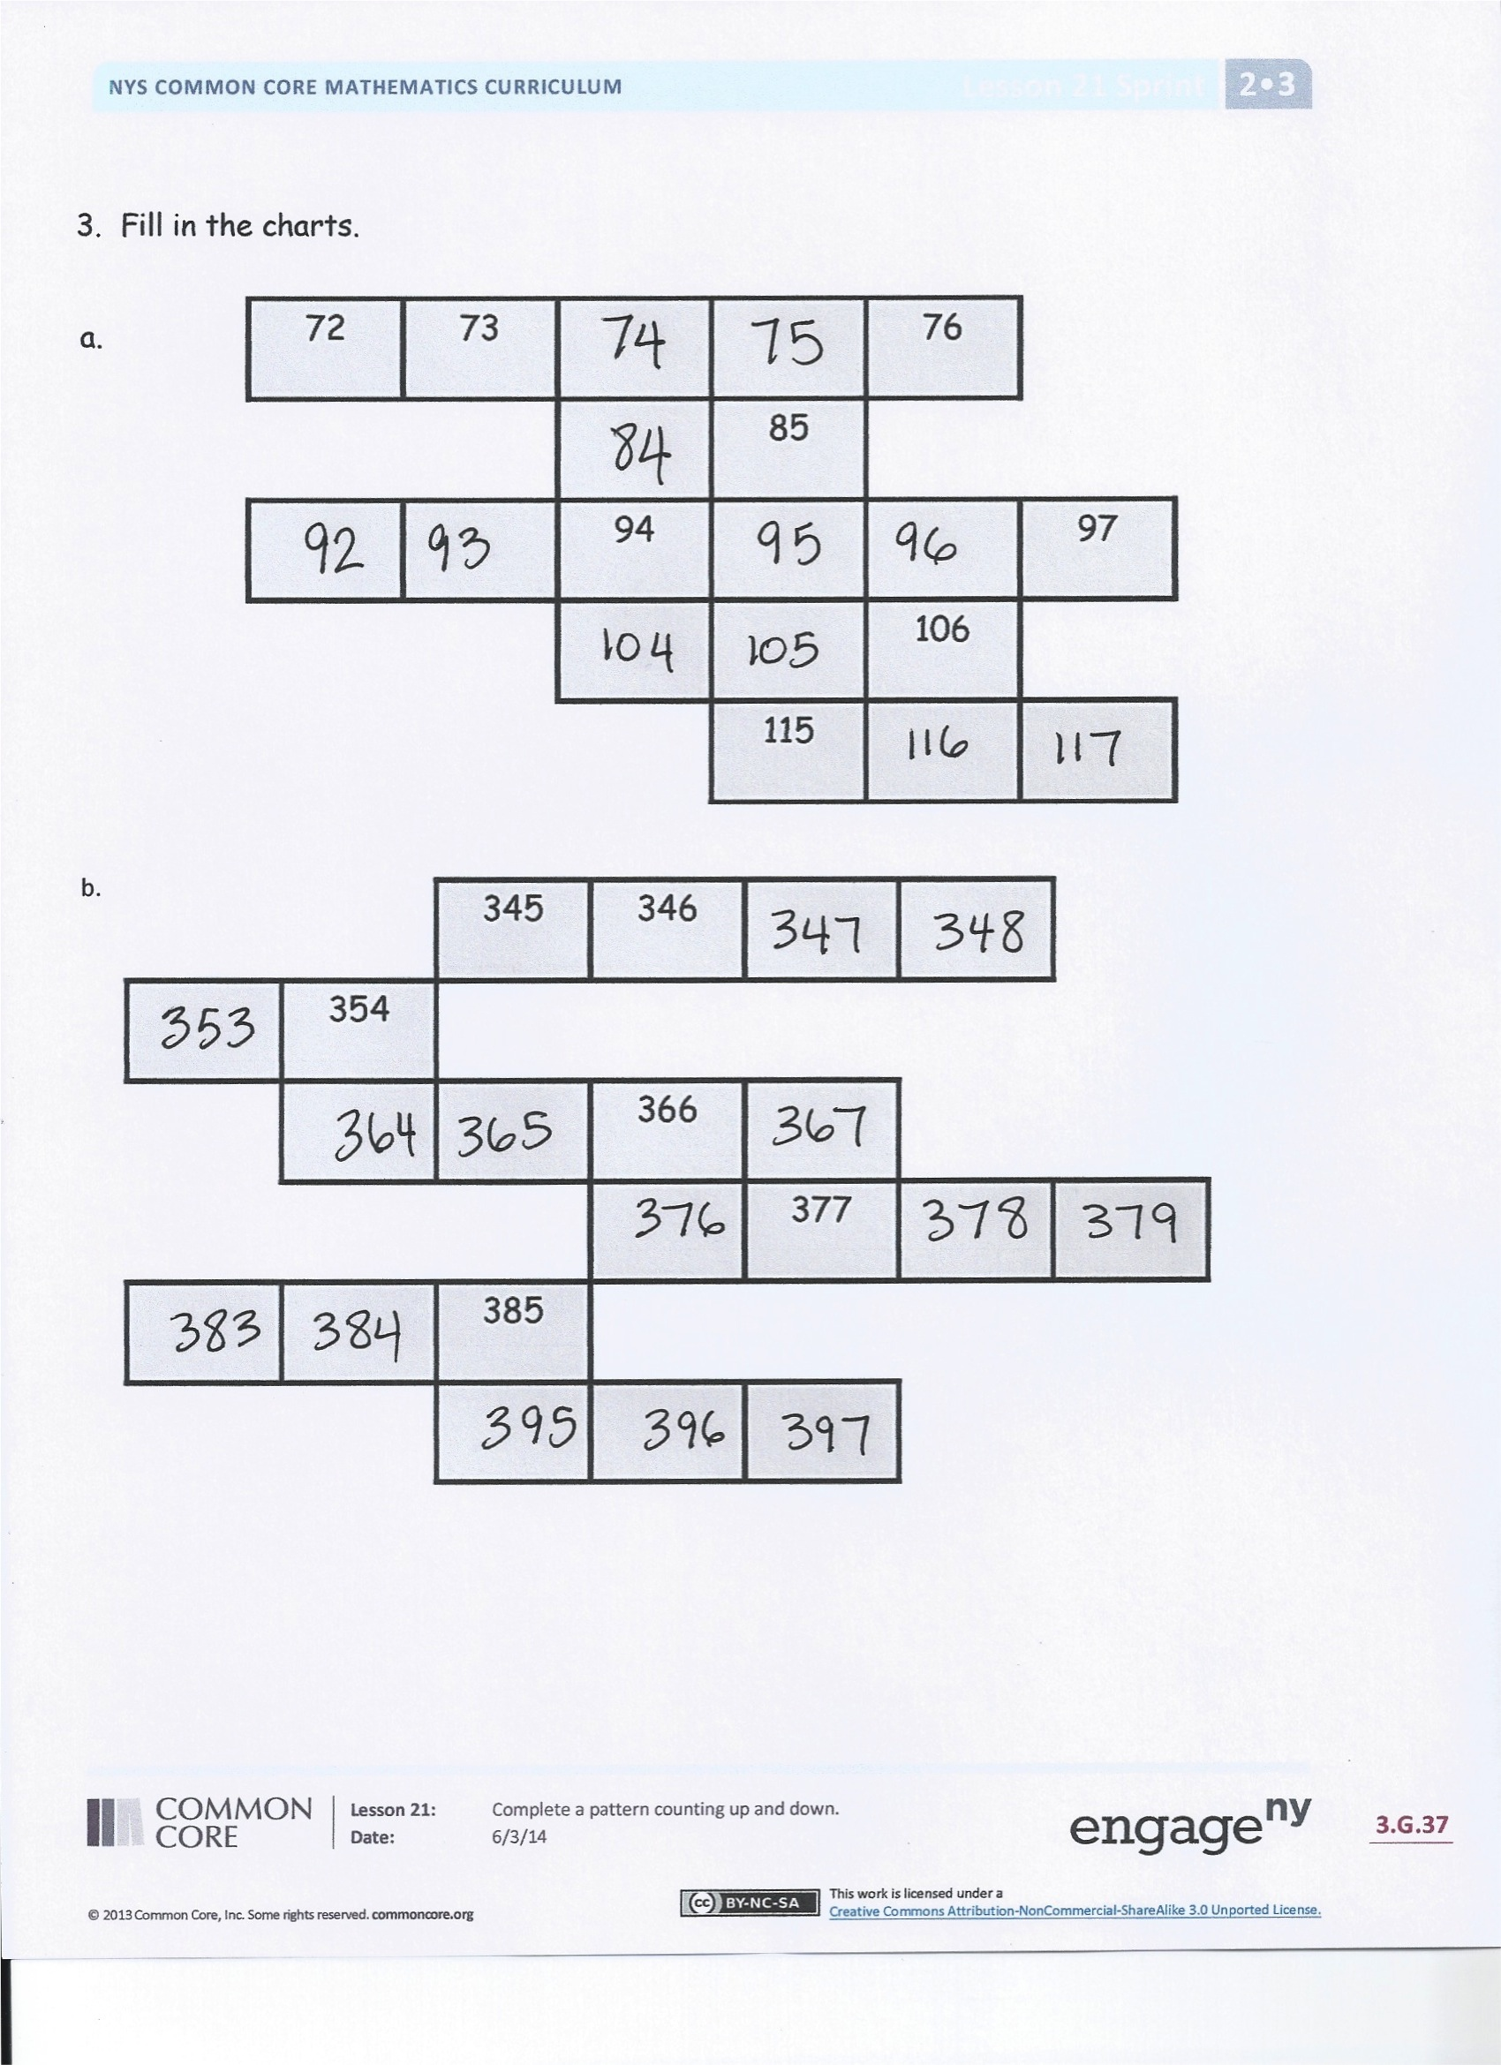Student Debrief (10 minutes)

**Lesson Objective:** Complete a pattern counting up and down.

The Student Debrief is intended to invite reflection and active processing of the total lesson experience.

Invite students to review their solutions for the Problem Set. They should check work by comparing answers with a partner before going over answers as a class. Look for misconceptions or misunderstandings that can be addressed in the Debrief. Guide students in a conversation to debrief the Problem Set and process the lesson.

T: Bring your Problem Set to the carpet.   
Count up by tens from 456 as you transition.

S: 466, 476, 486, 496, 506, 516, 526….

T: Take a couple of minutes and check over your answers with your partner.

S: (Check work.)

T: Turn and tell your partner your reaction to Problems 3(a) and (b)? What did you think?

S: It was hard! 🡪 At first, I didn’t know you had to go up and down over the white spaces to get the next number. 🡪 Yeah, the up and down ones were trickiest. 🡪 I had fun. It was like a puzzle. I used clues to fit the pieces of the puzzle together.

T: Tim, say more about what you mean about a pattern being like a puzzle.

**MP.8**

S: Well, you have to put it together in order. You have to find clues to help you figure it out.

T: What kinds of clues?

S: Like noticing if the counting is going by 1 more, 1 less, or 10 more or less, or 100 more or less.   
It makes a pattern. Once you know the pattern, it’s a clue that makes things easy. The pattern just repeats and you know the next number fast.

T: Retell Tim’s idea about patterns to your partner.

S: Tim said you have to look for clues about the counting. 🡪 He said you try and see if the pattern is going by ones, tens, or hundreds. 🡪 Tim said once you know what to count by, it’s a clue that makes it easy to know what comes next. You just follow the pattern.

T: So, to complete number sequences like these, we look for...

S: The pattern!

T: One way that Tim did that was by noticing…

S: What the numbers are counting by!

Exit Ticket (3 minutes)

After the Student Debrief, instruct students to complete the Exit Ticket. A review of their work will help you assess the students’ understanding of the concepts that were presented in the lesson today and plan more effectively for future lessons. You may read the questions aloud to the students.





Name Date

1. Whisper the numbers as you count:
2. Count by 1s from 326 to 334.
3. Skip-count by 10s from 472 to 532.
4. Skip-count by 10s from 930 to 860.
5. Skip-count by 100s from 708 to 108.
6. Find the pattern. Fill in the blanks.
7. 297, 298, __________, __________, __________, __________
8. 143, 133, __________, __________, __________, __________
9. 357, 457, __________, __________, __________, __________
10. 578, 588, __________, __________, __________, __________
11. 132, __________, 134, __________, __________, 137
12. 409, ___________, ____________, 709, 809, ____________
13. 210, ___________, 190, ___________, ___________, 160, 150

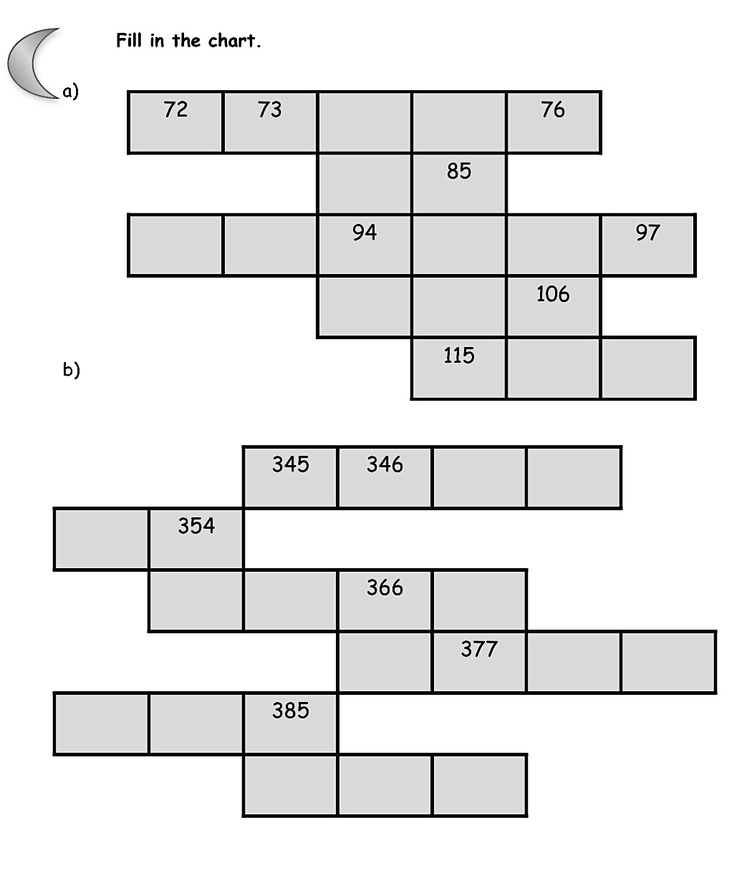

1. Fill in the charts.

a.

b.

Name Date

Find the pattern. Fill in the blanks.

1. 109, __________, 111, __________, __________, 114
2. 710, ___________, 690, ___________, ___________, 660, 650
3. 342, ___________, ____________, 642, 742, ____________
4. 902, ___________, _____________, 872 , _____________, 852

Name Date

1. Find the pattern. Fill in the blanks.
2. 396, 397, __________, __________, __________, __________
3. 251, 351, __________, __________, __________, __________
4. 476, 486, __________, __________, __________, __________
5. 630, 620, __________, __________, __________, __________
6. 208, 209, ___________, __________, __________, 213
7. 316, ___________, ____________, 616, 716, ____________
8. 547, ___________, 527, ___________, 507, _____________
9. 672, ___________, 692, _____________, _____________
10. Fill in the chart.

**MP.8**

**MP.8**

**MP.8**

**MP.8**

**MP.8**

**MP.8**

**MP.8**

|  |  |  |  |  |
| --- | --- | --- | --- | --- |
| 206 |  |  |  |  |
|  | 218 |  |
|  |  |  |  |  | 230 |
| 237 |  |