Lesson 19

Objective: Model and use language to tell about 1 more and 1 less, 10 more and 10 less, and 100 more and 100 less.

Suggested Lesson Structure

 Fluency Practice (12 minutes)

 Concept Development (28 minutes)

 Application Problem (10 minutes)

 Student Debrief (10 minutes)

**Total Time (60 minutes)**

Fluency Practice (12 minutes)

* Sprint: Differences **2.OA.2** (12 minutes)

Sprint: Differences (12 minutes)

Materials: (S) Differences Sprint

T: Yesterday was our third day of practicing sums. Time to move on to differences.

T: 5 – 3 is…?

S: 2.

T: 15 – 3 is…?

S: 12.

T: 7 – 1 is…?

S: 6.

T: 17 – 1 is…?

S: 16.

T: Discuss what you see happening. How do the simple problems relate to the subtraction from the teens?

S: (Share.)

T: That is a clue to help you with today’s Sprint. Take your mark, get set, think!

As you close this fluency activity, remind students that the same Sprint will be given tomorrow.

Concept Development (28 minutes)

Concrete (10 minutes)

Materials: (T) Plenty of board space, sentence frames for *1 more than ___ is ___,* *10 more than ___ is ___,* and *100 more than ___ is ___* (with an analogous *less than* set) (S) Unlabeled hundreds place value chart (Lesson 8 Template), place value disks (hundreds, tens, and ones)

T: Show 110 on your place value chart.

S: (Show.)

T: Use ten disks to count by tens up to 150. (Write 150 on the board.)

S: 120, 130, 140, 150.

T: Add another ten disk.

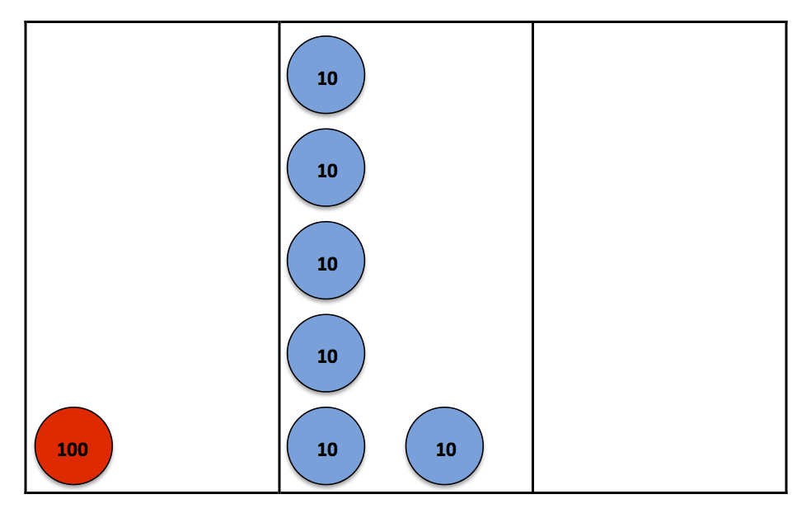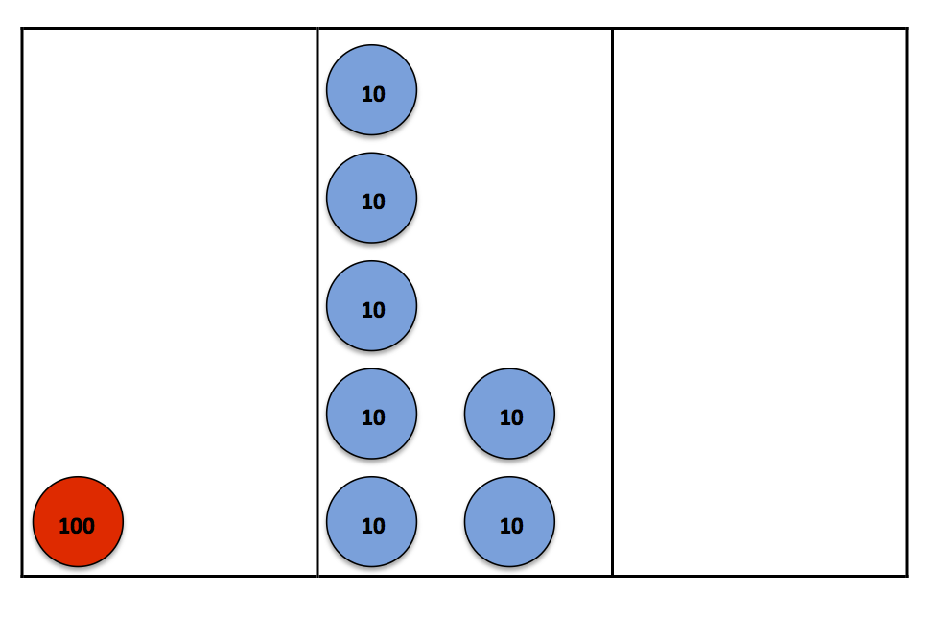

S: (Add.)

T: 10 more than 150 is…?

S: 160!

T: (Write 160 on the board directly below 150.) Good.

T: (Post sentence frame *10 more than ___ is ___*.) 10 more than 150 is 160. Your turn.

S: 10 more than 150 is 160.

T: Add another ten disk. How many now?

S: 170!

T: (Write 170 on the board under 160.) Use the frame to say a complete sentence.

S: 10 more than 160 is 170.

T: Look at the numbers we’ve counted (point to the list of 150, 160, 170). Turn and tell your partner what’s the same and different about them.

S: They all have three digits. 🡪 The hundreds and ones places are the same. 🡪 The tens are changing. Every time we add a ten disk the ten gets bigger. 5, 6, 7.

**MP.8**

T: I heard someone say that every time we add a ten disk the number in the tens place grows. Use our list to predict 10 more than 170.

S: 180!

T: Using our sentence frame?

S: 10 more than 170 is 180.

T: Good. Add the ten disk to show 180.

S: (Show 180.)

T: (Write 180 under 170.) Now, count by ones to show 186. (Start another list on the board to the right of the tens with 186 at the top.)

S: 181, 182, 183, 184, 185, 186.

T: (Post sentence frame *1 more than ___ is ___.*) Add another one disk. How many now?

S: 187.

T: Use our sentence frame to describe what you know. (Point to the *1 more than* frame.)

S: 1 more than 186 is 187.

T: (Write 187 on the board under 186.) Add another one disk.

S: 188.

T: Using our sentence frame?

S: 1 more than 187 is 188.

T: (Write 188 on the board under 187.) Look at our new list of numbers. What do you notice?

S: The ones are changing. 🡪 They’re counting up by one each time we add a disk.

T: I’ll label this list (150, 160, 170, 180) *10 more* since we counted by tens, and this list (186, 187, 188) *1 more* because we counted by ones.

T: Talk to your partner about how our *1 more* and *10 more* lists are the same and different.

S: The hundreds are all the same. 🡪 In both lists, only 1 number changes. 🡪 When we count by tens, the tens place changes, same for the ones. 🡪 The numbers in both lists grow by 1 each time. 🡪 They look like they’re growing by 1 in the tens list, but they’re really growing by 10!

**MP.8**

T: (Label a *100 more* list to the left of *10 more*.) Let’s count by hundreds. What place will change?

S: The hundreds place!

T: We have 188 now (write 188 at the top of the *100 more* list). Add a hundred disk.

S: (Show.)

|  |  |
| --- | --- |
|  | NOTES ON  MULTIPLE MEANS  OF ENGAGEMENT: |
| English language learners may have a challenging time articulating how the *1 more* and *10 more* lists are the same and different. Encourage them to use their place value disks to help them explain their thinking if needed. Additionally, invite them to refer to the sentence frames posted on the board to support their responses. | |

T: How many now?

S: 288!

T: So… (prompt students by posting the frame *100 more than ___ is ___*).

S: 100 more than 188 is 288!

T: (Write 288 under 188 on the *100 more* list.) Were we right? Which place is changing?

S: The hundreds place!

T: Use the pattern to finish my sentence. 100 more than 288 is…?

S: 388!

T: (Write 388 under 288.) Good. Place another hundred disk to check and see.

Continue, but switch so that students practice counting down by hundreds, tens, and ones.

Pictorial (8 minutes)

T: With 1 more and 1 less, which place is changing?

S: The ones!

T: (Draw and write 427.) What number am I showing?

S: 427.

T: (Draw a one disk.) Use our frame to describe what happened. (Point to the *1 more* frame.)

S: 1 more than 427 is 428.

|  |  |
| --- | --- |
|  | NOTES ON  MULTIPLE MEANS  OF ENGAGEMENT: |
| If students have a hard time identifying which place value is changing, instruct them to circle, underline, or highlight the number(s) that is changing. This enables them to explicitly see the change in the digits in the ones, tens, or hundreds place. | |

T: (Write 428 under 427.) 1 more than 428 is?

T: (Draw a one disk.)

S: 429.

T: So, 1 less than 429 is…?

S: 428.

T: We can say, “1 less than 429 is 428.” Your turn.

S: 1 less than 429 is 428.

T: (Draw a ten disk.) What place changed?

S: The tens!

T: Now, what’s my number?

S: 439.

T: I’ll add another ten (draw a ten disk). What’s my number now?

S: 449.

T: So, 10 less than 449 is…?

S: 439.

T: We can say, “10 less than 449 is 439.” Your turn.

S: 10 less than 449 is 439.

T: (Draw a hundred disk.) What’s my number?

S: 549.

T: (Write 649 in standard form next to the drawing.) What unit should I put in order to have 649?

S: 1 hundred.

T: We can say, “100 more than 549 is 649.” Your turn.

S: 100 more than 549 is 649.

T: (Write 650 next to 649.) What is the difference between 649 and 650?

S: A ten!

T: Let’s think about that. Join in and count with me.

S: (Chorally count.) 646, 647, 648, 649, 650.

T: So, what is the difference between 649 and 650?

S: 1!

T: Yes. We can say, “1 less than 650 is 649.” Your turn.

S: 1 less than 650 is 649.

Continue, alternating practice between *more* and *less*.

Problem Set (10 minutes)

Students should do their personal best to complete the Problem Set within the allotted 10 minutes. For some classes, it may be appropriate to modify the assignment by specifying which problems they work on first. Some problems do not specify a method for solving. Students should solve these problems using the RDW approach used for Application Problems.

Instruct students to model each problem on the place value chart, complete the chart, and whisper the complete sentence.

Application Problem (10 minutes)

Mr. Palmer’s second-grade class is collecting cans for recycling. Adrian collected 362 cans, Jade collected 392 cans, and Isaiah collected 562 cans.

a. How many more cans did Isaiah collect than Adrian?

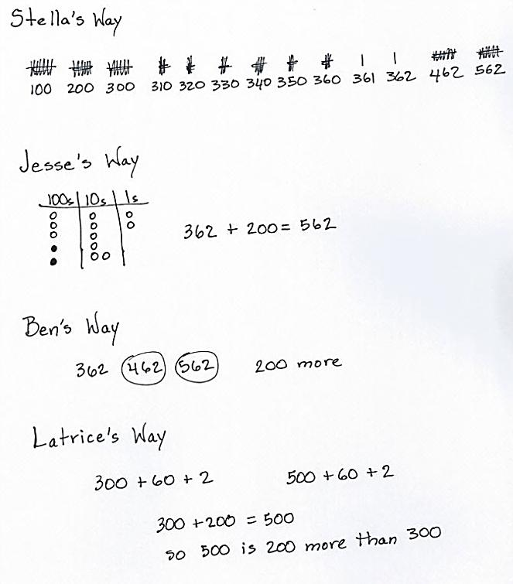Extension: How many less cans did Adrian collect than Jade?

Lead students as necessary through the sequence of questions we want them to internalize.

* What do you see?
* Can you draw something?
* What can you draw?
* What conclusions can you make from your drawing?

T: Use your RDW process.

T: Talk with your partner about different ways you   
can solve this problem using what you’ve learned.

S: I put 362 in my head and skip-counted by hundreds: 462, 562.

T: So, how many more cans did Isaiah collect than Adrian? Give me a complete sentence.

S: Isaiah collected 200 more cans than Adrian.

T: How can you show that your answer is correct?

S: I could draw bundles to show the numbers.

T: Would you please come up and show us, Stella?

T: Can someone show another way of proving that 562 is 200 more than 362?

S: I would draw a place value chart.

T: Please show us, Jesse.

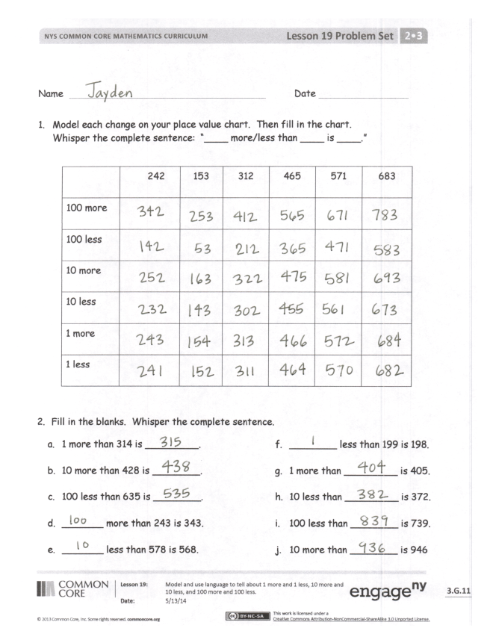T: Thank you both. Would anyone else like to share their thinking?

S: I counted on and wrote 362, 462, 562. And, then I circled how many groups of 100 I had to jump, and it was two groups, so 200.

S: I wrote it in expanded form, and it was easy to see the tens and ones were the same but 500 is 200 more than 300.

T: I so appreciate your many ways of seeing and solving this problem! And, we all agree on the same answer, which is…?

S: Isaiah collected 200 more cans than Adrian.

T: Yes! Please complete your drawings and add that statement to your paper.

Repeat this process with Part (b) of the question.

Student Debrief (10 minutes)

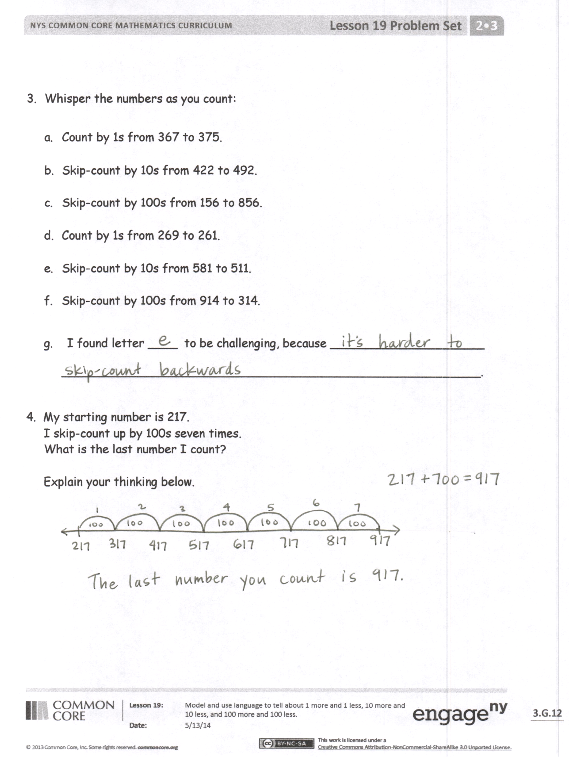**Lesson Objective:** Model and use language to tell about   
1 more and 1 less, 10 more and 10 less, and 100 more and 100 less.

The Student Debrief is intended to invite reflection and active processing of the total lesson experience.

Invite students to review their solutions for the Problem Set. They should check work by comparing answers with a partner before going over answers as a class. Look for misconceptions or misunderstandings that can be addressed in the Debrief. Guide students in a conversation to debrief the Problem Set and process the lesson.

T: Bring your Problem Set to our Debrief.

T: Take a couple of minutes to check over your answers with a partner.

T: Which section slowed you down? Why?

S: The fill in the blank section on the Problem Set, especially (g), (h), (i), and (j). When it said *10 less,* I knew I really had to look at the tens, and when it said *100 less,* I really looked at the hundreds because those places would change.

T: Turn and tell your partner Nadia’s strategy for helping herself with the fill in the blank section.

S: Nadia paid attention to the places of numbers. 🡪 Nadia used the *10 less* and *100 less* part of the question as a clue to help her know which numbers to look at and change.

T: Let’s look at Tyron and Heather’s strategies for solving the last problem. (Project student work.)

T: Tyron, tell us about your strategy for solving.

S: I drew 7 lines in a row. Then, I counted by hundreds and wrote each number on a line until I filled up all the lines.

T: Thumbs up if you used the same strategy.

S: (Some show thumbs up.)

T: Now, look at Heather’s strategy. Heather, can you tell us about yours?

S: I knew only the hundreds would change because we were counting by hundreds. I noticed counting by hundreds 7 times is the same as 700. I added those to the 200 in 217. I wrote 200 + 700 = 900. Then, I put 900 back together with 17 ones and got 917.

T: Good. How are these strategies the same and different?

S: They’re the same because they both got the right answer. 🡪 They both only changed hundreds. 🡪 In Tyron’s you can see the pattern of growing by 100. 🡪 Heather used a basic fact.

T: Pick a strategy that is different from the one you used and try it on your paper now.

S: (Work.)

T: Good. Head back to your seats to complete your Exit Ticket.

Exit Ticket (3 minutes)

After the Student Debrief, instruct students to complete the Exit Ticket. A review of their work will help you assess the students’ understanding of the concepts that were presented in the lesson today and plan more effectively for future lessons. You may read the questions aloud to the students.





Name Date

1. Model each change on your place value chart. Then fill in the chart.   
   Whisper the complete sentence: “____ more/less than ____ is ____.”

|  |  |  |  |  |  |  |
| --- | --- | --- | --- | --- | --- | --- |
|  | 242 | 153 | 312 | 465 | 571 | 683 |
| 100 more |  |  |  |  |  |  |
| 100 less |  |  |  |  |  |  |
| 10 more |  |  |  |  |  |  |
| 10 less |  |  |  |  |  |  |
| 1 more |  |  |  |  |  |  |
| 1 less |  |  |  |  |  |  |

1. Fill in the blanks. Whisper the complete sentence.
2. 1 more than 314 is _________.
3. 10 more than 428 is ________.
4. 100 less than 635 is ________.
5. _______ more than 243 is 343.
6. _______ less than 578 is 568.
7. ________ less than 199 is 198.
8. 1 more than _________ is 405.
9. 10 less than _________ is 372.
10. 100 less than ________ is 739.
11. 10 more than ________ is 946.
12. Whisper the numbers as you count:
13. Count by 1s from 367 to 375.
14. Skip-count by 10s from 422 to 492.
15. Skip-count by 100s from 156 to 856.
16. Count by 1s from 269 to 261.
17. Skip-count by 10s from 581 to 511.
18. Skip-count by 100s from 914 to 314.

g. I found letter ____ to be challenging, because _____________________

_________________________________________________________.

1. My starting number is 217.

I skip-count up by 100s seven times.

What is the last number I count?

Explain your thinking below.

Name Date

Fill in the blanks.

1. 10 more than 239 is ________.
2. 100 less than 524 is ________.
3. _______ more than 352 is 362.
4. _______ more than 467 is 567.
5. 1 more than _________ is 601.
6. 10 less than _________ is 241.
7. 100 less than ________ is 878.
8. 10 more than ________ is 734.

Name Date

1. Fill in the chart. Whisper the complete sentence: “___ more/less than ___ is ___.”

|  |  |  |  |  |  |  |
| --- | --- | --- | --- | --- | --- | --- |
|  | 146 | 235 | 357 | 481 | 672 | 814 |
| 100 more |  |  |  |  |  |  |
| 100 less |  |  |  |  |  |  |
| 10 more |  |  |  |  |  |  |
| 10 less |  |  |  |  |  |  |
| 1 more |  |  |  |  |  |  |
| 1 less |  |  |  |  |  |  |

1. Fill in the blanks. Whisper the complete sentence.
2. 1 more than 103 is _________.
3. ________ less than 422 is 421.
4. 1 more than _________ is 619.
5. 10 less than _________ is 546.
6. 100 less than ________ is 818.
7. 10 more than ________ is 974.
8. 10 more than 378 is ________.
9. 100 less than 545 is _______.
10. _______ more than 123 is 223.
11. _______ less than 987 is 977.