Lesson 24: Surface Area

Classwork
Example 1

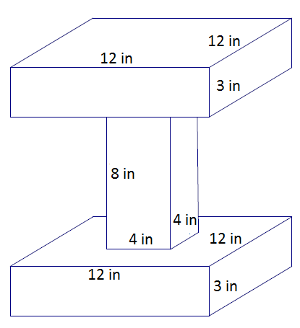

Example 2
- Determine the surface area of the cube.
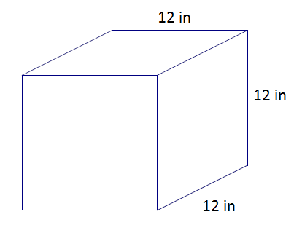

- A square hole with a side length of $4$inches is drilled through the cube. Determine the new surface area.
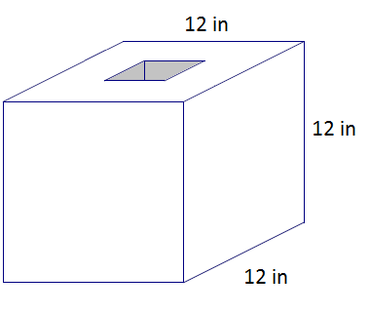

Example 3
A right rectangular pyramid has a square base with a side length of 10 inches. The surface area of the pyramid is $260$ in². Find the height of the four lateral triangular faces.

Exercises 1–8
- Determine the surface area of each figure. Assume all faces are rectangles unless it is indicated otherwise.
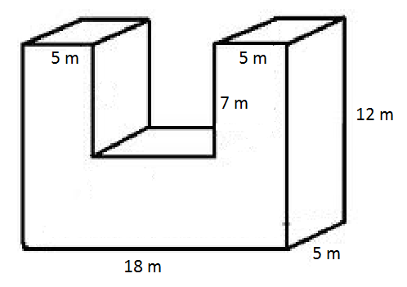

- In addition to your calculation, explain how the surface area was determined.
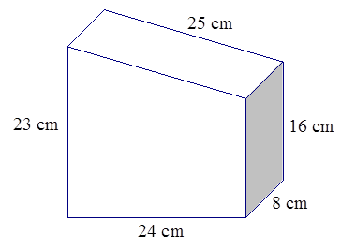

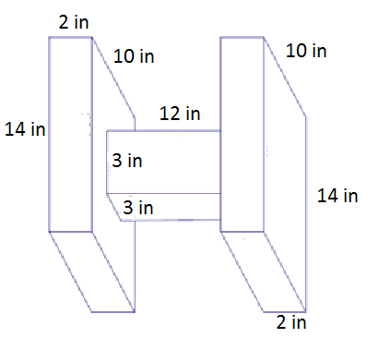

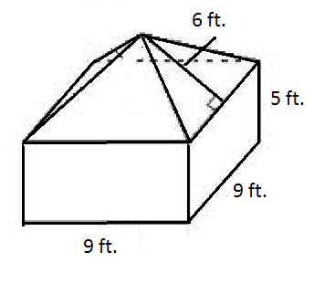
- In addition to your calculation, explain how the surface area was determined.

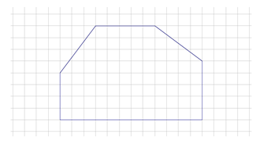
- A hexagonal prism has the following base and has a height of $8$ units. Determine the surface area of the prism.

- Determine the surface area of each figure.
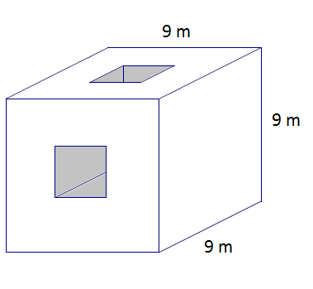
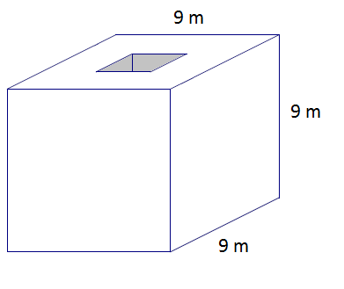
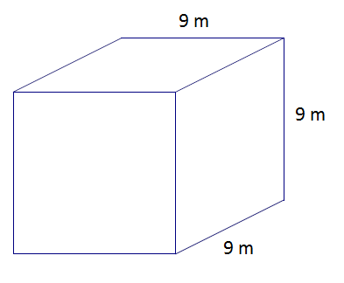

  - A cube with a square hole with $3$ m side lengths has been drilled through the cube.

  - A second square hole with $3$ m side lengths has been drilled through the cube.

- The figure below shows $28$ cubes with an edge length of $1$ unit. Determine the surface area.
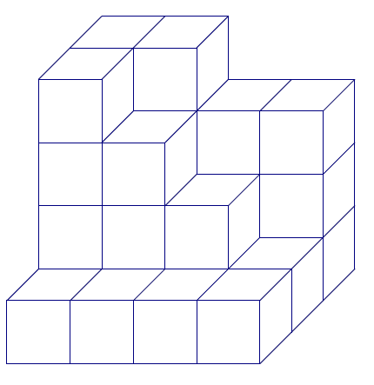

- The base rectangle of a right rectangular prism is$4$ft.$× 6$ft. The surface area is $288$ft². Find the height.
Let $h$ be the height in feet.

Problem Set

Determine the surface area of each figure.
- In addition to the calculation of the surface area, describe how you found the surface area.
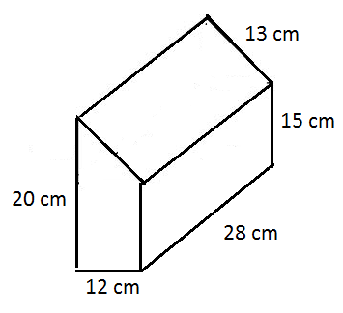
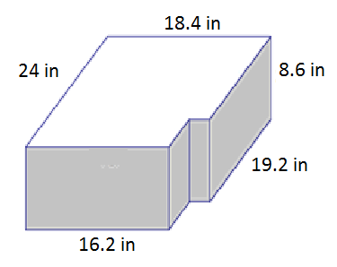

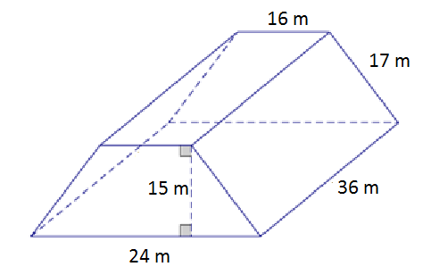
32 m

- Determine the surface area after two square holes with a side length of $2$ m are drilled through the solid figure composed of two rectangular prisms.
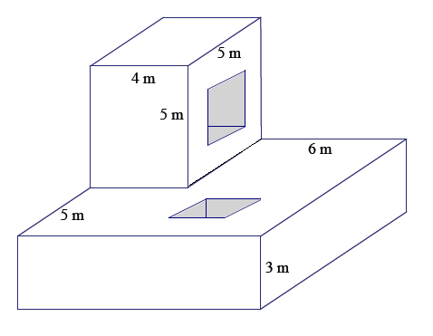

- The base of a right prism is shown below. Determine the surface area if the height of the prism is $10$cm. Explain how you determined the surface area.

