Lesson 24: Surface Area

Student Outcomes
- Students determine the surface area of three-dimensional figures, those that are composite figures and those that have missing sections.

Lesson Notes
This lesson is a continuation of Lesson 23. Students will continue to work on surface area advancing to figures with missing sections.

Classwork
Example 1 (8 minutes)
Scaffolding:
- As in Lesson 23, students can draw nets of the figures to help them visualize the area of the faces. They could determine the area of these without the holes first and subtract the surface area of the holes.
Students should solve this problem on their own.
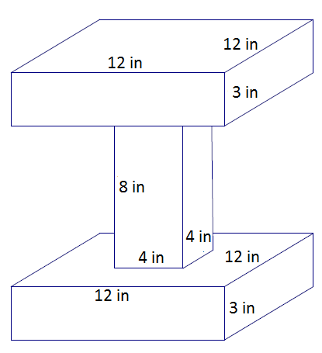
Example 1
Determine the surface area of the image.
Surface area of top and bottom prisms
Lateral sides  MP.7  &  MP.8 | $=4(12$ in.$×3$ in.$)$  $=144$in ²
Base face | $=12$ in. $×12$ in.  $=144$ in²
Base face with hole | $=12$ in. $×12$ in. $- 4$ in. $×4$in.  $=128$ in ²
There are two of these, making up $832$in².
Surface area of middle prism
Lateral Sides | $=4(4$ in. $×8$ in.$)$  $=128$ in²
Surface area: $832$in²$+ 128$ in² $=960$in²

- Describe the method you used to determine the surface area.
  - Answers will vary: I determined the surface area of each prism separately and added them together. Then I subtracted the area of the sections that were covered by another prism.
- If all three prisms were separate, would the sum of their surface areas be the same as the surface area you determined in this example?
  - No, if the prisms were separate, there would be more surfaces shown. The three separate prisms would have a greater surface area than this example. The area would be greater by the area of four $4$in.$×4$ in. squares ($64$ in²).
Example 2 (5 minutes)
Scaffolding:
- As in Lesson 23, students can draw nets of the figures to help them visualize the area of the faces. They could determine the area of these without the holes first and subtract the surface area of the holes.
Example 2
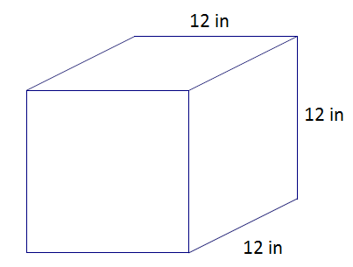
- Determine the surface area of the cube.

$$Surface area=6s^{2} \\ SA=6(12 in)^{2} \\ SA=6(144 in^{2}) \\ SA=864 {in}^{2}$$

- Explain how $6(12$in.$)^{2}$ represents the surface area of the cube.
  - The area of one face, one square with side length of $12$in., is $(12$ in$.)^{2}$, and so a total area of all six faces is $6(12$in$.)^{2}$.

- A square hole with a side length of $4$ inches is drilled through the cube. Determine the new surface area.
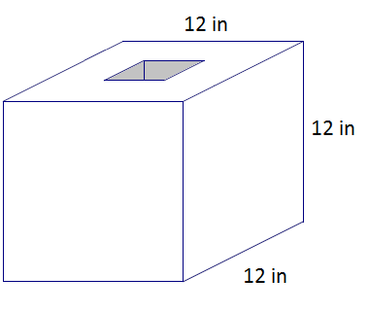
Area of interior lateral sides
$=4(12$ in. $×4$ in.$)$
$=192$in²

Surface Area of cube with holes
$=6(12$ in.$)^{2}-2(4$ in. $× 4$ in.$)+4(12$ in. $×4$ in$.)$
$=864$in²$- 32$in²$+ 192$in²
$=1,024$ in²

- How does drilling a hole in the cube change the surface area?
  - We have to subtract the area of the square at the surface from each end.
- What happens to the surfaces that now show inside the cube?
  - These are now part of the surface area.
- What is the shape of the piece that was removed from the cube?
  - A rectangular prism was drilled out of the cube with the following dimensions: $4$ in. $×4$ in. $×12$ in.
- How can we use this to help us determine the new total surface area?
  - We can find the surface area of the cube and the surface area of the rectangular prism, but we will have to subtract the area of the square bases from the cube and also exclude these bases in the area of the rectangular prism.
- Why is the surface area larger when holes have been cut into the cube?
  - There are more surfaces showing now. All of the surfaces need to be included in the surface area.
- Explain how the expression $6(12$in.$)^{2}-2(4$in. $× 4$in.$)+4(12$in. $× 4$ in.$)$ represents the surface area of the cube with the hole.
  - From the total surface area of a whole (uncut) cube, $6(12$in.$)^{2}$, the area of the bases (the cuts made to the surface of the cube) are subtracted: $6(12$in.$)^{2}-2(4$ in. $×4$ in.$)$. To this expression we add the area of the four lateral faces of the cut out prism, $4(12$in.$×4$ in.$)$. The complete expression then is $6(12$ in$.)^{2}-2(4$in. $×4$ in.$)+4(12$in. $×4$ in.$)$.

Example 3 (5 minutes)
Example 3
A right rectangular pyramid has a square base with a side length of $10$ inches. The surface area of the pyramid is $260$ in². Find the height of the four lateral triangular faces.
Area of base | $=10$ in. $×10$ in.  $=100$ in ²
Area of the four faces | $=260$ in² $- 100$in²  $=160$in²
The total area of the four faces is $160$ in². Therefore, the area of each triangular faces is $40$ in ².
Area of lateral side$=\frac{1}{2}bh$$$40 {in}^{2}=\frac{1}{2} (10 in.)h \\ 40 {in}^{2}=\left(5 in.\right)h \\ h=8 in.$$
The height of each lateral triangular face is $8$ inches.

- What strategies could you use to help you solve this problem?
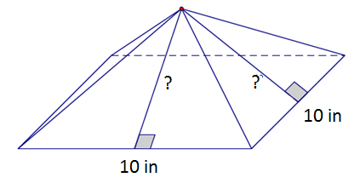
  - I could draw a picture of the pyramid and label the sides so that I can visualize what the problem is asking me to do.

- What information have we been given? How can we use the information?
  - We know the total surface area, and we know the length of the sides of the square.
  - We can use the length of the sides of the square to give us the area of the square base.
- How will the area of the base help us determine the slant height?
  - First, we can subtract the area of the base from the total surface area in order to determine what is left for the lateral sides.
  - Now we can divide the remaining area by $4$ to get the area of just one triangular face.
  - Finally, we can work backwards. We have the area of the triangle, and we know the base is $10$ in., so we can solve for the height.
Exercises 1–8 (20 minutes)
Students work in pairs to complete the exercises.
Exercises 1–8
Determine the surface area of each figure. Assume all faces are rectangles unless it is indicated otherwise.
Top and bottom | $$=2(18 m ×5 m)=180 m^{2}$$
Extra interior sides | $$=2(5 m ×7 m)=70 m^{2}$$
Left and right sides | $$=2(5 m ×12 m)=120 m^{2}$$
Front and back sides | $$=2\left(\left(18 m ×12 m\right)-(8 m ×7 m)\right)$$  $$=2\left(216 m^{2} - 56 m^{2}\right) \\ =2\left(160 m^{2}\right) \\ =320 m^{2}$$
Surface area | $$=180 m^{2}+70 m^{2}+120 m^{2}+320 m^{2}$$  $$= 690 m^{2}$$

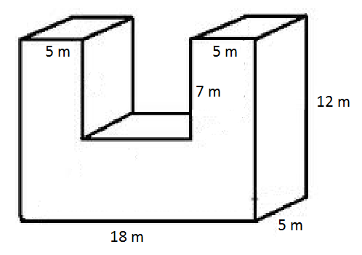

- In addition to your calculation, explain how the surface area was determined.
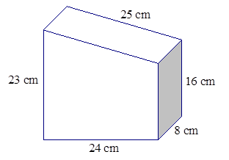
The surface area of the prism is found by taking the sum of the areas of the trapezoidal front and back areas of the four different sized rectangles that make up the lateral faces.

Area top | $$=25 cm×8 cm$$  $$=200 cm^{2}$$
Area bottom | $$=24 cm×8 cm$$  $$=192 cm^{2}$$
Area sides | $$=\left(23 cm×8 cm\right)+\left(16 cm 8 cm\right)$$  $$=312 cm^{2}$$
Area front and back | $$=2\left(\frac{1}{2}\left(16 cm+23 cm\right)\left(24 cm\right)\right)$$  $$=2\left(468 cm^{2}\right)$$  $$=936 cm^{2}$$
Surface Area | $$=200 cm^{2}+192 cm^{2}+312 cm^{2}+936 cm^{2}$$  $$=1,640 cm^{2}$$

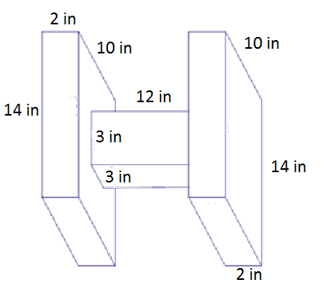
Surface Area of Prisms on the Sides:
Area of front and back | $=2(2$ in.$×14$ in.$)$  $=56$in²
Area of top and bottom | $=2(2$ in. $×10$ in.$)$  $=40$ in²
Area of side | $=14$in. $×10$in.$=140$in²
Area of side with hole | $=14$ in. $×10$ in. $- 3$ in. $×3$ in.  $=131$ in²

There are two such rectangular prisms, so the surface area of both is $734$ in².
Surface Area of Middle Prism:
Area of front and back | $=2(3$ in. $×12$ in.$)=72$in²
Area of sides | $=2(3$ in. $×12$ in.$)=72$ in²
Surface area | $=734$in²$+ 144$in² $=878$in²

- In addition to your calculation, explain how the surface area was determined.
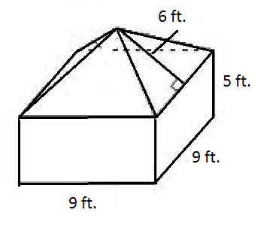
The surface area of the prism is found by taking the area of the base of the rectangular prism and the area of its four lateral faces and adding it to the area of the four lateral faces of the pyramid.
Area of base | $$=9 ft. ×9 ft.$$  $$=81 {ft}^{2}$$
Area of rectangular sides | $$=4\left(9 ft. ×5 ft.\right)$$  $$=180 {ft}^{2}$$
Area of triangular sides | $$=4\left(\frac{1}{2}\left(9 ft.\right)\left(6 ft.\right)\right)$$  $$=108 {ft}^{2}$$
Surface Area | $$=81 {ft}^{2}+180 {ft}^{2}+108 {ft}^{2}$$  $$=369{ ft}^{2}$$

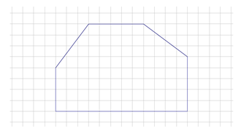
- A hexagonal prism has the following base and has a height of $8$ units. Determine the surface area of the prism.
Area of bases | $=2\left(48+6+20+10\right)$ units²  $=168$units²
Area of $5$ unit sides | $=4\left(5×8\right)$ units²  $=160$units²
Area of other sides | $=\left(4×8\right)$units²$+ \left(12×8\right)$units²  $=128$units²
Surface Area | $=168$units² $+ 160$units²$+ 128$units²  $=456$units²

- Determine the surface area of each figure.
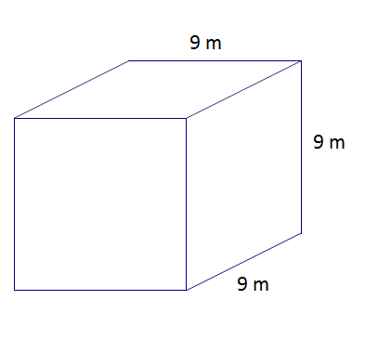
$$SA=6s^{2}$$
$=6(9$m$)^{2}$
$=6(81$m²$)$
$=486$m²

  - A cube with a square hole with $3$ m side lengths has been drilled through the cube.
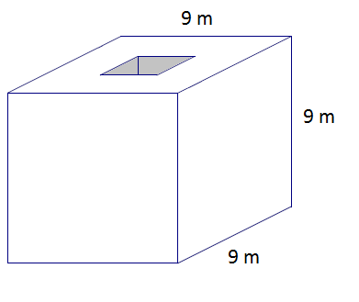
Lateral sides of the hole | $=4(9$ m $×3$ m$)=108$m²
Surface area of cube with holes | $=486$m²$- 2(3$ m $×3$ m$)+108$ m² $=576$m²

  - A second square hole with $3$ m side lengths has been drilled through the cube.
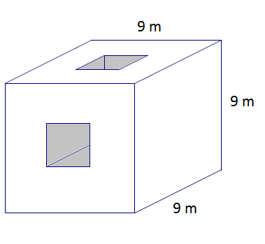
Surface Area$=576$m²$- 4(3$m$×3$m$)+2(4(3$ m $×3$ m$))$
$=612$m²

- The figure below shows $28$ cubes with an edge length of $1$ unit. Determine the surface area.
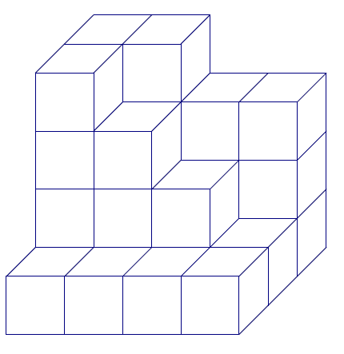
Area top and bottom | $=24$units²
Area sides | $=18$units²
Area front and back | $=28$units²
Surface Area | $$=24+18+28$$  $=70$units²

- The base rectangle of a right rectangular prism is$4$ ft.$×6$ft. The surface area is $288$ft². Find the height.
Let $h$ be the height in feet.
Area of one base: | $4$ft. $×6$ft.$=24$ft²
Area of two bases: | $2(24$ft² $)=48$ft²
Numeric area of four lateral faces: | $288$ft²$- 48$ft²$=240$ft²
Algebraic area of four lateral faces: | $$2(6h+4h)$$
Solve for $h$
$$2\left(6h+4h\right)=240 \\ 10h=120 \\ h=12$$
The height is $12$ feet.

Closing (2 minutes)
- Write down three tips that you would give a friend that is trying to calculate surface area.

Exit Ticket (5 minutes)

Name Date
Lesson 24: Surface Area

Exit Ticket

Determine the surface area of the right rectangular prism after the two square holes have been drilled. Explain how you determined the surface area.

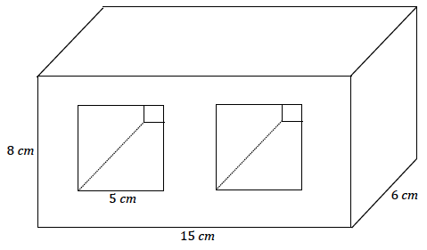

Exit Ticket Sample Solutions

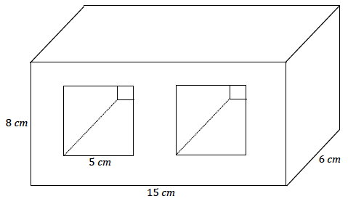
Determine the surface area of the right rectangular prism after the two square holes have been drilled. Explain how you determined the surface area.
Area of top and bottom | $$=2\left(15 cm × 6 cm\right)$$  $$=180 {cm}^{2}$$
Area of sides | $$=2\left(6 cm × 8 cm\right)$$  $$=96 {cm}^{2}$$
Area of front and back | $$=2\left(15 cm × 8 cm\right)-4\left(5 cm × 5 cm\right)$$  $$=140 {cm}^{2}$$
Area inside | $$=8\left(5 cm × 6 cm\right)$$  $$=240 {cm}^{2}$$
Surface Area | $$=180 {cm}^{2}+96 {cm}^{2}+140 {cm}^{2}+240{ cm}^{2}$$  $$=656 {cm}^{2}$$

Take the sum of the areas of the four lateral faces of the main rectangular prism, and subtract the areas of the four square cuts from the area of the bases of the main rectangular prism. Finally, add the lateral faces of the prisms that were cut out of the main prism.

Problem Set Sample Solutions

Determine the surface area of each figure.
- In addition to the calculation of the surface area, describe how you found the surface area.
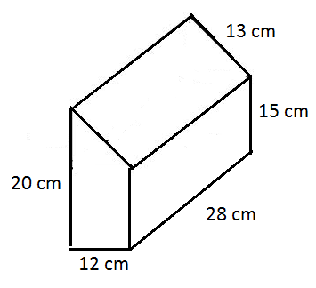
Area of top | $$=28 cm ×13 cm \\ = 364 cm^{2}$$
Area of bottom | $$= 28 cm ×12 cm \\ = 336 cm^{2}$$
Area of left and right sides | $$= 28 cm ×20 cm+15 cm ×28 cm \\ = 980 cm^{2}$$
Area of front and back sides | $$= 2\left(\left(12 cm × 15 cm\right)+\frac{1}{2}\left(5 cm × 12 cm\right)\right) \\ = 2\left(180 cm^{2}+30 cm^{2}\right) \\ = 2\left(210 cm^{2}\right) \\ = 420 cm^{2}$$
Surface area | $$= 364 cm^{2}+ 336 cm^{2}+ 980 cm^{2}+ 420 cm^{2} \\ = 2,100 cm^{2}$$

Split the area of the two trapezoidal bases, take the sum of the areas, and then add the areas of the four different sized rectangles that make up the lateral faces.

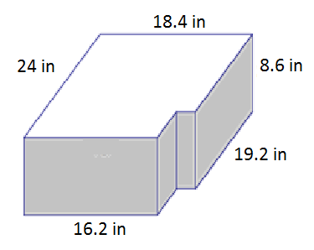
Area of front and back | $= 2(18.4$ in. $×8.6$ in.$)=316.48$in²
Area of sides | $$= 2\left(8.6 in. × 24 in.\right)= 412.8 {in}^{2}$$
Area of top and bottom | $= 2((18.4$ in. $×24$ in.$)-4.8$in.$× 2.2$in.$)$  $= 2(441.6$in² $- 10.56$ in²$)$  $= 2(431.04$ in²$)$  $= 862.08$in²
Surface Area | $= 316.48$in² $+ 412.8$in² $+ 862.08$in²  $= 1,591.36$in²

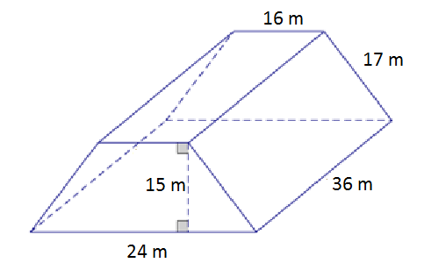
Area of front and back |  | $$=2\left(\frac{1}{2}\left(32 m+16 m\right)15 m\right)$$  $$=720{ m}^{2}$$
Area of top |  | $$= 16 m × 36 m$$  $$= 576 m^{2}$$
Area of left and right sides |  | $$= 2(17 m× 36 m)$$  $$= 2\left(612 m^{2}\right)$$  $$= 1,224 m^{2}$$
Area of bottom |  | $$= 32 m × 36 m$$  $$=1,152 m^{2}$$
Surface Area | $$= 720 m^{2}+1,152 m^{2}+1,224 m^{2} +576 m^{2}$$  $$= 3,672 m^{2}$$

32 m

- Determine the surface area after two square holes with a side length of$2$ m are drilled through the solid figure composed of two rectangular prisms.
Surface Area of Top Prism Before the Hole is Drilled:
Area of top | $$=4 m × 5 m$$  $$= 20 m^{2}$$
Area of front and back | $$= 2\left(4 m × 5 m\right)$$  $$= 40{ m}^{2}$$
Area of sides | $$= 2\left(5 m × 5 m\right)$$  $$= 50 m^{2}$$
Surface Area of Bottom Prism Before the Hole is Drilled:
Area of top | $$=10 m ×10 m-20 m^{2}$$  $$= 80 m^{2}$$
Area of bottom | $$= 10 m × 10 m$$  $$= 100 m^{2}$$
Area of front and back | $$= 2\left(10 m × 3 m\right)$$  $$= 60 m^{2}$$
Area of sides | $$= 2\left(10 m × 3 m\right)$$  $$= 60 m^{2}$$

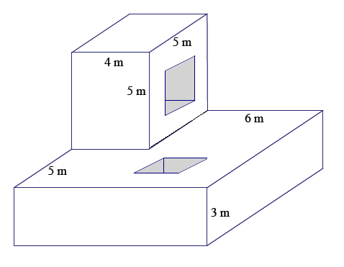

Surface Area of Interiors:
Area of Interiors | $=4\left(2 m ×4 m\right)+4(2 m × 3 m)$  $= 56$ $m^{2}$

Surface area $= 110 m^{2}+ 300 m^{2}+56 m^{2}-16 m^{2}= 450 m^{2}$

- The base of a right prism is shown below. Determine the surface area if the height of the prism is $10$cm. Explain how you determined the surface area.
Take the sum of the areas of the two bases made up of two right triangles, and add to it the sum of the areas of the lateral faces made up by rectangles of different sizes.
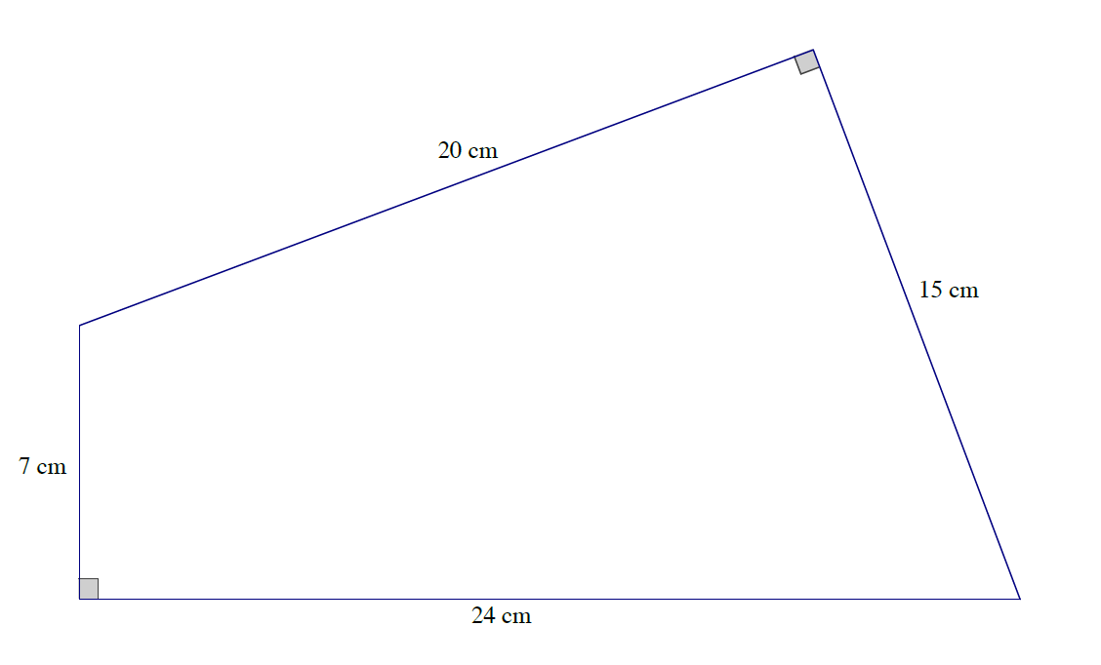
Area of sides | $$=\left(20 cm × 10 cm\right)+\left(15 cm × 10 cm\right)+\left(24 cm × 10 cm\right)+(7 cm × 10 cm)$$  $$=200 {cm}^{2} +150 {cm}^{2}+240{ cm}^{2}+70 {cm}^{2}$$  $$=660 {cm}^{2}$$
Area of bases | $$=2\left(\frac{1}{2}\left(7 cm × 24 cm\right)+\frac{1}{2}\left(20 cm × 15 cm\right)\right)$$  $$=\left(7 cm × 24 cm\right)+\left(20 cm × 15 cm\right)$$  $$= 168 {cm}^{2}+300 {cm}^{2}$$  $$=468 {cm}^{2}$$
Surface area | $$=660 {cm}^{2}+468 {cm}^{2}$$  $$=1,128 {cm}^{2}$$

